**­­**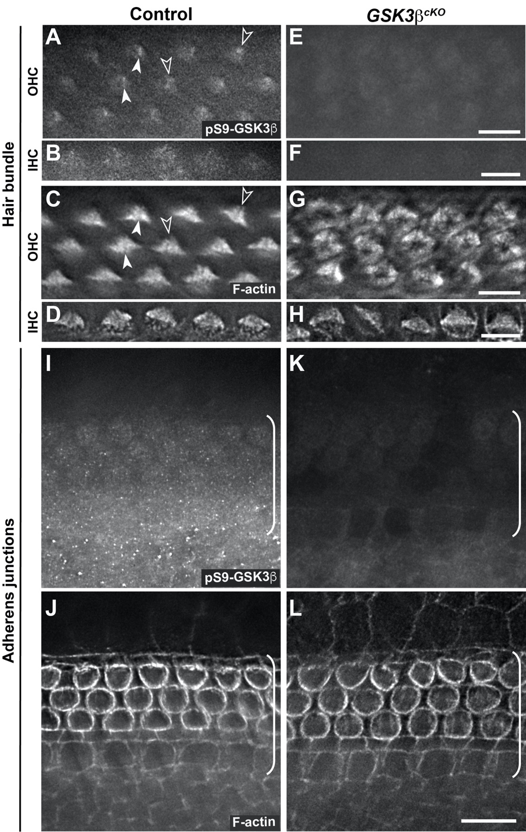

**Supplementary Figure 1. Specific staining patterns of pS9-Gsk3b in the cochlea.**

(A-H) pS9-Gsk3b and phalloidin staining at the level of hair bundle in control (A-D) and *Gsk3bcKO* (E-H) OC at E18.5. Open arrowheads indicate the pericentriolar region. Arrowheads indicate the kinocilium. (I-L) pS9-Gsk3b and phalloidin staining at the level of adherens junctions in control (I, J) and *Gsk3bcKO* (K, L) OC and surrounding regions. Brackets indicate the OC. Lateral is up. Scale bars: A-H, 6 µm; I-L, 10 µm.

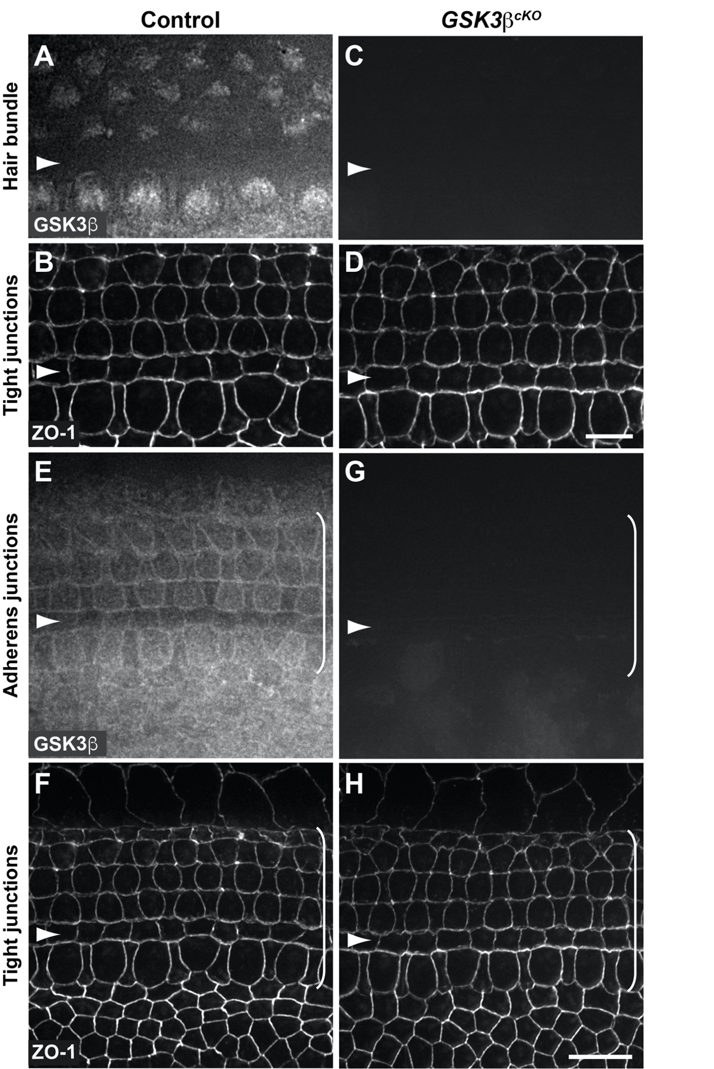

**Supplementary Figure 2. Specific staining patterns of Gsk3b in the cochlea.**

(A-D) Gsk3b staining at the level of hair bundle and ZO-1 staining at the level of tight junctions in control (A, B) and *Gsk3bcKO* (C, D) OC at E18.5. (E-H) Gsk3b staining at the level of adherens junctions and ZO-1 staining at the level of tight junctions in control (E, F) and *Gsk3bcKO* (G, H) OC and surrounding regions. Brackets indicated the OC. Lateral is up. Scale bars: A-D, 6 µm; E-H, 10 µm.

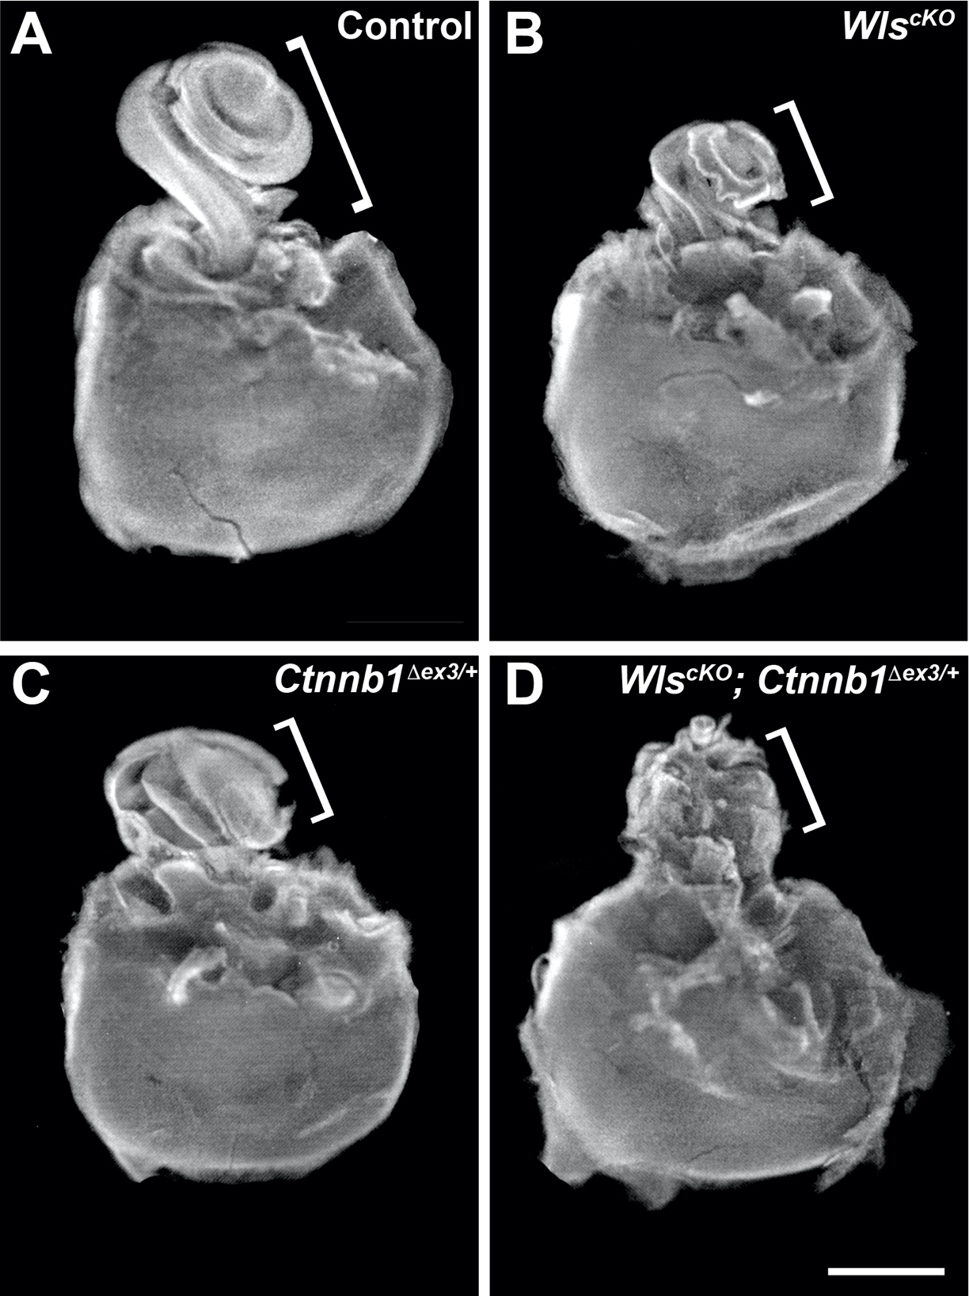

**Supplementary Figure 3. Cochlear outgrowth in *WlscKO; Ctnnb1Dex3/+* mutants was severely stunted.**

(A-D) E18.5 control (A), *WlscKO* (B), *Ctnnb1Dex3/+*(C) and *WlscKO; Ctnnb1Dex3/+*(D) otic capsules partially dissected to expose the cochlear duct. Brackets indicate the cochlea. Scale bar: 1 mm.

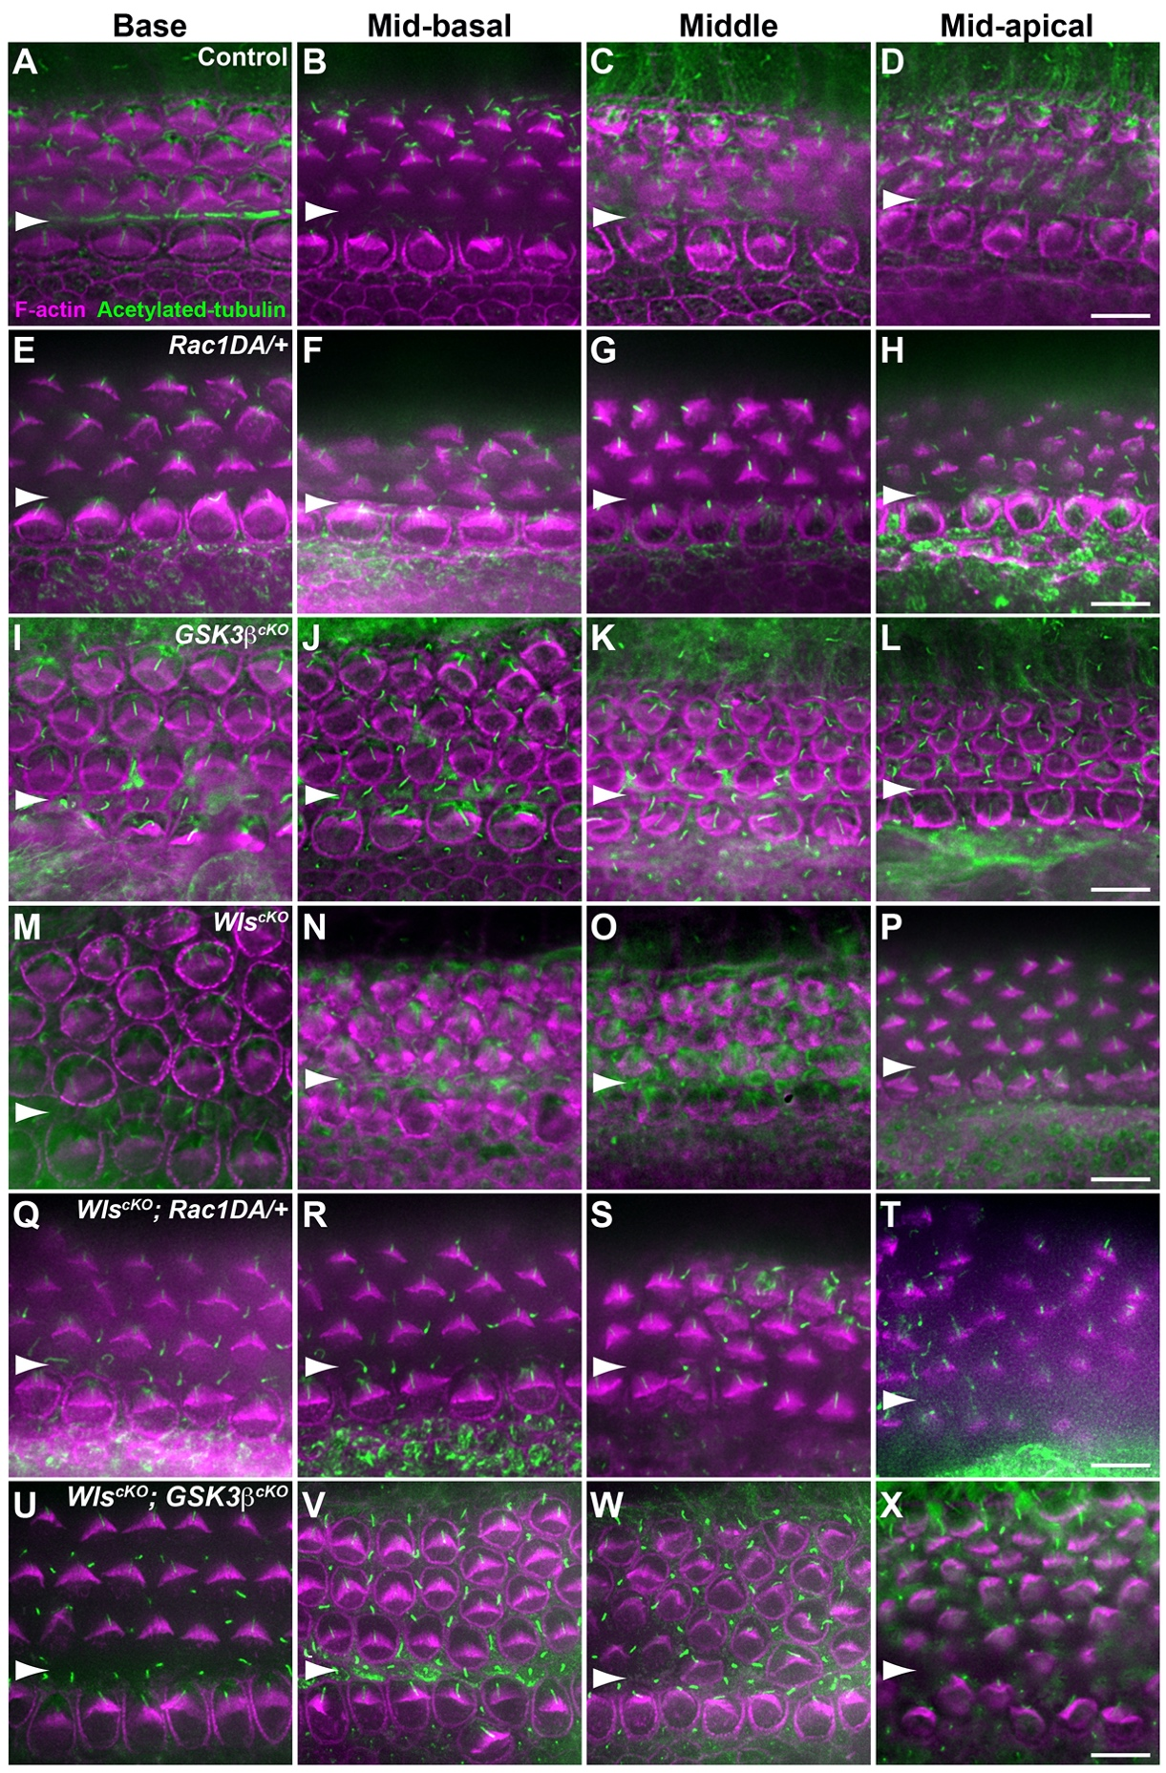

**Supplementary Figure 4. Hair bundle staining along the longitudinal axis of the cochlea.**

(A-X) Flat-mounted OC stained for acetylated tubulin (green) and F-actin (magenta). The positions along the longitudinal axis of the cochlea are indicated on top. The genotypes are: (A-D) Control, (E-H) *Rac1DA/+*, (I-L) *Gsk3bcKO*, (M-P) *WlscKO*, (Q-T) *WlscKO; Rac1DA/+*, and (U-X) *WlscKO*; *Gsk3bcKO*. Arrowheads indicate the inner pillar cell row. Lateral is up. Scale bars: 6 μm.