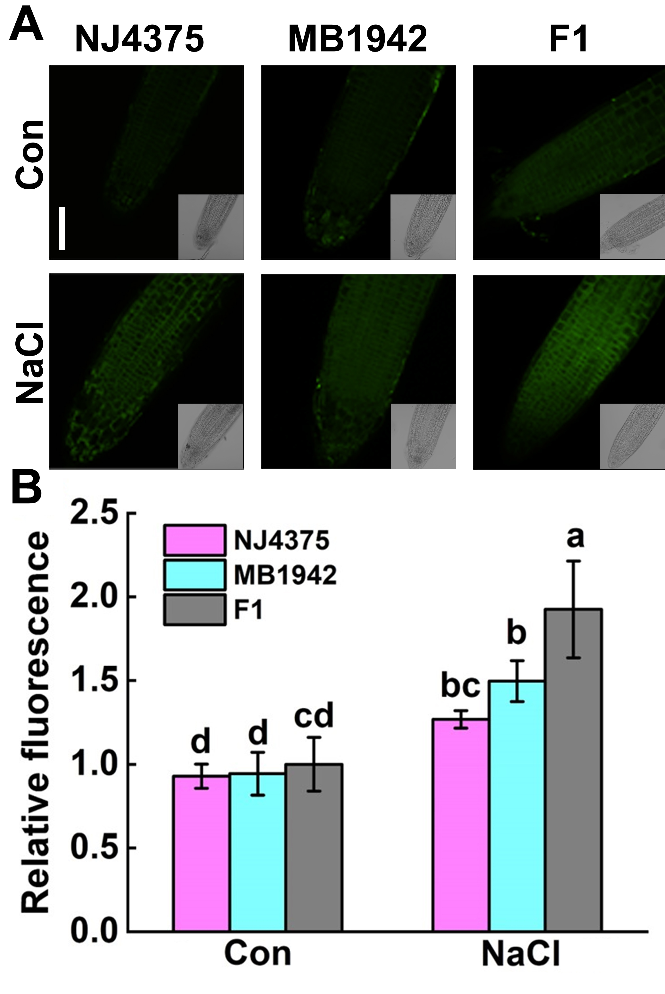
Supplementary Figure 1 The NO levels at germination stage. (A) After seeds germinated for 3 d, the roots were loaded with 4-amino-5-methylamino-2’,7’-difluorofluorescein diacetate (DAF-FM DA), and detected by laser scanning confocal microscopy (LSCM). DAF-FM DA-dependent fluorescence densities according to (A) were given (B). Values are the means ± SD for three independent experiments. One-way ANOVA analyses were conducted according to Duncan’s multiple range test. Different letters denote significant differences at P < 0.05.

