Supplementary Material

Supplementary Data
Supplementary Table 1. Summary table for variety of policy and management applied to management of the MPA from 2010-2020.
Level | Type | Description
BIOT-level | Sanctions | - Confiscation of all catch on-board non-compliant vessels, vessel gear and vessels (in their entirety)  - Financial sanctions, including fixed penalty notices  - Vessels are also prosecuted through a bilateral arrangement, where owners may be prosecuted under the Sri Lankan fisheries law.
 | Policy | - Encouraging vessels to submit notice of transit through the MPA
Regional Fisheries Management Organisation -level | Advocacy based | Through engagement at the IOTC RFMO, MPA management have advocated for changes to IOTC regulations to better capture issues related to IUU, which feed into national regulations, and to which Sri Lanka must be compliant. Advocacy has focused on the following issues;  - Updating the IUU Resolution to enable listing of member’s non-compliant vessels on the IOTC “IUU list” (since 2009 this enabled BIOT to seek to IUU list any non-compliant vessels)  - Extending VMS to vessels of any size operating outside of national waters  - Steps towards a centralised VMS system for all members of IOTC  - IUU listing of Sri Lankan vessels at IOTC  - Enabling prosecution of the skippers of non-compliant vessels.
.
Supplementary Table 2. Explanation of data used in analysis, including description of data type, availability in terms of time period and number of records. Analysis explains which study sections the data was used for.
Data type | Description | Insights | Time period | No. | Analysis
Enforcement data
Vessel record incl. time and location | Master database of location-specific records of vessel sightings and investigation | Date of arrest, location of arrest, vessel name, vessel registration, flag state, captain name and address, vessel owner name and address | 2010-2020 | 227 | Spatiotemporal trends; Vessel and fisher characteristics; Factors affecting non-compliance
Boarding reports | Reports written by enforcement personnel following investigation of a vessel sighting. Main purpose is to; i) collect details of vessel and fishers, ii) collect evidence to establish if non-compliance has occurred. | Vessel characteristics (incl. crew number, license details, IOTC registration, presence of VMS, fishing gear and catch).  Conversations with crew to ascertain nature of behaviour in the MPA | 2010-2020 | 188 | Vessel and fisher characteristics; Social networks; Factors affecting non-compliance
Arrest transcripts | Interviews with vessel captains following detention for further investigation to ascertain behaviour within the MPA (verbatim transcriptions) | Crew demographics, intention of vessel in BIOT, targeting behaviour incl. gear type and target species, vessel ownership details, understanding of BIOT regulations | 2010-2020 | 20 | Vessel and fisher characteristics; Social networks; Factors affecting non-compliance
Catch seizures | Master database of catch seized from vessels confirmed as non-compliant. | Weight, number, biological identification of catch | 2010-2020 | 58 | Illegal resource use
Community data
Fisher interview | Interviews with fishers at two sites in south west Sri Lanka known to target the MPA. Composed of closed and open-ended questions designed to ascertain spatial movement of vessels | Insights into drivers for spatial behaviour and non-compliance for Sri Lankan vessels | 2015-2020 | 95 | Factors affecting non-compliance
Focus groups | Focus groups with groups of fishers at four sites in south west Sri Lanka (see Collins et al., 2020) | Insights into non-compliance with management and policy for Sri Lankan vessels |  | 12 | Factors affecting non-compliance
Supplementary Table 3. Summary table showing availability of catch for all non-compliant (suspected and confirmed) vessels during the study period. The proportion (%) is shown, as well as number (in brackets).
Year | Catch data | Specimen no. | Specimen weight | Mix
2010 | 50% (10) | 36% (9) | 32% (7) | <1% (1)
2011 | 38% (6) | 38% (6)
2012 | 22% (2) | 22% (2) | 11% (1)
2013 | 43% (3) | 43% (3) | 0%
2014 | 52% (12) | 48% (11) | 0% | <1% (1)
2015 | 27% (6) | 23% (5) | 27% (6)
2016 | 100% (8) | 0% | 100% (8)
2017 | 80% (4) | 0% | 80% (4)
2018 | 60% (3) | 40% (2) | 40% (2) | 20% (1)
2019 | 50% (3) | 33% (2) | 33% (2)
2020 | 16% (1) | 17% (1) | 0%
Availability for all non-compliant vessels | 45% | 32% | 23% | 2%
Supplementary Table 4. List of identified catch for all non-compliant vessels that was either seized or viewed by staff during investigation for non-compliance, reported to the highest possible identification. Catch is organised into the three main groups found on-board (‘reef fish’, ‘elasmobranchs’ and ‘pelagic tuna/billfish species’), and a miscellaneous ‘other’ category. IUCN status (https://www.iucnredlist.org) abbreviated as Data Deficient (DD), Least Concern (LC), Near Threatened (NT), Vulnerable (VU), Endangered (EN), Critically Endangered (CR).
Catch group | Family | Species | Common name | IUCN status
Reef fish | Serranidae | Mycteroperca bonaci | Black grouper | NT
 |  | Cephalopholis miniata | Coral hind | LC
 |  | Variola louti | Lyretail
 |  | Cephalopholis spiloparaea | Strawberry hind | LC
 |  |  | Grouper
 | Carangidae | Caranx melampygus | Bluefin trevally | LC
 | Lethrinidae | Lethrinus erythracanthus | Orange-spotted emperor | LC
 |  | Lethrinus mahsena | Sky emperor | EN
 |  |  | Emperor
 | Lutjanidae | Pristipomoides filamentosus | Crimson jobfish | LC
 |  | Lutjanus gibbus | Humpback snapper | LC
 |  | Lutjanus sanguineus | Humphead snapper | LC
 |  |  | Red snapper
 |  |  | Snapper
 |  |  | Jobfish
Elasmobranch | Carcharhinidae | Carcharhinus melanopterus | Blacktip reef shark | VU
 |  | Carcharhinus limbatus | Blacktip shark | NT
 |  | Triaenodon obesus | Whitetip reef shark | VU
 |  | Carcharhinus albimarginatus | Silvertip shark | VU
 |  | Carcharhinus plumbeus | Sandbar shark | VU
 |  | Prionace glauca | Blue shark | NT
 |  | Carcharhinus leucas | Bull shark | NT
 |  | Carcharhinus brachyurus | Bronze whaler shark | VU
 |  | Carcharhinus amblyrhynchos | Grey reef shark | EN
 |  | Carcharhinus longimanus | Oceanic whitetip shark | CR
 |  | Carcharhinus falciformis | Silky shark | VU
 |  | Carcharhinus brevipinna | Spinner shark | VU
 |  | Galeocerdo cuvier | Tiger shark | NT
 | Sphyrnidae | Sphyrna lewini | Scalloped hammerhead | CR
 |  | Sphyrna zygaena | Smooth hammerhead | VU
 | Lamnidae | Isurus paucus | Longfin mako shark | EN
 | Lamnidae | Isurus oxyrinchus | Shortfin mako shark | EN
 | Alopiidae |  | Thresher shark
 | Rhinidae | Rhynchobatus djiddensis | Giant guitarfish | CR
 | Mobulidae |  | Manta ray
 | Miscellaneous dried elasmobranch incl. shark fin and manta gills
Pelagic tuna/billfish | Istiophoridae |  | Billfish
 |  | Kajikia audax | Striped marlin | NT
 |  | Istiophorus platypterus | Indo-Pacific sailfish | LC
 |  | Makaira nigricans | Blue marlin | VU
 |  | Istiompax indica | Black marlin | DD
 | Scombridae | Thunnus obesus | Bigeye tuna | VU
 |  | Thunnus albacares | Yellowfin tuna | NT
 |  | Katsuwonus pelamis | Skipjack tuna | LC
 |  | Thunnus tonggol | Longtail tuna | DD
 |  |  | Bonito
 |  | Gymnosarda unicolor | Dogtooth tuna | LC
 | Xiphiidae | Xiphias gladius | Swordfish | LC
 | Sphyraenidae |  | Barracuda
 | Triglidae |  | Flying fish
Other | Carangidae | Caranx ignobilis | Giant trevally | LC
 |  | Elagatis bipinnulata | Rainbow runner | LC
 | Scombridae | Euthynnus affinis | Kawakawa | LC
 |  | Acanthocybium solandri | Wahoo | LC
 | Stromateidae |  | Pomfret
 | Coryphaenidae | Coryphaena equiselis | Pompano dolphinfish | LC
Supplementary Table 5. Diagram of coding framework created by open-coding analysis. Insights gained through coding of both enforcement and fieldwork data have been summarised. Illustrative quotes are provided, with origin of data indicated in brackets.
Factor type | Factor description | Insights | Illustrative quote
Economic benefits from illegal fishery | Economic returns from non-compliance | 50% of arrest transcripts contained fishers discussing targeting sharks. Insights from boarding reports suggested that the MPA represents an attractive target for illegal fishing due to perceptions of higher populations here. Fishers also explained that catches of sharks within traditional waters had declined. | “they came to BIOT Water to catch more shark” (Enforcement, 2010)
 | Cost of non-compliance | Evidence from boarding reports and arrest transcripts suggested that fishers might choose to fish in BIOT because it is closer to Sri Lanka meaning lower fuel costs. | “they were heading towards Mala Banks to fish but decided it was too far from Sri Lanka” (Enforcement, 2019)
 | Comparative economic returns from compliant fisheries | 25% of arrested captains explained that they had come to BIOT because of poor catches of other species elsewhere. In particular, fishers discussed declines in sharks in traditional fishing sites and the coastal waters of Sri Lanka. | “decided to come into the BIOT waters because the fishing for sharks in Sri Lanka is now very poor” (Enforcement, 2018)  “they didn’t catch any fish so they decide to come” (Enforcement, 2011)
 | Probability of detection | Fieldwork data showed that fishers had knowledge of MPA management, including understanding that there was a BPV and sometimes aerial surveillance. There was a broad consensus that likelihood of detection was much higher now that regulations introducing VMS had been introduced. With fishers stating that this meant only smaller vessels could now target the MPA (as they weren’t required to have VMS installed). Some fishers perceived that turning of VMS systems helped them to evade detection, although others considered that they would still get caught if they did this. Overall, probability of detection was highly variable. | “No, only 1 or 2 % get caught. We have certain strategies to stay safe” (Community, 2019)  “Less than 1%. Recently some fishers have caught to Garcia, they have released those vessels, but have sent the message to our people. They arrest us soon we arrive” (Community, 2019)
 | Sanctions | Fieldwork highlighted variability amongst fisher perceptions of sanctions. Estimates for detentions varied from one month up to three years and fines also varied, from no fine to > ~$15,000. Interestingly, there were examples of fishers who thought that sanctions would not be applied until the third time they were spotted. | “sometimes even if we escaped, the navy of those countries cut our gear (which value for like around 2,200,000 LKR), which is a huge loss for us” (Community, 2019)
Socio-cultural factors | Social norms | There were multiple examples of social ties between vessels that may have affected interpretation of social norms. These include kin relations between vessels and frequent examples of vessels fishing together at some point during fishing trips. | “his brother and another guy been detained before” (Enforcement, 2010)
 | Transmission of information | 20% of arrest transcripts contained evidence that fishers had come to the MPA based upon information they had been given. Evidence was also found during boarding reports, in the form of coordinates in notebooks. Information had been passed on in the form of coordinates and particular target species to be targeted there. This information was relayed both at harbours, and during trips in the form of vessel communications. Some fishers explained that they were given this information without being told that it was in an MPA, and therefore illegal. | “they said one friend the fisherman give them position that’s why they come catch the fish” (Enforcement, 2010)  “before coming, they (got) information from a fisherman” (Enforcement, 2010)
Socio-political factors | Legitimacy of management | Negative perceptions of MPA legitimacy were associated, by fishers during fieldwork, with poor effectiveness in fish population recovery and also likelihood of reducing illegal fishing. Conversely, positive perceptions of MPA effectiveness were also discussed, with fishers discussing personal experience of benefits in terms of increased fish populations. | “Even they put closing areas, it’s really difficult to actually implement it” (Community, 2019)
 | Regulations | Fishers regularly discussed introduction of national regulations influencing non-compliance during fieldwork. Most notably, introduction of VMS was discussed frequently as a key driving factor reducing likelihood of non-compliance. | “most of the regulation came after 2015 with the government change” (Community, 2019)  “before we didn’t have any regulations so fishers went to those areas to catch fish” (Community, 2019)
Behavioural factors | Propensity to engage in illegal activities | Evidence of individuals returning to BIOT on multiple occasions was found (these could not be included in quantitative analysis as names were not provided). Crew on nine vessels mentioned that individuals had been to BIOT before, including those that had been caught previously. There were also admissions of fishing (illegally) in Madagascar, Maldives, Oman, Mauritius and Reunion Island. | “ before they came here (to the MPA) on the previous trip” (Enforcement, 2011)

Supplementary Figures
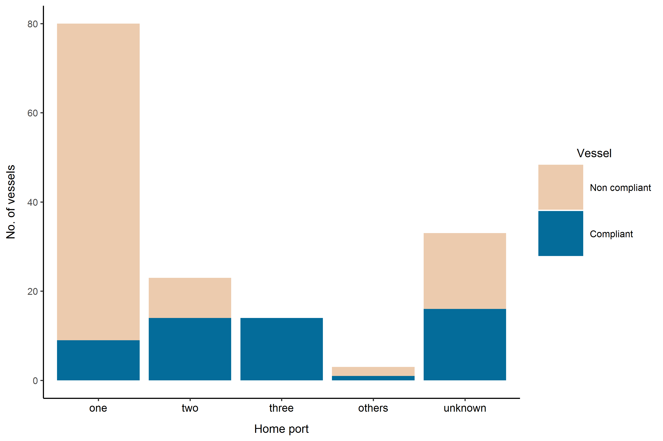Supplementary Figure 1. Port of origin for Sri Lankan vessels sighted in the MPA, taken from vessel registration details contained in enforcement data. All sites are anonymised. ‘Others’ represents two other known ports and ‘Unknown’ represents vessels without information on port of origin.
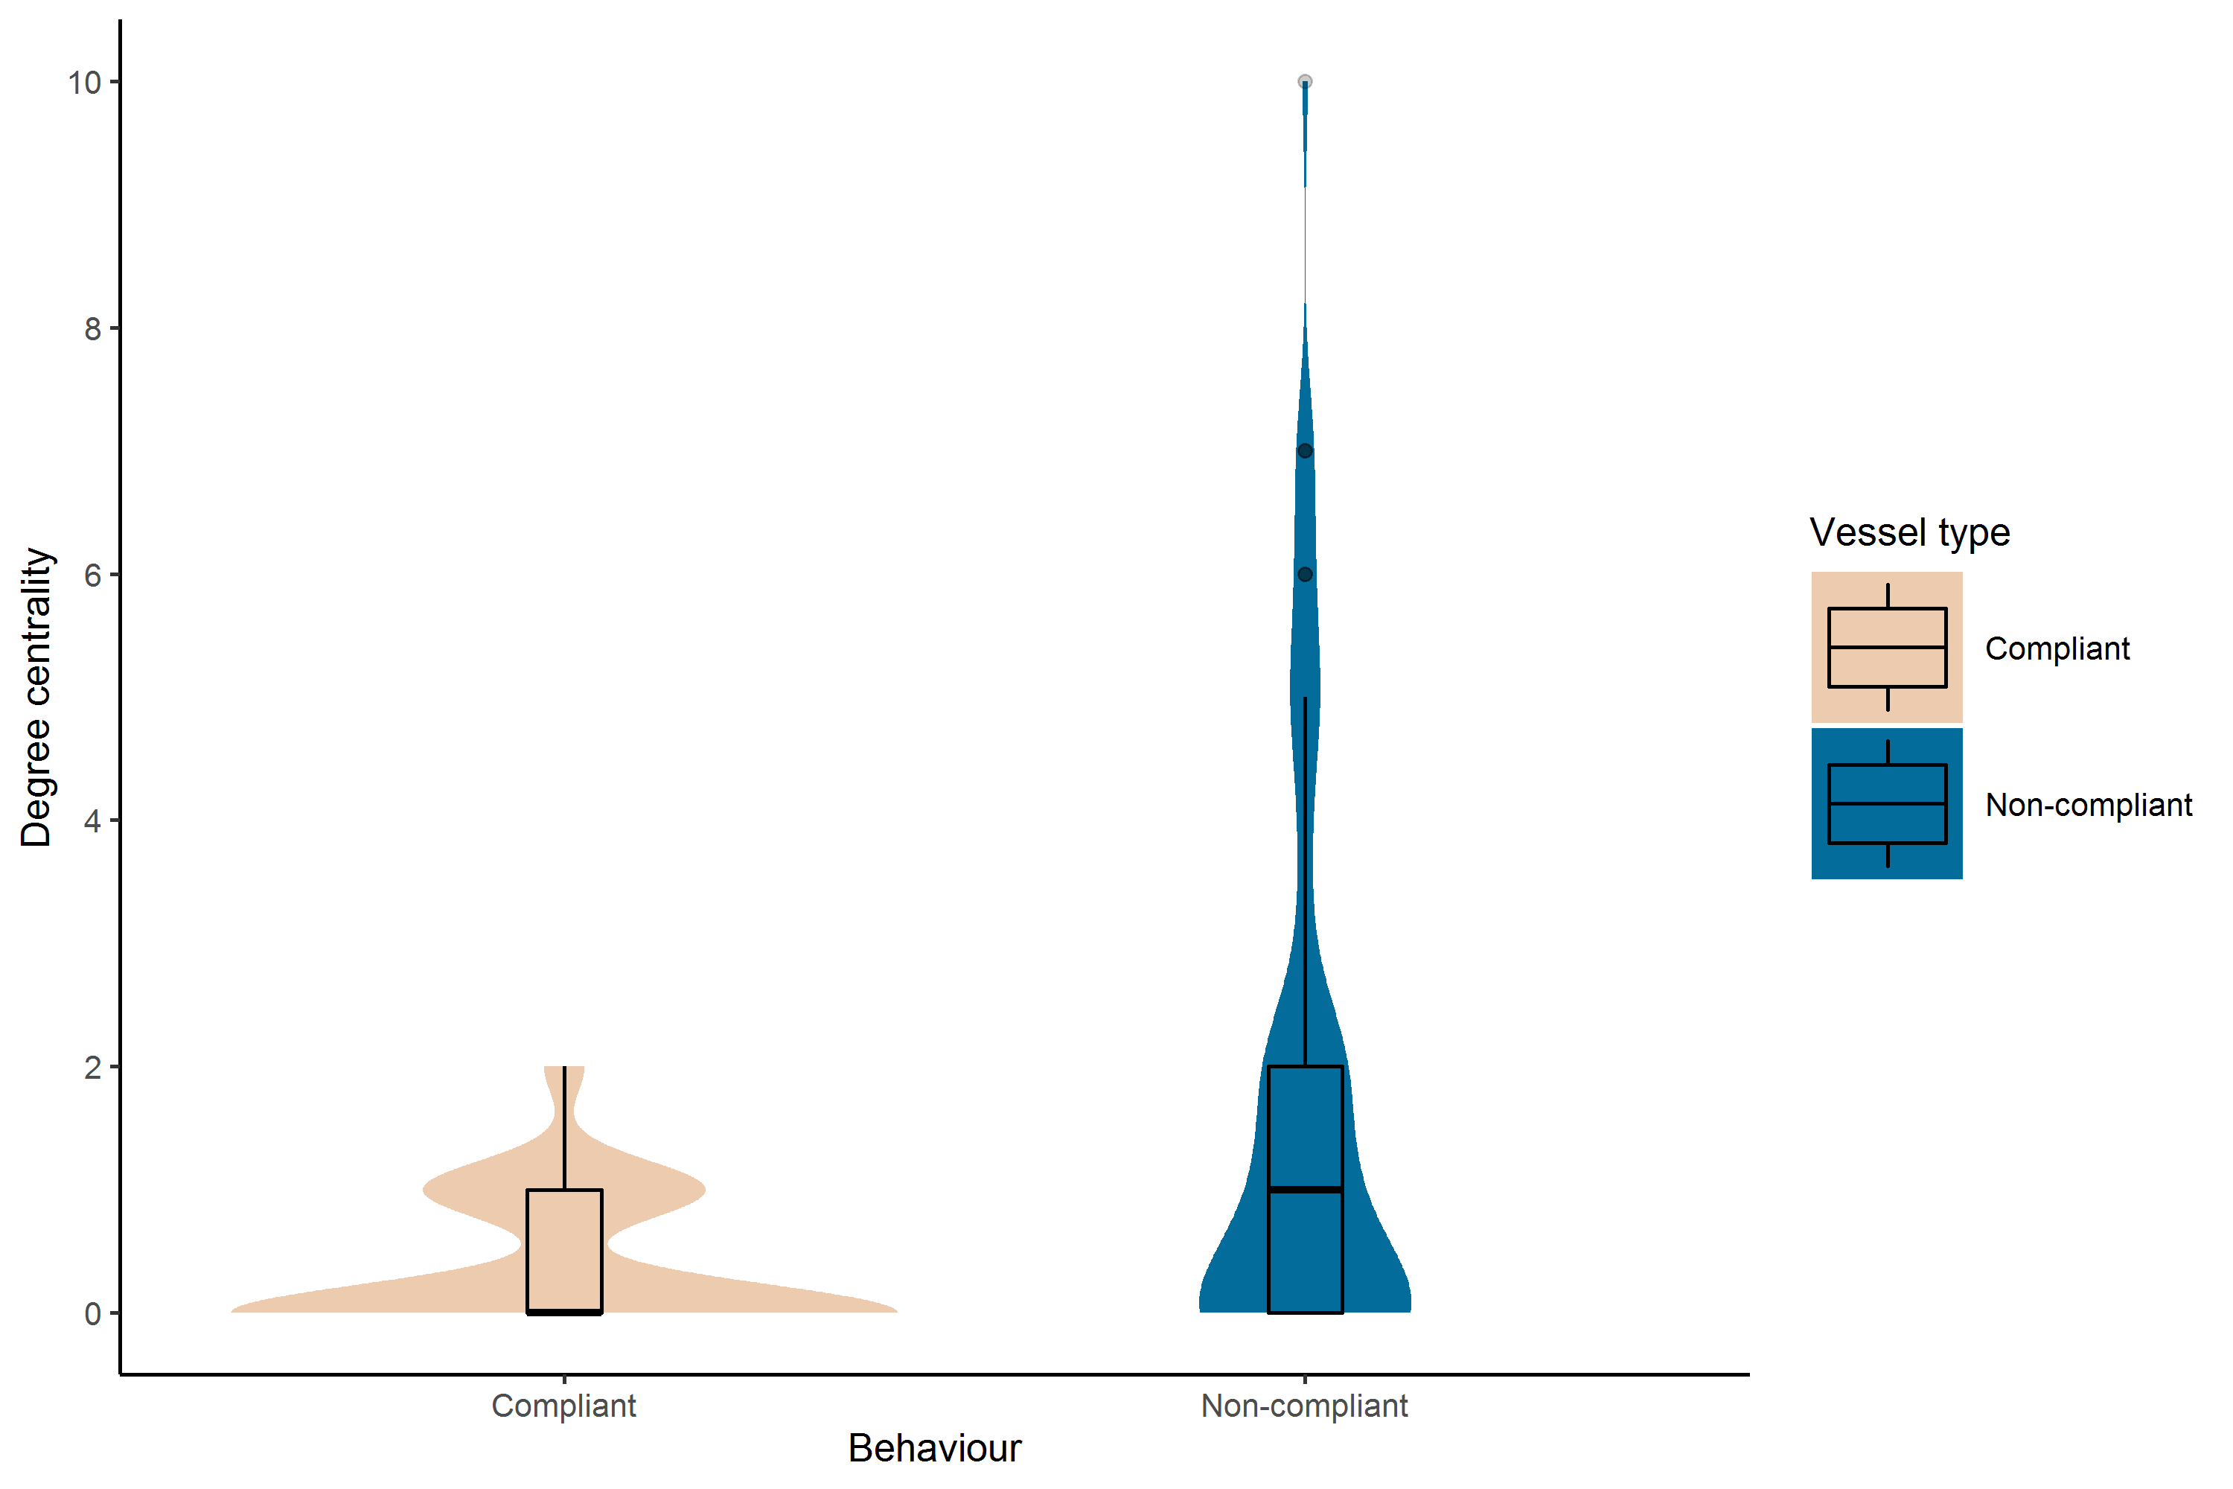
Supplementary Figure 2. Distribution of degree centrality scores for vessels according to social ties identified from enforcement records (violin plot). Interquartile range and median scores for both vessel groups are also shown (box plot).

