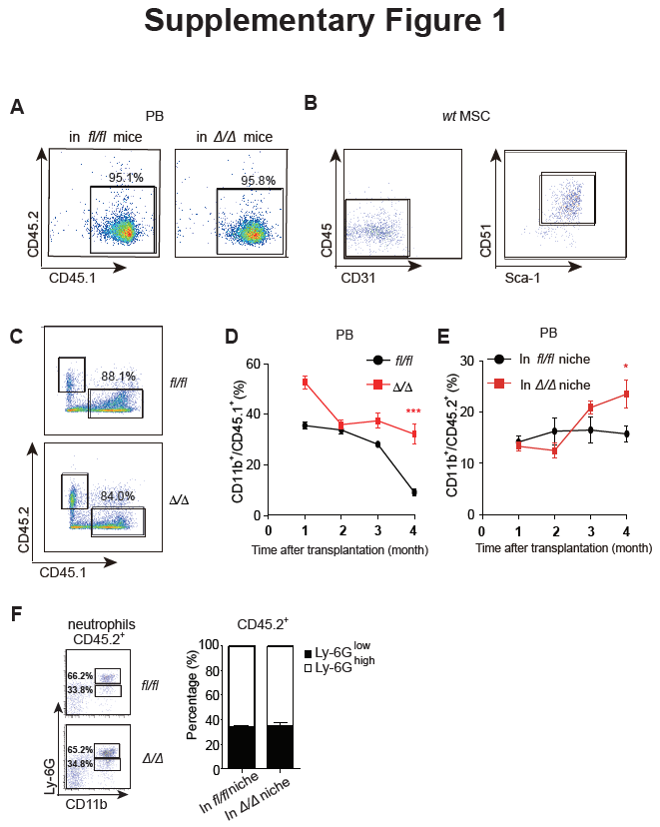
Supplementary Figure 1. WT HSCs could be differentiated into normal neutrophils in the presence of Rheb1^{Δ/Δ} blood cells in bone marrow.
(A) The percentage of CD45.1⁺ cells in PB of Rheb1^{fl/fl} and Rheb1^{Δ/Δ} mice. (B) The surface markers of isolated MSCs from bone of mice. (C) The percentages of CD45.1⁺ cells and CD45.2⁺ cells in BM four months after transplantation. (D)The percentage of donor-derived CD11b⁺ cells (CD45.1⁺) in PB. (E) The percentage of donor-derived CD11b⁺ cells (CD45.2⁺) in PB. (F) The percentage of donor-derived CD11b⁺Ly-6G^{high/low} cells (CD45.2⁺) in BM four months after transplantation. The data are presented as the mean ± SD, n=3.
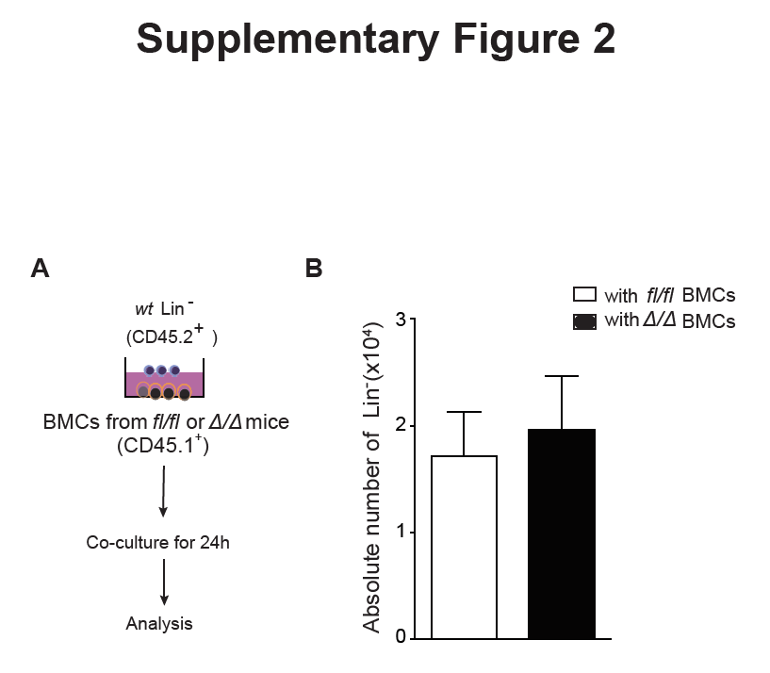
Supplementary Figure 2. Rheb1^{Δ/Δ} blood cells did not promote HSC proliferation in vitro.
- WT Lin⁻ cells (CD45.2⁺) with BMCs from Rheb1^{fl/fl} and Rheb1^{Δ/Δ} mice (CD45.1⁺) cocultured for 24 h. (B) The absolute number of Lin⁻ cells after cocultured with either Rheb1 ^{fl/fl} or Rheb1^{Δ/Δ} BMCs for 24 h. The data are presented as the mean ± SD, n=3.
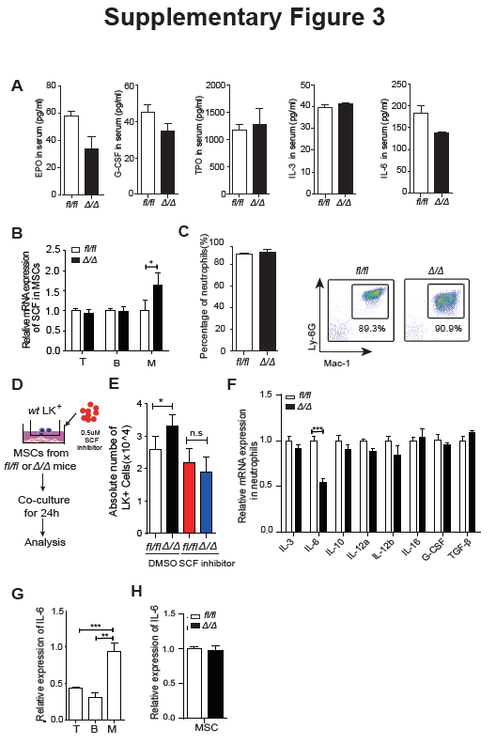
Supplementary Figure 3. The expression of IL-6 and other cytokines in blood cells in Rheb1^{fl/fl} or Rheb1^{Δ/Δ} mice.
(A) The protein level of EPO, G-SCF, TPO, IL-3 and IL-6 in the serum of Rheb1^{fl/fl} and Rheb1^{Δ/Δ} mice. (B) The relative mRNA expression of SCF in wt MSCs cocultured with Rheb1^{fl/fl} or Rheb1^{Δ/Δ} T cells, B cells and myeloid cells for 12 h. (C) Left panel, the percentage of isolated neutrophils from BM of Rheb1^{fl/fl} and Rheb1^{Δ/Δ} mice. Right panel, the surface markers of isolated neutrophils from BM of Rheb1^{fl/fl} and Rheb1^{Δ/Δ} mice. (D-E) The number of LK⁺ cells cocultured with MSCs from Rheb1^{fl/fl} and Rheb1^{Δ/Δ} mice for 24 h after adding SCF inhibitor (0.5 mM). (F) The relative mRNA expression of selected genes in Rheb1^{fl/fl} or Rheb1^{Δ/Δ} neutrophils isolated from BM. (G) The relative mRNA expression of IL-6 in T cells, B cells and myeloid cells from wt mice. (H) The relative mRNA expression of IL-6 in MSCs from Rheb1^{fl/fl} or Rheb1^{Δ/Δ} mice. The data are presented as the mean ± SD, n=3.

