Supplementary Material

# Supplementary Figures

# H:\0000000000000000000\xos-cos\1-cos paper\-----------------------paper\COS-figures\JPEG\supplementary\Supplementary-Figure-4A-_SF-4A_.jpeg

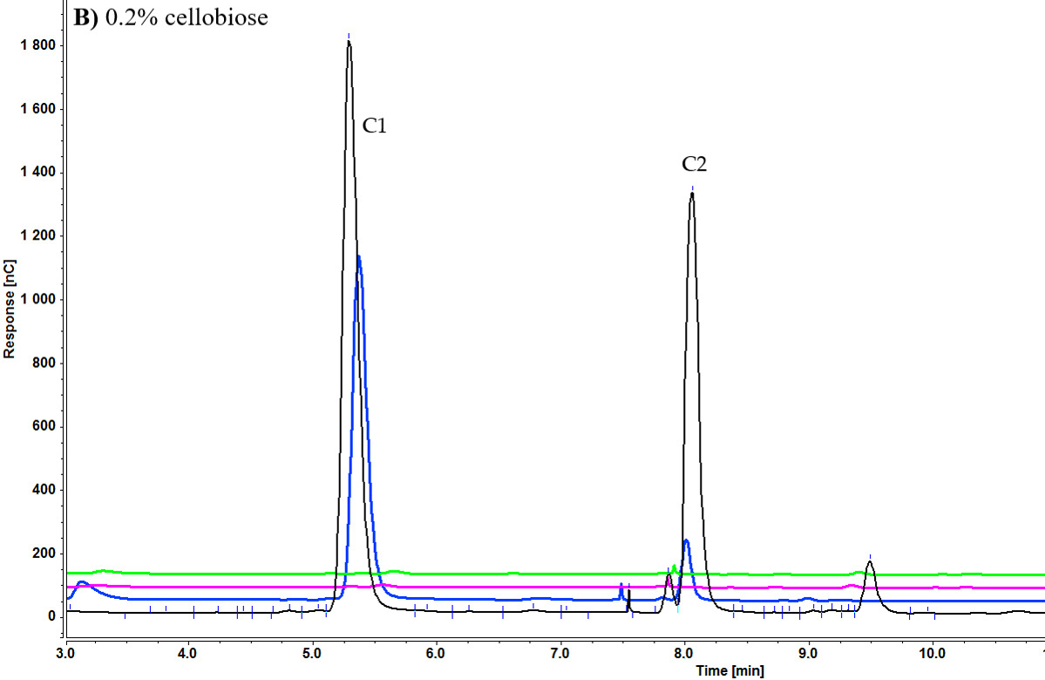

**Supplementary Figure S1.** Cellooligosaccharides concentration in the medium after 1 h (black), 3 h (blue), 5 h (pink), and 7 h (green) of induction with 0.1% cellobiose (A) and 0.2% cellobiose (B) (C1= glucose, C2= cellobiose).

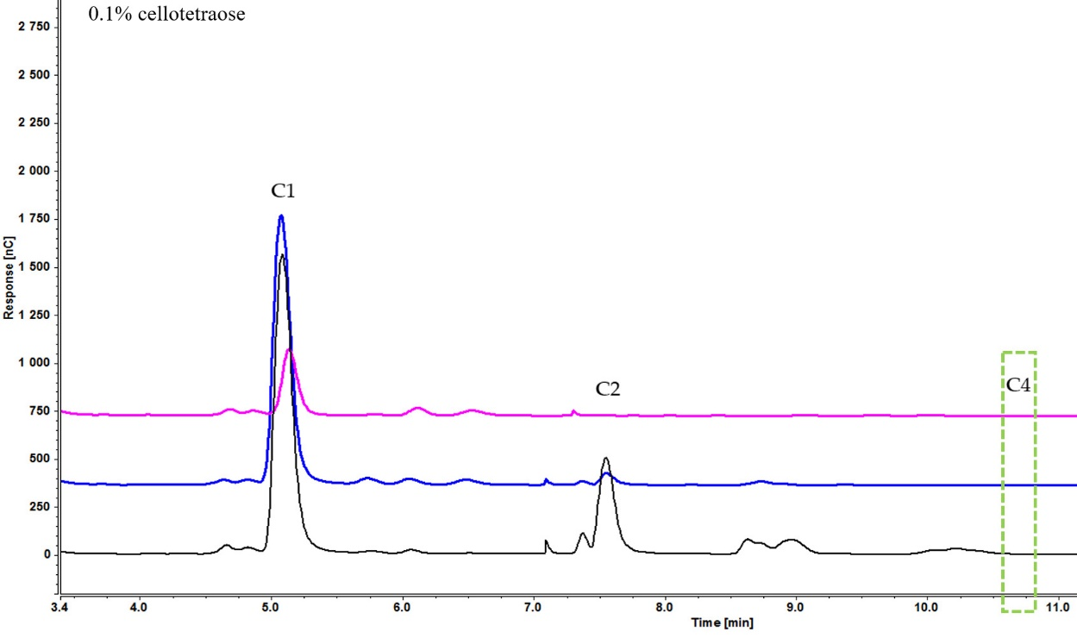

**Supplementary Figure S2.** Cellooligosaccharides concentration in the medium after 1 h (black), 3 h (blue), 5 h (pink) of induction with 0.1% cellotetraose (C1= glucose, C2= cellobiose).

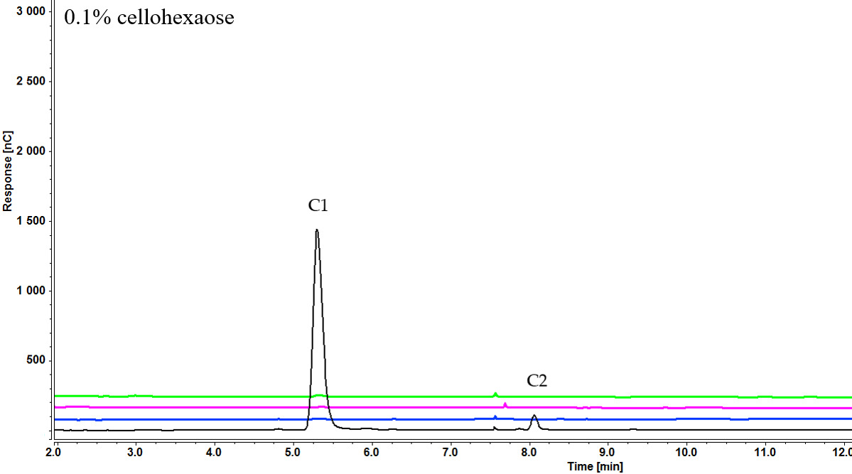

**Supplementary Figure S3.** Cellooligosaccharides concentration in the medium after 1 h (black), 3 h (blue), 5 h (pink), and 7 h (green) of induction with 0.1% cellohexaose (C1= glucose, C2= cellobiose).

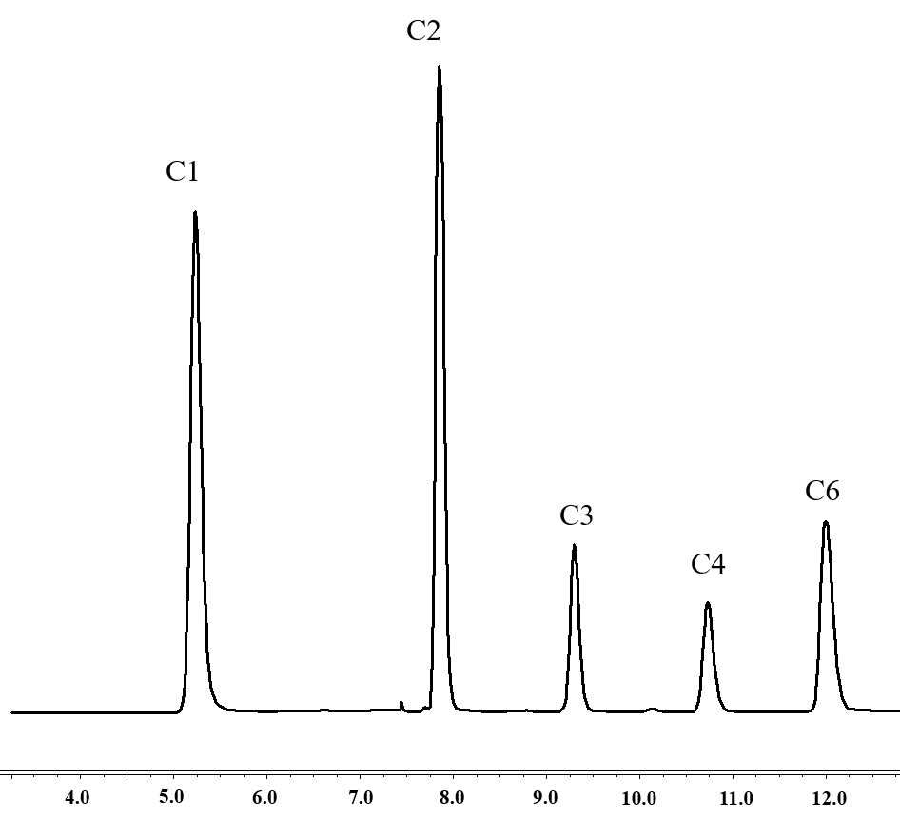

**Supplementary Figure S4.** Peaks of pure inducers(C1= glucose, C2= cellobiose, C3= cellotriose, C4= cellotetraose, C6= cellohexaose).

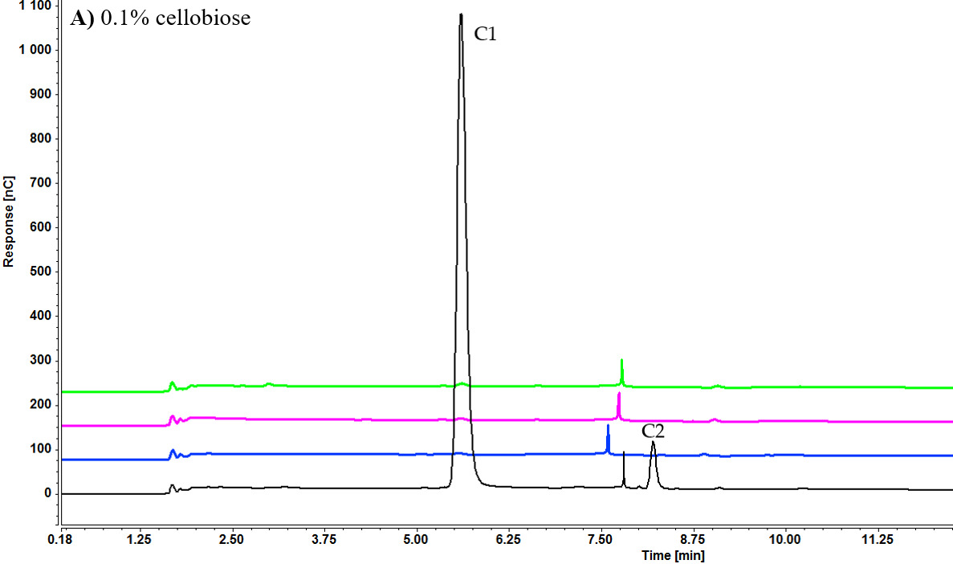

**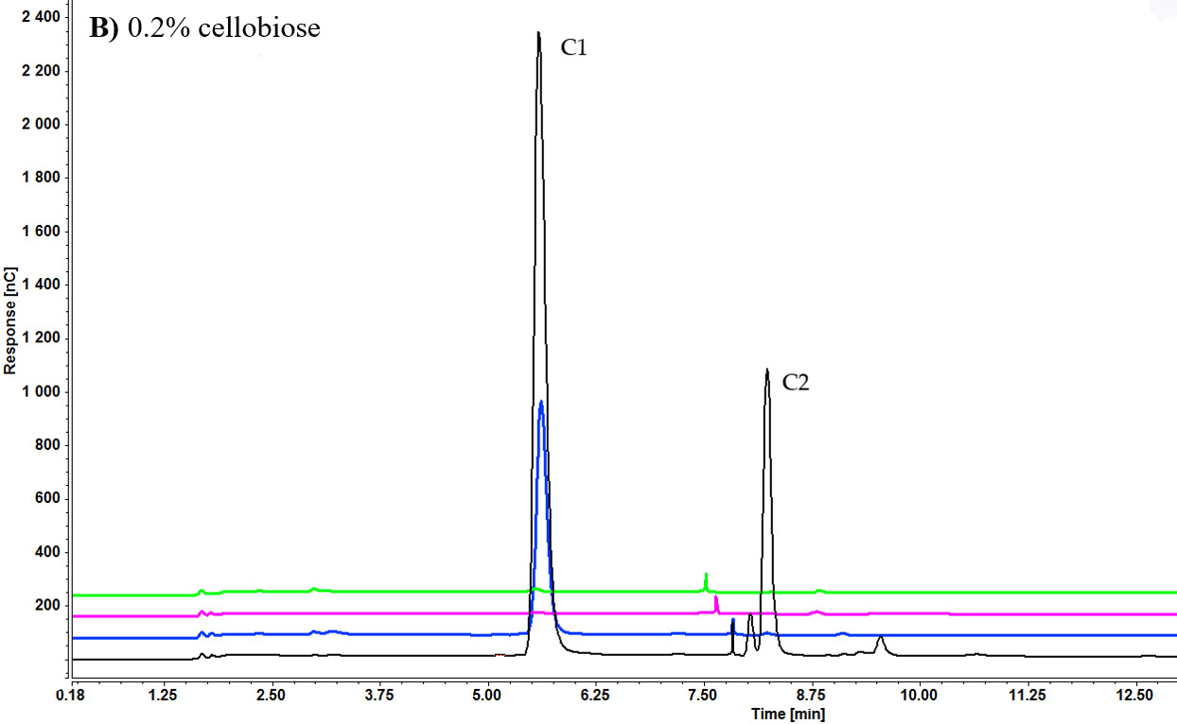**

**Supplementary Figure S5.** Cellooligosaccharides concentration in the medium after 1 h (black), 3 h (blue), 5 h (pink), and 7 h (green) of induction with 0.1% cellobiose (A) and 0.2% cellobiose (B) (C1= glucose, C2= cellobiose).

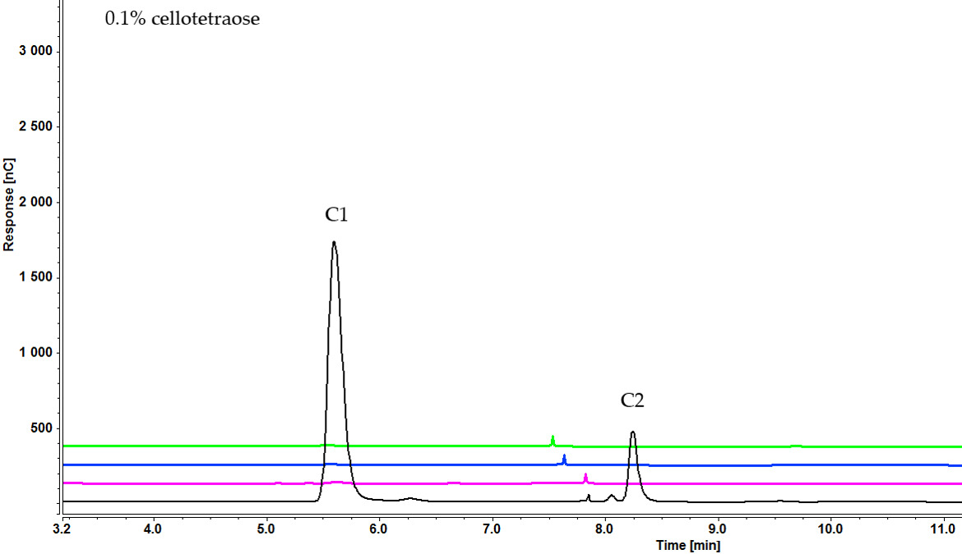

**Supplementary Figure S6.** Cellooligosaccharides concentration in the medium after 1 h (black), 3 h (pink), 5 h (blue), and 7 h (green) of induction with ) 0.1% cellotetraose (C1= glucose, C2= cellobiose, C4= cellotetraose).

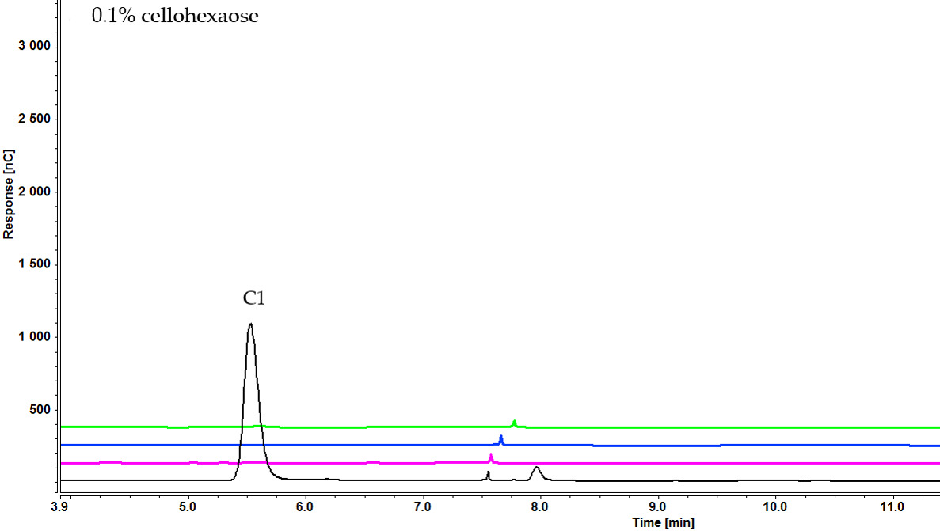

**Supplementary Figure S7.** Cellooligosaccharides concentration in the medium after 1 h (black), 3 h (pink), 5 h (blue), and 7 h (green) of induction with 0.1% cellohexaose cellotetraose (C1= glucose, C2= cellobiose, C4= cellotetraose).