Supplementary Material

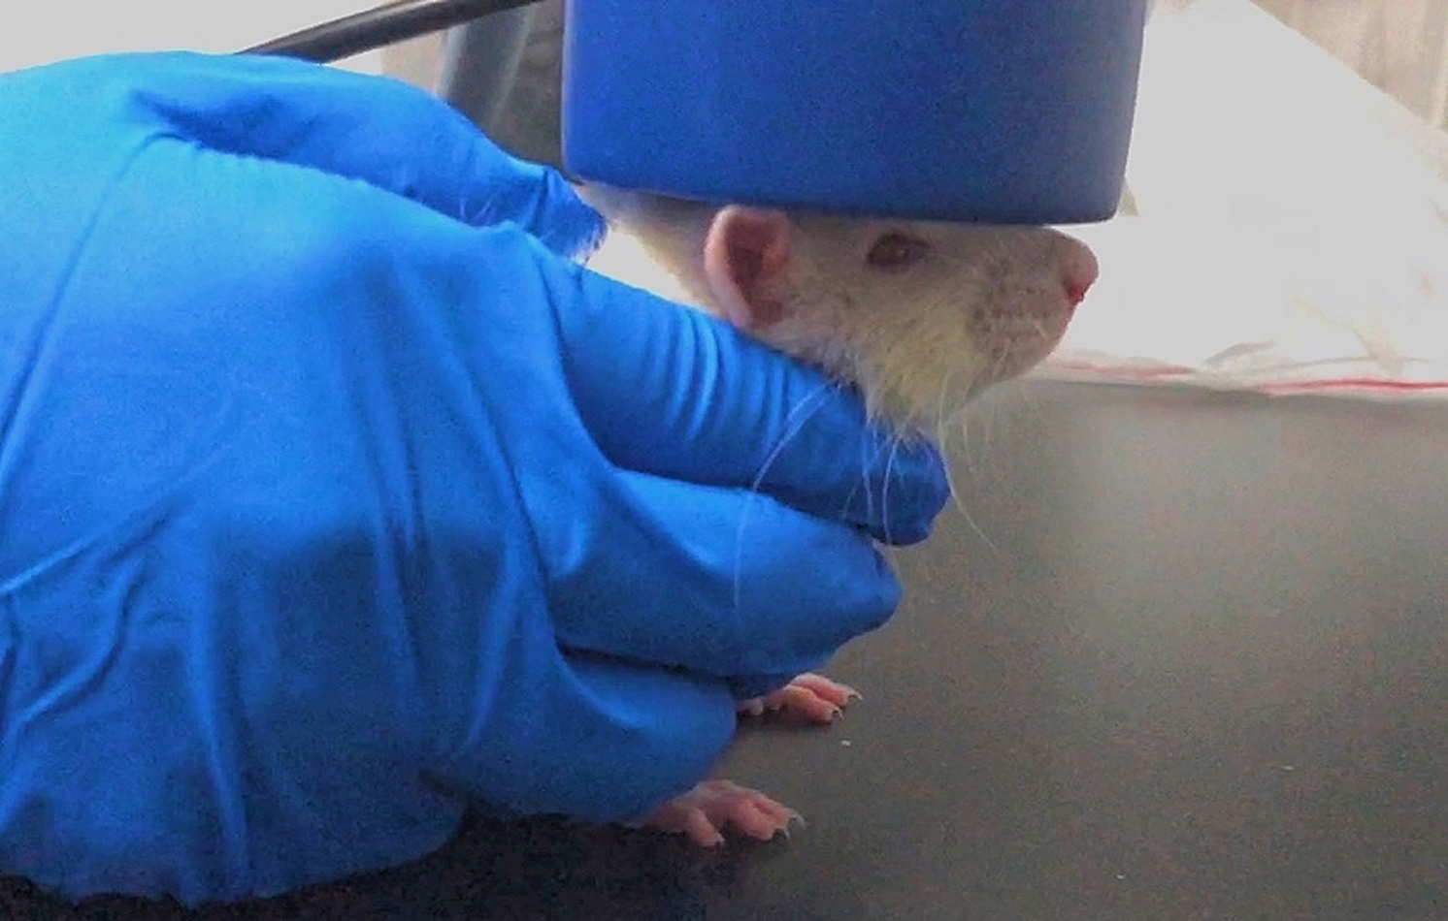

**Supplementary Figure 1.** One rat under rTMS treatment