Supporting Information for

**The sources of organic carbon in the deepest ocean**

Jiwei Li1,2#, Zhiyan Chen1,3,4#, Xinxin Li4,5, Shun Chen1, Hengchao Xu1, Kaiwen Ta1, Shamik Dasgupta1, Shijie Bai1, Mengran Du1, Shuangquan Liu1, Xiaotong Peng1*

1Institute of Deep-Sea Science and Engineering, Chinese Academy of Sciences, Sanya, China.

2Southern Marine Science and Engineering Guangdong Laboratory (Zhuhai), Zhuhai, China

3School of Environment, Harbin Institute of Technology, Harbin, China

4 Shenzhen Key Laboratory of Marine Archaea Geo-Omics, Department of Ocean Science and Engineering, Southern University of Science and Technology, Shenzhen, China

5 Southern Marine Science and Engineering Guangdong Laboratory (Guangzhou), Guangzhou, China

*Corresponding author: [xtpeng1973@163.com](mailto:xtpeng1973@163.com)

# The two authors contributed equally to this article.

**Contents of this file**

Equations

Figures S1 to S6

Tables S1 to S4

.

Equations

IsoGDGTs, in particular, are present at higher levels in aquatic environments such as oceans and lakes and may be formed by Thaumarchaeota and Euryarchaeota (Spang et al., 2010). BrGDGTs, on the other hand, are mainly derived from terrestrial soils and muds and may be formed by anaerobic heterotrophic Acidobacteria (Damste et al., 2011). The branched and isoprenoid tetraether (BIT) index was designed based on BrGDGTs and crenarchaeol (which is representative of marine IsoGDGTs) contents (for structures see **Fig.S1**):

BIT = (GDGT-I +GDGT-II +GDGT-III)/(GDGT-I +GDGT-II +GDGT-III + Crenarchaeol) (**Equation 1, Hopmans et al., 2004**)

The methylation of branched tetraethers (MBT) and cyclization of branched tetraethers (CBT) ratios were defined as follow (for structures see **Fig. S1**):

 $MBT=\frac{\left[GDGT\text{-I}\right]+[\text{BGDGT-Ia]+[GDGT-Ib}]}{∑\left[all BrGDGTs\right]}$ (**Equation 2, Weijers et al., 2007)**)

 (**Equation 3, Weijers et al., 2007**).

.Figures

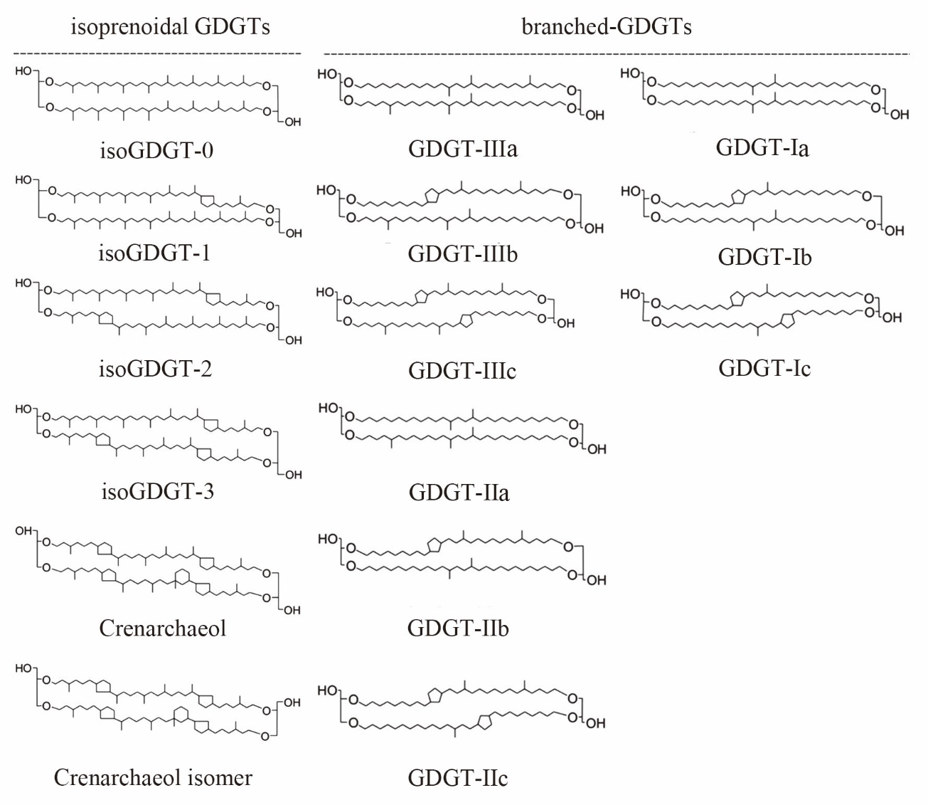

**Fig. S1** Molecular structures of studied compounds in this study

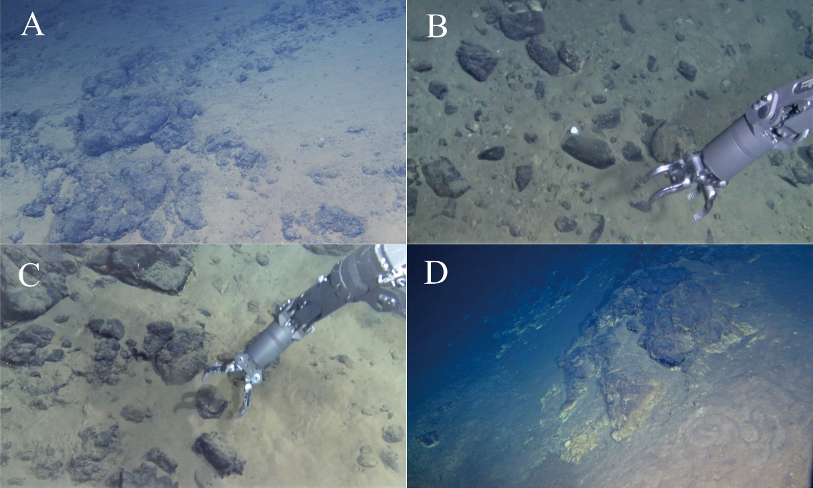

**Fig. S2** Seafloor photos taken by “Jiaolong” at the Mariana trench. A. Rock fragments and sediments observed at the southern wall during Dive 115; B. Rock fragments and sediments observed at the northern wall during Dive 118; C. Rock fragments and sediments observed at the southern wall during Dive 120; D. Gray-yellow high altered basement rock observed at the northern area during Dive 121.

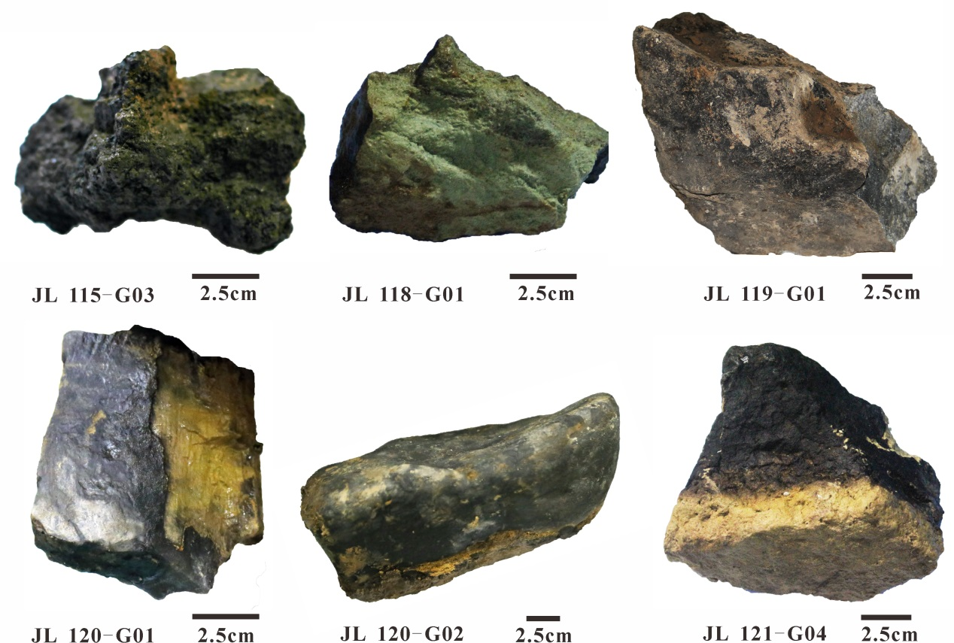

**Fig. S3** The photography of altered rocks from the Mariana trench

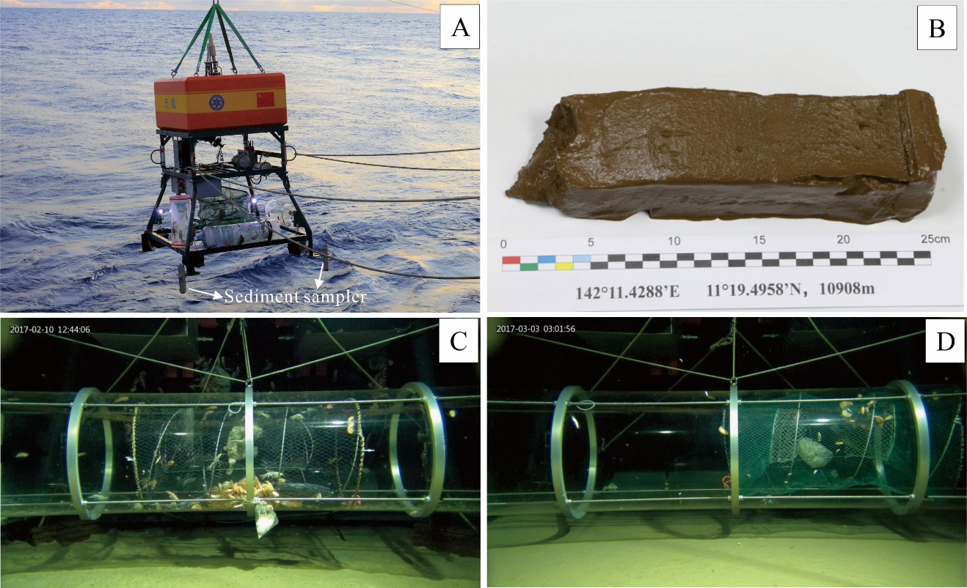

**Fig. S4** Images of "Tianya" Lander system and its application at the "Challenger Deep".(A)."Tianya" Lander system and its sediment sampler; (B). the short core from 10,908 m at the "Challenger Deep"; (C). The sediment interface and baited Hadal amphipods at 8,226 m water depth; (D). The sediment interface and baited Hadal amphipods at 10,908 m water depth.

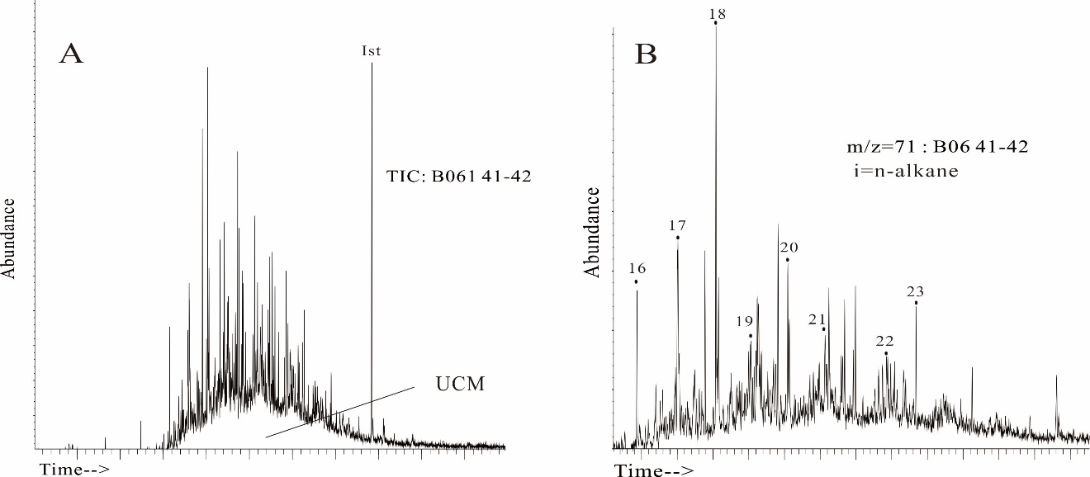

**Fig. S5** Unresolved Complex Mixture presented in most of the sediment sample from 7,000 m to 8,000 m. Examples of chromatogram of sample B06 41-42 were showed. (A) Total iron chromatography. (B) n-Alkane extracted by m/z=71.

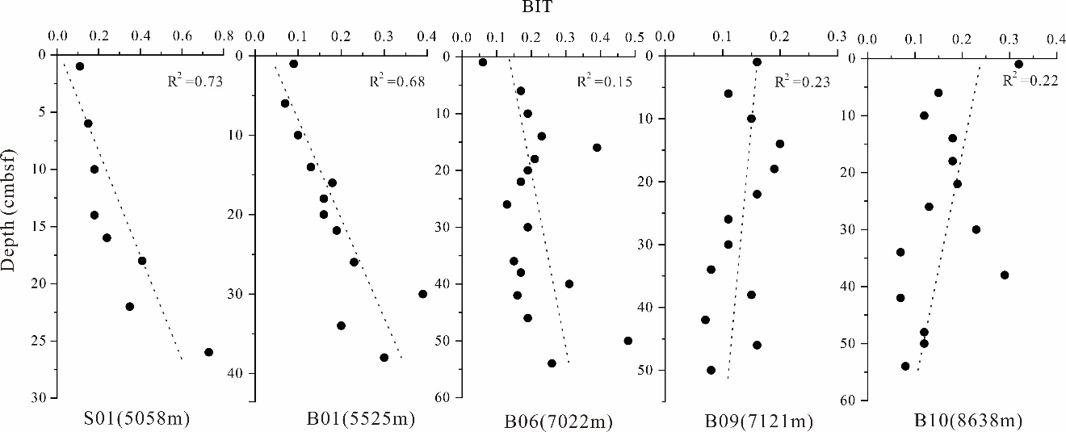

**Fig. S6** Distribution of BIT in sediment cores. (p<0.05)

**Table S1** The information of sample sites and sample methods

|  |  |  |  |  |  |  |  |
| --- | --- | --- | --- | --- | --- | --- | --- |
| Sample No | Longitude | Latitude | Water depth | Sample type | Sample methods | Voyage | Core length/ rock descriptions |
| S01 | 138°40.86'E | 9°39.67'N | 5058m | Sediment core | Multiple Cores sampler | DY-37 | 26cm |
| B01 | 141°58.50'E | 10°51.36'N | 5525m | Sediment core | Box sampler | TS-01 | 40cm |
| B06 | 142°18.25'E | 11°2.34'N | 7022m | Sediment core | Box sampler | TS-01 | 56cm |
| B09 | 141°59.65'E | 10°59.65'N | 7121m | Sediment core | Box sampler | TS-01 | 50cm |
| B10 | 141°48.70'E | 11°11.70'N | 8638m | Sediment core | Box sampler | TS-01 | 54cm |
| LR01 | 141°11.32'E | 11°19.50'N | 10908m | Sediment core | Tianya Lander | TS-03 | 23cm |
| JL118-G01 | 141° 52.93'E | 11° 34.85'N | 6697m | Rock | Jiaolong Dive | DY-37 | Grass green, highly altered basement rock. |
| JL119-G01 | 142° 14.97'E | 11° 39.83'N | 5997m | Rock | Jiaolong Dive | DY-37 | Gray-brown, lightly altered basalt |
| JL120-G01 | 142° 13.60'E | 10° 53.04'N | 6296m | Rock | Jiaolong Dive | DY-37 | Gray-brown, lightly altered basalt |
| JL120-G02 | 142° 13.58'E | 10° 53.04'N | 6296m | Rock | Jiaolong Dive | DY-37 | Gray-brown, lightly altered basalt |
| JL121-G04 | 142° 06.98'E | 11° 48.02'N | 5552 m | Rock | Jiaolong Dive | DY-37 | Gray-yellow, highly altered basalt rock with pelitic texture, and a thin layer of manganese oxide covered on its upper part |
| JL115-G03-1 | 141°57.73' E | 10°50.71'N | 5544 m | Rock | Jiaolong Dive | DY-37 | Dark-green, highly altered basement rock |
| JL115-G03-2 | 141°57.73' E | 10°50.71'N | 5544 m | Rock | Jiaolong Dive | DY-37 |

**Table S2** The organic geochemistry and GDGT concentration of the trench sediments and rocks from Mariana and Yap Trench

|  |  |  |  |  |  |  |  |  |  |  |  |  |  |  |  |  |  |  |  |  |  |  |
| --- | --- | --- | --- | --- | --- | --- | --- | --- | --- | --- | --- | --- | --- | --- | --- | --- | --- | --- | --- | --- | --- | --- |
| Sediment  Sample | **GDGT-la** | **GDGT-lb** | **GDGT-lc** | **GDGT-lla** | **GDGT-llb** | **GDGT-llc** | **GDGT-llla** | **GDGT-lllb** | **GDGT-lllc** | **BrGDGT** | **GDGT-0** | **Crenarchaeol** | **IsoGDGT** | **BIT** | **CBT** | **MBT** | **Br/ISO** | **III/II** | **TN** | **TOC %** | **δ13C** | **C/N** |
| ng/g dw | ng/g dw | ng/g dw | ng/g dw | ng/g dw | ng/g dw | ng/g dw | ng/g dw | ng/g dw | ng/g dw | ng/g dw | ng/g dw | ng/g dw |  |  |  |  |  | % | % | ‰ |  |
| B01 0-2cm | 0.28 | 0.028 | 0.019 | 0.297 | 0.072 | 0.023 | 1.405 | 0.025 | 0.015 | 2.164 | 9.852 | 20.256 | 37.323 | 0.09 | 0.76 | 0.15 | 0.058 | 4.73 | 0.062 | 0.274 | -19.45 | 5.11 |
| B01 5-6cm | 0.099 | 0.011 | 0.018 | 0.119 | 0.023 | 0.003 | 0.544 | 0.011 | 0.003 | 0.83 | 5.789 | 10.749 | 20.583 | 0.07 | 0.81 | 0.16 | 0.04 | 4.57 | 0.05 | 0.21 | -18.64 | 4.90 |
| B01 9-10cm | 0.113 | 0.013 | 0.008 | 0.101 | 0.002 | 0.002 | 0.452 | 0.005 | 0.002 | 0.697 | 3.038 | 6.239 | 12.177 | 0.1 | 1.17 | 0.19 | 0.057 | 4.48 | 0.06 | 0.227 | -19.41 | 4.41 |
| B01 13-14cm | 0.086 | 0.003 | 0.013 | 0.059 | 0.015 | 0.003 | 0.251 | 0.011 | 0.003 | 0.444 | 2.221 | 2.589 | 6.137 | 0.13 | 0.89 | 0.24 | 0.072 | 4.25 | 0.056 | 0.179 | -18.60 | 3.72 |
| B01 15-16cm | 0.056 | 0.008 | 0.011 | 0.03 | 0.002 | 0.003 | 0.13 | 0.006 | 0.002 | 0.247 | 1.256 | 0.991 | 2.63 | 0.18 | 0.93 | 0.31 | 0.094 | 4.33 | 0.052 | 0.19 | -18.21 | 4.22 |
| B01 17-18cm | 0.067 | 0.011 | 0.014 | 0.037 | 0.023 | 0.006 | 0.164 | 0.007 | 0.003 | 0.332 | 1.595 | 1.414 | 3.572 | 0.16 | 0.49 | 0.29 | 0.093 | 4.43 | 0.058 | 0.186 | -18.87 | 3.74 |
| B01 19-20cm | 0.038 | 0.006 | 0.002 | 0.021 | 0.009 | 0.002 | 0.096 | 0.003 | 0.001 | 0.178 | 0.716 | 0.789 | 1.824 | 0.16 | 0.59 | 0.26 | 0.098 | 4.57 | 0.05 | 0.15 | -18.57 | 3.50 |
| B01 21-22cm | 0.018 | 0.004 | 0 | 0.011 | 0.011 | 0.003 | 0.039 | 0.002 | 0.001 | 0.089 | 0.391 | 0.295 | 0.803 | 0.19 | 0.3 | 0.25 | 0.111 | 3.55 | 0.05 | 0.23 | -18.54 | 5.37 |
| B01 25-26cm | 0.011 | 0.002 | 0 | 0.005 | 0.006 | 0 | 0.025 | 0 | 0 | 0.049 | 0.264 | 0.14 | 0.469 | 0.23 | 0.33 | 0.27 | 0.104 | 5.00 | 0.053 | 0.164 | -18.68 | 3.60 |
| B01 29-30cm | 0.011 | 0.003 | 0 | 0.057 | 0.002 | 0 | 0.019 | 0 | 0 | 0.092 | 0.203 | 0.137 | 0.394 | 0.39 | 0.51 | 0.34 | 0.234 | 0.33 | 0.03 | 0.19 | -18.88 | 7.39 |
| B01 33-34cm | 0.049 | 0.007 | 0 | 0.03 | 0.015 | 0 | 0.128 | 0.005 | 0.002 | 0.236 | 1.1 | 0.856 | 2.303 | 0.2 | 0.57 | 0.24 | 0.102 | 4.27 | 0.039 | 0.121 | -19.49 | 3.61 |
| B01 37-38cm | 0.01 | 0 | 0 | 0.005 | 0.004 | 0 | 0.02 | 0 | 0 | 0.04 | 0.129 | 0.083 | 0.246 | 0.3 | 0.57 | 0.25 | 0.163 | 4.00 | 0.051 | 0.153 | -19.50 | 3.48 |
| B06 0-2cm | 0.889 | 0.11 | 0.054 | 0.86 | 0.065 | 0.017 | 5.39 | 0.042 | 0.029 | 7.457 | 87.091 | 111.054 | 246.963 | 0.06 | 1 | 0.14 | 0.03 | 6.27 | 0.07 | 0.4 | -19.82 | 6.67 |
| B06 5-6cm | 0.144 | 0.018 | 0.008 | 0.113 | 0.022 | 0.005 | 0.544 | 0.011 | 0.002 | 0.868 | 5.676 | 3.892 | 11.454 | 0.17 | 0.8 | 0.2 | 0.076 | 4.81 | 0.068 | 0.315 | -18.63 | 5.42 |
| B06 9-10cm | 0.094 | 0.012 | 0.007 | 0.066 | 0.017 | 0 | 0.229 | 0.007 | 0.003 | 0.435 | 3.101 | 1.615 | 5.404 | 0.19 | 0.74 | 0.27 | 0.08 | 3.47 | 0.071 | 0.283 | -18.24 | 4.64 |
| B06 13-14cm | 0.131 | 0.016 | 0.008 | 0.086 | 0.027 | 0.005 | 0.295 | 0.012 | 0.005 | 0.585 | 2.797 | 1.755 | 5.299 | 0.23 | 0.71 | 0.27 | 0.11 | 3.43 | 0.072 | 0.295 | -18.35 | 4.78 |
| B06 15-16cm | 0.051 | 0.003 | 0 | 0.042 | 0.004 | 0 | 0.091 | 0 | 0 | 0.191 | 0.602 | 0.292 | 1.028 | 0.39 | 1.13 | 0.29 | 0.186 | 2.17 | 0.057 | 0.219 | -19.23 | 4.46 |
| B06 17-18cm | 0.054 | 0.007 | 0.004 | 0.039 | 0.014 | 0.004 | 0.125 | 0.005 | 0.003 | 0.254 | 1.644 | 0.831 | 2.871 | 0.21 | 0.65 | 0.26 | 0.088 | 3.21 | 0.052 | 0.18 | -18.98 | 4.06 |
| B06 19-20cm | 0.101 | 0.023 | 0.009 | 0.063 | 0.072 | 0.023 | 0.221 | 0.019 | 0.009 | 0.539 | 3.18 | 1.653 | 5.573 | 0.19 | 0.24 | 0.26 | 0.097 | 3.51 | 0.036 | 0.149 | -17.27 | 4.80 |
| B06 21-22cm | 0.05 | 0.01 | 0.007 | 0.032 | 0.052 | 0.014 | 0.104 | 0.007 | 0.006 | 0.281 | 1.58 | 0.931 | 2.899 | 0.17 | 0.12 | 0.25 | 0.097 | 3.25 | 0.03 | 0.15 | -16.70 | 5.83 |
| B06 25-26cm | 0.186 | 0.025 | 0.011 | 0.108 | 0.059 | 0.014 | 0.417 | 0.015 | 0.011 | 0.847 | 7.576 | 4.98 | 14.696 | 0.13 | 0.54 | 0.27 | 0.058 | 3.86 | 0.065 | 0.326 | -18.07 | 5.88 |
| B06 29-30cm | 0.19 | 0.034 | 0.013 | 0.113 | 0.109 | 0.022 | 0.323 | 0.014 | 0.008 | 0.826 | 5.695 | 2.695 | 9.535 | 0.19 | 0.32 | 0.29 | 0.087 | 2.86 | 0.062 | 0.267 | -18.13 | 5.04 |
| B06 35-36cm | 0.105 | 0.016 | 0.009 | 0.056 | 0.066 | 0.015 | 0.15 | 0.008 | 0.006 | 0.431 | 3.514 | 1.763 | 5.99 | 0.15 | 0.29 | 0.31 | 0.072 | 2.68 | 0.057 | 0.234 | -17.92 | 4.76 |
| B06 37-38cm | 0.182 | 0.035 | 0.012 | 0.107 | 0.103 | 0.019 | 0.323 | 0.016 | 0.011 | 0.808 | 5.844 | 3.073 | 10.193 | 0.17 | 0.32 | 0.29 | 0.079 | 3.02 | 0.057 | 0.258 | -18.13 | 5.30 |
| B06 39-40cm | 0.102 | 0.017 | 0.009 | 0.09 | 0.045 | 0.008 | 0.162 | 0.01 | 0.005 | 0.448 | 1.901 | 0.79 | 3.045 | 0.31 | 0.5 | 0.3 | 0.147 | 1.80 | 0.04 | 0.16 | -18.21 | 4.67 |
| B06 41-42cm | 0.051 | 0.007 | 0.005 | 0.029 | 0.029 | 0.005 | 0.086 | 0.002 | 0.002 | 0.215 | 1.64 | 0.888 | 2.899 | 0.16 | 0.34 | 0.3 | 0.074 | 2.97 | 0.044 | 0.175 | -17.61 | 4.67 |
| B06 45-46cm | 0.106 | 0.023 | 0.015 | 0.064 | 0.093 | 0.022 | 0.182 | 0.008 | 0.013 | 0.525 | 2.652 | 1.478 | 4.731 | 0.19 | 0.17 | 0.29 | 0.111 | 2.84 | 0.064 | 0.279 | -18.24 | 5.12 |
| B06 49-50cm | 0.082 | 0.006 | 0.003 | 0.068 | 0.019 | 0.002 | 0.145 | 0 | 0 | 0.325 | 1.263 | 0.321 | 1.731 | 0.48 | 0.78 | 0.28 | 0.188 | 2.13 | 0.042 | 0.117 | -20.29 | 3.24 |
| B06 53-54cm | 0.006 | 0.002 | 0 | 0.003 | 0.001 | 0 | 0.009 | 0 | 0 | 0.021 | 0.078 | 0.053 | 0.157 | 0.26 | 0.54 | 0.36 | 0.134 | 3.00 | 0.046 | 0.118 | -21.72 | 3.00 |
| B09 0-2cm | 0.125 | 0.017 | 0.006 | 0.148 | 0.011 | 0 | 0.838 | 0.011 | 0 | 1.156 | 7.02 | 5.965 | 16.178 | 0.16 | 1 | 0.13 | 0.071 | 5.66 | 0.07 | 0.23 | -20.00 | 5.68 |
| B09 5-6cm | 0.237 | 0.032 | 0.014 | 0.258 | 0.018 | 0 | 1.483 | 0.018 | 0 | 2.059 | 14.062 | 16.17 | 37.131 | 0.11 | 1 | 0.14 | 0.055 | 5.75 | 0.049 | 0.235 | -19.97 | 5.57 |
| B09 9-10cm | 0.031 | 0.004 | 0 | 0.036 | 0.003 | 0 | 0.197 | 0.003 | 0 | 0.274 | 1.655 | 1.539 | 3.985 | 0.15 | 1.02 | 0.13 | 0.069 | 5.47 | 0.053 | 0.231 | -20.01 | 5.13 |
| B09 13-14cm | 0.194 | 0.026 | 0.014 | 0.172 | 0.016 | 0.002 | 1.045 | 0.017 | 0.004 | 1.491 | 5.789 | 5.505 | 13.82 | 0.2 | 0.94 | 0.16 | 0.108 | 6.08 | 0.056 | 0.235 | -19.80 | 4.87 |
| B09 17-18cm | 0.144 | 0.019 | 0.009 | 0.127 | 0.013 | 0 | 0.707 | 0.009 | 0 | 1.026 | 5.894 | 4.155 | 12.074 | 0.19 | 0.94 | 0.17 | 0.085 | 5.57 | 0.055 | 0.229 | -20.06 | 4.85 |
| B09 21-22cm | 0.341 | 0.041 | 0.02 | 0.213 | 0.041 | 0.012 | 1.082 | 0.025 | 0 | 1.776 | 12.654 | 8.388 | 24.796 | 0.16 | 0.83 | 0.23 | 0.072 | 5.08 | 0.064 | 0.224 | -20.45 | 4.09 |
| B09 25-26cm | 0.004 | 0.002 | 0 | 0.002 | 0.001 | 0 | 0.01 | 0.001 | 0 | 0.018 | 0.314 | 0.125 | 0.505 | 0.11 | 0.23 | 0.29 | 0.036 | 5.00 | 0.047 | 0.177 | -17.76 | 4.42 |
| B09 29-30cm | 0.036 | 0.005 | 0 | 0.024 | 0.028 | 0.006 | 0.083 | 0.004 | 0 | 0.186 | 2.051 | 1.163 | 3.806 | 0.11 | 0.26 | 0.23 | 0.049 | 3.46 | 0.046 | 0.178 | -18.03 | 4.53 |
| B09 33-34cm | 0.009 | 0.001 | 0 | 0.004 | 0.007 | 0 | 0.018 | 0.002 | 0 | 0.041 | 0.894 | 0.347 | 1.428 | 0.08 | 0.21 | 0.26 | 0.029 | 4.50 | 0.056 | 0.211 | -18.14 | 4.39 |
| B09 37-38cm | 0.088 | 0.009 | 0.008 | 0.059 | 0.05 | 0.016 | 0.122 | 0.01 | 0.007 | 0.369 | 2.504 | 1.523 | 4.646 | 0.15 | 0.4 | 0.3 | 0.079 | 2.07 | 0.043 | 0.161 | -17.25 | 4.41 |
| B09 41-42cm | 0.148 | 0.016 | 0.012 | 0.097 | 0.014 | 0 | 0.423 | 0 | 0 | 0.709 | 16.326 | 9.495 | 29.835 | 0.07 | 0.92 | 0.25 | 0.024 | 4.36 | 0.052 | 0.227 | -17.77 | 5.12 |
| B09 45-46cm | 0.159 | 0.017 | 0.009 | 0.116 | 0.081 | 0.025 | 0.194 | 0.02 | 0.013 | 0.634 | 4.362 | 2.418 | 7.81 | 0.16 | 0.45 | 0.31 | 0.081 | 1.67 | 0.051 | 0.223 | -17.62 | 5.06 |
| B09 49-50cm | 0.006 | 0.002 | 0.001 | 0.003 | 0.008 | 0 | 0.013 | 0 | 0 | 0.033 | 0.626 | 0.255 | 1.005 | 0.08 | -0.03 | 0.28 | 0.033 | 4.33 | 0.037 | 0.149 | -17.07 | 4.75 |
| B10 0-2cm | 0.222 | 0.032 | 0.012 | 0.168 | 0.009 | 0 | 0.771 | 0.003 | 0 | 1.217 | 7.964 | 6.695 | 17.427 | 0.32 | 0.11 | 0.22 | 0.07 | 4.59 | 0.053 | 0.243 | -20.15 | 7.39 |
| B10 5-6cm | 0.169 | 0.026 | 0.008 | 0.119 | 0.007 | 0 | 0.547 | 0 | 0 | 0.876 | 5.328 | 4.88 | 12.295 | 0.15 | 0.11 | 0.23 | 0.071 | 4.60 | 0.056 | 0.269 | -20.34 | 5.65 |
| B10 9-10cm | 0.722 | 0.097 | 0.04 | 0.469 | 0.021 | 0 | 2.216 | 0 | 0 | 3.565 | 27.651 | 25.286 | 63.225 | 0.12 | 0.1 | 0.24 | 0.056 | 4.72 | 0.053 | 0.261 | -20.16 | 5.74 |
| B10 13-14cm | 0.407 | 0.05 | 0.016 | 0.3 | 0.013 | 0 | 1.417 | 0 | 0 | 2.202 | 13.552 | 9.866 | 27.638 | 0.18 | 0.09 | 0.21 | 0.08 | 4.72 | 0.051 | 0.25 | -20.35 | 5.66 |
| B10 17-18cm | 0.348 | 0.036 | 0.014 | 0.223 | 0.012 | 0 | 1.139 | 0 | 0 | 1.773 | 12.254 | 7.641 | 23.039 | 0.18 | 0.09 | 0.22 | 0.077 | 5.11 | 0.058 | 0.252 | -20.13 | 5.12 |
| B10 21-22cm | 0.25 | 0.019 | 0.007 | 0.204 | 0.013 | 0 | 1.042 | 0 | 0 | 1.535 | 11.282 | 6.526 | 20.552 | 0.19 | 0.07 | 0.18 | 0.075 | 5.11 | 0.057 | 0.25 | -19.76 | 5.16 |
| B10 25-26cm | 0.273 | 0.029 | 0.014 | 0.193 | 0.015 | 0 | 0.823 | 0 | 0 | 1.347 | 11.049 | 8.885 | 23.419 | 0.13 | 0.09 | 0.23 | 0.058 | 4.26 | 0.057 | 0.262 | -19.56 | 5.35 |
| B10 29-30cm | 0.085 | 0.007 | 0.002 | 0.068 | 0.005 | 0 | 0.127 | 0 | 0 | 0.294 | 1.419 | 0.92 | 2.725 | 0.23 | 0.08 | 0.32 | 0.108 | 1.87 | 0.063 | 0.275 | -18.65 | 5.08 |
| B10 33-34cm | 0.27 | 0.041 | 0.014 | 0.193 | 0.06 | 0 | 0.939 | 0 | 0 | 1.519 | 25.531 | 18.19 | 50.673 | 0.07 | 0.22 | 0.21 | 0.03 | 4.87 | 0.056 | 0.275 | -18.63 | 5.73 |
| B10 37-38cm | 0.582 | 0.028 | 0.015 | 0.268 | 0.015 | 0.007 | 0.18 | 0 | 0 | 1.096 | 4.386 | 2.564 | 8.135 | 0.29 | 0.05 | 0.57 | 0.135 | 0.67 | 0.054 | 0.243 | -18.23 | 5.26 |
| B10 41-42cm | 0.148 | 0.016 | 0.012 | 0.097 | 0.014 | 0 | 0.423 | 0 | 0 | 0.709 | 16.326 | 9.495 | 29.835 | 0.07 | 0.12 | 0.25 | 0.024 | 4.36 | 0.054 | 0.21 | -18.36 | 4.57 |
| B10 47-48cm | 0.055 | 0.006 | 0 | 0.039 | 0.004 | 0 | 0.099 | 0 | 0 | 0.202 | 2.478 | 1.351 | 4.385 | 0.12 | 0.1 | 0.3 | 0.046 | 2.54 | 0.042 | 0.172 | -18.58 | 4.78 |
| B10 49-50cm | 0.13 | 0.025 | 0.009 | 0.107 | 0.038 | 0.008 | 0.276 | 0 | 0 | 0.593 | 7.651 | 3.762 | 12.884 | 0.12 | 0.27 | 0.28 | 0.046 | 2.58 | 0.047 | 0.192 | -18.52 | 6.13 |
| B10 53-54cm | 0.137 | 0.011 | 0.005 | 0.073 | 0.022 | 0.005 | 0.359 | 0 | 0.004 | 0.616 | 11.246 | 6.778 | 20.563 | 0.08 | 0.16 | 0.25 | 0.03 | 4.92 | 0.056 | 0.263 | -18.14 | 5.45 |
| LR 0-2cm | 0.121 | 0 | 0 | 0.09 | 0 | 0 | 0.598 | 0 | 0 | 0.809 | 16.075 | 15.413 | 40.374 | 0.05 | 0 | 0.15 | 0.02 | 6.64 | 0.059 | 0.415 | -18.66 | 8.21 |
| LR 9-10cm | 0.545 | 0.084 | 0.051 | 0.541 | 0.072 | 0 | 3.057 | 0.041 | 0 | 4.391 | 72.348 | 103.379 | 224.891 | 0.04 | 0.143 | 0.16 | 0.02 | 5.65 | 0.059 | 0.395 | -18.93 | 7.80 |
| LR 19-20cm | 0.732 | 0.113 | 0.128 | 0.695 | 0.103 | 0 | 3.777 | 0 | 0 | 5.548 | 115.038 | 169.945 | 363.848 | 0.03 | 0.15 | 0.18 | 0.015 | 5.43 | 0.056 | 0.384 | -18.68 | 7.96 |
| S01 0-2cm | 0.057 | 0.007 | 0 | 0.036 | 0.003 | 0 | 0.163 | 0.004 | 0 | 0.27 | 1.452 | 2.058 | 4.377 | 0.11 | 0.104 | 0.242 | 0.062 | 4.53 | 0.08 | 0.381 | -19.76 | 5.53 |
| S01 5-6cm | 0.035 | 0.004 | 0.002 | 0.021 | 0.003 | 0 | 0.079 | 0.003 | 0 | 0.147 | 0.678 | 0.782 | 1.834 | 0.15 | 0.118 | 0.286 | 0.08 | 3.76 | 0.081 | 0.347 | -20.03 | 5.03 |
| S01 9-10cm | 0.101 | 0.014 | 0.005 | 0.051 | 0.008 | 0.002 | 0.213 | 0.007 | 0 | 0.4 | 1.207 | 1.658 | 3.6 | 0.18 | 0.147 | 0.305 | 0.111 | 4.18 | 0.065 | 0.244 | -19.80 | 4.38 |
| S01 13-14cm | 0.018 | 0.001 | 0 | 0.01 | 0.002 | 0 | 0.035 | 0.002 | 0 | 0.067 | 0.257 | 0.292 | 0.699 | 0.18 | 0.102 | 0.287 | 0.096 | 3.50 | 0.06 | 0.18 | -20.32 | 4.67 |
| S01 15-16cm | 0.027 | 0.004 | 0.002 | 0.012 | 0.003 | 0 | 0.036 | 0.002 | 0 | 0.086 | 0.202 | 0.244 | 0.562 | 0.24 | 0.2 | 0.391 | 0.154 | 3.00 | 0.068 | 0.183 | -20.49 | 4.08 |
| S01 17-18cm | 0.021 | 0.003 | 0 | 0.012 | 0.003 | 0 | 0.019 | 0.002 | 0 | 0.061 | 0.071 | 0.074 | 0.179 | 0.41 | 0.202 | 0.405 | 0.341 | 1.58 | 0.059 | 0.167 | -20.47 | 3.30 |
| S01 21-22cm | 0.021 | 0.005 | 0.002 | 0.009 | 0.004 | 0 | 0.015 | 0.002 | 0 | 0.058 | 0.077 | 0.082 | 0.198 | 0.35 | 0.304 | 0.499 | 0.291 | 1.67 | 0.062 | 0.166 | -20.52 | 3.13 |
| S01 25-26cm | 0.056 | 0.011 | 0.004 | 0.026 | 0.012 | 0.001 | 0.035 | 0.005 | 0.001 | 0.151 | 0.106 | 0.043 | 0.172 | 0.73 | 0.277 | 0.488 | 0.879 | 1.35 | 0.058 | 0.16 | -20.68 | 3.21 |
| Mean | 0.155 | 0.020 | 0.011 | 0.119 | 0.026 | 0.005 | 0.547 | 0.007 | 0.003 | 0.892 | 8.988 | 9.649 | 22.947 | 0.18 | 0.428 | 0.262 | 0.100 | 3.87 | 0.055 | 0.229 | -19.02 | 4.96 |
| Rock  samples |  |  |  |  |  |  |  |  |  |  |  |  |  |  |  |  |  |  |  |  |  |  |
| JL118-G01 | 0.037 | 0.002 | 0 | 0.057 | 0.008 | 0.001 | 0.261 | 0.01 | 0 | 0.375 | 1.447 | 0.655 | 2.22 | 0.35 | 0.997 | 0.104 | 0.169 | 4.58 | n.a. | n.a. | n.a. | n.a. |
| JL119-G01 | 0.067 | 0.005 | 0.003 | 0.055 | 0.028 | 0.009 | 0.22 | 0.013 | 0.005 | 0.405 | 2.525 | 1.574 | 4.508 | 0.18 | 0.572 | 0.186 | 0.09 | 4.00 | n.a. | n.a. | n.a. | n.a. |
| JL120-G01 | 0.007 | 0.001 | 0 | 0.006 | 0.002 | 0.001 | 0.016 | 0 | 0 | 0.033 | 0.146 | 0.089 | 0.255 | 0.24 | 0.527 | 0.246 | 0.129 | 2.67 | n.a. | n.a. | n.a. | n.a. |
| JL120-G02 | 0.005 | 0 | 0 | 0.004 | 0.001 | 0 | 0.008 | 0 | 0 | 0.018 | 0.57 | 0.092 | 0.683 | 0.16 | 1.029 | 0.294 | 0.026 | 2.00 | n.a. | n.a. | n.a. | n.a. |
| JL121-G04 | 0.005 | 0.001 | 0 | 0.005 | 0.002 | 0.001 | 0.015 | 0.001 | 0 | 0.028 | 0.162 | 0.086 | 0.27 | 0.22 | 0.511 | 0.208 | 0.105 | 3.00 | n.a. | n.a. | n.a. | n.a. |
| JL115-G03-01 | 0.017 | 0 | 0 | 0.014 | 0 | 0 | 0.053 | 0.009 | 0 | 0.093 | 0.103 | 0.009 | 0.248 | 0.9 | 0 | 0.178 | 0.375 | 3.79 | n.a. | n.a. | n.a. | n.a. |
| JL115-G03-02 | 0.006 | 0 | 0 | 0.009 | 0 | 0 | 0.022 | 0 | 0 | 0.038 | 0.089 | 0.028 | 0.122 | 0.57 | 0 | 0.157 | 0.311 | 2.44 | n.a. | n.a. | n.a. | n.a. |
| Mean | 0.021 | 0.001 | 0.000 | 0.021 | 0.006 | 0.002 | 0.085 | 0.005 | 0.001 | 0.141 | 0.720 | 0.362 | 1.187 | 0.37 | 0.519 | 0.196 | 0.172 | 3.21 | n.a. | n.a. | n.a. | n.a. |

The concentration of GDGTs is normalized to dry weight of sediment. "n.a." means not analyzed. “Br/ISO”means the abundance ratio of BrGDGT to IsoGDGT, “III/II” means the abundance ratio of hexamethylated to pentamethylated BrGDGT.

**Table S3** The concentration of n-alkanes of the trench sediments from Mariana and Yap Trench

|  |  |  |  |  |  |  |  |  |  |  |  |  |  |  |  |  |
| --- | --- | --- | --- | --- | --- | --- | --- | --- | --- | --- | --- | --- | --- | --- | --- | --- |
| Sediment sample | C16 | C17 | C18 | C19 | C20 | C21 | C22 | C23 | C24 | C25 | C26 | C27 | C28 | C29 | ACL | CPI 15-25 |
| ng/g dw | ng/g dw | ng/g dw | ng/g dw | ng/g dw | ng/g dw | ng/g dw | ng/g dw | ng/g dw | ng/g dw | ng/g dw | ng/g dw | ng/g dw | ng/g dw |
| S01 0-2cm | n.a. | n.a. | n.a. | n.a. | n.a. | n.a. | n.a. | n.a. | n.a. | n.a. | n.a. | n.a. | n.a. | n.a. | n.a. | n.a. |
| S01 5-6cm | 14.54 | 13.74 | 8.01 | 4.83 | 13.81 | 7.89 | n.a. | n.a. | n.a. | n.a. | n.a. | n.a. | n.a. | n.a. | 18.21 | 0.73 |
| S01 9-10cm | 3.52 | 3.26 | 5.65 | 9.39 | 2.17 | 7.53 | n.a. | n.a. | n.a. | n.a. | n.a. | n.a. | n.a. | n.a. | 18.83 | 1.78 |
| S01 13-14cm | 10.72 | 6.89 | 17.38 | 8.31 | 27.53 | 128.63 | 346.14 | 350.23 | 43.66 | 43.88 | n.a. | n.a. | n.a. | n.a. | 22.20 | 1.16 |
| S01 15-16cm | n.a. | n.a. | 3.78 | 3.88 | 8.84 | 22.64 | 27.44 | 16.80 | 7.16 | n.a. | n.a. | n.a. | n.a. | n.a. | 21.60 | 0.92 |
| S01 17-18cm | n.a. | n.a. | n.a. | n.a. | n.a. | n.a. | n.a. | n.a. | n.a. | n.a. | n.a. | n.a. | n.a. | n.a. | n.a. | n.a. |
| S01 21-22cm | n.a. | n.a. | 2.44 | 1.39 | 4.08 | 14.05 | 26.21 | 21.79 | 11.00 | n.a. | n.a. | 4.87 | 6.49 | n.a. | 22.77 | 0.85 |
| S01 25-26cm | n.a. | n.a. | 54.59 | 56.55 | 102.13 | 565.06 | 2098.86 | 2162.58 | 732.07 | 138.70 | 48.09 | n.a. | n.a. | n.a. | 22.52 | 0.96 |
| B01 0-2cm | n.a. | n.a. | n.a. | n.a. | 0.10 | 0.65 | 1.37 | 1.07 | 0.44 | 0.17 | 0.02 | 0.03 | n.a. | n.a. | 22.48 | 0.94 |
| B01 9-10cm | n.a. | n.a. | n.a. | 3.62 | 16.03 | 68.03 | 105.67 | 56.69 | 18.88 | 6.26 | 3.24 | 3.09 | 1.46 | n.a. | 22.14 | 0.94 |
| B01 13-14cm | n.a. | n.a. | n.a. | 0.80 | 9.56 | 81.14 | 334.67 | 310.06 | 92.27 | 18.66 | 4.91 | 3.62 | n.a. | 2.79 | 22.57 | 0.92 |
| B01 15-16cm | n.a. | n.a. | n.a. | 0.88 | 9.37 | 16.47 | 36.81 | 24.37 | 7.56 | 2.99 | n.a. | n.a. | n.a. | n.a. | 22.11 | 0.80 |
| B01 17-18cm | n.a. | n.a. | n.a. | n.a. | 9.19 | 67.63 | 161.44 | 105.60 | 32.18 | 7.61 | n.a. | n.a. | n.a. | n.a. | 22.28 | 0.87 |
| B01 19-20cm | n.a. | n.a. | n.a. | n.a. | 2.34 | 9.83 | 14.86 | 11.82 | 4.17 | 1.50 | n.a. | n.a. | n.a. | n.a. | 22.23 | 1.05 |
| B01 21-22cm | n.a. | n.a. | n.a. | n.a. | 2.32 | 21.04 | 68.77 | 63.66 | 29.65 | 10.30 | n.a. | n.a. | n.a. | n.a. | 22.65 | 0.89 |
| B01 25-26cm | n.a. | n.a. | n.a. | n.a. | 10.72 | 37.02 | 57.71 | 37.16 | 13.49 | 3.23 | n.a. | n.a. | n.a. | n.a. | 22.10 | 0.93 |
| B01 29-30cm | n.a. | n.a. | n.a. | n.a. | 32.64 | 149.53 | 273.39 | 177.76 | 60.12 | 15.41 | n.a. | n.a. | n.a. | n.a. | 22.18 | 0.91 |
| B01 33-34cm | n.a. | n.a. | n.a. | n.a. | 7.77 | 21.42 | 35.07 | 24.23 | 10.22 | 4.29 | n.a. | n.a. | n.a. | n.a. | 22.20 | 0.90 |
| B01 37-38cm | n.a. | n.a. | n.a. | n.a. | 14.92 | 52.85 | 110.50 | 114.52 | 64.01 | 26.87 | n.a. | n.a. | n.a. | n.a. | 22.63 | 0.95 |
| B06 0-2cm | 7.58 | 15.09 | 8.71 | 3.79 | 4.10 | 2.74 | 1.88 | 1.45 | n.a. | n.a. | n.a. | n.a. | n.a. | n.a. | 18.11 | 1.04 |
| B06 5-6cm | 12.03 | 10.48 | 95.94 | 30.92 | 20.58 | 13.94 | 15.02 | 8.99 | 3.44 | 2.70 | n.a. | n.a. | n.a. | n.a. | 19.05 | 0.45 |
| B06 9-10cm | 4.29 | 4.22 | 20.52 | 8.67 | 3.72 | 2.03 | n.a. | n.a. | n.a. | n.a. | n.a. | n.a. | n.a. | n.a. | 18.22 | 0.52 |
| B06 13-14cm | n.a. | n.a. | n.a. | n.a. | n.a. | n.a. | n.a. | n.a. | n.a. | n.a. | n.a. | n.a. | n.a. | n.a. | n.a. | n.a. |
| B06 15-16cm | 1.84 | 5.19 | 13.94 | 2.41 | 3.53 | 2.60 | n.a. | n.a. | n.a. | n.a. | n.a. | n.a. | n.a. | n.a. | 18.28 | 0.53 |
| B06 17-18cm | n.a. | 16.41 | 3.91 | 4.39 | 13.04 | 72.17 | 244.82 | 306.53 | 154.98 | 37.82 | 8.68 | n.a. | n.a. | n.a. | 22.64 | 1.00 |
| B06 19-20cm | 65.86 | 189.41 | 284.67 | 99.62 | 40.93 | 35.15 | 21.24 | 17.07 | n.a. | n.a. | n.a. | n.a. | n.a. | n.a. | 36.36 | 0.83 |
| B06 21-22cm | n.a. | n.a. | 2.84 | 1.75 | 4.90 | 1.94 | n.a. | n.a. | n.a. | n.a. | n.a. | n.a. | n.a. | n.a. | 19.52 | 0.48 |
| B06 25-26cm | n.a. | 9.61 | 31.76 | 6.85 | 11.98 | 3.76 | n.a. | n.a. | n.a. | n.a. | n.a. | n.a. | n.a. | n.a. | 18.51 | 0.46 |
| B06 29-30cm | n.a. | 1.98 | 15.86 | 4.11 | 8.27 | 3.03 | n.a. | n.a. | n.a. | n.a. | n.a. | n.a. | n.a. | n.a. | 18.83 | 0.38 |
| B06 35-36cm | n.a. | 10.43 | 12.38 | 9.60 | 6.03 | 3.31 | n.a. | n.a. | n.a. | n.a. | n.a. | n.a. | n.a. | n.a. | 18.51 | 1.27 |
| B06 37-38cm | n.a. | n.a. | 2.17 | n.a. | 13.65 | 39.47 | n.a. | n.a. | n.a. | n.a. | n.a. | n.a. | n.a. | n.a. | 20.64 | 2.49 |
| B06 39-40cm | 2.32 | 2.57 | 31.25 | 0.92 | 0.61 | 1.08 | n.a. | n.a. | n.a. | n.a. | n.a. | n.a. | n.a. | n.a. | 17.95 | 0.13 |
| B06 41-42cm | 10.31 | 23.07 | 30.53 | 8.17 | 18.28 | 15.30 | 7.91 | 10.56 | 4.25 | 6.17 | 2.37 | 3.26 | 3.70 | n.a. | 19.98 | 0.84 |
| B06 45-46cm | 7.09 | 5.79 | 15.21 | 5.86 | 2.50 | 1.87 | 0.70 | 1.06 | n.a. | n.a. | n.a. | n.a. | n.a. | n.a. | 18.11 | 0.57 |
| B06 49-50cm | 4.76 | 12.88 | 5.78 | 11.45 | 9.11 | 8.07 | 8.07 | 4.27 | n.a. | n.a. | n.a. | n.a. | n.a. | n.a. | 19.32 | 1.32 |
| B06 53-54cm | n.a. | 4.17 | 5.78 | 4.16 | 3.68 | 2.26 | 1.61 | 1.47 | n.a. | n.a. | n.a. | n.a. | n.a. | n.a. | 19.21 | 1.09 |
| B09 0-2cm | 7.98 | 5.60 | 17.35 | 11.94 | 10.44 | 14.41 | 5.54 | 8.18 | n.a. | 3.71 | n.a. | 2.97 | n.a. | n.a. | 19.93 | 1.02 |
| B09 5-6cm | 5.94 | 37.29 | 19.61 | 9.78 | 9.94 | 15.89 | 9.93 | 5.74 | 2.45 | 1.89 | n.a. | n.a. | n.a. | n.a. | 19.05 | 1.46 |
| B09 9-10cm | 6.39 | 9.37 | 14.58 | 9.35 | 6.60 | 5.94 | 7.49 | 4.93 | 4.34 | 2.50 | n.a. | 3.23 | n.a. | n.a. | 19.95 | 0.78 |
| B09 13-14cm | n.a. | n.a. | n.a. | n.a. | n.a. | n.a. | n.a. | n.a. | n.a. | n.a. | n.a. | n.a. | n.a. | n.a. | n.a. | n.a. |
| B09 17-18cm | 5.78 | 8.13 | 4.78 | 7.36 | n.a. | 8.19 | 1.43 | n.a. | n.a. | n.a. | n.a. | n.a. | n.a. | n.a. | 18.50 | 1.97 |
| B09 21-22cm | 14.19 | n.a. | n.a. | n.a. | n.a. | n.a. | n.a. | n.a. | n.a. | n.a. | n.a. | n.a. | n.a. | n.a. | 16.00 | n.a. |
| B09 25-26cm | 7.08 | 7.93 | 11.27 | 4.26 | 4.54 | 11.72 | 30.95 | 43.75 | 38.40 | 21.41 | 16.88 | 14.50 | 10.93 | 8.20 | 20.80 | 0.85 |
| B09 29-30cm | n.a. | 18.78 | 21.45 | 19.55 | 14.33 | 18.38 | 13.21 | 9.94 | 3.49 | 4.96 | n.a. | n.a. | n.a. | n.a. | 19.96 | 1.32 |
| B09 33-34cm | 22.30 | 87.31 | 121.05 | 40.41 | 57.50 | 86.35 | 103.40 | n.a. | n.a. | n.a. | n.a. | n.a. | n.a. | n.a. | 19.34 | 0.70 |
| B09 37-38cm | n.a. | n.a. | 19.40 | 25.60 | 32.32 | 30.90 | 17.46 | 45.21 | 22.31 | 10.30 | 7.60 | 8.93 | 3.58 | n.a. | 21.85 | 1.17 |
| B09 41-42cm | n.a. | 8.74 | 6.89 | 5.90 | 3.99 | n.a. | 16.20 | 9.39 | n.a. | 4.09 | n.a. | 3.79 | n.a. | n.a. | 21.04 | 0.96 |
| B09 45-46cm | n.a. | n.a. | 7.52 | 9.53 | 6.95 | 4.68 | n.a. | n.a. | n.a. | n.a. | n.a. | n.a. | n.a. | n.a. | 19.31 | 0.98 |
| B09 49-50cm | n.a. | n.a. | n.a. | n.a. | n.a. | n.a. | n.a. | n.a. | n.a. | n.a. | n.a. | n.a. | n.a. | n.a. | n.a. | n.a. |
| B10 0-2cm | 2080.86 | 1830.88 | 2983.73 | 32.86 | n.a. | n.a. | 15.09 | 4.40 | n.a. | n.a. | n.a. | n.a. | n.a. | n.a. | 17.15 | 0.37 |
| B10 5-6cm | 385.39 | 124.03 | 271.58 | 11.25 | 29.64 | 19.58 | 1.14 | 0.99 | n.a. | n.a. | n.a. | n.a. | n.a. | n.a. | 17.05 | 0.24 |
| B10 9-10cm | 12.83 | 11.05 | 18.40 | 7.67 | 10.93 | 4.33 | n.a. | n.a. | n.a. | n.a. | n.a. | n.a. | n.a. | n.a. | 18.09 | 0.55 |
| B10 13-14cm | 786.31 | 524.03 | 1058.50 | 259.48 | n.a. | 21.44 | n.a. | 16.60 | n.a. | 8.50 | 2.51 | n.a. | n.a. | n.a. | 17.40 | 0.45 |
| B10 17-18cm | 1.77 | 6.74 | 22.25 | 3.62 | 9.30 | 11.39 | 3.90 | 3.07 | 0.99 | n.a. | n.a. | n.a. | n.a. | n.a. | 19.32 | 0.65 |
| B10 21-22cm | n.a. | 0.49 | 0.67 | 7.36 | 0.99 | 5.21 | 1.24 | 0.68 | 0.81 | 0.73 | 1.97 | n.a. | n.a. | n.a. | 20.91 | 3.82 |
| B10 25-26cm | 6.85 | 23.00 | 9.70 | 5.25 | 1.50 | n.a. | n.a. | n.a. | n.a. | n.a. | n.a. | n.a. | n.a. | n.a. | 17.39 | 1.57 |
| B10 29-30cm | 2.17 | 9.34 | 4.79 | 5.98 | 2.18 | 1.92 | 1.37 | 0.80 | 0.78 | 0.47 | 1.73 | n.a. | n.a. | n.a. | 19.07 | 1.62 |
| B10 33-34cm | 8.07 | 33.07 | 31.88 | 18.65 | 15.06 | n.a. | n.a. | n.a. | n.a. | n.a. | n.a. | n.a. | n.a. | n.a. | 18.00 | 0.94 |
| B10 37-38cm | 2.39 | 20.53 | 10.22 | 11.79 | 5.43 | 16.70 | n.a. | n.a. | n.a. | n.a. | n.a. | n.a. | n.a. | n.a. | 18.71 | 2.72 |
| B10 41-42cm | 13.73 | 24.64 | 26.47 | 22.75 | 14.38 | 18.91 | 14.47 | 7.54 | n.a. | n.a. | n.a. | n.a. | n.a. | n.a. | 19.06 | 1.07 |
| B10 47-48cm | 142.79 | 195.77 | 325.03 | 95.97 | 288.99 | 34.69 | 40.59 | 35.10 | n.a. | n.a. | n.a. | n.a. | n.a. | n.a. | 18.50 | 0.46 |
| B10 49-50cm | 4829.36 | 3145.99 | 3614.90 | 348.60 | n.a. | n.a. | n.a. | n.a. | n.a. | n.a. | n.a. | n.a. | n.a. | n.a. | 16.96 | 0.41 |
| B10 53-54cm | 0.15 | 3.57 | 3.43 | 8.36 | 4.37 | 8.17 | n.a. | n.a. | n.a. | n.a. | n.a. | n.a. | n.a. | n.a. | 19.35 | 2.53 |
| LR 0-2cm | 22.84 | 23.48 | 18.51 | 11.02 | 15.16 | 13.00 | 11.79 | 12.61 | 7.46 | 8.50 | 5.82 | 11.63 | n.a. | n.a. | 20.33 | 0.85 |
| LR 9-10cm | 12.08 | 23.24 | 19.67 | 11.44 | 14.23 | 14.00 | 16.38 | 19.69 | 13.59 | 17.99 | 12.74 | 20.49 | n.a. | n.a. | 21.54 | 1.02 |
| LR 19-20cm | 23.09 | 33.45 | 44.60 | 21.75 | 22.85 | 14.39 | 90.98 | 9.43 | 15.95 | 16.22 | 11.72 | 15.14 | n.a. | n.a. | 20.76 | 0.44 |

The concentrations of n-alkanes are normalized to dry weight of sediment. "n.a." means not analyzed.

**Table S4** XRD analytical results of the selected trench sediment and altered rock samples

|  |  |  |  |  |  |  |  |  |  |  |  |
| --- | --- | --- | --- | --- | --- | --- | --- | --- | --- | --- | --- |
| Sediment sample | Quartz | Feldspar | Illite | Montmorillonite | Chlorite | Hornblende | Zeolite | Halite | Daubreelite | Sepiolite | Talc |
| B01 0-2 | + | + |  | + | + | + | + | + |  |  |  |
| B01 29-30 | + | + | + | + | + |  | + | + |  |  |  |
| B06 21-22 | + | + | + | + | + |  | + | + |  |  |  |
| B06 25-26 | + | + | + | + | + | + | + | + |  |  |  |
| B06 39-40 | + | + | + | + | + |  | + | + |  |  |  |
| B06 49-50 | + | + | + | + | + | + | + | + |  |  |  |
| B09 37-38 | + | + | + | + | + |  |  | + |  |  |  |
| S01 5-6 | + | + |  | + | + | + | + | + |  |  |  |
| S01 17-18 | + | + | + | + | + | + | + | + |  |  |  |
| Rock sample |  |  |  |  |  |  |  |  |  |  |  |
| JL118-G01 | + |  |  |  |  |  | + | + |  |  |  |
| JL119-G01 | + | + |  |  |  |  | + | + |  | + |  |
| JL120-G01 |  |  |  |  |  |  | + |  |  | + |  |
| JL120-G02 |  |  |  |  |  |  | + |  | + | + | + |
| JL121-G04 | + | + |  |  | + |  | + |  |  |  |  |

"+" means it is detected in this study.