**Supplementary Figure:**

**Figure S1.** Rarefaction curve showing the sequence depth and observed OTUs.

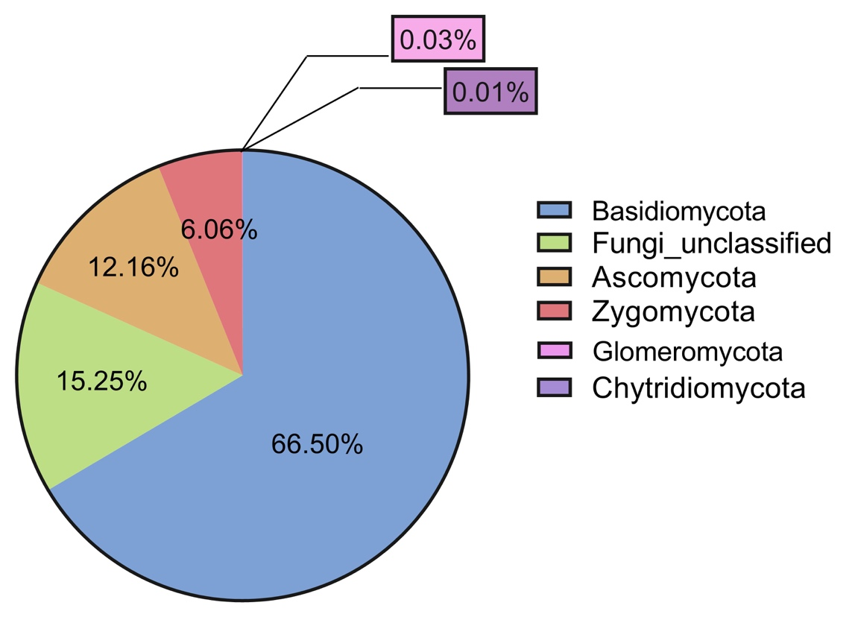

**Figure S2.** Pie chart showing the overall distribution of fungal sequences (n = 186,138) at the phylum level across the three locations in boreal pine forests.

**Table S1.** The basic information on the sites in the three locations.



**Table S2*.** The soil properties and plant vegetation information in the two northern locations



*The data were obtained from Santalahti et al. (2018). Unfortunately, such data on the southern site were not available.