**APPENDIX**

**1. Facebook Density change results**

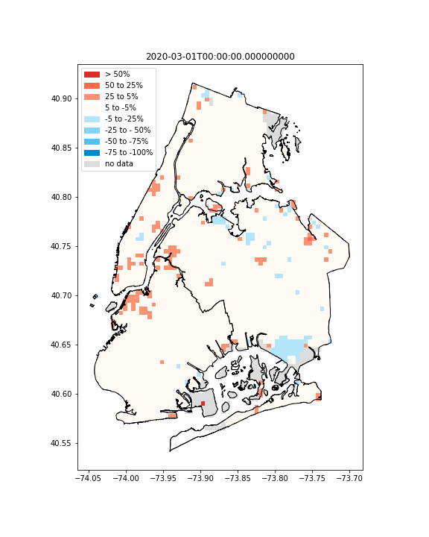Figure S1: Weekly aggregated population density change in percent with respect to baseline – Week 1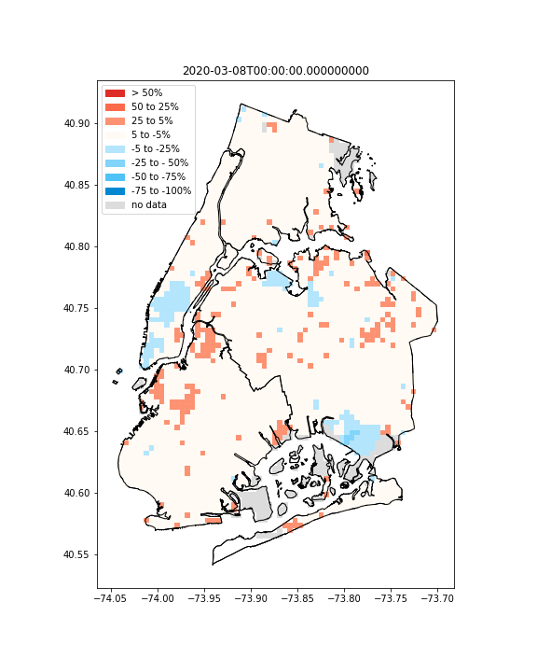

Figure S2: Weekly aggregated population density change in percent with respect to baseline - Week 2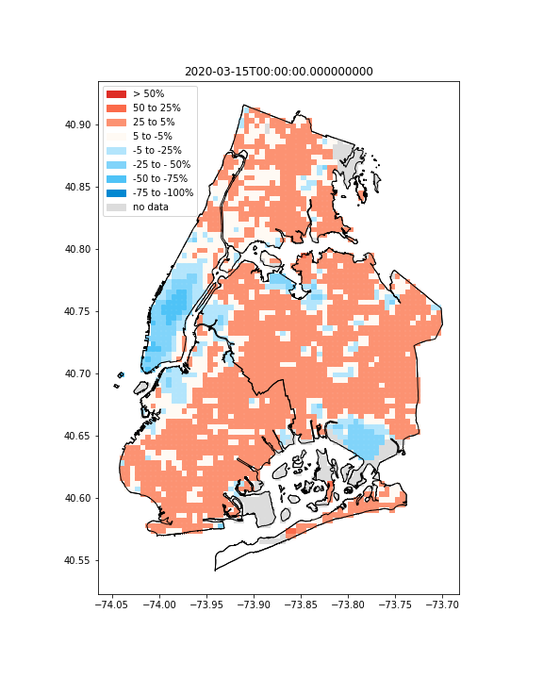Figure S3: Weekly aggregated population density change in percent with respect to baseline - Week 3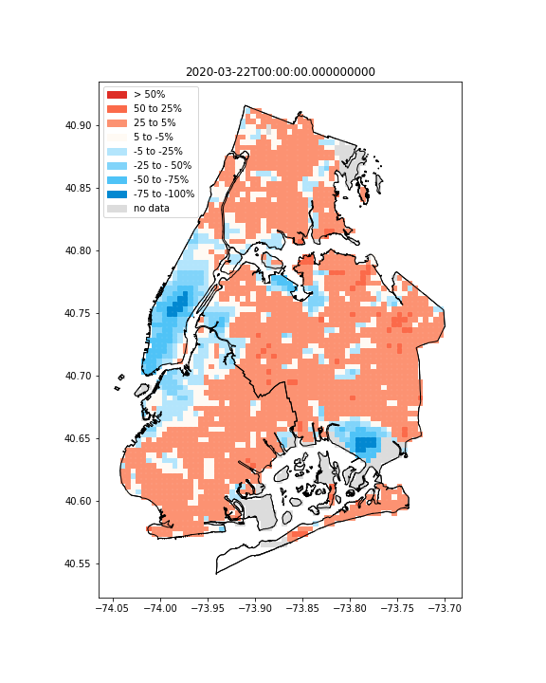Figure S4: Weekly aggregated population density change in percent with respect to baseline - Week 4

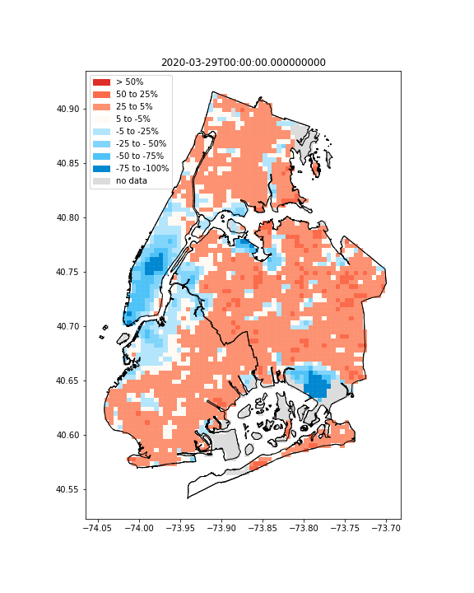Figure S5: Weekly aggregated population density change in percent with respect to baseline - Week 5 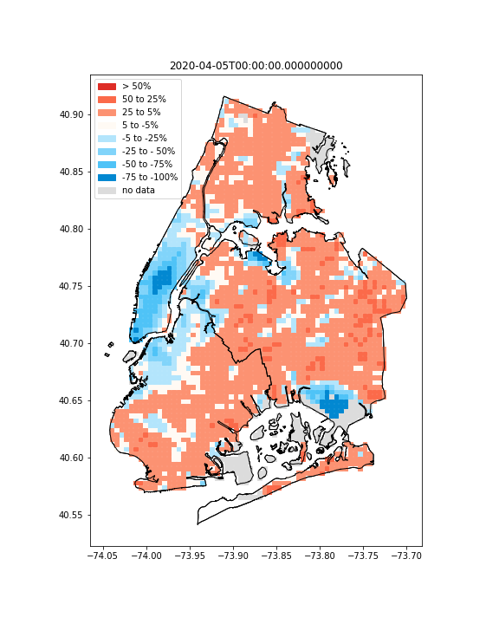Figure S6: Weekly aggregated population density change in percent with respect to baseline - Week 6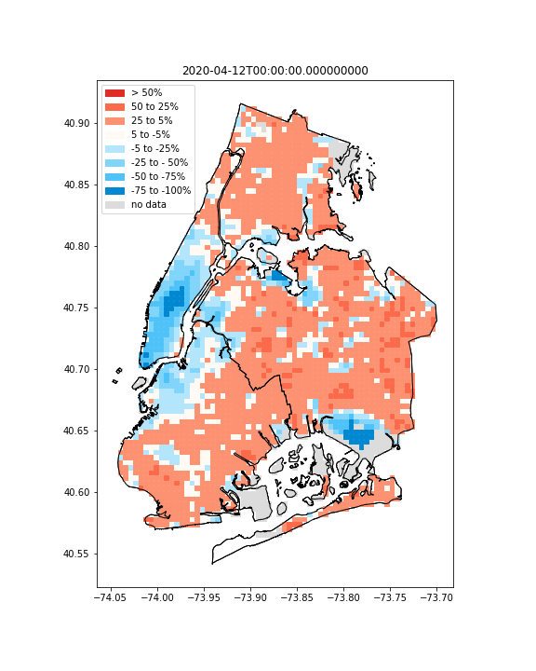Figure S7: Weekly aggregated population density change in percent with respect to baseline - Week 7  
 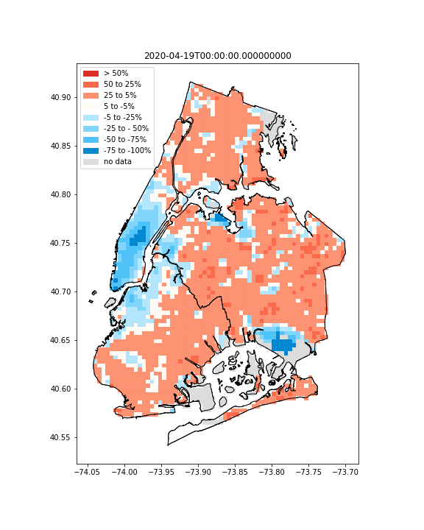Figure S8: Weekly aggregated population density change in percent with respect to baseline - Week 8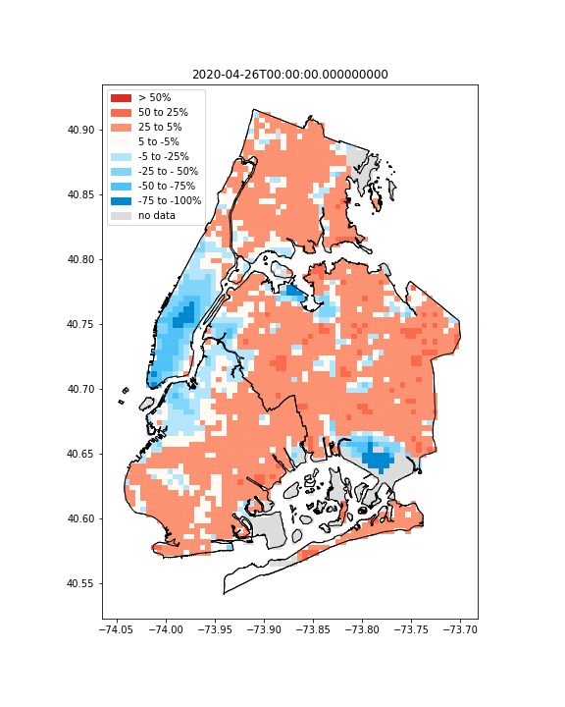Figure S9: Weekly aggregated population density change in percent with respect to baseline - Week 9

**2. Hotspot/non-hotspot movement results**

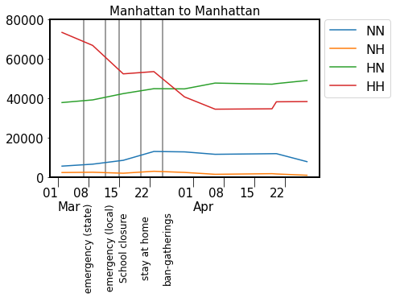Figure S13: Hotspot and non-hotspot movement trends

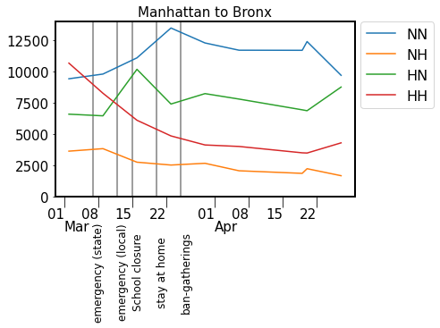Figure S14: Hotspot and non-hotspot movement trends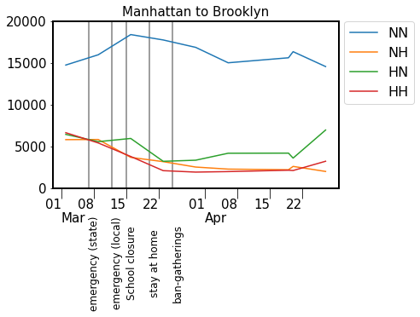Figure S15: Hotspot and non-hotspot movement trends

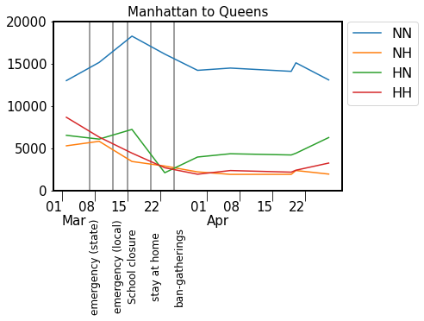Figure S16: Hotspot and non-hotspot movement trends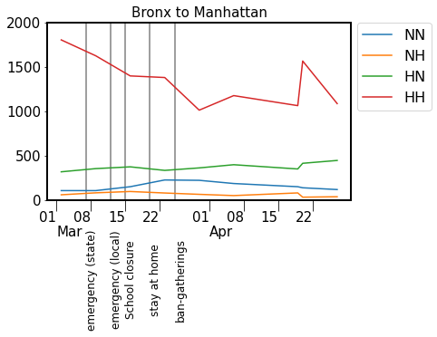Figure S17: Hotspot and non-hotspot movement trends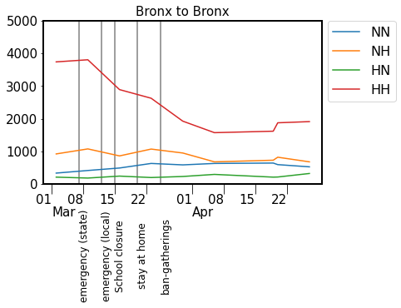Figure S18: Hotspot and non-hotspot movement trends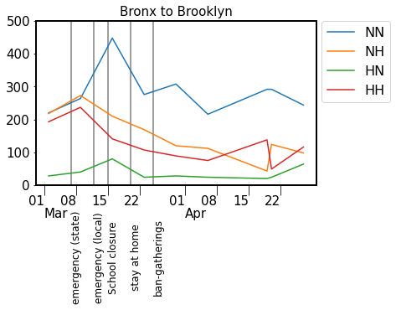Figure S19: Hotspot and non-hotspot movement trends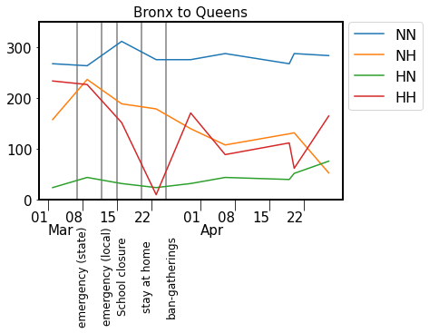Figure S20: Hotspot and non-hotspot movement trends 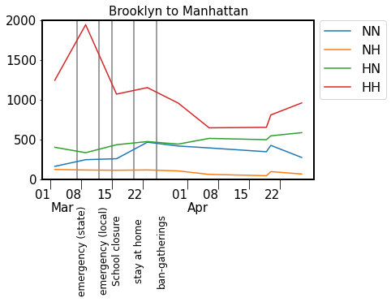Figure S21: Hotspot and non-hotspot movement trends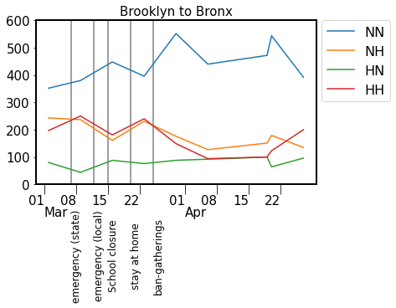Figure S22: Hotspot and non-hotspot movement trends 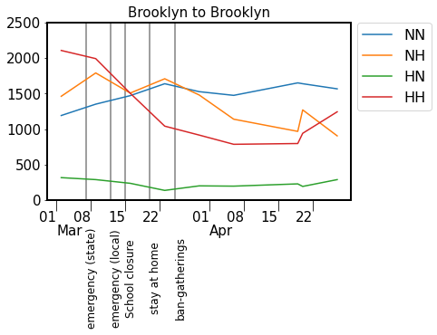Figure S23: Hotspot and non-hotspot movement trends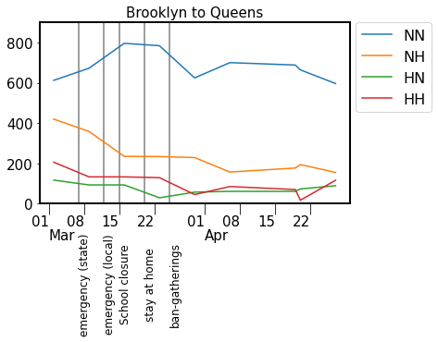Figure S24: Hotspot and non-hotspot movement trends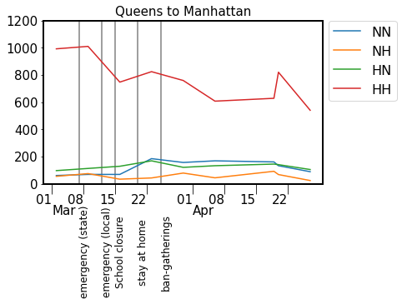Figure S25: Hotspot and non-hotspot movement trends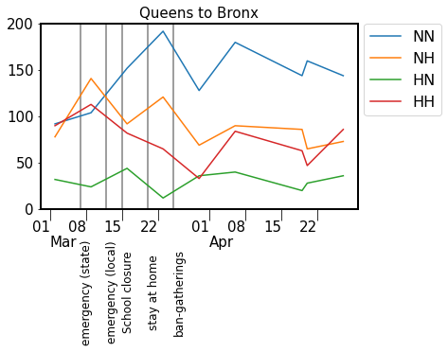Figure S26: Hotspot and non-hotspot movement trends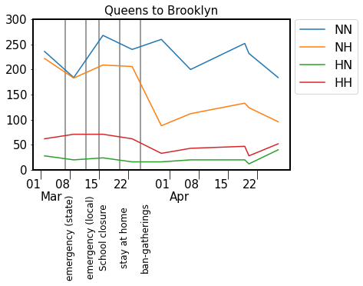Figure S27: Hotspot and non-hotspot movement trends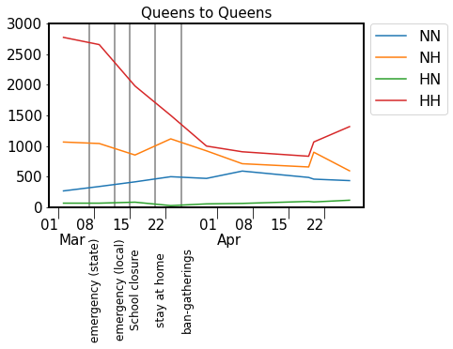Figure S28: Hotspot and non-hotspot movement trends