St Helena marine water quality: background conditions and development of assessment levels for coastal pollutants

Suzanne Painting1*, Eleanor Haigh1, Jennifer Graham1,2,SimonAMorley3, Leeann Henry4, Elizabeth Clingham5, Rhys Hobbs4, Frances Mynott1, Philippe Bersuder1, David Walker6, Tammy Stamford1

1Centre for Environment, Fisheries and Aquaculture Science (Cefas), Pakefield Road, Lowestoft, Suffolk, NR33 0HT, UK

2School of Environmental Sciences, University of East Anglia, Norwich, NR47TJ, UK

3British Antarctic Survey (BAS), Natural Environment Research Council, High Cross, Madingley Road, Cambridge, CB30ET, UK

4 Marine and Fisheries Conservation Section, Environment, Natural Resources & Planning Portfolio (ENRD), St Helena Government, Jamestown, St Helena Island

5 Foreign, Commonwealth and Development Office, Jamestown, St Helena Island6Centre for Environment, Fisheries and Aquaculture Science (Cefas), Barrack Road, Weymouth, DT4 8UB, UK

Supplementary Material

# Supplementary Table

Table S1. Contaminants detected and indicative concentrations (~ µg l-1) by site and station.

|  |  |  |  |  |  |
| --- | --- | --- | --- | --- | --- |
| Site | Station | Cas No | Contaminant | Indic-ative concen-tration (~ µg l-1) | Examples of Use |
| D | D1 | 541-73-1 | 1,3-Dichlorobenzene | 0.031 | Volatile Solvent |
| D | D2 | 541-73-1 | 1,3-Dichlorobenzene | 0.030 |
| D | D4 | 541-73-1 | 1,3-Dichlorobenzene | 0.041 |
| C | C1 | 118-79-6 | 2,4,6-Tribromophenol | 0.005 | Pesticide; Fungicide |
| D | D1 | 93-04-9 | 2-Methoxynaphthalene | 0.006 | Intermediate; Stabilizer |
| D | D2 | 93-04-9 | 2-Methoxynaphthalene | 0.009 |
| D | D4 | 93-04-9 | 2-Methoxynaphthalene | 0.009 |
| B | B3 | 119-61-9 | Benzophenone | 0.114 | Intermediate; Personal-care-products |
| K | K1 | 119-61-9 | Benzophenone | 0.030 |
| L | L1 | 119-61-9 | Benzophenone | 0.042 |
| B | B1 | 131-57-7 | Benzophenone-3 | 0.030 | Personal-care-products; Sun blocker |
| B | B2 | 131-57-7 | Benzophenone-3 | 0.048 |
| B | B3 | 131-57-7 | Benzophenone-3 | 3.100 |
| B | B4 | 131-57-7 | Benzophenone-3 | 0.087 |
| C | C1 | 131-57-7 | Benzophenone-3 | 0.038 |
| C | C2 | 131-57-7 | Benzophenone-3 | 0.033 |
| C | C3 | 131-57-7 | Benzophenone-3 | 0.044 |
| D | D1 | 131-57-7 | Benzophenone-3 | 0.072 |
| D | D2 | 131-57-7 | Benzophenone-3 | 0.054 |
| D | D3 | 131-57-7 | Benzophenone-3 | 0.024 |
| D | D4 | 131-57-7 | Benzophenone-3 | 0.055 |
| E | E1 | 131-57-7 | Benzophenone-3 | 0.035 |
| E | E2 | 131-57-7 | Benzophenone-3 | 0.038 |
| F | F1 | 131-57-7 | Benzophenone-3 | 0.038 |
| F | F2 | 131-57-7 | Benzophenone-3 | 0.051 |
| F | F3 | 131-57-7 | Benzophenone-3 | 0.046 |
| G | G2 | 131-57-7 | Benzophenone-3 | 0.035 |
| G | G3 | 131-57-7 | Benzophenone-3 | 0.011 |
| G | G4 | 131-57-7 | Benzophenone-3 | 0.013 |
| H | H2 | 131-57-7 | Benzophenone-3 | 0.027 |
| H | H3 | 131-57-7 | Benzophenone-3 | 0.011 |
| I | I2 | 131-57-7 | Benzophenone-3 | 0.072 |
| I | I3 | 131-57-7 | Benzophenone-3 | 0.037 |
| J | J1 | 131-57-7 | Benzophenone-3 | 0.113 |
| J | J2 | 131-57-7 | Benzophenone-3 | 0.112 |
| K | K1 | 131-57-7 | Benzophenone-3 | 0.009 |
| B | B1 | 75-25-2 | Bromoform | 0.099 | Volatile Solvent |
| B | B2 | 75-25-2 | Bromoform | 0.066 |
| B | B3 | 75-25-2 | Bromoform | 0.073 |
| B | B4 | 75-25-2 | Bromoform | 0.081 |
| C | C1 | 75-25-2 | Bromoform | 0.086 |
| C | C2 | 75-25-2 | Bromoform | 0.070 |
| C | C3 | 75-25-2 | Bromoform | 0.068 |
| D | D1 | 75-25-2 | Bromoform | 0.090 |
| D | D2 | 75-25-2 | Bromoform | 0.111 |
| D | D3 | 75-25-2 | Bromoform | 0.050 |
| D | D4 | 75-25-2 | Bromoform | 0.103 |
| E | E1 | 75-25-2 | Bromoform | 0.049 |
| E | E2 | 75-25-2 | Bromoform | 0.055 |
| E | E3 | 75-25-2 | Bromoform | 0.054 |
| F | F1 | 75-25-2 | Bromoform | 0.035 |
| F | F3 | 75-25-2 | Bromoform | 0.032 |
| H | H1 | 75-25-2 | Bromoform | 0.086 |
| H | H2 | 75-25-2 | Bromoform | 0.062 |
| H | H3 | 75-25-2 | Bromoform | 0.049 |
| H | H4 | 75-25-2 | Bromoform | 0.032 |
| I | I1 | 75-25-2 | Bromoform | 0.038 |
| I | I2 | 75-25-2 | Bromoform | 0.049 |
| I | I3 | 75-25-2 | Bromoform | 0.108 |
| J | J1 | 75-25-2 | Bromoform | 0.059 |
| J | J2 | 75-25-2 | Bromoform | 0.067 |
| K | K1 | 75-25-2 | Bromoform | 0.082 |
| K | K2 | 75-25-2 | Bromoform | 0.052 |
| L | L1 | 75-25-2 | Bromoform | 0.059 |
| L | L2 | 75-25-2 | Bromoform | 0.057 |
| D | D1 | 58-08-2 | Caffeine | 0.184 | Psychoactive stimulant drug |
| D | D2 | 58-08-2 | Caffeine | 0.251 |
| D | D4 | 58-08-2 | Caffeine | 0.290 |
| K | K1 | 58-08-2 | Caffeine | 0.029 |
| D | D2 | 88-04-0 | Chloroxylenol | 0.031 | Antiseptic; Antimicrobial |
| D | D4 | 88-04-0 | Chloroxylenol | 0.024 |
| B | B1 | 74-95-3 | Dibromomethane | 0.007 | Volatile Solvent |
| B | B2 | 74-95-3 | Dibromomethane | 0.004 |
| B | B3 | 74-95-3 | Dibromomethane | 0.004 |
| B | B4 | 74-95-3 | Dibromomethane | 0.005 |
| C | C1 | 74-95-3 | Dibromomethane | 0.008 |
| C | C2 | 74-95-3 | Dibromomethane | 0.006 |
| C | C3 | 74-95-3 | Dibromomethane | 0.004 |
| D | D1 | 74-95-3 | Dibromomethane | 0.022 |
| D | D2 | 74-95-3 | Dibromomethane | 0.023 |
| D | D3 | 74-95-3 | Dibromomethane | 0.004 |
| D | D4 | 74-95-3 | Dibromomethane | 0.026 |
| E | E1 | 74-95-3 | Dibromomethane | 0.004 |
| E | E2 | 74-95-3 | Dibromomethane | 0.003 |
| E | E3 | 74-95-3 | Dibromomethane | 0.005 |
| H | H1 | 74-95-3 | Dibromomethane | 0.006 |
| H | H2 | 74-95-3 | Dibromomethane | 0.005 |
| H | H3 | 74-95-3 | Dibromomethane | 0.003 |
| I | I1 | 74-95-3 | Dibromomethane | 0.006 |
| I | I2 | 74-95-3 | Dibromomethane | 0.003 | Volatile Solvent |
| I | I3 | 74-95-3 | Dibromomethane | 0.005 |
| J | J1 | 74-95-3 | Dibromomethane | 0.008 |
| J | J2 | 74-95-3 | Dibromomethane | 0.003 |
| K | K1 | 74-95-3 | Dibromomethane | 0.005 |
| K | K2 | 74-95-3 | Dibromomethane | 0.006 |
| L | L1 | 74-95-3 | Dibromomethane | 0.005 |
| L | L2 | 74-95-3 | Dibromomethane | 0.006 |
| G | G4 | 118-56-9 | Homosalate | 0.017 | UV filter; Sunscreens |
| I | I1 | 118-56-9 | Homosalate | 0.048 |
| I | I2 | 118-56-9 | Homosalate | 0.009 |
| I | I3 | 118-56-9 | Homosalate | 0.008 |
| K | K2 | 118-56-9 | Homosalate | 0.078 |
| L | L1 | 118-56-9 | Homosalate | 0.337 |
| L | L2 | 118-56-9 | Homosalate | 0.207 |
| C | C3 | 496-11-7 | Indane | 0.001 | Petrochemical compound |
| D | D1 | 80-54-6 | Lilial | 0.006 | EU regulated contact allergen |
| D | D1 | 134-62-3 | N,N-Diethyl-m-toluamide | 0.024 | DEET; Insect repellent |
| D | D2 | 134-62-3 | N,N-Diethyl-m-toluamide | 0.037 |
| D | D4 | 134-62-3 | N,N-Diethyl-m-toluamide | 0.025 |
| B | B3 | 6197-30-4 | Octocrylene | 0.160 | UV-filter |
| L | L1 | 6197-30-4 | Octocrylene | 0.045 |

# A close up of a map Description automatically generatedSupplementary Figures

Figure S1. Profiles from *RRS* James Clark Ross (2018) of (a) temperature, (b) fluorometric chlorophyll, (c) oxygen concentration, (d) practical salinity, and (e) oxygen saturation, from east and west stations. The legend shows the CTD profile numbers. See Figure 4 in manuscript.

Figure S2. Profiles from *RRS* Discovery (2019) of (a) temperature, (b) fluorometric chlorophyll, (c) oxygen concentration, (d) practical salinity, (e) turbidity, and (f) oxygen saturation, from east and west stations. The legend shows the CTD profile numbers. See Figure 5 in manuscript.

## Figure S3. *RRS* Discovery Survey DY100 - full CTD profiles

Stations 14 and 15 were inshore at James Bay. See Figure S4 for only the upper 300 m of the water column.

## Figure S4. *RRS* Discovery Survey DY100 - profiles to 300m

## Figure S5. *RRS* James Clark Ross Survey JR17-004 – full CTD profiles

See Figure S6 for only the upper 300 m of the water column.

## Figure S6. *RRS* James Clark Ross Survey JR17-004 - profiles to 300m

## Figure S7. James Bay CTD profiles

Figure S7 a-f. CTD profiles from the James Bay transect on DY100, from offshore (CTD 16) to inshore (CTD 14). The legend shows the CTD profile numbers.

## Figure S8. Inshore CTD profiles

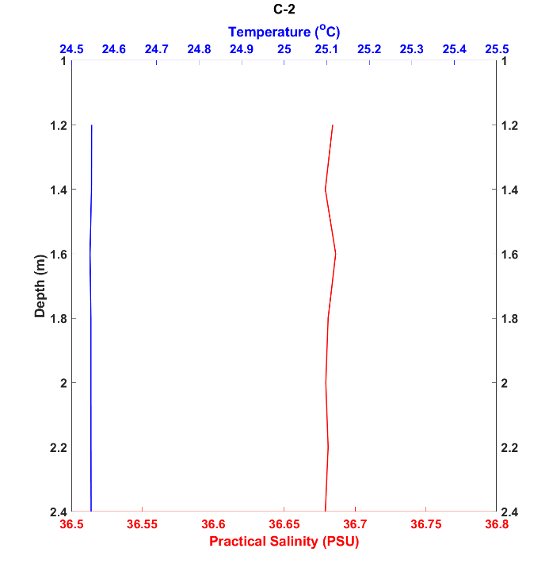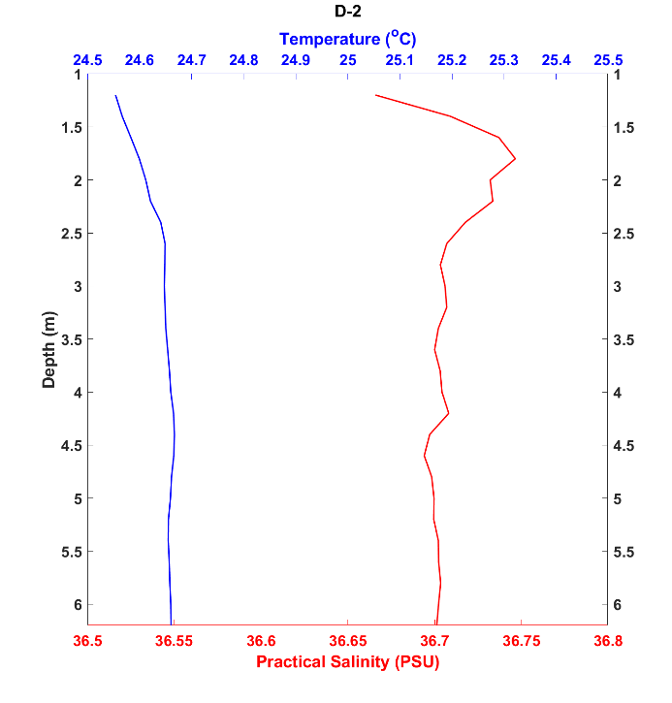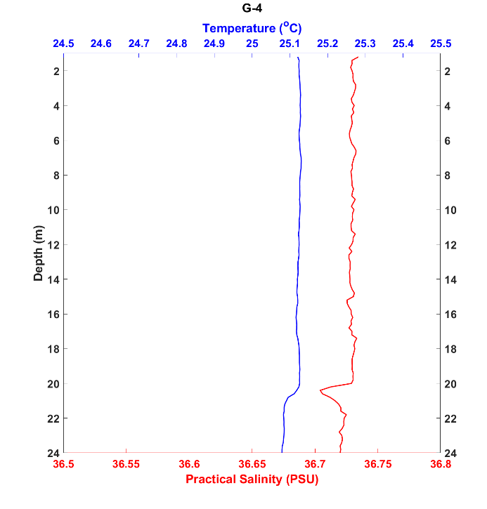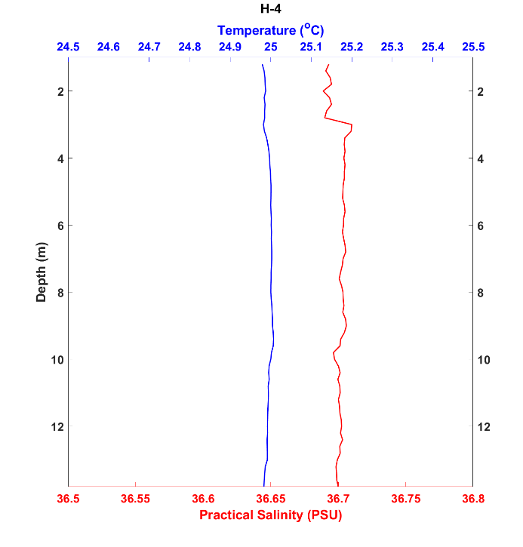

Figure S8.1. CTD profiles from sites C2 (Below Ladder Hill), D2 (West Rocks Outfall), G4 (RFA Darkdale) and H4 (Jamestown Steps).

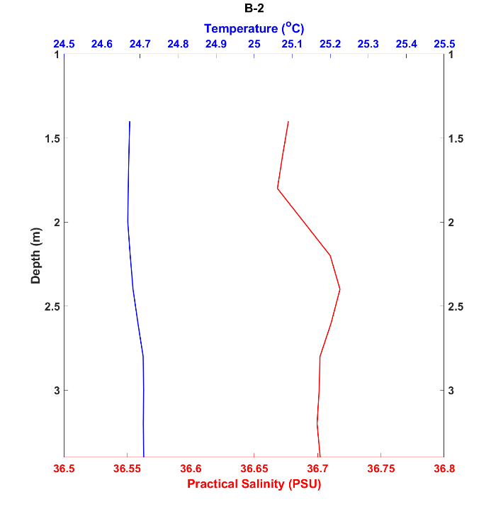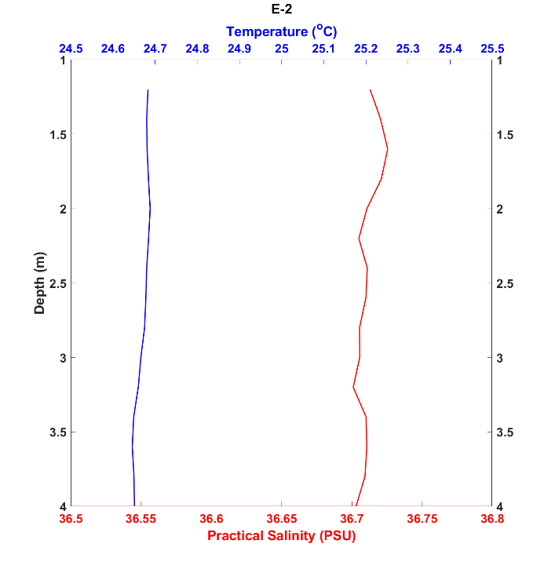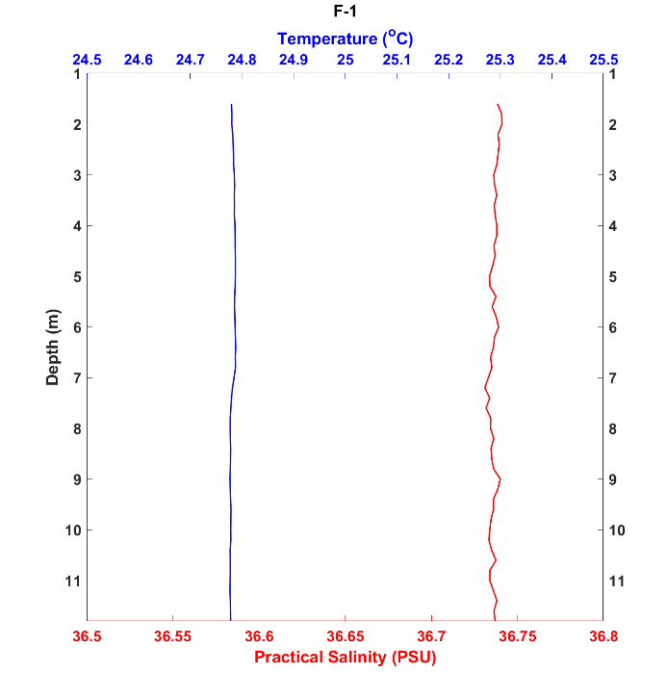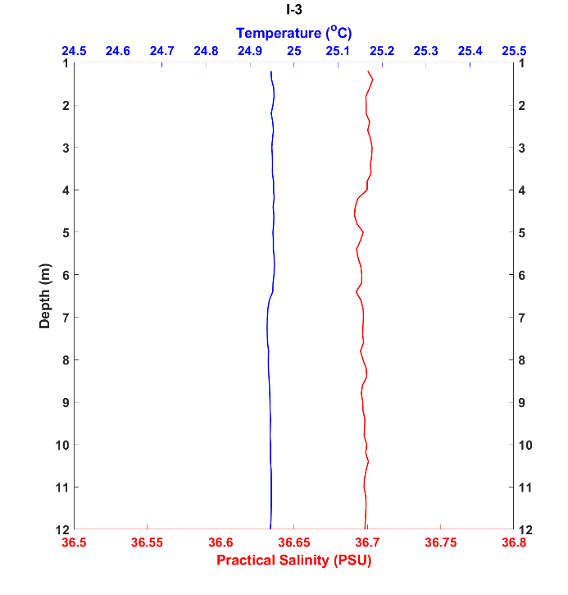

Figure S8.2. CTD profiles from sites B2 (Half Tree Hollow), E2 (Jamestown Outfall), F1 (James Bay Moorings) and I3 (Rupert’s main jetty).

Figure S8.3. CTD profiles obtained from sites J2 (Rupert’s Bay Temporary Jetty), K2 (Rupert’s Slipway) and L2 (Refuelling Dock).