# Supplementary material

**Figure S1.** Study site with an expanded view of the right-of-way showing that the reference ecosystem for vegetation and elevation data is the undisturbed right-of-way

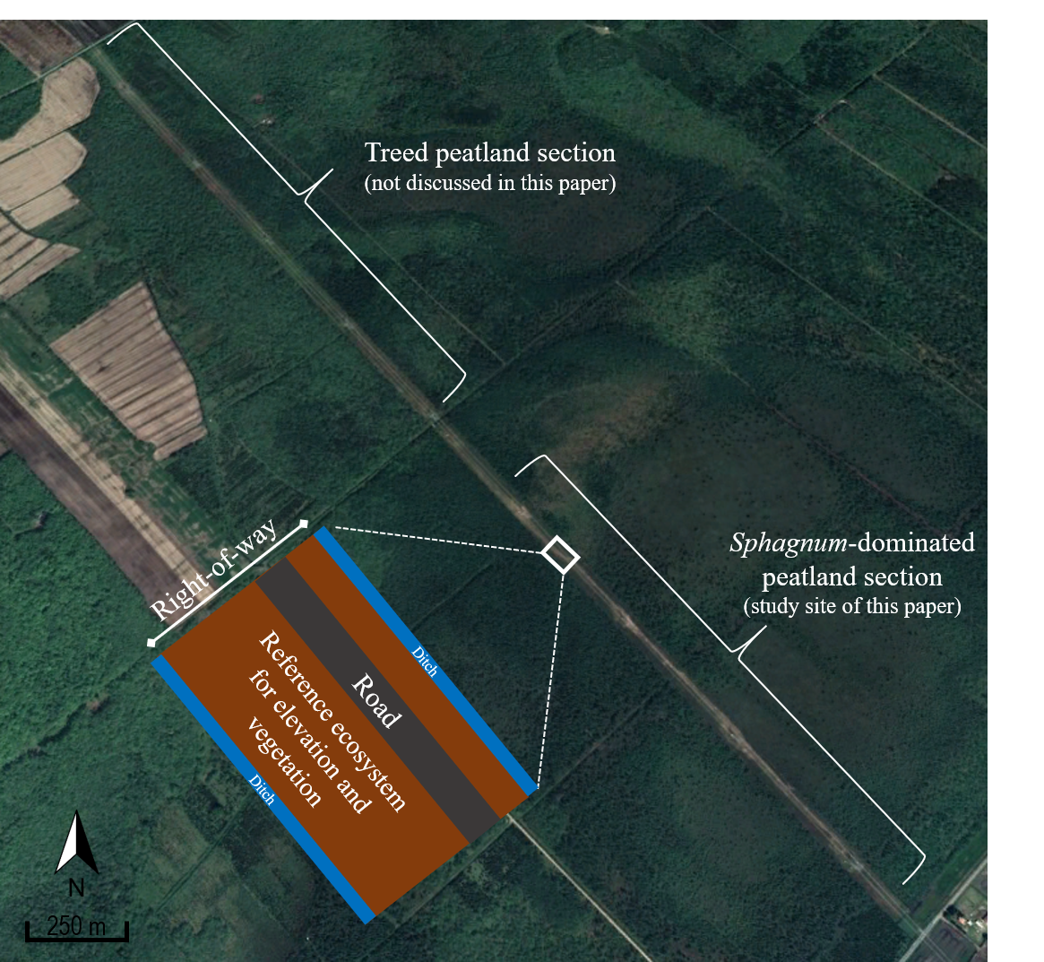

**Figure S2.** Sampling design for chemistry and elevation showing that the reference ecosystem for the chemistry is the surrounding peatland

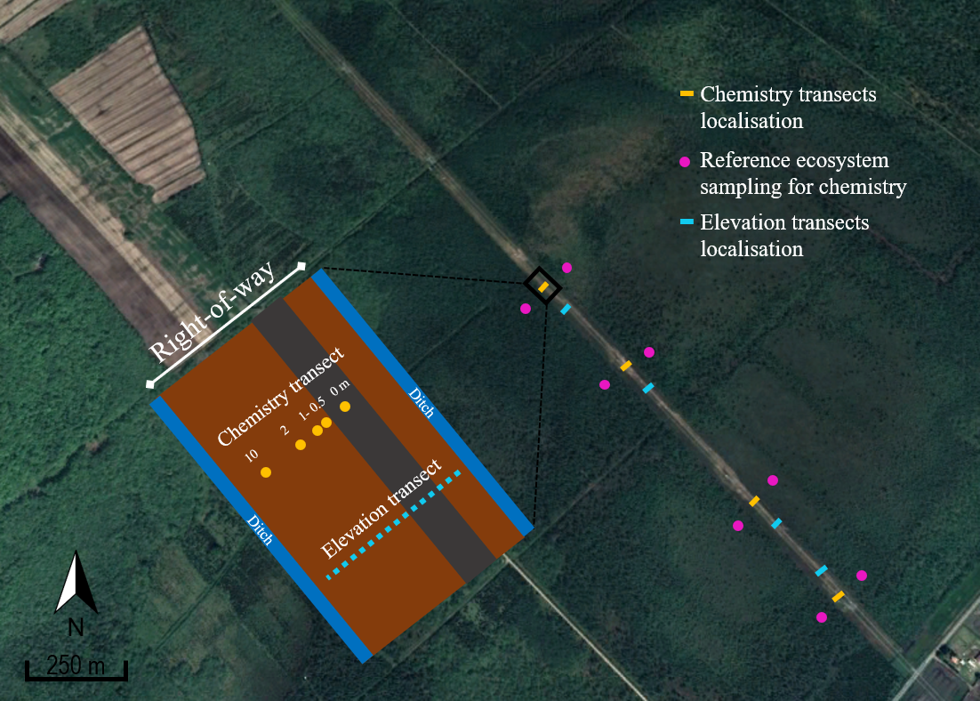

**Figure S3.** Area of vegetation surveys

**Table S1.** List of species surveyed in the restored strip and the reference ecosystem, and their preferential habitat*

|  |  |  |  |  |
| --- | --- | --- | --- | --- |
| Strata | Species | Preferential habitat | Present in | |
| Restored strip | Reference ecosystem |
| Trees | *Acer rubrum* Linnaeus | FAC | x | x |
| *Aronia melanocarpa* (Michaux) Elliott | PEAT |  | x |
| *Betula populifolia* Marshall | FAC | x | x |
| *Larix laricina* (Du Roi) K. Koch | FACW |  | x |
| *Picea mariana* (Miller) Britton, Sterns and Poggenburgh | FACW | x |  |
| *Rubus hispidus* Linnaeus | FACW | x |  |
| *Spiraea tomentosa* Linnaeus | FACW | x |  |
| Ericaceous | *Chamaedaphne calyculata* (Linnaeus) Moench | PEAT | x | x |
| *Kalmia polifolia* Wangenheim | PEAT |  | x |
| *Rhododendron canadense* (Linnaeus) Torrey | FACW |  | x |
| *Rhododendron groenlandicum* (Oeder) Kron and Judd | PEAT | x | x |
| *Vaccinium myrtilloides* Michaux | FACW | x | x |
| *Vaccinium oxycoccos* Linnaeus | PEAT |  | x |
| Herbaceous | *Calamagrostis canadensis* (Michaux) Palisot de Beauvois | OBL | x |  |
| *Carex lurida* Wahlenberg | OBL | x |  |
| *Carex magellanica* Lamarck | PEAT |  | x |
| *Carex trisperma* Dewey | PEAT |  | x |
| *Epilobium palustre* Linnaeus | OBL | x |  |
| *Eriophorum angustifolium* Honckeny | PEAT |  | x |
| *Eriophorum vaginatum* Linnaeus | PEAT |  | x |
| *Gentiana linearis* Froelich | FACW | x |  |
| *Hypericum boreale* (Britton) E.P. Bicknell | OBL | x |  |
| *Hypericum virginicum* Linnaeus | OBL | x |  |
| *Juncus effusus* Linnaeus | OBL | x |  |
| *Phragmites australis* (Cavanilles) Trinius ex Steudel | FACW | x |  |
| *Pilosella caespitosa* (Dumortier) P.D. Sell and C. West | UPL | x |  |
| *Scirpus cyperinus* (Linnaeus) Kunth | OBL | x |  |
| *Solidago canadensis* Linnaeus | FACU | x |  |
| *Solidago rugosa* Miller | FAC | x |  |
| *Typha latifolia* Linnaeus | OBL | x |  |
| *Viola* sp. | - | x |  |

* Peatland obligated (PEAT), Obligate Wetland (OBL), Facultative wetland (FACW), Facultative to both wetlands and uplands (FAC), Facultative Upland (FACU) and Upland (UPL). Classification of vascular species done according to the Wetland Indicator Status of the United States Department of Agriculture. A customized peatland status has been given to Obligate Wetland species that occurs mostly in peatlands according to the S1 appendix in Poulin et al. (2012).