**Supplementary Material**

**Tables**

**Table S1.** Statistical summary of the size-wise PM and its chemical compositions.

|  |  |  |  |  |  |  |  |  |  |
| --- | --- | --- | --- | --- | --- | --- | --- | --- | --- |
|  | **PM1** | | | **PM2.5** | | | **PM10** | | |
| **Species** | **Average** | **SD** | **Range** | **Average** | **SD** | **Range** | **Average** | **SD** | **Range** |
| **(µg/m3)** |  |  |  |  |  |  |  |  |  |
| **PM** | **32.4** | **17.4** | **13.7-93.9** | **53.3** | **28.9** | **19.2-159.0** | **102.6** | **44.9** | **35.4-224.9** |
| **(µg/m3)** |  |  |  |  |  |  |  |  |  |
| **OC** | **5.33** | **1.66** | **2.73-8.39** | **5.96** | **1.77** | **2.89-9.62** | **8.99** | **2.71** | **3.90-16.15** |
| **EC** | **2.14** | **0.93** | **0.52-4.82** | **2.60** | **1.01** | **0.68-6.38** | **3.59** | **1.12** | **0.85-7.01** |
| **(µg/m3)** |  |  |  |  |  |  |  |  |  |
| **Cl-** | **0.23** | **0.22** | **0.04-1.26** | **0.46** | **0.48** | **0.08-2.42** | **1.01** | **0.74** | **0.25-4.22** |
| **NO3-** | **2.42** | **2.68** | **0.18-16.09** | **5.20** | **5.55** | **0.57-29.67** | **9.00** | **5.97** | **1.88-32.27** |
| **SO42-** | **2.59** | **2.19** | **0.38-11.61** | **4.33** | **3.24** | **0.74-13.91** | **5.41** | **3.22** | **0.93-14.47** |
| **Na+** | **0.15** | **0.08** | **0.04-0.32** | **0.29** | **0.14** | **0.08-0.73** | **0.72** | **0.41** | **0.23-2.51** |
| **NH4+** | **1.60** | **1.16** | **0.32-4.51** | **2.43** | **1.97** | **0.43-10.76** | **2.87** | **2.08** | **0.77-10.88** |
| **K+** | **0.10** | **0.12** | **0.01-0.61** | **0.18** | **0.20** | **0.01-0.86** | **0.26** | **0.25** | **0.03-1.23** |
| **(µg/m3)** |  |  |  |  |  |  |  |  |  |
| **Al** | **0.25** | **0.17** | **0.06-0.93** | **0.58** | **0.53** | **0.06-3.56** | **2.21** | **1.87** | **0.18-11.64** |
| **Ca** | **0.48** | **0.46** | **0.07-2.11** | **0.89** | **0.54** | **0.23-2.50** | **3.35** | **1.45** | **0.67-7.19** |
| **Fe** | **0.17** | **0.12** | **0.07-0.94** | **0.49** | **0.32** | **0.12-1.91** | **2.12** | **1.23** | **0.34-7.02** |
| **Mg** | **0.06** | **0.02** | **0.02-0.11** | **0.19** | **0.15** | **0.06-0.87** | **0.91** | **0.57** | **0.12-3.25** |
| **Si** | **0.63** | **0.58** | **0.17-3.10** | **1.77** | **1.44** | **0.39-9.24** | **6.97** | **5.40** | **0.97-34.07** |
| **(ng/m3)** |  |  |  |  |  |  |  |  |  |
| **As** | **6.5** | **7.9** | **0.6-39.4** | **11.2** | **10.3** | **1.3-48.4** | **23.3** | **21.3** | **1.9-88.4** |
| **Cu** | **21.8** | **17.3** | **0.9-73.4** | **31.5** | **18.5** | **6.4-79.5** | **92.8** | **58.9** | **16.6-340.6** |
| **Mn** | **6.5** | **3.4** | **1.9-18.7** | **17.0** | **9.0** | **3.6-52.0** | **53.9** | **29.9** | **8.8-172.1** |
| **Ni** | **8.6** | **7.7** | **0.9-29.4** | **11.9** | **9.7** | **1.3-39.2** | **20.3** | **13.2** | **2.2-49.3** |
| **Pb** | **11.3** | **8.9** | **0.8-41.6** | **19.4** | **12.4** | **1.4-65.6** | **34.4** | **16.5** | **4.6-90.1** |
| **Ti** | **5.5** | **2.6** | **1.1-14.1** | **15.9** | **11.9** | **5.3-75.6** | **68.2** | **48.4** | **7.9-283.8** |
| **V** | **0.9** | **1.0** | **0.1-3.8** | **2.2** | **1.7** | **0.3-7.6** | **4.8** | **2.2** | **1.8-10.7** |
| **Zn** | **44.0** | **26.8** | **2.6-137.2** | **86.0** | **40.2** | **13.5-205.4** | **152.7** | **57.7** | **47.9-333.9** |
| **(ng/m3)** |  |  |  |  |  |  |  |  |  |
| **Levoglucosan** | **14.7** | **13.3** | **1.9-82.5** | **20.8** | **18.6** | **3.3-131.2** | **39.6** | **26.6** | **8.2-173.4** |
| **Glucose** | **3.0** | **5.9** | **0.0-18.9** | **14.6** | **8.8** | **2.4-31.3** | **43.0** | **15.6** | **19.3-97.2** |
| **Fructose** | **-** | **-** | **-** | **1.0** | **2.6** | **0.0-12.5** | **12.4** | **8.7** | **3.1-44.0** |
| **Arabitol** | **-** | **-** | **-** | **3.3** | **5.9** | **0.0-22.6** | **24.2** | **24.7** | **3.4-120.2** |
| **Mannitol** | **9.8** | **5.3** | **4.2-25.3** | **15.2** | **5.9** | **4.2-30.9** | **44.6** | **24.9** | **17.6-134.0** |

**Table S2.** Statistical summary of the size-wise PM’s characteristic ratios.

|  |  |  |  |  |  |  |  |  |  |
| --- | --- | --- | --- | --- | --- | --- | --- | --- | --- |
|  | **PM1** | | | **PM2.5** | | | **PM10** | | |
| **Species** | **Average** | **SD** | **Range** | **Average** | **SD** | **Range** | **Average** | **SD** | **Range** |
| **(µg/m3)** |  |  |  |  |  |  |  |  |  |
| **PM1/PM2.5** | - | - | - | **0.63** | **0.13** | **0.30-0.93** | - | - | - |
| **PM1/ PM10** | - | - | - | **0.33** | **0.10** | **0.08-0.51** | - | - | - |
| **PM2.5/PM10** | - | - | - | **0.53** | **0.16** | **0.26-0.81** | - | - | - |
| **(µg/m3)** |  |  |  |  |  |  |  |  |  |
| **OC/EC** | **2.81** | **1.34** | **1.38-9.07** | **2.47** | **0.84** | **1.11-6.17** | **2.58** | **0.59** | **1.65-4.99** |
| **SOC/OC** | **0.44** | **0.18** | **0.00-0.85** | **0.51** | **0.15** | **0.00-0.82** | **0.33** | **0.14** | **0.00-0.67** |
| **AE/CE** | **0.53** | **0.31** | **0.15-1.62** | **0.69** | **0.37** | **0.24-1.87** | **0.70** | **0.24** | **0.38-1.32** |
| **NO3-/SO42-** | **0.94** | **0.69** | **0.16-3.89** | **1.17** | **0.74** | **0.16-3.64** | **1.80** | **0.71** | **0.68-3.79** |
| **K+/EC** | **0.05** | **0.05** | **0.00-0.27** | **0.07** | **0.07** | **0.01-0.42** | **0.07** | **0.06** | **0.01-0.28** |
| **Levoglucosan/K+** | **0.27** | **0.22** | **0.02-0.95** | **0.20** | **0.14** | **0.04-0.73** | **0.21** | **0.13** | **0.03-0.60** |

**Table S3.** Correlation matrix for PM₁'s chemical species: bold for significant correlations (red and green fills for strong and moderate correlations).

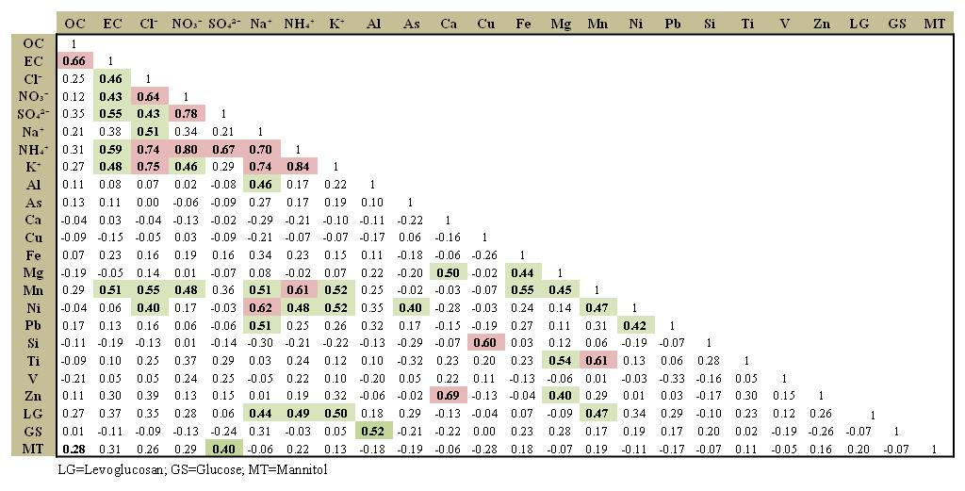

**Table S4.** Correlation matrix for PM₁₋₂.₅'s chemical species: bold for significant correlations (red and green fills for strong and moderate correlations).

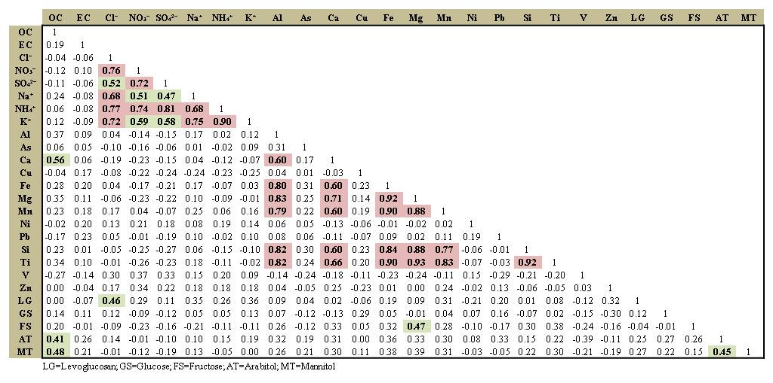

**Table S5.** Correlation matrix for PM₂.₅₋₁₀'s chemical species: bold for significant correlations (red and green fills for strong and moderate correlations).

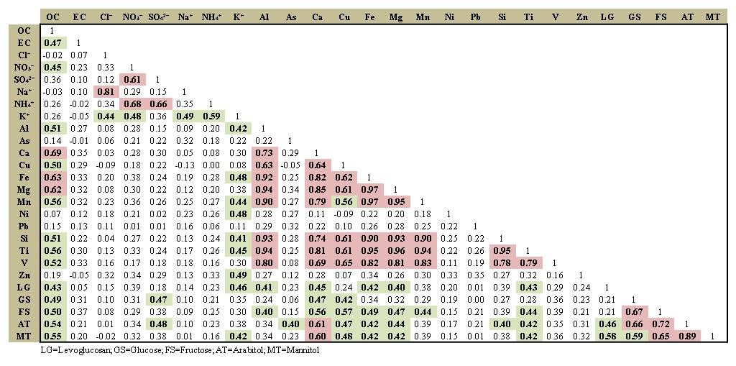

**Figures**

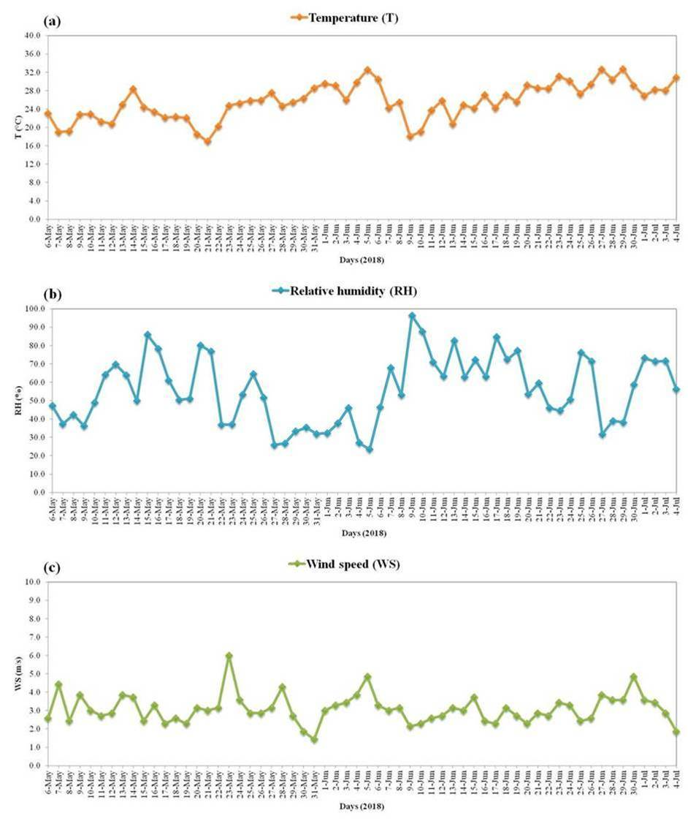

**Figure S1.** Temporal trends of the meteorological parameters: (a) temperature [°C], (b) relative humidity [%], and (c) wind speed [m/s].

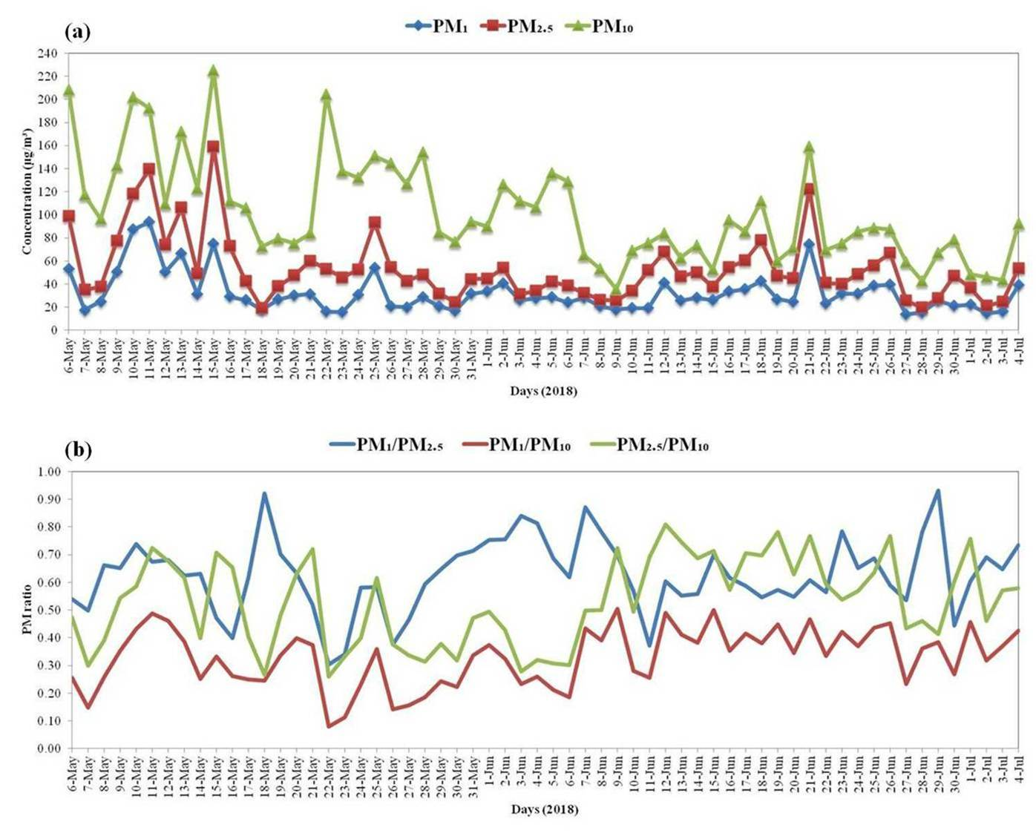

**Figure S2.** PM temporal trends: (a) PM1, PM2.5, and PM10 concentrations [µg/m3] and (b) PM1/PM2.5, PM1/PM10, and PM2.5/PM10 ratios.

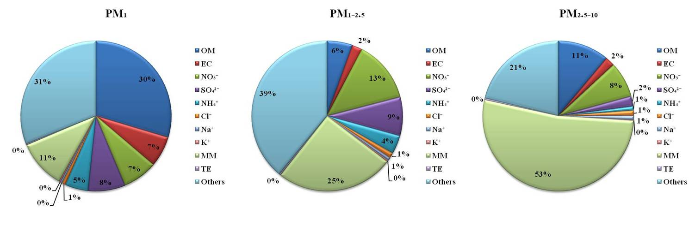

**Figure S3.** Component species’ contributions to the total PM mass concentration for the PM size fractions.

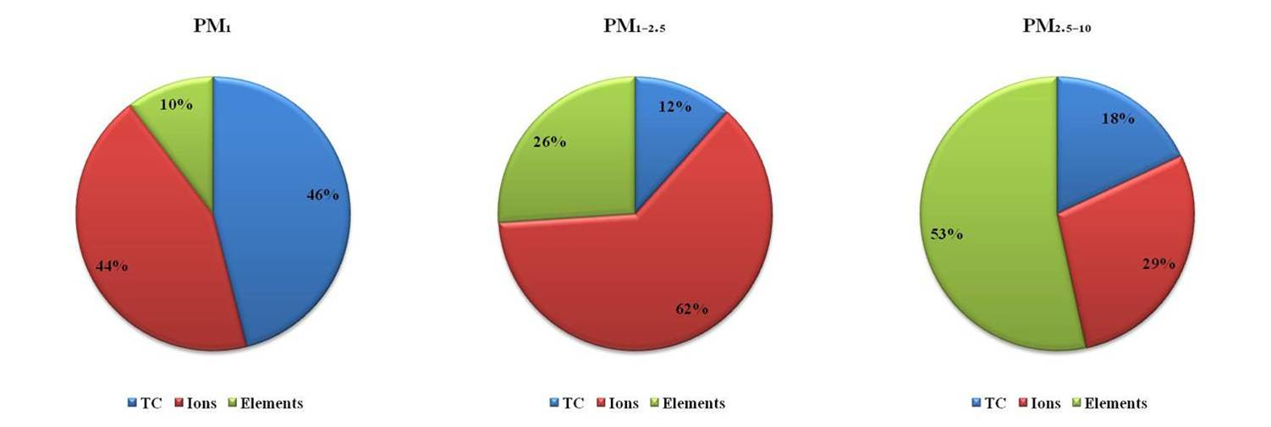

**Figure S4.** TC, ions, and elements compositions of the fraction-wise PM.

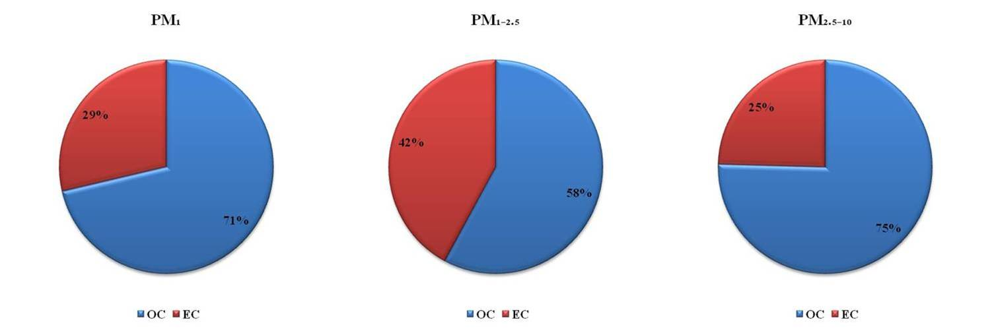

**Figure S5.** Carbonaceous compositions of the fraction-wise PM.

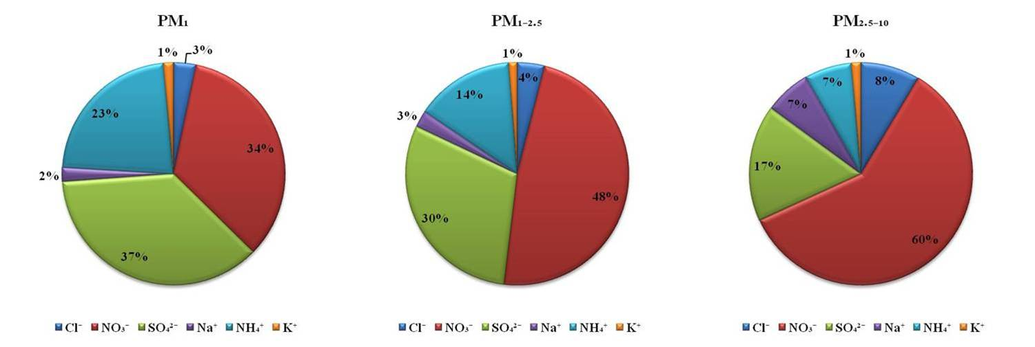

**Figure S6.** Ionic compositions of the fraction-wise PM.

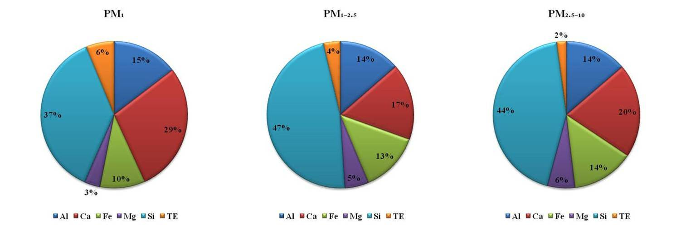

**Figure S7.** Elemental compositions of the fraction-wise PM.

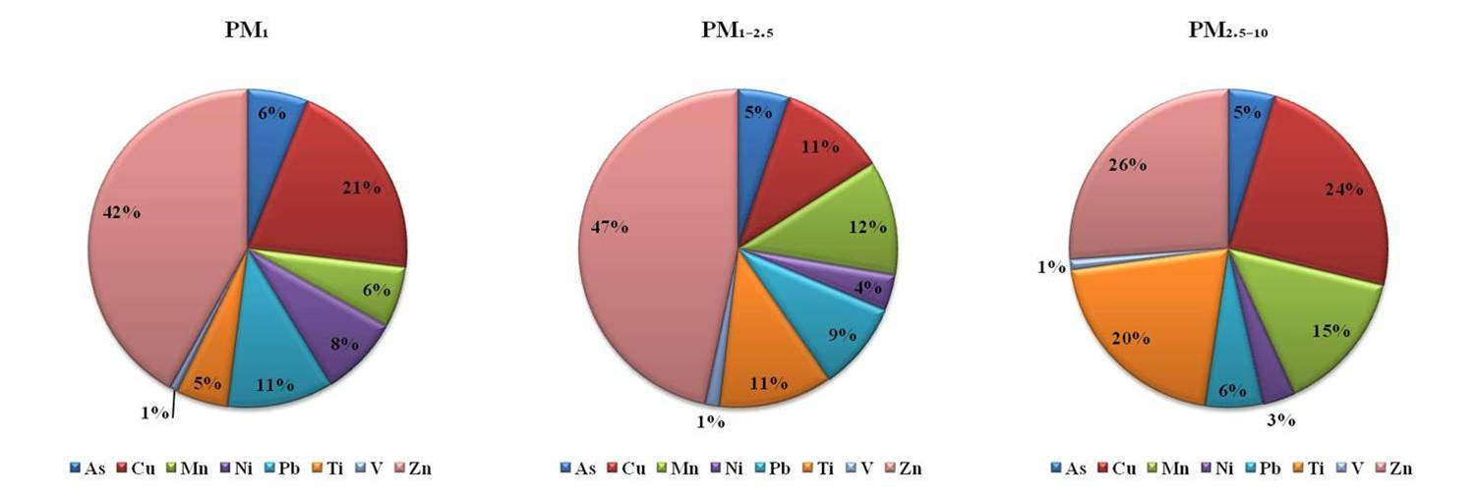

**Figure S8.** Trace elemental compositions of the fraction-wise PM.

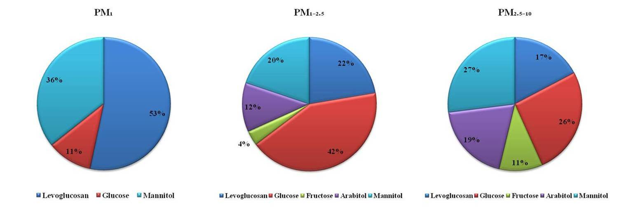

**Figure S9.** Saccharides compositions of the fraction-wise PM.

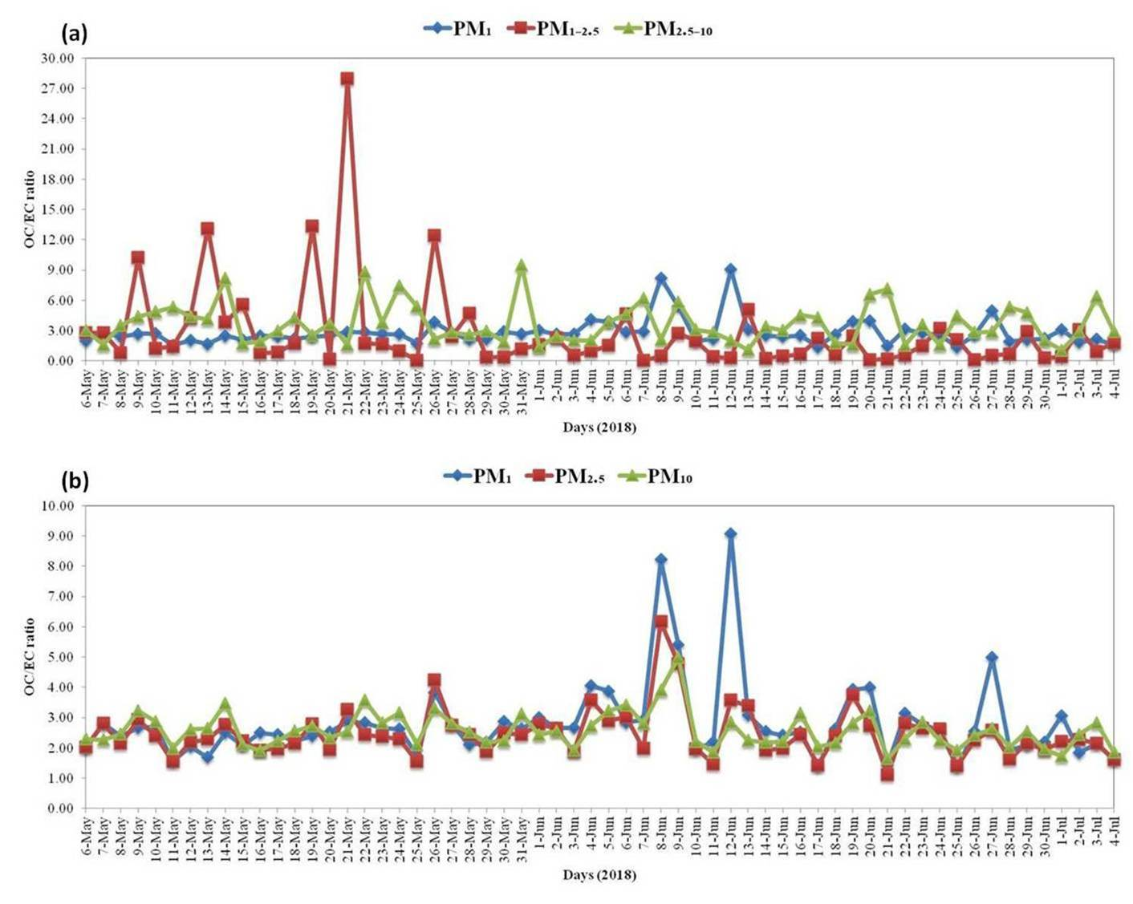

**Figure S10.** OC/EC temporal trends: (a) for PM fractions and (b) for PM sizes.

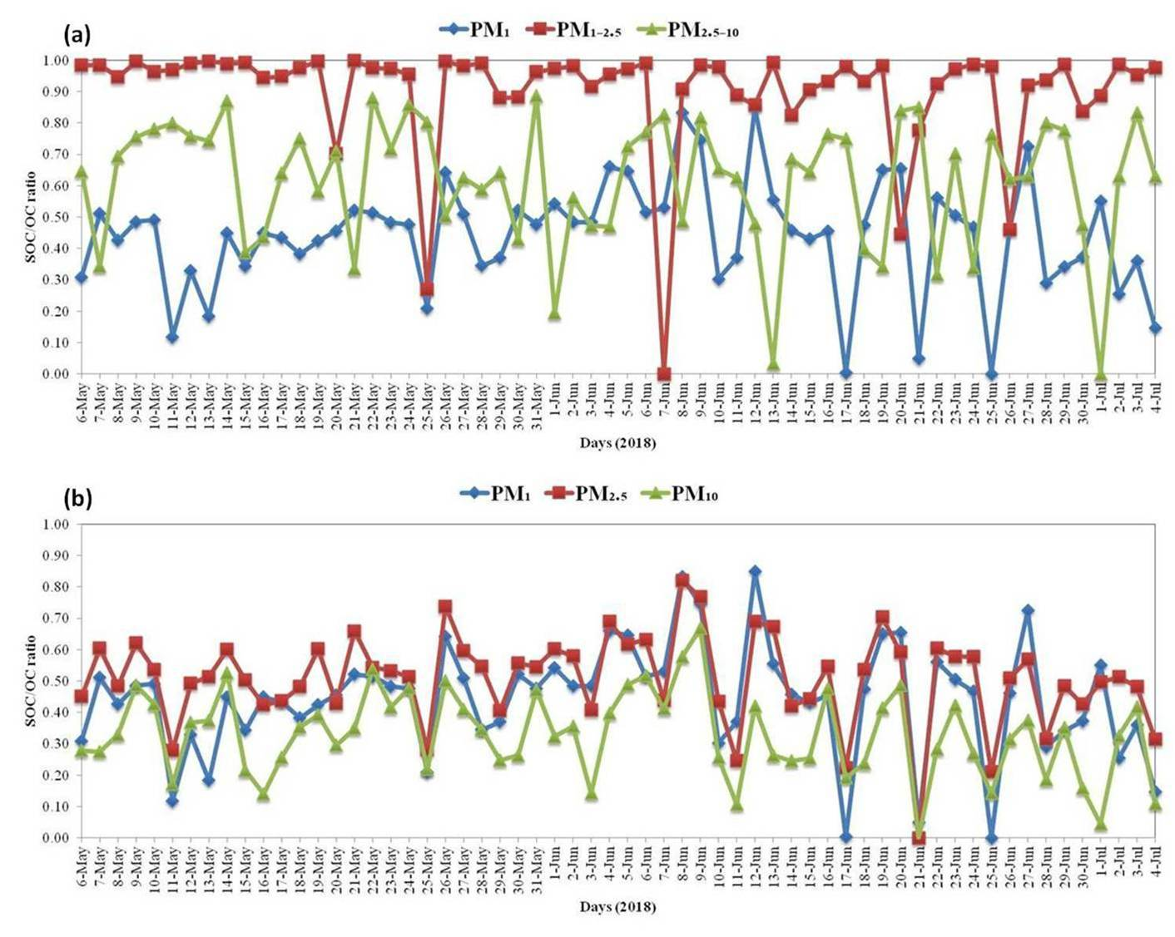

**Figure S11.** SOC/OC temporal trends: (a) for PM fractions and (b) for PM sizes.

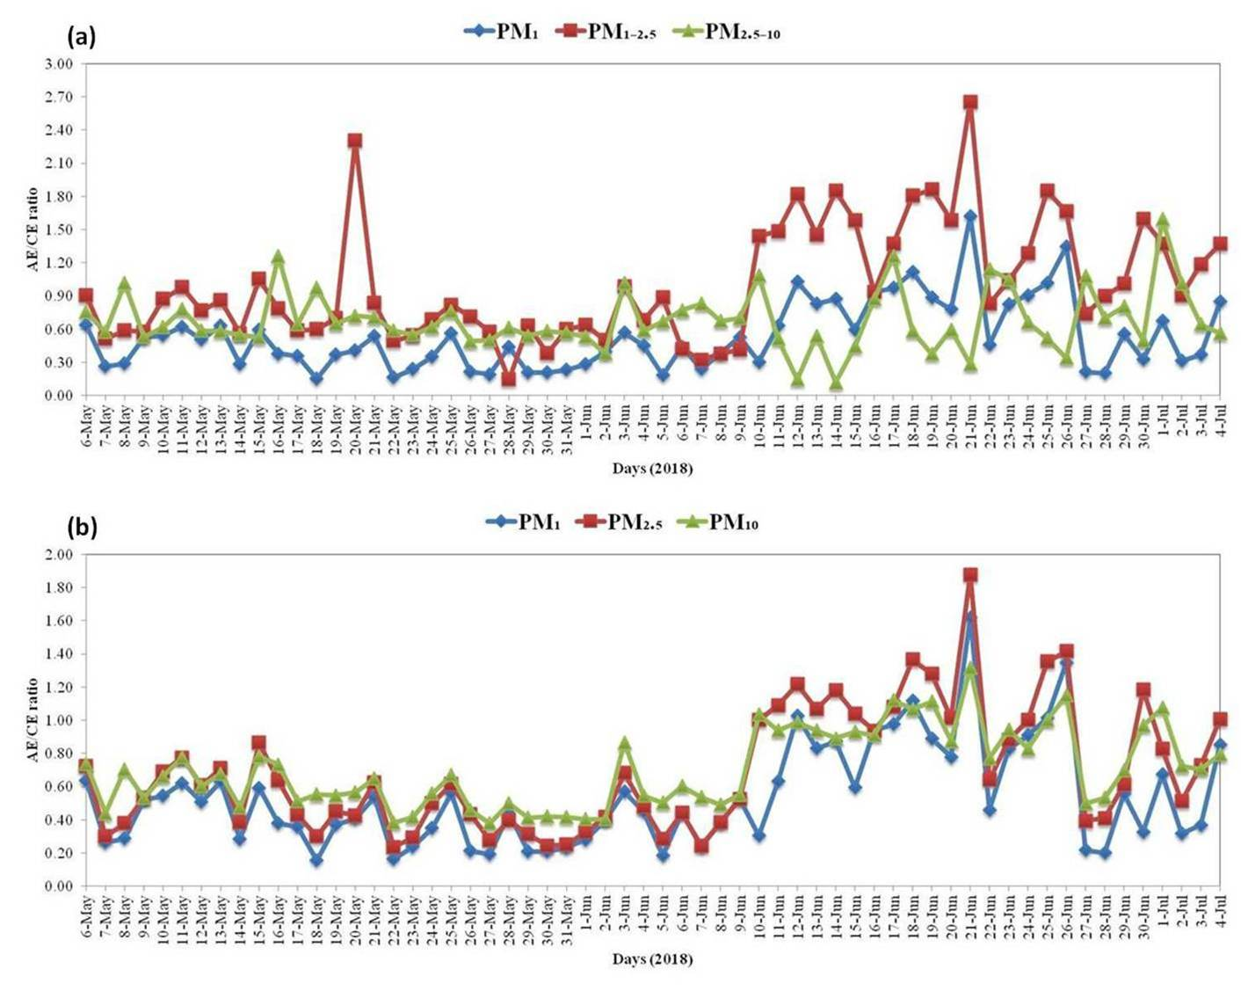

**Figure S12.** AE/CE temporal trends: (a) for PM fractions and (b) for PM sizes.

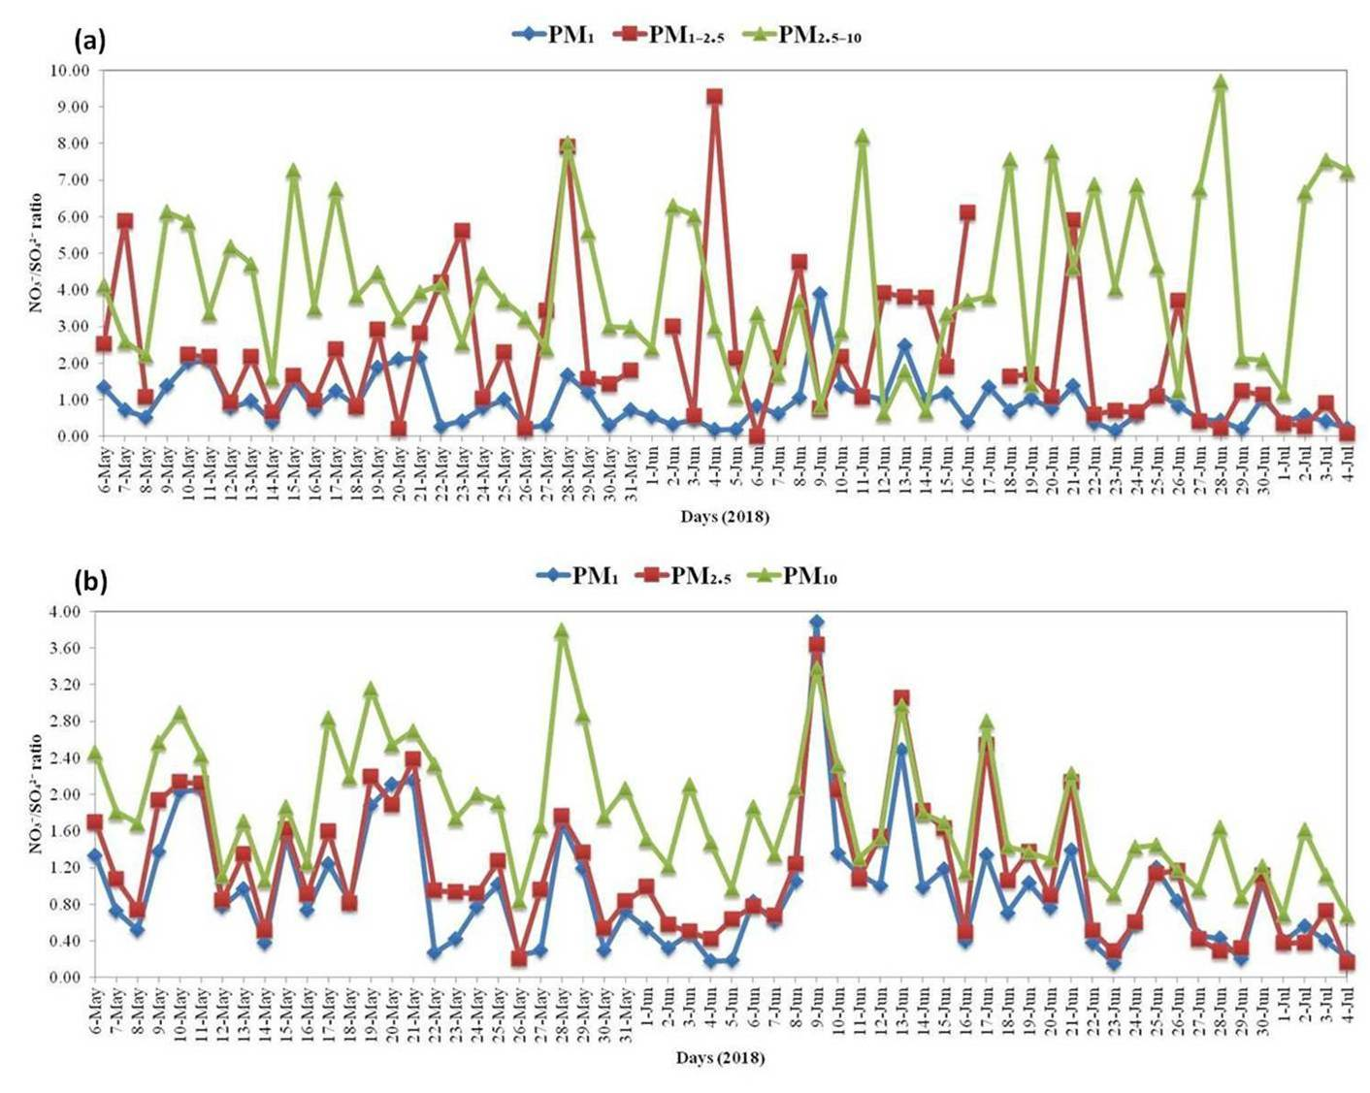

**Figure S13.** NO3-/SO42- temporal trends: (a) for PM fractions and (b) for PM sizes.

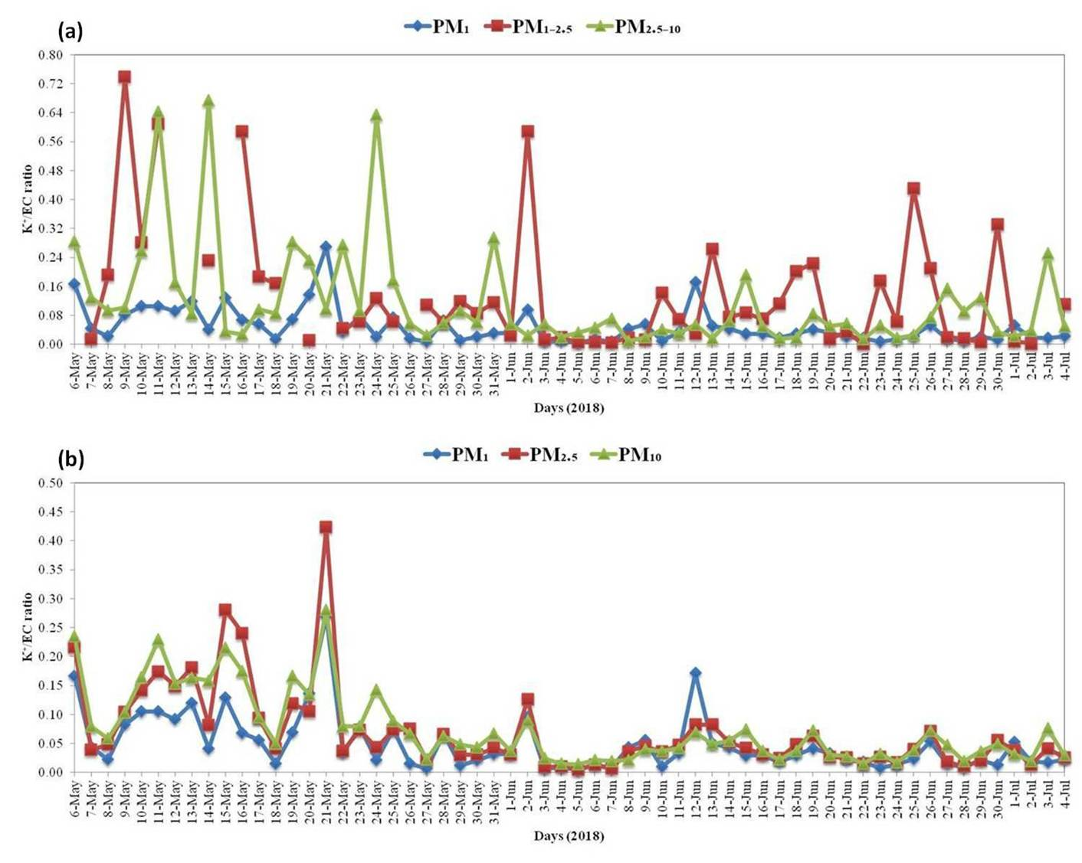

**Figure S14.** K+/EC temporal trends: (a) for PM fractions and (b) for PM sizes.

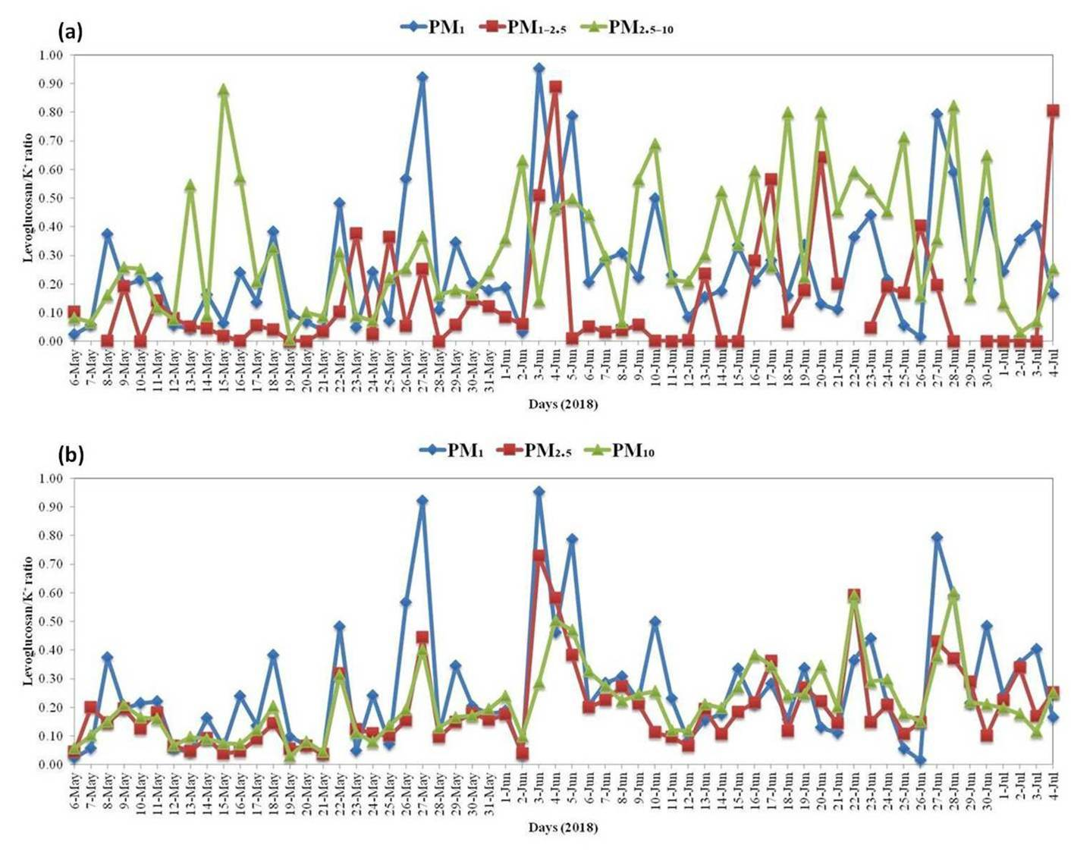

**Figure S15.** Levoglucosan/K+ temporal trends: (a) for PM fractions and (b) for PM sizes.