*Supplementary Materials for:*

**A Perspective of Bark-Water Interactions Across Ecosystem States and Fluxes**

John T. Van Stan1,2*, Salli F. Dymond3, Anna Klamerus-Iwan4

1 Applied Coastal Research Laboratory, Georgia Southern University, Savannah GA, 31411

2 Geology & Geography, Georgia Southern University, Savannah GA, 31419

3 Earth & Environmental Sciences, University of Minnesota, Duluth MN, 55812

4 Forest Utilization, Engineering & Forest Technology, University of Agriculture, Krakow, Poland

**Section S1. Estimation of additional bark surface area due to microrelief.**

A comparison of a smooth (i.e., projected trunk or branch) cylinder surface area per mm of length [mm2 mm-1] against the surface area of a cylinder with bark microrelief [mm2 mm-1] was done using past data from high-resolution trunk lidar (LaserBark: Van Stan et al., 2009) scans of oak and beech (Van Stan et al., 2016) and pine trees (Gutmann et al., 2017). To approximate bark surface area as a uniform cylinder, bark surface laser scans are fitted using a circle fitting routine (Pratt, 1987). This approach does well to approximate the mean radius of a branch, but aliases surface area created by relief along the bark surface. An alternative approach to approximate surface area is to calculate the arclength along the laser scan of the bark surface using piecewise continuous cubic spline fit to survey data. Arclength is calculated actual distance along the path of the undulating bark surface. In this analysis, laser scans include three pine, ten beech, and nine oak surveys. For comparison, a regression model (*y* = *m \** *x*), is applied to each tree type in Figure S1. In the case of Beech trees, the nominal bark roughness causes fitted circular circumference to scale nearly directly proportionally to the arclength of the laser survey (Fig. S1). Indeed, the mean arclength of 1396.5 mm is ~1.22% away from the slightly smaller mean fitted circumference of 1379.6 mm. Pine trees, however, show just under 10% more surface area as computed via arclength estimates when compared with a given circular circumference. On average, the arclength of the pine bark scans is 663.5 mm and the fitted circumference is 606.1 mm, therefore, applying a circular circumference reduces the actual bark surface area by 9.5% per unit stem length. However, in the case of oak trees, the relatively high rugosity of the bark surface yields approximately 16% more surface area per unit length of stem when compared to a given fitted circumference (Fig. S1). The mean fitted circumference is 1179.1 mm and the mean arclength is 1366.8 mm, giving an error of just under 16%.

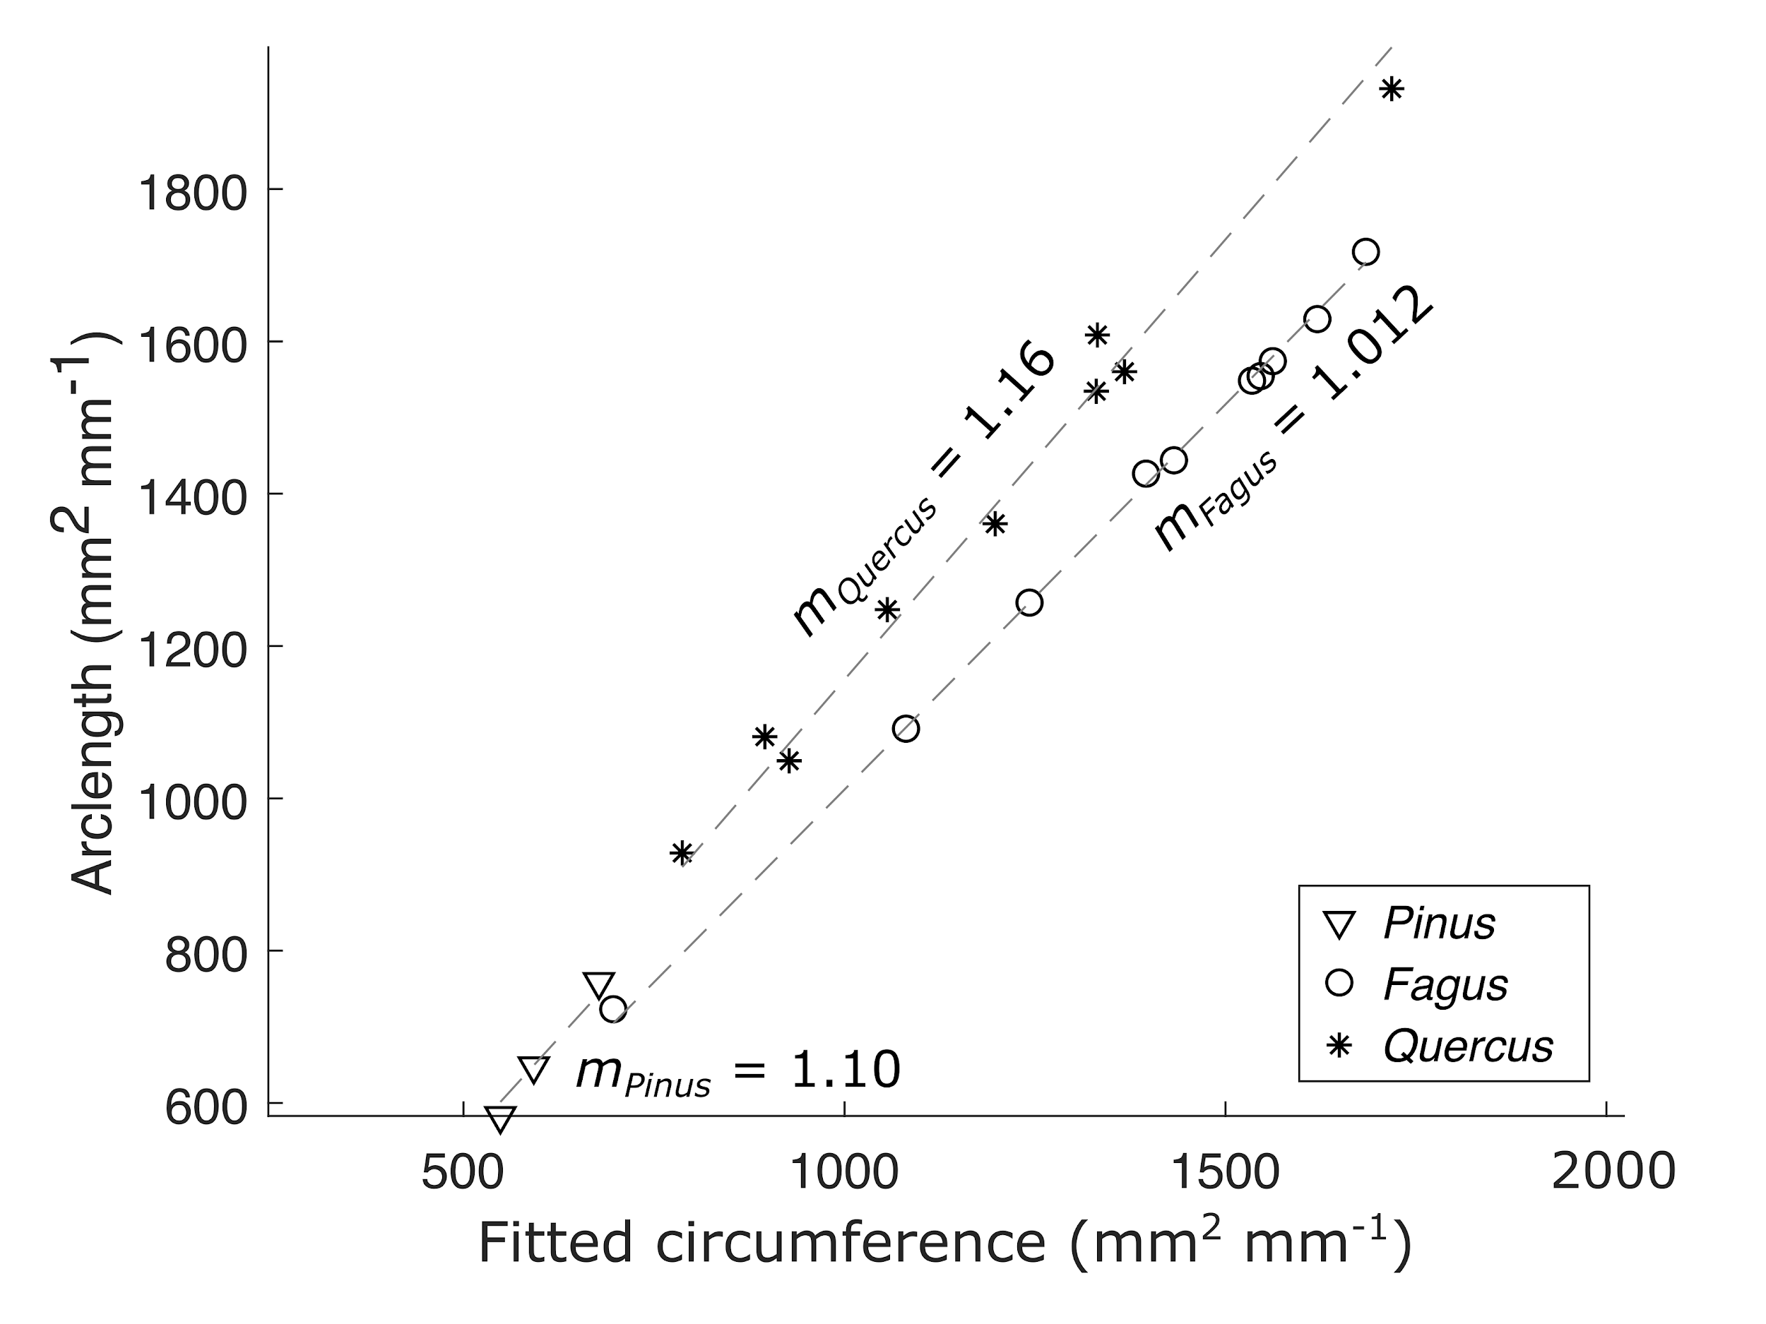

**Figure S1.** Area per arclength computed from piecewise continuous cubic spline interpolants shown as a function of area per circumference computed by circles fitted to bark surface laser scans.

***References.***

Gutmann, E. D., Van Stan II, J. T., Friesen, J., Aubrey, D. P., & Lundquist, J. (2017). Observed compression of in situ tree stems during freezing. *Agricultural and Forest Meteorology*, *243*, 19-24.

Pratt, V. (1987). Direct least-squares fitting of algebraic surfaces. *ACM SIGGRAPH computer graphics*, 21(4), 145-152.

Van Stan, J. T., Jarvis, M. T., & Levia, D. F. (2009). An automated instrument for the measurement of bark microrelief. *IEEE Transactions on Instrumentation and Measurement*, *59*(2), 491-493.

Van Stan, J. T., Lewis, E. S., Hildebrandt, A., Rebmann, C., & Friesen, J. (2016). Impact of interacting bark structure and rainfall conditions on stemflow variability in a temperate beech-oak forest, central Germany. *Hydrological Sciences Journal*, *61*(11), 2071-2083.