APPENDIX A: TAKI PSEUDOWORDS USED IN THE ORAL TESTS: PHONEMIC
TRANSCRIPTIONS AND ENGLISH TRANSLATION*

Pretest: Target words and distractors
/st/ |  | /sn/ |  | /sl/
stukab | clarinet | snapib | microwave oven | slakap | radio
stinup | orange | snomip | toothbrush | slimub | map
stibut | envelope | snumat | light bulb | slugad | garlic
stemid | chicken | snagud | telephone | slobit | egg
stamik | dress | snipuk | hot dog | slegak | hat
stopug | glasses | snetag | spider | slubig | sandwich
Distractors
isnoka | pineapple | istedu | screwdriver | kopa | binoculars
islepi | sword | muki | truck | sutu | cigarette

Posttest: Target words and distractors
/st/ |  | /sn/ |  |  | /sl/
stunap | motorcycle | snotip |  | bottle | slekab | carrot
stagib | ball | snikub |  | flip flops | slagup | tiger
stimut | kite | snukid |  | onion | slopat | printer
stekud | helmet | snapit |  | credit card | slumid | money
stapak | foot | snobuk |  | cup | slibug | iron
stunig | briefcase | snudig |  | saxophone | slenak | hammock
Distractors
isnadu | spoon |  | istodi | turntable | kapi | shorts
islika | earrings |  | toku | eye | mida | USB key

Delayed posttest: Target words and distractors
/st/ |  |  | /sn/ |  | /sl/
stakub | banana |  | snikab | knife | sledib | book
stenup | escalator |  | snugip | laptop | slokap | flag
stogud | trumpet |  | sneput | backpack | slibad | mosquito
stumit | elephant |  | snigat | key chain | slupid | fan
stimag | jacket |  | snabuk | lion | sliguk | ring
stupig | drum |  | snomak | bicycle | slamig | socks
Distractors
isnepi | camera | istaku |  | latter | kipu | stapler
islota | mirror | neki |  | newspaper | suda | calculator

* In addition to the 18 target sC-initial words (6 st, 6 sn, 6 sl), each test included six distractors that consisted of unrelated non sC-initial pseudowords (e.g., neki, isnadu). To aid learning and recall, these words were presented to the participants (in both instruction and tests) accompanied by their associated pictorial representations (as shown in Appendix B) so that the participants could establish word-to-meaning associations. The tests, however, did not assess the acquisition of vocabulary and associated meaning.
APPENDIX B: TAKI PSEUDOWORDS USED IN A TEACHING SESSION
(M GROUP): A SAMPLE*

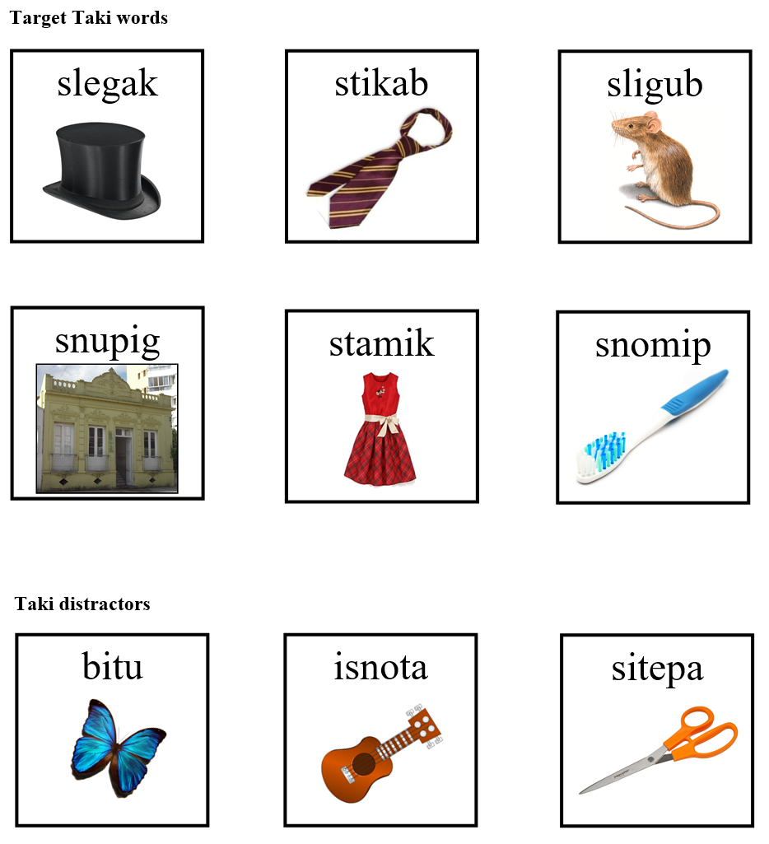

* The Taki words illustrated above were utilized in one of the classes taught in Mixed Group (M). A similar format was adopted for Groups P and T. The images used in this study were downloaded from http://openclipart.org or searched via the http://yotophoto.com search engine (now defunct). According to Yotophoto, they are not subject to copyright: “Yotophoto is a search engine for free-to-use stock photographs and images. These are images that are either in the Public Domain or released under generous Creative Commons, or similar licenses […] to help educators, bloggers and digital artists find photos they can use”.

