**Supplementary Data Sheet 4**

**Village clusters**

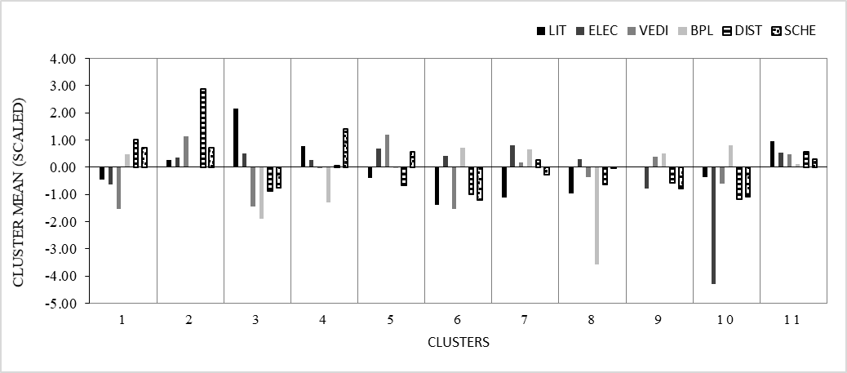 **Figure 1: Cluster Means for variables under ‘socio-economic’ category**

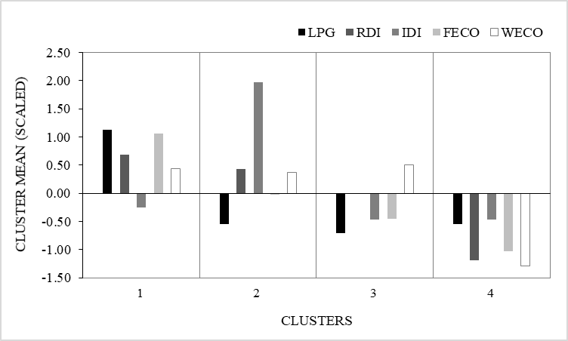

**Figure 2: Cluster Means for variables under ‘Ecosystem Values and Dependence’ category**

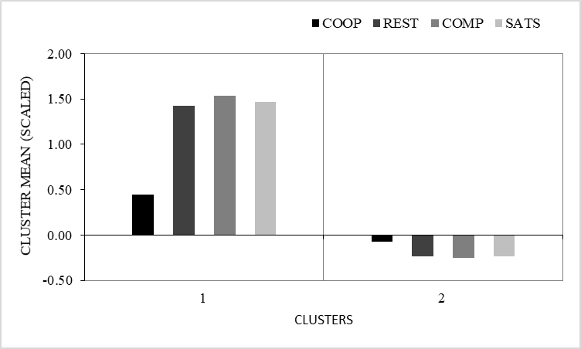

**Figure 3: Cluster Means for variables under ‘Relationship with Forest Department’ category**

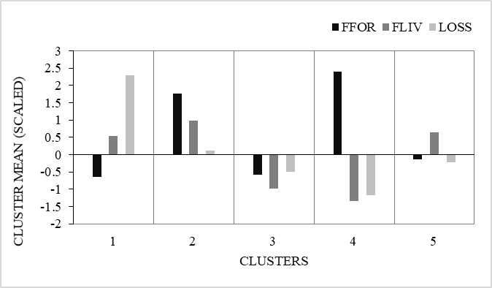

**Figure 4: Cluster Means for variables under ‘Fear and Losses’ category**

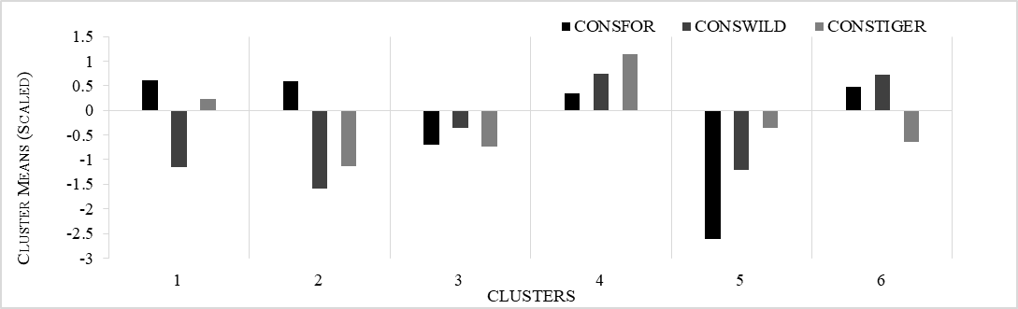

**Figure 5: Cluster Means for variables under ‘Attitude towards conservation’ category**