**Supplementary materials**

**Supplementary table S1. Primers used in this study**

|  |  |
| --- | --- |
| **Target gene** | **Sequences** |
| F-EV71/4643-3D | 5’-CCAAGATGAGCATGGAGGAT 3’ |
| R-EV71/4643-3D | 5’GATCTTGTCGATGGCCCTAA 3’ |
| F-Luc | 5’ CGTTATTTATCGGAGTTGCAGTTG 3’ |
| R-Luc | 5’ AAATCCCTGGTAATCCGTTTTAGA 3’ |
| F-GAPDH | 5’ GTATTGGGCGCCTGGTCACC 3’ |
| R-GAPDH | 5’ CGCTCCTGGAAGATGGTGATGG 3’ |
| F-HSPA6 | 5’GAGGAGGTGGAGAGGATGGTTCA 3’ |
| R-HSPA6 | 5’GCCTGTCCTCTTCGGGAATCTTG 3’ |

**Supplementary figures**

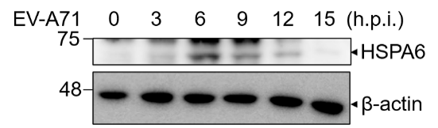

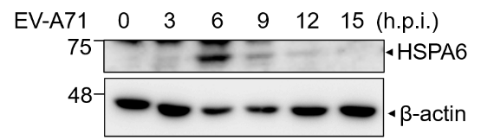

**Supplementary Figure S1. Biological replica for Figure 1A.** Two additional sets of the Western analyses showing that HSPA6 protein is induced upon EV-A71 infection.

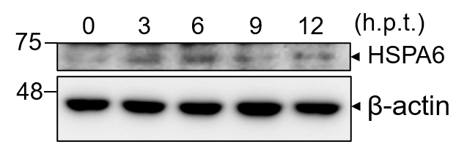

**Supplementary Figure S2. RNA transfection induced HSPA6 protein expression in RD cells.** Wild-type RD cells were transfected with IRES-Luc. Cells were harvested at 0, 3, 6, 9, and 12 h post transfection for Western analysis using anti-HSPA6 antibody.

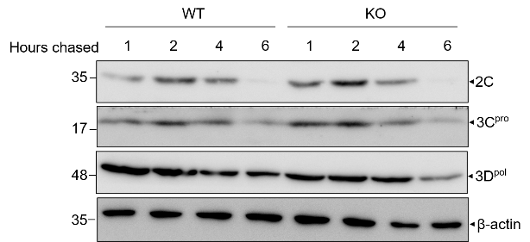

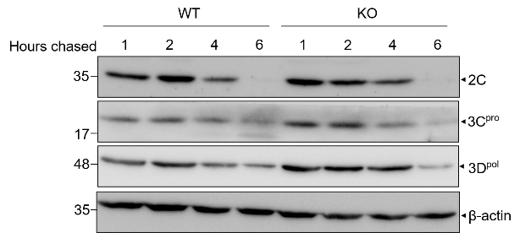

**Supplementary Figure S3. Biological replica for Figures 5A, 5B, and 5C.** Two additional sets of the Western analyses showing that knockout of HSPA6 protein did not affect the protein stability of viral proteins 2C,3Cpro, and 3Dpol.