**SI4 Alignment of occludin, MAPK8 and MAPK10 in human**

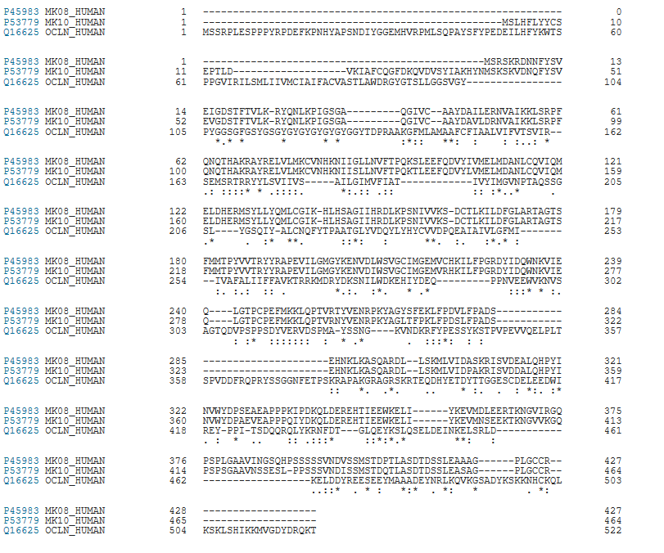

“*” indicating a single and fully conserved residue, “:” indicating residue with very similar properties, “.” indicating residue that is weakly similar.