**SI6 Reports of Occludin Plasmids**

1. Occludin-full length

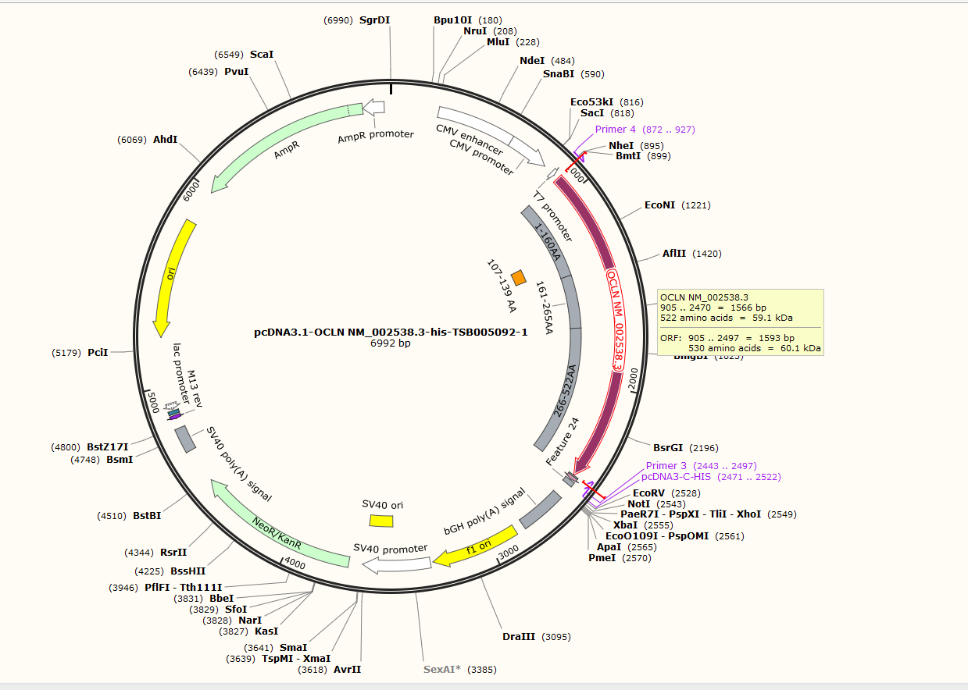

2. Occludin △1-160

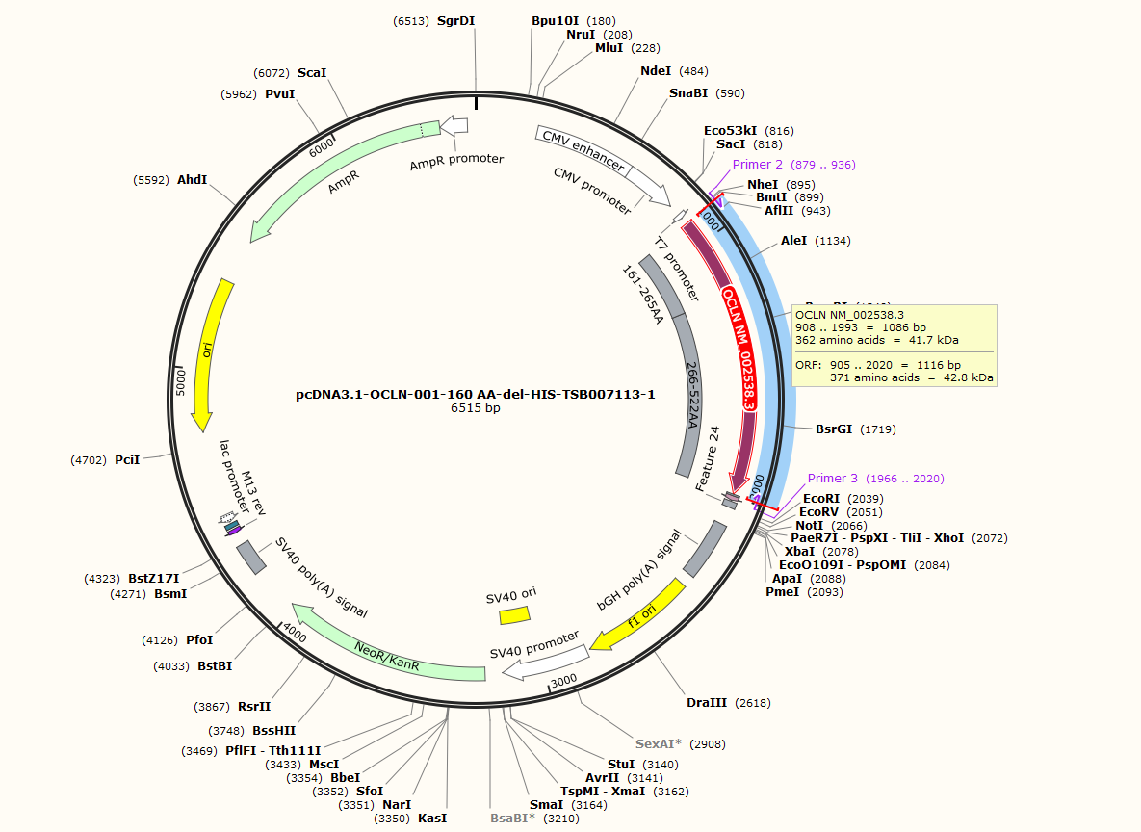

3. Occludin △161-265

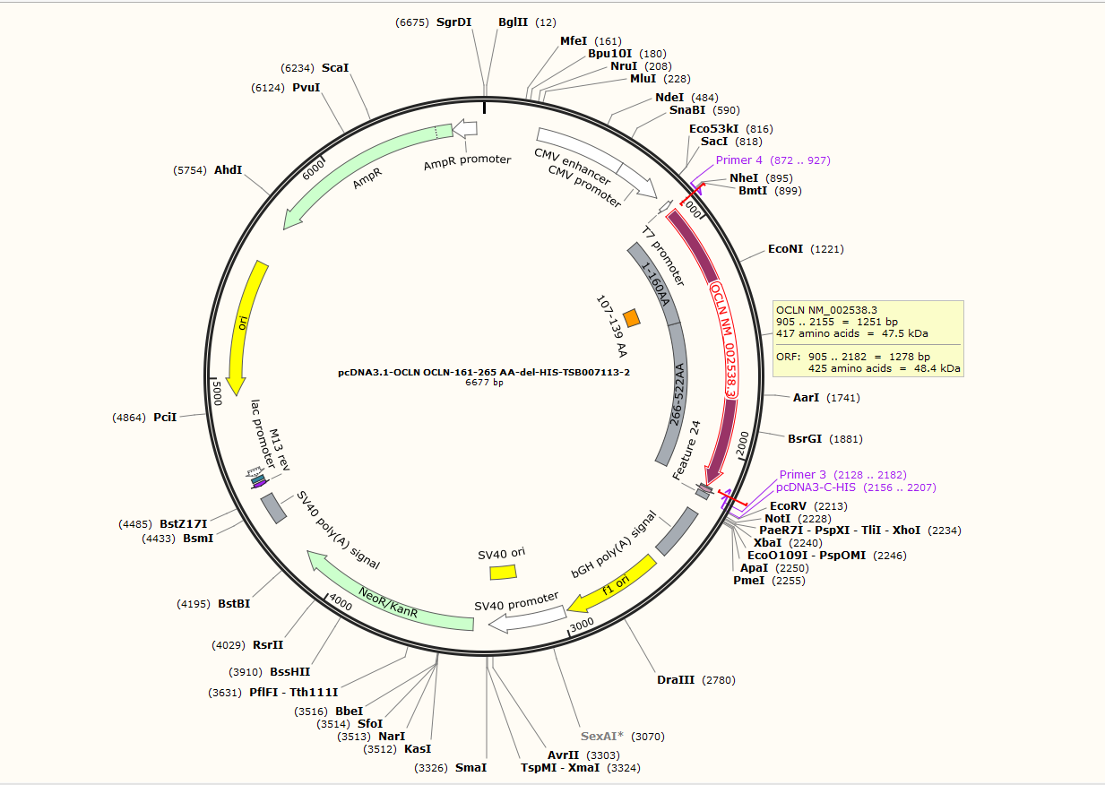

4. Occludin △266-522

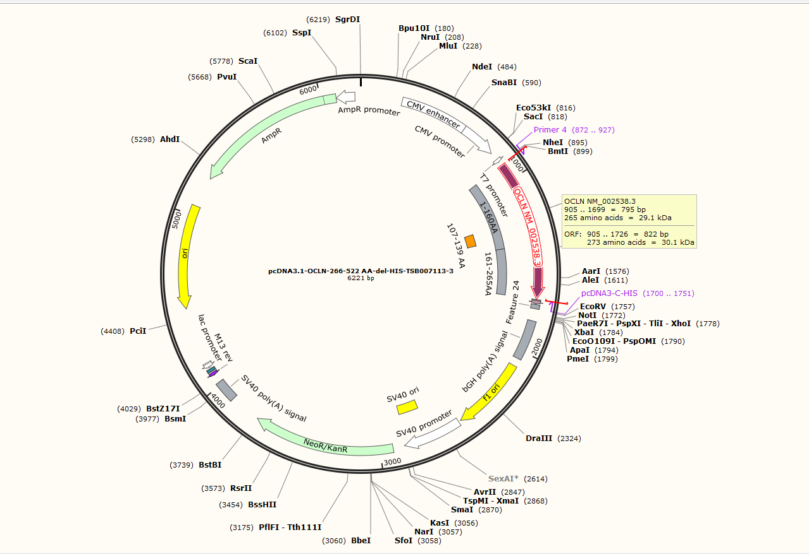

5. Occludin △107-139

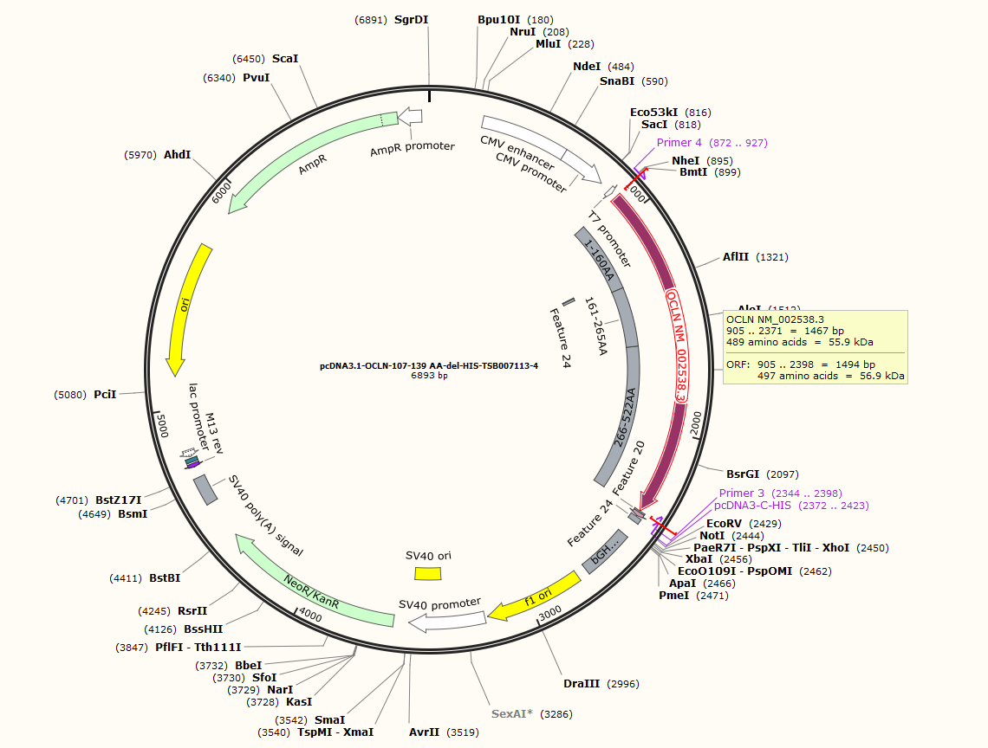

1. Occludin 266-522

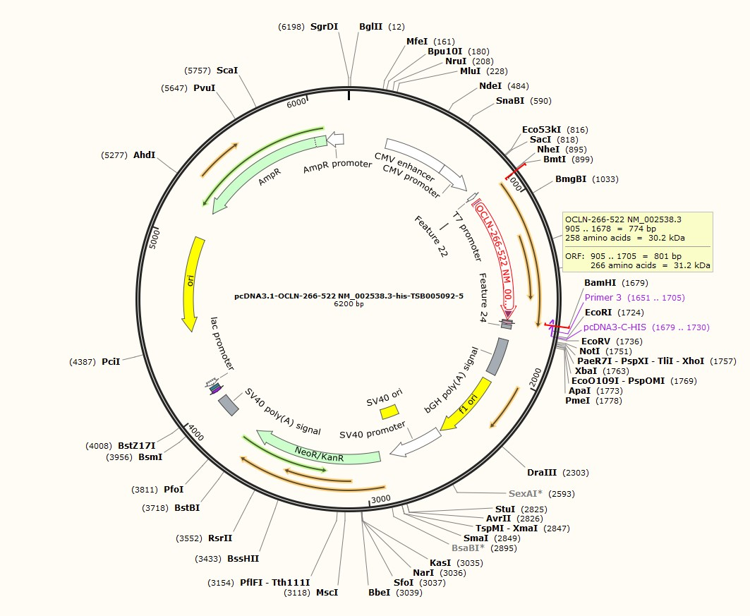

1. Molecular weight of occludin (Del 161-265) calculated the molecular weight using *Peptide and Protein Molecular Weight Calculator*

(https://www.aatbio.com/tools/calculate-peptide-and-protein-molecular-weight-mw)

