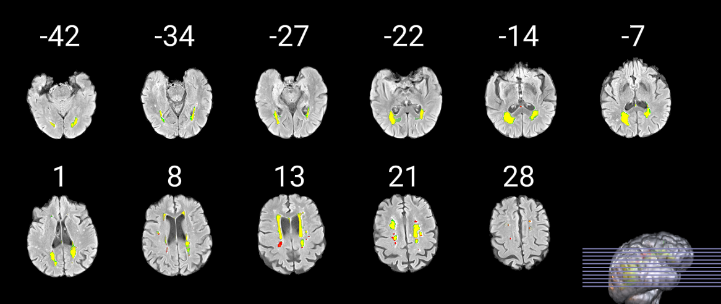

x

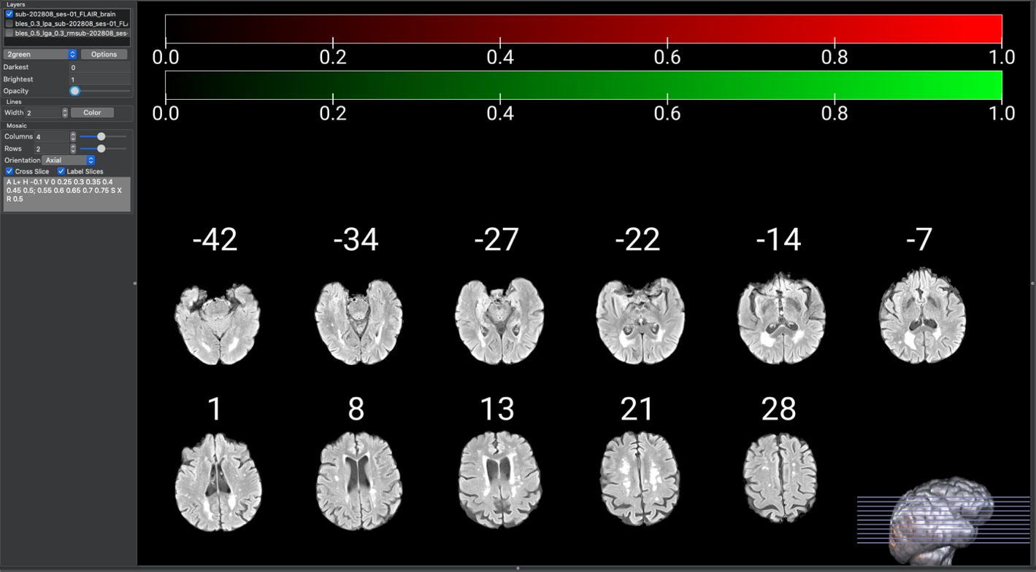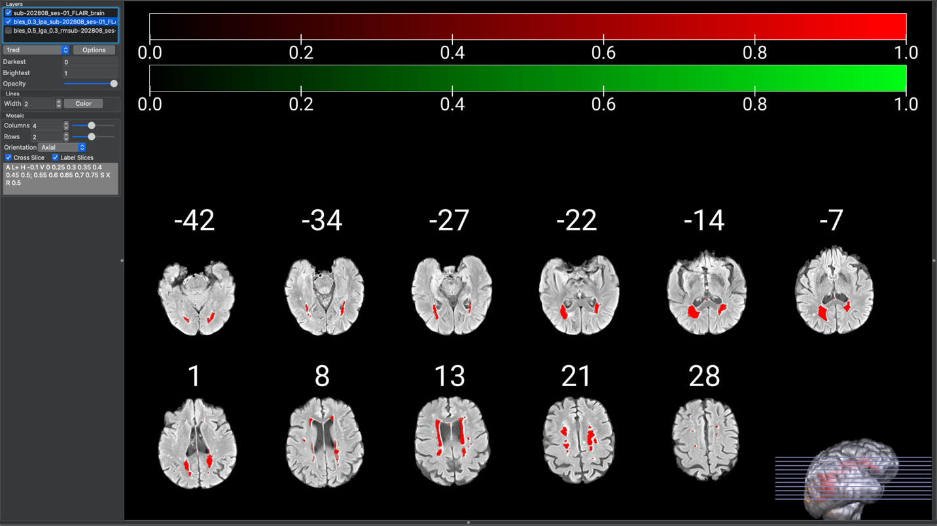

**LESION PREDICTION ALGORITHM, k = 0.3**

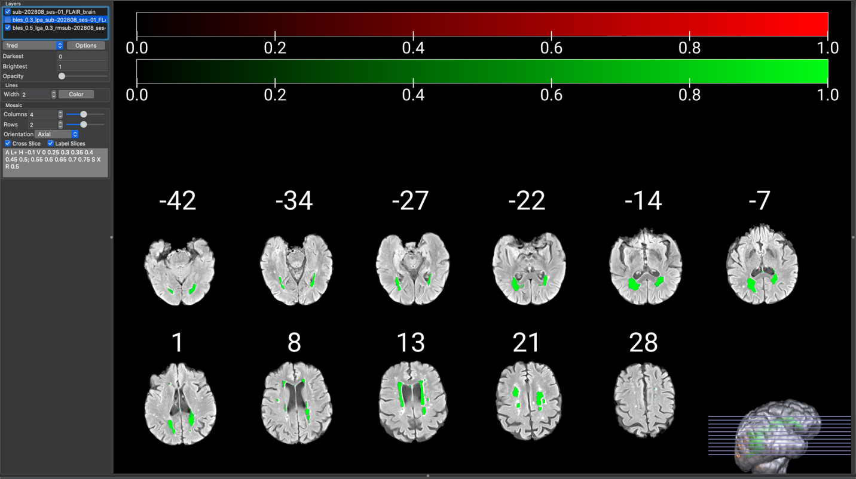

**LESION GROWTH ALGORITHM, k = 0.3**

LESION PREDICTION ALGORITHM

LESION GROWTH ALGORITHM

LESION ALGORITHM OVERLAP

**LESION ALGORITHM OVERLAP**

**Supplemental Figure 1.** Comparison of Lesion Segmentation Tool algorithm, Lesion Prediction Algorithm (LPA) and Lesion Growth Algorithm (LGA).

**REGIONS OF ALGORITHM OVERLAP**