Supplementary Material

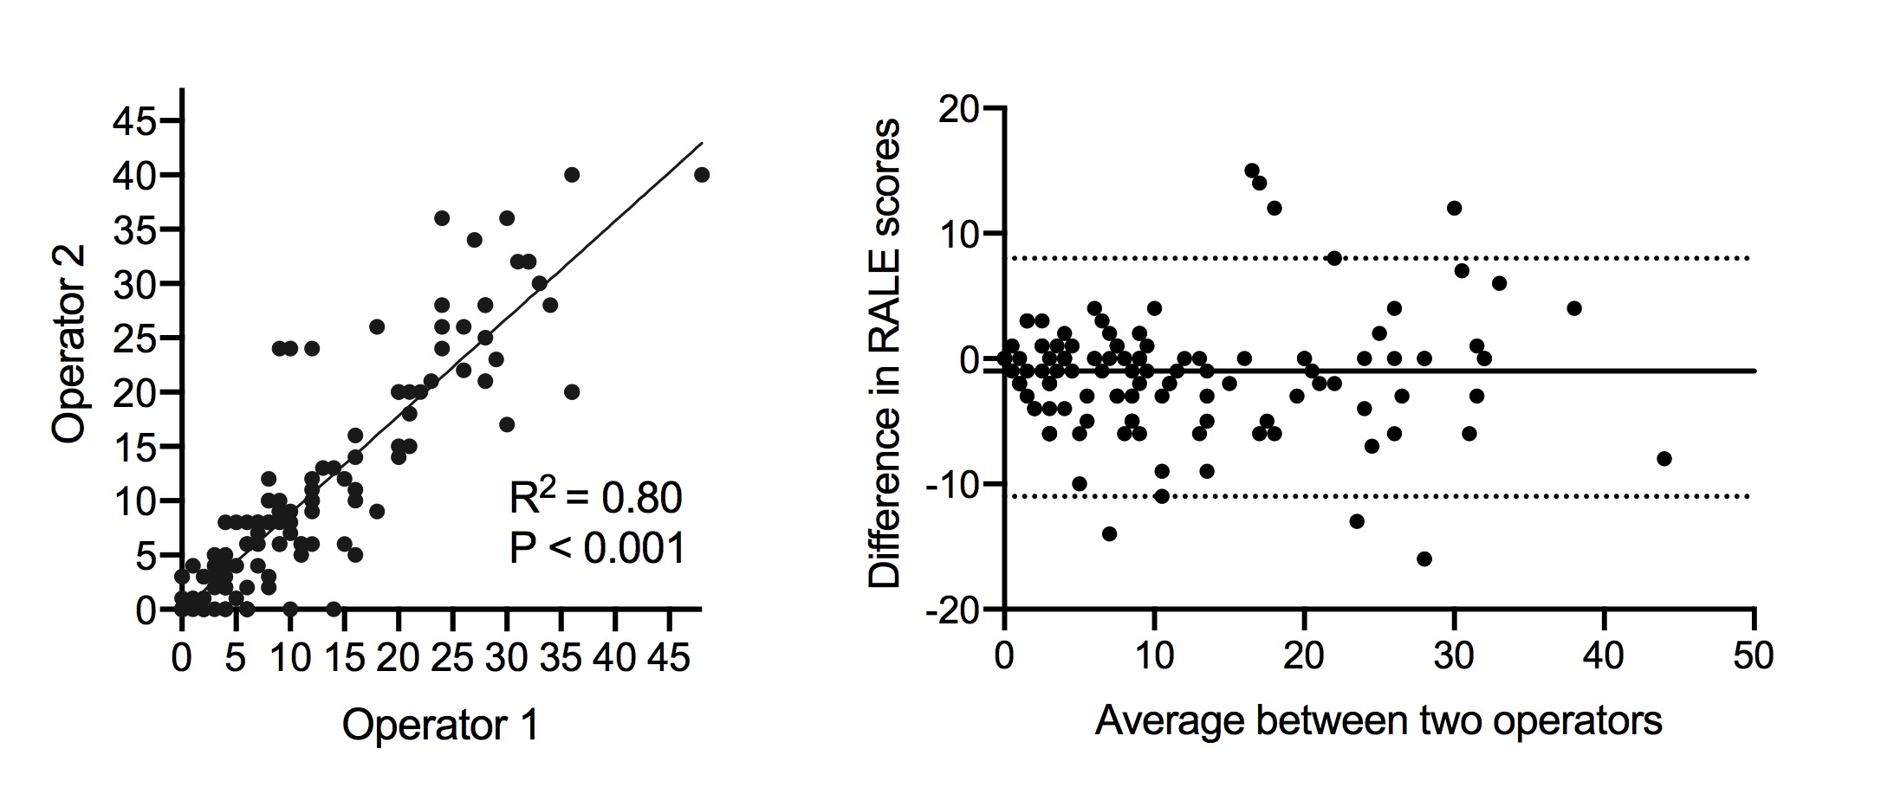

**eFigure 1:** Scatter plot and Bland–Altman plot showing agreement between two independent scorers for the Radiographic Assessment of Lung Edema (RALE) scores on 131 patients. Intraclass correlation coefficient (two-way, consistency type, average measures) among scorers was 0.97 (95% CI 0.94 – 0.98).

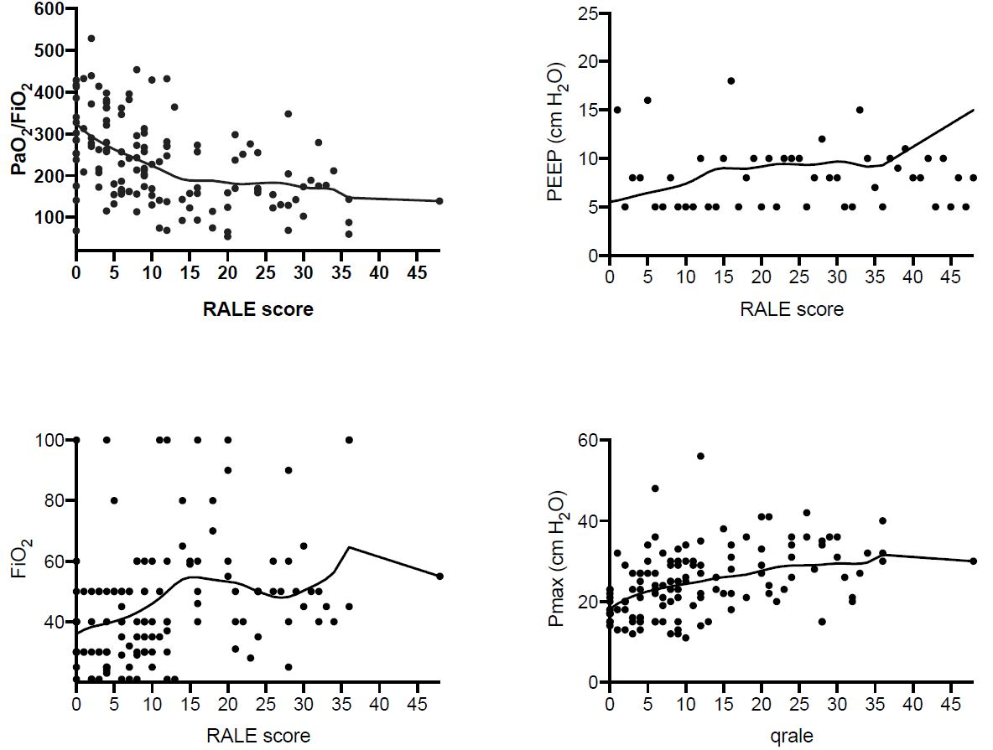

**eFigure 2.** Scatterplots assessing the relationship between the RALE score and PaO2/FiO2, positive end-expiratory pressure (PEEP), FiO2 and maximum airway pressure (Pmax). Locally weighted scatterplot smoothing (LOWESS) lines were fitted to allow trend visualization.

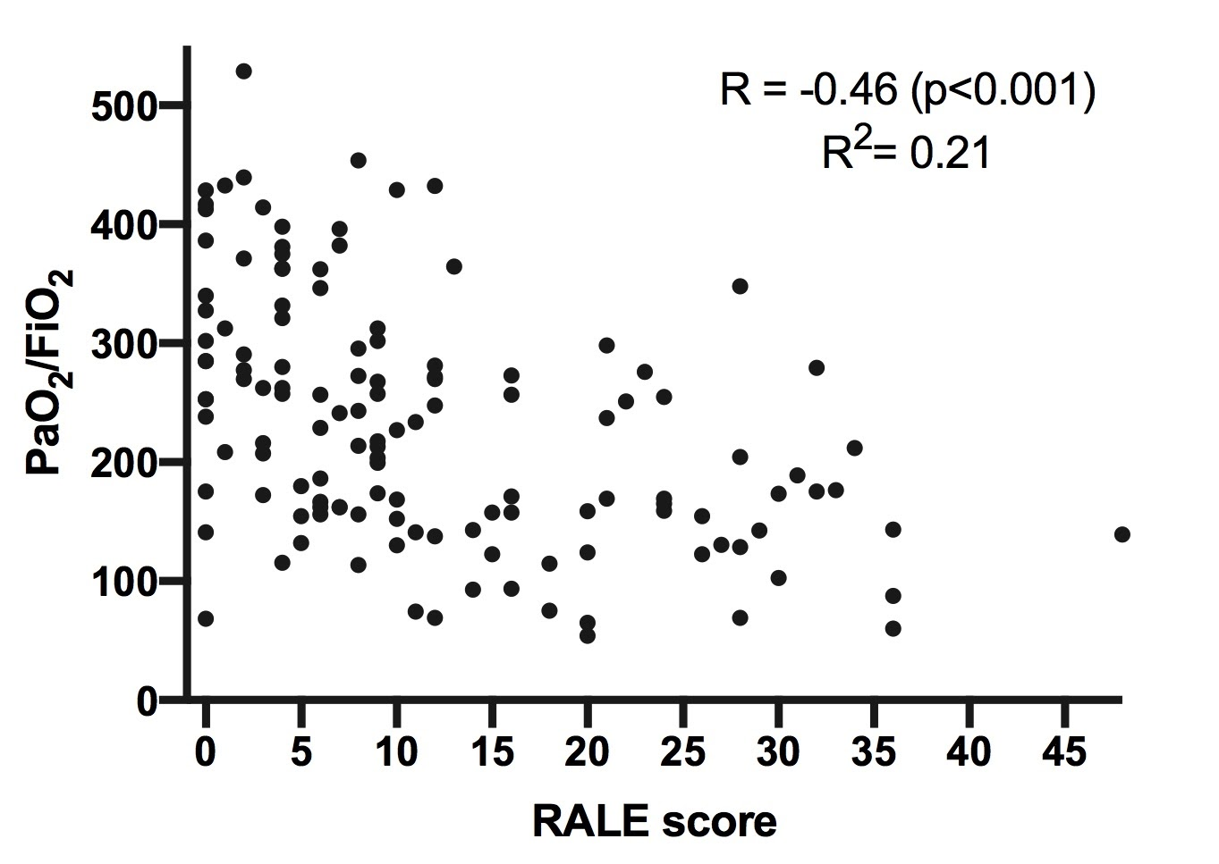

**eFigure 3.** Scatterplot assessing the relationship between the RALE score and the PaO2/FiO2 score in both ARDS and non ARDS patients.