Supplementary Figures
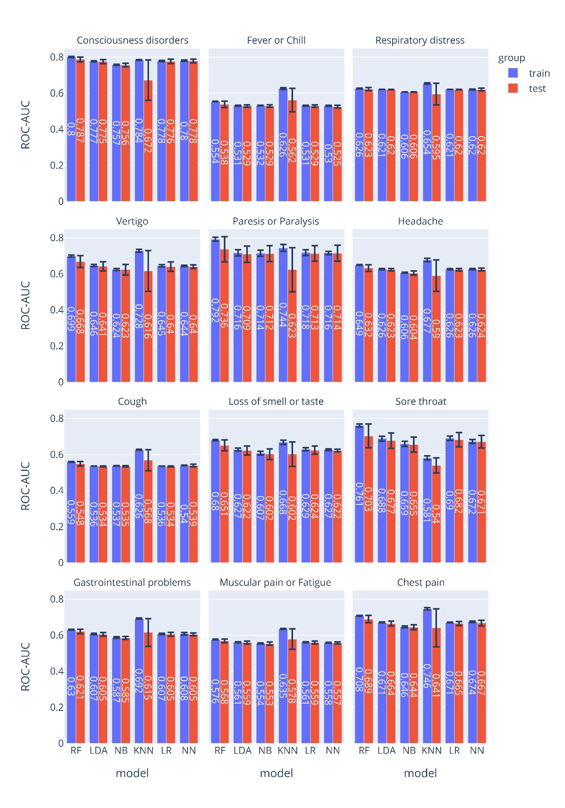
Supplementary Figure 1. ROC-AUCs for specific COVID-19 symptoms.

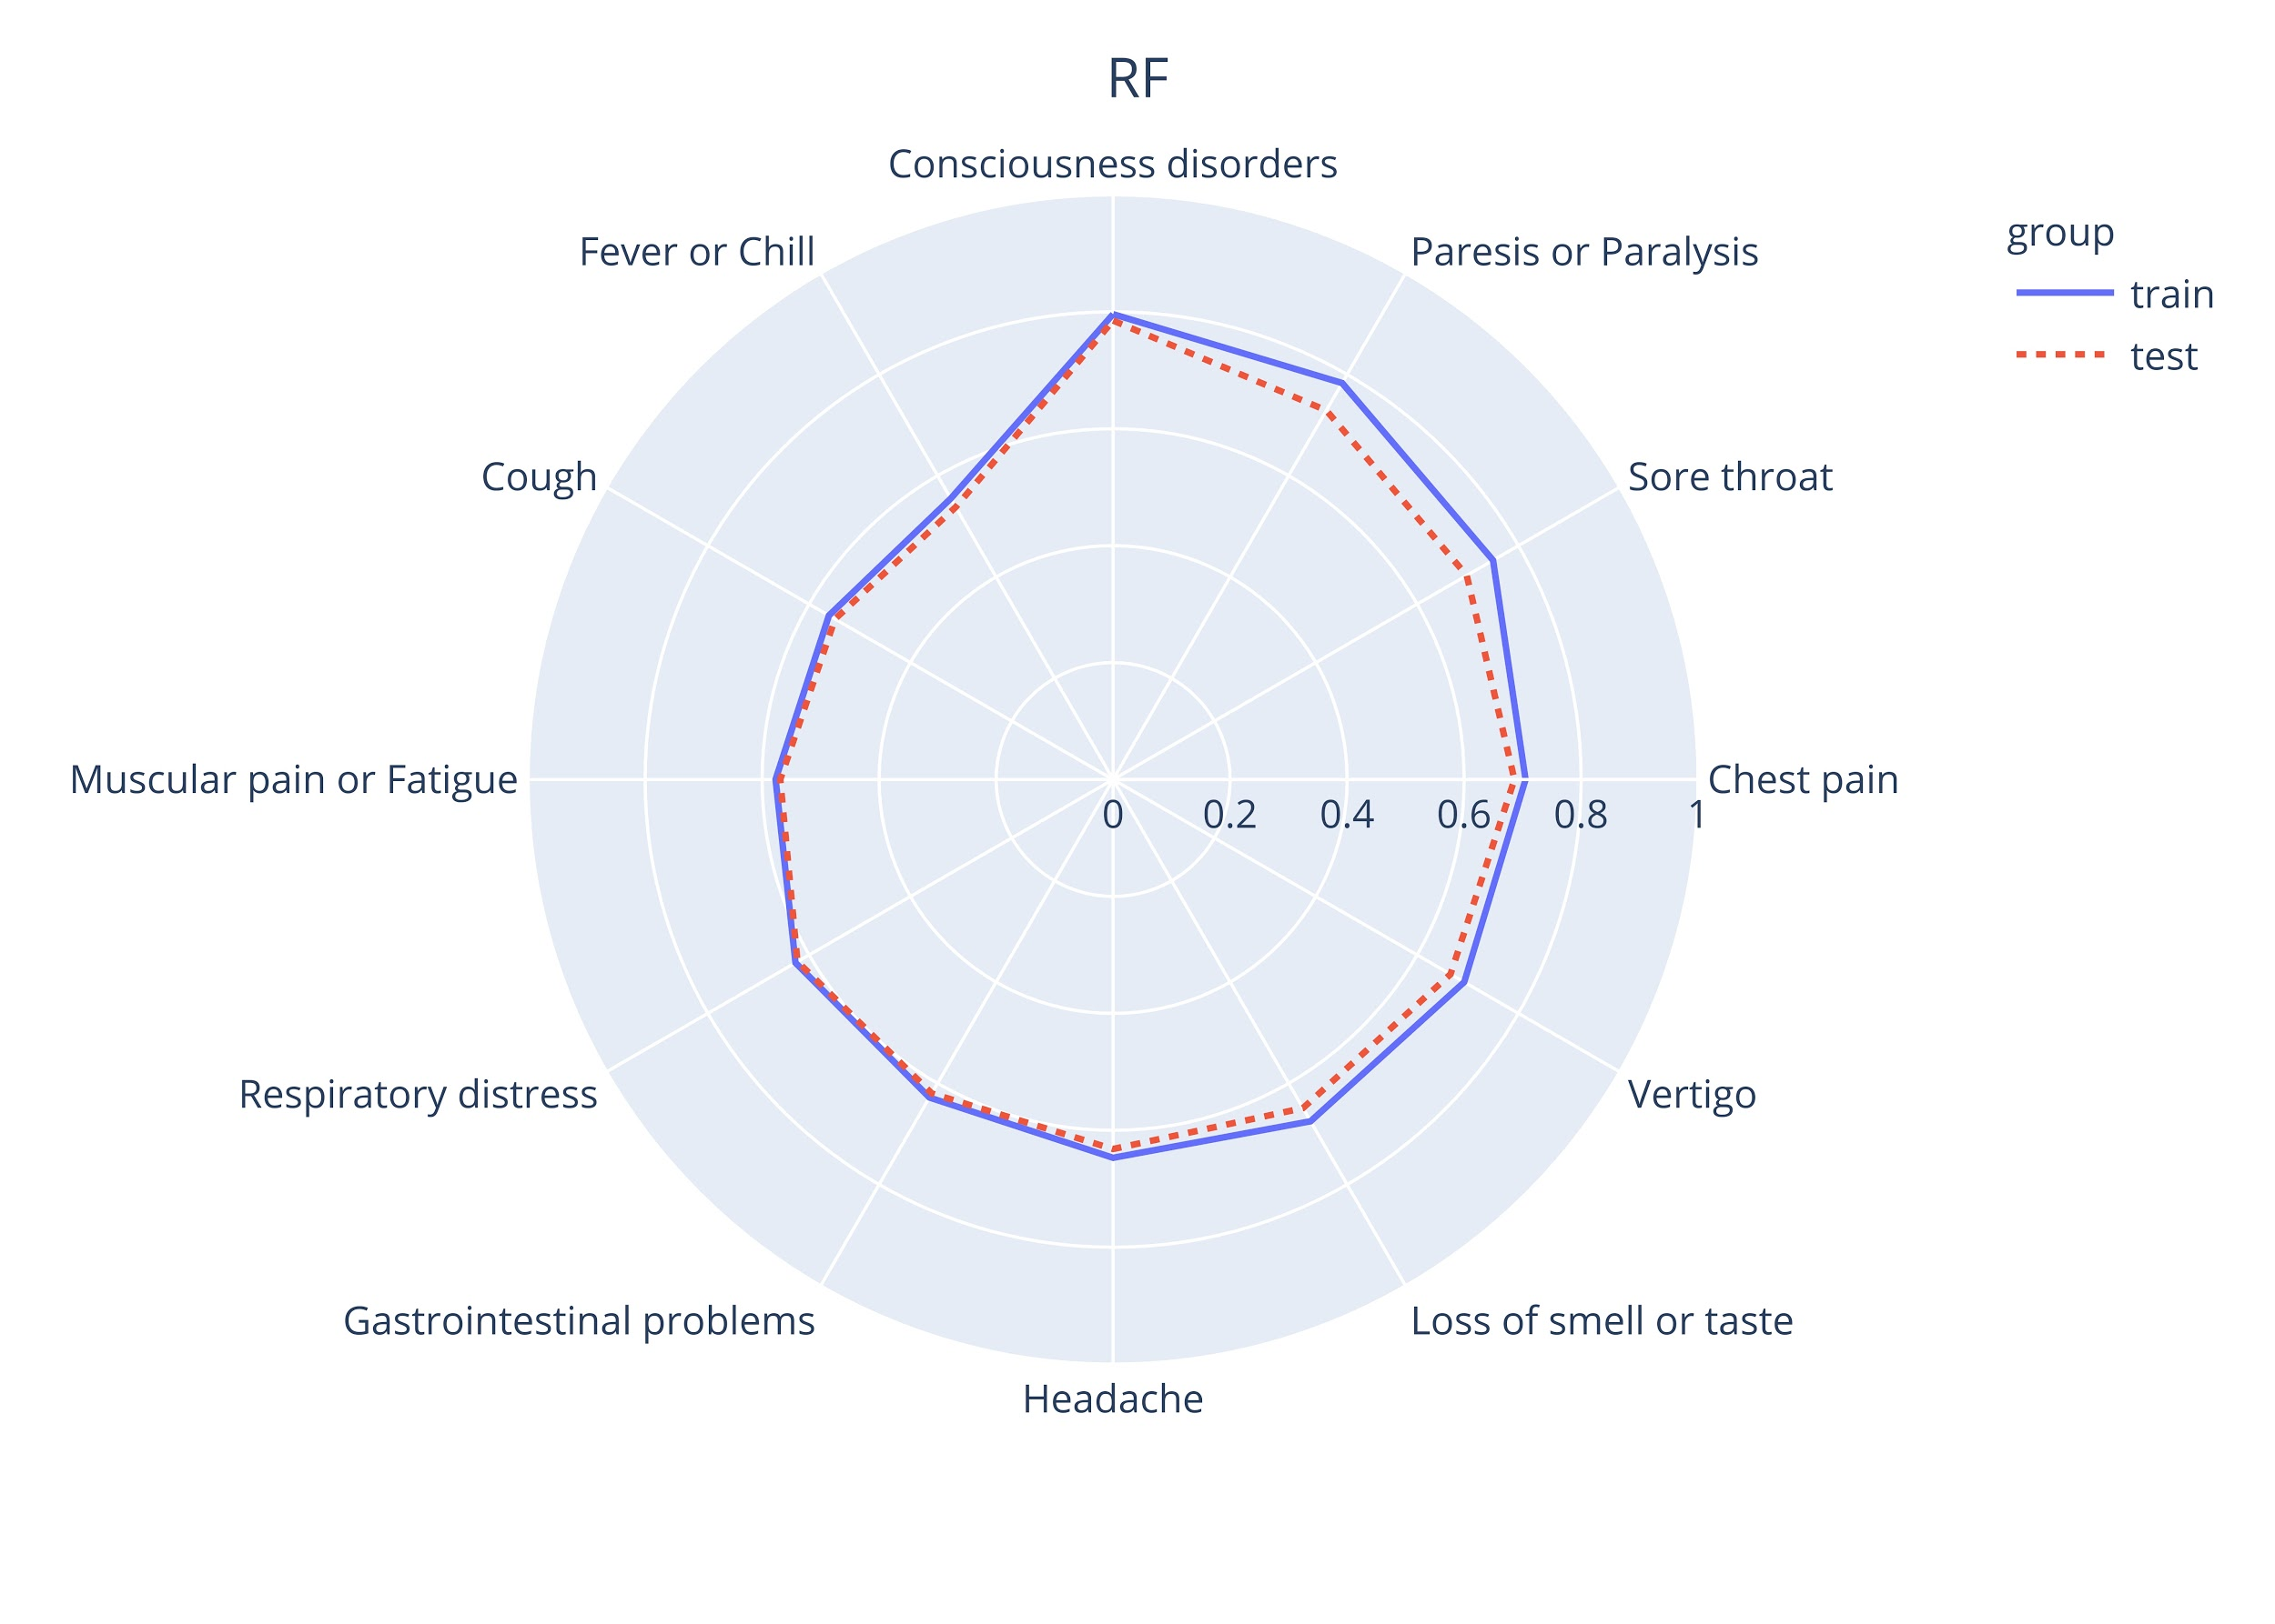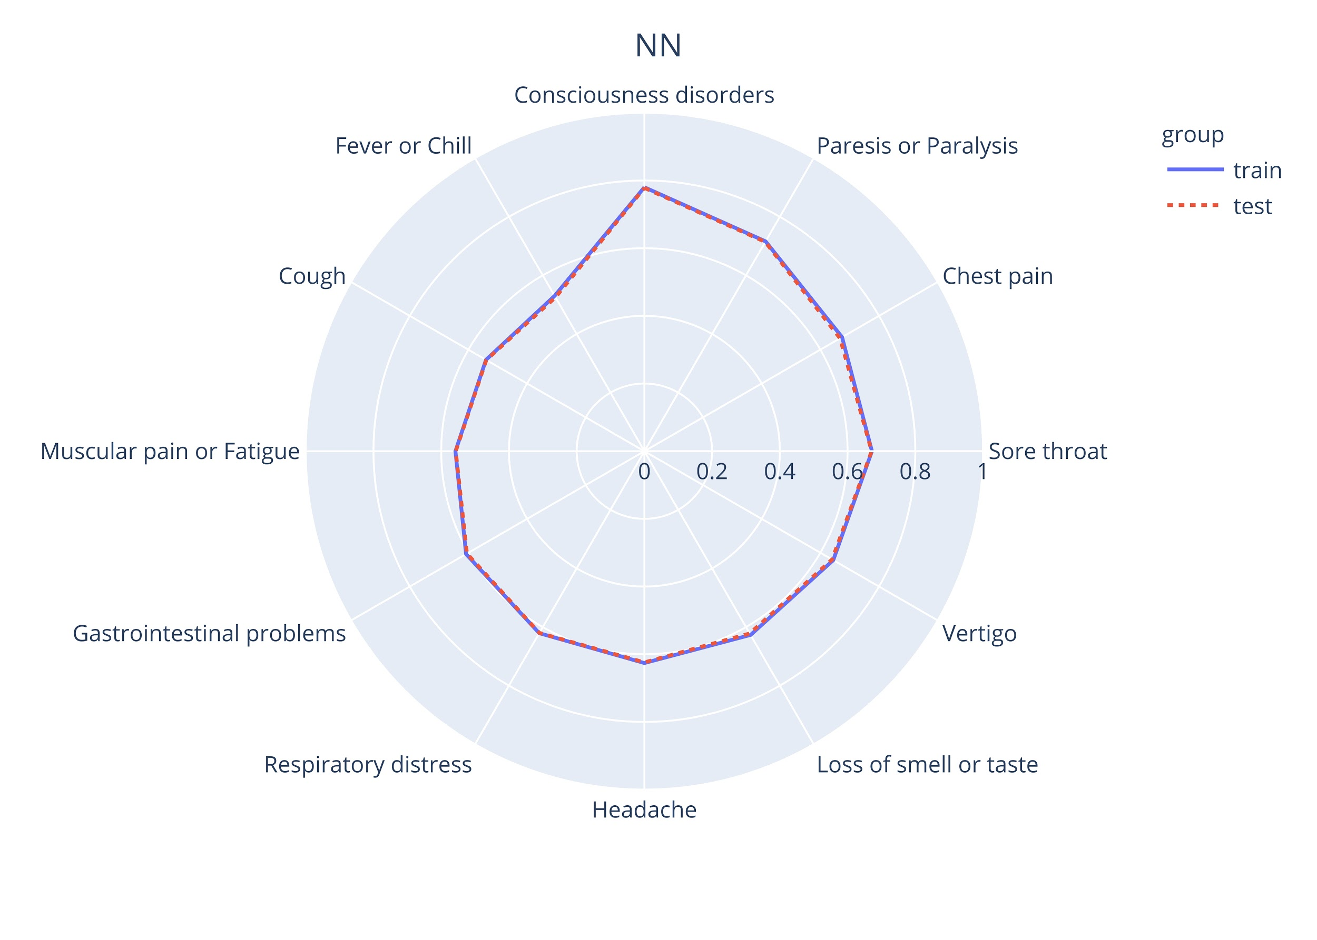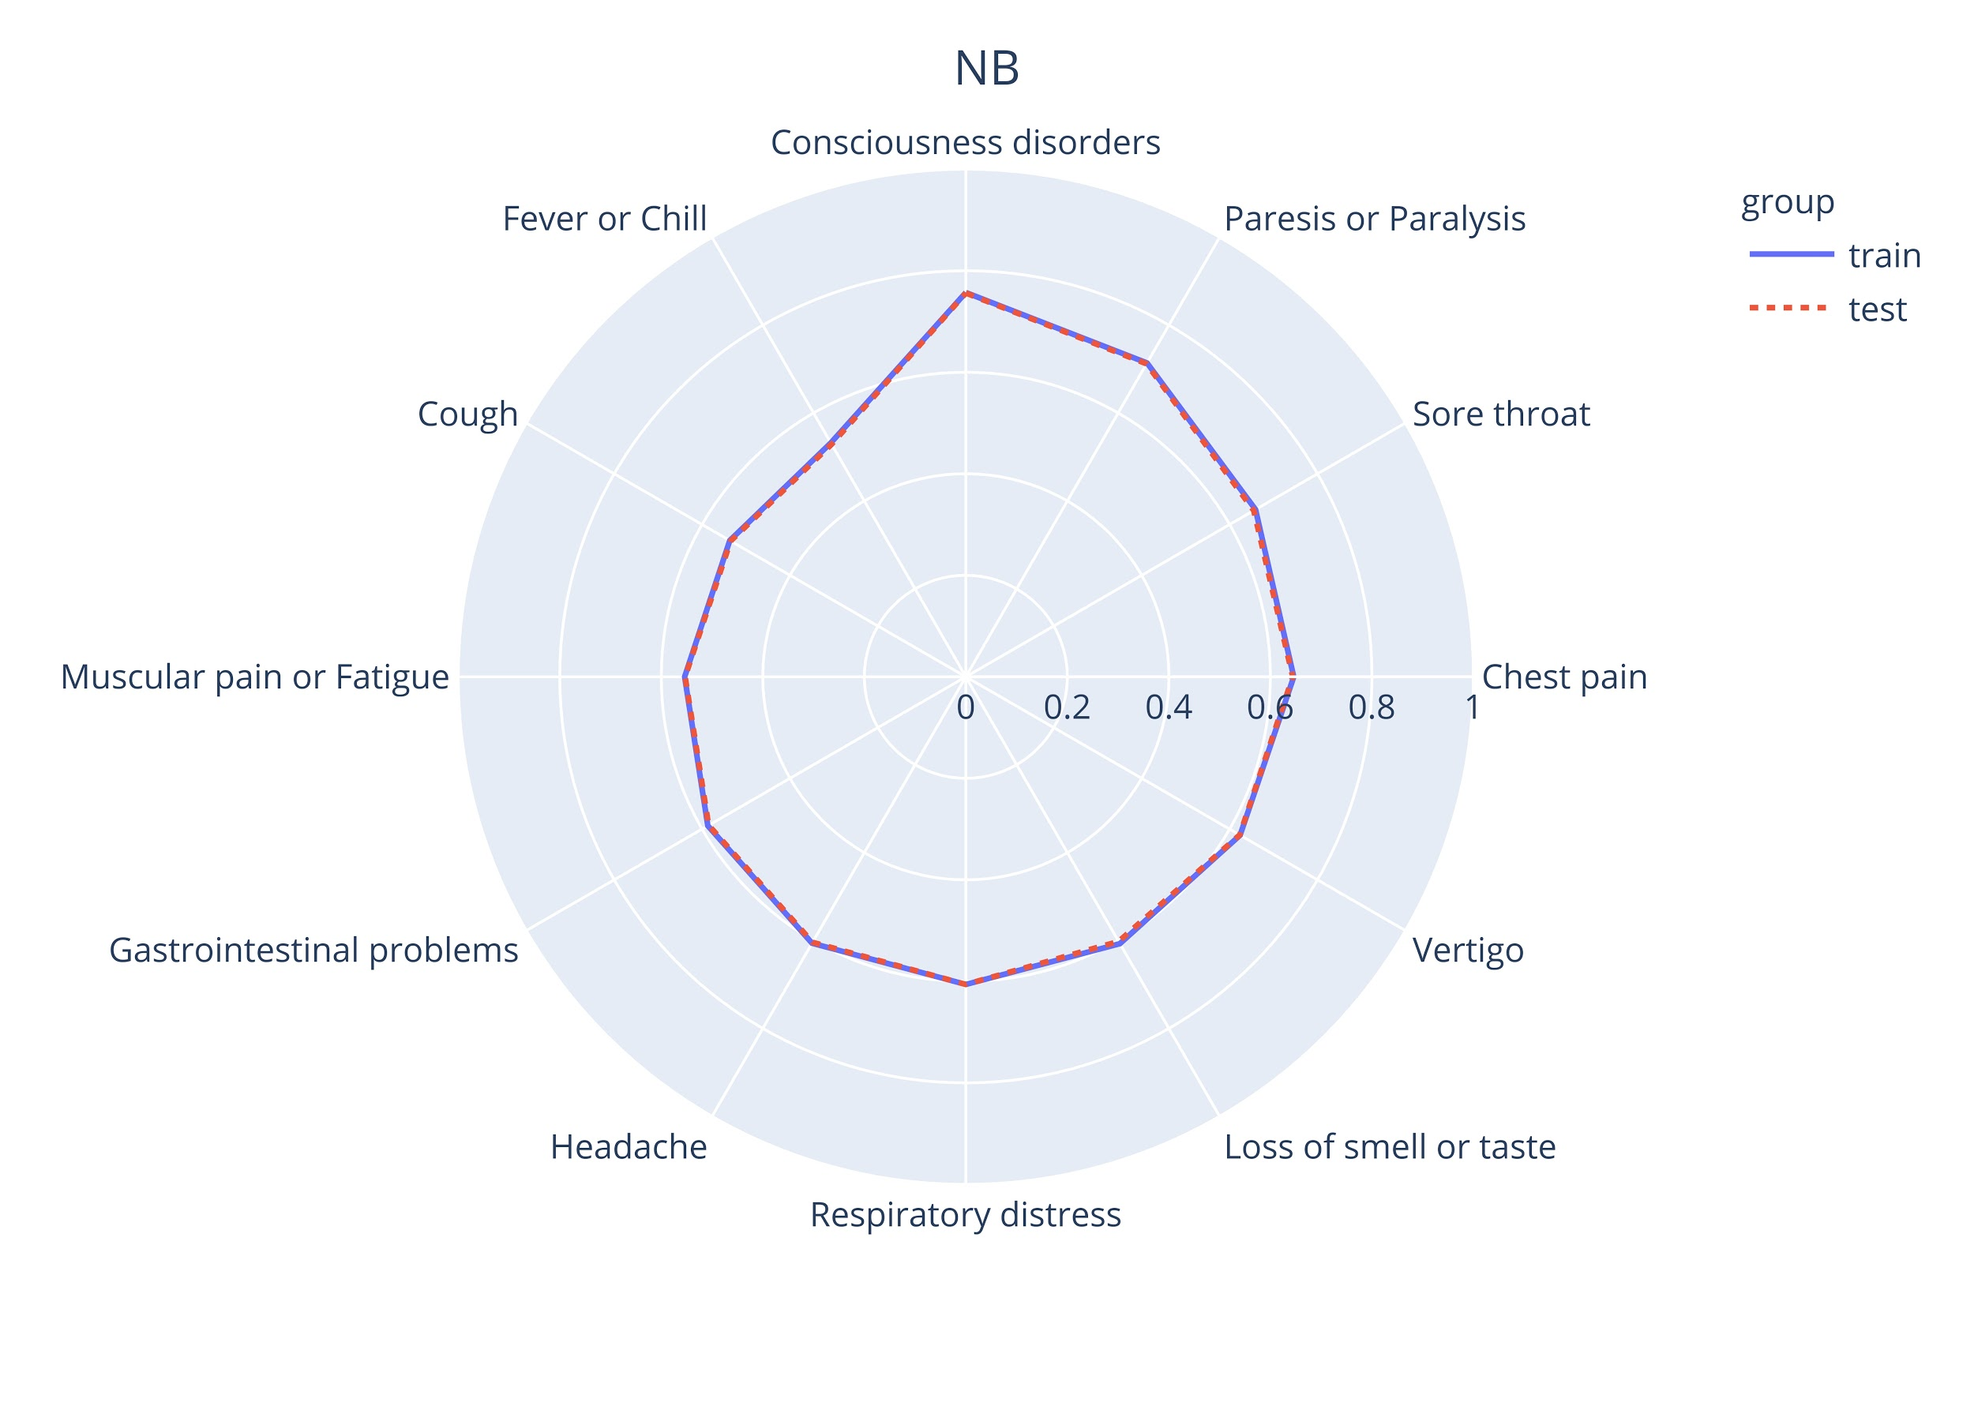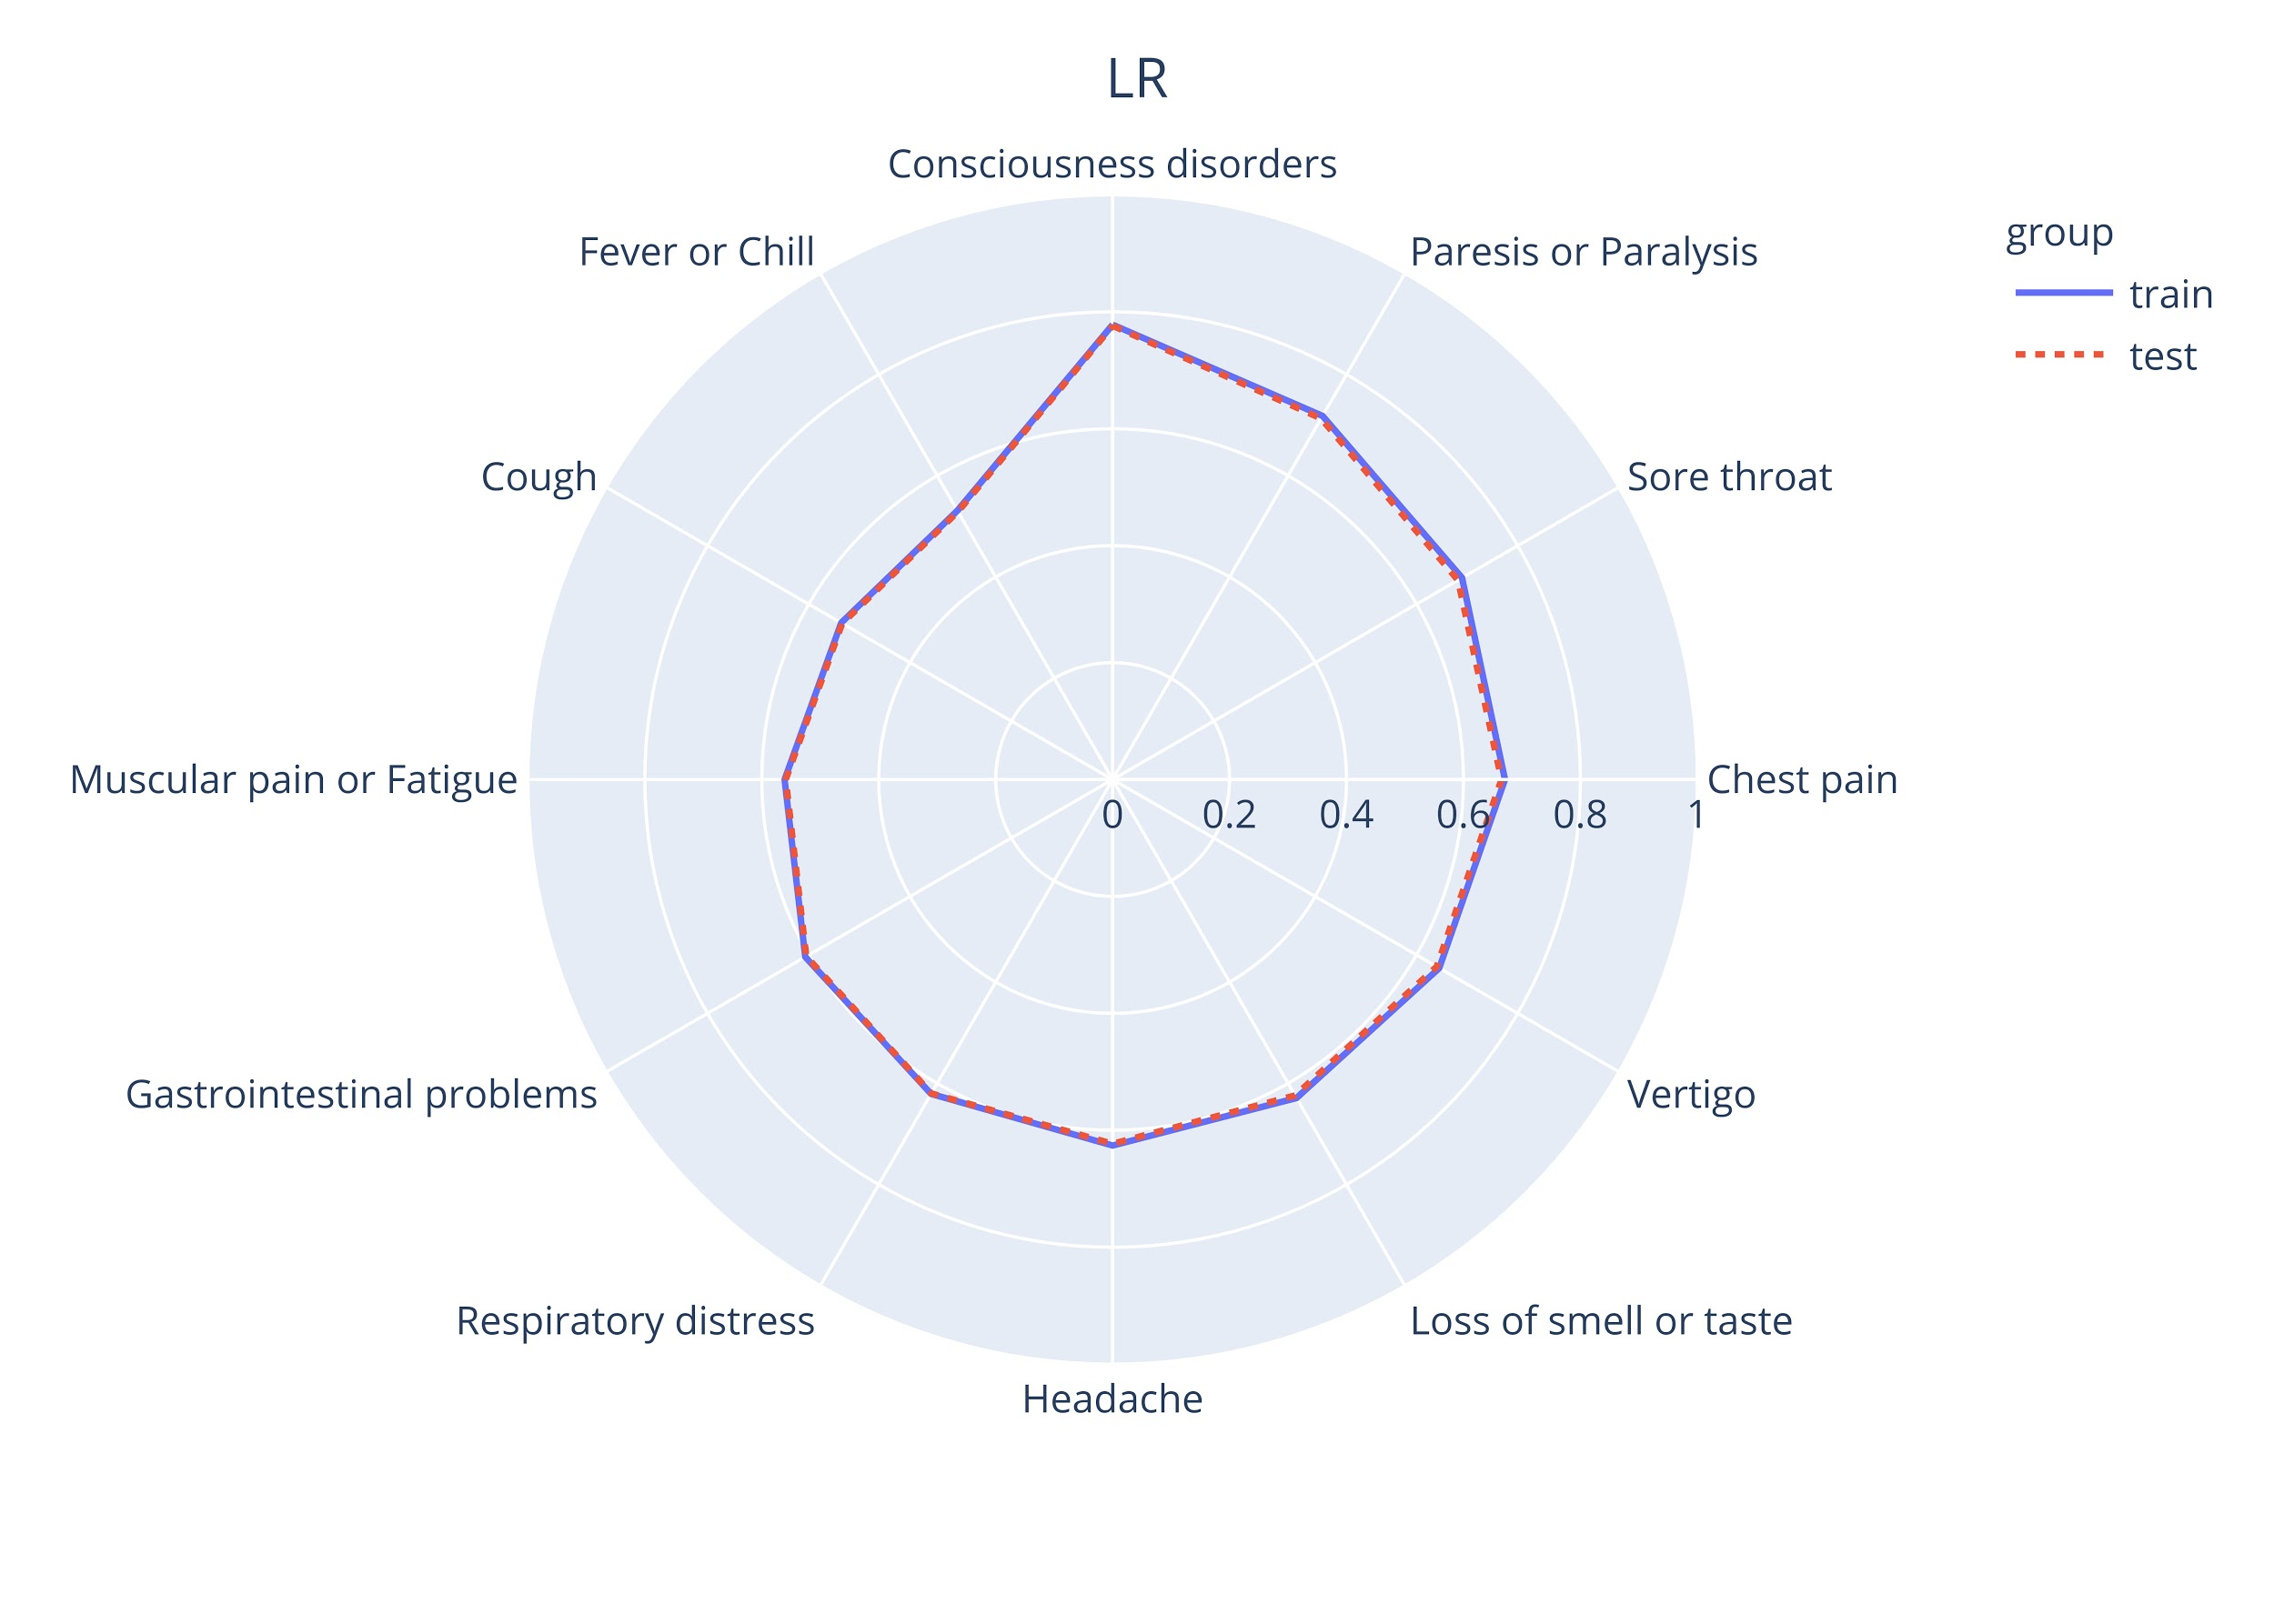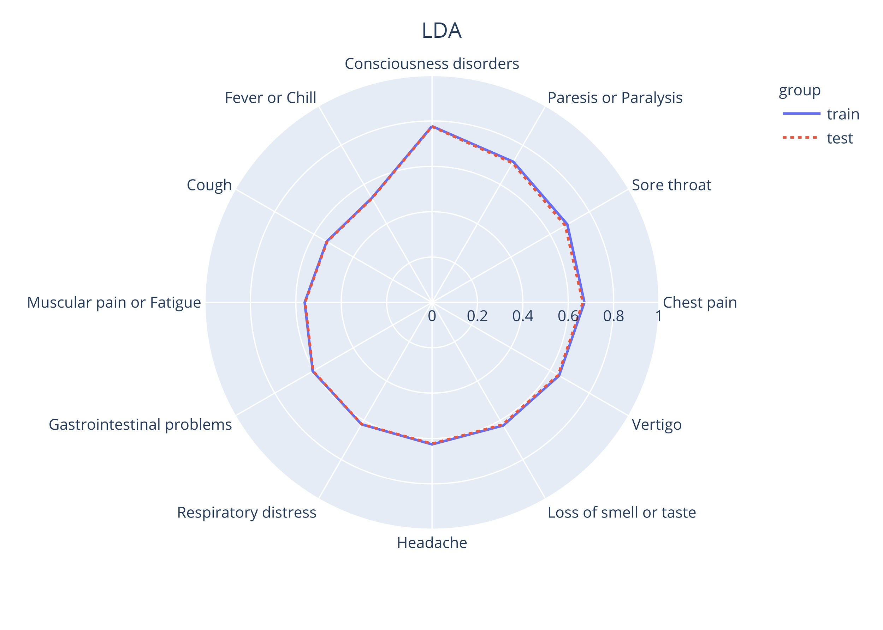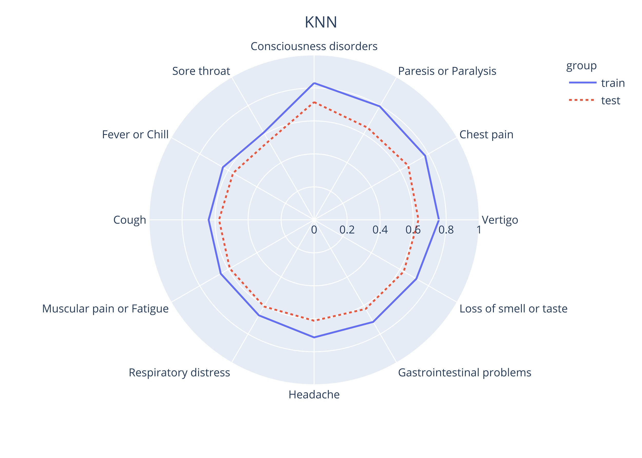
Supplementary Figure 2. Performance of ML methods for specific symptoms.

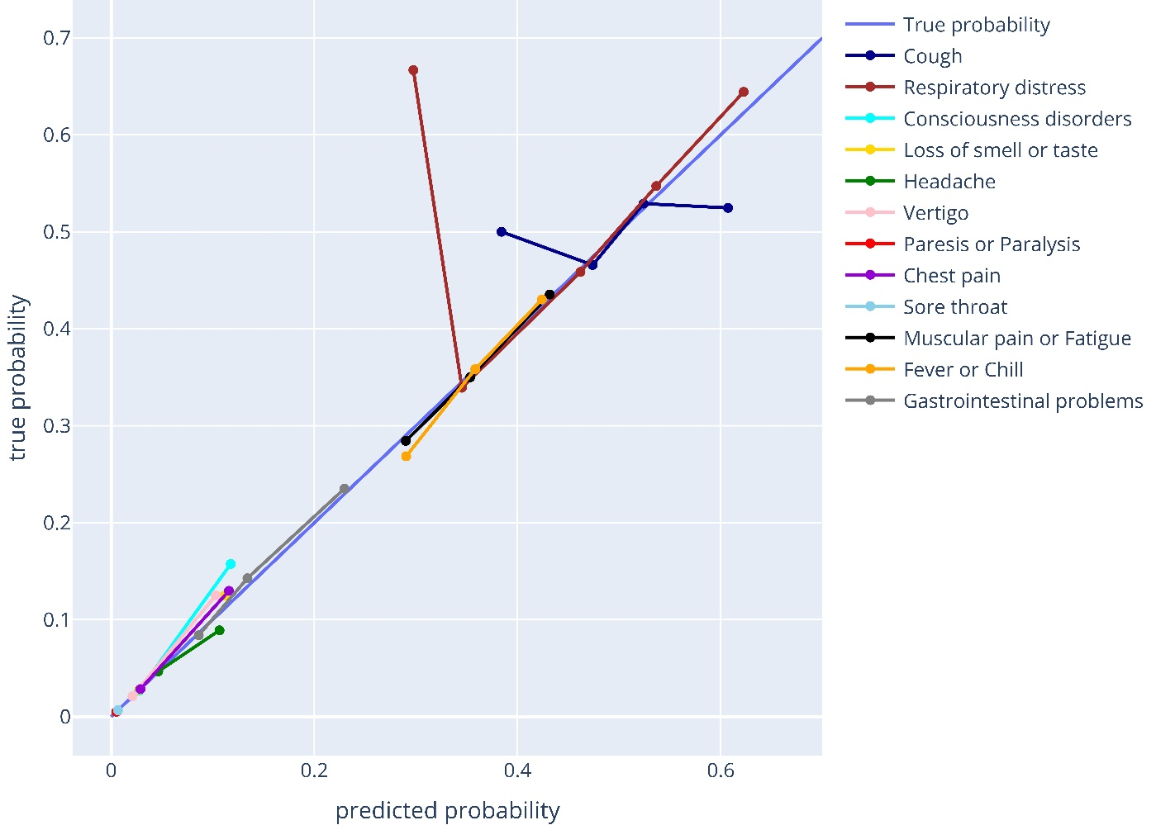
Supplementary Figure 3. Calibration of predicted probability symptoms in the SPM.

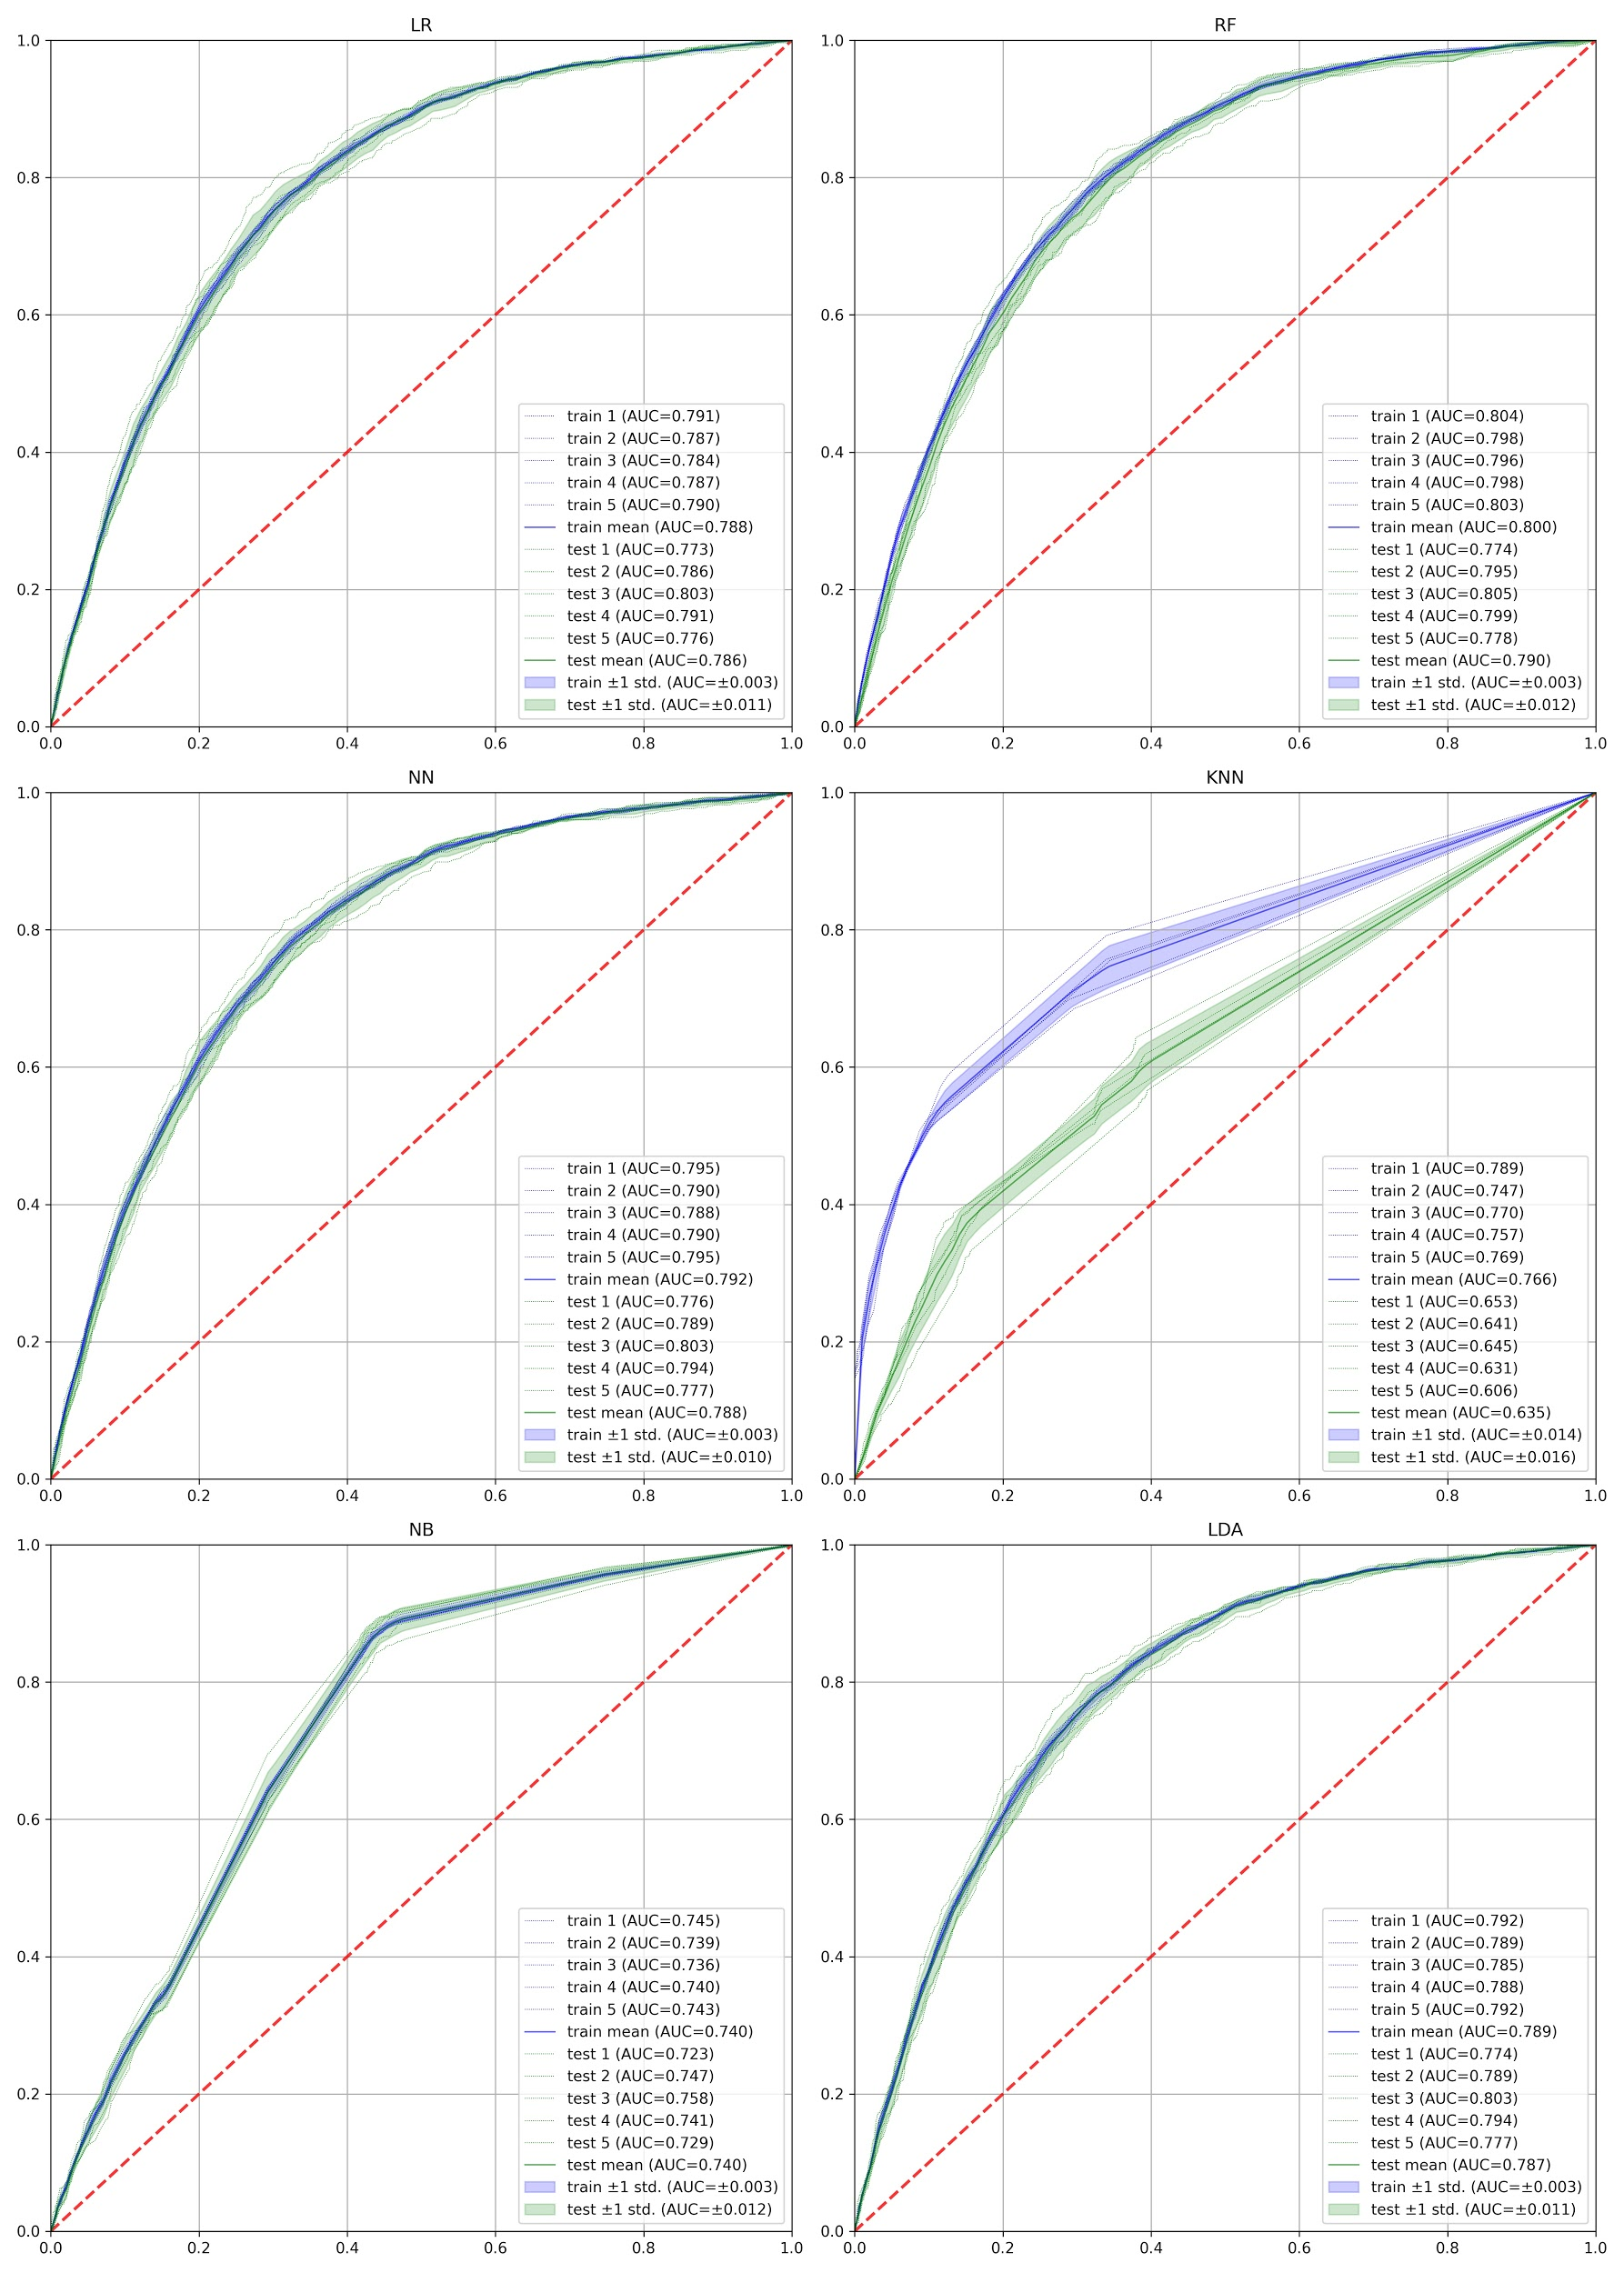
Supplementary Figure 4. ROCs of different ML methods which were used to implement the MPM. The ROC curves of each cross-validation fold are depicted.

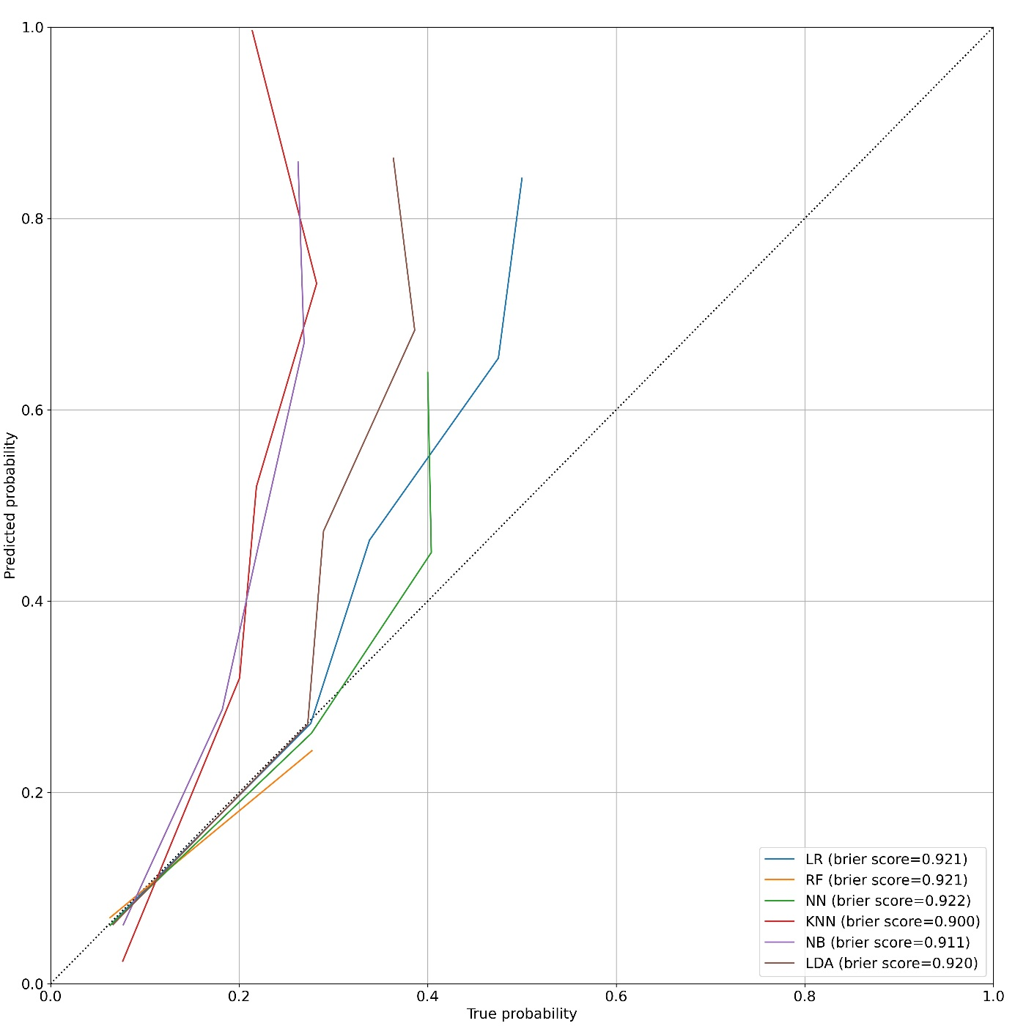
Supplementary Figure 5. Calibration of predicted probabilities in the MPM.

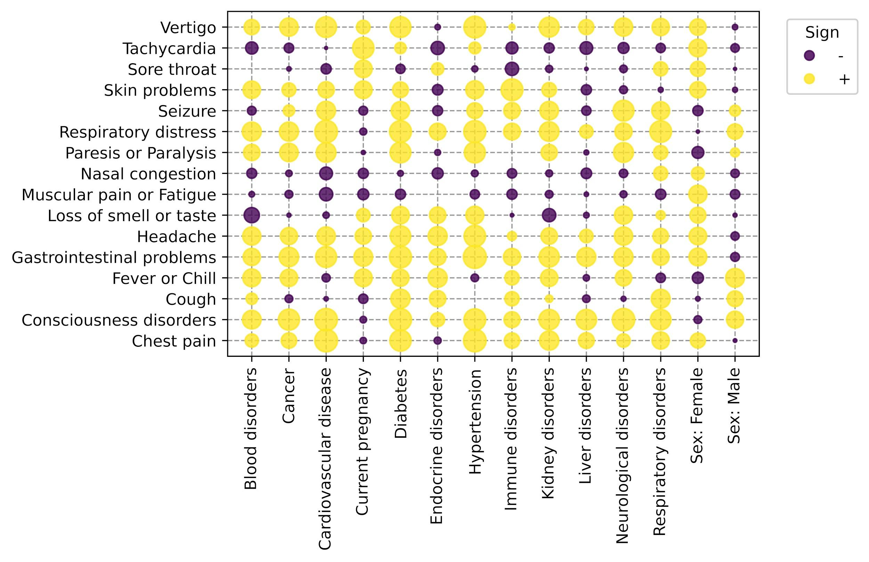
Supplementary Figure 6. Chi2 statistics of categorical PMH factors in the SPM. The larger the radius, the more two parameters are correlated.

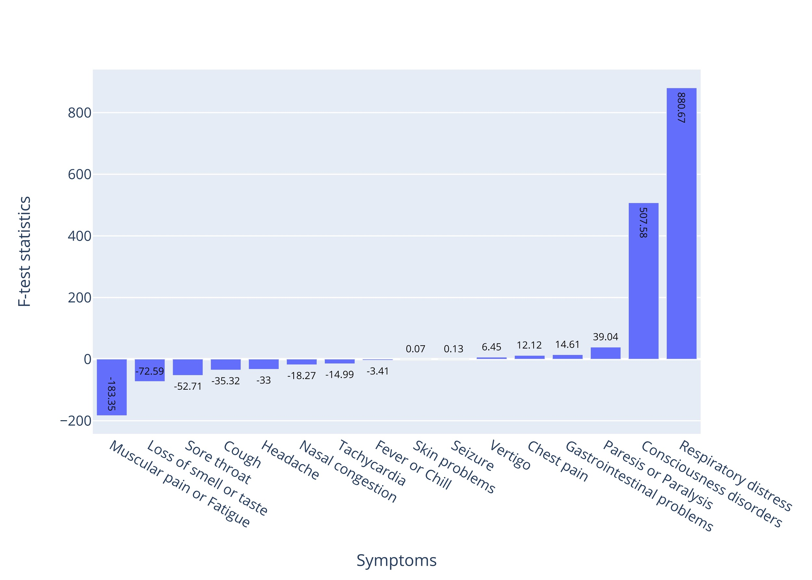
Supplementary Figure 7. F-test statistics of age in the SPM.

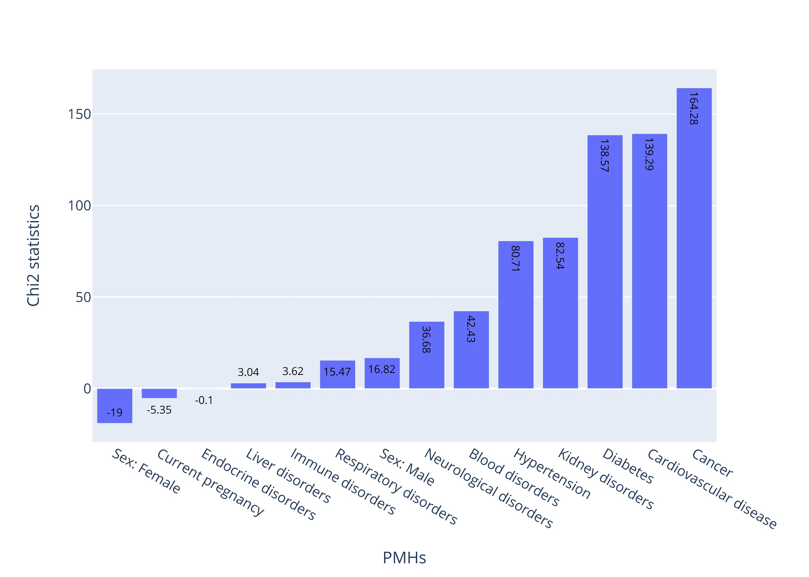
Supplementary Figure 8. Chi2 statistics of categorical past medical history factors in the MPM.

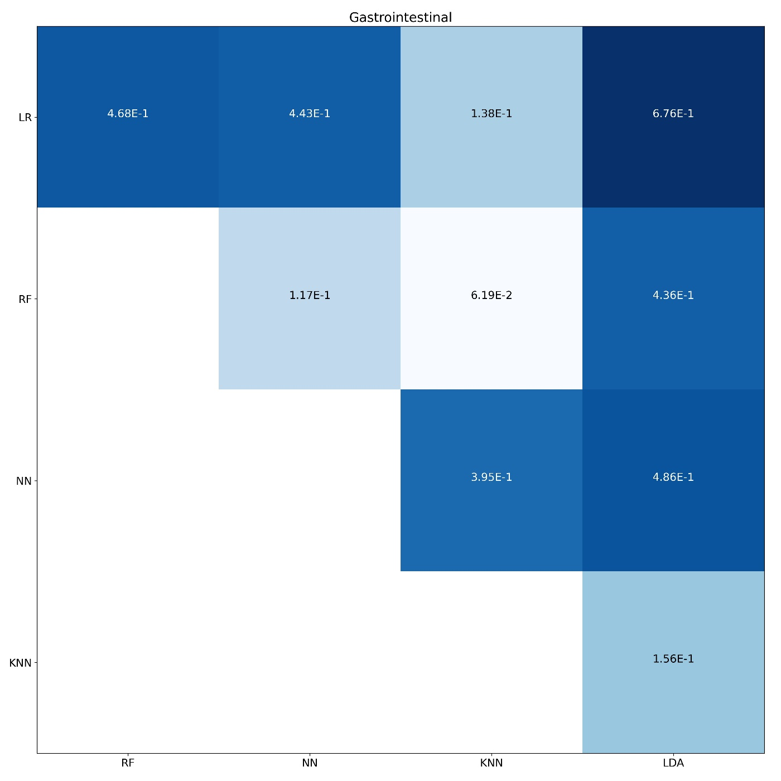
Supplementary Figure 9. DeLong's test for gastrointestinal symptom prediction

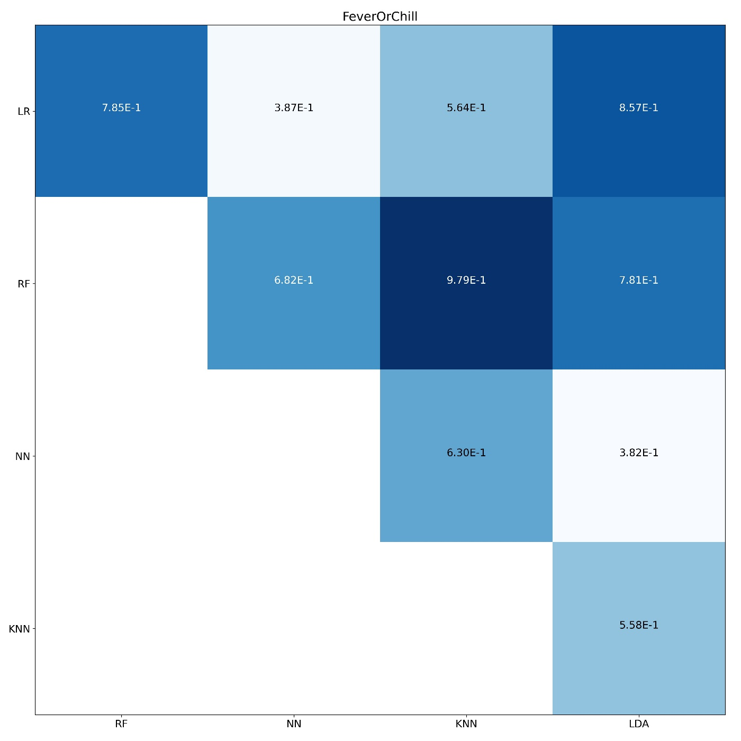
Supplementary Figure 10. DeLong's test for fever or chill symptom prediction

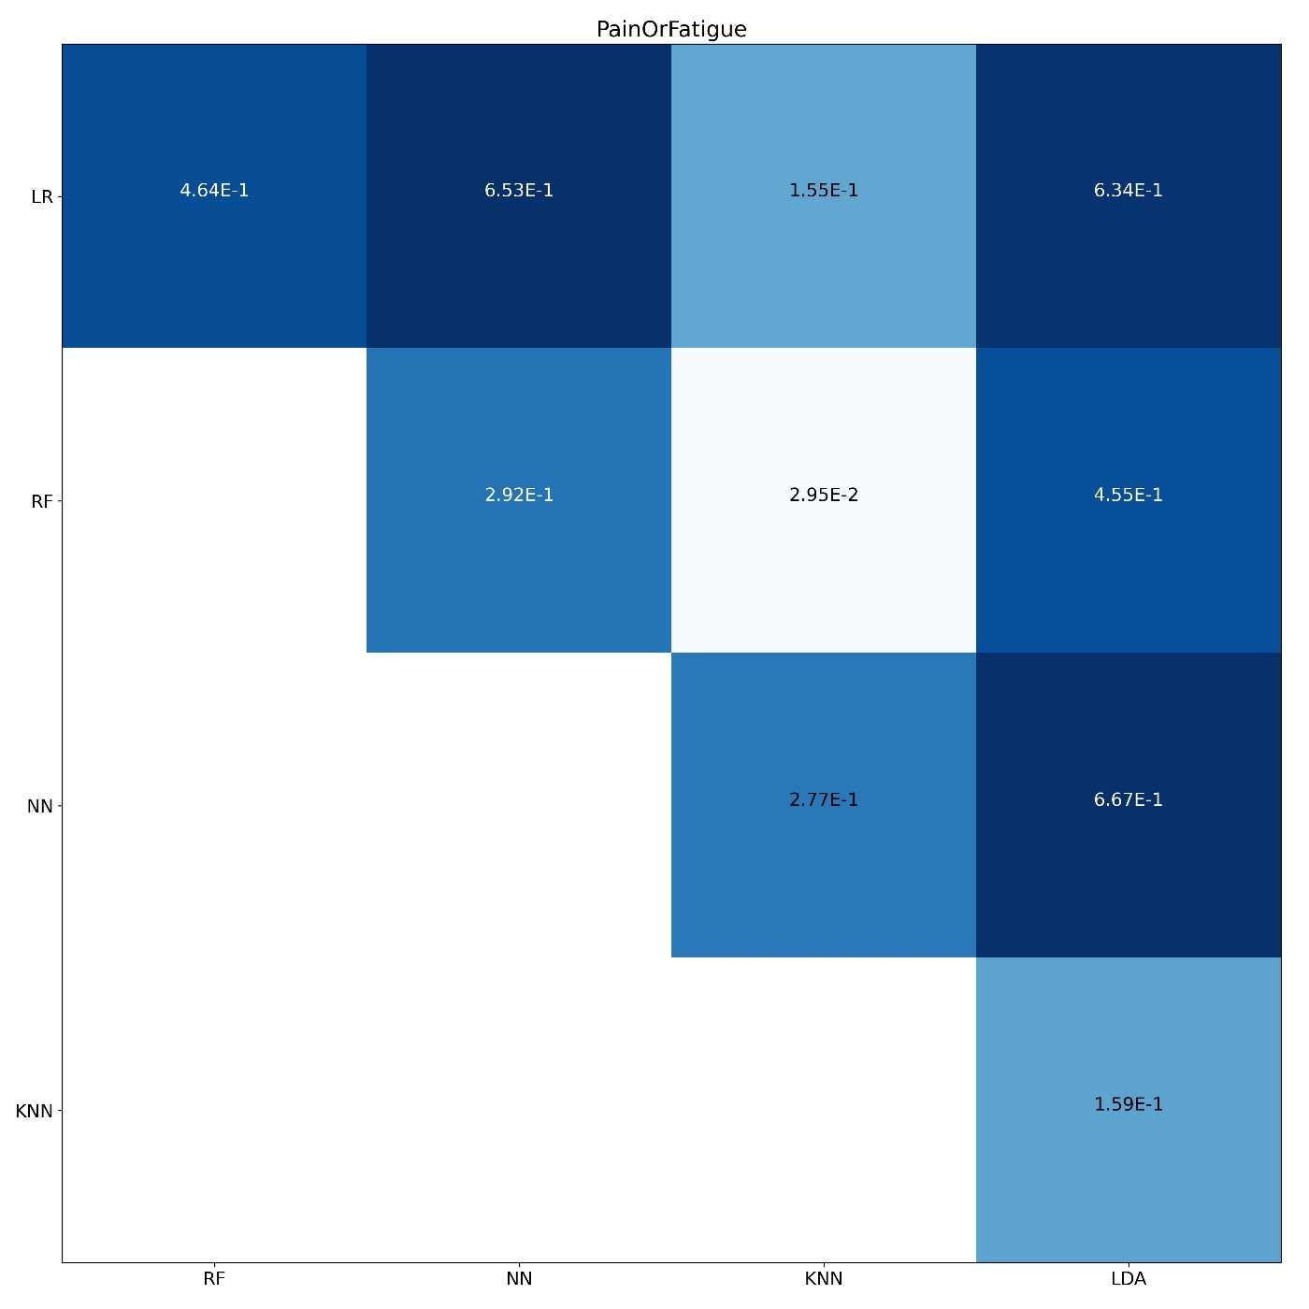
Supplementary Figure 11. DeLong's test for pain and fatigue symptom prediction

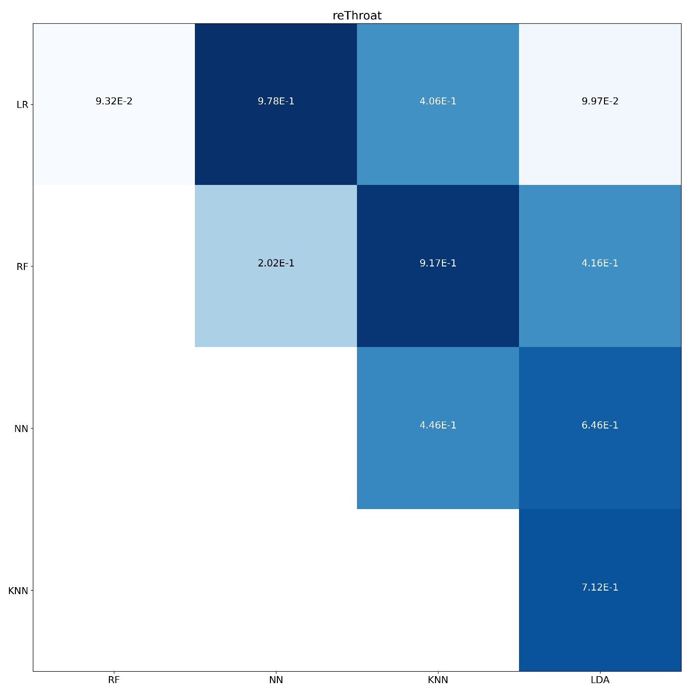
Supplementary Figure 12. DeLong's test for sore throat symptom prediction

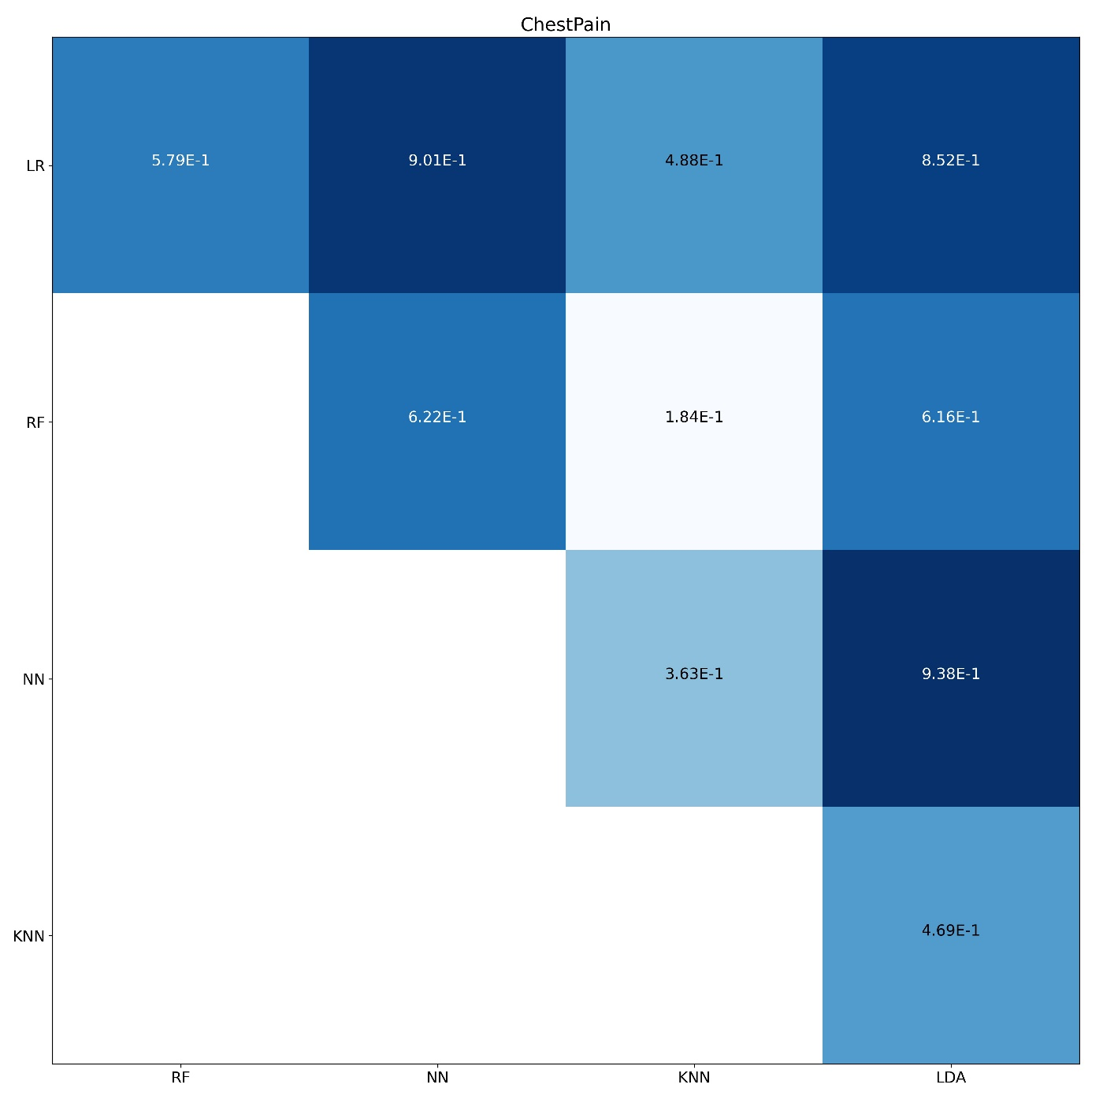
Supplementary Figure 13. DeLong's test for chest pain symptom prediction

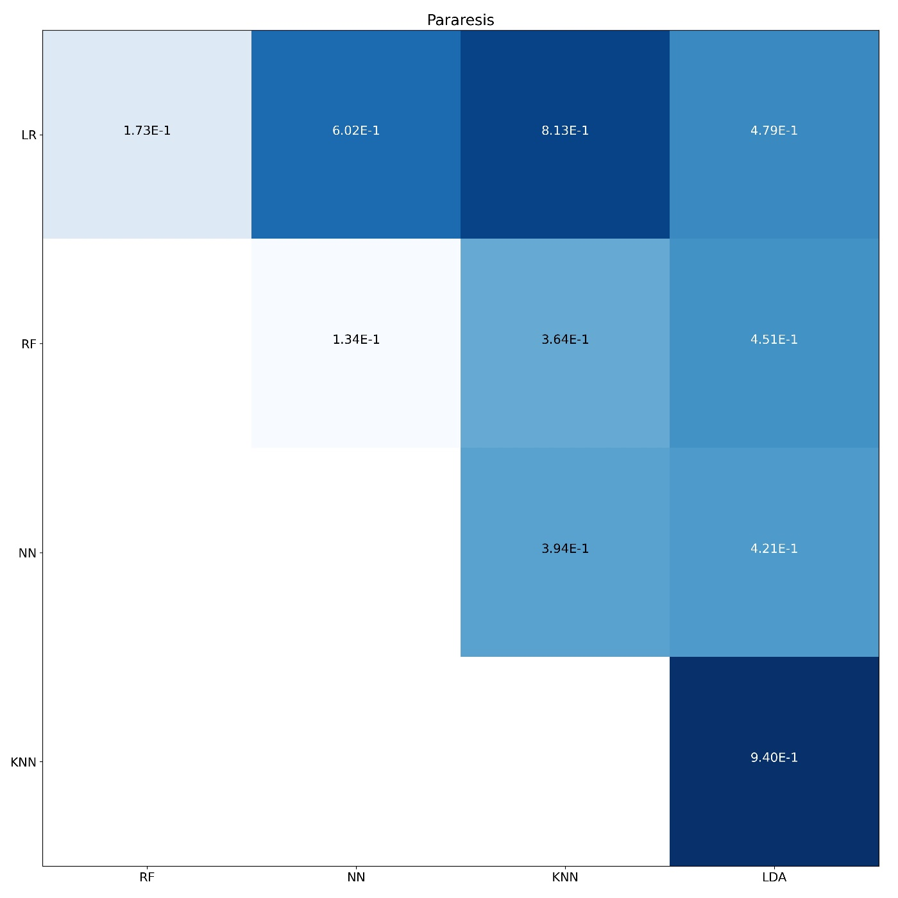
Supplementary Figure 14. DeLong's test for pararesis symptom prediction

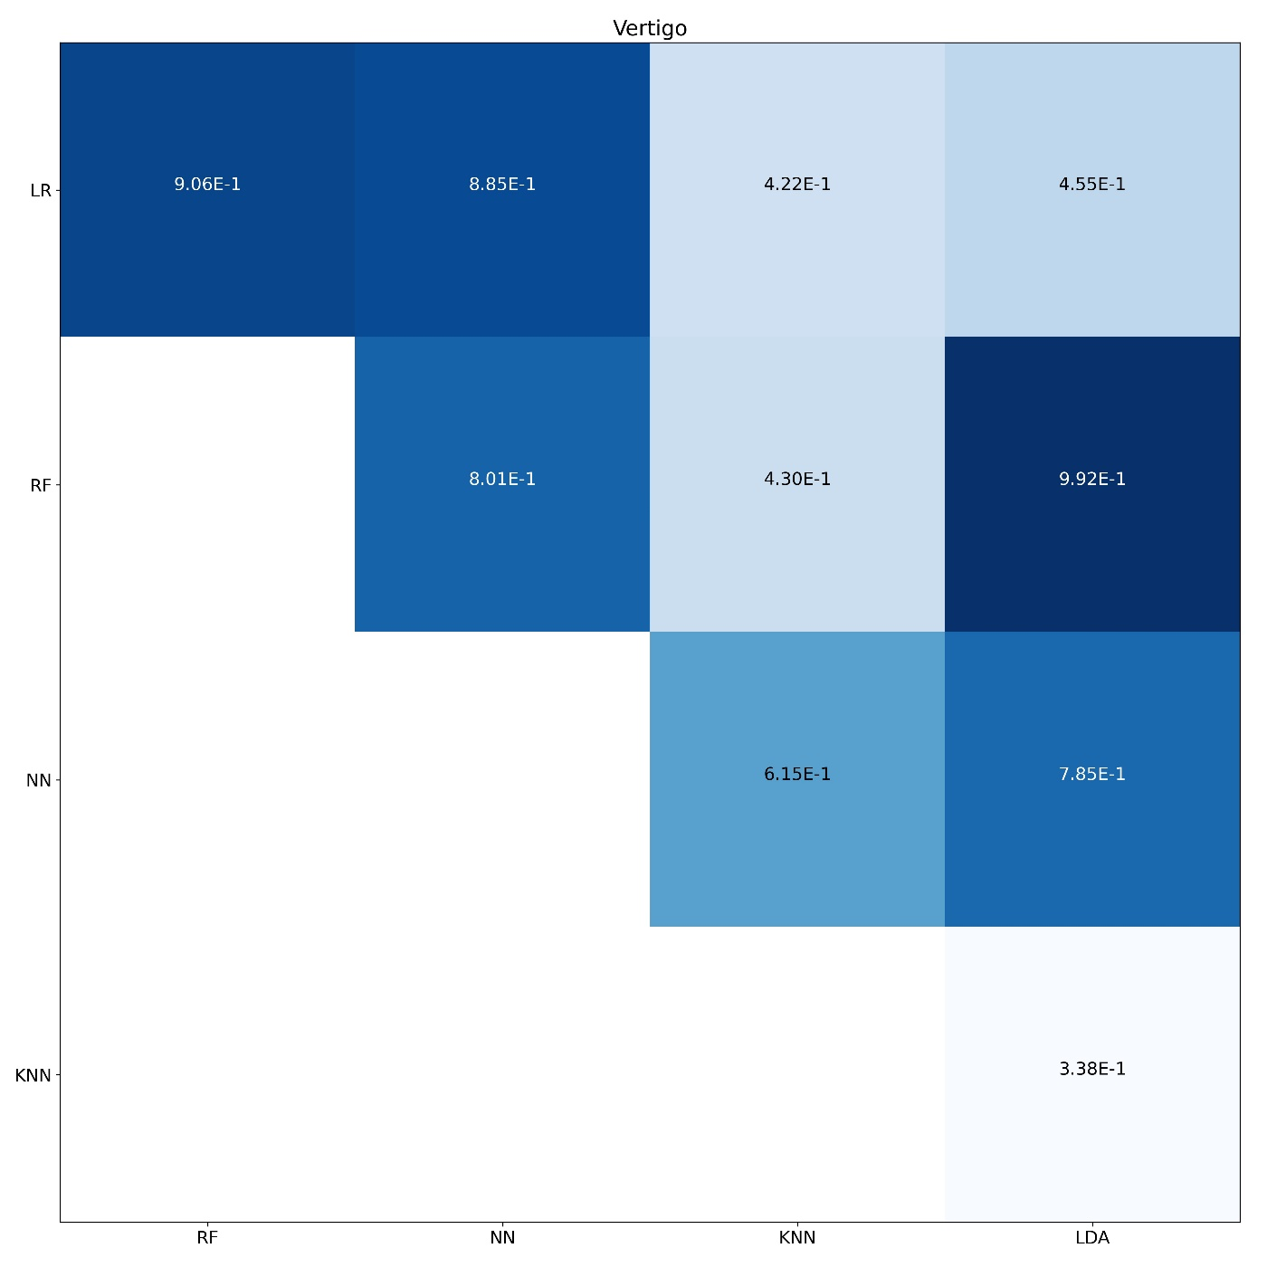
Supplementary Figure 15. DeLong's test for vertigo symptom prediction

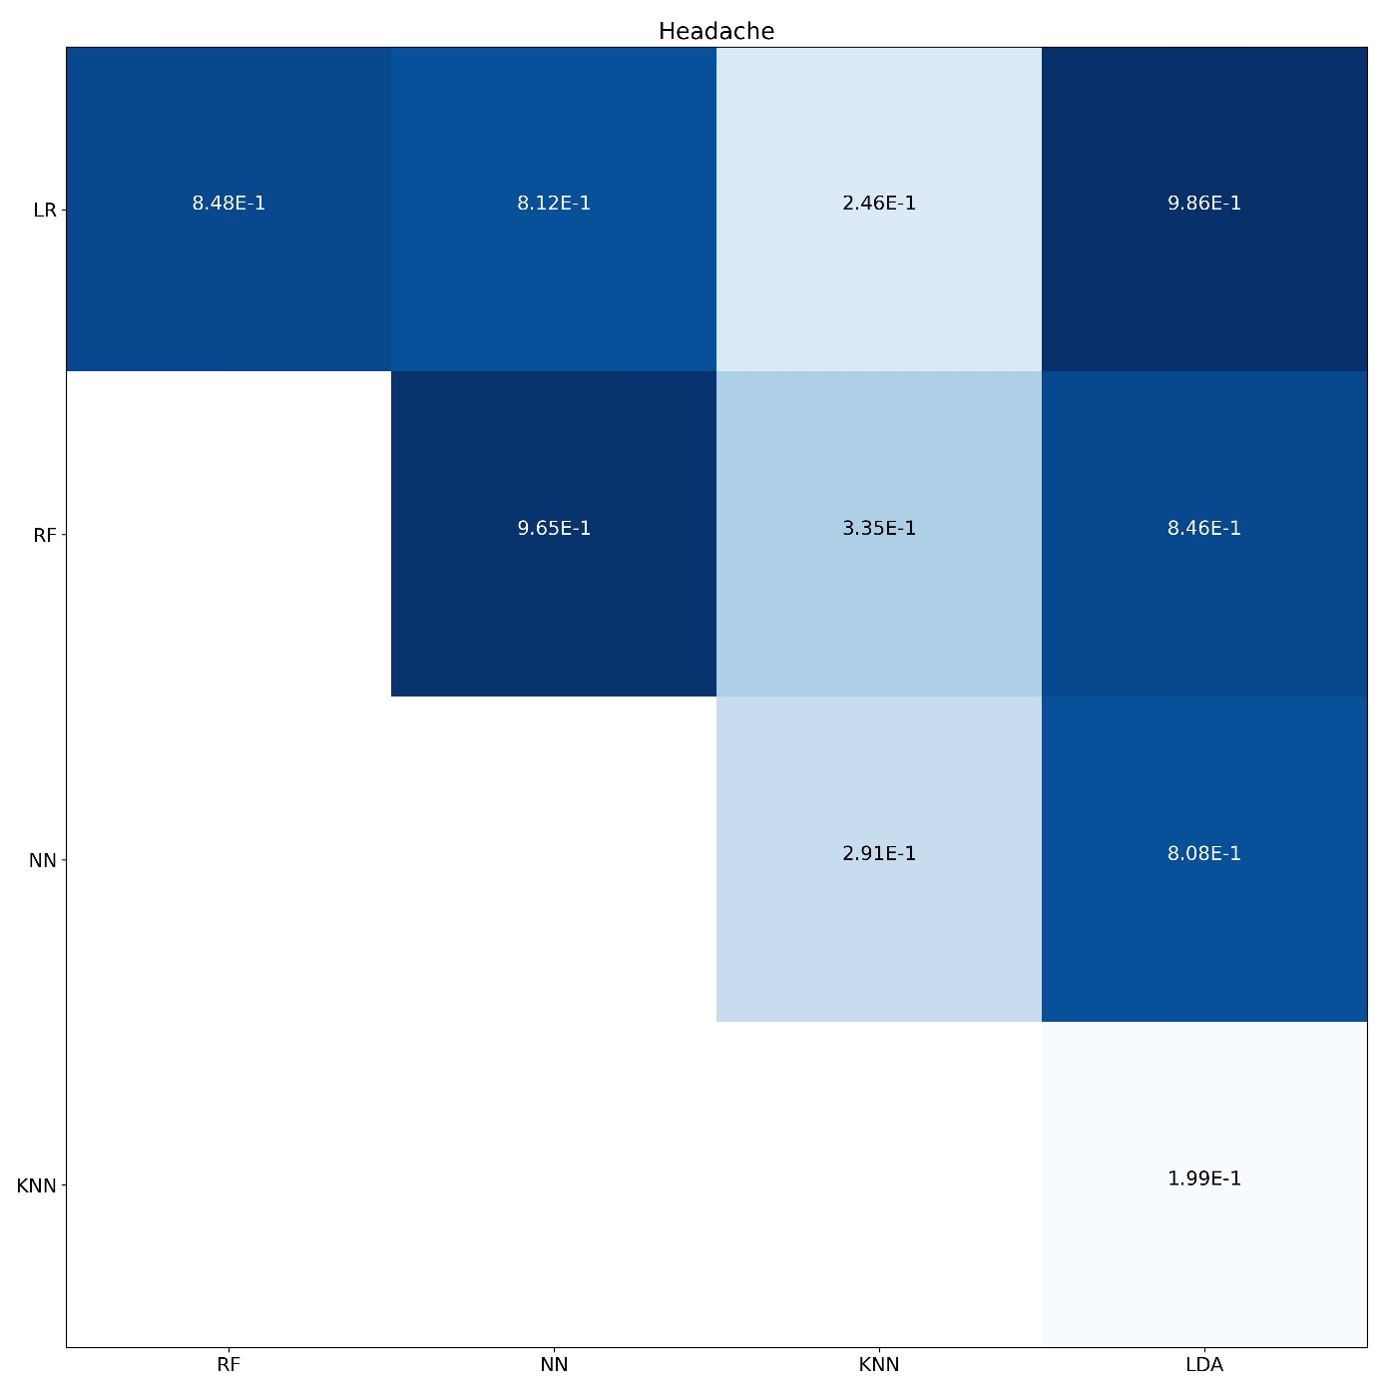
Supplementary Figure 16. DeLong's test for headache symptom prediction

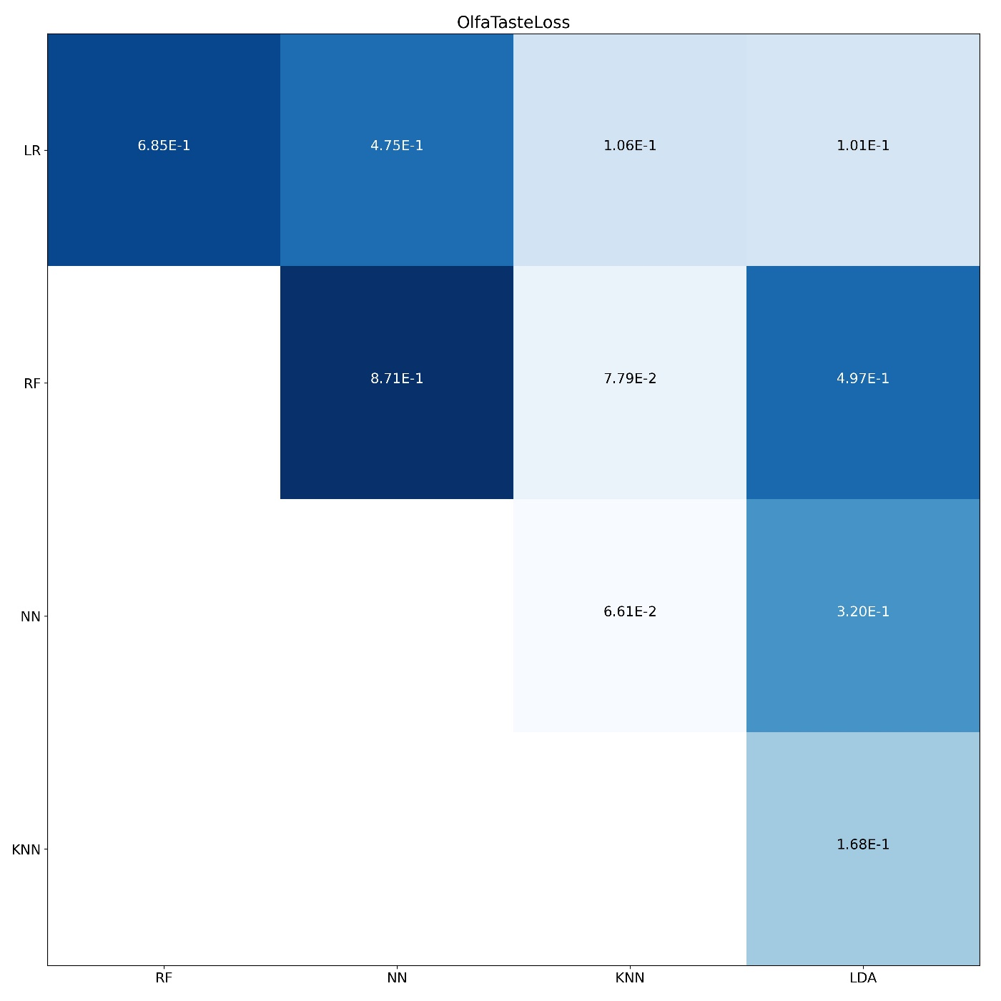
Supplementary Figure 17. DeLong's test for loss of smell or taste symptom prediction

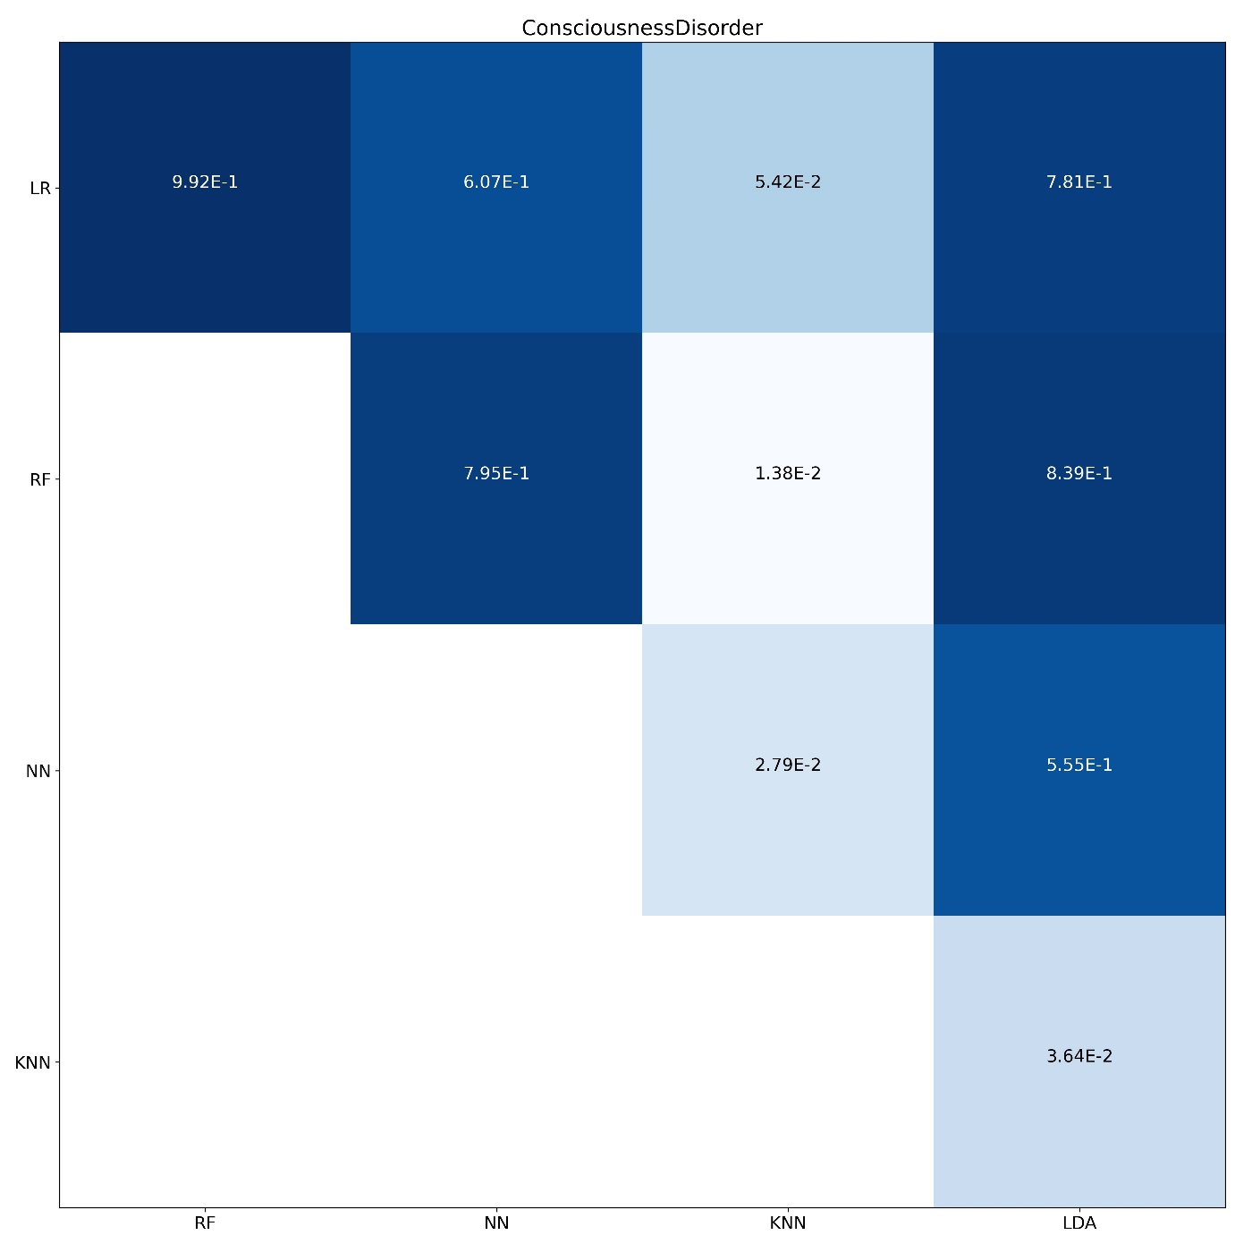
Supplementary Figure 18. DeLong's test for consciousness disorder symptom prediction

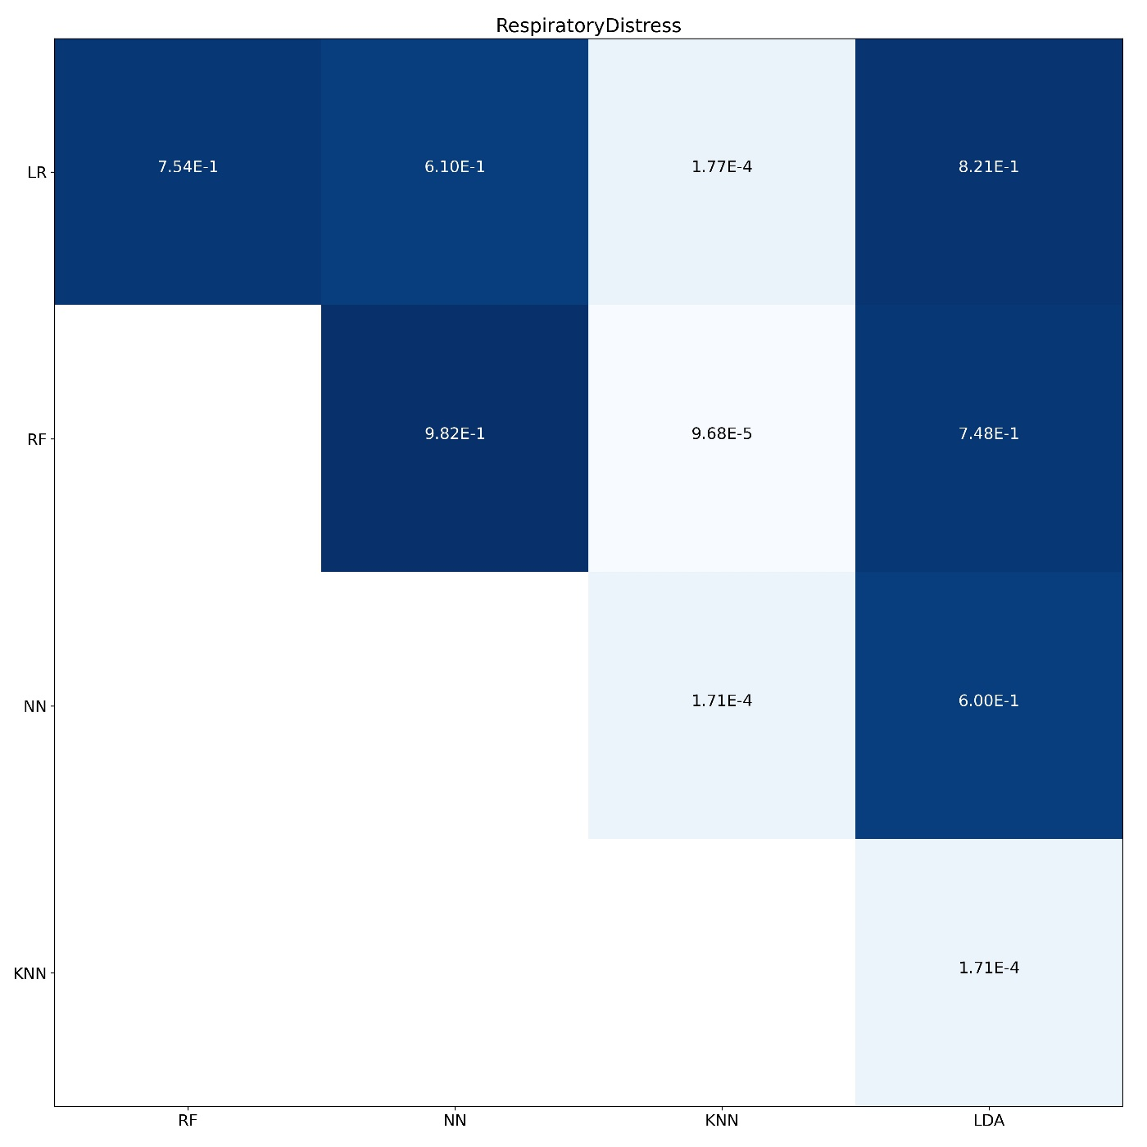
Supplementary Figure 19. DeLong's test for respiratory distress symptom prediction

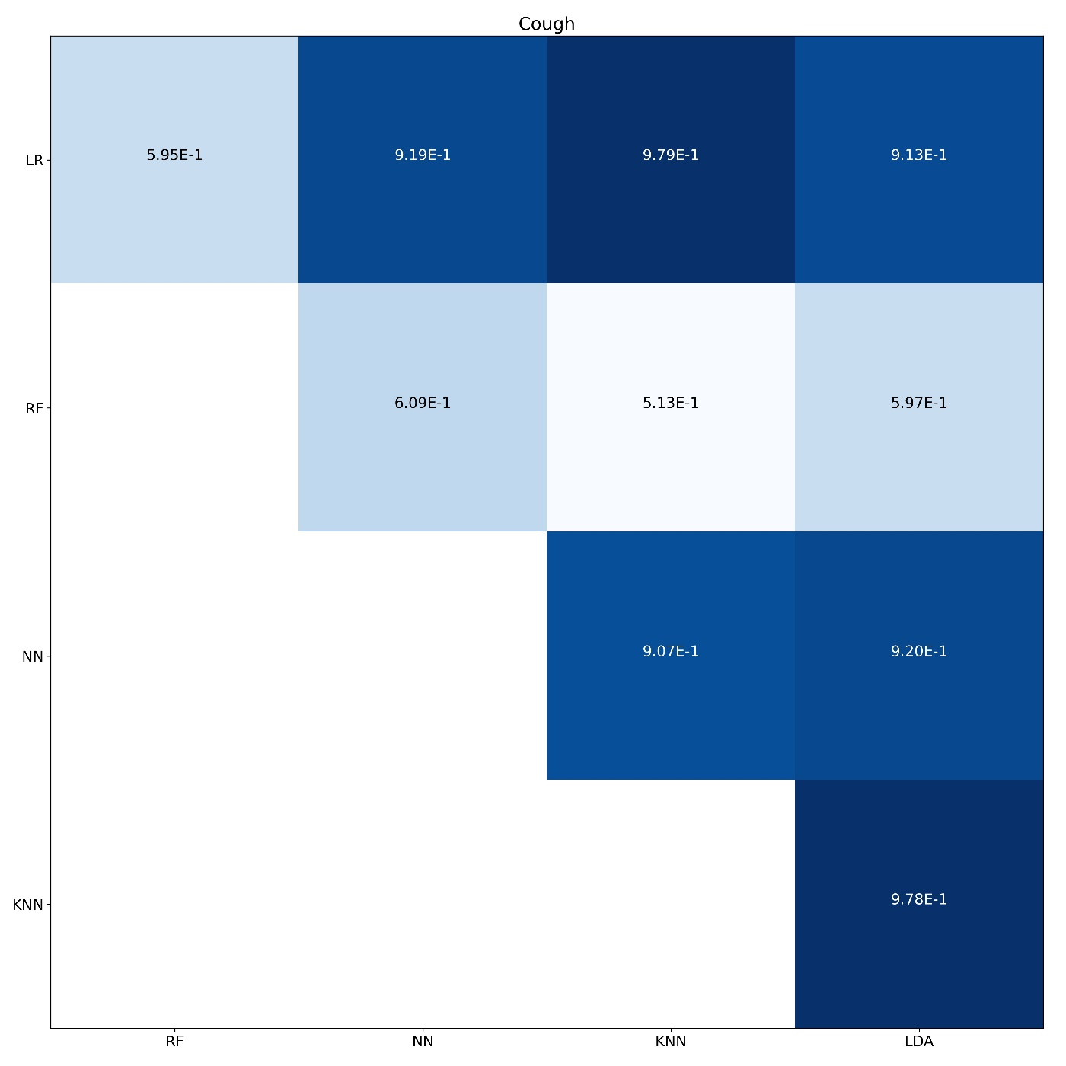
Supplementary Figure 20. DeLong's test for cough symptom prediction

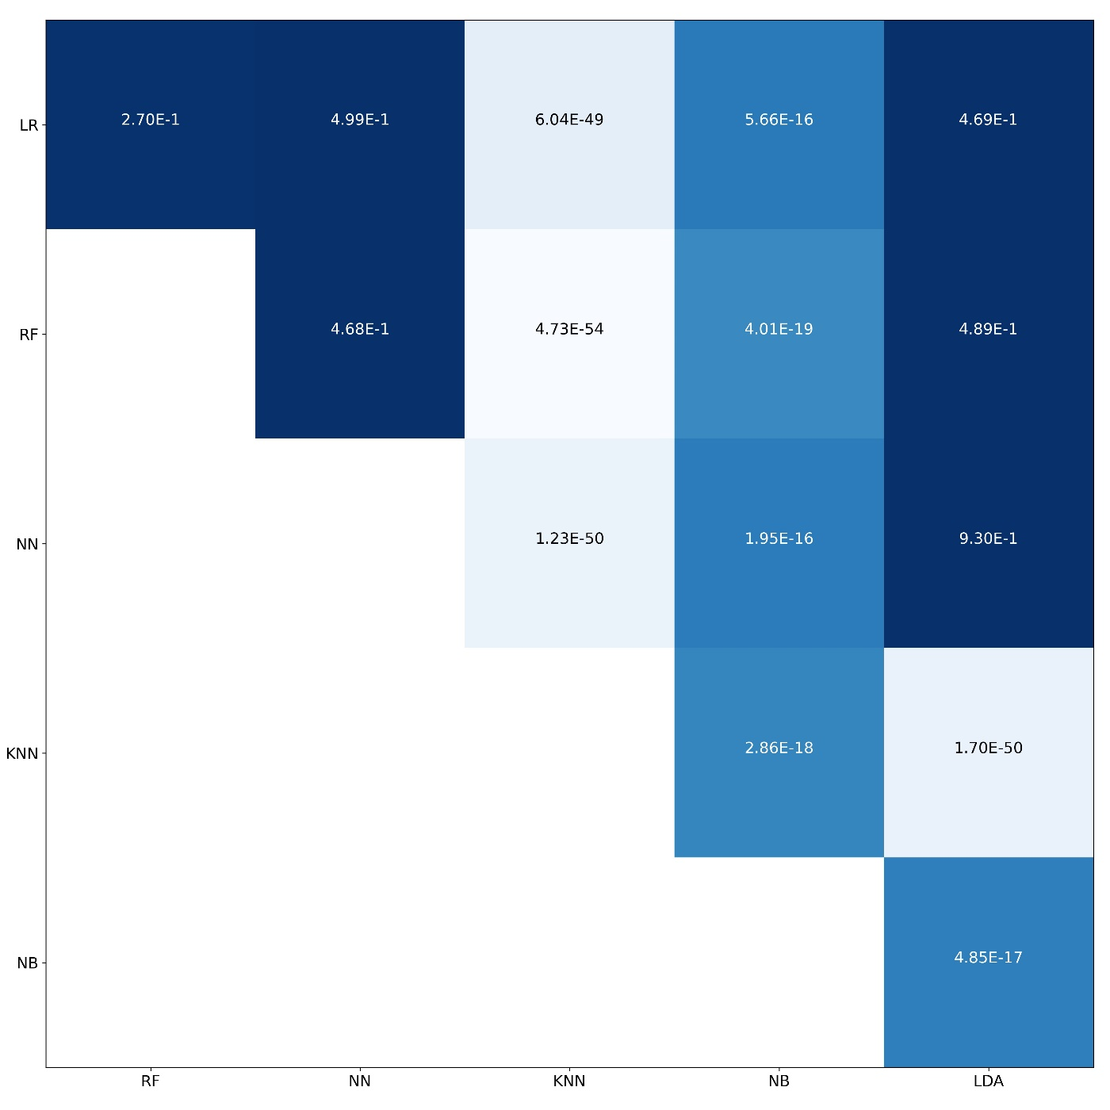
Supplementary Figure 21. DeLong's test for mortality risk prediction

Supplementary Tables
Table 1. Comparison of characteristics between COVID-19 patients with and without cough symptom
Cough
Continue variables
Variable | Median in not appearance (±IQR) | Median appearance (±IQR) | F-test statistics | F-test p-value
Age | 53 (±30) | 51 (±29) | 35.32 | <0.001
Categorical/Binary variables
Variable | Count in not appearance (percent in not appearance) | Count in appearance (percent in appearance) | Chi2 statics | Chi2 p-value
Sex
Male | 6,169 (52.48%) | 6,428 (53.59%) | 1.37 | 0.243
Female | 5,585 (47.52%) | 5,567 (46.41%) | 1.54 | 0.214
Cardiovascular disease | 1,253 (10.66%) | 1,218 (10.15%) | 1.46 | 0.227
Diabetes | 935 (7.95%) | 1,133 (9.45%) | 15.15 | <0.001
Hypertension | 992 (8.44%) | 1,012 (8.44%) | 0 | 0.994
Respiratory disorders | 229 (1.95%) | 317 (2.64%) | 12.45 | <0.001
Cancer | 256 (2.18%) | 221 (1.84%) | 3.33 | 0.068
Kidney disorders | 204 (1.74%) | 212 (1.77%) | 0.03 | 0.853
Neurological disorders | 137 (1.17%) | 127 (1.06%) | 0.61 | 0.435
Immune disorders | 83 (0.71%) | 95 (0.79%) | 0.58 | 0.445
Blood disorders | 73 (0.62%) | 79 (0.66%) | 0.13 | 0.718
Current pregnancy | 83 (0.71%) | 56 (0.47%) | 5.81 | 0.016
Liver disorders | 62 (0.53%) | 57 (0.48%) | 0.32 | 0.569
Endocrine disorders | 41 (0.35%) | 56 (0.47%) | 2.03 | 0.155
Organ or bone marrow Transplant | 16 (0.14%) | 13 (0.11%) | 0.37 | 0.541
Psychiatric disorders | 6 (0.05%) | 13 (0.11%) | 2.44 | 0.118
Thrombosis | 7 (0.06%) | 8 (0.07%) | 0.05 | 0.827
Past COVID-19 infection | 5 (0.04%) | 5 (0.04%) | 0 | 0.974

Table 2. Comparison of characteristics between COVID-19 patients with and without respiratory distress
Respiratory Distress
Continue variables
Variable | Median in not appearance (±IQR) | Median appearance (±IQR) | F-test statistics | F-test p-value
Age | 47 (±28) | 57 (±29) | 880.67 | <0.001
Categorical/Binary variables
Variable | Count in not appearance (percent in not appearance) | Count in appearance (percent in appearance) | Chi2 statics | Chi2 p-value
Sex
Male | 7,053 (52.61%) | 5,544 (53.61%) | 1.1 | 0.294
Female | 6,354 (47.39%) | 4,798 (46.39%) | 1.24 | 0.265
Cardiovascular disease | 1,014 (7.56%) | 1,457 (14.09%) | 238.9 | <0.001
Diabetes | 909 (6.78%) | 1,159 (11.21%) | 131.38 | <0.001
Hypertension | 855 (6.38%) | 1,149 (11.11%) | 154.98 | <0.001
Respiratory disorders | 186 (1.39%) | 360 (3.48%) | 111.31 | <0.001
Cancer | 229 (1.71%) | 248 (2.4%) | 13.84 | <0.001
Kidney disorders | 190 (1.42%) | 226 (2.19%) | 19.66 | <0.001
Neurological disorders | 134 (1.0%) | 130 (1.26%) | 3.48 | 0.062
Immune disorders | 90 (0.67%) | 88 (0.85%) | 2.51 | 0.113
Blood disorders | 64 (0.48%) | 88 (0.85%) | 12.73 | <0.001
Current pregnancy | 88 (0.66%) | 51 (0.49%) | 2.66 | 0.103
Liver disorders | 64 (0.48%) | 55 (0.53%) | 0.35 | 0.557
Endocrine disorders | 47 (0.35%) | 50 (0.48%) | 2.52 | 0.112
Organ or bone marrow Transplant | 16 (0.12%) | 13 (0.13%) | 0.02 | 0.889
Psychiatric disorders | 10 (0.07%) | 9 (0.09%) | 0.11 | 0.737
Thrombosis | 5 (0.04%) | 10 (0.1%) | 3.26 | 0.071
Past COVID-19 infection | 8 (0.06%) | 2 (0.02%) | 2.26 | 0.133

Table 3. Comparison of characteristics between COVID-19 patients with and without muscular pain or fatigue
Muscular Pain or Fatigue
Continue variables
Variable | Median in not appearance (±IQR) | Median appearance (±IQR) | F-test statistics | F-test p-value
Age | 54 (±29) | 49 (±29) | 183.35 | <0.001
Categorical/Binary variables
Variable | Count in not appearance (percent in not appearance) | Count in appearance (percent in appearance) | Chi2 statics | Chi2 p-value
Sex
Male | 7,824 (53.96%) | 4,773 (51.61%) | 5.89 | 0.015
Female | 6,676 (46.04%) | 4,476 (48.39%) | 6.66 | 0.01
Cardiovascular disease | 1,649 (11.37%) | 822 (8.89%) | 33.51 | <0.001
Diabetes | 1,324 (9.13%) | 744 (8.04%) | 7.66 | 0.006
Hypertension | 1,275 (8.79%) | 729 (7.88%) | 5.56 | 0.018
Respiratory disorders | 366 (2.52%) | 180 (1.95%) | 8.21 | 0.004
Cancer | 297 (2.05%) | 180 (1.95%) | 0.29 | 0.588
Kidney disorders | 272 (1.88%) | 144 (1.56%) | 3.28 | 0.07
Neurological disorders | 174 (1.2%) | 90 (0.97%) | 2.62 | 0.106
Immune disorders | 111 (0.77%) | 67 (0.72%) | 0.13 | 0.721
Blood disorders | 101 (0.7%) | 51 (0.55%) | 1.86 | 0.173
Current pregnancy | 104 (0.72%) | 35 (0.38%) | 11.08 | 0.001
Liver disorders | 77 (0.53%) | 42 (0.45%) | 0.67 | 0.414
Endocrine disorders | 59 (0.41%) | 38 (0.41%) | 0 | 0.963
Organ or bone marrow Transplant | 22 (0.15%) | 7 (0.08%) | 2.67 | 0.102
Psychiatric disorders | 14 (0.1%) | 5 (0.05%) | 1.27 | 0.259
Thrombosis | 10 (0.07%) | 5 (0.05%) | 0.2 | 0.656
Past COVID-19 infection | 6 (0.04%) | 4 (0.04%) | 0 | 0.945

Table 4. Comparison of characteristics between COVID-19 patients with and without fever or chill
Fever or Chill
Continue variables
Variable | Median in not appearance (±IQR) | Median appearance (±IQR) | F-test statistics | F-test p-value
Age | 52 (±29) | 51 (±28) | 3.41 | 0.065
Categorical/Binary variables
Variable | Count in not appearance (percent in not appearance) | Count in appearance (percent in appearance) | Chi2 statics | Chi2 p-value
Sex
Male | 7,883 (51.88%) | 4,714 (55.12%) | 10.83 | 0.001
Female | 7,313 (48.12%) | 3,839 (44.88%) | 12.23 | <0.001
Cardiovascular disease | 1,628 (10.71%) | 843 (9.86%) | 3.86 | 0.049
Diabetes | 1,284 (8.45%) | 784 (9.17%) | 3.23 | 0.072
Hypertension | 1,321 (8.69%) | 683 (7.99%) | 3.25 | 0.072
Respiratory disorders | 354 (2.33%) | 192 (2.24%) | 0.17 | 0.679
Cancer | 284 (1.87%) | 193 (2.26%) | 4.09 | 0.043
Kidney disorders | 247 (1.63%) | 169 (1.98%) | 3.84 | 0.05
Neurological disorders | 158 (1.04%) | 106 (1.24%) | 1.96 | 0.161
Immune disorders | 109 (0.72%) | 69 (0.81%) | 0.58 | 0.445
Blood disorders | 83 (0.55%) | 69 (0.81%) | 5.8 | 0.016
Current pregnancy | 76 (0.5%) | 63 (0.74%) | 5.23 | 0.022
Liver disorders | 84 (0.55%) | 35 (0.41%) | 2.25 | 0.134
Endocrine disorders | 45 (0.3%) | 52 (0.61%) | 13.03 | <0.001
Organ or bone marrow Transplant | 20 (0.13%) | 9 (0.11%) | 0.31 | 0.576
Psychiatric disorders | 9 (0.06%) | 10 (0.12%) | 2.28 | 0.131
Thrombosis | 10 (0.07%) | 5 (0.06%) | 0.05 | 0.829
Past COVID-19 infection | 6 (0.04%) | 4 (0.05%) | 0.07 | 0.793

Table 5. Comparison of characteristics between COVID-19 patients with and without gastrointestinal problems
Gastrointestinal Problems
Continue variables
Variable | Median in not appearance (±IQR) | Median appearance (±IQR) | F-test statistics | F-test p-value
Age | 51.5 (±28) | 54 (±31) | 14.61 | <0.001
Categorical/Binary variables
Variable | Count in not appearance (percent in not appearance) | Count in appearance (percent in appearance) | Chi2 statics | Chi2 p-value
Sex
Male | 11,362 (53.39%) | 1,235 (50.02%) | 4.74 | 0.029
Female | 9,918 (46.61%) | 1,234 (49.98%) | 5.36 | 0.021
Cardiovascular disease | 2,097 (9.85%) | 374 (15.15%) | 59.58 | <0.001
Diabetes | 1,689 (7.94%) | 379 (15.35%) | 139.63 | <0.001
Hypertension | 1,533 (7.2%) | 471 (19.08%) | 369.56 | <0.001
Respiratory disorders | 478 (2.25%) | 68 (2.75%) | 2.48 | 0.115
Cancer | 399 (1.88%) | 78 (3.16%) | 18.16 | <0.001
Kidney disorders | 338 (1.59%) | 78 (3.16%) | 31.16 | <0.001
Neurological disorders | 219 (1.03%) | 45 (1.82%) | 12.53 | <0.001
Immune disorders | 152 (0.71%) | 26 (1.05%) | 3.39 | 0.066
Blood disorders | 129 (0.61%) | 23 (0.93%) | 3.66 | 0.056
Current pregnancy | 113 (0.53%) | 26 (1.05%) | 10.3 | 0.001
Liver disorders | 95 (0.45%) | 24 (0.97%) | 12.2 | <0.001
Endocrine disorders | 82 (0.39%) | 15 (0.61%) | 2.67 | 0.102
Organ or bone marrow Transplant | 25 (0.12%) | 4 (0.16%) | 0.36 | 0.549
Psychiatric disorders | 14 (0.07%) | 5 (0.2%) | 5.17 | 0.023
Thrombosis | 10 (0.05%) | 5 (0.2%) | 8.47 | 0.004
Past COVID-19 infection | 9 (0.04%) | 1 (0.04%) | 0 | 0.967

Table 6. Comparison of characteristics between COVID-19 patients with and without headache
Headache
Continue variables
Variable | Median in not appearance (±IQR) | Median appearance (±IQR) | F-test statistics | F-test p-value
Age | 52 (±29) | 48 (±28) | 33 | <0.001
Categorical/Binary variables
Variable | Count in not appearance (percent in not appearance) | Count in appearance (percent in appearance) | Chi2 statics | Chi2 p-value
Sex
Male | 12,050 (53.25%) | 547 (48.84%) | 3.91 | 0.048
Female | 10,579 (46.75%) | 573 (51.16%) | 4.42 | 0.035
Cardiovascular disease | 2,324 (10.27%) | 147 (13.12%) | 8.36 | 0.004
Diabetes | 1,908 (8.43%) | 160 (14.29%) | 42 | <0.001
Hypertension | 1,818 (8.03%) | 186 (16.61%) | 92.95 | <0.001
Respiratory disorders | 515 (2.28%) | 31 (2.77%) | 1.12 | 0.289
Cancer | 446 (1.97%) | 31 (2.77%) | 3.37 | 0.066
Kidney disorders | 390 (1.72%) | 26 (2.32%) | 2.18 | 0.14
Neurological disorders | 242 (1.07%) | 22 (1.96%) | 7.69 | 0.006
Immune disorders | 169 (0.75%) | 9 (0.8%) | 0.05 | 0.83
Blood disorders | 138 (0.61%) | 14 (1.25%) | 6.83 | 0.009
Current pregnancy | 129 (0.57%) | 10 (0.89%) | 1.9 | 0.168
Liver disorders | 112 (0.49%) | 7 (0.62%) | 0.36 | 0.548
Endocrine disorders | 85 (0.38%) | 12 (1.07%) | 12.65 | <0.001
Organ or bone marrow Transplant | 25 (0.11%) | 4 (0.36%) | 5.32 | 0.021
Psychiatric disorders | 17 (0.08%) | 2 (0.18%) | 1.43 | 0.232
Thrombosis | 15 (0.07%) | 0 (0.0%) | 0.74 | 0.389
Past COVID-19 infection | 8 (0.04%) | 2 (0.18%) | 5.2 | 0.023

Table 7. Comparison of characteristics between COVID-19 patients with and without chest pain
Chest Pain
Continue variables
Variable | Median in not appearance (±IQR) | Median appearance (±IQR) | F-test statistics | F-test p-value
Age | 52 (±29) | 55 (±27) | 12.12 | <0.001
Categorical/Binary variables
Variable | Count in not appearance (percent in not appearance) | Count in appearance (percent in appearance) | Chi2 statics | Chi2 p-value
Sex
Male | 12,219 (53.12%) | 378 (50.74%) | 0.77 | 0.38
Female | 10,785 (46.88%) | 367 (49.26%) | 0.87 | 0.351
Cardiovascular disease | 2,250 (9.78%) | 221 (29.66%) | 274.2 | <0.001
Diabetes | 1,932 (8.4%) | 136 (18.26%) | 80.51 | <0.001
Hypertension | 1,817 (7.9%) | 187 (25.1%) | 253.06 | <0.001
Respiratory disorders | 521 (2.26%) | 25 (3.36%) | 3.74 | 0.053
Cancer | 458 (1.99%) | 19 (2.55%) | 1.12 | 0.289
Kidney disorders | 389 (1.69%) | 27 (3.62%) | 15.4 | <0.001
Neurological disorders | 254 (1.1%) | 10 (1.34%) | 0.37 | 0.544
Immune disorders | 170 (0.74%) | 8 (1.07%) | 1.08 | 0.299
Blood disorders | 146 (0.63%) | 6 (0.81%) | 0.33 | 0.567
Current pregnancy | 136 (0.59%) | 3 (0.4%) | 0.44 | 0.508
Liver disorders | 113 (0.49%) | 6 (0.81%) | 1.42 | 0.233
Endocrine disorders | 95 (0.41%) | 2 (0.27%) | 0.37 | 0.544
Organ or bone marrow Transplant | 27 (0.12%) | 2 (0.27%) | 1.35 | 0.245
Psychiatric disorders | 19 (0.08%) | 0 (0.0%) | 0.62 | 0.433
Thrombosis | 15 (0.07%) | 0 (0.0%) | 0.49 | 0.486
Past COVID-19 infection | 10 (0.04%) | 0 (0.0%) | 0.32 | 0.569

Table 8. Comparison of characteristics between covid-19 patients with and without consciousness disorder
Consciousness Disorders
Continue variables
Variable | Median in not appearance (±IQR) | Median appearance (±IQR) | F-test statistics | F-test p-value
Age | 51 (±29) | 71 (±22) | 507.58 | <0.001
Categorical/Binary variables
Variable | Count in not appearance (percent in not appearance) | Count in appearance (percent in appearance) | Chi2 statics | Chi2 p-value
Sex
Male | 12,194 (52.9%) | 403 (57.74%) | 2.99 | 0.084
Female | 10,857 (47.1%) | 295 (42.26%) | 3.37 | 0.066
Cardiovascular disease | 2,273 (9.86%) | 198 (28.37%) | 223 | <0.001
Diabetes | 1,912 (8.29%) | 156 (22.35%) | 153.69 | <0.001
Hypertension | 1,863 (8.08%) | 141 (20.2%) | 117.91 | <0.001
Respiratory disorders | 504 (2.19%) | 42 (6.02%) | 43.24 | <0.001
Cancer | 432 (1.87%) | 45 (6.45%) | 70.54 | <0.001
Kidney disorders | 382 (1.66%) | 34 (4.87%) | 39.95 | <0.001
Neurological disorders | 216 (0.94%) | 48 (6.88%) | 215.02 | <0.001
Immune disorders | 170 (0.74%) | 8 (1.15%) | 1.51 | 0.219
Blood disorders | 141 (0.61%) | 11 (1.58%) | 9.84 | 0.002
Current pregnancy | 138 (0.6%) | 1 (0.14%) | 2.4 | 0.121
Liver disorders | 104 (0.45%) | 15 (2.15%) | 38.97 | <0.001
Endocrine disorders | 93 (0.4%) | 4 (0.57%) | 0.48 | 0.49
Organ or bone marrow Transplant | 29 (0.13%) | 0 (0.0%) | 0.88 | 0.349
Psychiatric disorders | 17 (0.07%) | 2 (0.29%) | 3.83 | 0.05
Thrombosis | 15 (0.07%) | 0 (0.0%) | 0.45 | 0.5
Past COVID-19 infection | 10 (0.04%) | 0 (0.0%) | 0.3 | 0.582

Table 9. Comparison of characteristics between COVID-19 patients with and without loss of smell or taste
Loss of Smell or Taste
Continue variables
Variable | Median in not appearance (±IQR) | Median appearance (±IQR) | F-test statistics | F-test p-value
Age | 52 (±29) | 42 (±25) | 72.59 | <0.001
Categorical/Binary variables
Variable | Count in not appearance (percent in not appearance) | Count in appearance (percent in appearance) | Chi2 statics | Chi2 p-value
Sex
Male | 12,269 (53.14%) | 328 (49.77%) | 1.37 | 0.242
Female | 10,821 (46.86%) | 331 (50.23%) | 1.54 | 0.214
Cardiovascular disease | 2,408 (10.43%) | 63 (9.56%) | 0.46 | 0.495
Diabetes | 1,995 (8.64%) | 73 (11.08%) | 4.37 | 0.037
Hypertension | 1,931 (8.36%) | 73 (11.08%) | 5.59 | 0.018
Respiratory disorders | 530 (2.3%) | 16 (2.43%) | 0.05 | 0.825
Cancer | 468 (2.03%) | 9 (1.37%) | 1.39 | 0.238
Kidney disorders | 405 (1.75%) | 11 (1.67%) | 0.03 | 0.871
Neurological disorders | 250 (1.08%) | 14 (2.12%) | 6.25 | 0.012
Immune disorders | 175 (0.76%) | 3 (0.46%) | 0.78 | 0.376
Blood disorders | 148 (0.64%) | 4 (0.61%) | 0.01 | 0.914
Current pregnancy | 134 (0.58%) | 5 (0.76%) | 0.35 | 0.555
Liver disorders | 117 (0.51%) | 2 (0.3%) | 0.53 | 0.467
Endocrine disorders | 92 (0.4%) | 5 (0.76%) | 2.04 | 0.154
Organ or bone marrow Transplant | 29 (0.13%) | 0 (0.0%) | 0.83 | 0.363
Psychiatric disorders | 19 (0.08%) | 0 (0.0%) | 0.54 | 0.461
Thrombosis | 15 (0.06%) | 0 (0.0%) | 0.43 | 0.513
Past COVID-19 infection | 9 (0.04%) | 1 (0.15%) | 1.93 | 0.164

Table 10. Comparison of characteristics between COVID-19 patients with and without vertigo
Vertigo
Continue variables
Variable | Median in not appearance (±IQR) | Median appearance (±IQR) | F-test statistics | F-test p-value
Age | 52 (±29) | 55 (±29) | 6.45 | 0.011
Categorical/Binary variables
Variable | Count in not appearance (percent in not appearance) | Count in appearance (percent in appearance) | Chi2 statics | Chi2 p-value
Sex
Male | 12,353 (53.14%) | 244 (48.7%) | 1.82 | 0.178
Female | 10,895 (46.86%) | 257 (51.3%) | 2.05 | 0.152
Cardiovascular disease | 2,367 (10.18%) | 104 (20.76%) | 52.73 | <0.001
Diabetes | 1,976 (8.5%) | 92 (18.36%) | 54.8 | <0.001
Hypertension | 1,890 (8.13%) | 114 (22.75%) | 124.31 | <0.001
Respiratory disorders | 528 (2.27%) | 18 (3.59%) | 3.73 | 0.054
Cancer | 458 (1.97%) | 19 (3.79%) | 8.11 | 0.004
Kidney disorders | 392 (1.69%) | 24 (4.79%) | 26.98 | <0.001
Neurological disorders | 252 (1.08%) | 12 (2.4%) | 7.59 | 0.006
Immune disorders | 174 (0.75%) | 4 (0.8%) | 0.02 | 0.898
Blood disorders | 147 (0.63%) | 5 (1.0%) | 1.02 | 0.311
Current pregnancy | 135 (0.58%) | 4 (0.8%) | 0.4 | 0.529
Liver disorders | 115 (0.49%) | 4 (0.8%) | 0.9 | 0.342
Endocrine disorders | 96 (0.41%) | 1 (0.2%) | 0.55 | 0.46
Organ or bone marrow Transplant | 26 (0.11%) | 3 (0.6%) | 9.52 | 0.002
Psychiatric disorders | 19 (0.08%) | 0 (0.0%) | 0.41 | 0.522
Thrombosis | 15 (0.06%) | 0 (0.0%) | 0.32 | 0.57
Past COVID-19 infection | 10 (0.04%) | 0 (0.0%) | 0.22 | 0.642

Table 11. Comparison of characteristics between COVID-19 patients with and without sore throat
Sore Throat
Continue variables
Variable | Median in not appearance (±IQR) | Median appearance (±IQR) | F-test statistics | F-test p-value
Age | 52 (±29) | 38 (±19) | 52.71 | <0.001
Categorical/Binary variables
Variable | Count in not appearance (percent in not appearance) | Count in appearance (percent in appearance) | Chi2 statics | Chi2 p-value
Sex
Male | 12,522 (53.08%) | 75 (47.77%) | 0.83 | 0.363
Female | 11,070 (46.92%) | 82 (52.23%) | 0.94 | 0.333
Cardiovascular disease | 2,466 (10.45%) | 5 (3.18%) | 7.92 | 0.005
Diabetes | 2,063 (8.74%) | 5 (3.18%) | 5.54 | 0.019
Hypertension | 1,996 (8.46%) | 8 (5.1%) | 2.09 | 0.148
Respiratory disorders | 541 (2.29%) | 5 (3.18%) | 0.54 | 0.463
Cancer | 476 (2.02%) | 1 (0.64%) | 1.48 | 0.224
Kidney disorders | 416 (1.76%) | 0 (0.0%) | 2.77 | 0.096
Neurological disorders | 263 (1.11%) | 1 (0.64%) | 0.32 | 0.571
Immune disorders | 177 (0.75%) | 1 (0.64%) | 0.03 | 0.87
Blood disorders | 151 (0.64%) | 1 (0.64%) | 0 | 0.996
Current pregnancy | 136 (0.58%) | 3 (1.91%) | 4.74 | 0.029
Liver disorders | 119 (0.5%) | 0 (0.0%) | 0.79 | 0.374
Endocrine disorders | 96 (0.41%) | 1 (0.64%) | 0.2 | 0.653
Organ or bone marrow Transplant | 28 (0.12%) | 1 (0.64%) | 3.43 | 0.064
Psychiatric disorders | 19 (0.08%) | 0 (0.0%) | 0.13 | 0.722
Thrombosis | 15 (0.06%) | 0 (0.0%) | 0.1 | 0.752
Past COVID-19 infection | 9 (0.04%) | 1 (0.64%) | 13.28 | <0.001

Table 12. Comparison of characteristics between COVID-19 patients with and without paresis or paralysis.
Paresis or Paralysis
Continue variables
Variable | Median in not appearance (±IQR) | Median appearance (±IQR) | F-test statistics | F-test p-value
Age | 52 (±29) | 67 (±21) | 39.04 | <0.001
Categorical/Binary variables
Variable | Count in not appearance (percent in not appearance) | Count in appearance (percent in appearance) | Chi2 statics | Chi2 p-value
Sex
Male | 12,531 (53.03%) | 66 (54.55%) | 0.05 | 0.82
Female | 11,097 (46.97%) | 55 (45.45%) | 0.06 | 0.809
Cardiovascular disease | 2,442 (10.34%) | 29 (23.97%) | 21.5 | <0.001
Diabetes | 2,034 (8.61%) | 34 (28.1%) | 52.52 | <0.001
Hypertension | 1,969 (8.33%) | 35 (28.93%) | 60.5 | <0.001
Respiratory disorders | 542 (2.29%) | 4 (3.31%) | 0.54 | 0.464
Cancer | 470 (1.99%) | 7 (5.79%) | 8.64 | 0.003
Kidney disorders | 412 (1.74%) | 4 (3.31%) | 1.68 | 0.195
Neurological disorders | 257 (1.09%) | 7 (5.79%) | 23.9 | <0.001
Immune disorders | 177 (0.75%) | 1 (0.83%) | 0.01 | 0.922
Blood disorders | 150 (0.63%) | 2 (1.65%) | 1.95 | 0.163
Current pregnancy | 139 (0.59%) | 0 (0.0%) | 0.71 | 0.399
Liver disorders | 119 (0.5%) | 0 (0.0%) | 0.61 | 0.435
Endocrine disorders | 97 (0.41%) | 0 (0.0%) | 0.5 | 0.481
Organ or bone marrow Transplant | 29 (0.12%) | 0 (0.0%) | 0.15 | 0.7
Psychiatric disorders | 19 (0.08%) | 0 (0.0%) | 0.1 | 0.755
Thrombosis | 15 (0.06%) | 0 (0.0%) | 0.08 | 0.782
Past COVID-19 infection | 10 (0.04%) | 0 (0.0%) | 0.05 | 0.821

Table 13. Comparison of characteristics between COVID-19 patients with and without seizure.
Seizure
Continue variables
Variable | Median in not appearance (±IQR) | Median appearance (±IQR) | F-test statistics | F-test p-value
Age | 52 (±29) | 55 (±21.5) | 0.13 | 0.72
Categorical/Binary variables
Variable | Count in not appearance (percent in not appearance) | Count in appearance (percent in appearance) | Chi2 statics | Chi2 p-value
Sex
Male | 12,577 (53.04%) | 20 (57.14%) | 0.11 | 0.739
Female | 11,137 (46.96%) | 15 (42.86%) | 0.13 | 0.723
Cardiovascular disease | 2,461 (10.38%) | 10 (28.57%) | 11.12 | 0.001
Diabetes | 2,060 (8.69%) | 8 (22.86%) | 8.06 | 0.005
Hypertension | 1,999 (8.43%) | 5 (14.29%) | 1.42 | 0.233
Respiratory disorders | 543 (2.29%) | 3 (8.57%) | 6 | 0.014
Cancer | 476 (2.01%) | 1 (2.86%) | 0.13 | 0.723
Kidney disorders | 413 (1.74%) | 3 (8.57%) | 9.31 | 0.002
Neurological disorders | 259 (1.09%) | 5 (14.29%) | 54.73 | <0.001
Immune disorders | 177 (0.75%) | 1 (2.86%) | 2.08 | 0.149
Blood disorders | 152 (0.64%) | 0 (0.0%) | 0.22 | 0.636
Current pregnancy | 139 (0.59%) | 0 (0.0%) | 0.21 | 0.651
Liver disorders | 119 (0.5%) | 0 (0.0%) | 0.18 | 0.675
Endocrine disorders | 97 (0.41%) | 0 (0.0%) | 0.14 | 0.705
Organ or bone marrow Transplant | 29 (0.12%) | 0 (0.0%) | 0.04 | 0.836
Psychiatric disorders | 19 (0.08%) | 0 (0.0%) | 0.03 | 0.867
Thrombosis | 15 (0.06%) | 0 (0.0%) | 0.02 | 0.882
Past COVID-19 infection | 10 (0.04%) | 0 (0.0%) | 0.01 | 0.903

Table 14. Comparison of characteristics between COVID-19 patients with and without Skin Problems.
Skin Problems
Continue variables
Variable | Median in not appearance (±IQR) | Median appearance (±IQR) | F-test statistics | F-test p-value
Age | 52 (±29) | 57 (±35.75) | 0.07 | 0.79
Categorical/Binary variables
Variable | Count in not appearance (percent in not appearance) | Count in appearance (percent in appearance) | Chi2 statics | Chi2 p-value
Sex
Male | 12,588 (53.06%) | 9 (34.62%) | 1.67 | 0.197
Female | 11,135 (46.94%) | 17 (65.38%) | 1.88 | 0.17
Cardiovascular disease | 2,466 (10.39%) | 5 (19.23%) | 1.95 | 0.163
Diabetes | 2,064 (8.7%) | 4 (15.38%) | 1.33 | 0.248
Hypertension | 1,998 (8.42%) | 6 (23.08%) | 6.61 | 0.01
Respiratory disorders | 546 (2.3%) | 0 (0.0%) | 0.6 | 0.439
Cancer | 476 (2.01%) | 1 (3.85%) | 0.44 | 0.508
Kidney disorders | 415 (1.75%) | 1 (3.85%) | 0.65 | 0.419
Neurological disorders | 264 (1.11%) | 0 (0.0%) | 0.29 | 0.591
Immune disorders | 173 (0.73%) | 5 (19.23%) | 118.61 | <0.001
Blood disorders | 151 (0.64%) | 1 (3.85%) | 4.18 | 0.041
Current pregnancy | 138 (0.58%) | 1 (3.85%) | 4.73 | 0.03
Liver disorders | 119 (0.5%) | 0 (0.0%) | 0.13 | 0.718
Endocrine disorders | 97 (0.41%) | 0 (0.0%) | 0.11 | 0.744
Organ or bone marrow Transplant | 29 (0.12%) | 0 (0.0%) | 0.03 | 0.859
Psychiatric disorders | 19 (0.08%) | 0 (0.0%) | 0.02 | 0.885
Thrombosis | 15 (0.06%) | 0 (0.0%) | 0.02 | 0.898
Past COVID-19 infection | 10 (0.04%) | 0 (0.0%) | 0.01 | 0.917

Table 15. Comparison of characteristics between COVID-19 patients with and without nasal congestion
Nasal Congestion
Continue variables
Variable | Median in not appearance (±IQR) | Median appearance (±IQR) | F-test statistics | F-test p-value
Age | 52 (±29) | 35 (±6.75) | 18.27 | <0.001
Categorical/Binary variables
Variable | Count in not appearance (percent in not appearance) | Count in appearance (percent in appearance) | Chi2 statics | Chi2 p-value
Sex
Male | 12,587 (53.05%) | 10 (45.45%) | 0.24 | 0.625
Female | 11,140 (46.95%) | 12 (54.55%) | 0.27 | 0.603
Cardiovascular disease | 2,469 (10.41%) | 2 (9.09%) | 0.04 | 0.848
Diabetes | 2,068 (8.72%) | 0 (0.0%) | 1.92 | 0.166
Hypertension | 2,003 (8.44%) | 1 (4.55%) | 0.4 | 0.529
Respiratory disorders | 545 (2.3%) | 1 (4.55%) | 0.48 | 0.487
Cancer | 477 (2.01%) | 0 (0.0%) | 0.44 | 0.506
Kidney disorders | 416 (1.75%) | 0 (0.0%) | 0.39 | 0.535
Neurological disorders | 264 (1.11%) | 0 (0.0%) | 0.24 | 0.621
Immune disorders | 178 (0.75%) | 0 (0.0%) | 0.17 | 0.685
Blood disorders | 152 (0.64%) | 0 (0.0%) | 0.14 | 0.707
Current pregnancy | 139 (0.59%) | 0 (0.0%) | 0.13 | 0.72
Liver disorders | 119 (0.5%) | 0 (0.0%) | 0.11 | 0.74
Endocrine disorders | 97 (0.41%) | 0 (0.0%) | 0.09 | 0.764
Organ or bone marrow Transplant | 28 (0.12%) | 1 (4.55%) | 35.28 | <0.001
Psychiatric disorders | 19 (0.08%) | 0 (0.0%) | 0.02 | 0.894
Thrombosis | 15 (0.06%) | 0 (0.0%) | 0.01 | 0.906
Past COVID-19 infection | 10 (0.04%) | 0 (0.0%) | 0.01 | 0.923

Table 16. Comparison of characteristics between COVID-19 patients with and without tachycardia
Tachycardia
Continue variables
Variable | Median in not appearance (±IQR) | Median appearance (±IQR) | F-test statistics | F-test p-value
Age | 52 (±29) | 26.5 (±5.75) | 15 | <0.001
Categorical/Binary variables
Variable | Count in not appearance (percent in not appearance) | Count in appearance (percent in appearance) | Chi2 statics | Chi2 p-value
Sex
Male | 12,597 (53.06%) | 0 (0.0%) | 4.24 | 0.039
Female | 11,144 (46.94%) | 8 (100.0%) | 4.79 | 0.029
Cardiovascular disease | 2,471 (10.41%) | 0 (0.0%) | 0.83 | 0.362
Diabetes | 2,067 (8.71%) | 1 (12.5%) | 0.13 | 0.716
Hypertension | 2,003 (8.44%) | 1 (12.5%) | 0.16 | 0.692
Respiratory disorders | 546 (2.3%) | 0 (0.0%) | 0.18 | 0.668
Cancer | 477 (2.01%) | 0 (0.0%) | 0.16 | 0.688
Kidney disorders | 416 (1.75%) | 0 (0.0%) | 0.14 | 0.708
Neurological disorders | 264 (1.11%) | 0 (0.0%) | 0.09 | 0.766
Immune disorders | 178 (0.75%) | 0 (0.0%) | 0.06 | 0.807
Blood disorders | 152 (0.64%) | 0 (0.0%) | 0.05 | 0.821
Current pregnancy | 137 (0.58%) | 2 (25.0%) | 81.5 | <0.001
Liver disorders | 119 (0.5%) | 0 (0.0%) | 0.04 | 0.841
Endocrine disorders | 97 (0.41%) | 0 (0.0%) | 0.03 | 0.857
Organ or bone marrow Transplant | 29 (0.12%) | 0 (0.0%) | 0.01 | 0.921
Psychiatric disorders | 19 (0.08%) | 0 (0.0%) | 0.01 | 0.936
Thrombosis | 15 (0.06%) | 0 (0.0%) | 0.01 | 0.943
Past COVID-19 infection | 10 (0.04%) | 0 (0.0%) | 0 | 0.954

Table 17. Comparison of different algorithms and their characteristics for the MPM. (NPV=negative predictive valur, PPV=positive predictive value, SE=standard error)

Algorithm | Dataset | Sensitivity (SE) | NPV (SE) | PPV (SE) | ROC_AUC (SE)
KNN | train | 0.685 (±0.033) | 0.959 (±0.003) | 0.250 (±0.017) | 0.766 (±0.014)
KNN | test | 0.544 (±0.034) | 0.938 (±0.004) | 0.179 (±0.013) | 0.635(±0.016)
NB | train | 0.643 (±0.007) | 0.949 (±0.001) | 0.189 (±0.002) | 0.740 (±0.003)
NB | test | 0.642 (±0.031) | 0.949 (±0.004) | 0.189 (±0.008) | 0.740 (±0.012)
LDA | train | 0.750 (±0.010) | 0.963 (±0.001) | 0.212 (±0.001) | 0.789 (±0.003)
LDA | test | 0.750 (±0.028) | 0.963 (±0.004) | 0.211 (±0.006) | 0.787 (±0.011)
LR | train | 0.750 (±0.006) | 0.963 (±0.001) | 0.212 (±0.002) | 0.788 (±0.003)
LR | test | 0.747 (±0.031) | 0.963 (±0.004) | 0.211 (±0.007) | 0.786 (±0.011)
NN | train | 0.750 (±0.007) | 0.963 (±0.001) | 0.212 (±0.002) | 0.792 (±0.003)
NN | test | 0.745 (±0.028) | 0.963 (±0.004) | 0.211 (±0.006) | 0.788 (±0.010)
RF | train | 0.761 (±0.007) | 0.965 (±0.001) | 0.214 (±0.002) | 0.800 (±0.003)
RF | test | 0.749 (±0.032) | 0.963 (±0.004) | 0.212 (±0.006) | 0.790 (±0.012)

Table 18. Comparison of different algorithms and their characteristics for the SPM. (NPV=negative predictive valur, PPV=positive predictive value, SE=standard error)
Alghoritm | Dataset | Type of symptom | Sensitivity (SE) | NPV (SE) | PPV (SE)
KNN | train | Symptom_Cough | 0.295 (±0.027) | 0.542 (±0.002) | 0.672 (±0.024)
KNN | train | Symptom_RespiratoryDistress | 0.418 (±0.118) | 0.639 (±0.017) | 0.622 (±0.067)
KNN | train | Symptom_ConsciousnessDisorder | 0.654 (±0.017) | 0.989 (±0.000) | 0.203 (±0.022)
KNN | train | Symptom_OlfaTasteLoss | 0.401 (±0.029) | 0.981 (±0.000) | 0.101 (±0.016)
KNN | train | Symptom_Headache | 0.479 (±0.034) | 0.970 (±0.001) | 0.132 (±0.020)
KNN | train | Symptom_Vertigo | 0.507 (±0.027) | 0.989 (±0.000) | 0.135 (±0.014)
KNN | train | Symptom_Pararesis | 0.535 (±0.013) | 0.998 (±0.000) | 0.144 (±0.071)
KNN | train | Symptom_ChestPain | 0.547 (±0.028) | 0.984 (±0.000) | 0.160 (±0.044)
KNN | train | Symptom_SoreThroat | 0.192 (±0.030) | 0.995 (±0.000) | 0.049 (±0.009)
KNN | train | Symptom_PainOrFatigue | 0.365 (±0.025) | 0.660 (±0.003) | 0.523 (±0.014)
KNN | train | Symptom_FeverOrChill | 0.358 (±0.047) | 0.688 (±0.006) | 0.501 (±0.017)
KNN | train | Symptom_Gastrointestinal | 0.541 (±0.072) | 0.934 (±0.005) | 0.209 (±0.034)
KNN | test | Symptom_Cough | 0.226 (±0.029) | 0.497 (±0.008) | 0.512 (±0.008)
KNN | test | Symptom_RespiratoryDistress | 0.378 (±0.089) | 0.589 (±0.009) | 0.484 (±0.016)
KNN | test | Symptom_ConsciousnessDisorder | 0.251 (±0.026) | 0.975 (±0.002) | 0.069 (±0.011)
KNN | test | Symptom_OlfaTasteLoss | 0.164 (±0.021) | 0.974 (±0.003) | 0.040 (±0.013)
KNN | test | Symptom_Headache | 0.203 (±0.054) | 0.954 (±0.003) | 0.050 (±0.006)
KNN | test | Symptom_Vertigo | 0.112 (±0.014) | 0.980 (±0.002) | 0.028 (±0.005)
KNN | test | Symptom_Pararesis | 0.027 (±0.048) | 0.995 (±0.002) | 0.004 (±0.006)
KNN | test | Symptom_ChestPain | 0.179 (±0.025) | 0.970 (±0.002) | 0.045 (±0.011)
KNN | test | Symptom_SoreThroat | 0.024 (±0.033) | 0.993 (±0.001) | 0.008 (±0.011)
KNN | test | Symptom_PainOrFatigue | 0.280 (±0.030) | 0.613 (±0.010) | 0.396 (±0.017)
KNN | test | Symptom_FeverOrChill | 0.265 (±0.039) | 0.643 (±0.005) | 0.368 (±0.008)
KNN | test | Symptom_Gastrointestinal | 0.225 (±0.080) | 0.902 (±0.007) | 0.135 (±0.015)
RF | train | Symptom_Cough | 0.367 (±0.006) | 0.522 (±0.001) | 0.559 (±0.003)
RF | train | Symptom_RespiratoryDistress | 0.473 (±0.004) | 0.633 (±0.002) | 0.551 (±0.003)
RF | train | Symptom_ConsciousnessDisorder | 0.761 (±0.008) | 0.990 (±0.000) | 0.072 (±0.001)
RF | train | Symptom_OlfaTasteLoss | 0.547 (±0.015) | 0.982 (±0.001) | 0.050 (±0.002)
RF | train | Symptom_Headache | 0.495 (±0.005) | 0.966 (±0.000) | 0.076 (±0.001)
RF | train | Symptom_Vertigo | 0.570 (±0.009) | 0.987 (±0.000) | 0.040 (±0.001)
RF | train | Symptom_Pararesis | 0.746 (±0.002) | 0.998 (±0.000) | 0.013 (±0.001)
RF | train | Symptom_ChestPain | 0.591 (±0.005) | 0.982 (±0.000) | 0.061 (±0.001)
RF | train | Symptom_SoreThroat | 0.649 (±0.027) | 0.997 (±0.000) | 0.014 (±0.000)
RF | train | Symptom_PainOrFatigue | 0.389 (±0.009) | 0.643 (±0.003) | 0.455 (±0.005)
RF | train | Symptom_FeverOrChill | 0.363 (±0.004) | 0.663 (±0.002) | 0.409 (±0.002)
RF | train | Symptom_Gastrointestinal | 0.483 (±0.004) | 0.922 (±0.001) | 0.159 (±0.002)
RF | test | Symptom_Cough | 0.338 (±0.006) | 0.510 (±0.005) | 0.538 (±0.009)
RF | test | Symptom_RespiratoryDistress | 0.462 (±0.019) | 0.629 (±0.005) | 0.545 (±0.013)
RF | test | Symptom_ConsciousnessDisorder | 0.736 (±0.026) | 0.989 (±0.002) | 0.070 (±0.004)
RF | test | Symptom_OlfaTasteLoss | 0.454 (±0.031) | 0.978 (±0.003) | 0.042 (±0.004)
RF | test | Symptom_Headache | 0.449 (±0.013) | 0.963 (±0.002) | 0.070 (±0.005)
RF | test | Symptom_Vertigo | 0.523 (±0.031) | 0.986 (±0.001) | 0.037 (±0.005)
RF | test | Symptom_Pararesis | 0.587 (±0.163) | 0.997 (±0.001) | 0.010 (±0.004)
RF | test | Symptom_ChestPain | 0.547 (±0.014) | 0.980 (±0.001) | 0.057 (±0.005)
RF | test | Symptom_SoreThroat | 0.478 (±0.090) | 0.995 (±0.001) | 0.010 (±0.002)
RF | test | Symptom_PainOrFatigue | 0.380 (±0.021) | 0.639 (±0.013) | 0.448 (±0.017)
RF | test | Symptom_FeverOrChill | 0.326 (±0.014) | 0.649 (±0.003) | 0.381 (±0.014)
RF | test | Symptom_Gastrointestinal | 0.465 (±0.011) | 0.919 (±0.006) | 0.153 (±0.007)
LR | train | Symptom_Cough | 0.325 (±0.004) | 0.506 (±0.002) | 0.529 (±0.002)
LR | train | Symptom_RespiratoryDistress | 0.464 (±0.004) | 0.630 (±0.002) | 0.546 (±0.004)
LR | train | Symptom_ConsciousnessDisorder | 0.751 (±0.012) | 0.989 (±0.001) | 0.071 (±0.001)
LR | train | Symptom_OlfaTasteLoss | 0.473 (±0.016) | 0.979 (±0.001) | 0.043 (±0.002)
LR | train | Symptom_Headache | 0.453 (±0.006) | 0.963 (±0.001) | 0.070 (±0.001)
LR | train | Symptom_Vertigo | 0.511 (±0.011) | 0.985 (±0.000) | 0.036 (±0.001)
LR | train | Symptom_Pararesis | 0.628 (±0.035) | 0.997 (±0.000) | 0.011 (±0.001)
LR | train | Symptom_ChestPain | 0.541 (±0.010) | 0.979 (±0.000) | 0.056 (±0.001)
LR | train | Symptom_SoreThroat | 0.537 (±0.022) | 0.996 (±0.000) | 0.012 (±0.000)
LR | train | Symptom_PainOrFatigue | 0.379 (±0.004) | 0.640 (±0.002) | 0.449 (±0.004)
LR | train | Symptom_FeverOrChill | 0.337 (±0.004) | 0.653 (±0.001) | 0.390 (±0.004)
LR | train | Symptom_Gastrointestinal | 0.462 (±0.003) | 0.919 (±0.001) | 0.154 (±0.002)
LR | test | Symptom_Cough | 0.325 (±0.011) | 0.505 (±0.007) | 0.528 (±0.010)
LR | test | Symptom_RespiratoryDistress | 0.464 (±0.017) | 0.630 (±0.004) | 0.546 (±0.013)
LR | test | Symptom_ConsciousnessDisorder | 0.747 (±0.031) | 0.989 (±0.002) | 0.070 (±0.006)
LR | test | Symptom_OlfaTasteLoss | 0.436 (±0.021) | 0.978 (±0.003) | 0.040 (±0.003)
LR | test | Symptom_Headache | 0.437 (±0.025) | 0.962 (±0.003) | 0.068 (±0.004)
LR | test | Symptom_Vertigo | 0.503 (±0.035) | 0.985 (±0.001) | 0.035 (±0.005)
LR | test | Symptom_Pararesis | 0.602 (±0.099) | 0.997 (±0.001) | 0.010 (±0.004)
LR | test | Symptom_ChestPain | 0.530 (±0.036) | 0.979 (±0.001) | 0.055 (±0.007)
LR | test | Symptom_SoreThroat | 0.516 (±0.099) | 0.995 (±0.002) | 0.011 (±0.001)
LR | test | Symptom_PainOrFatigue | 0.376 (±0.018) | 0.638 (±0.012) | 0.446 (±0.015)
LR | test | Symptom_FeverOrChill | 0.330 (±0.015) | 0.651 (±0.006) | 0.385 (±0.012)
LR | test | Symptom_Gastrointestinal | 0.460 (±0.021) | 0.918 (±0.007) | 0.152 (±0.007)
LDA | train | Symptom_Cough | 0.328 (±0.003) | 0.506 (±0.002) | 0.530 (±0.003)
LDA | train | Symptom_RespiratoryDistress | 0.465 (±0.004) | 0.630 (±0.002) | 0.546 (±0.004)
LDA | train | Symptom_ConsciousnessDisorder | 0.744 (±0.005) | 0.989 (±0.000) | 0.070 (±0.001)
LDA | train | Symptom_OlfaTasteLoss | 0.468 (±0.012) | 0.979 (±0.001) | 0.043 (±0.001)
LDA | train | Symptom_Headache | 0.457 (±0.008) | 0.963 (±0.001) | 0.070 (±0.002)
LDA | train | Symptom_Vertigo | 0.514 (±0.008) | 0.985 (±0.000) | 0.036 (±0.001)
LDA | train | Symptom_Pararesis | 0.613 (±0.031) | 0.997 (±0.000) | 0.010 (±0.001)
LDA | train | Symptom_ChestPain | 0.545 (±0.010) | 0.980 (±0.000) | 0.056 (±0.002)
LDA | train | Symptom_SoreThroat | 0.538 (±0.030) | 0.996 (±0.000) | 0.012 (±0.000)
LDA | train | Symptom_PainOrFatigue | 0.379 (±0.004) | 0.640 (±0.002) | 0.449 (±0.004)
LDA | train | Symptom_FeverOrChill | 0.336 (±0.005) | 0.653 (±0.002) | 0.390 (±0.004)
LDA | train | Symptom_Gastrointestinal | 0.462 (±0.003) | 0.919 (±0.001) | 0.154 (±0.002)
LDA | test | Symptom_Cough | 0.325 (±0.011) | 0.505 (±0.007) | 0.527 (±0.010)
LDA | test | Symptom_RespiratoryDistress | 0.464 (±0.017) | 0.630 (±0.004) | 0.546 (±0.013)
LDA | test | Symptom_ConsciousnessDisorder | 0.746 (±0.017) | 0.989 (±0.001) | 0.070 (±0.005)
LDA | test | Symptom_OlfaTasteLoss | 0.426 (±0.019) | 0.977 (±0.003) | 0.039 (±0.004)
LDA | test | Symptom_Headache | 0.441 (±0.030) | 0.962 (±0.003) | 0.069 (±0.004)
LDA | test | Symptom_Vertigo | 0.507 (±0.036) | 0.985 (±0.001) | 0.035 (±0.006)
LDA | test | Symptom_Pararesis | 0.606 (±0.086) | 0.997 (±0.001) | 0.010 (±0.004)
LDA | test | Symptom_ChestPain | 0.533 (±0.033) | 0.979 (±0.001) | 0.055 (±0.007)
LDA | test | Symptom_SoreThroat | 0.497 (±0.095) | 0.995 (±0.002) | 0.011 (±0.001)
LDA | test | Symptom_PainOrFatigue | 0.376 (±0.018) | 0.638 (±0.012) | 0.446 (±0.015)
LDA | test | Symptom_FeverOrChill | 0.329 (±0.015) | 0.651 (±0.006) | 0.384 (±0.012)
LDA | test | Symptom_Gastrointestinal | 0.462 (±0.019) | 0.918 (±0.006) | 0.153 (±0.007)
NB | train | Symptom_Cough | 0.246 (±0.134) | 0.508 (±0.005) | 0.554 (±0.020)
NB | train | Symptom_RespiratoryDistress | 0.439 (±0.004) | 0.620 (±0.001) | 0.536 (±0.004)
NB | train | Symptom_ConsciousnessDisorder | 0.534 (±0.007) | 0.983 (±0.000) | 0.080 (±0.002)
NB | train | Symptom_OlfaTasteLoss | 0.369 (±0.127) | 0.977 (±0.002) | 0.041 (±0.003)
NB | train | Symptom_Headache | 0.334 (±0.007) | 0.960 (±0.001) | 0.074 (±0.002)
NB | train | Symptom_Vertigo | 0.482 (±0.012) | 0.985 (±0.000) | 0.041 (±0.002)
NB | train | Symptom_Pararesis | 0.523 (±0.028) | 0.997 (±0.000) | 0.012 (±0.001)
NB | train | Symptom_ChestPain | 0.508 (±0.010) | 0.980 (±0.000) | 0.067 (±0.001)
NB | train | Symptom_SoreThroat | 0.428 (±0.013) | 0.995 (±0.000) | 0.012 (±0.001)
NB | train | Symptom_PainOrFatigue | 0.258 (±0.005) | 0.626 (±0.002) | 0.443 (±0.003)
NB | train | Symptom_FeverOrChill | 0.150 (±0.107) | 0.648 (±0.003) | 0.424 (±0.022)
NB | train | Symptom_Gastrointestinal | 0.401 (±0.004) | 0.917 (±0.001) | 0.169 (±0.002)
NB | test | Symptom_Cough | 0.187 (±0.141) | 0.504 (±0.011) | 0.543 (±0.013)
NB | test | Symptom_RespiratoryDistress | 0.368 (±0.091) | 0.611 (±0.015) | 0.544 (±0.017)
NB | test | Symptom_ConsciousnessDisorder | 0.533 (±0.033) | 0.983 (±0.002) | 0.080 (±0.008)
NB | test | Symptom_OlfaTasteLoss | 0.341 (±0.123) | 0.976 (±0.002) | 0.037 (±0.006)
NB | test | Symptom_Headache | 0.333 (±0.021) | 0.960 (±0.003) | 0.074 (±0.007)
NB | test | Symptom_Vertigo | 0.477 (±0.043) | 0.985 (±0.001) | 0.041 (±0.006)
NB | test | Symptom_Pararesis | 0.517 (±0.128) | 0.997 (±0.001) | 0.012 (±0.005)
NB | test | Symptom_ChestPain | 0.505 (±0.035) | 0.980 (±0.002) | 0.067 (±0.007)
NB | test | Symptom_SoreThroat | 0.395 (±0.025) | 0.995 (±0.001) | 0.011 (±0.002)
NB | test | Symptom_PainOrFatigue | 0.256 (±0.009) | 0.626 (±0.010) | 0.441 (±0.011)
NB | test | Symptom_FeverOrChill | 0.193 (±0.131) | 0.647 (±0.005) | 0.390 (±0.012)
NB | test | Symptom_Gastrointestinal | 0.399 (±0.009) | 0.917 (±0.005) | 0.168 (±0.010)
NN | train | Symptom_Cough | 0.344 (±0.003) | 0.511 (±0.002) | 0.540 (±0.002)
NN | train | Symptom_RespiratoryDistress | 0.463 (±0.005) | 0.629 (±0.002) | 0.546 (±0.004)
NN | train | Symptom_ConsciousnessDisorder | 0.750 (±0.007) | 0.989 (±0.000) | 0.071 (±0.001)
NN | train | Symptom_OlfaTasteLoss | 0.462 (±0.014) | 0.979 (±0.001) | 0.043 (±0.001)
NN | train | Symptom_Headache | 0.448 (±0.011) | 0.963 (±0.001) | 0.070 (±0.002)
NN | train | Symptom_Vertigo | 0.517 (±0.010) | 0.985 (±0.000) | 0.036 (±0.001)
NN | train | Symptom_Pararesis | 0.614 (±0.024) | 0.997 (±0.000) | 0.010 (±0.001)
NN | train | Symptom_ChestPain | 0.552 (±0.010) | 0.980 (±0.000) | 0.057 (±0.002)
NN | train | Symptom_SoreThroat | 0.523 (±0.019) | 0.996 (±0.000) | 0.012 (±0.000)
NN | train | Symptom_PainOrFatigue | 0.377 (±0.007) | 0.639 (±0.003) | 0.447 (±0.004)
NN | train | Symptom_FeverOrChill | 0.335 (±0.009) | 0.653 (±0.002) | 0.389 (±0.007)
NN | train | Symptom_Gastrointestinal | 0.466 (±0.011) | 0.919 (±0.002) | 0.154 (±0.003)
NN | test | Symptom_Cough | 0.334 (±0.012) | 0.509 (±0.006) | 0.536 (±0.013)
NN | test | Symptom_RespiratoryDistress | 0.463 (±0.019) | 0.629 (±0.006) | 0.545 (±0.015)
NN | test | Symptom_ConsciousnessDisorder | 0.744 (±0.021) | 0.989 (±0.001) | 0.070 (±0.005)
NN | test | Symptom_OlfaTasteLoss | 0.446 (±0.015) | 0.978 (±0.002) | 0.041 (±0.005)
NN | test | Symptom_Headache | 0.450 (±0.027) | 0.963 (±0.003) | 0.070 (±0.004)
NN | test | Symptom_Vertigo | 0.513 (±0.037) | 0.985 (±0.001) | 0.036 (±0.006)
NN | test | Symptom_Pararesis | 0.619 (±0.120) | 0.997 (±0.001) | 0.010 (±0.004)
NN | test | Symptom_ChestPain | 0.535 (±0.039) | 0.979 (±0.001) | 0.056 (±0.007)
NN | test | Symptom_SoreThroat | 0.527 (±0.088) | 0.995 (±0.002) | 0.011 (±0.001)
NN | test | Symptom_PainOrFatigue | 0.375 (±0.014) | 0.638 (±0.012) | 0.446 (±0.013)
NN | test | Symptom_FeverOrChill | 0.317 (±0.015) | 0.646 (±0.009) | 0.374 (±0.009)
NN | test | Symptom_Gastrointestinal | 0.456 (±0.006) | 0.918 (±0.005) | 0.151 (±0.009)

