Supplementary Material

# Supplementary Tables

|  |  |  |  |
| --- | --- | --- | --- |
| **Antigen** | **Clone** | **Fluorophore** | **Manufacturer** |
| Dead Cell Marker | - | Green | ThermoFisher |
| CD1a | HI149 | FITC | Biolegend |
| CD14 | TÜK4 | FITC | Dako |
| CD19 | 4G7 | FITC | BD |
| CD34 | 581 | FITC | Biolegend |
| CD94 | DX22 | FITC | Biolegend |
| CD123 | 6H6 | FITC | Biolegend |
| BDCA2 | AC144 | FITC | Miltenyi Biotec |
| FcεRIα | AER-37 | FITC | Biolegend |
| TCRαβ | IP26 | FITC | Biolegend |
| TCRγδ | B1 | FITC | Biolegend |
| KLRG1 | 13F12F2 | APC | eBioscience/ ThermoFisher |
| CD69 | FN50 | A700 | Biolegend |
| CD161 | 191B8 | APC-A750 | BeckmanCoulter |
| CRTH2 | BM16 | v450 | BD |
| CD4 | RPA-T4 | BV510 | Biolegend |
| PD1 | EH12.1 | BV605 | BD |
| CD25 | BC96 | BV650 | Biolegend |
| CD56 | HCD56 | BV711 | Biolegend |
| CD3 | OKT3 | BV785 | Biolegend |
| NRP1 | 12C2 | PE | Biolegend |
| CD62L | DREG56 | ECD | BeckmanCoulter |
| NKp44 | Z231 | PE-Cy5 | BeckmanCoulter |
| CD117 | 104D2D1 | PE-Cy5.5 | BeckmanCoulter |
| CD127 | R34.34 | PE-Cy7 | BeckmanCoulter |
| CD45 | HI30 | BUV395 | BD |
| CD45RA | HI100 | BUV737 | BD |

**Supplementary Table 1.** Staining panel used to identify ILC sub-populations in small and large tonsils. Markers used to run UMAP and PhenoGraph algorithms on Lin-CD127+ ILCs are underlined.

|  |  |  |  |  |
| --- | --- | --- | --- | --- |
| **No.** | **Cluster** | **Phenotype** | **Tissue resident/activated (CD69+)** | **Frequency (%)** |
| *1* | *CD56lo LTi-like cells* | *NRP1+/-CD161+NKp44++CD117+CRTH2-CD45RA- & CD56lo* | *Resident/activated* | *1.69* |
| *2* | *ILC2* | *KLRG1+CD161+CD45RA+/-CRTH2+CD117-CD25+* | *CD69- 80%* | *10.1* |
| *3* | *CD56- LTi-like cells* | *NRP1+CD161+NKp44+CD117+CRTH2-CD45RA- & CD56-* | *Resident/activated 80%* | *13* |
| *4* | *CD56+ matureILC3* | *NKp44+NRP1-CD161+CD45RA+/-CD62L-CD117+ & CD56+* | *Resident/activated 87%* | *16* |
| *5* | *CD56+ naïve ILC3* | *CD45RA+CD25+CD161+/-CD62L-/+NKp44-CD117+ & CD56+* | *CD69-/CD69+ 50/50* | *10.9* |
| *6* | *CD4+ ILC1* | *CD117-CRTH2-CD4+CD127+CD3lo/-* | *CD69- 82%* | *0.86* |
| *7* | *CD161- ILC3* | *CD45RA+CD161-CD127+CD117+CRTH2-NKp44+CD56-* | *CD69- 74%* | *0.68* |
| *8* | *CD56+ LTi-like cells* | *NRP1+CD161+NKp44+CD117+CD45RA- & CD56+* | *CD69-/CD69+ 50/50* | *12.6* |
| *9* | *CD161- ILC1* | *CD45RA+CD161-CD127+CD117-CRTH2-NKp44-CD56-* | *CD69- 86%* | *6.5* |
| *10* | *CD56+ LTi-like cells* | *NRP1+CD161+NKp44+/-CD117+CD45RA- & CD56+* | *Resident/activated 90%* | *13.2* |
| *11* | *CD56- naïve ILC3* | *CD45RA+CD25+CD161+/-CD62L-/+NKp44-CD117+ & CD56-* | *CD69-/CD69+ 50/50* | *14.4* |

**Supplementary Table 2.** Defining marker expression on ILC clusters from patients with small tonsils and moderate OSA. Clusters correspond to those depicted in Fig. 2 (A-D)

|  |  |  |  |  |
| --- | --- | --- | --- | --- |
| **No.** | **Cluster** | **Phenotype** | **Tissue resident/activated (CD69+)** | **Frequency (%)** |
| *1* | *CD62L+ naïve ILC3* | *CD45RA+CD62L+CD25+CD161+/-NKp44-CD117+ & CD56+/-* | *CD69-/CD69+*  *36/64* | *2.29* |
| *2* | *CD4+ ILC1* | *CD4+CD127+CD3lo/-* | *CD69- 82%* | *2.86* |
| *3* | *CD56+ matureILC3* | *NKp44+CD25-NRP1-CD161+CD45RA+/-CD62L-CD117+ & CD56+* | *Resident/activated 86%* | *13* |
| *4* | *CD56- naïve ILC3* | *CD45RA+CD25+CD161+/-CD62L-NKp44-CD117+ & CD56-* | *CD69-/CD69+*  *70/30* | *13.2* |
| 5 | ILC2 | KLRG1+CD161+CD45RA+/-CD62L-/+CRTH2+CD25+ | *CD69-* 77% | 11 |
| *6* | *RA- NKp44- ILC3* | *NKp44-CD25-/+NRP1-CD161+CD45RA-CD62L-CD117+ & CD56+/-* | *CD69-/CD69+*  *50/50* | *3.33* |
| *7* | *CD56+ LTi* | *NRP1+CD161+NKp44+CD117+CD45RA- & CD56+* | *Resident/activated*  *84%* | *18.5* |
| *8* | *CD56+ naïve ILC3* | *CD45RA+CD25+CD161+/-CD62L-NKp44-CD117+ & CD56+* | *CD69-/CD69+*  *50/50* | *14.7* |
| *9* | *CD161- ILC1* | *CD45RA+CD161-CD127+CD117-CRTH2-NKp44-CD56-* | *CD69- 86%* | *7.41* |
| *10* | *CD161- ILC3* | *CD45RA+CD62L-/+CD161-CD127+CD117+CRTH2-NKp44+/-CD56-* | *CD69-* | *0.76* |
| *11* | *CD56- LTi* | *NRP1+CD161+NKp44+CD117+CD45RA- & CD56-* | *Resident/activated 80%* | *12.2* |
| *12* | *CD161- ILC1* | *CD45RA+CD161-CD127+CD117-CRTH2-NKp44+CD56+* | *Resident/activated* | *0.79* |

**Supplementary Table 3.** Defining marker expression on ILC clusters from patients with large tonsils and very severe OSA. Clusters correspond to those depicted in Fig. 2 (E-H)

|  |  |  |  |
| --- | --- | --- | --- |
| **Antigen** | **Clone** | **Fluorophore** | **Manufacturer** |
| CD19 | 4G7 | FITC | BD |
| DCM | - | Far red | ThermoFisher |
| **CCR7** | G043H7 | APC-Cy7 | Biolegend |
| **ICOS** | C398.4A | v450 | Biolegend |
| **CD4** | RPA-T4 | BV510 | Biolegend |
| IgM | MHM-88 | BV570 | Biolegend |
| **PD1** | EH12.1 | BV605 | BD |
| **CD25** | BC96 | BV650 | Biolegend |
| **CD8** | RPA-T8 | BV711 | Biolegend |
| **CD3** | OKT3 | BV785 | Biolegend |
| **CD27** | O323 | PE | Biolegend |
| **CXCR5** | REA103 | PE-Vio615 | Miltenyi Biotec |
| CD20 | 2H7 | PE-Cy5 | Biolegend |
| **CD38** | HIT2 | PE-Cy7 | Biolegend |
| CD45 | HI30 | BUV395 | BD |
| **CD45RA** | HI100 | BUV737 | BD |

**Supplementary Table 4.** Staining panel used to identify T-cell and B-cell sub-populations in small and large tonsils. Markers, which are bold and underlined, were used to run UMAP and PhenoGraph algorithms on CD3+ T cells and CD19+CD20+ B cells, respectively.

|  |  |  |  |
| --- | --- | --- | --- |
| **No.** | **Cluster** | **Phenotype** | **Frequency (%)** |
| *1* | *CD38- double negative* | *CD4-CD8-CD45RA+/-CCR7-ICOS-PD1-CD25-CXCR5-CD38-CD27+* | *2.1* |
| *2* | *Naïve CD8+* | *CD4-CD8+CD45RA+CCR7+ICOS-PD1-CD25-CXCR5-CD38-CD27++* | *8.8* |
| 3 | *CD25lo TFH CD4+* | CD4+CD8-CD45RA-CCR7-ICOS++PD1+++CD25loCXCR5+CD38+CD27++ | 10.8 |
| *4* | *CD25- TFH CD4+* | *CD4+CD8-CD45RA-CCR7-ICOS+PD1++CD25-CXCR5+CD38loCD27++* | *12.5* |
| *5* | *Double positive TFH-like* | *CD4+CD8+CD45RA-CCR7-ICOS+PD1++CD25-/loCXCR5+/-  (75% positive) CD38+CD27++* | *2.6* |
| *6* | *Effector (Memory + TEMRA) CD8+* | *CD4-CD8+CD45RA+/-CCR7-ICOS-PD1loCD25-CXCR5-CD38-CD27++* | *6.6* |
| *7* | *CCR7- memory CD4+* | *CD4+CD8-CD45RA-CCR7-/+ICOS++PD1+CD25-/loCXCR5-CD38+CD27-/+* | *5.2* |
| *8* | *CD25+ memory CD4+* | *CD4+CD8-CD45RA-CCR7-/+ICOS++PD1+CD25+CXCR5-CD38-CD27++* | *1.7* |
| *9* | *CD25lo TFH CD4+* | *CD4+CD8-CD45RA-CCR7-ICOS++PD1+++CD25loCXCR5++CD38+CD27+++* | *5.9* |
| *10* | *Naïve CD4+* | *CD4+CD8-CD45RA+CCR7+ICOS-PD1-CD25-CXCR5-CD38+/-CD27+* | *15.5* |
| *11* | *CCR7lo memory CD4+* | *CD4+CD8-CD45RA-CCR7loICOSloPD1-/loCD25-CXCR5-CD38-CD27+* | *16.7* |
| *12* | *CD38+ double negative* | *CD4-CD8-CD45RA+CCR7-ICOS-PD1-CD25-CXCR5-CD38+CD27+++* | *3.2* |
| *13* | *CXCR5lo TFH CD4+* | *CD4+CD8-CD45RA-CCR7-/+ ICOS+PD1+CD25loCXCR5loCD38+CD27++* | *8.5* |

**Supplementary Table 5.** Defining marker expression on T-cell clusters from patients with small tonsils and moderate OSA. Clusters correspond to those depicted in Fig. 3 (D-G)

|  |  |  |  |
| --- | --- | --- | --- |
| **No.** | **Cluster** | **Phenotype** | **Frequency (%)** |
| *1* | *CD45RA- double negative* | *CD4-CD8-CD45RA-CCR7-ICOS-PD1-CD25-CXCR5-CD38-CD27++* | *0.52* |
| *2* | *CD27- memory CD4+* | *CD4+CD8-CD45RA-CCR7-ICOS+PD1loCD25-/loCXCR5-CD38-/loCD27-* | *0.54* |
| *3* | *CD25lo TFH CD4+* | *CD4+CD8-CD45RA-CCR7-ICOS++PD1+++CD25loCXCR5++CD38+CD27++* | *17.2* |
| *4* | *CD27+ memory CD4+* | *CD4+CD8-CD45RA-CCR7-ICOS+PD1+CD25+/-CXCR5-/loCD38+CD27+* | *9.95* |
| *5* | *Memory CD4+* | *CD4+CD8-CD45RA-CCR7-/+ICOSloPD1loCD25-CXCR5-/loCD38-/loCD27+* | *11.3* |
| *6* | *Naïve CD8+* | *CD4-CD8+CD45RA+CCR7+ICOS-PD1-CD25-CXCR5-CD38-CD27+* | *7.05* |
| *7* | *CCR7+ memory CD4+* | *CD4+CD8-CD45RA-CCR7+ICOS+PD1+CD25loCXCR5loCD38+CD27++* | *2.75* |
| *8* | *CD25- TFH CD4+* | *CD4+CD8-CD45RA-CCR7-ICOS++PD1++CD25-CXCR5+CD38loCD27++* | *10.4* |
| *9* | *CCR7- memory CD4+* | *CD4+CD8-CD45RA-CCR7-ICOSloPD1loCD25-/+CXCR5-CD38-CD27++* | *2.73* |
| *10* | *Double positive TFH-like* | *CD4+CD8+CD45RA-CCR7-ICOS++PD1++CD25-/loCXCR5+/-  (65% positive) CD38+CD27+* | *2.72* |
| *11* | *CD45RA+ double negative* | *CD4-CD8-CD45RA+CCR7-ICOS-PD1-CD25-CXCR5-CD38loCD27+++* | *3.52* |
| *12* | *Naïve CD4+* | *CD4+CD8-CD45RA+CCR7+ICOS-PD1-CD25-CXCR5-CD38-/+CD27+* | *15.4* |
| *13* | *Memory CD8+* | *CD4-CD8+CD45RA-CCR7-ICOS-/loPD1intCD25-CXCR5-CD38-/+CD27+* | *5.72* |
| *14* | *TEMRA CD8+* | *CD4-CD8+CD45RA+CCR7-ICOS-PD1int/-CD25-CXCR5-CD38-CD27++* | *2.36* |
| *15* | *CXCR5lo TFH CD4+* | *CD4+CD8-CD45RA-CCR7-ICOS++PD1+++CD25loCXCR5loCD38+CD27++* | *7.86* |

**Supplementary Table 6.** Defining marker expression on T-cell clusters from patients with large tonsils and very severe OSA. Clusters correspond to those depicted in Fig. 3 (H-K).

|  |  |  |  |
| --- | --- | --- | --- |
| **No.** | **Cluster** | **Phenotype** | **Frequency (%)** |
| *1* | *Naïve B cells* | *CD19+CD20+IgMloCD45RA+CD27-CXCR5+CD38lo* | *9.7* |
| *2* | *Plasma*  *blasts* | *CD19++CD20loIgM-CD45RA+/-CD27+++CXCR5-/loCD38+++* | *2.9* |
| *3* | *GC B cells* | *CD19++CD20+++IgM-CD45RA+CD27+CXCR5+CD38++* | *9.7* |
| *4* | *Naïve B cells* | *CD19+CD20+IgM++CD45RA+CD27-CXCR5+CD38+* | *10.6* |
| *5* | *Memory IgM* | *CD19+CD20+IgM++CD45RA+CD27+CXCR5+CD38-* | *6.4* |
| *6* | *CD38+ memory IgM* | *CD19+CD20++IgM+CD45RA+CD27+CXCR5+CD38++* | *2.98* |
| *7* | *Naïve B cells* | *CD19+CD20loIgM+CD45RA+CD27-CXCR5loCD38-* | *8* |
| *8* | *GC B cells* | *CD19+CD20++IgM-CD45RA+CD27-/+CXCR5+CD38++* | *7.6* |
| *9* | *GC B cells* | *CD19loCD20++IgM-CD45RA+CD27-CXCR5loCD38+* | *6.2* |
| *10* | *Naïve B cells* | *CD19+CD20+IgM+CD45RA+CD27-CXCR5+CD38-* | *9* |
| *11* | *CD27- memory B cells* | *CD19++CD20+IgM-CD45RA+CD27-CXCR5loCD38-* | *3.4* |
| *12* | *Naïve B cells* | *CD19+CD20+IgM++CD45RA+CD27-CXCR5+CD38lo* | *9.8* |
| *13* | *Memory B cells* | *CD19+CD20+IgM-CD45RA+CD27+CXCR5+CD38-* | *13.6* |

**Supplementary Table 7.** Defining marker expression on B-cell clusters from patients with small tonsils and moderate OSA. Clusters correspond to those depicted in Fig. 4 (B-E).

|  |  |  |  |
| --- | --- | --- | --- |
| **No.** | **Cluster** | **Phenotype** | **Frequency (%)** |
| 1 | *GC B cells* | *CD19+CD20+++IgM-CD45RA+CD27-CXCR5+CD38++* | *5.28* |
| 2 | *CD27- memory B cells* | *CD19++CD20++IgM-CD45RA+CD27-CXCR5-/loCD38-* | *2.09* |
| 3 | *Naïve B cells* | *CD19+CD20+IgM++CD45RA+CD27-CXCR5+CD38lo* | *7.5* |
| 4 | *GC B cells* | *CD19++CD20+++IgM-CD45RA+CD27+CXCR5+CD38++* | *7.05* |
| 5 | *Naïve B cells* | *CD19+CD20+IgM+CD45RA+CD27-CXCR5+CD38-* | *8.96* |
| 6 | *Naïve B cells* | *CD19++CD20++IgM++CD45RA+CD27-CXCR5+CD38-* | *2.57* |
| 7 | *Plasma blasts* | *CD19++CD20loIgM-CD45RA+/-CD27+++CXCR5-/loCD38+++* | *1.69* |
| 8 | *CD38+ memory IgM* | *CD19+CD20++IgM++CD45RA+CD27+CXCR5+CD38++* | *4.99* |
| 9 | *Memory B cells* | *CD19+CD20+IgM-CD45RA+CD27+CXCR5loCD38-* | *7.83* |
| 10 | *Naïve B cells* | *CD19+CD20+IgMloCD45RA+CD27-CXCR5+CD38lo* | *4.77* |
| 11 | *Naïve B cells* | *CD19+CD20+IgM+CD45RA+CD27-CXCR5+CD38-* | *3.46* |
| 12 | *Naïve B cells* | *CD19+CD20+IgM++CD45RA+CD27-CXCR5+CD38lo* | *12.2* |
| 13 | *Naïve B cells* | *CD19+CD20+IgM+CD45RA+CD27-CXCR5+CD38lo* | *9.45* |
| 14 | *Naïve B cells* | *CD19+CD20+IgMloCD45RA+CD27-CXCR5+CD38-* | *10.6* |
| 15 | *GC B cells* | *CD19loCD20++IgM-CD45RA+CD27-CXCR5loCD38+* | *6.47* |
| 16 | *Memory IgM* | *CD19+CD20+IgM++CD45RA+CD27+CXCR5+CD38-* | *5.08* |

**Supplementary Table 8.** Defining marker expression on B-cell clusters from patients with large tonsils and very severe OSA. Clusters correspond to those depicted in Fig. 4 (F-I).

|  |  |  |  |
| --- | --- | --- | --- |
| **Antigen** | **Clone** | **Fluorophore** | **Manufacturer** |
| CD11c | 3.9 | FITC | Biolegend |
| Ki67 | B56 | A700 | BD |
| DCM |  | nearIR | ThermoFisher |
| CD20 | 2H7 | PacificBlue | Biolegend |
| CD45 | HI30 | v500 | BD |
| CD21 | B-ly4 | BV605 | BD |
| CD3 | SK7 | BV711 | Biolegend |
| CD19 | HIB19 | BV786 | BD |
| CD27 | O323 | PE | Biolegend |
| T-bet | O4-46 | PE-CF594 | BD |
| CD38 | HIT2 | PE-Cy7 | Biolegend |
| FcRL4 | A1 | BUV395 | BD |
| FcRL5 | 509F6 | BUV737 | BD |

**Supplementary Table 9.** Staining panel used to identify atypical memory B-cell sub-populations in small and large tonsils. Markers used to run UMAP and PhenoGraph algorithms on CD19+CD20+ B cells are underlined.

|  |  |  |  |
| --- | --- | --- | --- |
| **No.** | **Cluster** | **Phenotype** | **Frequency (%)** |
| *1* | *CD27- B cells* | *CD11c-KI67-FcRL4-FcRL5-CD20+ CD21lo/+CD27-T-bet-CD38lo* | *6.98* |
| *2* | *CD27- B cells* | *CD11c-KI67-/+FcRL4-FcRL5-CD20lo CD21-/loCD27-/+T-bet-CD38lo* | *5.32* |
| *3* | *CD27+ B cells* | *CD11c-KI67-FcRL4-FcRL5-CD20++ CD21+CD27+T-bet-CD38-/lo* | *13.6* |
| *4* | *CD27- B cells* | *CD11c-KI67-FcRL4-FcRL5-CD20+ +CD21++CD27-T-bet-CD38lo* | *14.9* |
| *5* | *Plasma blasts* | *CD11c-KI67-FcRL4-FcRL5+CD20lo CD21+CD27+++T-bet-CD38+++* | *4.57* |
| *6* | *GC B cells* | *CD11c-KI67++FcRL4-FcRL5-CD20+++ CD21++CD27+T-bet-CD38+* | *9.8* |
| *7* | *CD27- B cells* | *CD11c-KI67-FcRL4-FcRL5-CD20+ CD21lo/+CD27-T-bet-CD38-* | *10.6* |
| *8* | *GC B cells* | *CD11c-KI67+FcRL4-FcRL5-CD20+++ CD21+CD27-/+T-bet-CD38+* | *9.43* |
| *9* | *CD27- B cells* | *CD11c-KI67-FcRL4-FcRL5-CD20+CD21loCD27-T-bet-CD38+* | *2.07* |
| *10* | *CD27- B cells* | *CD11c-KI67-FcRL4-FcRL5-CD20+CD21lo/+CD27-T-bet-CD38lo* | *12.6* |
| *11* | *Atypical B cells* | *CD11cloKI67-/+ (58/42%) FcRL4+FcRL5+CD20+++CD21-/+CD27-/+T-bet-/+ (70/30%) CD38-/lo* | *10.1* |

**Supplementary Table 10.** Defining marker expression on B-cell clusters from patients with small tonsils and moderate OSA (atypical B cells). Clusters correspond to those depicted in Fig. 5 (A-D).

|  |  |  |  |
| --- | --- | --- | --- |
| **No.** | **Cluster** | **Phenotype** | **Frequency (%)** |
| *1* | *CD27- B cells* | *CD11c-KI67-FcRL4-FcRL5-CD20+ CD21lo/+CD27-T-bet-CD38-* | *6.95* |
| *2* | *GC B cells* | *CD11c-KI67++FcRL4-FcRL5-CD20+++ CD21+CD27+T-bet-CD38+* | *8.84* |
| *3* | *CD27- Atypical B cells* | *CD11cloKI67-/+(30/70%)FcRL4+FcRL5-/+CD20+++CD21-/+CD27-T-bet-/+ (75/25%)CD38-/lo* | *7.5* |
| *4* | *CD27- B cells* | *CD11c-KI67-FcRL4-FcRL5-CD20+ CD21+CD27-T-bet-CD38lo* | *9.98* |
| *5* | *CD27- B cells* | *CD11c-KI67-FcRL4-FcRL5-CD20+ CD21++CD27-T-bet-CD38lo* | *11.2* |
| *6* | *CD27- B cells* | *CD11c-KI67-/+FcRL4-FcRL5-CD20lo CD21loCD27-T-bet-CD38lo* | *5.19* |
| *7* | *Plasma blasts* | *CD11c-KI67-FcRL4-FcRL5+CD20lo CD21+CD27++T-bet-CD38+++* | *3.08* |
| *8* | *CD27- B cells* | *CD11c-KI67-FcRL4-FcRL5-CD20+ CD21+CD27-T-bet-CD38-/lo* | *10.2* |
| *9* | *CD27+ Atypical B cells* | *CD11cloKI67-/+(82/18%)FcRL4+FcRL5+CD20+++CD21loCD27+T-bet-/+(75/25%)CD38-* | *1.58* |
| *10* | *GC B cells* | *CD11c-KI67+FcRL4-FcRL5-CD20+++ CD21++CD27-/+T-bet-CD38+* | *10.5* |
| *11* | *CD27- B cells* | *CD11c-KI67-FcRL4-FcRL5-CD20+ CD21++CD27-T-bet-CD38-/lo* | *6.33* |
| *12* | *CD27- B cells* | *CD11c-KI67-FcRL4-FcRL5-/+CD20+ CD21++CD27-T-bet-CD38-* | *8.87* |
| *13* | *CD27+ B cells* | *CD11c-KI67-FcRL4-FcRL5-CD20++ CD21+CD27+T-bet-CD38-* | *9.81* |

**Supplementary Table 11.** Defining marker expression on B-cell clusters from patients with large tonsils and very severe OSA (atypical B cells). Clusters correspond to those depicted in Fig. 5 (E-H).

# Supplementary Figures

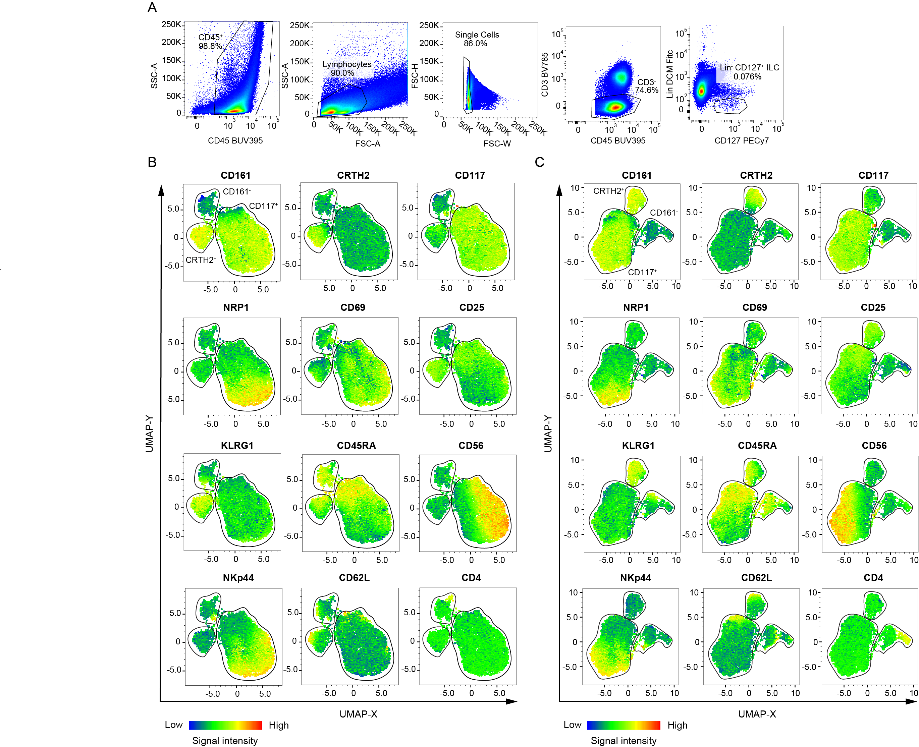

**Supplementary Figure 1.** **(A)** Gating strategy for CD127+ ILCs. **(B, C)** UMAP of CD127+ ILCs in small **(B)** and large **(C)** tonsils. Major UMAP groups of CD117+, CRTH2+, as well as CD161- ILCs are outlined with borders.

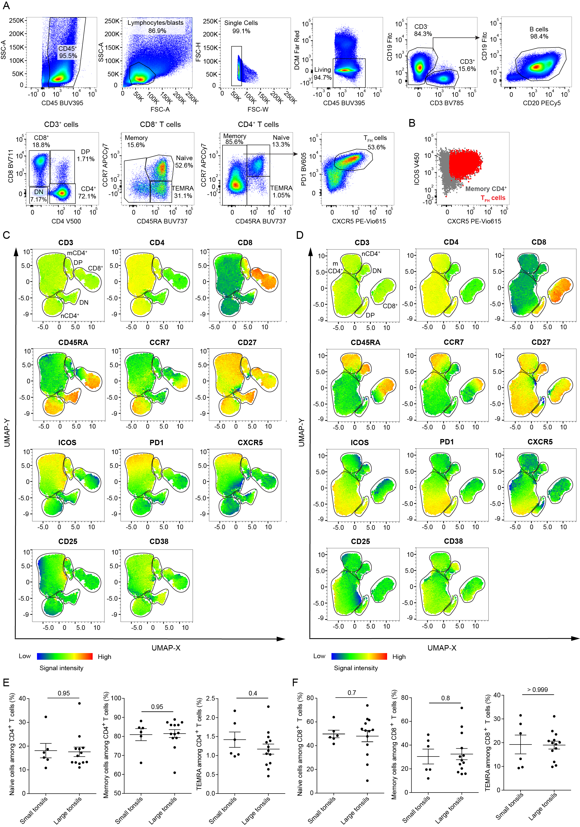

**Supplementary Figure 2. (A)** Gating strategy for B cells and T cells, as well as naïve, TEMRA and memory T-cell subsets and TFH cells. **(B)** Representative plot of ICOS vs. CXCR5 expression on memory CD4+ T cells and TFH cells. **(C, D)** UMAP of CD3+ T cells in small **(C)** and large **(D)** tonsils. UMAP groups of memory CD4+ (mCD4+), naïve CD4+ (nCD4+), CD8+, double positive (DP) and double negative (DN) T cells and outlined with borders **(E, F)** Frequencies of naïve, memory and TEMRA CD4+ **(E)** and CD8+ **(F)** T cells in small and large tonsils. Lines represent mean ± SEM. Statistical significance was calculated using Mann-Whitney *U* test.

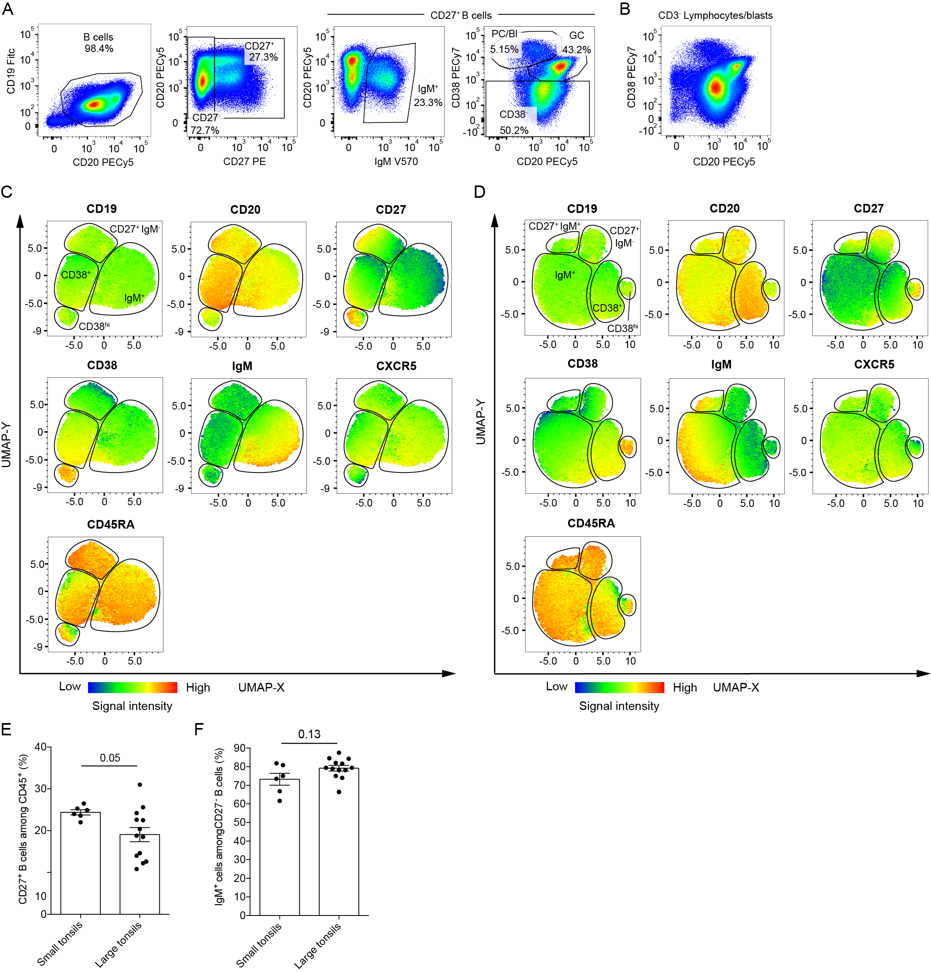

**Supplementary Figure 3. (A)** Gating strategy for assessing B-cell sub-populations among B cells gated as in supplementary figure 2A. **(B)** Representative plot of CD38 vs. CD20 expression on total living CD3- lymphocytes and lymphoblasts. **(C, D)** UMAP of CD19+CD20+ B cells in small **(C)** and large **(D)** tonsils. UMAP groups of CD38hi, CD38+, IgM+, CD27+IgM- and CD27+IgM+ B cells are outlined with borders. **(E)** Frequency of CD27+ B cells among total living CD45+ cells in small and large tonsils. **(F)** Frequency of IgM+ cells among CD27- B cells in small and large tonsils. **(E, F)** Bars and error bars represent mean ± SEM. Statistical significance was calculated using Mann-Whitney *U* test.

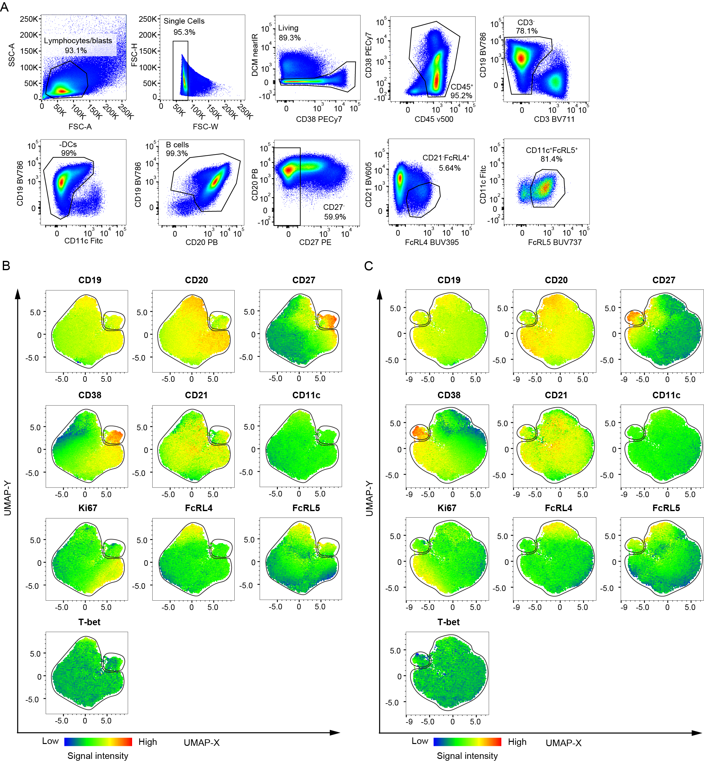

**Supplementary Fig. 4 (A)** Gating strategy for B cells and atypical memory B cells. **(B, C)** UMAP of CD19+CD20+ B cells in small **(B)** and large **(C)** tonsils. Identified UMAP groups are outlined with borders.