Supplementary data
Inhibition of extracellular cathepsin D reduces hepatic lipid accumulation and leads to mild changes in inflammation in NASH mice

Short title: Extracellular cathepsin D in NASH

Tulasi Yadati¹, Tom Houben¹, Albert Bitorina¹, Yvonne Oligschlaeger¹, Marion J. Gijbels^{2,3}, Ronny Mohren⁴, Dieter Lütjohann⁵, Princy Khurana⁶, Sandeep Goyal⁶, Aditya Kulkarni⁶, Jan Theys⁷, Berta Cillero-Pastor⁴ and Ronit Shiri-Sverdlov¹

Supplementary Figure 1

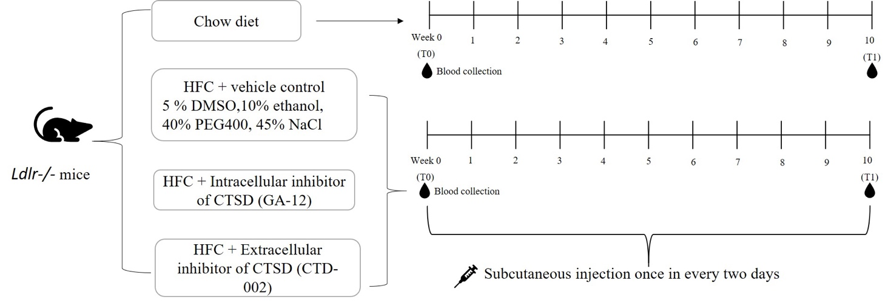

Figure S1. Schematic representation of the study design and the timeline of the in vivo experiment
Experimental timeline (Schematic drawing) of the in vivo experiment. Ldlr^{-/-} mice fed a regular chow diet were included as a control group for NASH disease phenotype (n=20). HFC mice received vehicle or CTSD inhibitors subcutaneously once in every two days for 10 weeks. Sample sizes are n=17 for vehicle group, n=20 for intracellular inhibitor (GA-12)-treated group and n=17 for extracellular inhibitor (CTD-002)-treated group.

Supplementary Figure 2

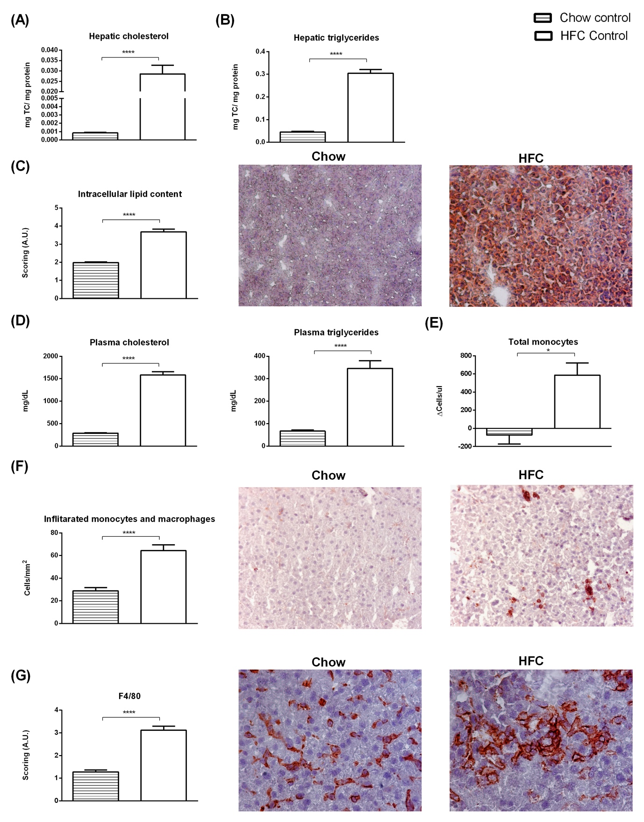

Figure S2. HFC supplementation for 10 week induces NASH in Ldlr-/- mice
(A-B) Feeding mice with HFC diet for 10 weeks lead to a significant increase in hepatic cholesterol and triglyceride levels compared to mice on chow diet. (C) Scoring of hepatic lipid content (oil red o staining) using arbitrary units (A.U.). (Original magnification, 200x) (D) Plasma lipid levels between chow and HFC mice. (E) Total number of plasma monocytes as measured by FACS. (F) Liver sections were stained for infiltrating macrophages and neutrophils (Mac-1). Positive cells were counted in six microscopical views (original magnification, 200x) (G) Hepatic immunostaining for F4/80. Postive cells were evaluated and scored according to arbitrary units (original magnification, 400x). Error bars represent ±SEM; n=17-20 animals; n=5 per each group for FACS; * represents p<0.05 **** represents p<0.001 compared to chow control mice as determined by two-tailed unpaired t test.

Supplementary Figure 3

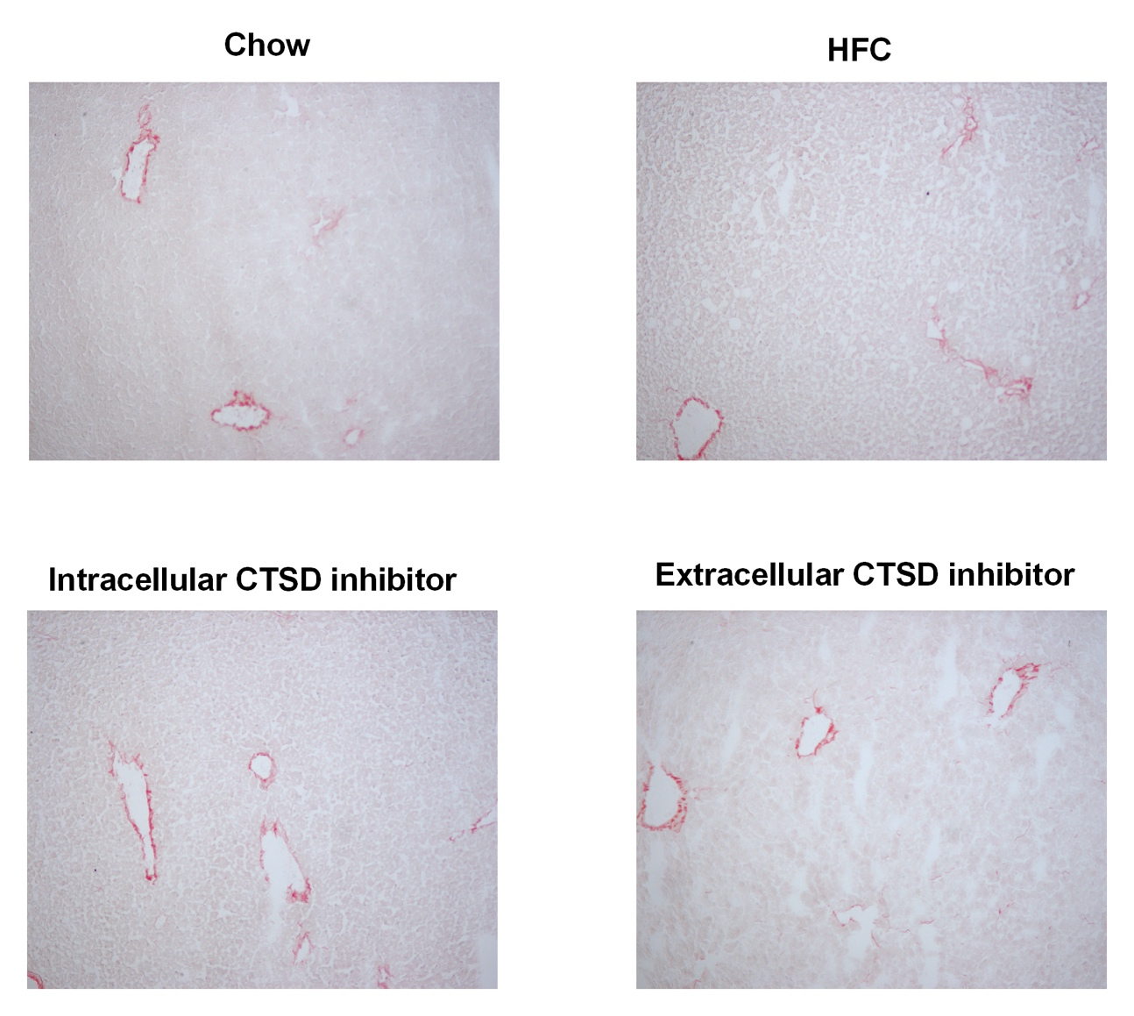
Figure S3. No changes in hepatic fibrosis between different experimental groups of mice.
Representative pictures of Sirius Red staining (original magnification, 100x)

Supplementary Figure 4

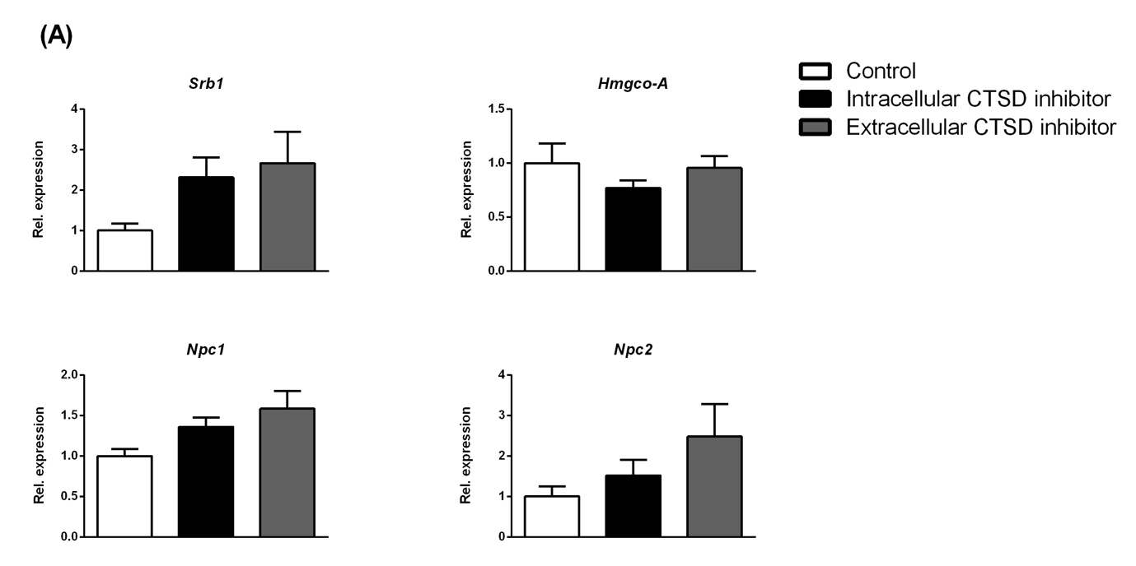
Figure S4. Hepatic gene expression of lipid-related genes
(A) Hepatic gene expression of lipid metabolism-related genes. Error bars represent ±SEM. n=16-20 per group.
Supplementary Figure 5

(A)

(B)

(C)

Figure S5. Label-free quantitative LC-MS proteomics of different groups of mice.
Volcano plots of protein changes observed in the livers of mice belonging to different groups. The −log10 (Benjamini–Hochberg corrected P value) is plotted against the log2 (fold change) for respective groups. (A) extracellular inhibitor-treated group vs control (B) intracellular inhibitor-treated group vs control and (C) extracellular vs intracellular inhibitor-treated groups.

Table S1: Significantly upregulated proteins found in control mice compared to intracellular inhibitor-treated mice. Proteins were selected with a ratio of at least 1.5-fold change and p-value of ≤ 0.05. In the table, Protein accession number according to UniProt, protein names, gene ID, abundance ratio (log2 ≥0.58) are listed.

 | Upregulated proteins in control mice compared to intracellular inhibitor-treated mice |  | Control/ intracellular inhibitor
Accession number | Description | Gene ID | Abundance ratio (log2)
Q9D6Y9 | 1,4-alpha-glucan-branching enzyme | Gbe1 | 1,26
Q9R092 | 17-beta-hydroxysteroid dehydrogenase type 6 | Hsd17b6 | 2,08
P61922 | 4-aminobutyrate aminotransferase, mitochondrial | Abat | 1,4
A0JNU3 | 60 kDa lysophospholipase | Aspg | 1,46
Q9DCD0 | 6-phosphogluconate dehydrogenase, decarboxylating | Pgd | 1,78
Q80XL6 | Acyl-CoA dehydrogenase family member 11 | Acad11 | 1,35
Q99PL7 | Acyl-CoA desaturase | Scd3 | 3,31
Q5XG73 | Acyl-CoA-binding domain-containing protein 5 | Acbd5 | 2,6
P51881 | ADP/ATP translocase 2 | Slc25a5 | 1,75
P47740 | Aldehyde dehydrogenase family 3 member A2 | Aldh3a2 | 1,79
Q8BW75 | Amine oxidase [flavin-containing] B | Maob | 1,49
Q91YI0 | Arginosuccinate lyase | Asl | 1,8
P34927 | Asialoglycoprotein receptor 1 | Asgr1 | 1,79
Q8BP47 | Asparagine--tRNA ligase, cytoplasmic | NARS1 | 1,79
P04919 | Band 3 anion transport protein | Slc4a1 | 2,13
P18572 | Basigin | Bsg | 1,61
Q61335 | B-cell receptor-associated protein 31 | Bcap31 | 1,83
Q9QXX4 | Calcium-binding mitochondrial carrier protein Aralar2 | Slc25a13 | 2,03
Q61490 | CD166 antigen | Alcam | 1,77
Q91WS0 | CDGSH iron-sulfur domain-containing protein 1 | Cisd1 | 2,14
P60766 | Cell division control protein 42 homolog | Cdc42 | 2,37
Q68FD5 | Clathrin heavy chain 1 | Cltc | 1,43
Q9QZE5 | Coatomer subunit gamma-1 | Copg1 | 1,77
Q9QZQ8 | Core histone macro-H2A.1 | H2afy | 1,89
P50172 | Corticosteroid 11-beta-dehydrogenase isozyme 1 | Hsd11b1 | 1,88
Q99L04 | Dehydrogenase/reductase SDR family member 1 | Dhrs1 | 2,59
P50285 | Dimethylaniline monooxygenase [N-oxide-forming] 1 | Fmo1 | 2,72
P97501 | Dimethylaniline monooxygenase [N-oxide-forming] 3 | Fmo3 | 2,38
P97872 | Dimethylaniline monooxygenase [N-oxide-forming] 5 | Fmo5 | 2,57
O54734 | Dolichyl-diphosphooligosaccharide--protein glycosyltransferase 48 kDa subunit | Ddost | 1,67
Q91YQ5 | Dolichyl-diphosphooligosaccharide--protein glycosyltransferase subunit 1 | Rpn1 | 2,31
P58252 | Elongation factor 2 | Eef2 | 1,66
Q8BHI7 | Elongation of very long chain fatty acids protein 5 | Elovl5 | 3,2
P19096 | Fatty acid synthase | Fasn | 2,24
O08914 | Fatty-acid amide hydrolase 1 | Faah | 1,55
P35576 | Glucose-6-phosphatase | G6pc | 2,12
Q64516 | Glycerol kinase | Gk | 1,73
Q9ET01 | Glycogen phosphorylase, liver form | Pygl | 1,51
P01901 | H-2 class I histocompatibility antigen, K-B alpha chain | H2-K1 | 1,58
P10922 | Histone H1. | H1-0 | 2,72
P15864 | Histone H1.2 | H1-2 | 2,48
P43274 | Histone H1.4 | H1-4 | 2,91
P43276 | Histone H1.5 | H1-5 | 2,61
P02301 | Histone H3.3C | H3f3c | 1,57
P62806 | Histone H4 | H4c1 | 1,3
Q8VCZ9 | Hydroxyproline dehydrogenase | Prodh2 | 2,82
P01872 | Immunoglobulin heavy constant mu | Ighm | 1,43
P70168 | Importin subunit beta-1 | Kpnb1 | 1,97
Q9CXF0 | Kynureninase | Kynu | 1,67
Q9WVM8 | Kynurenine/alpha-aminoadipate aminotransferase, mitochondrial | Aadat | 2,16
Q922Q8 | Leucine-rich repeat-containing protein 59 | Lrrc59 | 2,76
P58710 | L-gulonolactone oxidase | Gulo | 2,12
P41216 | Long-chain-fatty-acid--CoA ligase 1 | Acsl1 | 1,68
Q8JZR0 | Long-chain-fatty-acid--CoA ligase 5 | Acsl5 | 1,84
O35114 | Lysosome membrane protein 2 | Scarb2 | 2,1
Q99J39 | Malonyl-CoA decarboxylase, mitochondrial | Mlycd | 1,62
O55022 | Membrane-associated progesterone receptor component 1 | Pgrmc1 | 1,58
Q80UU9 | Membrane-associated progesterone receptor component 2 | Pgrmc2 | 2,33
Q9DD20 | Methyltransferase-like protein 7B | Mettl7b | 2,33
Q91VS7 | Microsomal glutathione S-transferase 1 | Mgst1 | 2,91
Q922Q1 | Mitochondrial amidoxime reducing component 2 | Marc2 | 2
Q9CW42 | Mitochondrial amidoxime-reducing component 1 | Marc1 | 1,79
Q791V5 | Mitochondrial carrier homolog 2 | Mtch2 | 2,86
Q9CZW5 | Mitochondrial import receptor subunit TOM70 | Tomm70 | 1,63
Q9D023 | Mitochondrial pyruvate carrier 2 OS=Mus musculus OX=10090 GN=Mpc2 PE=1 SV=1 | Mpc2 | 1,93
Q8VDD5 | Myosin-9 OS=Mus musculus | Myh9 | 1,71
Q9ERS2 | NADH dehydrogenase [ubiquinone] 1 alpha subcomplex subunit 13 | Ndufa13 | 1,86
O09111 | NADH dehydrogenase [ubiquinone] 1 beta subcomplex subunit 11, mitochondrial | Ndufb11 | 2,39
Q9CQC7 | NADH dehydrogenase [ubiquinone] 1 beta subcomplex subunit 4 | Ndufb4 | 1,73
Q9DC70 | NADH dehydrogenase [ubiquinone] iron-sulfur protein 7, mitochondrial | Ndufs7 | 2
Q9DCN2 | NADH-cytochrome b5 reductase 3 | Cyb5r3 | 2,45
Q9QXD1 | Peroxisomal acyl-coenzyme A oxidase 2 | Acox2 | 1,84
P97372 | Proteasome activator complex subunit 2 | Psme2 | 2,13
Q9CQS8 | Protein transport protein Sec61 subunit beta OS=Mus musculus OX=10090 GN=Sec61b PE=1 SV=3 | Sec61b | 3,18
P35293 | Ras-related protein Rab-18 | Rab18 | 1,67
P35278 | Ras-related protein Rab-5C | Rab5c | 2,09
P51150 | Ras-related protein Rab-7a | Rab7a | 2,51
Q9JM62 | Receptor expression-enhancing protein 6 | Reep6 | 1,49
O88451 | Retinol dehydrogenase 7 | Rdh7 | 2,23
Q9D5J6 | Sedoheptulokinase | Shpk | 1,89
P52430 | Serum paraoxonase/arylesterase 1 | Pon1 | 1,45
Q9JJL3 | Solute carrier organic anion transporter family member 1B2 | Slco1b2 | 3,72
Q62465 | Synaptic vesicle membrane protein VAT-1 homolog | Vat1 | 2,13
Q9D0R2 | Threonine--tRNA ligase 1, cytoplasmic | Tars1 | 2,12
Q9QUI0 | Transforming protein RhoA | Rhoa | 2,27
Q62186 | Translocon-associated protein subunit delta | Ssr4 | 1,97
Q99KF1 | Transmembrane emp24 domain-containing protein 9 | Tmed9 | 2,41
Q8JZU2 | Tricarboxylate transport protein, mitochondrial | Slc25a1 | 2,52
P68373 | Tubulin alpha-1C chain | Tuba1c | 1,17
P68372 | Tubulin beta-4B chain | Tubb4b | 1,21
Q8BWQ1 | UDP-glucuronosyltransferase 2A3 | Ugt2a3 | 2,81
P17717 | UDP-glucuronosyltransferase 2B17 | Ugt2b17 | 2,29
Q8JZZ0 | UDP-glucuronosyltransferase 3A2 | Ugt3a2 | 2,78
O35488 | Very long-chain acyl-CoA synthetase | Slc27a2 | 2,32
O70503 | Very-long-chain 3-oxoacyl-CoA reductase | Hsd17b12 | 1,79
Q9QY76 | Vesicle-associated membrane protein-associated protein B | Vapb | 2,09
O08547 | Vesicle-trafficking protein SEC22b | Sec22b | 2,11
P25444 | 40S ribosomal protein S2 | Rps2 | 1,32
P97461 | 40S ribosomal protein S5 | Rps5 | 2,98
Q6ZWV3 | 60S ribosomal protein L10 | Rpl10 | 1,24
P19253 | 60S ribosomal protein L13a | Rpl13a | 1,5
Q9CR57 | 60S ribosomal protein L14 | Rpl14 | 1,7
Q9CZM2 | 60S ribosomal protein L15 | Rpl15 | 1,75
P35980 | 60S ribosomal protein L18 | Rpl18 | 2,69
Q8BP67 | 60S ribosomal protein L24 | Rpl24 | 1,71
P41105 | 60S ribosomal protein L28 | Rpl28 | 1,74
P47915 | 60S ribosomal protein L29 | Rpl29 | 1,55
Q9D1R9 | 60S ribosomal protein L34 | Rpl34 | 2,36
Q6ZWV7 | 60S ribosomal protein L35 | Rpl35 | 2,08
P83882 | 60S ribosomal protein L36a | Rpl36a | 1,64
Q9D8E6 | 60S ribosomal protein L4 | Rpl4 | 1,73
P47911 | 60S ribosomal protein L6 | Rpl6 | 2,91
P14148 | 60S ribosomal protein L7 | Rpl7 | 3,09
P12970 | 60S ribosomal protein L7a | Rpl7a | 1,31
Q9CQX2 | Cytochrome b5 type B | Cyb5b | 1,84
P00405 | Cytochrome c oxidase subunit 2 | Mtco2 | 2,51
P19783 | Cytochrome c oxidase subunit 4 isoform 1, mitochondrial | Cox4i1 | 1,96
Q9CPQ1 | Cytochrome c oxidase subunit 6C | Cox6c | 2,19
P20852 | Cytochrome P450 2A5 | Cyp2a5 | 2,78
Q64458 | Cytochrome P450 2C29 | Cyp2c29 | 1,35
P56654 | Cytochrome P450 2C37 | Cyp2c37 | 2,32
P56657 | Cytochrome P450 2C40 | Cyp2c40 | 1,94
P24456 | Cytochrome P450 2D10 | Cyp2d10 | 1,82
Q8CIM7 | Cytochrome P450 2D26 | Cyp2d26 | 3,06
Q05421 | Cytochrome P450 2E1 | Cyp2e1 | 2,68
Q64459 | Cytochrome P450 3A11 | Cyp3a11 | 2,87
Q9JMA7 | Cytochrome P450 3A41 | Cyp3a41a | 1,77
Q9CQQ7 | ATP synthase F(0) complex subunit B1, mitochondrial | Atp5pb | 1,41
P03930 | ATP synthase protein 8 | Mtatp8 | 1,97
P56379 | ATP synthase subunit ATP5MPL, mitochondrial | Atp5mpl | 2,71
Q9CPQ8 | ATP synthase subunit g, mitochondrial | Atp5mg | 1,63
P55096 | ATP-binding cassette sub-family D member 3 | Abcd3 | 2,57

Table S2: Significantly upregulated proteins found in control mice compared to extracellular inhibitor-treated mice. Proteins were selected with a ratio of at least 1.5-fold change and p-value of ≤ 0.05. In the table, Protein accession number according to UniProt, protein names, gene ID, abundance ratio (log2 ≥0.58) are listed.

 | Upregulated proteins in response in control mice compared to extracellular inhibitor-treated mice |  | Control/ extracellular inhibitor
Accession number | Description | Gene Id | Abundance ratio (log2)
Ca1 | Carbonic anhydrase 1 | Ca1 | 0,9
Col14a1 | Collagen alpha-1(XIV) chain | Col14a1 | 0,82
Ckm | Creatine kinase M-type | Ckm | 0,65
Fabp3 | Fatty acid-binding protein, heart | Fabp3 | 0,69
Gsta1 | Glutathione S-transferase A1 | Gsta1 | 0,66
Hbb-b1 | Hemoglobin subunit beta-1 | Hbb-b1 | 0,65
Ighv3-6 | Ig heavy chain V region 3-6 | Ighv3-6 | 1,28
Nubpl | Iron-sulfur protein NUBPL | Nubpl | 0,59
Mb | Myoglobin | Mb | 2,35
Myl1 | Myosin light chain 1/3, skeletal muscle isoform | Myl1 | 1,04
Prelp | Prolargin | Prelp | 0,74
S100a8 | Protein S100-A8 | S100a8 | 0,83
S100a9 | Protein S100-A9 | S100a9 | 0,65
Spta1 | Spectrin alpha chain, erythrocytic 1 | Spta1 | 0,68
Tnnc2 | Troponin C, skeletal muscle | Tnnc2 | 1,37
Xylt2 | Xylosyltransferase 2 | Xylt2 | 0,91

Table S3: Significantly upregulated proteins found in extracellular inhibitor-treated mice compared to control mice. Proteins were selected with a ratio of at least 1.5-fold change and p-value of ≤ 0.05. In the table, Protein accession number according to UniProt, protein names, gene ID, abundance ratio (log2 ≥0.58) are listed.

 | Upregulated proteins in extracellular inhibitor-treated mice compared to control mice |  | Extracellular inhibitor/  control
Accession number | Description | Gene Id | Abundance ratio (log2)
Q99PL7 | Acyl-CoA desaturase 3 | Scd3 | 0,6
P07361 | Alpha-1-acid glycoprotein 2 | Orm2 | 1,12
Q9DBE0 | Cysteine sulfinic acid decarboxylase | Csad | 0,8
Q05816 | Fatty acid-binding protein 5 | Fabp5 | 0,71
P01864 | Ig gamma-2A chain C region secreted form |  | 0,91
P01655 | Ig kappa chain V-III region PC 7132 |  | 0,8
Q8K2C9 | Very-long-chain (3R)-3-hydroxyacyl-CoA dehydratase 3 | Hacd3 | 0,86
Q9R1Z8 | Vinexin | Sorbs3 | 0,68
P18242 | Cathepsin D | Ctsd | 0,58
O35403 | Amine sulfotransferase | Sult3a1 | 0,64
P00186 | Cytochrome P450 1A2 | Cyp1a2 | 0,59
O54749 | Cytochrome P450 2J5 | Cyp2j5 | 0,71
Q64481 | Cytochrome P450 3A16 | Cyp3a16 | 1,12
P04938 | Major urinary protein 11 | Mup11 | 0,66
P11589 | Major urinary protein 2 | Mup2 | 0,61
P09528 | Ferritin heavy chain | Fth1 | 0,85
P29391 | Ferritin light chain 1 | Ftl1 | 0,9
P46978 | Dolichyl-diphosphooligosaccharide--protein glycosyltransferase subunit STT3A | Stt3a | 0,72
Q99KR7 | Peptidyl-prolyl cis-trans isomerase F, mitochondrial | Ppif | 0,71
P54726 | UV excision repair protein RAD23 homolog A | Rad23a | 0,66

Table S4: Significantly upregulated proteins found in extracellular inhibitor-treated mice compared to intracellular inhibitor-treated mice. Proteins were selected with a ratio of at least 1.5-fold change and p-value of ≤ 0.05. In the table, Protein accession number according to UniProt, protein names, gene ID, abundance ratio (log2 ≥0.58) are listed.

 | Upregulated proteins in extracellular inhibitor-treated mice compared to Intracellular inhibitor-treated mice |  | Extracellular inhibitor/  intracellular  inhibitor
Accession number | Description | Gene ID | Abundance ratio (log2)
P19096 | Fatty acid synthase | Fasn | 1,91
Q9ET01 | Glycogen phosphorylase, liver form | Pygl | 1,66
Q9DCN2 | NADH-cytochrome b5 reductase 3 | Cyb5r3 | 2,19
Q791V5 | Mitochondrial carrier homolog 2 | Mtch2 | 2,42
P35576 | Glucose-6-phosphatase | G6pc | 3,54
Q91YI0 | Argininosuccinate lyase | Asl | 1,61
P51881 | ADP/ATP translocase 2 | Slc25a5 | 1,66
P41216 | Long-chain-fatty-acid--CoA ligase 1 | Acsl1 | 1,71
Q9CZM2 | 60S ribosomal protein L15 | Rpl15 | 1,61
P47740 | Aldehyde dehydrogenase family 3 member A2 | Aldh3a2 | 1,73
P50172 | Corticosteroid 11-beta-dehydrogenase isozyme 1 | Hsd11b1 | 1,74
Q9DD20 | Methyltransferase-like protein 7B | Mettl7b | 2,42
P19783 | Cytochrome c oxidase subunit 4 isoform 1, mitochondrial | Cox4i1 | 1,79
P01872 | Immunoglobulin heavy constant mu | Ighm | 1,72
P58710 | L-gulonolactone oxidase | Gulo | 1,73
Q922Q1 | Mitochondrial amidoxime reducing component 2 | Marc2 | 2
O35488 | Very long-chain acyl-CoA synthetase | Slc27a2 | 1,7
Q8JZR0 | Long-chain-fatty-acid--CoA ligase 5 | Acsl5 | 1,65
Q9QXX4 | Calcium-binding mitochondrial carrier protein Aralar2 | Slc25a13 | 2,03
P43274 | Histone H1.4 | H1-4 | 1,74
O88451 | Retinol dehydrogenase 7 | Rdh7 | 1,79
Q91WS0 | CDGSH iron-sulfur domain-containing protein 1 | Cisd1 | 1,83
P00405 | Cytochrome c oxidase subunit 2 | Mtco2 | 2,35
P97872 | Dimethylaniline monooxygenase [N-oxide-forming] 5 | Fmo5 | 2,29
Q9CPQ1 | Cytochrome c oxidase subunit 6C | Cox6c | 2,35
Q64516 | Glycerol kinase OS=Mus musculus OX=10090 GN=Gk PE=1 SV=2 | Gk | 1,78
Q9DCD0 | 6-phosphogluconate dehydrogenase, decarboxylating | Pgd | 1,95
Q9DCM2 | Glutathione S-transferase kappa 1 | Gstk1 | 1,7
Q91YQ5 | Dolichyl-diphosphooligosaccharide--protein glycosyltransferase subunit 1 | Rpn1 | 1,86
Q9CW42 | Mitochondrial amidoxime-reducing component 1 | Marc1 | 1,82
Q9CXF0 | Kynureninase | Kynu | 1,73
P03930 | ATP synthase protein 8 | Mtatp8 | 1,9
Q8BP67 | 60S ribosomal protein L24 | Rpl24 | 1,58
P35980 | 60S ribosomal protein L18 | Rpl18 | 2,06
Q9D0R2 | Threonine--tRNA ligase 1, cytoplasmic | Tars1 | 2,1
Q8CIM7 | Cytochrome P450 2D26 | Cyp2d26 | 2,6
Q64458 | Cytochrome P450 2C29 | Cyp2c29 | 1,85
Q99L04 | Dehydrogenase/reductase SDR family member 1 | Dhrs1 | 2,17
P14148 | 60S ribosomal protein L7 | Rpl7 | 2,73
P55096 | ATP-binding cassette sub-family D member 3 | Abcd3 | 2,27
Q9QXD1 | Peroxisomal acyl-coenzyme A oxidase 2 | Acox2 | 2,03
P47911 | 60S ribosomal protein L6 | Rpl6 | 1,86
Q9D5J6 | Sedoheptulokinase | Shpk | 1,91
P97372 | Proteasome activator complex subunit 2 | Psme2 | 1,69
Q9QUI0 | Transforming protein RhoA | Rhoa | 2,34
P50285 | Dimethylaniline monooxygenase [N-oxide-forming] 1 | Fmo1 | 2,07
Q91X44 | Glucokinase regulatory protein | Gckr | 1,67
P24456 | Cytochrome P450 2D10 | Cyp2d10 | 2,15
Q9D1R9 | 60S ribosomal protein L34 | Rpl34 | 2,3
P34927 | Asialoglycoprotein receptor 1 | Asgr1 | 1,61
Q922Q8 | Leucine-rich repeat-containing protein 59 | Lrrc59 | 2,25
Q9CZW5 | Mitochondrial import receptor subunit TOM70 | Tomm70 | 1,59
P97461 | 40S ribosomal protein S5 | Rps5 | 2,85
P15864 | Histone H1.2 | H1-2 | 1,69
P10922 | Histone H1.0 | H1-0 | 1,83
P17717 | UDP-glucuronosyltransferase 2B17 | Ugt2b17 | 2,28
Q9CQC7 | NADH dehydrogenase [ubiquinone] 1 beta subcomplex subunit 4 | Ndufb4 | 1,67
Q61335 | B-cell receptor-associated protein 31 | Bcap31 | 1,58
Q99J39 | Malonyl-CoA decarboxylase, mitochondrial | Mlycd | 1,58
Q9WVM8 | Kynurenine/alpha-aminoadipate aminotransferase, mitochondrial | Aadat | 2,02
P60766 | Cell division control protein 42 homolog | Cdc42 | 2,38
Q8BWQ1 | UDP-glucuronosyltransferase 2A3 | Ugt2a3 | 2,75
Q62465 | Synaptic vesicle membrane protein VAT-1 homolog | Vat1 | 1,93
P56654 | Cytochrome P450 2C37 | Cyp2c37 | 1,78
P97501 | Dimethylaniline monooxygenase [N-oxide-forming] 3 | Fmo3 | 1,98
P56135 | ATP synthase subunit f, mitochondrial | Atp5mf | 1,95
Q9CQX2 | Cytochrome b5 type B | Cyb5b | 2,01
O35114 | Lysosome membrane protein 2 | Scarb2 | 2,12
Q8R1I1 | Cytochrome b-c1 complex subunit 9 | Uqcr10 | 1,77
A2AKK5 | Acyl-coenzyme A amino acid N-acyltransferase 1 | Acnat1 | 1,59
Q9DC70 | NADH dehydrogenase [ubiquinone] iron-sulfur protein 7, mitochondrial | Ndufs7 | 1,95
O08547 | Vesicle-trafficking protein SEC22b | Sec22b | 1,73
P61027 | Ras-related protein Rab-10 | Rab10 | 1,56
Q62186 | Translocon-associated protein subunit delta | Ssr4 | 1,58
P56657 | Cytochrome P450 2C40 | Cyp2c40 | 1,98
Q9QY76 | Vesicle-associated membrane protein-associated protein B | Vapb | 1,79
P18572 | Basigin | Bsg | 1,82
Q64514 | Tripeptidyl-peptidase 2 | Tpp2 | 1,71
Q8JZZ0 | UDP-glucuronosyltransferase 3A2 | Ugt3a2 | 1,88
Q9D023 | Mitochondrial pyruvate carrier 2 | Mpc2 | 1,76
Q8JZU2 | Tricarboxylate transport protein, mitochondrial | Slc25a1 | 2,32
P00186 | Cytochrome P450 1A2 | Cyp1a2 | 2,39
Q8BP47 | Asparagine--tRNA ligase, cytoplasmic | NARS1 | 1,72
Q64459 | Cytochrome P450 3A11 | Cyp3a11 | 2
Q5XG73 | Acyl-CoA-binding domain-containing protein 5 | Acbd5 | 2,45
B1AR13 | CDGSH iron-sulfur domain-containing protein 3, mitochondrial | Cisd3 | 1,85
O70503 | Very-long-chain 3-oxoacyl-CoA reductase | Hsd17b12 | 1,64
Q9JMA7 | Cytochrome P450 3A41 | Cyp3a41a | 2,87
O09111 | NADH dehydrogenase [ubiquinone] 1 beta subcomplex subunit 11, mitochondrial | Ndufb11 | 2,48
Q8BHI7 | Elongation of very long chain fatty acids protein 5 | Elovl5 | 2,55
Q8VCZ9 | Hydroxyproline dehydrogenase | Prodh2 | 2,91
P51150 | Ras-related protein Rab-7a | Rab7a | 2,26
P04919 | Band 3 anion transport protein | Slc4a1 | 1,67
P35278 | Ras-related protein Rab-5C | Rab5c | 1,92
Q9CR61 | NADH dehydrogenase [ubiquinone] 1 beta subcomplex subunit 7 | Ndufb7 | 1,81
Q9R092 | 17-beta-hydroxysteroid dehydrogenase type 6 | Hsd17b6 | 1,82
P56379 | ATP synthase subunit ATP5MPL, mitochondrial | Atp5mpl | 3,36
Q925I1 | ATPase family AAA domain-containing protein 3 | Atad3 | 1,63
Q80UU9 | Membrane-associated progesterone receptor component 2 | Pgrmc2 | 2,13
Q99PL7 | Acyl-CoA desaturase | Scd3 | 2,8
Q9CQS8 | Protein transport protein Sec61 subunit beta | Sec61b | 3,03
Q9R1J0 | Sterol-4-alpha-carboxylate 3-dehydrogenase, decarboxylating | Nsdhl | 1,78
Q99KF1 | Transmembrane emp24 domain-containing protein 9 | Tmed9 | 2,27
Q9R1P3 | Proteasome subunit beta type-2 | Psmb2 | 1,72
P15392 | Cytochrome P450 2A4 | Cyp2a4 | 2,21
Q9CRC0 | Vitamin K epoxide reductase complex subunit 1 | Vkorc1 | 1,88
O09117 | Synaptophysin-like protein 1 | Sypl1 | 1,79
P20852 | Cytochrome P450 2A5 | Cyp2a5 | 2,92
P43276 | Histone H1.5 | H1-5 | 1,57
Q9CQW9 | Interferon-induced transmembrane protein 3 | Ifitm3 | 1,79
Q9D2R0 | Acetoacetyl-CoA synthetase | Aacs | 2,02
Q9CQC6 | Basic leucine zipper and W2 domain-containing protein 1 | Bzw1 | 1,68
Q9JJL3 | Solute carrier organic anion transporter family member 1B2 | Slco1b2 | 3,87
Q64669 | NAD(P)H dehydrogenase [quinone] | Nqo1 | 1,83
Q76M72 | Solute carrier family 22 member 27 | Slc22a27 | 2,31
Q61490 | CD166 antigen | Alcam | 1,65
Q05421 | Cytochrome P450 2E1 | Cyp2e1 | 2,07
P20852 | Cytochrome P450 2A5 | Cyp2a5 | 2,92
P15392 | Cytochrome P450 2A4 | Cyp2a4 | 2,21
Q9JMA7 | Cytochrome P450 3A41 | Cyp3a41a | 2,87
Q64459 | Cytochrome P450 3A11 | Cyp3a11 | 2
P00186 | Cytochrome P450 1A2 | Cyp1a2 | 2,39
P56657 | Cytochrome P450 2C40 | Cyp2c40 | 1,98
Q9CQX2 | Cytochrome b5 type B | Cyb5b | 2,01
P56654 | Cytochrome P450 2C37 | Cyp2c37 | 1,78
Q64458 | Cytochrome P450 2C29 | Cyp2c29 | 1,85
Q8CIM7 | Cytochrome P450 2D26 | Cyp2d26 | 2,6
Q9DCN2 | NADH-cytochrome b5 reductase 3 | Cyb5r3 | 2,19

Table S5: Significantly upregulated proteins found in intracellular inhibitor-treated mice compared to control mice. Proteins were selected with a ratio of at least 1.5-fold change and p-value of ≤ 0.05. In the table, Protein accession number according to UniProt, protein names, gene ID, abundance ratio (log2 ≥0.58) are listed.

 | Upregulated proteins in intracellular inhibitor-treated mice compared to control mice |  | Intracellular inhibitor/  control
Accession number | Description | Gene ID | Abundance ratio (log2)
Q9R0Y5 | Adenylate kinase isoenzyme 1 | Ak1 | 4,1
P21550 | Beta-enolase | Eno3 | 5,97
O54724 | Caveolae-associated protein 1 | Cavin1 | 2,37
P07310 | Creatine kinase M-type | Ckm | 4,05
Q6P8J7 | Creatine kinase S-type, mitochondrial | Ckmt2 | 3,2
P31001 | Desmin | Des | 2,42
P11404 | Fatty acid-binding protein, heart | Fabp3 | 3,04
P97447 | Four and a half LIM domains protein 1 | Fhl1 | 3,4
P14602 | Heat shock protein beta-1 | Hspb1 | 1,98
Q5EBG6 | Heat shock protein beta-6 | Hspb6 | 3,79
Q9JKS4 | LIM domain-binding protein 3 | Ldb3 | 5,75
P16125 | L-lactate dehydrogenase B chain | Ldhb | 2,11
P04247 | Myoglobin OS=Mus musculus | Mb | 6,52
Q62234 | Myomesin-1 OS=Mus musculus | Myom1 | 3,59
P05977 | Myosin light chain 1/3, skeletal muscle isoform | Myl1 | 3,64
P51667 | Myosin regulatory light chain 2, ventricular/cardiac muscle isoform | Myl2 | 4,68
Q5SX40 | Myosin-1 OS=Mus musculus | Myh1 | 2,31
Q5SX39 | Myosin-4 OS=Mus musculus | Myh4 | 1,81
Q91Z83 | Myosin-7 OS=Mus musculus | Myh7 | 1,85
Q9JK37 | Myozenin-1 | Myoz1 | 2,54
Q9JJW5 | Myozenin-2 | Myoz2 | 1,95
P00688 | Pancreatic alpha-amylase | Amy2 | 2,89
O70250 | Phosphoglycerate mutase 2 | Pgam2 | 4,87
Q9R1C7 | Pre-mRNA-processing factor 40 homolog A | Prpf40a | 2,27
P58771 | Tropomyosin alpha-1 chain | Tpm1 | 3,35
P58774 | Tropomyosin beta chain | Tpm2 | 4,93
P20801 | Troponin C, skeletal muscle | Tnnc2 | 4,08
P13412 | Troponin I, fast skeletal muscle | Tnni2 | 2,25
Q9QZ47 | Troponin T, fast skeletal muscle | Tnnt3 | 2,53
Q11136 | Xaa-Pro dipeptidase | Pepd | 3,81
Table S6: Significantly upregulated proteins found in intracellular inhibitor-treated mice compared to extracellular inhibitor-treated mice. Proteins were selected with a ratio of at least 1.5-fold change and p-value of ≤ 0.05. In the table, Protein accession number according to UniProt, protein names, gene ID, abundance ratio (log2 ≥0.58) are listed.

 | Upregulated proteins in intracellular inhibitor-treated mice compared to extracellular inhibitor-treated mice |  | Intracellular inhibitor/ extracellular inhibitor
Accession number | Description | Gene ID | Abundance ratio (log2)
Q5SX40 | Myosin-1 | Myh1 | 2,54
P07310 | Creatine kinase M-type | Ckm | 5,61
P58771 | Tropomyosin alpha-1 chain | Tpm1 | 3,31
P05977 | Myosin light chain 1/3, skeletal muscle isoform | Myl1 | 3,07
P58774 | Tropomyosin beta chain | Tpm2 | 5,16
Q9QZ47 | Troponin T, fast skeletal muscle | Tnnt3 | 3,48
P21550 | Beta-enolase | Eno3 | 4,56
P31001 | Desmin | Des | 2,71
P13412 | Troponin I, fast skeletal muscle | Tnni2 | 2,42
P97447 | Four and a half LIM domains protein 1 | Fhl1 | 3,47
P11404 | Fatty acid-binding protein, heart | Fabp3 | 6,52
Q9R0Y5 | Adenylate kinase isoenzyme 1 | Ak1 | 3,89
O70250 | Phosphoglycerate mutase 2 | Pgam2 | 4,04
Q62234 | Myomesin-1 | Myom1 | 3,85
Q5SX39 | Myosin-4 | Myh4 | 2,08
P16125 | L-lactate dehydrogenase B chain | Ldhb | 2,03
Q9JK37 | Myozenin-1 | Myoz1 | 2,45
P14602 | Heat shock protein beta-1 | Hspb1 | 2,14
O54724 | Caveolae-associated protein 1 | Cavin1 | 2,33
Q9JJW5 | Myozenin-2 | Myoz2 | 2,11
Q91WK1 | SPRY domain-containing protein 4 | Spryd4 | 1,62
P14602 | Heat shock protein beta-1 | Hspb1 | 2,14

Table S7: Top 10 enriched pathways upon intracellular CTSD inhibition
KEGG database (Mouse) – Intracellular inhibitor-treated mice/ control
Name | P-value (p) | Combined Score
Hypertrophic cardiomyopathy (HCM) | 1.711e-7 | 603.92
Dilated cardiomyopathy (DCM) | 2.150e-7 | 568.61
Cardiac muscle contraction | 0.000005430 | 414.48
Glycolysis / Gluconeogenesis | 0.0001367 | 265.60
Adrenergic signalling in cardiomyocytes | 0.00006793 | 172.92
Thiamine metabolism | 0.02227 | 169.08
Arginine and proline metabolism | 0.002548 | 159.27
Tight junction | 0.001967 | 74.63
Propanoate metabolism | 0.04550 | 66.45
Glucagon signalling pathway | 0.01021 | 59.93

KEGG database (Mouse) –control/ intracellular inhibitor-treated mice
Name | P-value (p) | Combined Score
Steroid hormone biosynthesis | 6.332e-13 | 573.81
Ribosome | 1.294e-15 | 519.41
Fatty acid biosynthesis | 0.00009699 | 300.03
Retinol metabolism | 8.955e-9 | 277.69
Chemical carcinogenesis | 1.195e-8 | 264.64
Linoleic acid metabolism | 9.232e-7 | 252.64
Ascorbate and aldarate metabolism | 0.0007320 | 121.54
Peroxisome | 0.00001966 | 117.28
PPAR signalling pathway | 0.00002104 | 115.18
Drug metabolism | 0.00001064 | 106.53

