*Supplementary Online Appendix*

**Mariano Torcal* and Pablo Christmann (2021): “Responsiveness, performance and corruption: Reasons for the decline of political trust”**

**\*Correspondence:** [mariano.torcal@upf.edu](mailto:mariano.torcal@upf.edu)

# Aggregate-Level Panel Analysis

## Context-Level Variables

**Economic Performance Index (EPI):** Own estimation. Measured on a monthly basis. The EPI combines information on unemployment, government deficit, inflation and GDP growth into a single composite index. Thereby, it attempts to capture the economy’s monetary status, its production stance, the fiscal stance and the aggregate performance of the economy respectively. The index is constructed as follows:

$$Weighted EPI = 100\%-W_{Inf}×(\left|Inf\left(\%\right)-I^{*}\right|)-W_{Unem}×\left(Unem\left(\%\right)-U^{*}\right)-W_{Def}×\left(\frac{Def}{GDP\left(\%\right)}-\frac{Def}{{GDP}^{*}}\right)+ W_{GDP}×(ΔGDP\left(\%\right)-Δ{GDP}^{*})$$

where I* is the desired inflation rate (0%), U* is the desired unemployment rate (4.75%), (Def/GDP*) is the desired government deficit as a share of GDP (0%) and ΔGDP* is the desired change in GDP (4.75%). The weights (W) are generated by estimating the inverse standard deviation for each economic variable multiplied by the average standard deviation of all variables. For a detailed description of the construction of the index compare Khramov and Lee (2013: 6f.).

**Budget Deficit**: General government net lending/ borrowing, calculated as revenue minus total expenditure and expressed as percentage of GDP. This indicator is used to approximate the government budget deficit and its consequences for the economy’s fiscal stance. Measured on a yearly basis. Source: IMF WEO Database, <https://www.imf.org/external/pubs/ft/weo/2020/01/weodata/weorept.aspx?sy=1997&ey=2019&scsm=1&ssd=1&sort=country&ds=.&br=0&pr1.x=69&pr1.y=14&c=184&s=GGXCNL_NGDP&grp=0&a=> (retrieved 2020/08/19).

**GDP growth rate:** Gross domestic product, total, percentage change. GDP measures the value of goods and services produced by a state minus its imports. Measured on a quarterly basis. Annual change rate. Source: OECD Stat, <https://data.oecd.org/gdp/quarterly-gdp.htm#indicator-chart> (retrieved 2020/08/19).

**Government and Opposition index:** Index used as a robustness test instead of the index salience of politicians and politics as a problem. Arithmetic average of the Government's Performance Evaluation index and the First Opposition Party's Performance Evaluation index. Based on the following questions: 1) “As a whole, how would you rate the performance of the PSOE government: very good, good, so-so, bad, or very bad?”, 2) “As a whole, how would you rate the performance of the PP government: very good, good, so-so, bad, or very bad?”, 3) “In general, how would you rate the political performance of the PSOE as opposition party: very good, good, so-so, bad, or very bad?”, 4) “In general, how would you rate the political performance of the PP as opposition party: very good, good, so-so, bad, or very bad?” Data comes from opinion barometer of the Centro de Investigaciones Sociológicas (CIS), <http://www.cis.es/cis/opencms/ES/11_barometros/Indicadores_PI/gobierno.html> (retrieved 2021/04/15).

**Inflation Rate:** Total, growth rate compared to the same period of the previous year. The inflation rate is measured using the consumer price index and reflects the annual percentage change in the costs of an average consumer basket. Measured on a quarterly basis. Source: OECD Stat, <https://data.oecd.org/price/inflation-cpi.htm> (retrieved 2020/08/19).

**Salience of Corruption (Public):** Percentage of respondents who have answered that ‘corruption and fraud’ are among the ‘three principal problems that currently exist in Spain.’ Weighted quarterly averages. Although data coverage is very good since the beginning of the 2000s (i.e. 11 out of 12 months are usually covered), this is not true for the 1990s and the beginning of 2000s. For this reason, we have chosen to partially impute missing data with a linear interpolation. Following this procedure, we replace missing values for the following time points: quarter 2 in 1999, quarter 4 in 2000, quarter 2 in 2001. Excluding the imputed values from analysis does not substantially affect the results of our models. Data comes from opinion barometer of the Centro de Investigaciones Sociológicas (CIS), <http://www.cis.es/cis/export/sites/default/-Archivos/Indicadores/documentos_html/TresProblemas.html> (retrieved 2020/08/24).

**Salience of Politicians and Politics as a problem (Public):** Percentage of respondents who have answered that ‘politicians, political parties and politics’ are among the ‘three principal problems that currently exist in Spain.’ Weighted quarterly averages. Although data coverage is very good since the beginning of the 2000s (i.e. 11 out of 12 months are usually covered), this is not true for the 1990s and the beginning of 2000s. For this reason, we have chosen to partially impute missing data with a linear interpolation. Following this procedure, we replace missing values for the following time points: quarter 2 in 1999, quarter 4 in 2000, quarter 2 in 2001. Excluding the imputed values from analysis does not substantially affect the results of our models. Data comes from opinion barometer of the Centro de Investigaciones Sociológicas (CIS), <http://www.cis.es/cis/export/sites/default/-Archivos/Indicadores/documentos_html/TresProblemas.html> (retrieved 2020/08/24).

**Effective Number of Electoral Parties:** Party supply ismeasured using the effective number of electoral parties (ENEP). According to Laakso and Taagepera (1979: 4) it is calculated as 1/∑x2i, where xi is the percentage of votes won by the i-th party. Measured on a quarterly basis. Own elaboration, based on data from Gallagher, <https://www.tcd.ie/Political_Science/people/michael_gallagher/ElSystems/Docts/ElectionIndices.pdf> (retrieved 2020/08/19).

**Proximity to national legislative election:** Measures whether a survey has been conducted during or shortly after a national legislative election. Takes on the value 1 for within 2 quarters after an election has taken place (including the quarter in which the election falls). Measured on a quarterly basis. Own estimation.

**Unemployment rate:** Total, percentage of the labour force. Unemployment refers to people aged 15 and over who were without work during the reference week but available for work and actively seeking work during the previous four weeks including the reference week. Measured on a quarterly basis. Source: OECD Stat, <https://data.oecd.org/unemp/unemployment-rate.htm> (retrieved 2020/08/19).

*Additional References*

Gallagher, Michael (2017). ‘Election Indices Dataset’, available at <https://www.tcd.ie/Political_Science/staff/michael_gallagher/ElSystems/Docts/ElectionIndices.pdf> (accessed on 1 May 2017).

Khramov, Vadim, and John Lee R. (2013). ‘The Economic Performance Index (EPI):  An Intuitive Indicator for Assessing a Country’s  Economic Performance Dynamics in an  Historical Perspective.’ *IMF Working Paper*, no. WP/ 13/214.

Laakso, Markku, and Rein Taagepera (1979). ‘The “Effective” Number of Parties: A Measure with Application to West Europe’, *Comparative Political Studies*, 12:1, 3–27.

## Eurobarometer: Question Wording and Variable Coding

**Age**: in years.

**Education**: (1) finished at age 15 or below, (2) finished at age 16–19, (3) finished at age 20 or older, and (4) still studying. Reference category = (3) finished at age 20 or older.

**Male**: gender of respondent, reference category = female.

**Marital status:** (1) married, re-married or cohabitating, reference category = (0) single, separated, widowed or divorced.

**Unemployed**: (1) unemployed, reference category = (0) employed, student, retired or other.

**Urban residency:** (0) less than 10.000 inhabitants; (1) more than 10.000 inhabitants.

**Political discussion:** ‘When you get together with friends, would you say you discuss political matters frequently, occasionally, or never?’ (0) Never; (1) occasionally; (2) frequently.

**Trust in parliament:** ‘I would like to ask you a question about how much trust you have in certain institutions. For each of the following institutions, please tell me if you tend to trust it or tend not to trust it? The Spanish parliament’ (0) Tend not to trust; (1) tend to trust.

**Trust in political parties:** ‘I would like to ask you a question about how much trust you have in certain institutions. For each of the following institutions, please tell me if you tend to trust it or tend not to trust it? Political parties’ (0) Tend not to trust; (1) tend to trust.

**Trust in judiciary:** ‘I would like to ask you a question about how much trust you have in certain institutions. For each of the following institutions, please tell me if you tend to trust it or tend not to trust it? Justice/the Spanish legal system’ (0) Tend not to trust; (1) tend to trust.

## Eurobarometer: Surveys included in sample

Table A.1 Eurobarometer Surveys.

|  |  |  |  |  |  |
| --- | --- | --- | --- | --- | --- |
| Eurobarometer Number | Year | Quarter | ZA | doi | Dataset version |
| EB 48.0 | 1997 | 4 | 2959 | 10.4232/1.10929 | 1.0.1 |
| EB 51.0 | 1999 | 2 | 3171 | 10.4232/1.10931 | 1.0.1 |
| EB 54.1 | 2000 | 4 | 3387 | 10.4232/1.10937 | 1.1.0 |
| EB 55.1 | 2001 | 2 | 3507 | 10.4232/1.10942 | 1.0.1 |
| EB 56.2 | 2001 | 3 | 3627 | 10.4232/1.10946 | 1.0.1 |
| EB 57.1 | 2002 | 2 | 3639 | 10.4232/1.10949 | 1.0.1 |
| EB 59.1 | 2003 | 2 | 3904 | 10.4232/1.10955 | 1.0.1 |
| EB 60.1 | 2003 | 4 | 3938 | 10.4232/1.10958 | 1.0.1 |
| EB 61 | 2004 | 1 | 4056 | 10.4232/1.10961 | 1.0.1 |
| EB 62.0 | 2004 | 4 | 4229 | 10.4232/1.10962 | 1.1.0 |
| EB 63.4 | 2005 | 2 | 4411 | 10.4232/1.10968 | 1.1.0 |
| EB 64.2 | 2005 | 4 | 4414 | 10.4232/1.10970 | 1.1.0 |
| EB 65.2 | 2006 | 2 | 4506 | 10.4232/1.10974 | 1.0.1 |
| EB 66.1 | 2006 | 3 | 4526 | 10.4232/1.10980 | 1.0.1 |
| EB 66.3 | 2006 | 4 | 4528 | 10.4232/1.10982 | 2.0.1 |
| EB 67.2 | 2007 | 2 | 4530 | 10.4232/1.10984 | 2.1.0 |
| EB 68.1 | 2007 | 4 | 4565 | 10.4232/1.10988 | 4.0.1 |
| EB 69.2 | 2008 | 2 | 4744 | 10.4232/1.11755 | 5.0.0 |
| EB 70.1 | 2008 | 4 | 4819 | 10.4232/1.10989 | 3.0.2 |
| EB 71.1 | 2009 | 1 | 4971 | 10.4232/1.11756 | 4.0.0 |
| EB 71.3 | 2009 | 2 | 4973 | 10.4232/1.11135 | 3.0.0 |
| EB 72.4 | 2009 | 4 | 4994 | 10.4232/1.11141 | 3.0.0 |
| EB 73.4 | 2010 | 2 | 5234 | 10.4232/1.11479 | 2.0.1 |
| EB 74.2 | 2010 | 4 | 5449 | 10.4232/1.11626 | 2.2.0 |
| EB 75.3 | 2011 | 2 | 5481 | 10.4232/1.11852 | 2.0.1 |
| EB 76.3 | 2011 | 4 | 5567 | 10.4232/1.11852 | 2.0.1 |
| EB 77.3 | 2012 | 2 | 5612 | 10.4232/1.12050 | 2.0.0 |
| EB 78.1 | 2012 | 4 | 5685 | 10.4232/1.12061 | 2.0.0 |
| EB 79.3 | 2013 | 2 | 5689 | 10.4232/1.12718 | 1.1.0 |
| EB 80.1 | 2013 | 4 | 5876 | 10.4232/1.12768 | 1.0.0 |
| EB 81.2 | 2014 | 1 | 5913 | 10.4232/1.12884 | 1.0.0 |
| EB 81.4 | 2014 | 2 | 5928 | 10.4232/1.12956 | 2.0.0 |
| EB 82.3 | 2014 | 4 | 5932 | 10.4232/1.13021 | 2.0.1 |
| EB 83.3 | 2015 | 2 | 5998 | 10.4232/1.13133 | 1.0.0 |
| EB 84.3 | 2015 | 4 | 6643 | 10.4232/1.13249 | 3.0.0 |
| EB 85.2 | 2016 | 2 | 6694 | 10.4232/1.13438 | 1.0.0 |
| EB 86.2 | 2016 | 4 | 6788 | 10.4232/1.13602 | 1.0.0 |
| EB 87.3 | 2017 | 2 | 6863 | 10.4232/1.12847 | 1.0.0 |
| EB 88.3 | 2017 | 4 | 6928 | 10.4232/1.13007 | 1.0.0 |
| EB 89.1 | 2018 | 1 | 6963 | 10.4232/1.13154 | 1.0.0 |
| EB 90.3 | 2018 | 4 | 7489 | 10.4232/1.13254 | 1.0.0 |
| EB 91.2 | 2019 | 1 | 7562 | 10.4232/1.13318 | 1.0.0 |
| EB 91.5 | 2019 | 2 | 7576 | 10.4232/1.13393 | 1.0.0 |

## Eurobarometer: Descriptive Statistics

Table A.2. Descriptive Statistics (Trust in Parliament Sample).

|  |  |  |  |  |  |
| --- | --- | --- | --- | --- | --- |
|  | **Mean** | **SD** | **Min** | **Max** | **N** |
| Age | 46.89 | 18.59 | 15 | 99 | 33,954 |
| *Education* |  |  |  |  |  |
| finished at age 15 or below | 0.39 | 0.49 | 0 | 1 | 33,954 |
| finished at age 16–19 | 0.31 | 0.46 | 0 | 1 | 33,954 |
| finished at age 20 or older | 0.21 | 0.41 | 0 | 1 | 33,954 |
| still studying | 0.09 | 0.28 | 0 | 1 | 33,954 |
| Male | 0.47 | 0.50 | 0 | 1 | 33,954 |
| Married/ cohabitating | 0.62 | 0.49 | 0 | 1 | 33,954 |
| *Political Discussion* |  |  |  |  |  |
| never | 0.39 | 0.49 | 0 | 1 | 33,954 |
| occasionally | 0.45 | 0.50 | 0 | 1 | 33,954 |
| frequently | 0.16 | 0.36 | 0 | 1 | 33,954 |
| Trust in Parliament | 0.32 | 0.47 | 0 | 1 | 33,954 |
| Unemployed | 0.13 | 0.34 | 0 | 1 | 33,954 |
| Urban residency | 0.79 | 0.40 | 0 | 1 | 33,954 |
| Proximity to general election | 0.16 | 0.37 | 0 | 1 | 38 quarters |
| ENEP | 3.61 | 1.01 | 2.79 | 6.11 | 38 quarters |
| Economic Performance Index (EPI) | 81.08 | 8.46 | 59.86 | 92.72 | 38 quarters |
| Perception of corruption | 15.77 | 18.45 | 0 | 55.37 | 38 quarters |
| Politicians, parties and politics as a problem | 16.71 | 8.79 | 5.2 | 30.43 | 38 quarters |

Table A.3. Descriptive Statistics (Trust in Political Parties Sample).

|  |  |  |  |  |  |
| --- | --- | --- | --- | --- | --- |
|  | **Mean** | **SD** | **Min** | **Max** | **N** |
| Age | 46.94 | 18.71 | 15 | 99 | 32,372 |
| *Education* |  |  |  |  |  |
| finished at age 15 or below | 0.40 | 0.49 | 0 | 1 | 32,372 |
| finished at age 16–19 | 0.30 | 0.46 | 0 | 1 | 32,372 |
| finished at age 20 or older | 0.21 | 0.41 | 0 | 1 | 32,372 |
| still studying | 0.09 | 0.28 | 0 | 1 | 32,372 |
| Male | 0.47 | 0.50 | 0 | 1 | 32,372 |
| Married/ cohabitating | 0.62 | 0.49 | 0 | 1 | 32,372 |
| *Political Discussion* |  |  |  |  |  |
| never | 0.40 | 0.49 | 0 | 1 | 32,372 |
| occasionally | 0.45 | 0.50 | 0 | 1 | 32,372 |
| frequently | 0.16 | 0.36 | 0 | 1 | 32,372 |
| Trust in Political Parties | 0.18 | 0.38 | 0 | 1 | 32,372 |
| Unemployed | 0.13 | 0.34 | 0 | 1 | 32,372 |
| Urban residency | 0.80 | 0.40 | 0 | 1 | 32,372 |
| Proximity to general election | 0.17 | 0.38 | 0 | 1 | 35 quarters |
| ENEP | 3.68 | 1.02 | 2.79 | 6.11 | 35 quarters |
| Economic Performance Index (EPI) | 81.63 | 8.18 | 59.59 | 91.04 | 35 quarters |
| Perception of corruption | 16.87 | 18.83 | 0 | 55.37 | 35 quarters |
| Politicians, parties and politics as a problem | 16.92 | 8.96 | 5.2 | 30.43 | 35 quarters |

Table A.4. Descriptive Statistics (Trust in Judiciary Sample).

|  |  |  |  |  |  |
| --- | --- | --- | --- | --- | --- |
|  | **Mean** | **SD** | **Min** | **Max** | **N** |
| Age | 46.60 | 18.84 | 15 | 95 | 23,856 |
| *Education* |  |  |  |  |  |
| finished at age 15 or below | 0.40 | 0.49 | 0 | 1 | 23,856 |
| finished at age 16–19 | 0.30 | 0.46 | 0 | 1 | 23,856 |
| finished at age 20 or older | 0.20 | 0.40 | 0 | 1 | 23,856 |
| still studying | 0.09 | 0.29 | 0 | 1 | 23,856 |
| Male | 0.47 | 0.50 | 0 | 1 | 23,856 |
| Married/ cohabitating | 0.61 | 0.49 | 0 | 1 | 23,856 |
| *Political Discussion* |  |  |  |  |  |
| never | 0.41 | 0.49 | 0 | 1 | 23,856 |
| occasionally | 0.45 | 0.50 | 0 | 1 | 23,856 |
| frequently | 0.14 | 0.34 | 0 | 1 | 23,856 |
| Trust in Judiciary | 0.46 | 0.50 | 0 | 1 | 23,856 |
| Unemployed | 0.10 | 0.30 | 0 | 1 | 23,856 |
| Urban residency | 0.79 | 0.41 | 0 | 1 | 23,856 |
| Proximity to general election | 0.15 | 0.37 | 0 | 1 | 26 quarters |
| ENEP | 3.66 | 1.05 | 2.79 | 6.11 | 26 quarters |
| Economic Performance Index (EPI) | 85.40 | 5.36 | 69.51 | 92.69 | 26 quarters |
| Perception of corruption | 14.51 | 19.67 | 0 | 55.37 | 26 quarters |
| Politicians, parties and politics as a problem | 14.14 | 8.46 | 5.2 | 30.43 | 26 quarters |

## Eurobarometer Analysis: Robustness Test

Table A.5. Robustness Test – Government and Opposition Index.

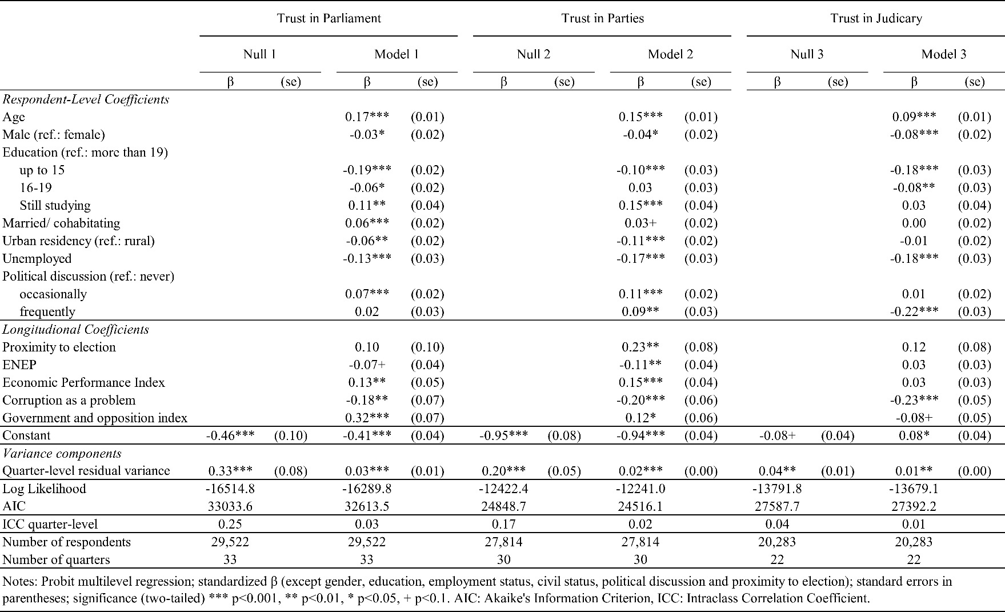

## Additional Time Trends

**Figure A.1. Economic Performance in Spain, 1997-2019.**

*Notes*: Measured on a quarterly or yearly basis.

*Sources*: OECD Stat (2020), IMF WEO Database (2020).

**Figure A.2. Political Trust in Spain – European Social Survey.**

*Notes*: Measured on a yearly basis. Weighted average values. The values for political trust are interpolated (line); dots show the observed values. The political trust variables have been measured on a scale from 0 (no trust at all) to 10 (complete trust). *Sources*: European Social Survey.

# Individual-Level Panel Analysis

## CIUPANEL: Question Wording and Variable Coding

**Economic situation in Spain (retrospective)**: ‘In the last twelve months would you say that the economic situation in Spain in general is:’ (1) Going much worse?’; (2) Going a little worse; (3) The same; (4) Going a little better; (5) Going much better.

**Government evaluation:** ‘Overall, do you approve or disapprove the job of the Spanish government to the present?’ (0) Disapprove ; (1) Approve.

**Left-right ideology**: ‘In politics people sometimes talk of left and right. Where would you place yourself on a scale from 0 to 10 where 0 means the left and 10 means the right?’

**Perception of political corruption:** ‘In your opinion, how many politicians in our country have been involved or related with corruption?’ (1) Almost nobody; (2) A few of them; (3) Many of them; (4) Almost all of them.

**Perception of political responsiveness index:** The index created is based on the factor scores of the following questions: (A) ‘To what extent would you say that politicians care what people like you think?’ (B) ‘To what extent would you say that the political system in Spain allows people like you to have something to say in what the Government does?’ (0) Not at all; (10) very much.

**Personal economic situation index:** The index created is based on factor scores of the following questions: (A) ‘Today, to what extent are you worried about paying the bills for your home?’ (B) ‘Today, to what extent are you worried about needing to reduce your standard of living?’ (C) ‘Today, to what extent are you worried about having a job?’ (D) ‘Today, to what extent are you worried about paying back bank loans or mortgages?’ (4) Very worried; (3) somewhat worried; (2) not very worried; (1) not at all worried.

**Political interest**: ‘How much are you interested in politics?’ (4) Very much; (3) much; (2) a little bit; or (1) not at all.

**Trust in Parliament:** ‘On a scale from 0 to 10 how much do you trust the Spanish parliament?’

**Trust in Parties:** ‘On a scale from 0 to 10 how much do you trust the political parties in Spain?’

**Trust in Judiciary:** ‘On a scale from 0 to 10 how much do you trust the Spanish judicial system?’

## CIUPANEL: Descriptive Statistics

Table A.6. Descriptive Statistics.

|  |  |  |  |  |  |
| --- | --- | --- | --- | --- | --- |
|  | **Mean** | **SD** | **Min** | **Max** | **N** |
| Economic situation in Spain (retrospective) (wave 3) | 2.17 | 1.17 | 1 | 5 | 2,274 |
| Economic situation in Spain (retrospective) (wave 4) | 2.85 | 1.01 | 1 | 5 | 2,313 |
| Economic situation in Spain (retrospective) (wave 5) | 2.53 | 1.14 | 1 | 5 | 2,172 |
| Government performance evaluation (wave 3) | 0.17 | 0.37 | 0 | 1 | 2,274 |
| Government performance evaluation (wave 4) | 0.17 | 0.38 | 0 | 1 | 2,313 |
| Government performance evaluation (wave 5) | 0.22 | 0.41 | 0 | 1 | 2,172 |
| Left-right ideology (wave 3) | 3.99 | 2.43 | 0 | 10 | 2,274 |
| Left-right ideology (wave 4) | 3.88 | 2.42 | 0 | 10 | 2,313 |
| Left-right ideology (wave 5) | 4.07 | 2.48 | 0 | 10 | 2,172 |
| Perception of political corruption (wave 3) | 3.36 | 0.65 | 1 | 4 | 2,274 |
| Perception of political corruption (wave 4) | 3.29 | 0.65 | 1 | 4 | 2,313 |
| Perception of political corruption (wave 5) | 3.15 | 0.65 | 1 | 4 | 2,172 |
| Perception of responsiveness index (wave 3) | -0.04 | 0.81 | -0.96 | 3.05 | 2,274 |
| Perception of responsiveness index (wave 4) | -0.11 | 0.85 | -0.96 | 3.05 | 2,313 |
| Perception of responsiveness index (wave 5) | 0.15 | 0.87 | -0.96 | 3.05 | 2,172 |
| Personal economic situation index (wave 3) | -0.03 | 0.95 | -1.51 | 1.75 | 2,274 |
| Personal economic situation index (wave 4) | -0.06 | 0.93 | -1.51 | 1.75 | 2,313 |
| Personal economic situation index (wave 5) | 0.09 | 0.96 | -1.51 | 1.75 | 2,172 |
| Political interest (wave 3) | 2.69 | 0.80 | 1 | 4 | 2,274 |
| Political interest (wave 4) | 2.72 | 0.79 | 1 | 4 | 2,313 |
| Political interest (wave 5) | 2.79 | 0.78 | 1 | 4 | 2,172 |
| Trust in Parliament (wave 3) | 3.56 | 2.44 | 0 | 10 | 2,274 |
| Trust in Parliament (wave 4) | 2.54 | 2.38 | 0 | 10 | 2,313 |
| Trust in Parliament (wave 5) | 3.56 | 2.43 | 0 | 10 | 2,172 |
| Trust in Parties (wave 3) | 2.26 | 1.97 | 0 | 10 | 2,274 |
| Trust in Parties (wave 4) | 1.60 | 1.89 | 0 | 10 | 2,313 |
| Trust in Parties (wave 5) | 2.30 | 2.01 | 0 | 10 | 2,172 |
| Trust in Judiciary (wave 3) | 3.55 | 2.46 | 0 | 10 | 2,274 |
| Trust in Judiciary (wave 4) | 2.63 | 2.43 | 0 | 10 | 2,313 |
| Trust in Judiciary (wave 5) | 3.23 | 2.45 | 0 | 10 | 2,172 |

## CIUPANEL Analysis: Robustness Test

Table A.7. Robustness Test – Without Government Evaluation.

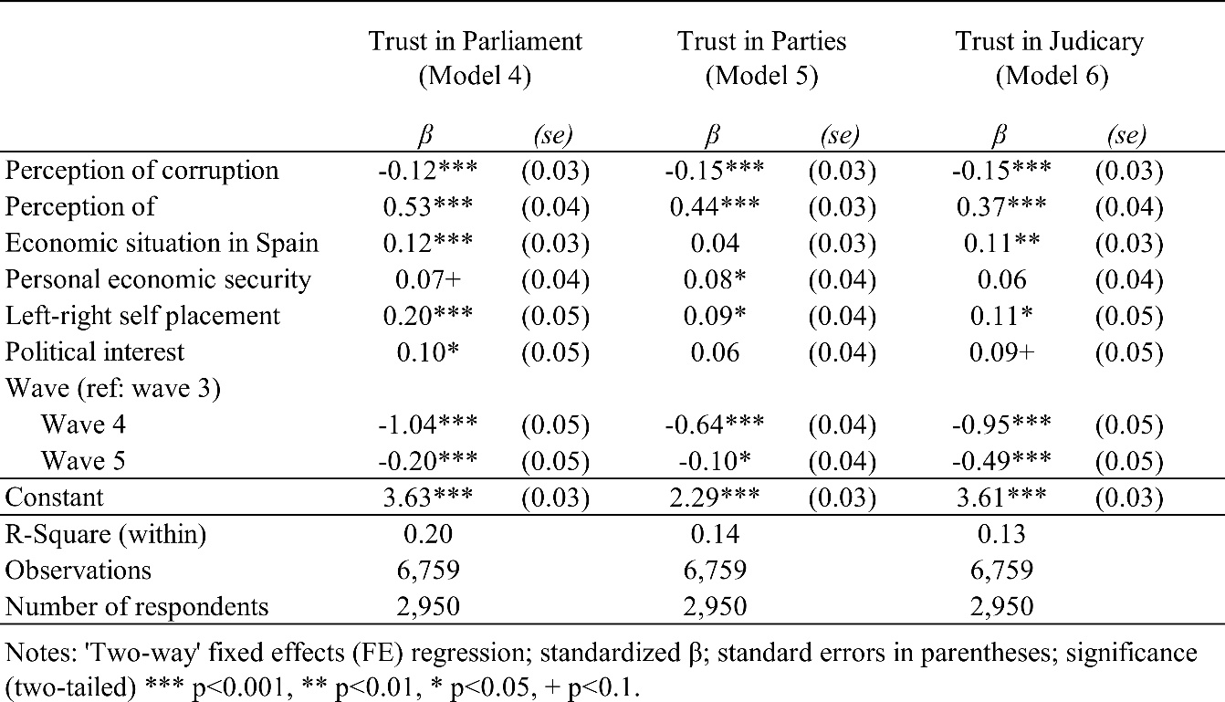

Table A.8. Robustness Test – Lagged Independent Variables.

