**Supplementary material 1. Aquaculture module to capture Fish-farmers’ voice for aquaculture CIS**

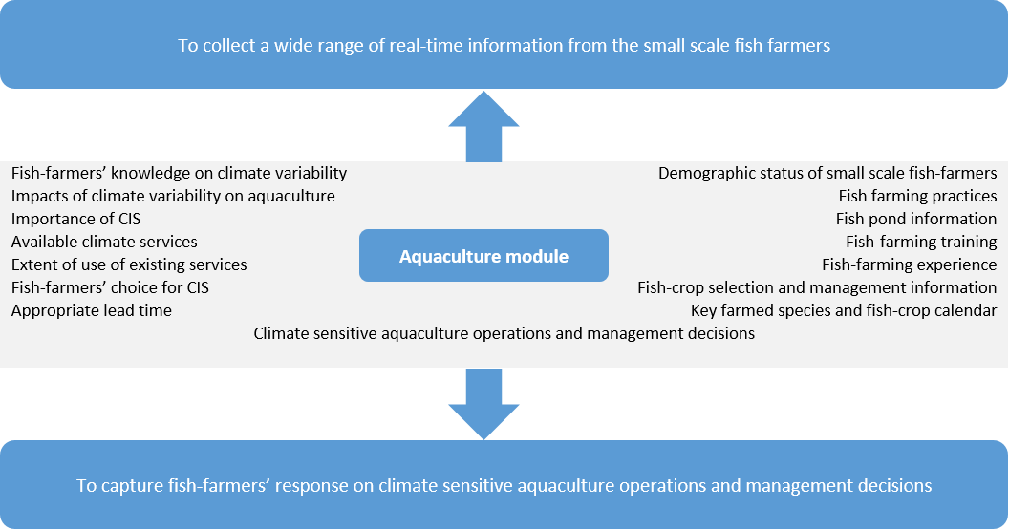

**Supplementary material 2. Methods of sample selection**

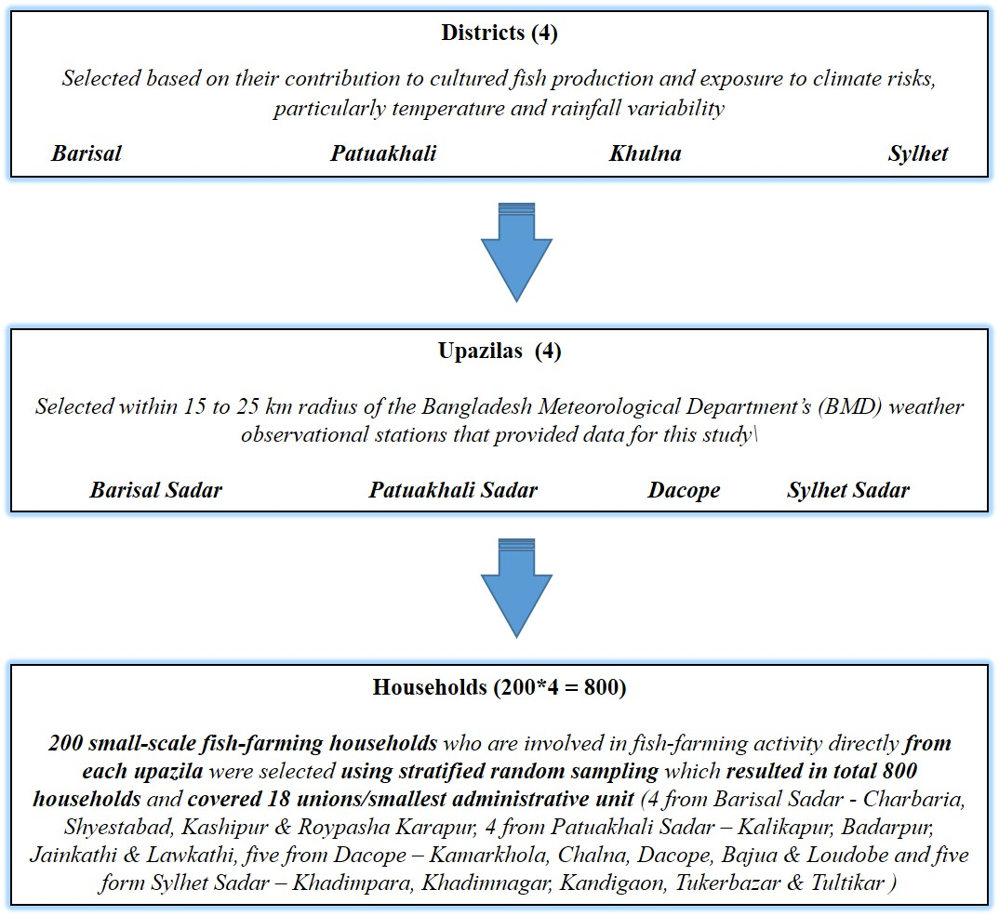

**Supplementary material 3. Literature review papers for temperature thresholds**

|  |
| --- |
| Adey, S. A., Abba, H., Benabid, M., Gmira, N., & Droussi, M. (2015). Influence of temperature on breeding of tilapia (Oreochromis niloticus) in the station of fish farming of Deroua, Beni Mellal/Morocco. *International Research Journal of Biological Sciences*, *4*(4), 1-5. |
| Bhujel, R. C. (2000). A review of strategies for the management of Nile tilapia (Oreochromis niloticus) broodfish in seed production systems, especially hapa-based systems. *Aquaculture*, *181*(1), 37-59. |
| Brahmane, M. P., Krishnani, K. K., Sarkar, B., Sajjanar, B., Kumar, S., Nakhawa, A. D. and Minhas, P. S. 2014. Growth, thermal tolerance and oxygen consumption in rohu, Labeo rohita early fry acclimated to four temperatures. African Journal of Agricultural Research. 9(9): 854-858 |
| Chaitanawisuti, N., Santhaweesuk, W., & Wattayakorn, G. (2013). The combined effects of temperature and salinity on survival of postlarvae tiger prawn Penaeus monodon under laboratory conditions. *Agricultural Sciences*, *4*(6A), 53. |
| Charo-Karisa, H., Rezk, M. A., & Bovenhuis, K. (2004). Effects of rearing conditions on low temperature tolerance of Nile tilapia, Oreochromis niloticus, juveniles. |
| Coche, A. G., James, F. M. and Laughlin, T. (1996). Simple Methods for Aquaculture: Management for Freshwater Fish Culture Ponds and Water Practices. Food & Agriculture Org. |
| Das, M. K., Srivastava, P. K., Dey, S., Mondal, M. L., Mukhopadhyay, M. K. and Saha, P.K. 2013. Impact of temperature change on the growth of Labeo rohita: development of a growth model.. Journal of Inland Fisheries Society of India. 45(1). 41-45. |
| Das, T., Pal, A., Chakraborty, S., Saydmohammed, M., Sahu, N. and Mukherjee, S. 2005. Thermal tolerance, growth and oxygen consumption of Labeo rohita fry (Hamilton, 1822) acclimated to four temperatures. Journal of Thermal Biology. 30. 378-383. |
| Drummond, C. D., Murgas, L. D. S., & Vicentini, B. (2009). Growth and survival of tilapia Oreochromis niloticus (Linnaeus, 1758) submitted to different temperatures during the process of sex reversal. *Ciência e agrotecnologia*, *33*(3), 895- 902. |
| El-Naggar, G. O., El Nady, M. A., Kamar, M. G., & Al-Kobabay, A. I. (2000). Effect of photoperiod, dietary protein and temperature on reproduction in Nile tilapia (Oreochromis niloticus). In *Tilapia Culture in the 21st Century. Proceedings from the Fifth International Symposium on Tilapia Aquaculture, Rio de Janeiro, Brazil. American Tilapia* (Vol. 26, pp. 352-358) |
| FAO. 2009. Labeo rohita. In Cultured aquatic species fact sheets. Text by Jena, J.K. Edited and compiled by Valerio Crespi and Michael New. |
| Hossain, M. I., Kamal, M. M., Mannan, M. A., & Bhuyain, M. A. B. (2013). Effects of probiotics on growth and survival of shrimp (Penaeus monodon) in coastal pond at Khulna, Bangladesh. *Journal of Scientific Research*, *5*(2), 363-370. |
| <http://www.fao.org/3/ac006e/AC006E04.htm> |
| <http://www.fao.org/fishery/affris/profil-des-especes/giant-tiger-prawn/giant-tiger-prawn-home/fr/> |
| Kausar, R. and Salim, M. 2006. Effect of water temperature on the growth performance and feed conversion ratio of Labeo rohita. Pakistan Vet. J. 26(3): 105-108. |
| Kumar, P. and Sharma, B. K. 2018. Impact of rohu (Labeo rohita) feeding probiotic (Proteus) on selected water quality parameters. Journal of Entomology and Zoology Studies. 6(6): 800-804. |
| Maguire, G. B., & Allan, G. L. (1991, April). Effects of temperature on growth, food consumption and food conversion for Penaeus monodon, Penaeus plebejus and Metapenaeus macleayi. In *Proceedings of the Aquaculture Nutrition Workshop, Salamander Bay* (Vol. 15, p. 17). |
| Mishra, B. K., Khalid, M. A. and Labh, S. N. 2019. Assessment of the effect of water temperature on length gain, feed conversion ratio (FCR) and protein profile in brain of Labeo rohita (Hamilton 1822) fed Nigella sativa incorporated diets. International Journal of Fisheries and Aquatic Studies. 7(3): 06-13 |
| Mjoun, K., Rosentrater, K. A., and Brown, M. L. (2010) Tilapia: Profile and Economic Importance. FS963-01, South Dakota Cooperative Extension Service, South Dakota State University. Access at <http://pubstorage.sdstate.edu/AgBio_Publications/articles/FS963-01.pdf> |
| Mohapatra S, Chakraborty T, Prusty AK, PaniPrasad K, Mohanta KN (2014) Beneficial Effects of Dietary Probiotics Mixture on Hemato-Immunology and Cell Apoptosis of Labeo rohita Fingerlings Reared at Higher Water Temperatures. PLoS ONE 9(6): e100929. |
| Pandit, N. P., & Nakamura, M. (2010). Effect of high temperature on survival, growth and feed conversion ratio of Nile tilapia, Oreochromis niloticus. *Our Nature*, *8*(1), 219-224. |
| Premchand, K., Kiranmai, G. U. 2017. Impact Of Physico-Chemical Parameters On Growth Of Indian Major Carps Cultured In Different Ponds At Krishna District, Andhra Pradesh, India. International Journal of Innovative Research and Creative Technology. 2(4): 169-173. |
| Pushparajan, N., & Soundarapandian, P. (2010). Recent farming of marine black tiger shrimp, Penaeus monodon (Fabricius) in South India. *African Journal of Basic & Applied Sciences*, *2*(1-2), 33-36 |
| Singh, A. K. 2019. Effect of Water Temperature on The Growth Performance of Labeo Rohita. International Journal of Engineering Development and Research. 7(1):84-86. |
| Zadeh, M. S. A., Feshalami, Y. M., Sehafii, H. H., Amiri, F. and Makvandi, G. 2012. Impact of temperature on growth rate and survival of Indian fry carp (Catla catla), rohu (Labeo rohita) and mrigal (Cirrhinus reba) in cultured ponds condition in Khozestan provience. New technologies in aquaculture development (Journal of fisheries). 4 (20): 61-70 |