**Appendix A. Methodological framework used to develop the decision framework for aquaculture CIS**

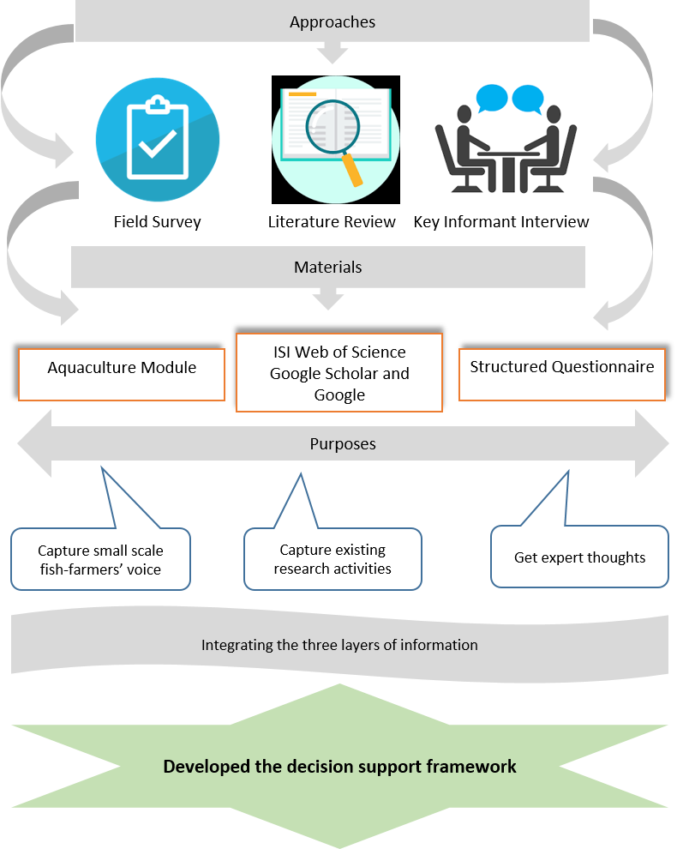

**Appendix B. Temperature decision matrix to support fish-farmers’ decision making during grow out phase of four widely cultivated fish species**

|  |  |  |  |  |  |  |  |
| --- | --- | --- | --- | --- | --- | --- | --- |
| Fish-Species | Phase | Month Start | Month end | MnT Threshold (0C) | MnT Advisory | MxT Threshold (0C) | MxT Advisory |
| Nile Tilapia  (*O. niloticus*) | Grow-out | May | November | <20 | Water quality  1. If pond water temperature goes below 200C, it deteriorates pond water quality (i.e., pH and dissolve O2);  2. Fish producers who have fishes in their ponds at grow out phase can use aerator or any oxygen promoter aqua-medicine;  3. Fish producers can also manage pump to irrigate the pond with ground water;  4. Fish producers can restrict lime application;  Feeding  5. If pond water temperature goes below 200C, it affects food intake behavior of fish;  6. Fish-farmers can reduce feeding ratio;  Harvesting  7. If fishes show any abnormal behavior like floating near the water level, fish-farmers can reduce fish stock density by partial harvesting | >32 | Water quality  1. If pond water temperature goes above 320C, it promotes bacterial decomposition and deteriorates pond water quality (i.e., pH, dissolve O2, NH3, H2S) ;  2. Fish producers who have fishes in their ponds at grow out phase can apply lime;  3. Can use aerator or any oxygen promoter aqua-medicine;  4. Fish producers can also manage pump to irrigate the pond with ground water;  5. Can apply Horra pulling to remove toxic gases;  6. Also can apply zeolite;  Feeding  7. Pond water temperature above 320C reduces digestion capacity of fish;  8. Fish producers who have fishes in their ponds at grow out phase can stop feeding temporarily during afternoon;  9. Also farmers can apply vitamin C supplement during morning time; |
| Rohu  *(L. Rohita)* | Grow-out | May | November | <22 | >30 |
| Black tiger shrimp/Bagda  *(P. monodon)* | Grow-out | February | June | <25 | >30 |
| Fresh water prawn/Golda  *(M. rosenbergii* | Grow-out | July | November | <25 | >30 |

**Appendix C. Rainfall decision matrix to support Fish producers’ decision making during grow out phase of four widely cultivated fish** species

|  |  |  |  |  |  |  |  |  |  |
| --- | --- | --- | --- | --- | --- | --- | --- | --- | --- |
| Fish-Species | Phase | Month Start | Month end | VHR threshold (mm/day) | VHR Advisory | HR Threshold (mm/day) | HR Advisory | DS threshold (mm/day) | DS Advisory |
| Nile Tilapia  (*O. niloticus*) | Grow-out | May | November | >88 | *Protection*  1. Very heavy rain (>88mm/d) may cause flooding and help fish to escape from enclosures;  2. Fish producers can heighten the pond banks and use nets to protect the fish from escaping | >44 to <88 | *Water quality*  1. Heavy rain (>44 to <88 mm/d) deteriorates pond water quality (like dissolve O2 and pH level);  2. Farmers can arrange artificial dissolve O2 supply;  3. Farmers can apply lime after the rain;  *Feeding*  4. Heavy rain (>44 to <88 mm/d) also affects food intake behavior of fish;  5. Fish producers can stop feeding during heavy rain; | <3 for 5 consecutive days  during monsoon (i.e. June-September)  and  <1 for 5 consecutive days  during pre-monsoon (March-May) and post monsoon (October-November) | *Water Quantity/Supply*  1. Low or no rain can cause lack of water availability;  2. Fish producers who have fishes in their ponds at grow out phase should irrigate the pond;  *Harvesting*  3. Low or no rain can cause disease outbreak;  4. Farmers can partially harvest to reduce stocking density;  *Feeding*  5. Low or no rain can cause fish to less food intake;  6. Farmers can reduce feeding during low/no rain; |
| Rohu  *(L. Rohita)* | Grow-out | May | November |
| Black tiger shrimp/Bagda  *(P. monodon)* | Grow-out | February | June |
| Fresh water prawn/Golda  *(M. rosenbergii)* | Grow-out | July | November |