Supplementary Figures

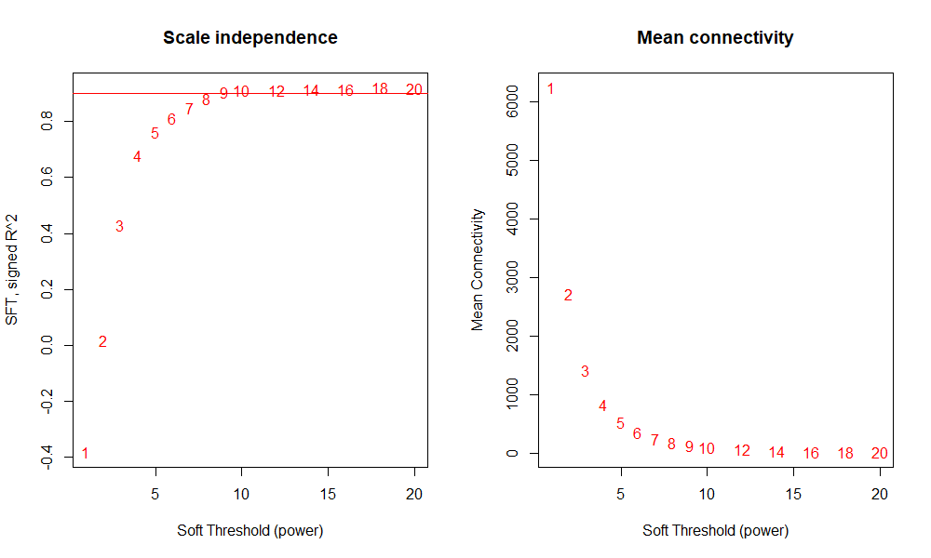

**Supplementary Figure 1** **Soft threshold determination of WGCNA.**



**Supplementary Figure 2 Correlation analysis (A) and principal component analysis (PCA, B) of samples.**