Figure S1 Cluster centers without global signal regression; colored by correlation (z) of parcel-pairs compared across dynamic methods. The clusters are sorted by occurrence rate (% shown above each centroid). The 360 spatial parcels are sorted into 7 major functional networks identified by Yeo et al. (Yeo, Krienen et al. 2014). The bottom row displays the time-averaged FC for the full dataset and the mean across cluster centers weighted by the occurrence rates for each dynamic method. The cluster weighted averages are correlated with time-averaged FC with r = 0.993, 0.998, and 0.804 for SWC, PS, and CAP methods respectively.

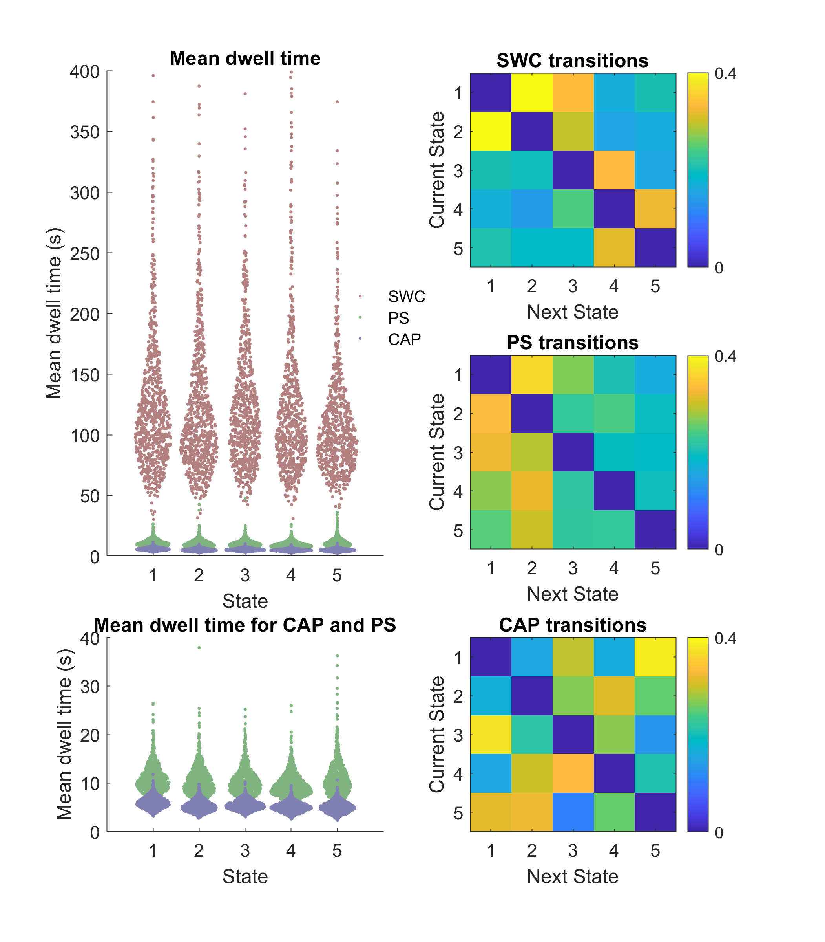
Figure S2 Summary of dynamics metrics without global signal regression; Distribution of mean dwell time between state transitions for each state in each subject (N=817) and transition probability matrices from each state to the next. Mean dwell time is displayed with and without SWC included.

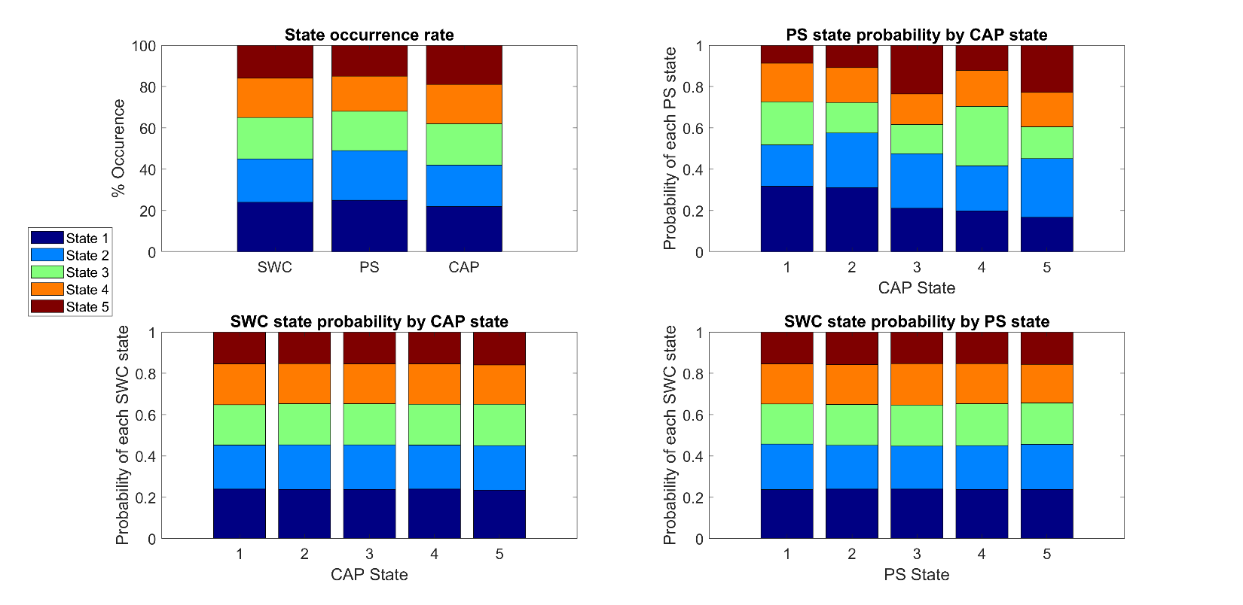
Figure S3 Comparison of state composition across dynamics methods without global signal regression. Top-left shows the state occurrence rate of each analysis method with states sorted from highest occurrence (state 1) to lowest occurrence (state 5). Top-right shows the probability of a timepoint that belongs to a specified CAP state corresponding to each of the 5 PS states. The bottom panels show the probability of a timepoint that belongs to a specified CAP state (Bottom-left) or PS state (Bottom-right) corresponding to each of the 5 SWC states.

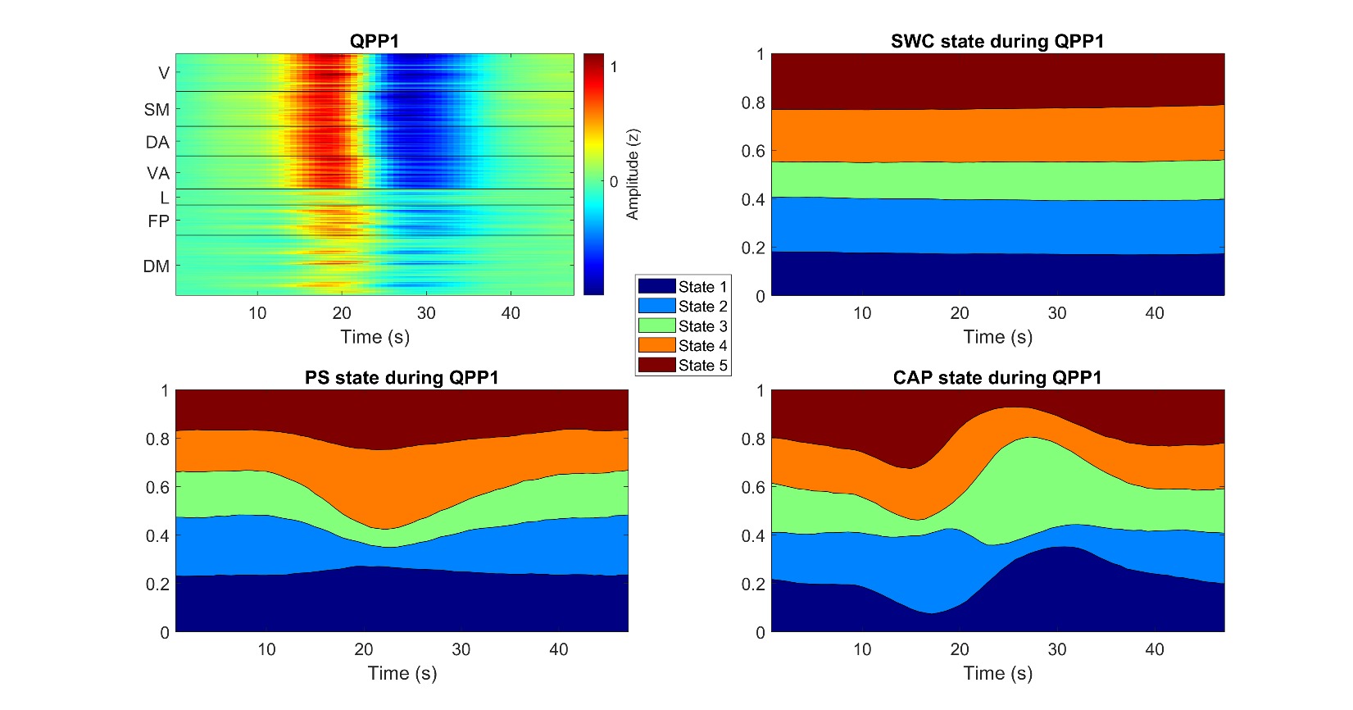
Figure S4 Comparison of most likely states during QPP1 without global signal regression. Top-left shows spatiotemporal QPP1 template with timepoints on the x-axis and space (Glasser’s 360 parcels) on the y-axis and colors corresponding to z-score BOLD signal amplitude. The other 3 panels show the same timepoints on the x-axis with the likelihood of being in each state plotted on the y-axis with the colors corresponding to the 5 brain states identified by each dynamic analysis method.

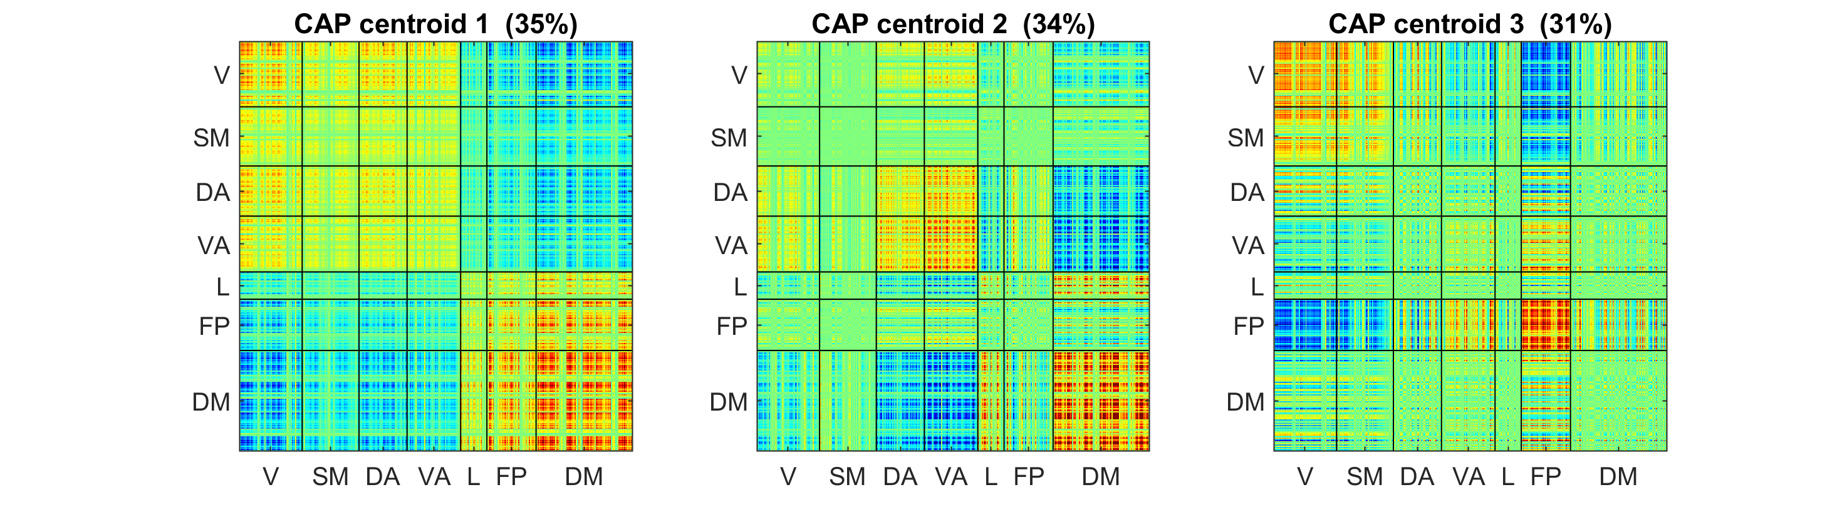
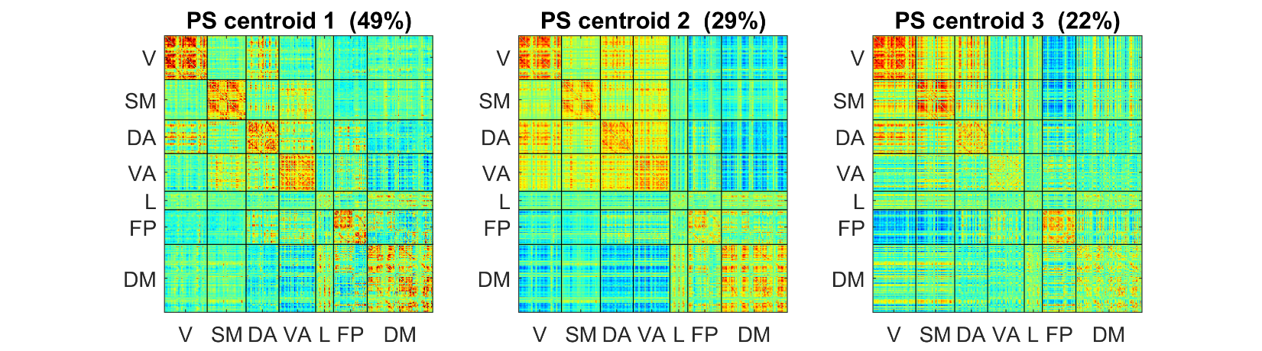
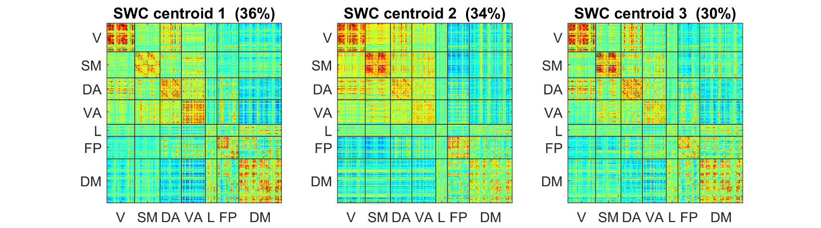

Figure S5 Cluster centers with k=3 clusters for a subset of the data (N=20); colored by correlation (z) of parcel-pairs compared across dynamic methods. The clusters are sorted by occurrence rate (% shown above each centroid). The 360 spatial parcels are sorted into 7 major functional networks identified by Yeo et al. (Yeo, Krienen et al. 2014).

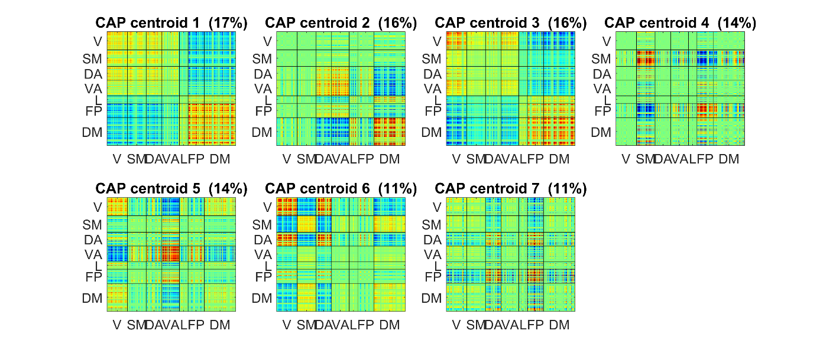
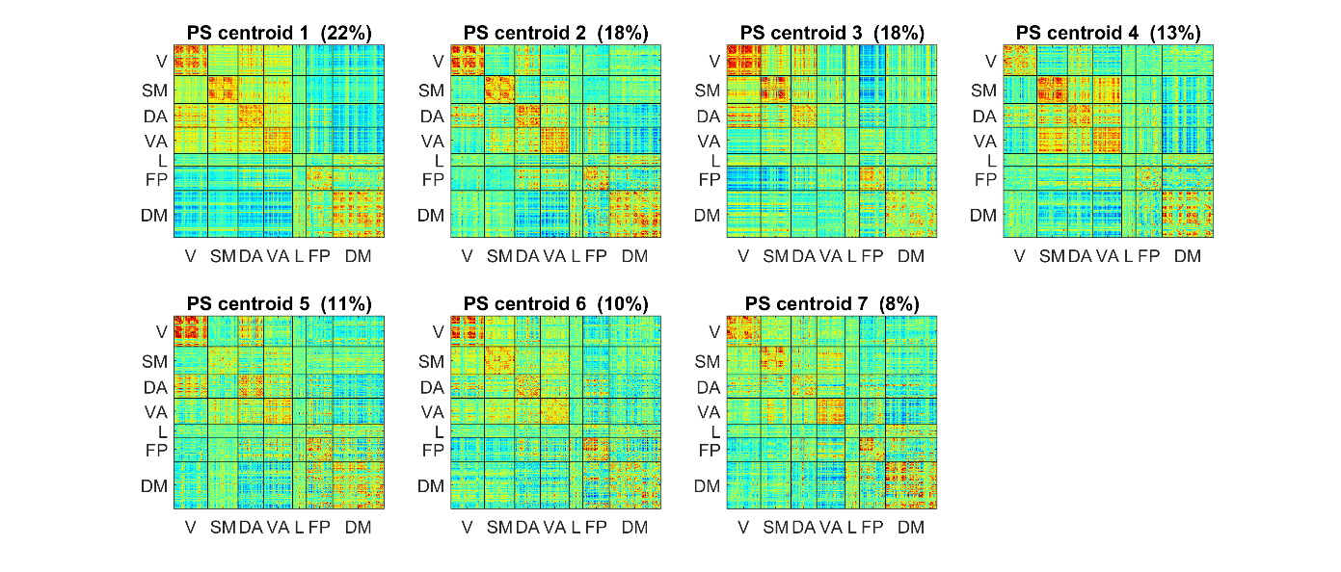
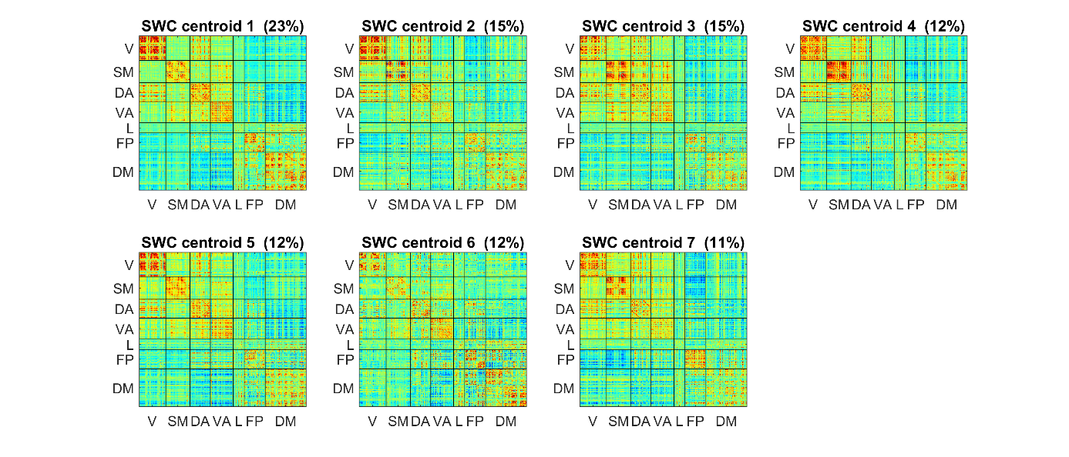
Figure S6 Cluster centers with k=7 clusters for a subset of the data (N=20); colored by correlation (z) of parcel-pairs compared across dynamic methods. The clusters are sorted by occurrence rate (% shown above each centroid). The 360 spatial parcels are sorted into 7 major functional networks identified by Yeo et al. (Yeo, Krienen et al. 2014).

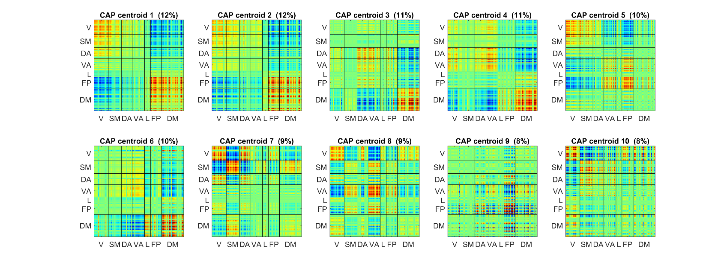
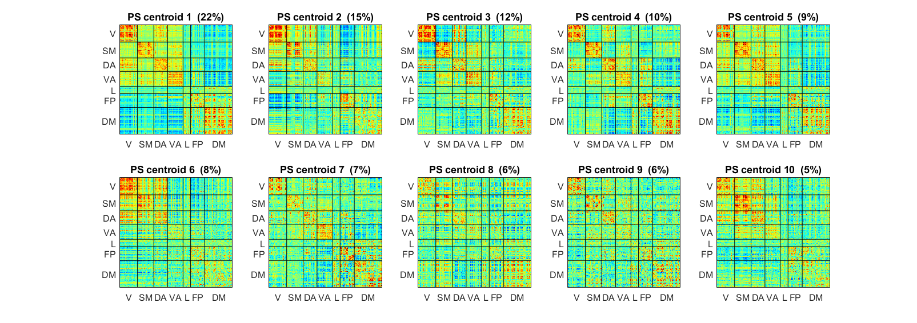
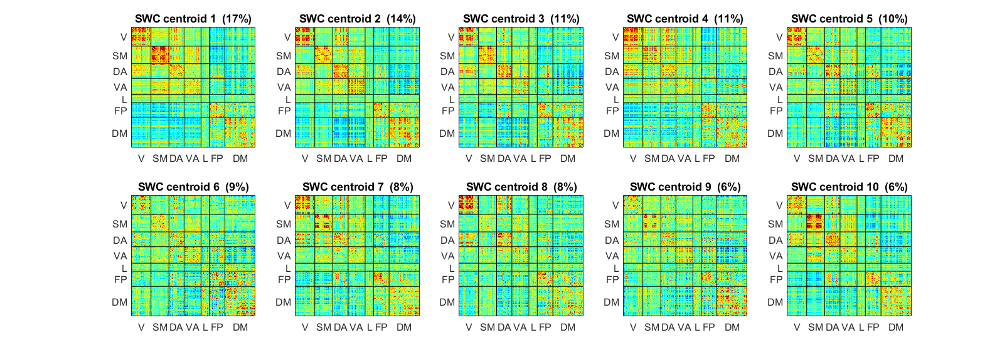
Figure S7 Cluster centers with k=10 clusters for a subset of the data (N=20); colored by correlation (z) of parcel-pairs compared across dynamic methods. The clusters are sorted by occurrence rate (% shown above each centroid). The 360 spatial parcels are sorted into 7 major functional networks identified by Yeo et al. (Yeo, Krienen et al. 2014).

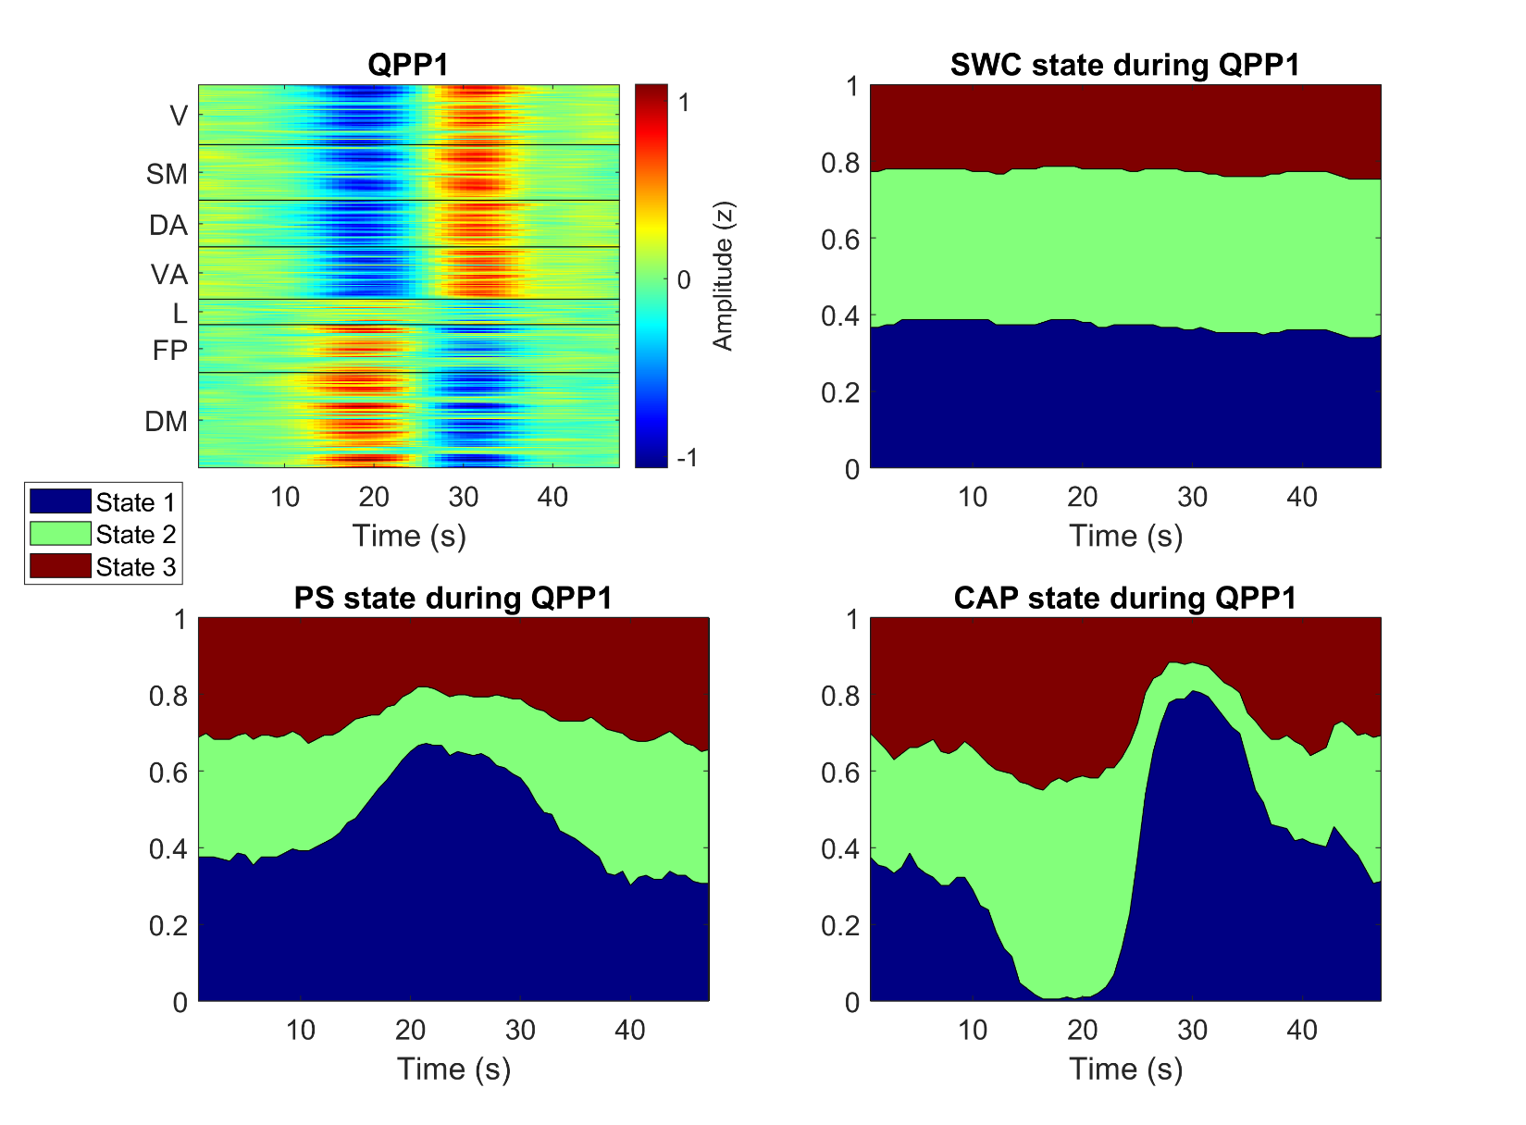
Figure S8 Comparison of most likely states during QPP1 with k=3 clusters for a subset of the data (N=20). Top-left shows spatiotemporal QPP1 template with timepoints on the x-axis and space (Glasser’s 360 parcels) on the y-axis and colors corresponding to z-score BOLD signal amplitude. The other 3 panels show the same timepoints on the x-axis with the likelihood of being in each state plotted on the y-axis with the colors corresponding to the 3 brain states identified by each dynamic analysis method.

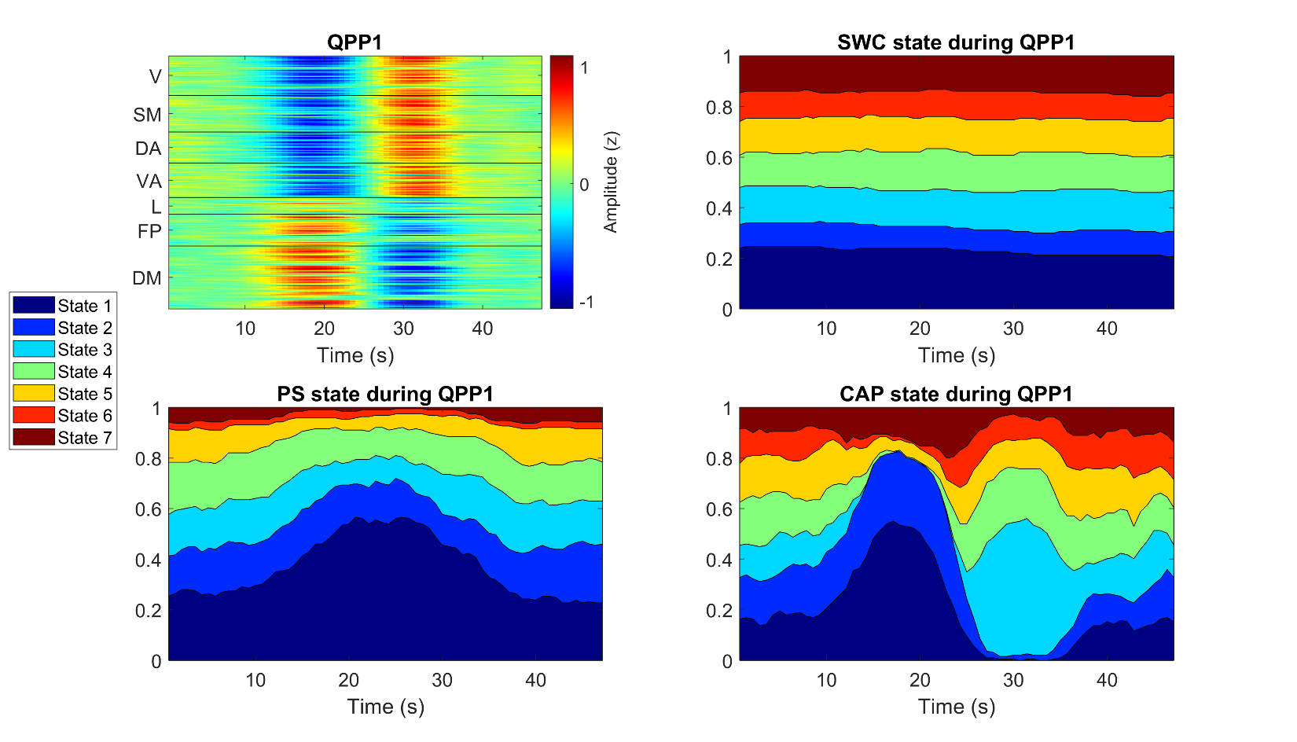
Figure S9 Comparison of most likely states during QPP1 with k=7 clusters for a subset of the data (N=20). Top-left shows spatiotemporal QPP1 template with timepoints on the x-axis and space (Glasser’s 360 parcels) on the y-axis and colors corresponding to z-score BOLD signal amplitude. The other 3 panels show the same timepoints on the x-axis with the likelihood of being in each state plotted on the y-axis with the colors corresponding to the 7 brain states identified by each dynamic analysis method.

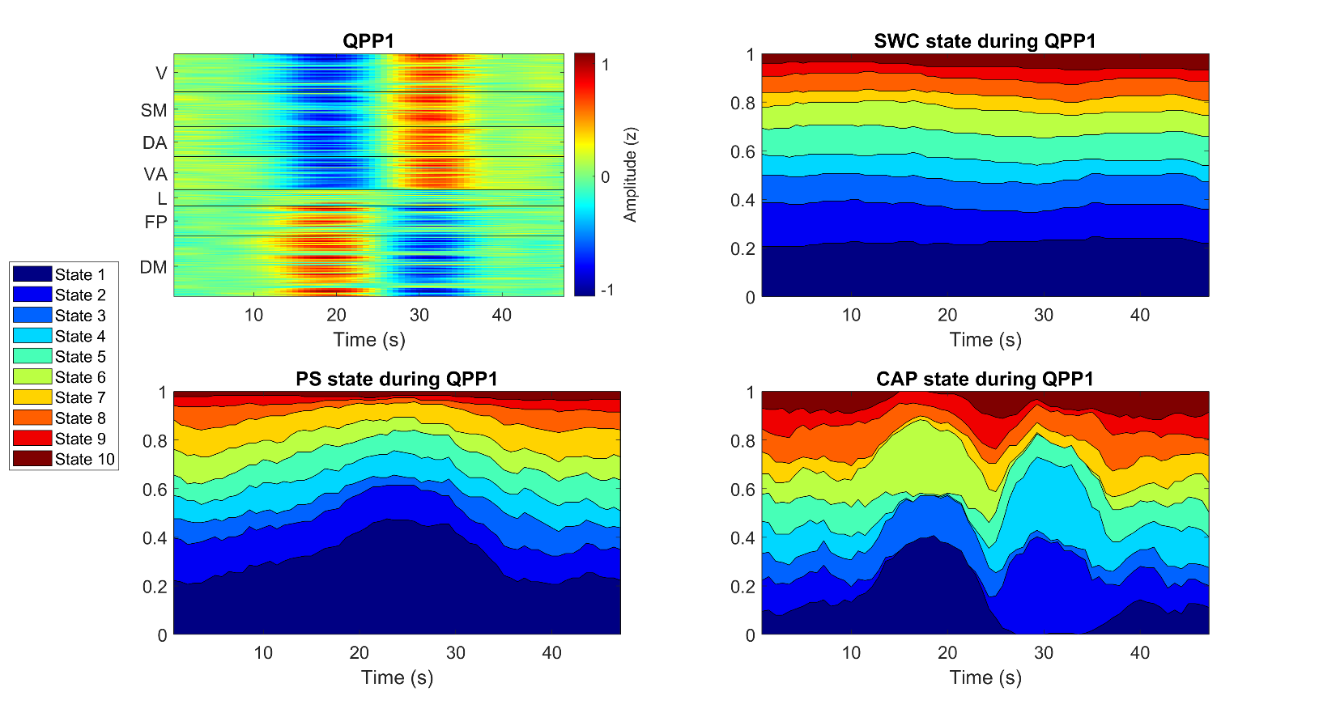
Figure S10 Comparison of most likely states during QPP1 with k=10 clusters for a subset of the data (N=20). Top-left shows spatiotemporal QPP1 template with timepoints on the x-axis and space (Glasser’s 360 parcels) on the y-axis and colors corresponding to z-score BOLD signal amplitude. The other 3 panels show the same timepoints on the x-axis with the likelihood of being in each state plotted on the y-axis with the colors corresponding to the 10 brain states identified by each dynamic analysis method.

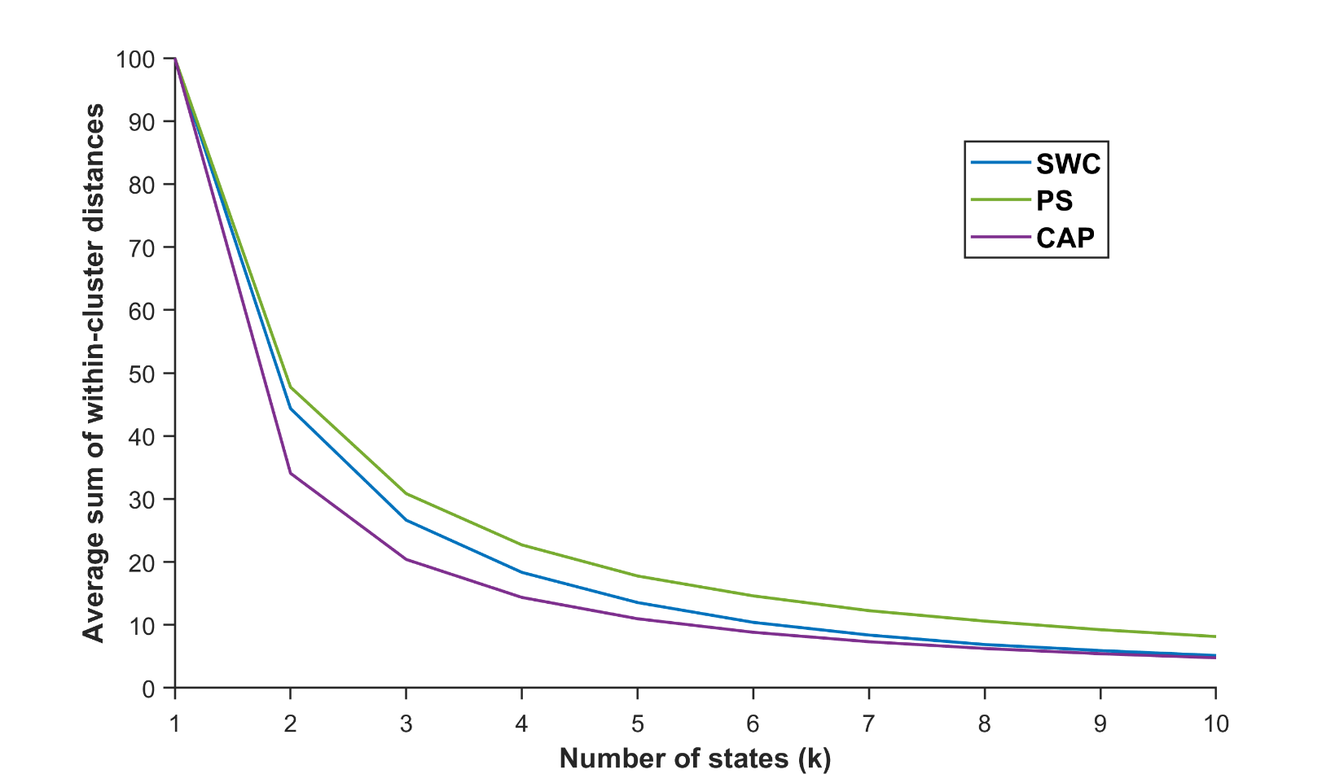
Figure S11 – Plot of the average sum of within-cluster distances as a percentage of the total sum of distances in the data for each analysis method over a range of k = 2:10 clusters.

