Supplement Information

S1. PCR Primer

|  |  |
| --- | --- |
| SLC25A21: |  |
| Forward primer: | 5'- ATTTGGGATTGGTCTTCT-3' |
| Reverse primer: | 5'- GACTGTTGCCATTGTTTT-3' |
| GAPDH: |  |
| Forward primer: | 5'- ACAGTCAGCCGCATCTTCTT-3' |
| Reverse primer: | 5'- GACAAGCTTCCCGTTCTCAG-3' |

S2. siRNA sequence

|  |  |
| --- | --- |
| SLC25A21 siRNA: | 5'-GGAGA GAUCA AGUAC AGAATT-3' |
| NC siRNA: | 5’-ACGUGACACGUUCGGAGAATT-3’ |

**Figure S1**.

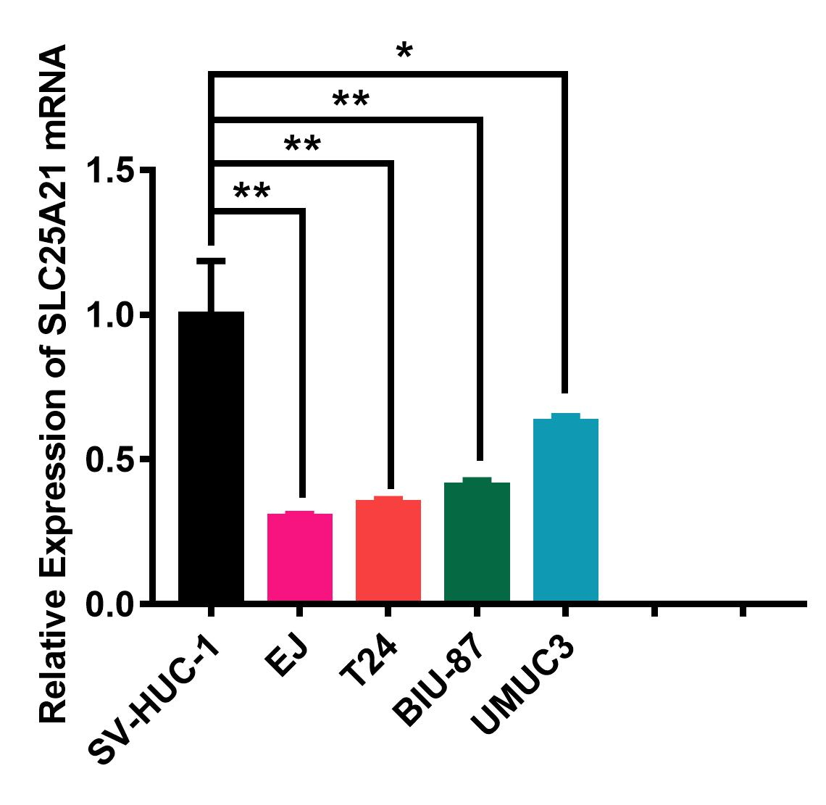

**Figure S1.** **The expression levels of SLC25A21 mRNA in BCa and normal cell lines.**

**Figure S2**.

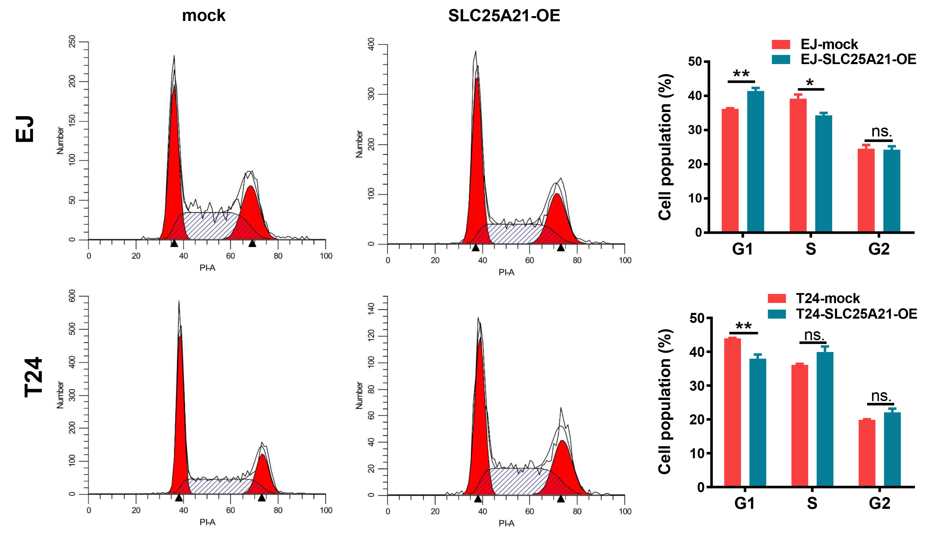

**Figure S2.** **The effect of SLC25A21 overexpression on cell cycle in BCa cells**

**Figure S3**.

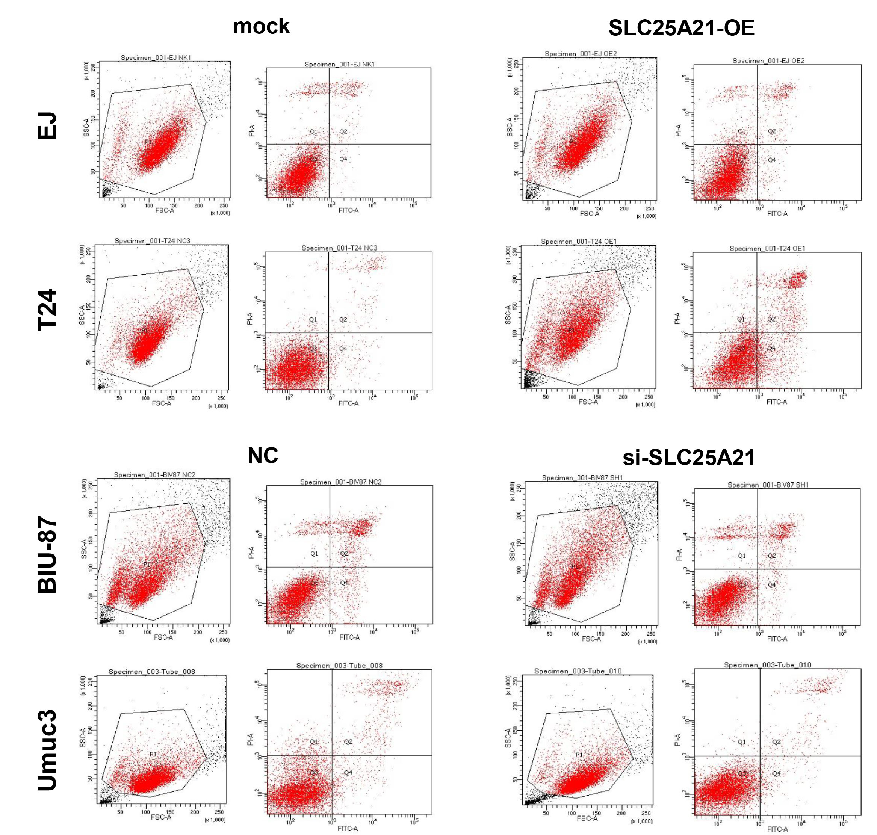

**Figure S3.** **The effect of SLC25A21 on cell apoptosis in BCa cells**