**Legends of Supplementary Figures**

**Supplementary Figure 1.** HPLC/UV spectrum of major active components BBR/JAT/COP/PAL in CREA, CREB and CREC.

**Supplementary Figure 2.** Quantity and integrity of fecal DNA samples in WT, db, CREA, CREB, and CREC group (n=5/group) of mice.

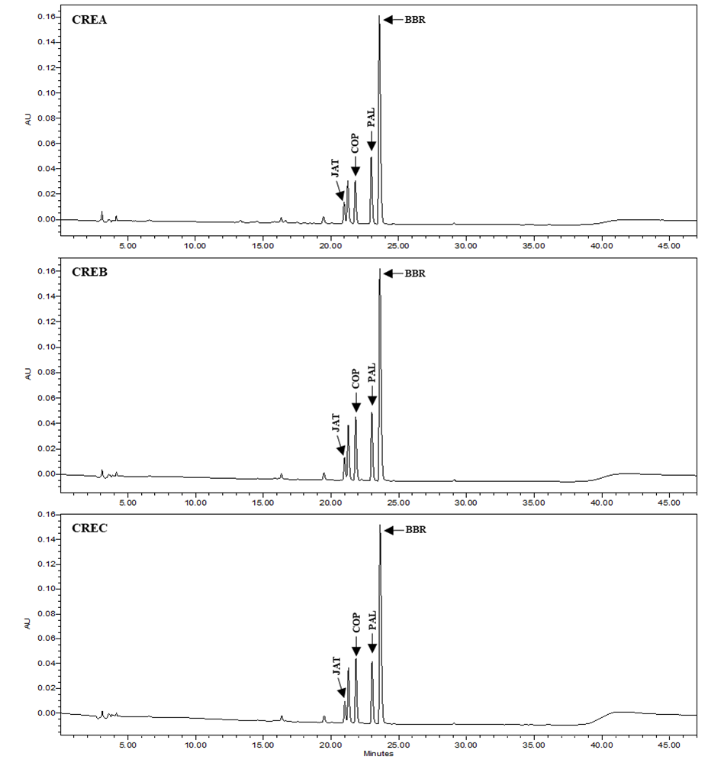

**Supplementary Figure 1.** HPLC/UV spectrum of major active components BBR/JAT/COP/PAL in CREA, CREB and CREC.

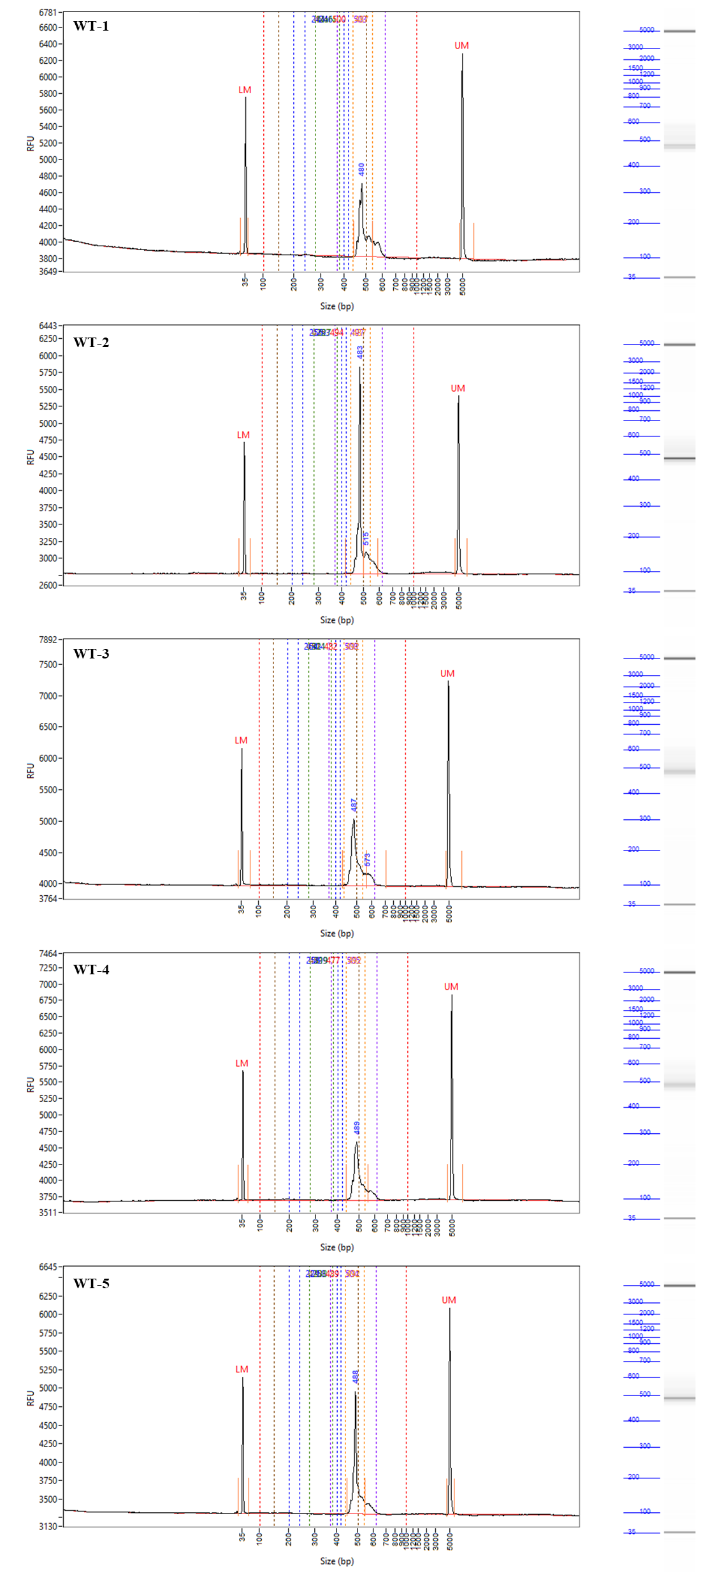 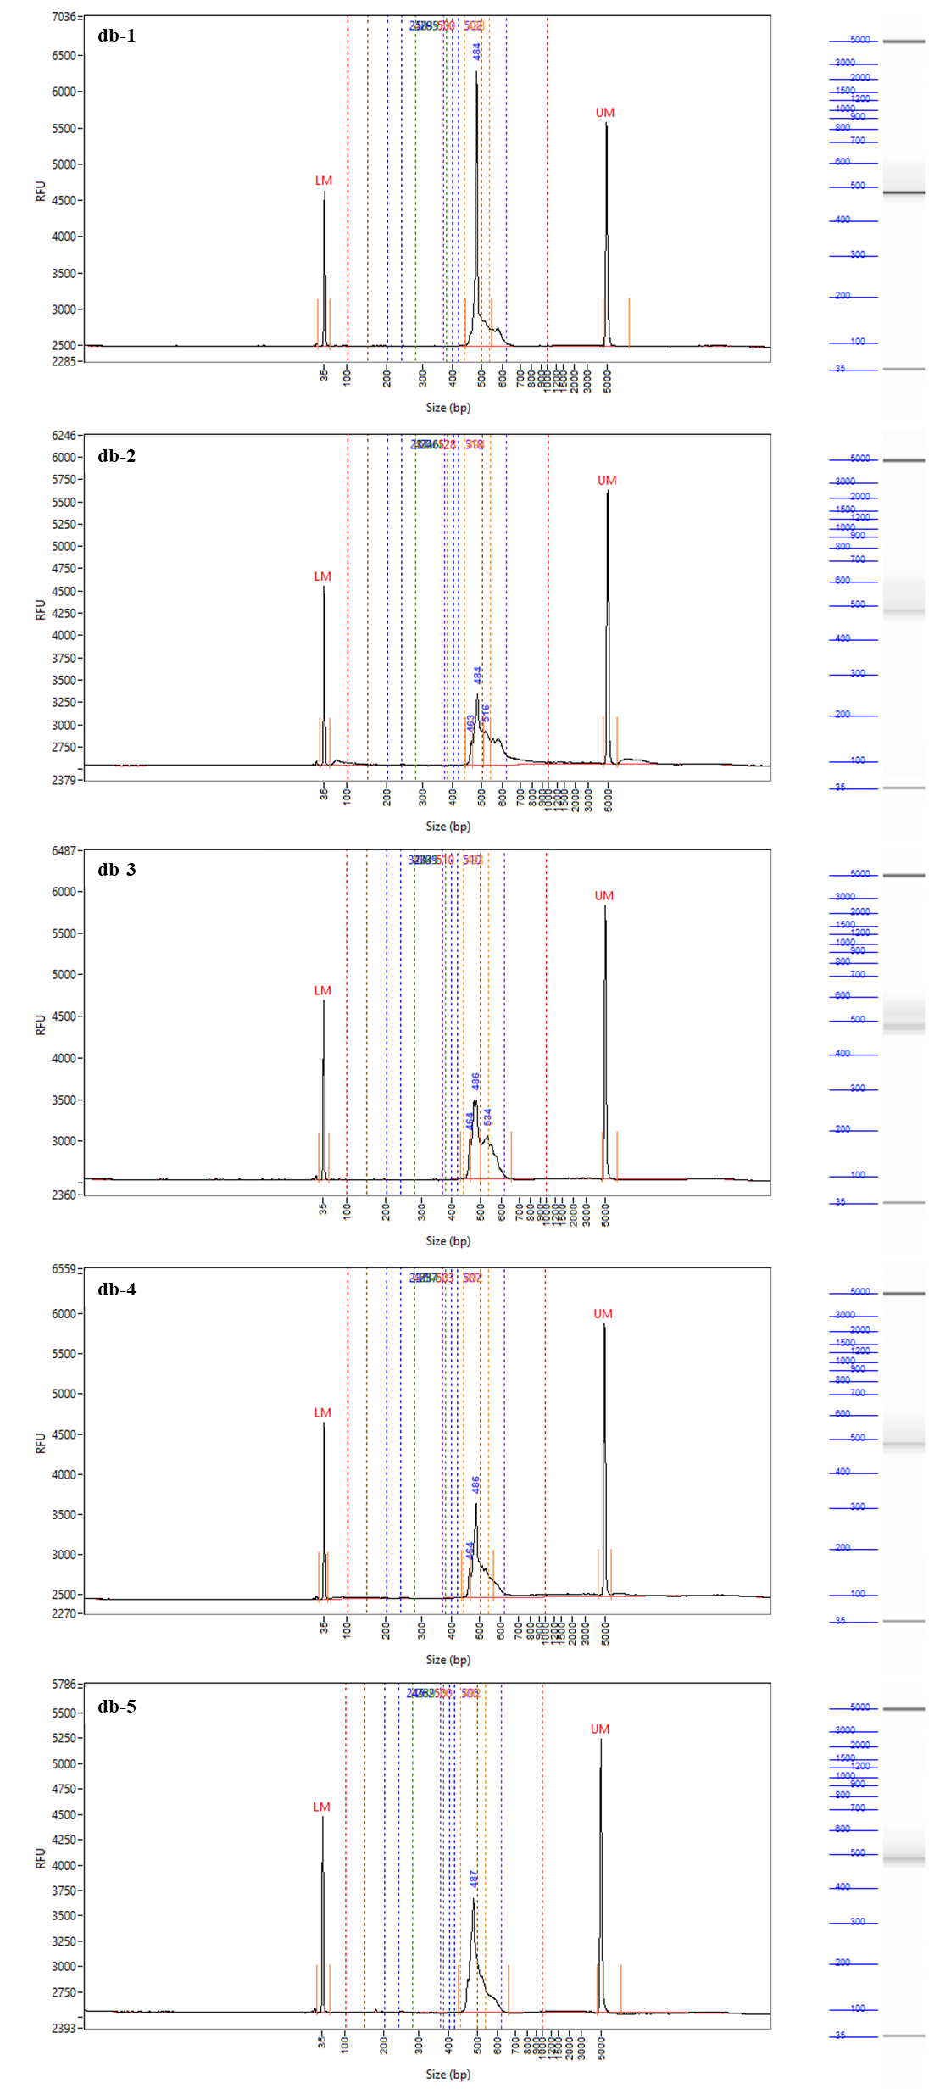

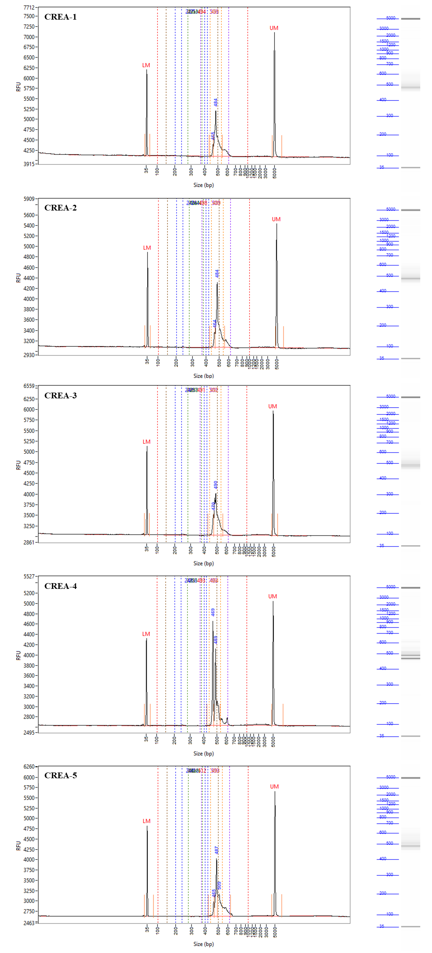

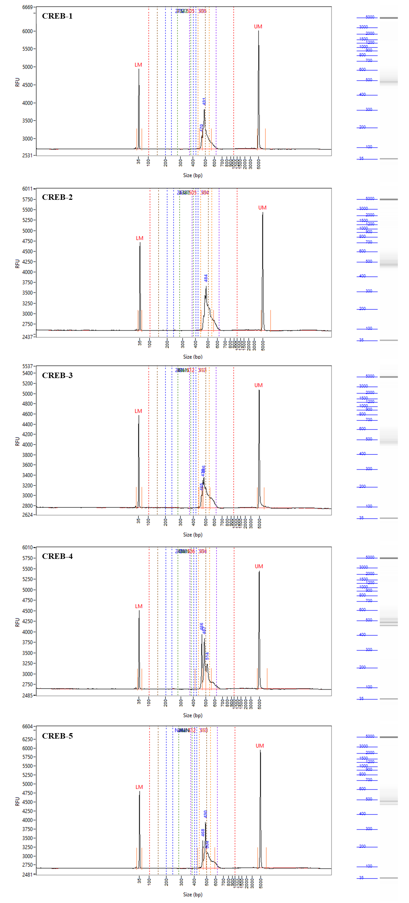

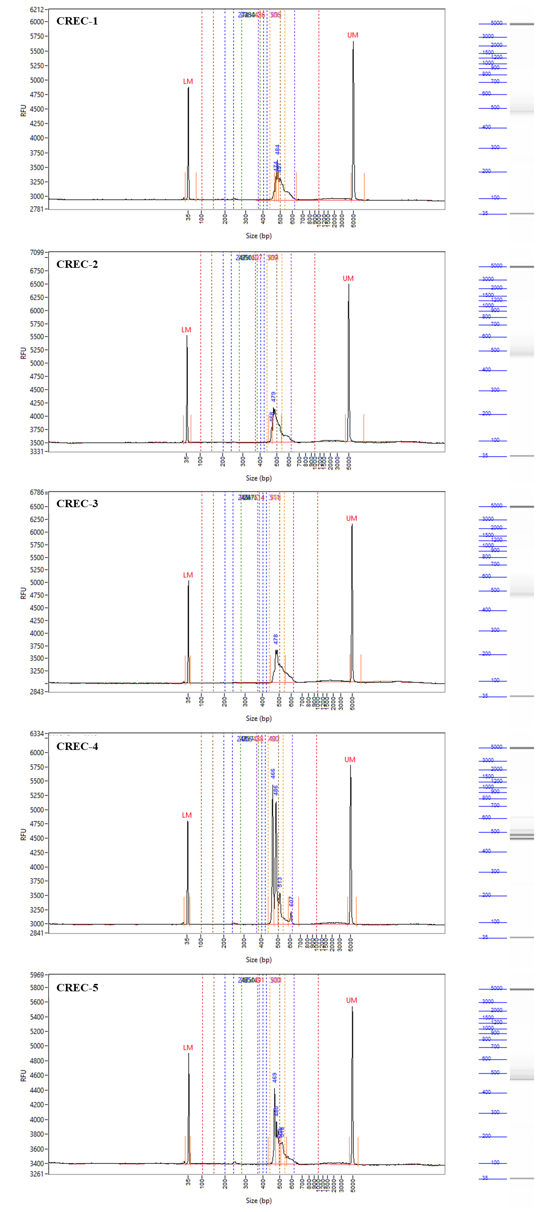

**Supplementary Figure 2.** Quantity and integrity of fecal DNA samples in WT, db, CREA, CREB, and CREC group (n=5/group) of mice.