Supplementary Material

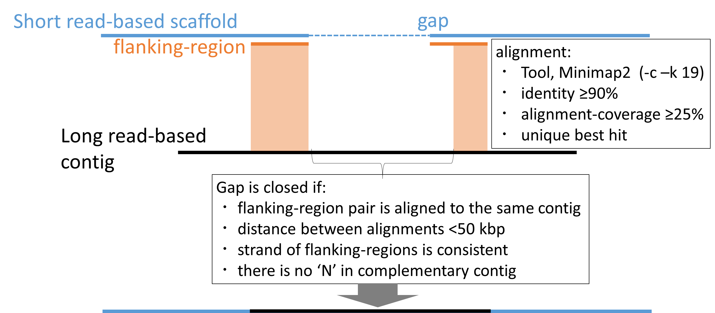

Supplementary Figure 1. Schematic model of gap-filling with long read-based contigs. Flanking-region lengths: 500, 1k, 5k, 10k, 20k, 40 kbp, 80 kbp, 160 kbp (multiple values are applied). Gap-closing step is iterated two times.
Supplementary Figure 2. A histogram estimating possible clonemates. The x axis indicates genetic distance between pair of individuals and y axis indicates the number of pairs calculated by GenoDive v. 3.0.
Supplementary Figure 3. The connectivity matrix of the simulation of 26-year larval dispersal. The sink location is indicated on the x axis, and the source location is indicated on the y axis. Colors indicate numbers of particles.
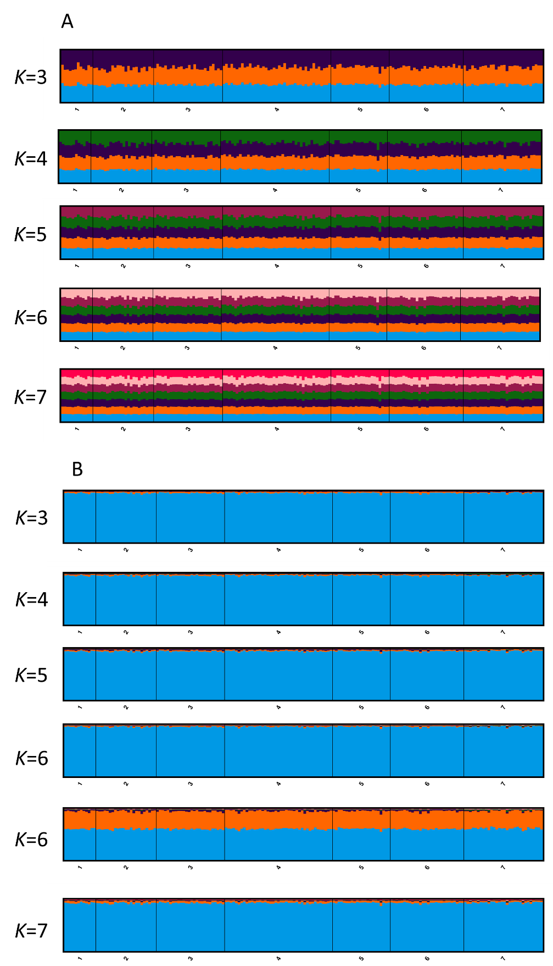
Supplementary Figure 4. Structure analysis at comparable K from 3 to 7 (1 = Tatsukushi [TTK], 2 = Miyazaki [MYZ], 3 = Sakurajima [SKR], 4 = Onna Village [ONN], 5 = Miyako [MYK], 6 = Sekisei Lagoon [SKS], 7 = Ogasawara [OGS]). (A): without prior and (B): with prior grouping for Ogasawara. In K = 6, each pattern was supported in five out of ten iterations. The x axis indicates sampling sites. The y axis indicates the probability of membership.

Supplementary Table 1. Statistics of the draft genome.
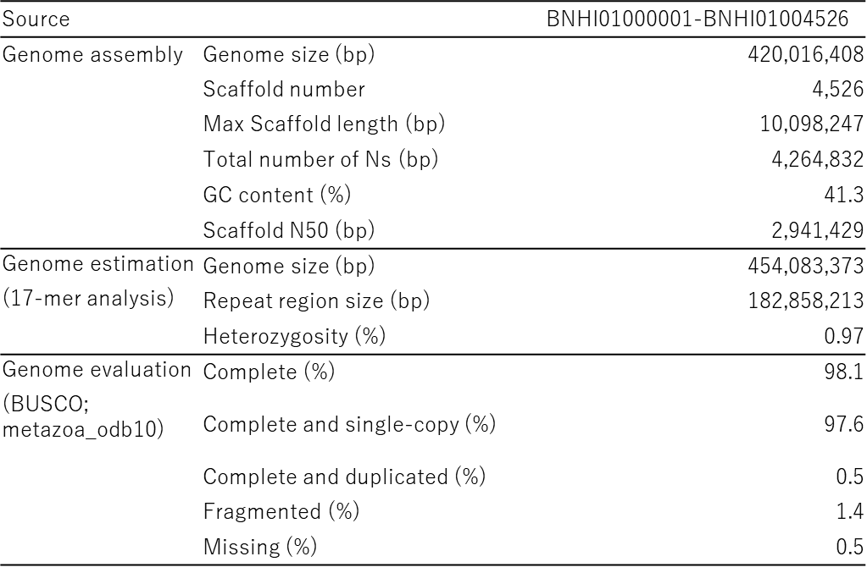

Supplementary Table 2. The results from Structure Harvester to calculate ΔK. K is the number of hypothetical clusters assumed in Structure analysis.
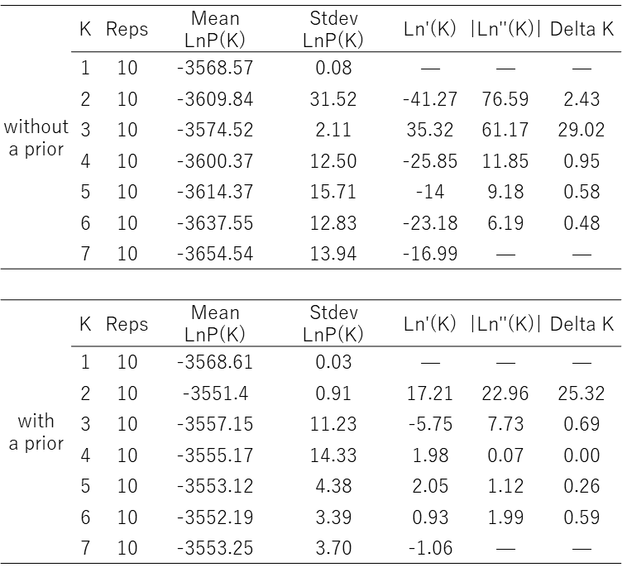
K is the number of hypothetical clusters assumed in Structure analysis.

Supplementary Table 3. The total number of arrived particles over 26 years. Bold face numbers indicate self-seeding. Self-seeding at Ogasawara is highlighted in yellow. Vertical columns indicate source populations, and horizontal rows indicate sink sites.
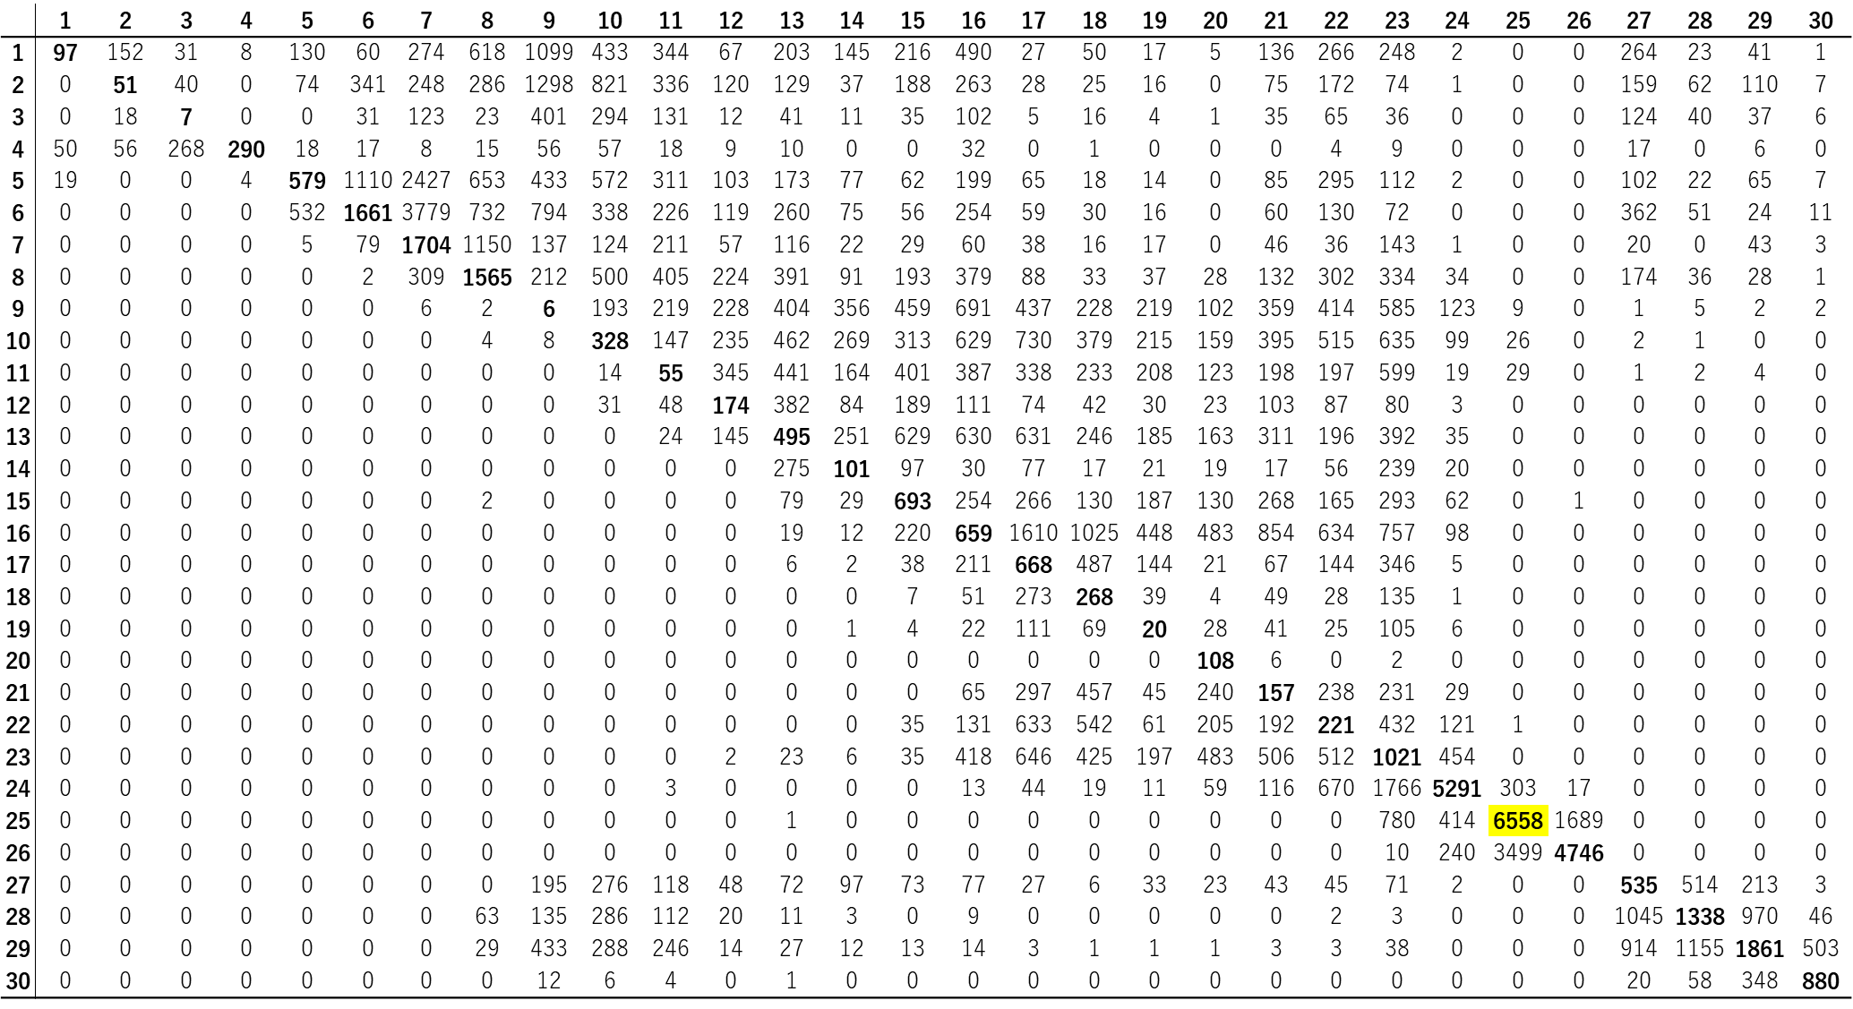
Bold face numbers indicate self-seeding. Self-seeding at Ogasawara is highlighted in yellow. Vertical columns indicate source populations, and horizontal rows indicate sink sites.

Supplementary Table 4. The average number of arrived particles over 26 years. Bold face numbers indicate self-seeding. Self-seeding at Ogasawara is highlighted in yellow. Vertical columns indicate source populations, and horizontal rows indicate sink sites.

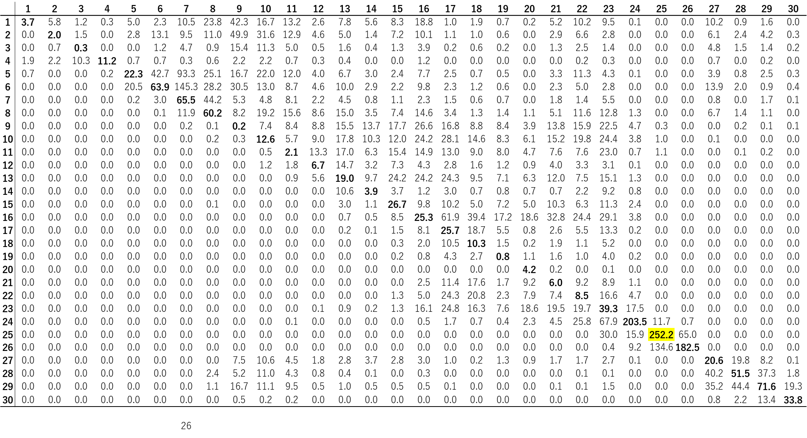 Bold face numbers indicate self-seeding. Self-seeding at Ogasawara is highlighted in yellow. Vertical columns indicate source populations, and horizontal rows indicate sink sites.

Supplementary Table 5. The number of typhoons approaching Ogasawara and Izu Islands over a 70-year span (1951–2020).
