Supplementary Material

# Supplementary Tables and Figures

**S1. Number of children per day during the time period of 08:30 to 14:00 for time I and II. The intervention preschools are denoted i1… i7 and the reference preschools c1, c2 and c3.**

|  |  |  |  |  |  |  |  |  |  |  |  |  |  |
| --- | --- | --- | --- | --- | --- | --- | --- | --- | --- | --- | --- | --- | --- |
| **Day** | **Monday** | | **Tuesday** | | **Wedensday** | | **Thursday** | | **Friday** | | **Mean** | | |
| **Time period** | **I** | **II** | **I** | **II** | **I** | **II** | **I** | **II** | **I** | **II** | **I** | **II** |
| **i1** | 10 | - | 16 | 20 | 14 | 17 | 16 | 17 | 11 | 15 | **13** | **17** |
| **i2** | 19 | 13 | 17 | 19 | 17 | 18 | 20 | 19 | 19 | 16 | **18** | **18** |
| **i3** | 15 | 17 | 19 | 16 | 15 | 15 | 17 | 15 | 11 | 13 | **15** | **15** |
| **i4** | 15 | 13 | 17 | 18 | 17 | 17 | 19 | 11 | 13 | 9 | **16** | **14** |
| **i5** | 14 | 13 | 20 | 17 | 17 | 12 | 14 | 15 | 19 | 14 | **17** | **15** |
| **i6** | 15 | 9 | 13 | 10 | 13 | 8 | 14 | 15 | 14 | 12 | **14** | **11** |
| **i7** | 13 | 16 | 15 | 15 | 15 | 13 | 14 | - | 13 | - | **14** | **15** |
| **Mean**  (SD) | **14**  (2.70) | **14**  (2.81) | **17**  (2.36) | **16**  (3.30) | **15**  (1.62) | **14**  (3.55) | **16**  (2.50) | **15**  (2.66) | **14**  (3.40) | **13**  (2.48) | **15**  (1.83) | **15**  (2.24) |
| **c1** | **-** | 13 | 20 | 20 | 19 | 20 | 17 | 15 | - | - | **19** | **17** |
| **c2** | **-** | - | 15 | 14 | 12 | 12 | 12 | 14 | - | 12 | **13** | **13** |
| **c3** | **-** | 15 | 21 | 13 | 18 | 15 | 17 | 20 | - | 20 | **19** | **17** |
| **Mean** (SD) | **-** | **14**  (1.41) | **19**  (3.21) | **16**  (3.79) | **16**  (3.79) | **16**  (4.04) | **15**  (2.89) | **16**  (3.21) | **-** | **16**  (5.66) | **17**  (3.27) | **16**  (2,01) |

* Denotes days where the number of children were not recorded

# Calculations of area under the curve

**S2. Step by step description for area under the curve calculation.**

The following steps are taken when calculating the area under the curve for each frequency response.

* Using the software REW (Room EQ wizard) the measurement positions, for each room and time, are averaged to a single frequency response curve.
* The averaged frequency response’s magnitude values are then extracted in the chosen frequency range 250 - 4000 Hz.
* The extracted values are imported to matlab where an evenly spaced frequency vector with unit spacing ‘1’ is created.
* The frequency responses are interpolated using the function **interp1** with method ‘spline’.
* The frequency responses are normalized using the minimum value for each frequency response within the chosen frequency range.
* The area under the curve is calculated by the **trapz** function using the interpolated normalized frequency response.

For further reference see:

<https://se.mathworks.com/help/matlab/ref/interp1.html>

<https://se.mathworks.com/help/matlab/ref/trapz.html>

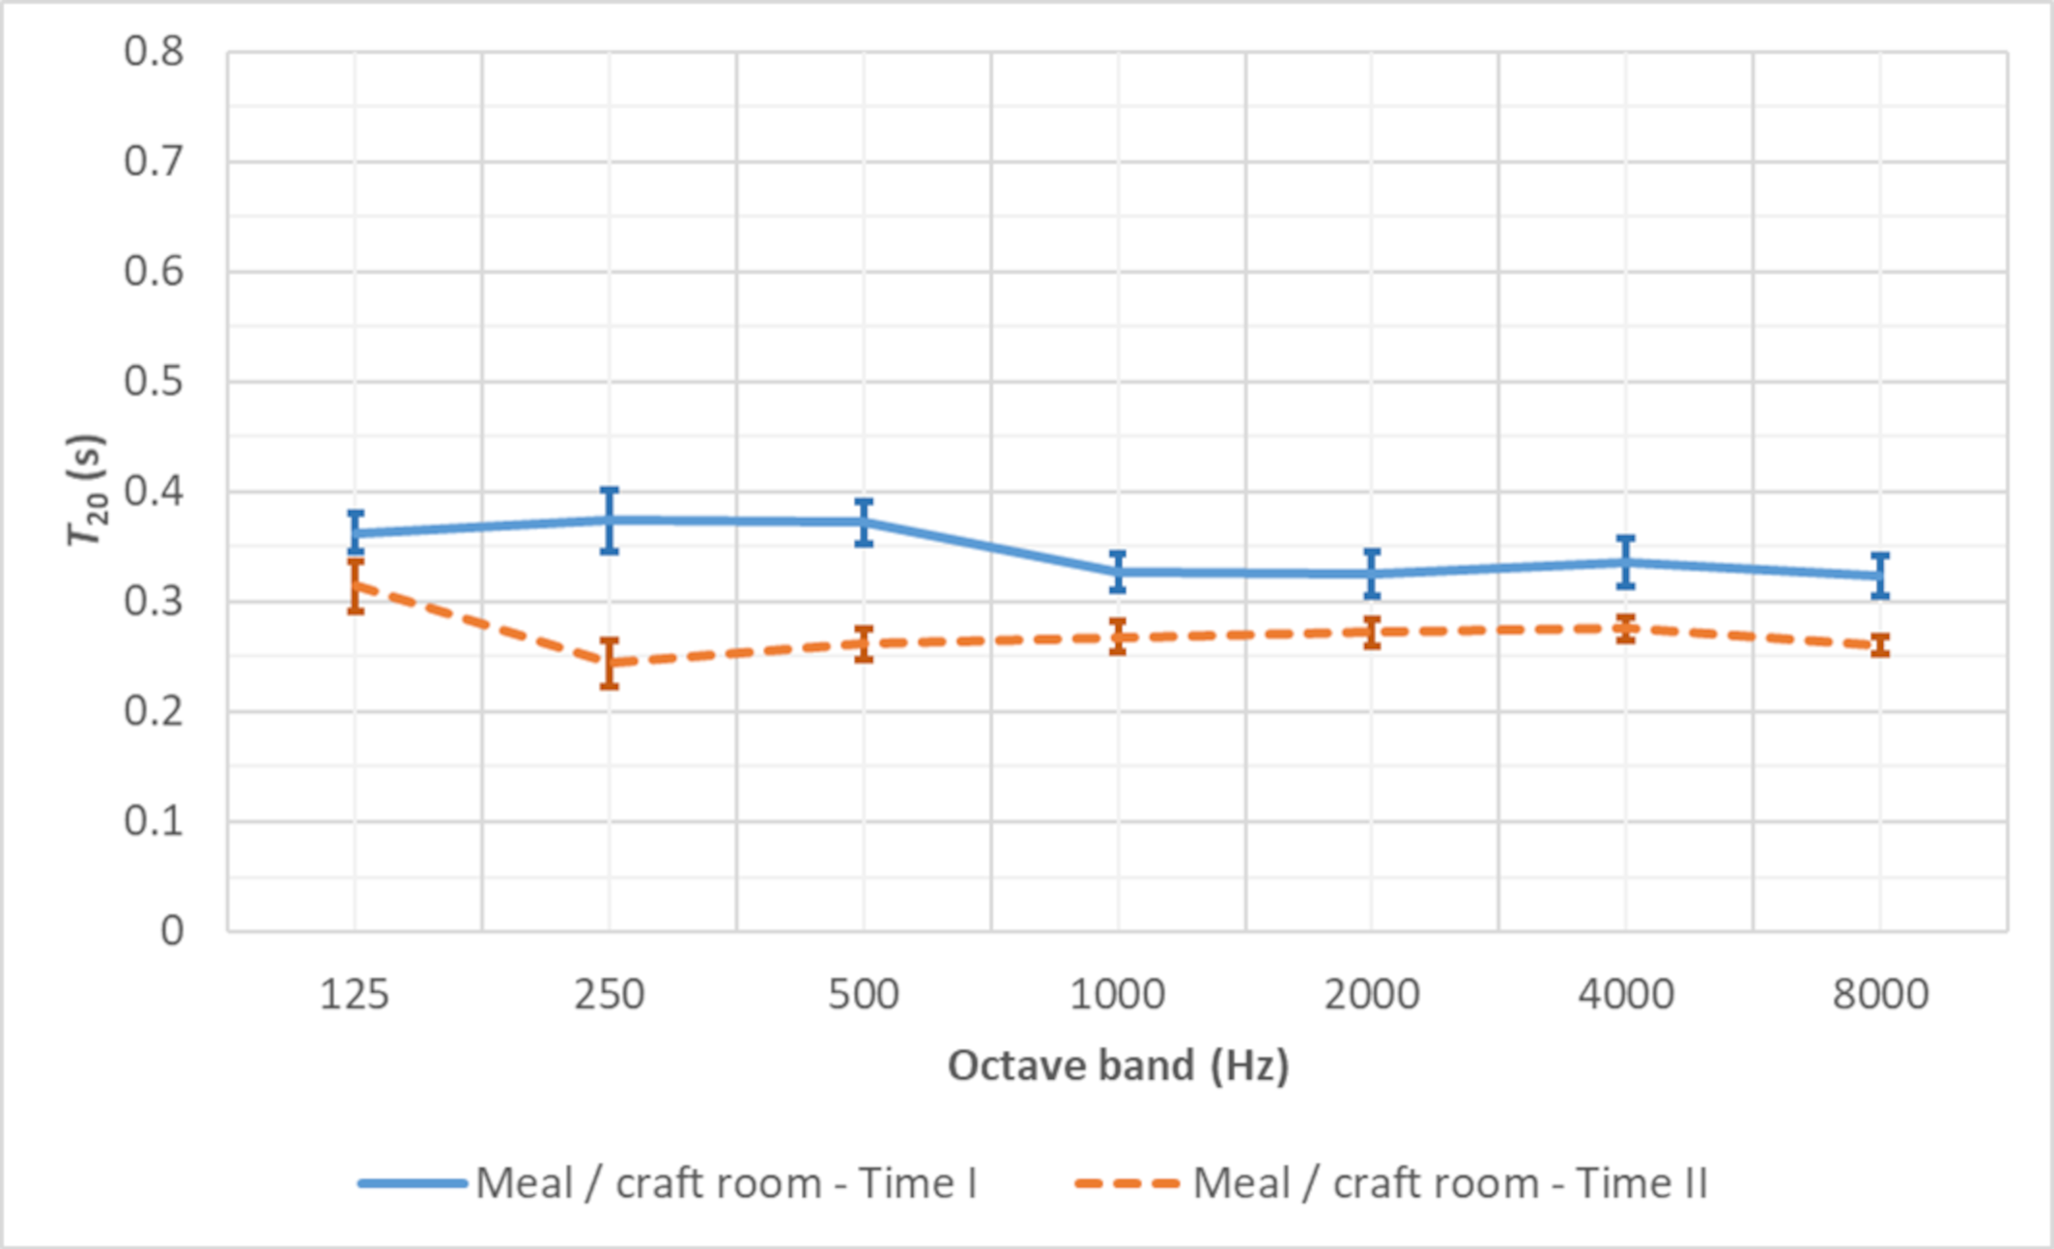

Figure S3. Averaged values for T20 for Play room. Solid line represents values before (time I) and dashed line after the interventions (time II). The error bars show 95% CI.

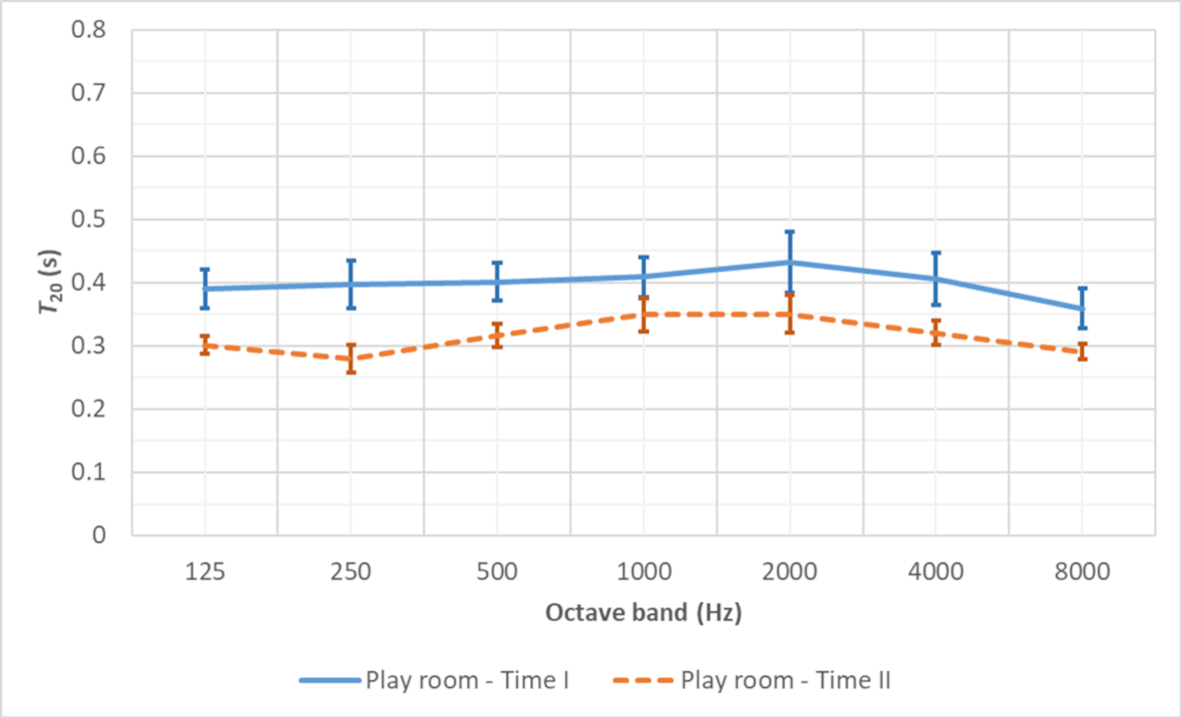

Figure S4. Averaged values for T20 for Meal/craft room. Solid line represents values before (time I) and dashed line after the interventions (time II). The error bars show 95% CI.

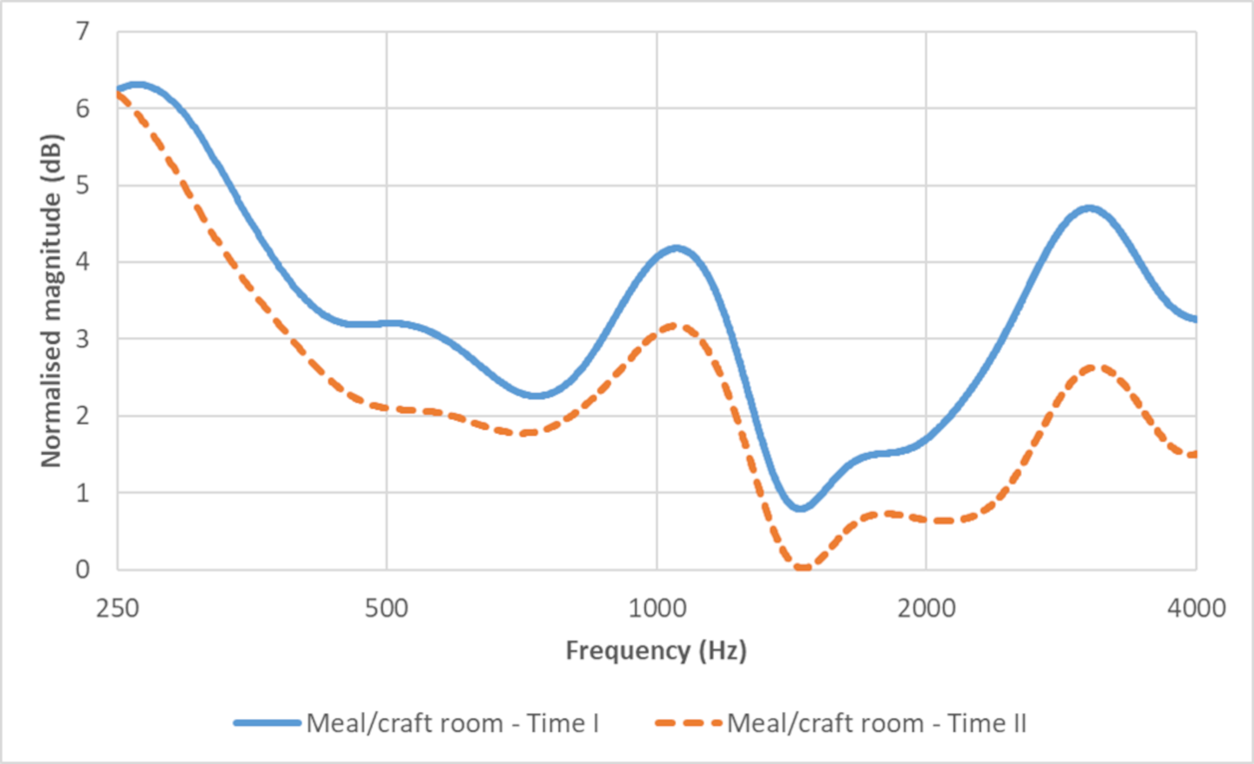

Figure S5. Averaged room frequency response of Meal/craft room The y-axis was normalised to the minimum sound pressure level, within the chosen frequency range 250 – 4000 Hz, for each frequency response.

S:\Shared Folders\Ljudmiljö\Skola_buller\Artiklar\figures\supplementary figures\figure S 6.tif

Figure S6. Averaged room frequency response of Play room The y-axis was normalised to the minimum sound pressure level, within the chosen frequency range 250 – 4000 Hz, for each frequency response.