Appendix B. Examples of Images that the System Extracts Desired Output

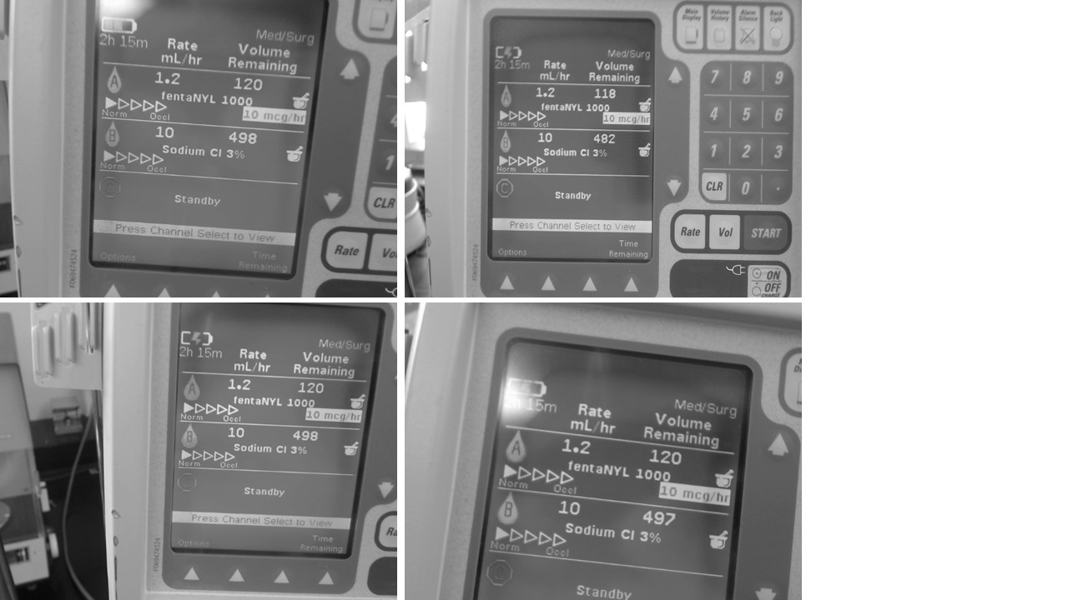

Each of these four images were captured from the camera while running a real time serial output of the digitized data. The output was: “fentanyl 1000: 1.2 Sodium Cl 3%: 10” demonstrating the types of images that can be captured and still have a working system.

