SUPPORTING INFORMATION

**Calibration-less DNA Concentration Measurements using Volumetric Flow and Single Molecule Counting**

Nasim Farajpour1, Lauren Lastra1, Vinay Sharma1,Kevin Freedman1*

1Department of Bioengineering, University of California Riverside, Riverside, CA 92521, USA.

Corresponding author: [*kfreedman@engr.ucr.edu](mailto:*kfreedman@engr.ucr.edu)

Figure S1. Characterization of the glass nanopores

Table S1.

Pulling Parameters for Glass Nanopore Fabrication

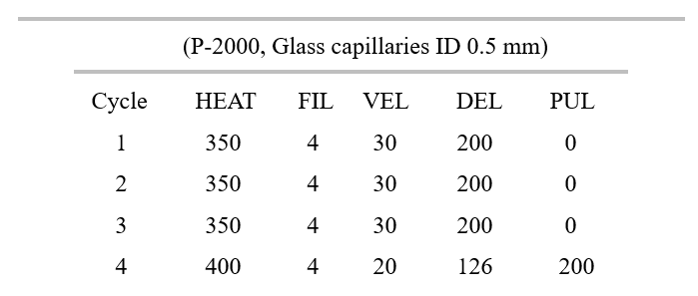

Note S1. Mounting Procedure and TEM Imaging

The conical glass nanopores were first fabricated using a laser assist pipette puller device. Two-part epoxy glue was used to make an adhesive surface on the TEM grid for the nanopore mounting procedure.

Next, the TEM grid with epoxy on top was set under an optical microscope, and the nanopore was secured inside the grid using a micrometer. The process was done under the optical microscope to ensure that the pore's opening does not touch the epoxy. The nanopore was stayed for about 15 minutes to get attached to the TEM grid.

Before the imaging, gold sputter coating was performed on the nanopores mounted on the TEM grid. Thermo Fisher Scientific Tecnai12 Transmission Electron Microscope was used for visualizing the nanopore. The machine operated at 120 kV voltage and utilized a Lanthanum Hexaboride as the electron source.

Note S2. Finite Element Analysis Modeling

Finite element analysis was performed using COMSOL Multiphysics software. The nanopores conical geometries were modeled built on the same pulling protocols used in the experimental study. The electrostatics, transport of diluted species, and laminar flow physics were utilized based on a 2D axisymmetric model using a stationary study. For most of simulations, a surface charge density of -2E-2 C/m2 was set as the electrostatics boundary condition for the glass nanopores. The volumetric flow was calculated using 2D cut line data set across the nanopore. The line integration method was used to obtain the electroosmotic flow. The salt concentrations were the same as the experimental parameters.

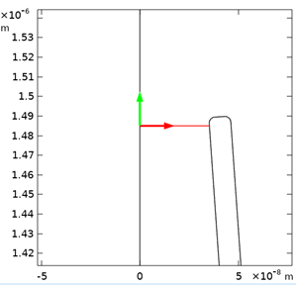

Figure S2. Cutline 2D data line spanning the width of the nanopore opening



Figure S3. DNA translocation data as the function of applied voltages. A) Dwell time distributions for glass nanopore at 10 mM KCl salt concentration plus 500 pM λ-DNA. B) Current drop distributions for glass nanopore at 10 mM KCl salt concentration and 500 pM λ-DNA.

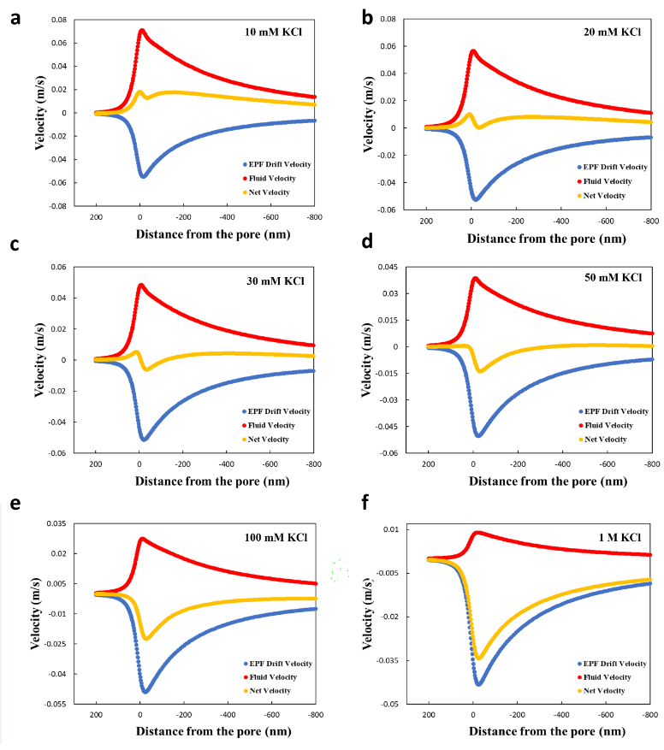Figure S4. The EPF drift velocity, EOF and, net velocity directions in a 70 nm nanopore at different salt concentrations.



Figure S5. The EPF drift velocity, EOF and, net velocity directions in a 600 nm nanopore at different salt concentrations.