**Title: Aspirin use and common cancer risk: a meta-analysis of cohort studies and randomized controlled trials**

**Supplementary Figures**

**Supplementary Figure 1**. Forest plot of aspirin use and risk of CRC.

**Supplementary Figure 2**. Forest plot of aspirin use and risk of gastric cancer.

**Supplementary Figure 3**. Forest plot of aspirin use and risk of breast cancer.

**Supplementary Figure 4**. Forest plot of aspirin use and risk of prostate cancer.

**Supplementary Figure 5**. Forest plot of aspirin use and risk of lung cancer.

**Supplementary Figure 6**. Forest plot of aspirin use and CRC specific mortality.

**Supplementary Figure 7**. Forest plot of aspirin use and breast cancer specific mortality.

**Supplementary Figure 8**. Forest plot of aspirin use and prostate cancer specific mortality.

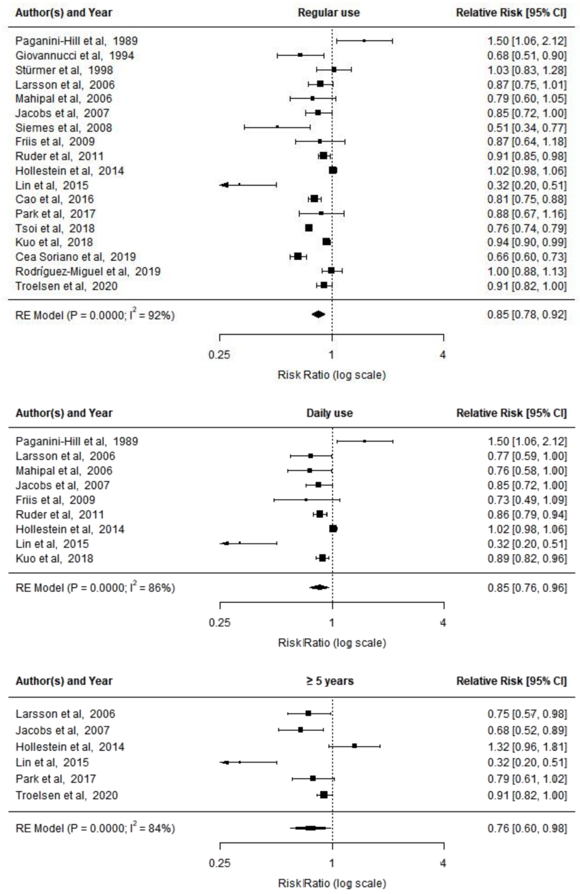

**Supplementary Figure 1**. Forest plot of aspirin use and risk of CRC.

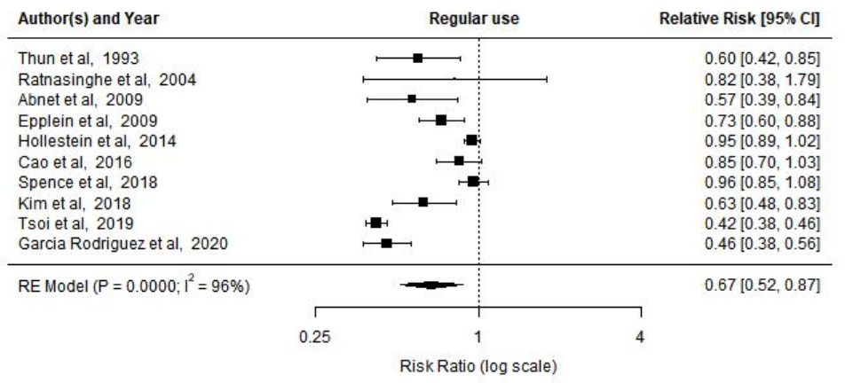

**Supplementary Figure 2**. Forest plot of aspirin use and risk of gastric cancer.

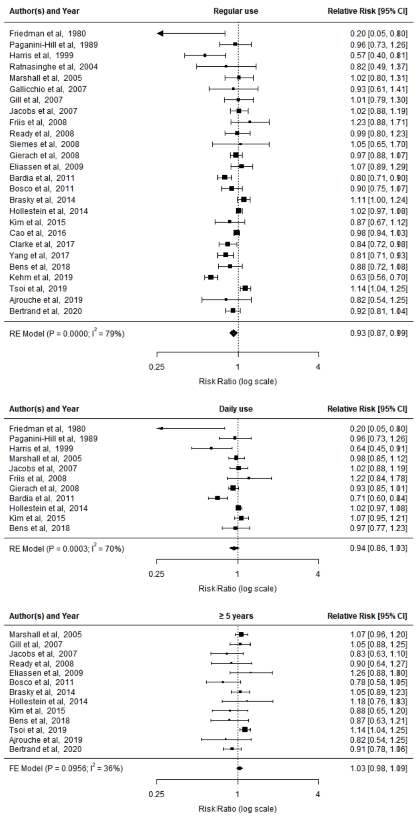

**Supplementary Figure 3**. Forest plot of aspirin use and risk of breast cancer.

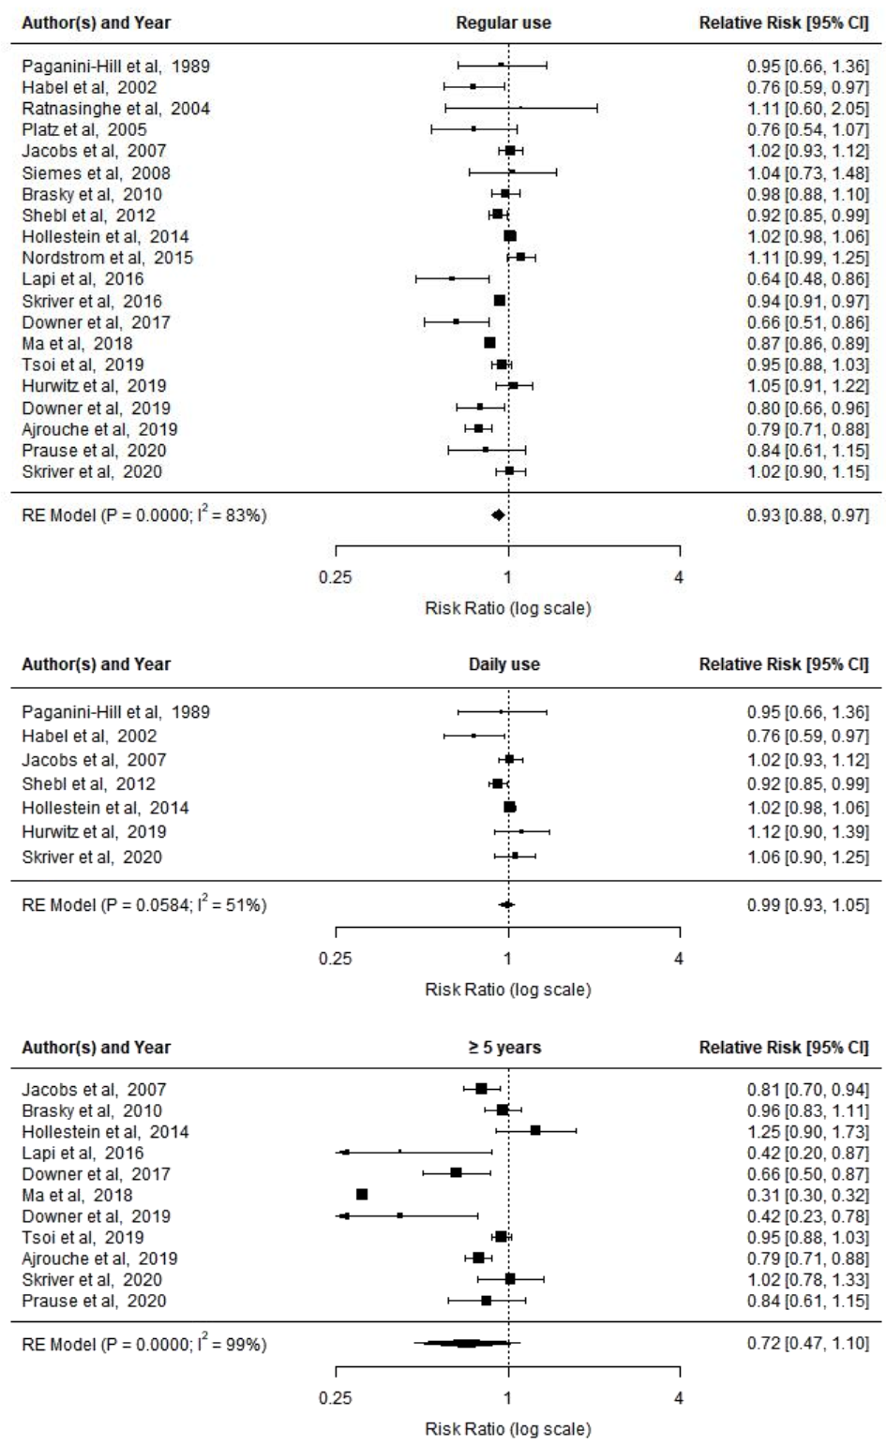

**Supplementary Figure 4**. Forest plot of aspirin use and risk of prostate cancer.

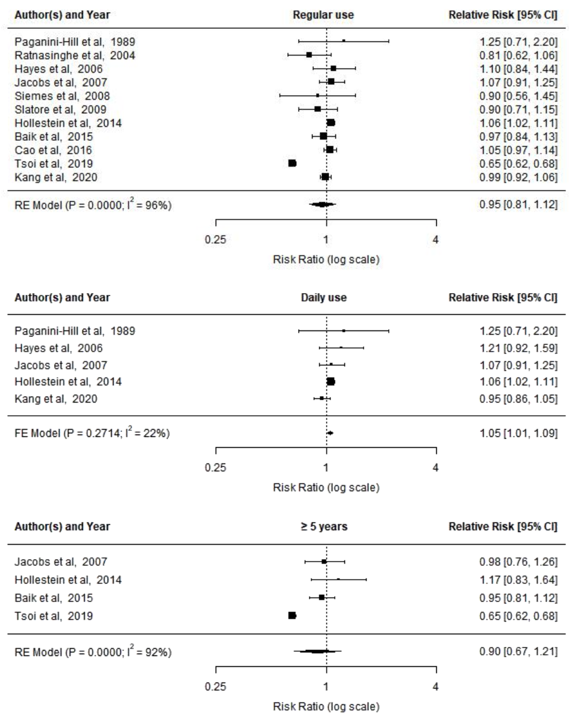

**Supplementary Figure 5**. Forest plot of aspirin use and risk of lung cancer.

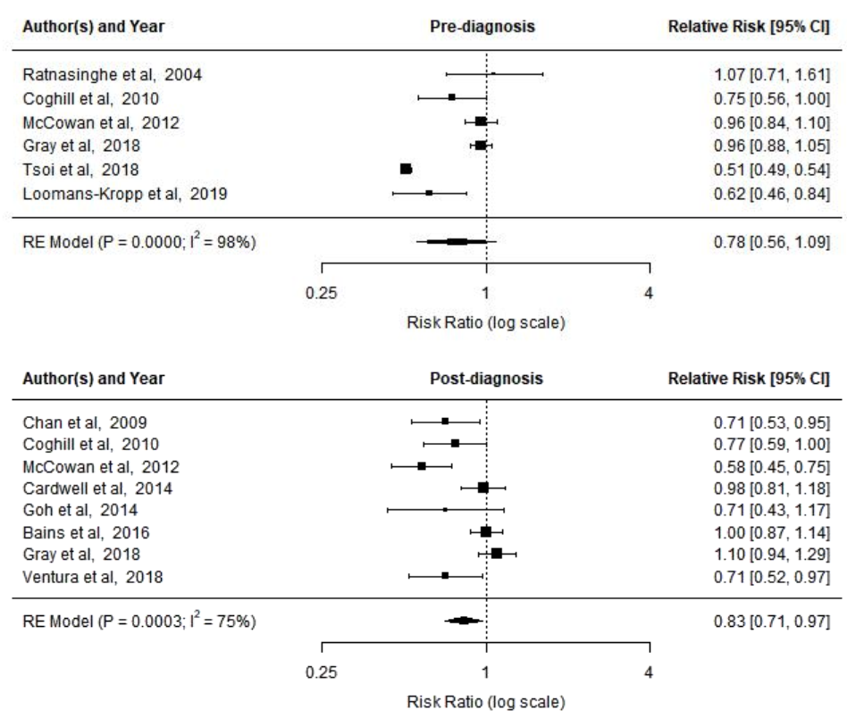

**Supplementary Figure 6**. Forest plot of aspirin use and CRC specific mortality.

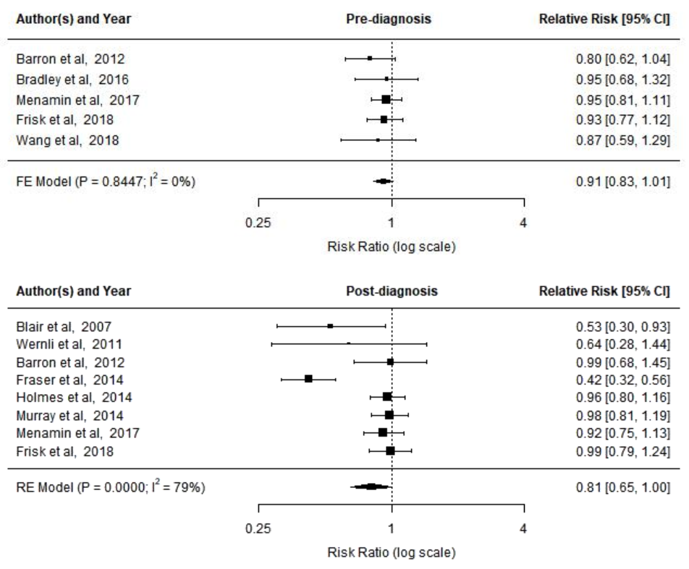

**Supplementary Figure 7**. Forest plot of aspirin use and breast cancer specific mortality.

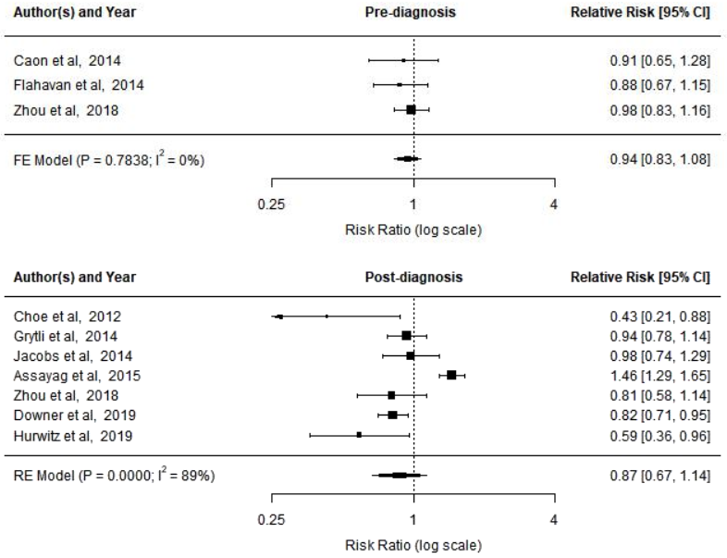

**Supplementary Figure 8**. Forest plot of aspirin use and prostate cancer specific mortality.