Supplementary Fig. S1. Demographic data distribution of subjects included in this study.

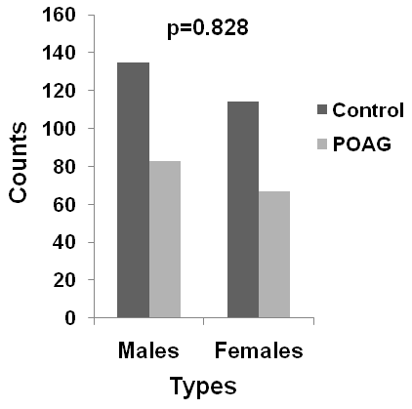
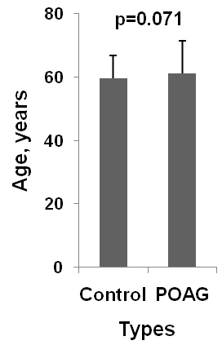

Note: p-value for age was determined by t-test and gender distribution by Pearson’s Chi-square analysis.

Supplementary Table S1: Association analysis of rs35934224 variant in TXNRD2 with primary open-angle glaucoma according to gender
Group | Genetic Model | Genotype | Control  n (%) | POAG  n (%) | Odds ratio (95% confidence interval) | p-value | p-value*
Men | Codominant | C/C | 91 (67.4) | 52 (62.6) | 1.00 | 0.200 | 0.230
Men | Codominant | C/T | 41 (30.4) | 25 (30.1) | 1.07 (0.58-1.95) | 0.200 | 0.230
Men | Codominant | T/T | 3 (2.2) | 6 (7.2) | 3.50 (0.84-14.58) | 0.200 | 0.230
Men | Dominant | C/C | 91 (67.4) | 52 (62.6) | 1.00 | 0.470 | 0.600
Men | Dominant | C/T-T/T | 44 (32.6) | 31 (37.4) | 1.23 (0.70-2.18) | 0.470 | 0.600
Men | Recessive | C/C-C/T | 132 (97.8) | 77 (92.8) | 1.00 | 0.076 | 0.088
Men | Recessive | T/T | 3 (2.2) | 6 (7.2) | 3.43 (0.83-14.10) | 0.076 | 0.088
Women | Codominant | C/C | 68 (59.6) | 45 (67.2) | 1.00 | 0.120 | 0.110
Women | Codominant | C/T | 44 (38.6) | 18 (26.9) | 0.62 (0.32-1.20) | 0.120 | 0.110
Women | Codominant | T/T | 2 (1.8) | 4 (6.0) | 3.02 (0.53-17.20) | 0.120 | 0.110
Women | Dominant | C/C | 68 (59.6) | 45 (67.2) | 1.00 | 0.310 | 0.380
Women | Dominant | C/T-T/T | 46 (40.4) | 22 (32.8) | 0.72 (0.38-1.36) | 0.310 | 0.380
Women | Recessive | C/C-C/T | 112 (98.2) | 63 (94.0) | 1.00 | 0.130 | 0.100
Women | Recessive | T/T | 2 (1.8) | 4 (6.0) | 3.56 (0.63-19.96) | 0.130 | 0.100

*p-value adjusted by age in men and women groups
Abbreviations: POAG, primary open-angle glaucoma

Supplementary Table S2: Association analysis of rs6478746 variant near LMX1B with primary open-angle glaucoma according to gender
Group | Genetic Model | Genotype | Control  n (%) | POAG  n (%) | Odds ratio (95% confidence interval) | p | p*
Men | Codominant | A/A | 104 (77.0) | 64 (77.1) | 1.00 | 1.000 | 0.990
Men | Codominant | A/G | 28 (20.7) | 17 (20.5) | 0.99 (0.50-1.94) | 1.000 | 0.990
Men | Codominant | G/G | 3 (2.2) | 2 (2.4) | 1.08 (0.18-6.66) | 1.000 | 0.990
Men | Dominant | A/A | 104 (77.0) | 64 (77.1) | 1.00 | 0.990 | 0.950
Men | Dominant | A/G-G/G | 31 (23.0) | 19 (22.9) | 1.00 (0.52-1.91) | 0.990 | 0.950
Men | Recessive | A/A-A/G | 132 (97.8) | 81 (97.6) | 1.00 | 0.930 | 0.930
Men | Recessive | G/G | 3 (2.2) | 2 (2.4) | 1.09 (0.18-6.64) | 0.930 | 0.930
Women | Codominant | A/A | 91 (79.8) | 53 (79.1) | 1.00 | 0.990 | 0.860
Women | Codominant | A/G | 20 (17.5) | 12 (17.9) | 1.03 (0.47-2.27) | 0.990 | 0.860
Women | Codominant | G/G | 3 (2.6) | 2 (3) | 1.14 (0.19-7.07) | 0.990 | 0.860
Women | Dominant | A/A | 91 (79.8) | 53 (79.1) | 1.00 | 0.910 | 0.580
Women | Dominant | A/G-G/G | 23 (20.2) | 14 (20.9) | 1.05 (0.50-2.20) | 0.910 | 0.580
Women | Recessive | A/A-A/G | 111 (97.4) | 65 (97.0) | 1.00 | 0.890 | 0.870
Women | Recessive | G/G | 3 (2.6) | 2 (3.0) | 1.14 (0.19-6.99) | 0.890 | 0.870

*p value adjusted age in men and women groups
Abbreviations: POAG, primary open-angle glaucoma

