# Supplementary Material for

Effective repulsion between oppositely charged particles in symmetrical multivalent salt solutions: effect of salt valence

Yao Li1, Hai-Long Dong1, Jin-Si Zhang2, Cheng Lin1*, and Zhi-Jie Tan1*

*1Department of Physics and Key Laboratory of Artificial Micro & Nano-structures of Ministry of Education, School of Physics and Technology, Wuhan University, Wuhan 430072, China*

*2College of Electrical and Photoelectronic Engineering, West Anhui University, Lu’an, 237012, China*

* Corresponding author: zjtan@whu.edu.cn; 17clin@whu.edu.cn



FIG. S1 (A-C) Charge fraction of ions as a function of the radial distance *r* to the center of a charged particle for different salt concentrations and |Z| = 36 *e*; (D-F) Charge fraction of ions as a function of the radial distance *r* to the center of a charged particle for 0.3M *z*:*z* salts and different particle charges. *Rc* denotes the distance where *Q*(*r*) has a maximum value at high 2:2 (A, D), 3:3 (B, E) and 4:4 (C, F) salts. The salt concentrations and particle charges have been shown in the respective panels. In the work, we used *R*c to roughly describe the boundary between condensed counterions and diffusive ones, and in our calculations, *Rc* was taken as ~18 Å, ~18 Å, ~16.5 Å and ~15.5 Å for 1:1, 2:2, 3:3 and 4:4 salts, respectively. It is also noted that the minimum values adjacent maximum ones are caused by the existence of coions around the “over-condensed” counterions for the oppositely charged particles due to the counterion-coion Coulombic attractions.



FIG. S2. (A-C) Effective potentials of mean force ∆*G* between equally and oppositely charged colloidal particles with different charge particles |Z| in symmetrical 1:1, 2:2, 3:3 and 4:4 salt solutions from the MC simulations. (D-F) The relative charge fraction Δ*f* = *f*(*x*)-*f*(*x*ref) of condensed counterions obtained from the MC simulations as a function of separation *x* between two oppositely charged colloidal particles. The insets are the charge fraction *f*(*x*). The salt concentrations are 0.3 M, and the particle charges and ion valences have been shown in the respective panels. The reference separation is taken as *x*ref = 45 Å.



FIG. S3. The concentration distributions of counterions and coions as functions of radial distance *r* from charged particles in symmetrical 1:1, 2:2, 3:3 and 4:4 salt solutions from the MC simulations. Here, *c*counterion and *c*coion denote the concentrations of counterions and coions, respectively. The peaks of *c*counterion represent the counterions condensation and the peaks of *c*coion in the inserts show the coion condensation around the condensed counterions for the oppositely charged particles; see also Fig. S1. In this work, as shown in Fig. S1, we used the radial distance of *R*c = ~18 Å, ~18 Å, ~16.5 Å, and ~15.5 Å for 1:1, 2:2, 3:3 and 4:4 salts to describe the boundary between condensed counterions and diffusive ones. Similarly, we used another radial distance of *R*o to include the condensed coions around the condensed counterions for the charged particles, and *R*o was roughly taken as the values corresponding to the maximum values of *c*coion in the inserts. Specifically, *R*o = ~20 Å, ~19 Å, and ~18 Å for 2:2, 3:3 and 4:4 salts, respectively. Here, *R*o for 1:1 salts were not shown since there is no peak of *c*coion distribution for 1:1 salt over the covered salt concentrations.

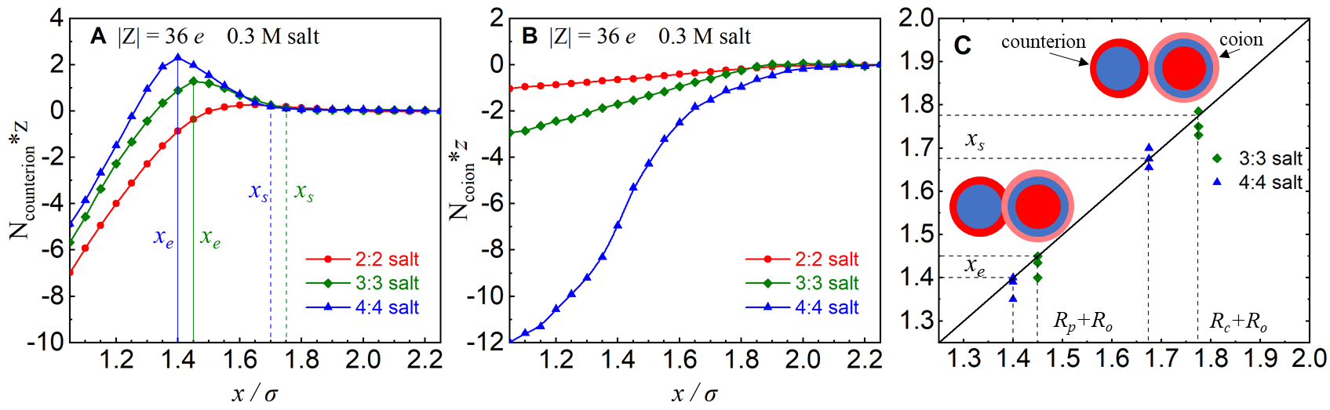

FIG. S4. (A) The number of counterions within the radial distance of *R*c versus the separation *x* for the charged particles with |Z| = 36 *e*. (B) The number of coions within the radial distance of *R*o versus the separation *x* for the charged particles with |Z| = 36 *e*. (C) Comparison between the typical separations where the increase trend of *f* with the decrease of *x* starts (*x*s) and ends (*x*e), and the separations where the condensed coion shell around a particle starts to contact with the condensed counterion shell around the other particle (*Rc*+*Ro*) and with the other particle (*Rp*+*Ro*) for different salt concentrations. Here, *Rp* (=10 Å) is the radius of the charged particles and |Z| = 36*e*. The relationship of *x*s ~ *R*o+*R*c and *x*e ~ *Rp*+*Ro* suggest that the coions in the shell of *R*o for a charged particle begin to become the condensed counterions for the other oppositely charged particle when the separation *x* is decreased to ~*R*o+*R*c, which would cause the increased number of condensed counterions with the decrease of *x* until ~*Rp*+*Ro*; see panel a. When *x* <~*Rp*+*Ro*, the number of condensed counterions will decrease due to the weak electrostatic field and the excluded volume effect between two oppositely charged particles.



FIG. S5 Charge fraction of ions as a function of the radial distance *r* to the center of a charged particle in symmetrical 2:2, 3:3 and 4:4 salt solutions, from the MC simulations with involving local-ranged counterion-coion repulsions of ∆ = 0.5 Å and ∆ = 2 Å; see Eq. (5) in the main text for details. The dashed lines are the same as the lines in Fig. S1. The salt concentrations are 0.3 M and particle charges are |Z| = 36 *e*.