Supplementary Material

# Supplementary information, figures and tables

## Supplementary tables

**Table S1**. Fruit and sample size of woody plants in Białowieża Forest.

|  |  |  |  |  |  |  |
| --- | --- | --- | --- | --- | --- | --- |
| **No.** | **Plants** | **Fruit diameter (cm)** | |  | **Sample size** | |
|  |  | **Albrecht et al. 2018** | **This study** |  | **No. of individuals** | **No. of fruit** |
| 1 | *Cornus sanguinea* | 0.68 | - |  | - | - |
| 2 | *Crataegis monogyna* | 0.93 | - |  | - | - |
| 3 | *Euonymus europaeus* | 0.51 | 0.61 |  | 15 | 151 |
| 4 | *Euonymus verrucosus* | 0.51 | - |  | - | - |
| 5 | *Frangula alnus* | 0.69 | 0.82 |  | 12 | 101 |
| 6 | *Lonicera xylosteum* | 0.93 | - |  | - | - |
| 7 | *Prunus padus* | 0.79 | 0.67 |  | 15 | 151 |
| 8 | *Rhamnus cathartica* | 0.74 | 0.67 |  | 12 | 102 |
| 9 | *Ribes alpinum* | 0.63 | - |  | - | - |
| 10 | *Ribes nigrum* | 0.73 | 0.82 |  | 13 | 101 |
| 11 | *Ribes spicatum* | 0.62 | 0.61 |  | 12 | 99 |
| 12 | *Rubus idaeus* | 1.23 | - |  | - | - |
| 13 | *Sambucus nigra* | 0.40 | 0.51 |  | 7 | 100 |
| 14 | *Sorbus aucuparia* | 0.93 | 0.83 |  | 15 | 107 |
| 15 | *Viburnum opulus* | 0.74 | 0.96 |  | 14 | 100 |

**Table S2**. List of frugivores of fleshy-fruited plants in Białowieża Forest.

|  |  |  |  |  |  |  |  |
| --- | --- | --- | --- | --- | --- | --- | --- |
| **ID** | **Frugivore species** | **Occurence** | **Class** | **Gape width (cm)** | | | |
|  |  |  |  | **study** | **Jordano** | **Herrera** | **Collection** |
| 1 | *Apodemus flavicollis* | B | Mammalia | ≥ 2.0 |  |  |  |
| 2 | *Bos bonasus* | D | Mammalia | ≥ 2.0 |  |  |  |
| 3 | *Carpodacus erythrinus* | D | Aves | 0.99** |  |  |  |
| 4 | *Cervus elaphus* | D | Mammalia | ≥ 2.0 |  |  |  |
| 5 | *Coccothraustes coccothraustes* | B | Aves | 1.63 |  | 1.63 | 1.41 |
| 6 | *Columba palumbus* | B | Aves | 1.16 |  |  | 1.16 |
| 7 | *Dendrocopos leucotos* | R | Aves | 1.7 |  |  | 1.7 |
| 8 | *Dendrocopos major* | B | Aves | 0.96 |  |  | 0.96 |
| 9 | *Dendrocopos medius* | R | Aves | 0.91 |  |  | 0.91 |
| 10 | *Dryocopus martius* | R | Aves | 2.05 |  |  | 2.05 |
| 11 | *Dryomys nitedula* | D | Mammalia | ≥ 2.0 |  |  |  |
| 12 | *Erithacus rubecula* | B | Aves | 0.78 | 0.77 | 0.8 | 0.61 |
| 13 | *Ficedula hypoleuca* | R | Aves | 0.78 | 0.77 | 0.79 | 0.75 |
| 14 | *Ficedula parva* | R | Aves | 0.4 |  |  | 0.4 |
| 15 | *Fringilla coelebs* | R | Aves | 0.80 |  | 0.8 | 0.74 |
| 16 | *Garrulus glandarius* | B | Aves | 1.88 |  | 1.88 | 1.53 |
| 17 | *Hippolais icterina* | R | Aves | 0.78 |  |  | 0.78 |
| 18 | *Luscinia luscinia* | B | Aves | 0.92 |  |  | 0.92 |
| 19 | *Martes martes* | B | Mammalia | ≥ 2.0 |  |  |  |
| 20 | *Muscardinus avellanarius* | B | Mammalia | ≥ 2.0 |  |  |  |
| 21 | *Muscicapa striata* | R | Aves | 0.84 | 0.88 | 0.8 | 0.8 |
| 22 | *Myodes glareolus* | D | Mammalia | ≥ 2.0 |  |  |  |
| 23 | *Oriolus oriolus* | R | Aves | 1.33 |  |  | 1.33 |
| 24 | *Parus major* | B | Aves | 0.73 |  | 0.73 | 0.58 |
| 25 | *Periparus ater* | R | Aves | 0.53 |  | 0.53 | 0.36 |
| 26 | *Phylloscopus trochilus* | R | Aves | 0.52 | 0.49 | 0.55 | 0.53 |
| 27 | *Poecile palustris* | R | Aves | 0.43 |  |  | 0.43 |
| 28 | *Prunella modularis* | D | Aves | 0.68 |  | 0.68 |  |
| 29 | *Pyrrhula pyrrhula* | D | Aves | 1.02 |  | 1.02 | 0.93 |
| 30 | *Sciurus vulgaris* | B | Mammalia | ≥ 2.0 |  |  |  |
| 31 | *Sitta europaea* | R | Aves | 0.83 |  | 0.83 | 0.7 |
| 32 | *Sus scrofa* | D* | Mammalia | ≥ 2.0 |  |  |  |
| 33 | *Sylvia atricapilla* | B | Aves | 0.81 | 0.76 | 0.85 | 0.85 |
| 34 | *Sylvia borin* | B | Aves | 0.82 | 0.78 | 0.86 | 0.72 |
| 35 | *Tetrastes bonasia* | R | Aves | 1.17 |  |  | 1.17 |
| 36 | *Turdus iliacus* | R | Aves | 1.12 | 1.12 |  | 0.94 |
| 37 | *Turdus merula* | B | Aves | 1.34 | 1.35 | 1.34 | 1.33 |
| 38 | *Turdus philomelos* | B | Aves | 1.29 | 1.21 | 1.37 | 1.2 |
| 39 | *Turdus pilaris* | R | Aves | 1.10 |  |  | 1.1 |
| 40 | *Turdus viscivorus* | B | Aves | 1.27 | 1.27 |  | 1.03 |
| 41 | *Vulpes vulpes* | D* | Mammalia | ≥ 2.0 |  |  |  |

Observation; information on if frugivore species were observed based fruit removal observations (R, Albrecht et al. 2013), based on seed deposition pattern (D, Schlautmann et al. submitted), or based on both approaches (B).

Gape width; The width of gapes used in this study was based on three sources, measurements on mist-netting birds (Herrera 1984, Jordano 1984) and mounted individuals of an animal collection in the Philipps-University Marburg (‘Collection’).

*unpublished results.

**Estimated based on body mass and type of diet of the animal species (see supplementary figure S1)

**Table S3: Proportion of fruits accessible to the main animal dispersers.**

|  |  |  |  |  |  |  |  |
| --- | --- | --- | --- | --- | --- | --- | --- |
| **Plant species** | **Main animal dispersers** | | | | | | |
|  | ***E. rubecula*** | | |  | ***S. atricapilla*** | | |
|  | Small (0.734 cm) | Intermediate (0.780 cm) | Large (0.826 cm) |  | Small (0.768 cm) | Intermediate (0.810 cm) | Large (0.849 cm) |
| *E. europaeus* | 0.93 | 0.98 | 0.99 |  | 0.97 | 0.99 | 1.00 |
| *F. alnus* | 0.14 | 0.31 | 0.59 |  | 0.26 | 0.47 | 0.72 |
| *P. padus* | 0.88 | 0.97 | 0.98 |  | 0.96 | 0.98 | 1.00 |
| *R. cathartica* | 0.78 | 0.90 | 0.99 |  | 0.90 | 0.98 | 1.00 |
| *R. spicatum* | 0.83 | 0.93 | 0.95 |  | 0.89 | 0.95 | 0.96 |
| *R. nigrum* | 0.21 | 0.30 | 0.52 |  | 0.26 | 0.43 | 0.61 |
| *S. nigra* | 1.00 | 1.00 | 1.00 |  | 1.00 | 1.00 | 1.00 |
| *S. aucuaparia* | 0.15 | 0.28 | 0.42 |  | 0.24 | 0.37 | 0.53 |
| *V. opulus* | 0.00 | 0.00 | 0.01 |  | 0.00 | 0.00 | 0.04 |
|  |  |  |  |  |  |  |  |
|  | ***S. borin*** | | |  | ***M. martes, T. merula, T. philomelos*** | | |
|  | Small (0.772 cm) | Intermediate (0.820 cm) | Large (0.867 cm) |  | Small | Intermediate | Large |
| *E. europaeus* | 0.97 | 0.99 | 1.00 |  | 1.00 | 1.00 | 1.00 |
| *F. alnus* | 0.26 | 0.54 | 0.76 |  | 1.00 | 1.00 | 1.00 |
| *P. padus* | 0.97 | 0.98 | 1.00 |  | 1.00 | 1.00 | 1.00 |
| *R. cathartica* | 0.90 | 0.99 | 1.00 |  | 1.00 | 1.00 | 1.00 |
| *R. spicatum* | 0.91 | 0.95 | 0.97 |  | 1.00 | 1.00 | 1.00 |
| *R. nigrum* | 0.26 | 0.48 | 0.69 |  | 1.00 | 1.00 | 1.00 |
| *S. nigra* | 1.00 | 1.00 | 1.00 |  | 1.00 | 1.00 | 1.00 |
| *S. aucuaparia* | 0.24 | 0.38 | 0.58 |  | 1.00 | 1.00 | 1.00 |
| *V. opulus* | 0.00 | 0.01 | 0.08 |  | 1.00 | 1.00 | 1.00 |

The proportion of accessible fruit depends on the gape width of the animal dispersers (in brackets).

## Supplementary information and figure on estimating gape widths based on the body size of birds

We predicted the gape size of *Carpodacus erythrinus* by using body mass as a predictor. To do so, we used a linear model to test for the relationship between body mass and gape size of birds in Herrera (1984, Appendix). This relationship, however, is affected by the type of diet of the frugivores (body mass * diet interaction, F2,34 = 23.55, p < 0.001, Fig. S1). The information on the main diet of birds in Herrera (1984) was based on the Elton database (Wilman et al., 2014).

The gape size *y* of birds can be predicted by

$y= 0.60826 -0.55917x+0.59909x²$ (Eqn 1)

$y= 0.51495- 0.36283x+0.44771x^{2}$ (Eqn 2)

$y= 2.35794-3.80050x+2.03923x²$ (Eqn 3)

where $x$ is the log-transformed body size of bird species with an insectivorous diet (Eqn 1), an omnivorous diet (Eqn 2) or a diet mainly based on seeds (Eqn 3), respectively (Fig. S1).

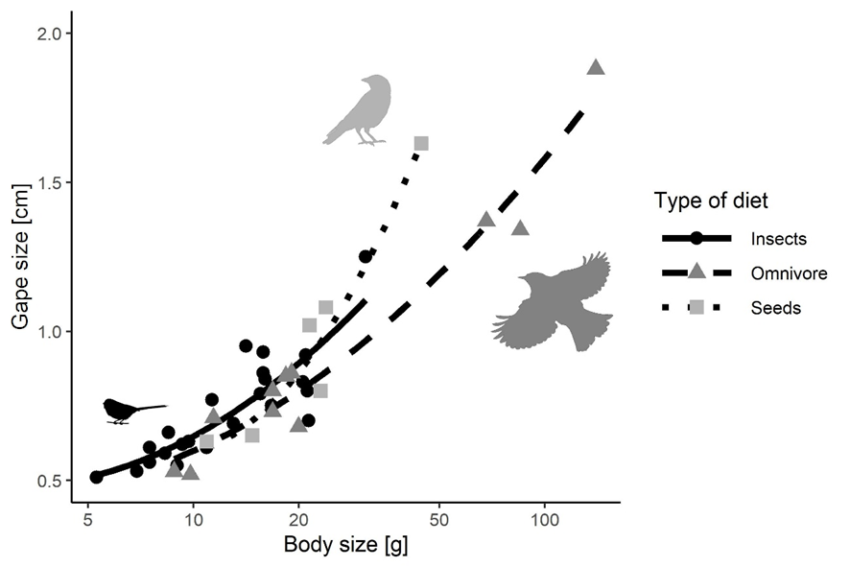

**Supplementary figure S1**. The relationship between body size and gape size of animals with different types of diet. The gape size of bird species and body size is based on Herrera (1984). Information about the diet of birds is based on the Elton database (Wilman et al. 2014). Note the log-scale for body size.

## Correlation of sub-individual CV and interindividual CV among plants

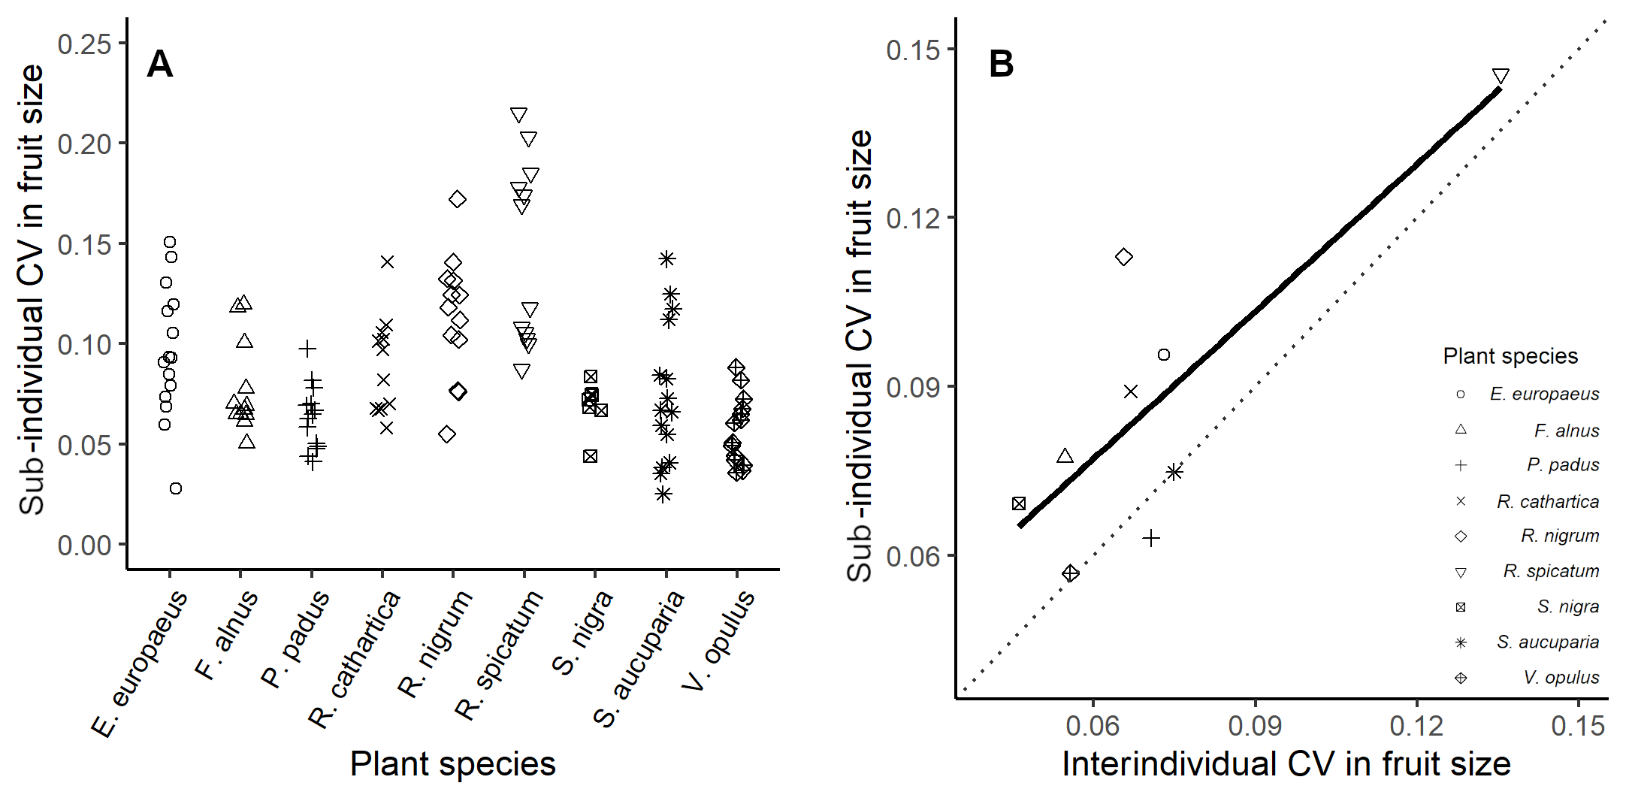

**Supplementary figure S2**. (A) Coefficient of variation (CV) in fruit size of individuals of different fleshy-fruited plant species. (B) Correlation between mean sub-individual CV and interindividual CV in fruit size (n = 9, Spearman’s ρ = 0.45, p = 0.230).

## Pecking of fruits

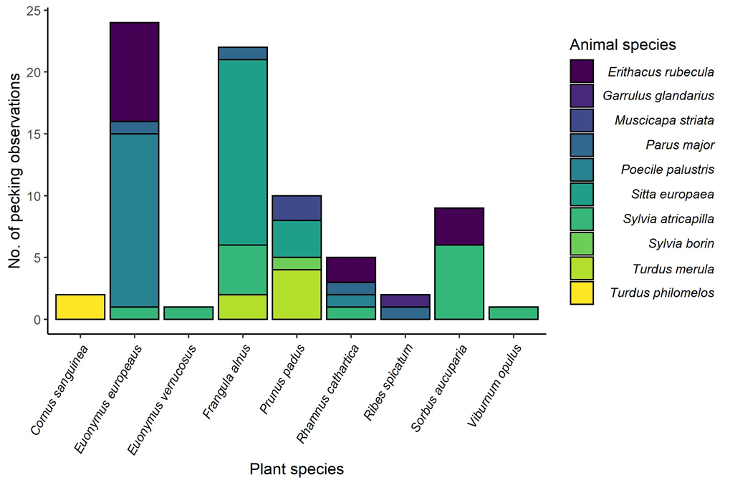

**Supplementary Figure S3.** Total number of pecking attempts of different disperser species on fruits of different plant species during fruit removal observations in Albrecht et al. (2013).

**References**

Albrecht, J., Berens, D. G., Blüthgen, N., Jaroszewicz, B., Selva, N., and Farwig, N. (2013). Logging and forest edges reduce redundancy in plant-frugivore networks in an old-growth European forest. *J. Ecol.* 101, 990–999. doi:10.1111/1365-2745.12105.

Albrecht, J., Hagge, J., Schabo, D. G., Schaefer, H. M., and Farwig, N. (2018). Reward regulation in plant–frugivore networks requires only weak cues. *Nat. Commun.* 9, 1–11. doi:10.1038/s41467-018-07362-z.

Herrera, C. M. (1984). Adaptation to frugivory of Mediterranean avian seed dispersers. *Ecology* 65, 609–617.

Jordano, P. (1984). Relaciones entre plantas y aves frugívoras en el matorral mediterráneo del área de Doñana. *Phd thesis*, University of Sevilla, Sevilla.

Wilman, H., Belmaker, J., Simpson, J., de la Rosa, C., Rivadeneira, M., & Jetz, W. (2014). EltonTraits 1.0: Species-level foraging attributes of the world’s birds and mammals. *Ecology*, *95*(7), 2027.