Supplementary Material

Supplementary Figures and Tables

Supplementary Figures

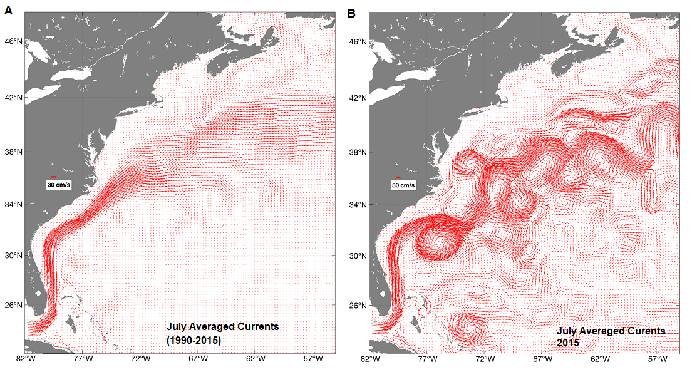
Supplementary Figure 1. Surface current velocity vectors for July from the BNAM Ocean Model. (A) Currents averaged from 1990 to 2015 (long-term average); (B) Currents averaged for July 2015 showing enhanced eddy formations (monthly-averaged currents within selected year).
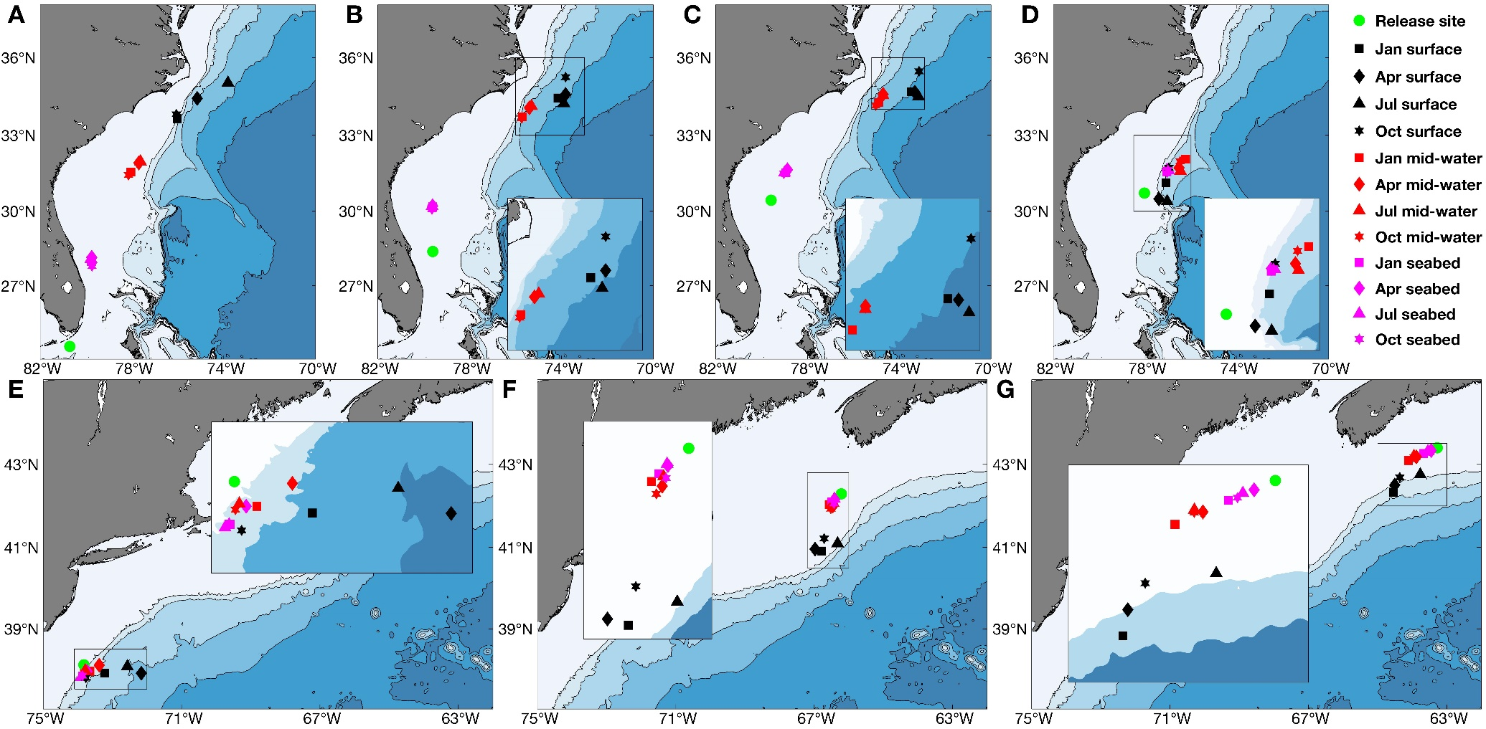
Supplementary Figure 2. Mean ending positions of particles released using monthly long-term averaged data (1990-2105) at each of three depths (seabed, mid-water and surface) in January, April, July or October in release sites from (A) Group 1, (B) Group 2, (C) Group 3, (D) Group 4, (E) Group 5, (F) Group 6 and (G) Group 7, modelled with k_{h}=250 m² s⁻¹. (For results from modeling with k_{h}=0, see Figure 3.) Filled green circles denote mean release position of particles in each Group.

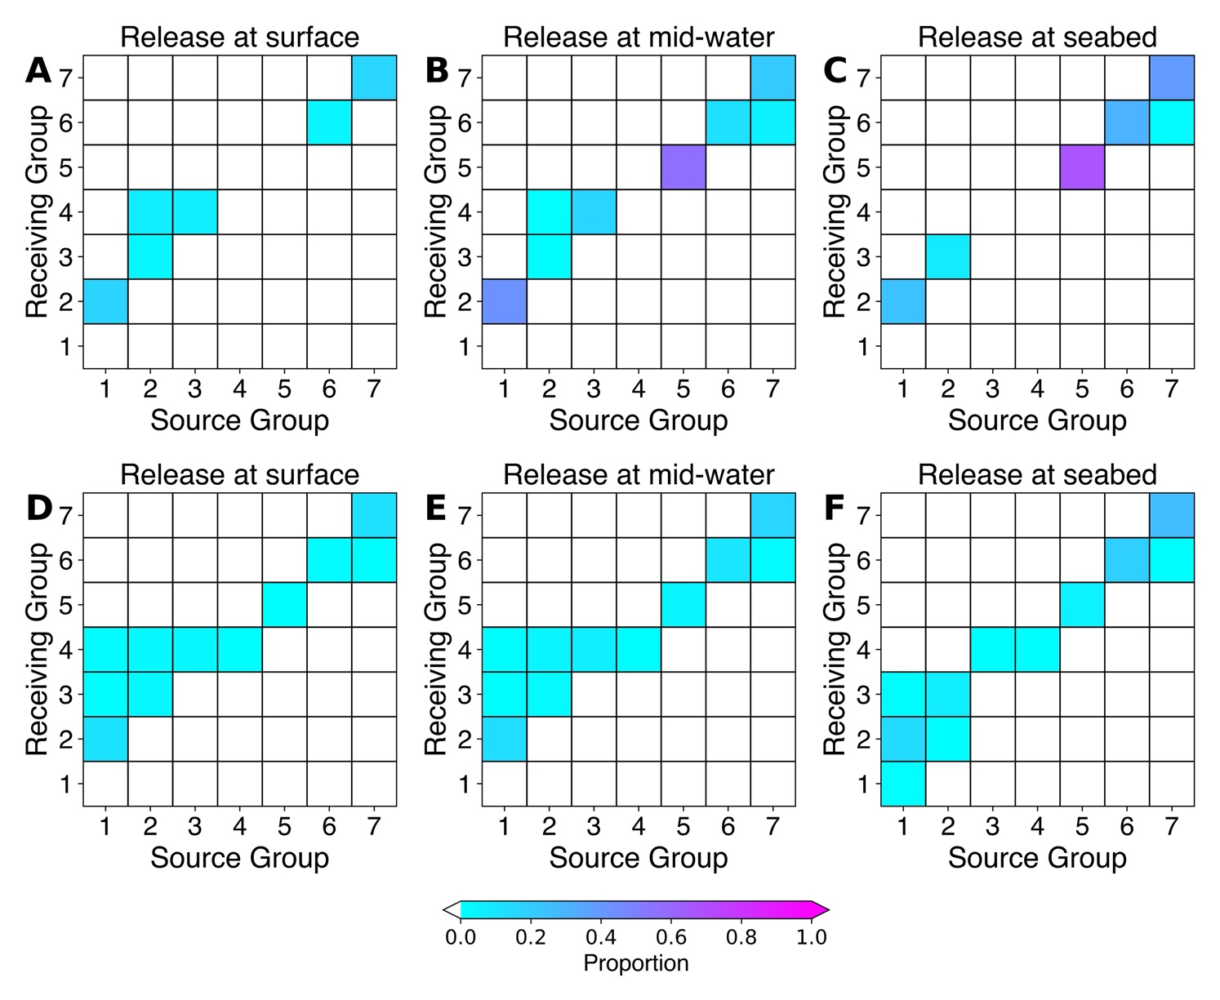
Supplementary Figure 3. Proportion of particles showing connections and retention in August by each of three release depths (surface, mid-water and seabed) after a 2-week drift duration using long-term averaged currents (1990-2015). Connectivity matrices show the proportion of modeled particles released from each of the occupied grid cells in each of the seven Groups (Source) passing over or terminating in another occupied grid cell in another Group (Receiving Area). Diagonal cells indicate particle retention within the occupied cells within each Group. A, B, C) Results with k_{h}=0; D, E, F) Results with k_{h}=250 m² s⁻¹.
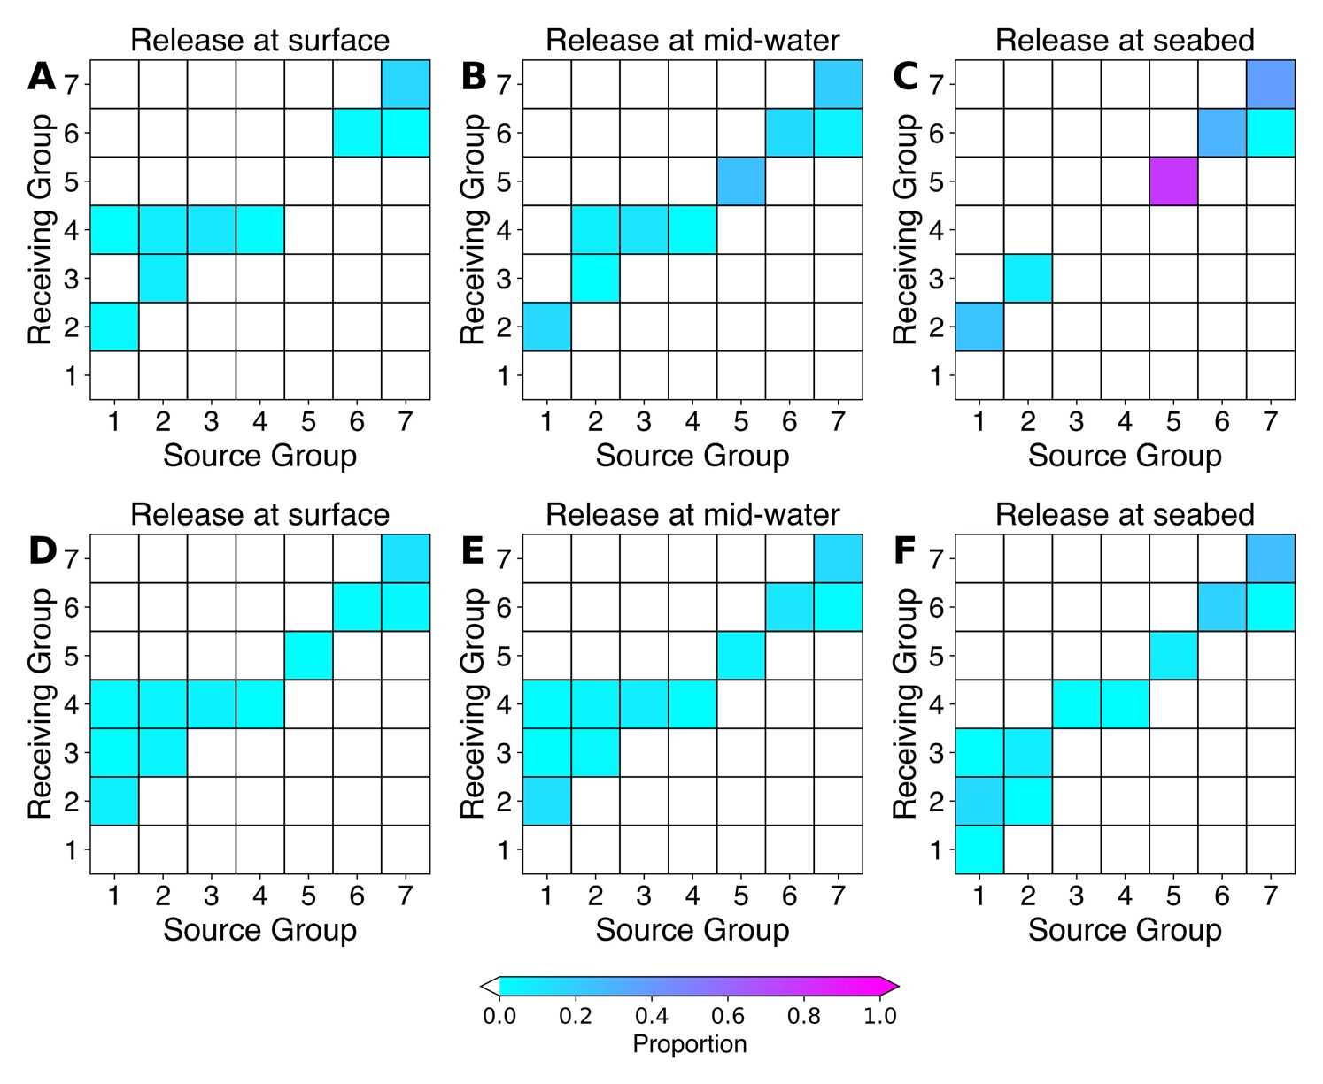
Supplementary Figure 4. Proportion of particles showing connections and retention over all months by each of three release depths (surface, mid-water and seabed) after a 2-week drift duration using long-term averaged currents (1990-2015). Connectivity matrices show the proportion of modeled particles released from each of the occupied grid cells in each of the seven Groups (Source) passing over or terminating in another occupied grid cell in another Group (Receiving Area). Diagonal cells indicate particle retention within the occupied cells within each Group. A, B, C) Results with k_{h}=0; D, E, F). Results with k_{h}=250 m² s⁻¹.

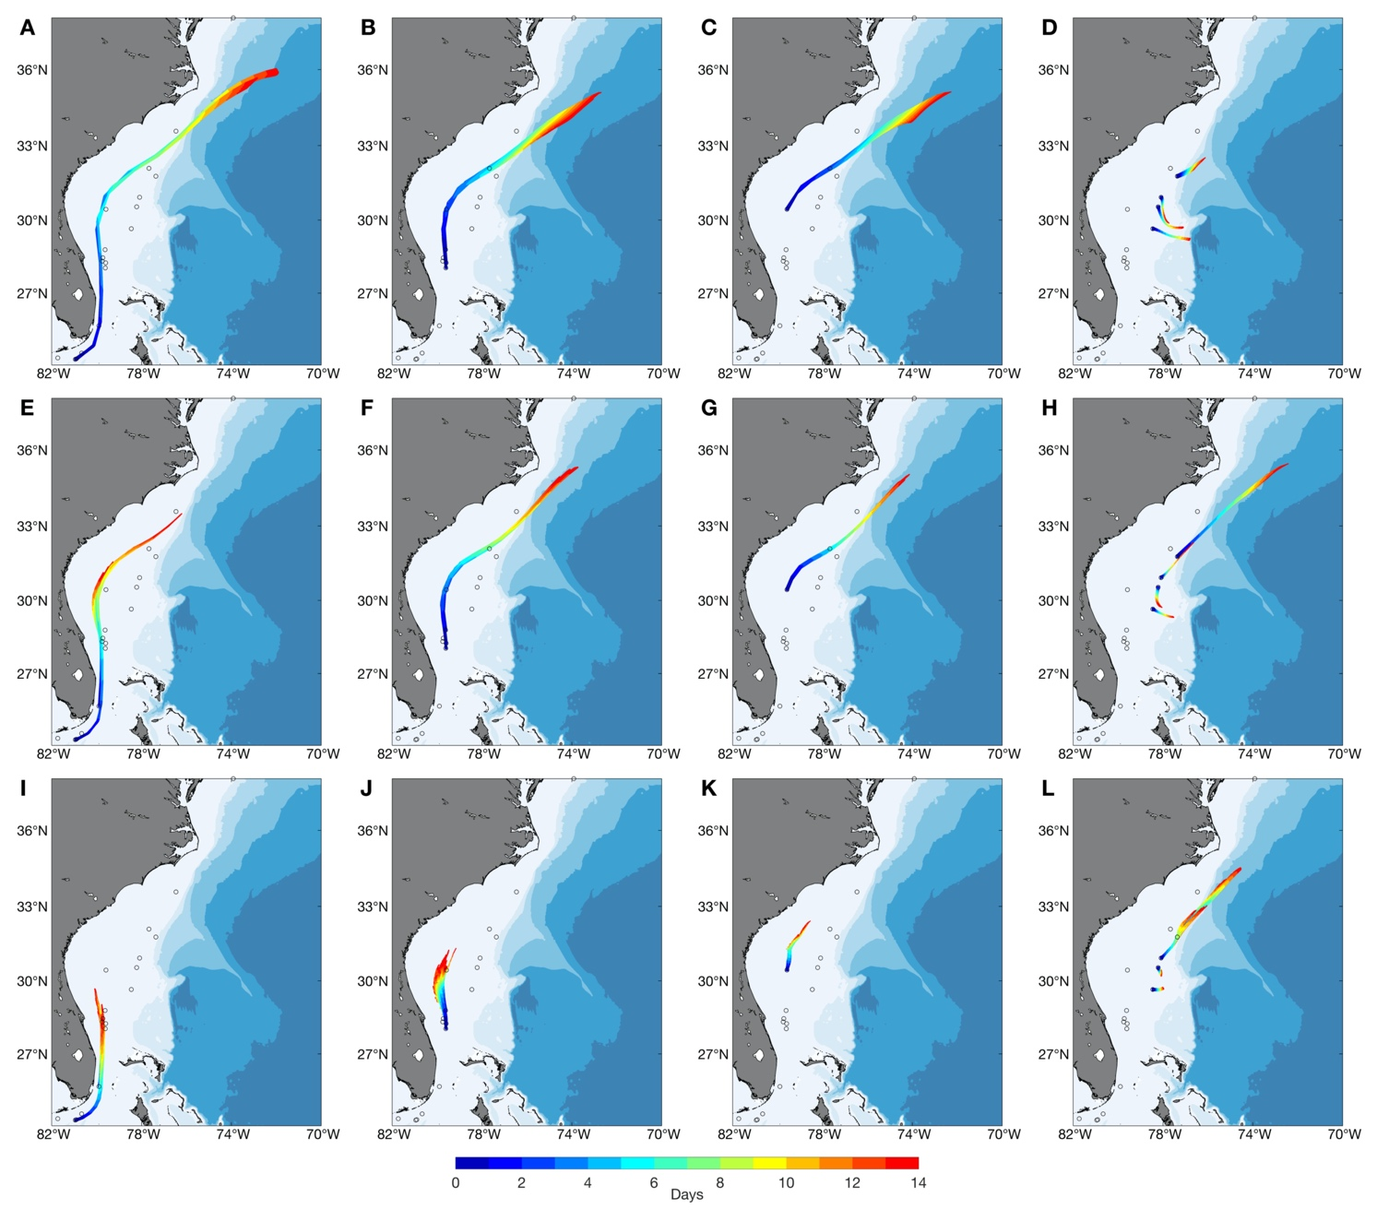
Supplementary Figure 5. Trajectories of particles released from occupied grid cells in Groups 1, 2, 3 and 4 (Groups 1 (A, E, I), 2 (B, F, J), 3 (C, G, K) and 4 (D, H, L)) at the surface (A-D), mid-water (E-H) and the seabed (I-L) in July, modelled using long-term averaged currents (1990-2015) with k_{h}=0. (Open circles indicate the locations of occurrence records. For results from modeling with k_{h}=250 m² s⁻¹, see Figure 5.)

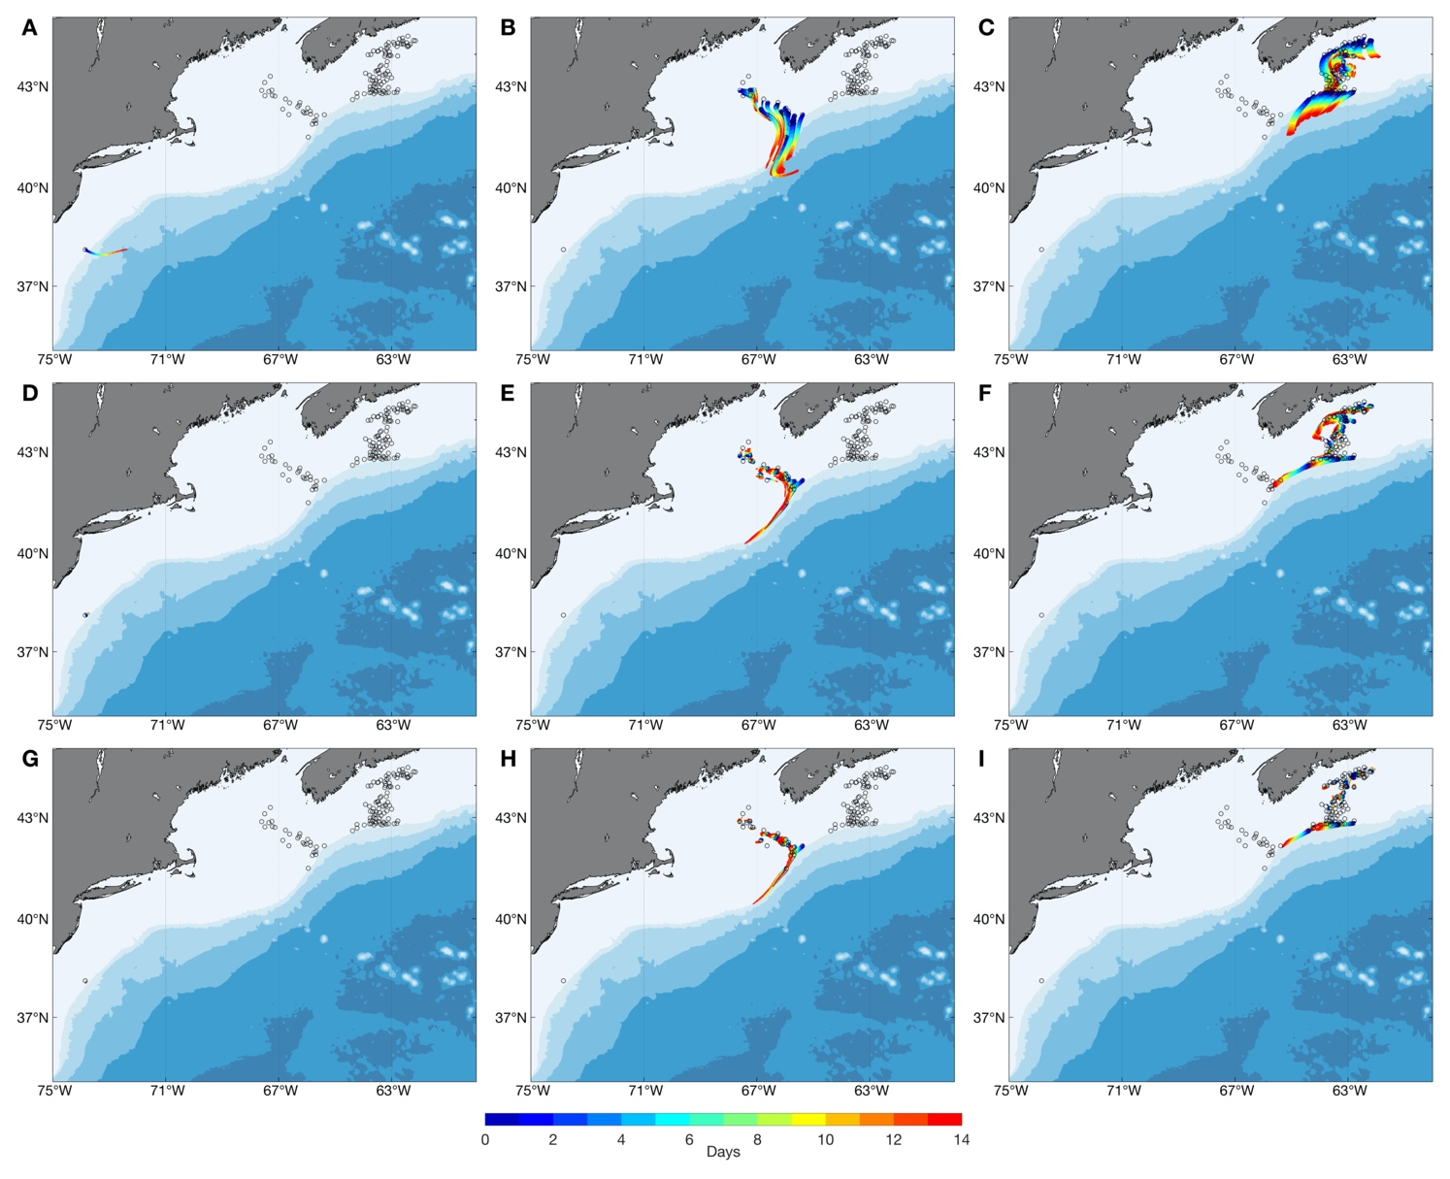
Supplementary Figure 6. Trajectories of particles released in Groups 5, 6 and 7 (Groups 5 (A, D, G), 6 (B, E, H), and 7 (C, F, I)) at the surface (A-C), mid-water (D-F) and the seabed (G-I) in July, modelled using long-term averaged currents (1990-2015) with k_{h}=0. (Open circles indicate the locations of occurrence records. For results from modeling with k_{h}=250 m² s⁻¹, see Figure 6.)
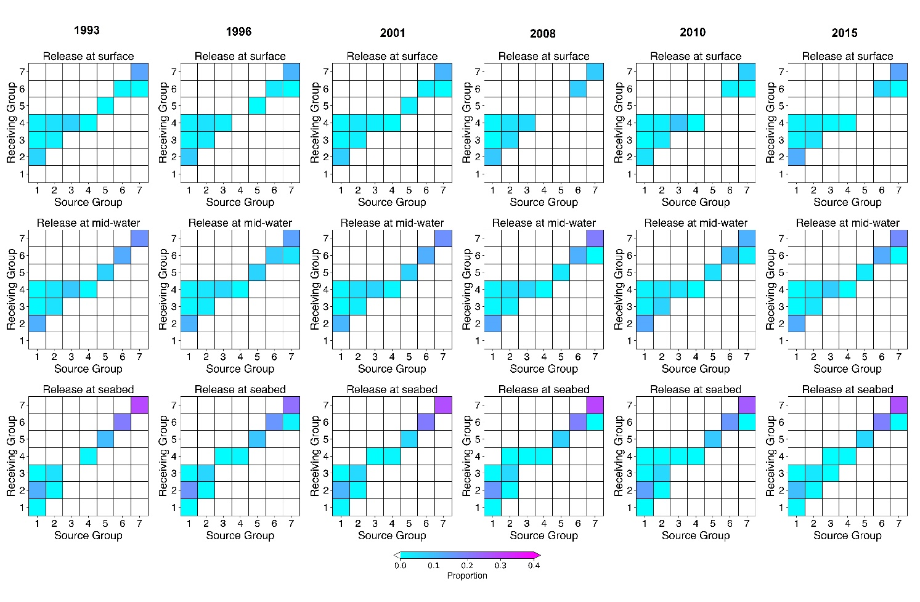
Supplementary Figure 7. Proportion of particles showing connections and retention for particles released in July of 1993, 1996, 2001, 2008, 2010 and 2015, by each of three release depths (surface, mid-water and seabed) after a 2-week drift duration. Connectivity matrices show the proportion of modeled particles released from each of the occupied grid cells in each of the seven Groups (Source) passing over or terminating in another occupied grid cell in another Group (Receiving Area). Diagonal cells indicate particle retention within the occupied cells within each Group. Results with k_{h}=250 m² s⁻¹.

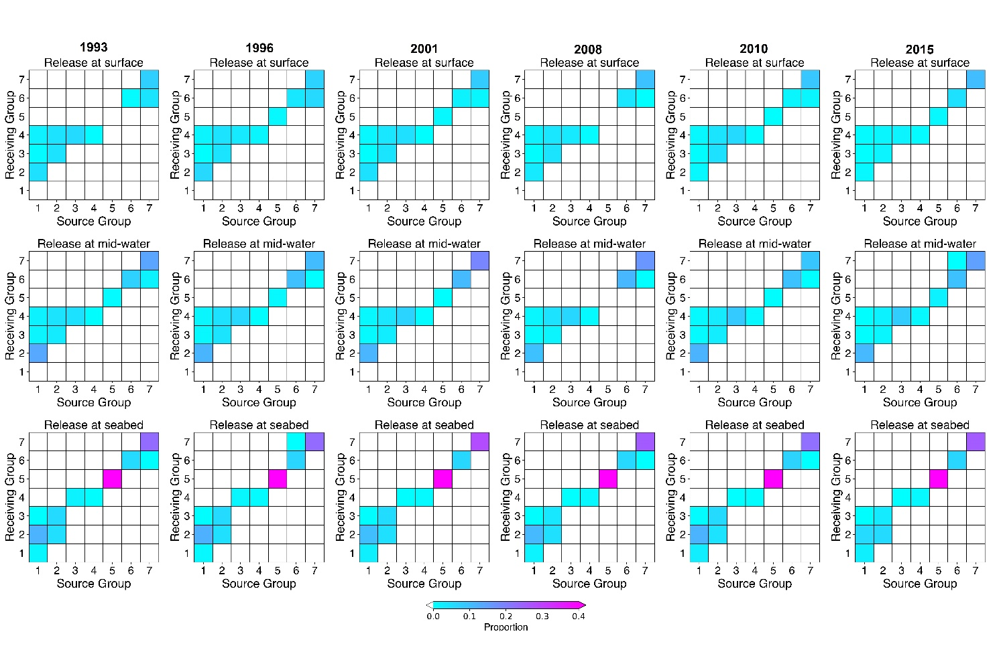
Supplementary Figure 8. Proportion of particles showing connections and retention for particles released in January of 1993, 1996, 2001, 2008, 2010 and 2015, by each of three release depths (surface, mid-water and seabed) after a 2-week drift duration. Connectivity matrices show the proportion of modeled particles released from each of the occupied grid cells in each of the seven Groups (Source) passing over or terminating in another occupied grid cell in another Group (Receiving Area). Diagonal cells indicate particle retention within the occupied cells within each Group. Results with k_{h}=250 m² s⁻¹.

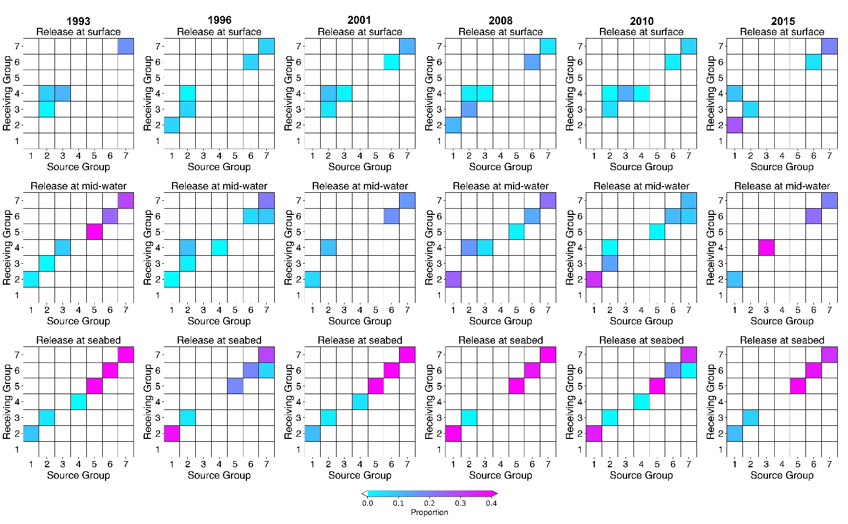
Supplementary Figure 9. Proportion of particles showing connections and retention for particles released in July of 1993, 1996, 2001, 2008, 2010 and 2015, by each of three release depths (surface, mid-water and seabed) after a 2-week drift duration. Connectivity matrices show the proportion of modeled particles released from each of the occupied grid cells in each of the seven Groups (Source) passing over or terminating in another occupied grid cell in another Group (Receiving Area). Diagonal cells indicate particle retention within the occupied cells within each Group. Results with k_{h}=0 m² s⁻¹.

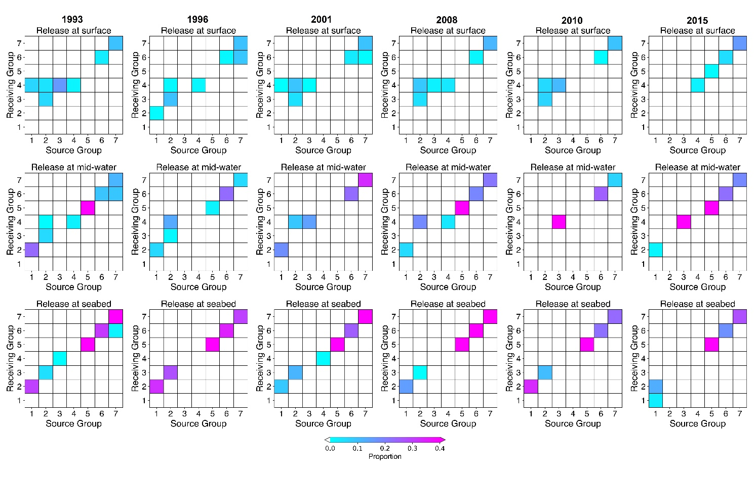

Supplementary Figure 10. Proportion of particles showing connections and retention for particles released in January of 1993, 1996, 2001, 2008, 2010 and 2015, by each of three release depths (surface, mid-water and seabed) after a 2-week drift duration. Connectivity matrices show the proportion of modeled particles released from each of the occupied grid cells in each of the seven Groups (Source) passing over or terminating in another occupied grid cell in another Group (Receiving Area). Diagonal cells indicate particle retention within the occupied cells within each Group. Results with k_{h}=0 m² s⁻¹.
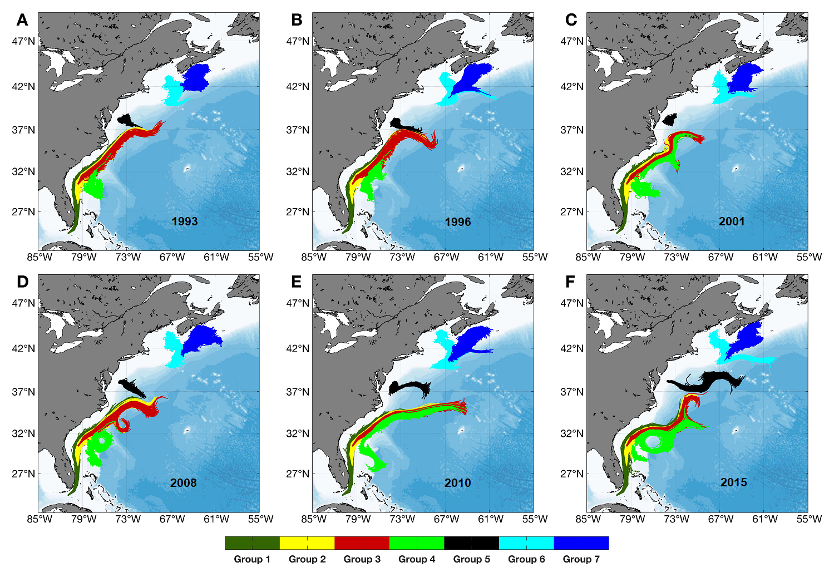
Supplementary Figure 11. Dispersal kernels after a 2-week drift duration from particle releases at the surface from each of the occupied grid cells in each of the seven Groups (Table 1) in July in each of six different years (1993, 1996, 2001, 2008, 2010 and 2015) and when k_{h}=250 m² s⁻¹.
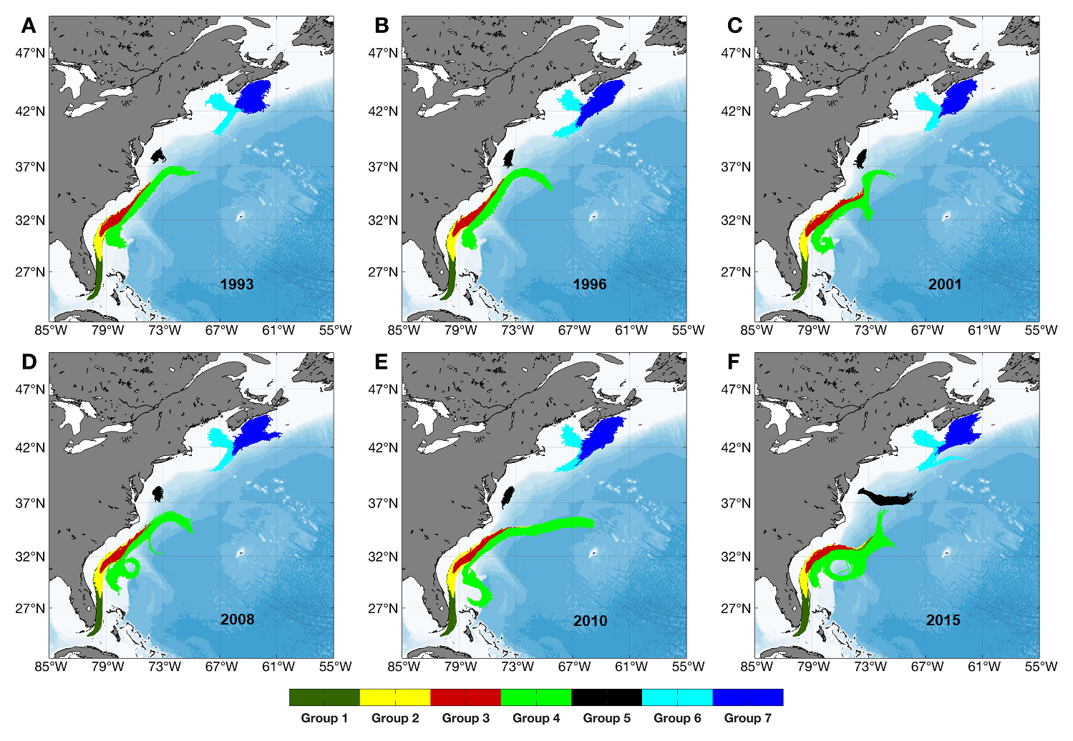
Supplementary Figure 12. Dispersal kernels after a 2-week drift duration from particle releases at mid-water depths from each of the occupied grid cells in each of the seven Groups (Table 1) in July in each of six different years (1993, 1996, 2001, 2008, 2010 and 2015) and when k_{h}=250 m² s⁻¹.
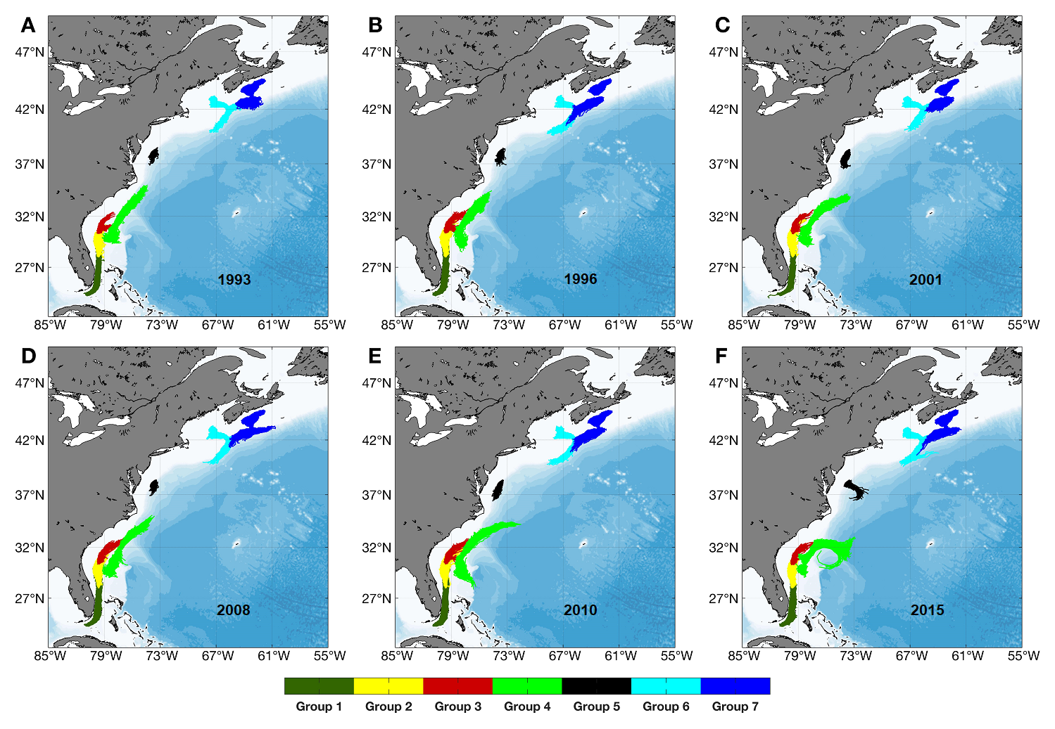
Supplementary Figure 13. Dispersal kernels after a 2-week drift duration from particle releases at the seabed from each of the occupied grid cells in each of the seven Groups (Table 1) in July in each of six different years (1993, 1996, 2001, 2008, 2010 and 2015) and when k_{h}=250 m² s⁻¹.
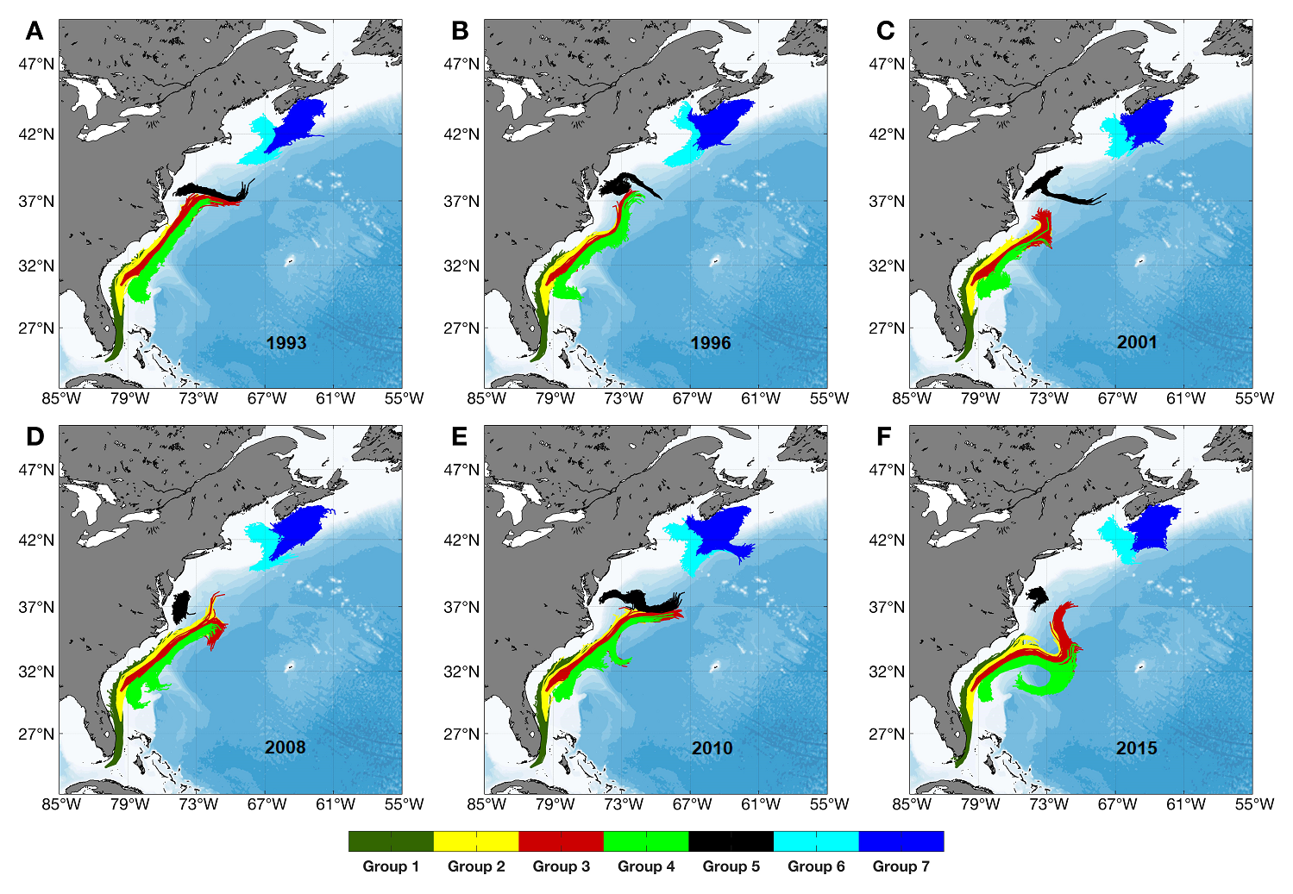
Supplementary Figure 14. Dispersal kernels after a 2-week drift duration from particle releases at the surface from each of the occupied grid cells in each of the seven Groups (Table 1) in January in each of six different years (1993, 1996, 2001, 2008, 2010 and 2015) and when k_{h}=250 m² s⁻¹.
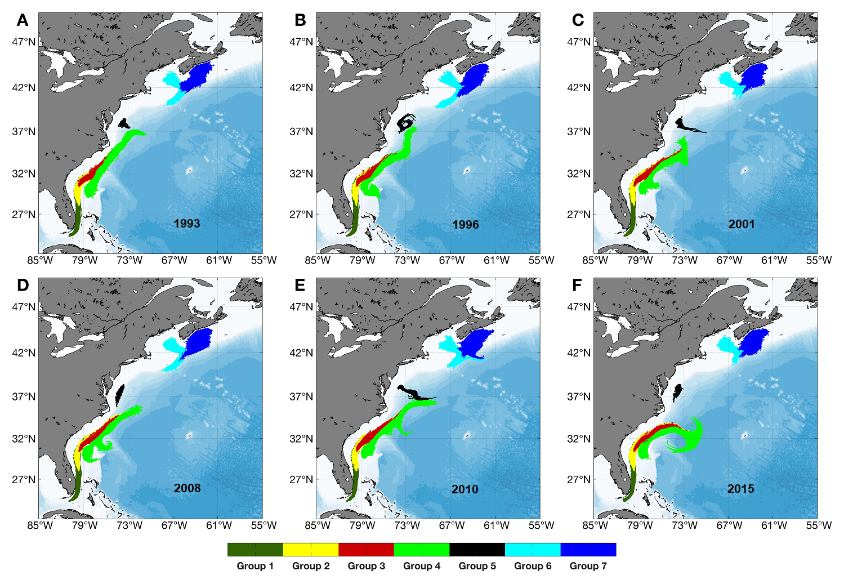
Supplementary Figure 15. Dispersal kernels after a 2-week drift duration from particle releases at mid-water depths from each of the occupied grid cells in each of the seven Groups (Table 1) in January in each of six different years (1993, 1996, 2001, 2008, 2010 and 2015) and when k_{h}=250 m² s⁻¹.
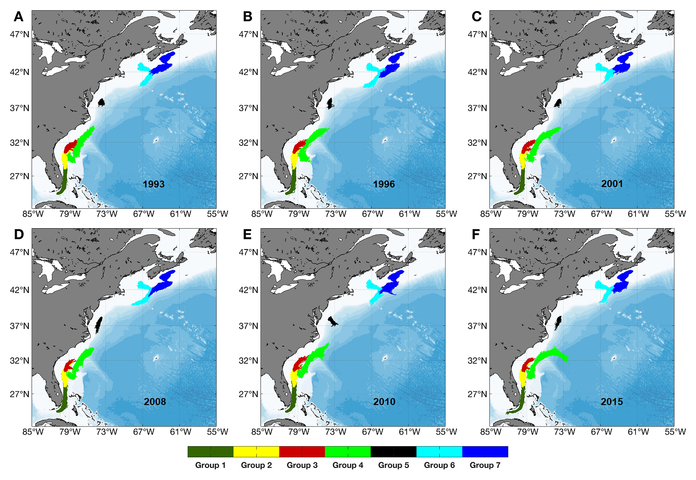
Supplementary Figure 16. Dispersal kernels after a 2-week drift duration from particle releases at the seabed from each of the occupied grid cells in each of the seven Groups (Table 1) in January in each of six different years (1993, 1996, 2001, 2008, 2010 and 2015) and when k_{h}=250 m² s⁻¹.
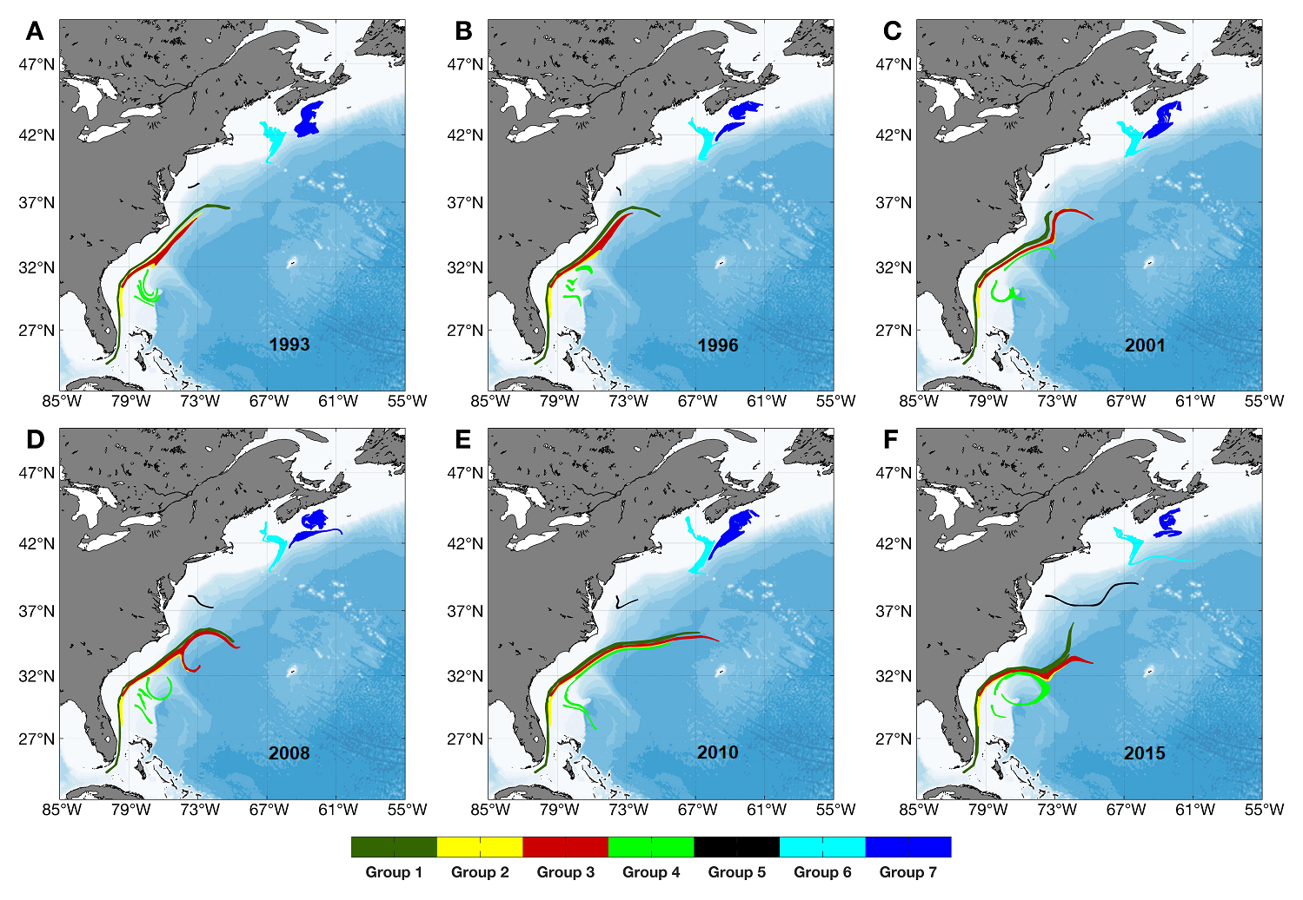
Supplementary Figure 17. Dispersal kernels after a 2-week drift duration from particle releases at the surface from each of the occupied grid cells in each of the seven Groups (Table 1) in July in each of six different years (1993, 1996, 2001, 2008, 2010 and 2015) and when k_{h}=0 m² s⁻¹.
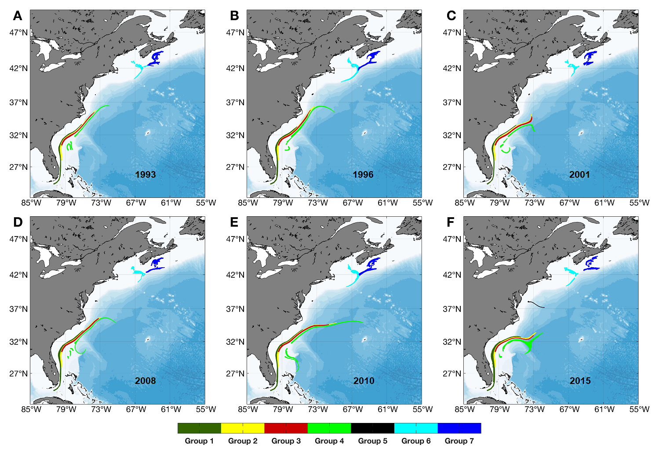
Supplementary Figure 18. Dispersal kernels after a 2-week drift duration from particle releases at mid-water depths from each of the occupied grid cells in each of the seven Groups (Table 1) in July in each of six different years (1993, 1996, 2001, 2008, 2010 and 2015) and when k_{h}=0 m² s⁻¹.
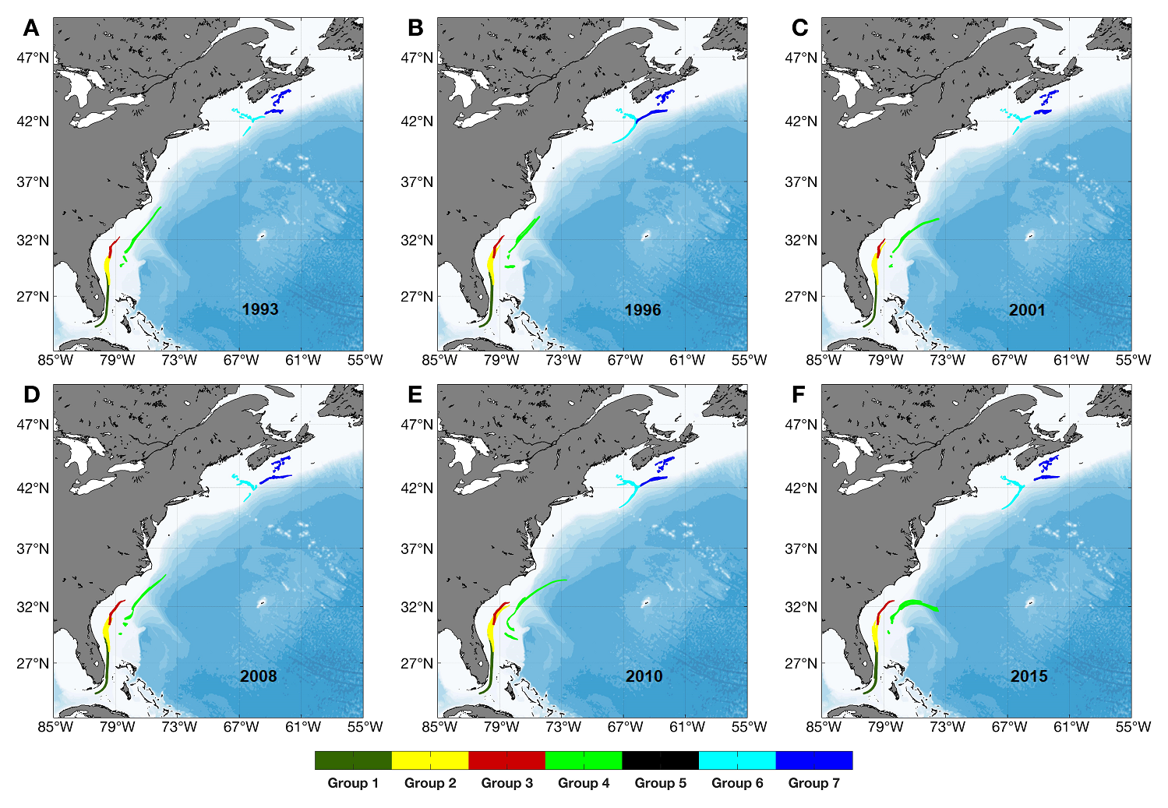
Supplementary Figure 19. Dispersal kernels after a 2-week drift duration from particle releases at the seabed from each of the occupied grid cells in each of the seven Groups (Table 1) in July in each of six different years (1993, 1996, 2001, 2008, 2010 and 2015) and when k_{h}=0 m² s⁻¹.
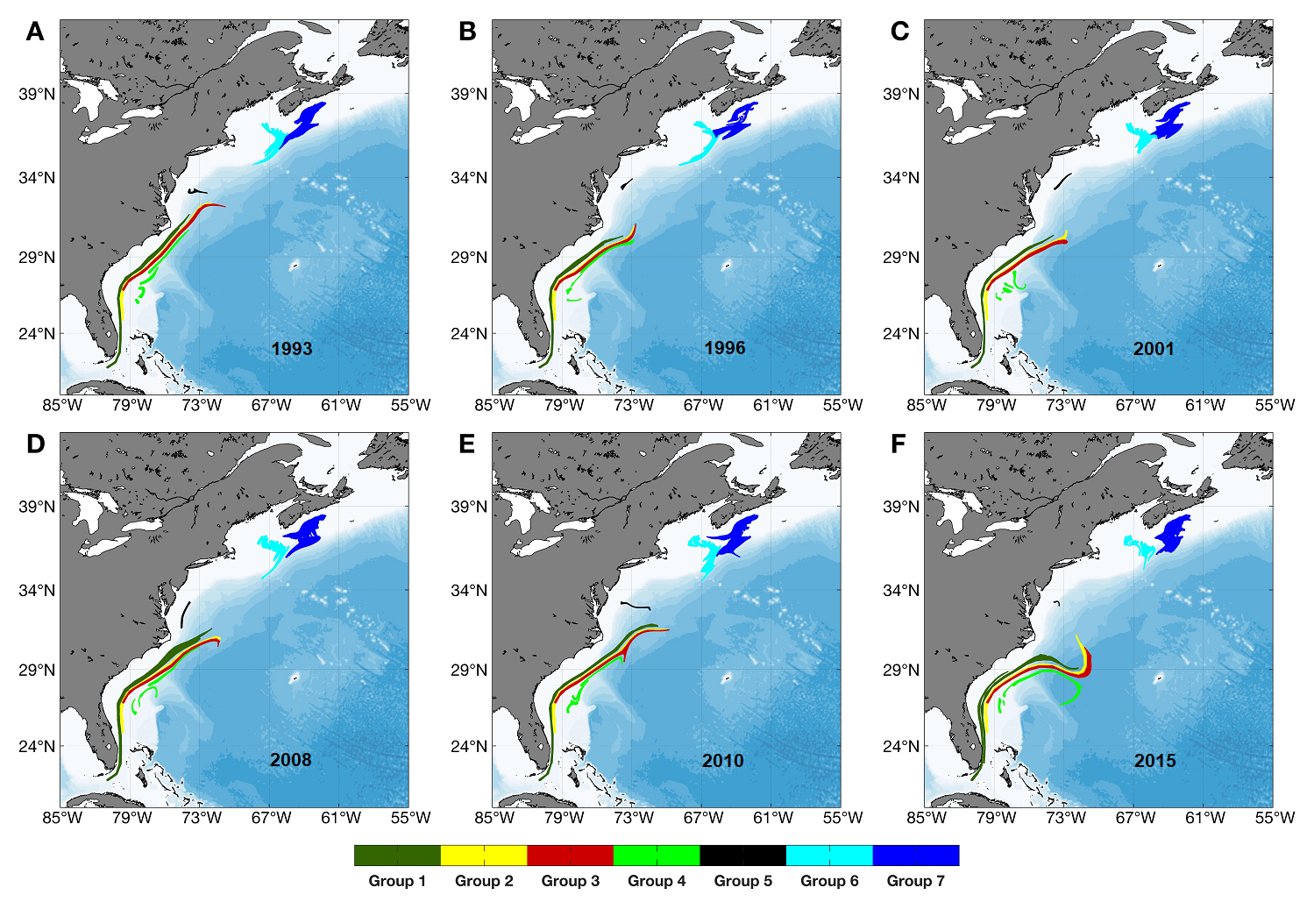
Supplementary Figure 20. Dispersal kernels after a 2-week drift duration from particle releases at the surface from each of the occupied grid cells in each of the seven Groups (Table 1) in January in each of six different years (1993, 1996, 2001, 2008, 2010 and 2015) and when k_{h}=0 m² s⁻¹.
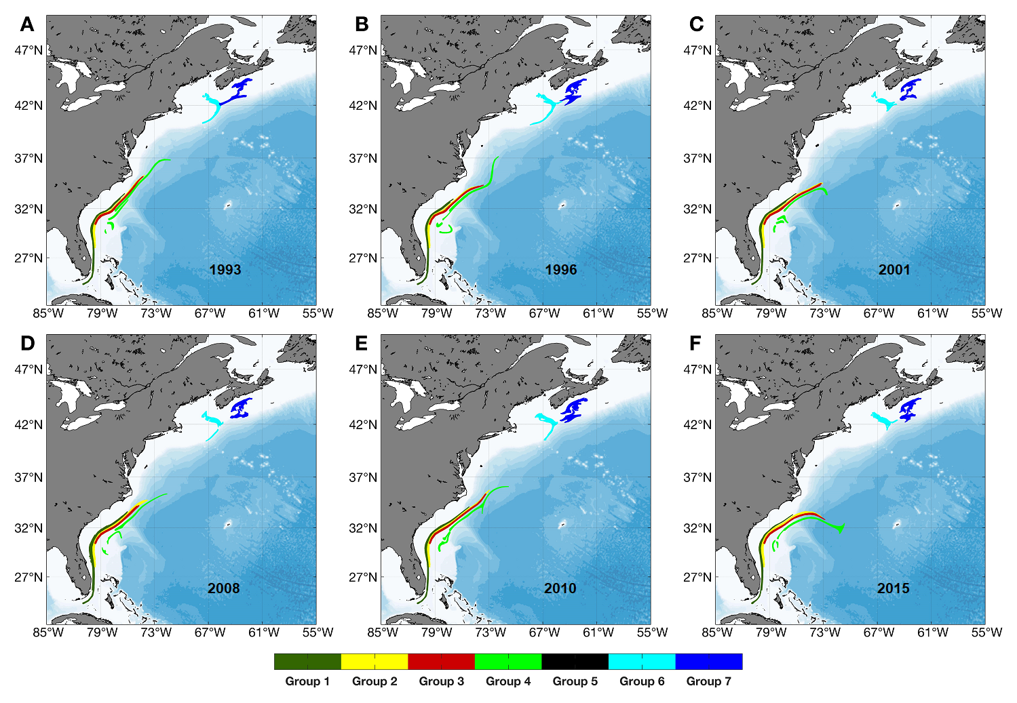
Supplementary Figure 21. Dispersal kernels after a 2-week drift duration from particle releases at mid-water depths from each of the occupied grid cells in each of the seven Groups (Table 1) in January in each of six different years (1993, 1996, 2001, 2008, 2010 and 2015) and when k_{h}=0 m² s⁻¹.
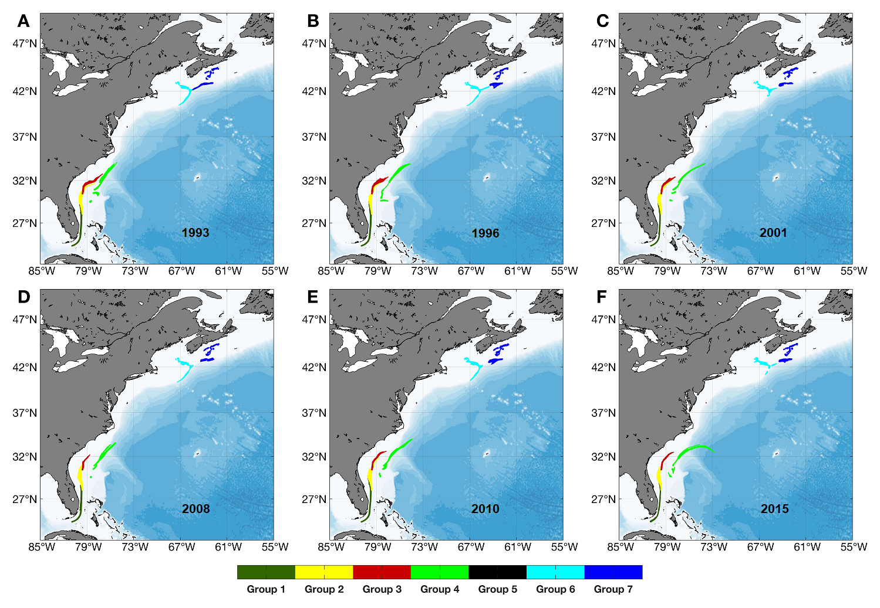
Supplementary Figure 22. Dispersal kernels after a 2-week drift duration from particle releases at the seabed from each of the occupied grid cells in each of the seven Groups (Table 1) in January in each of six different years (1993, 1996, 2001, 2008, 2010 and 2015) and when k_{h}=0 m² s⁻¹.
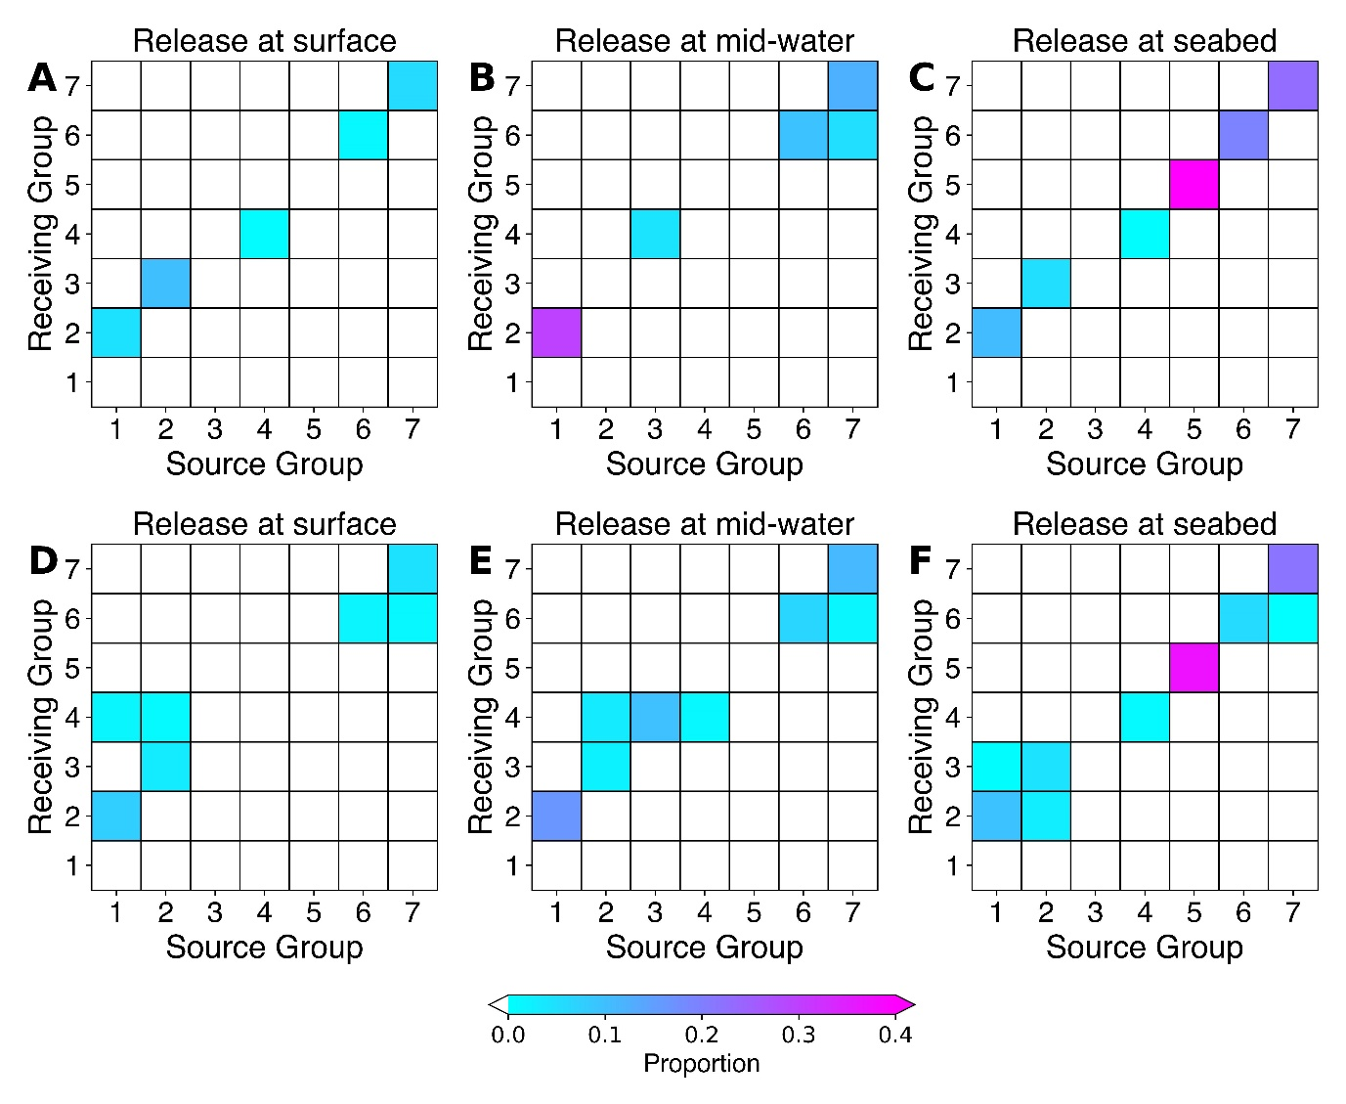
Supplementary Figure 23. Proportion of particles showing connections and retention for particles released in July, 2010 from particle releases at the surface (A, D), mid-depth (B, E) and the seabed (C, F) from each of the occupied grid cells in each of the seven Groups (Table 1) in July, 2010 produced using 5-day averaged products from the BNAM ocean model when k_{h}=0 m² s⁻¹ (top row) and when k_{h}=250 m² s⁻¹ (bottom row). Connectivity matrices show the proportion of modeled particles released from each of the occupied grid cells in each of the seven Groups (Source) passing over or terminating in another occupied grid cell in another Group (Receiving Area). Diagonal cells indicate particle retention within the occupied cells within each Group.
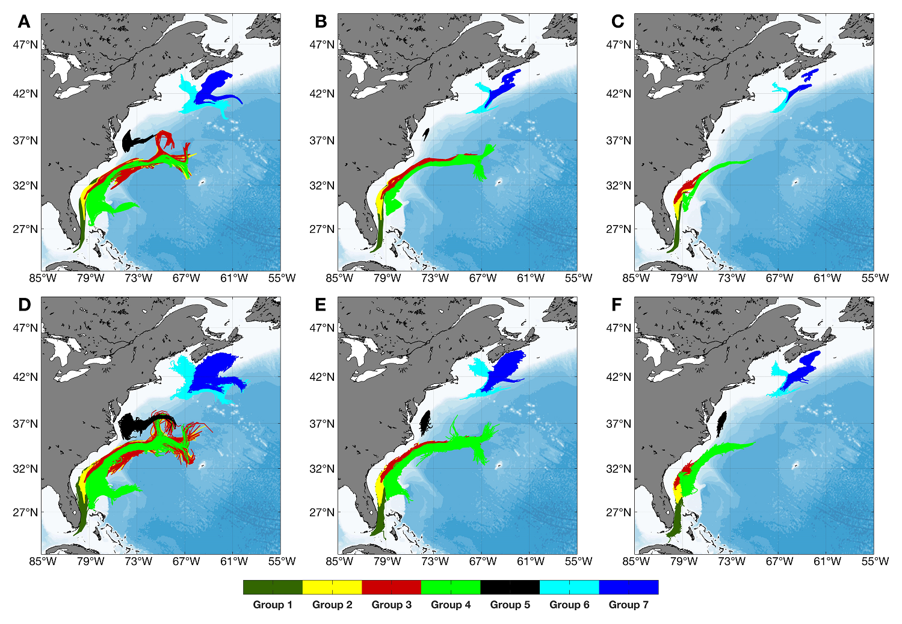 Supplementary Figure 24. Dispersal kernels after a 2-week drift duration from particle releases at the surface (A, D), mid-depth (B, E) and the seabed (C, F) from each of the occupied grid cells in each of the seven Groups (Table 1) in July, 2010 produced using 5-day averaged products from the BNAM ocean model when k_{h}=0 m² s⁻¹ (top row) and when k_{h}=250 m² s⁻¹ (bottom row).

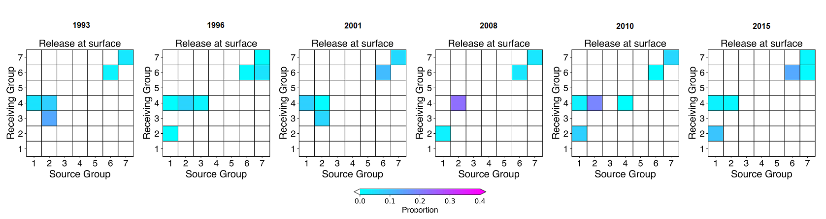Supplementary Figure 25. Proportion of particles showing connections and retention for particles released in July of 1993, 1996, 2001, 2008, 2010 and 2015, at the surface after a 2-week drift duration produced using daily-averaged products from the GLORYS12VI ocean model products. Connectivity matrices show the proportion of modeled particles released from each of the occupied grid cells in each of the seven Groups (Source) passing over or terminating in another occupied grid cell in another Group (Receiving Area). Diagonal cells indicate particle retention within the occupied cells within each Group. Results with k_{h}=0 m² s⁻¹.

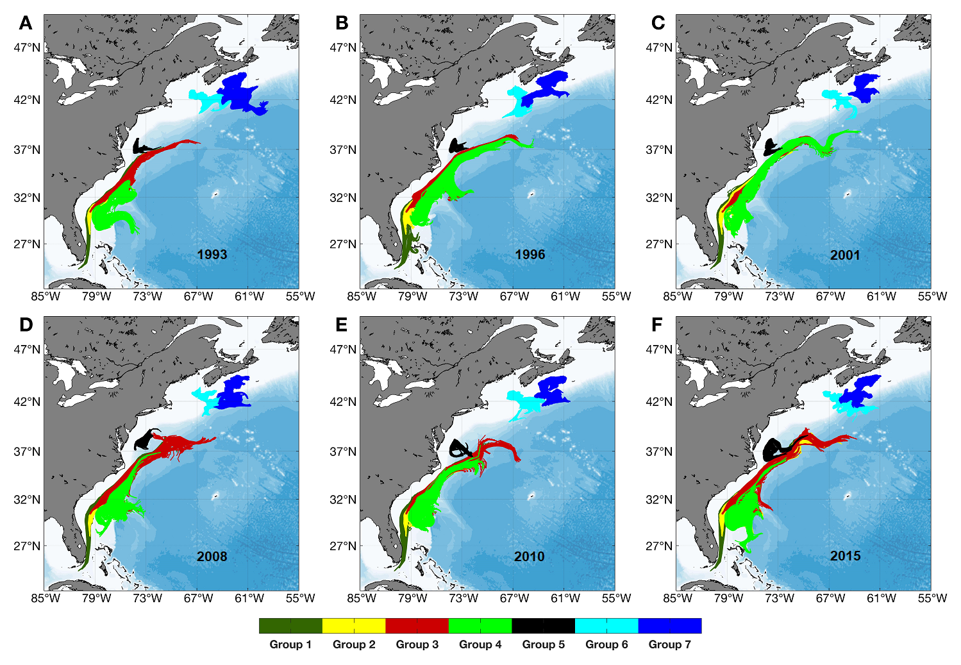
Supplementary Figure 26. Dispersal kernels after a 2-week drift duration from particle releases at the surface from each of the occupied grid cells in each of the seven Groups (Table 1) in July in each of six different years (1993, 1996, 2001, 2008, 2010 and 2015) using the GLORYS12VI ocean model products and when k_{h}=0 m² s⁻¹.

Supplementary Tables
Supplementary Table 1. Median, 95th percentile and maximum flow distances (km) of particles released at each of three depths, by Group, and alternative values of diffusivity using long-term averaged currents (1990-2015).
k_{h}=0
Positions | Group 1 | Group 2 | Group 3 | Group 4 | Group 5 | Group 6 | Group 7
Surface | 1591/1614/1623 | 955/1072/1111 | 767/847/873 | 150/163/168 | 123/129/131 | 170/204/209 | 93/135/145
Mid-water | 1147/1213/1246 | 942/961/972 | 694/724/729 | 85/572/617 | 12/13/13 | 19/125/185 | 72/117/123
Seabed | 488/541/602 | 231/291/310 | 133/219/248 | 106/392/402 | 0.4/3.8/5.2 | 16/82/156 | 19/66/95
k_{h}=250 m² s⁻¹
Positions | Group 1 | Group 2 | Group 3 | Group 4 | Group 5 | Group 6 | Group 7
Surface | 2014/2074/2135 | 1716/1871/1943 | 1632/1751/1810 | 1463/1487/1547 | 1465/1486/1501 | 1465/1488/1518 | 1454/1475/1516
Mid-water | 1712/1842/1907 | 1618/1653/1724 | 1561/1593/1640 | 1469/1564/1623 | 1341/1462/1492 | 1452/1452/1510 | 1443/1466/1513
Seabed | 1468/1546/1664 | 1397/1463/1530 | 1020/1422/1490 | 1441/1495/1548 | 1252/1452/1485 | 1305/1443/1512 | 1366/1440/1513

Supplementary Table 2. Median, 95th percentile and maximum flow distances (km) of particles released at each of three depths, by Group, and alternative values of diffusivity using monthly-mean ocean currents in July of individual years (1993, 1996, 2001, 2008, 2010, 2015).
k_{h}=0 (1993)
Positions | Group 1 | Group 2 | Group 3 | Group 4 | Group 5 | Group 6 | Group 7
Surface | 1743/1755/1756 | 859/1119/1184 | 620/775/858 | 272/323/334 | 86/91/91 | 157/210/225 | 105/168/191
Mid-water | 997/1075/1122 | 842/995/1001 | 702/748/779 | 128/711/781 | 3/7/8 | 17/56/159 | 58/100/104
Seabed | 426/476/509 | 197/254/282 | 106/166/234 | 53/420/431 | 0.4/1.5/1.7 | 8/55/100 | 12/27/36
k_{h}=250 m² s⁻¹ (1993)
Positions | Group 1 | Group 2 | Group 3 | Group 4 | Group 5 | Group 6 | Group 7
Surface | 2021/2123/2192 | 1676/1986/2079 | 1582/1871/1976 | 1478/1499/1532 | 1461/1484/1500 | 1465/1486/1538 | 1464/1485/1517
Mid-water | 1664/1804/1909 | 1600/1666/1733 | 1545/1611/1677 | 1465/1622/1720 | 1353/1463/1491 | 1435/1462/1516 | 1447/1469/1512
Seabed | 1456/1530/1604 | 1423/1457/1525 | 1064/1393/1492 | 1451/1504/1557 | 1249/1426/1496 | 1334/1438/1507 | 1367/1441/1514
k_{h}=0 (1996)
Positions | Group 1 | Group 2 | Group 3 | Group 4 | Group 5 | Group 6 | Group 7
Surface | 1707/1758/1773 | 922/1102/1171 | 725/872/940 | 140/184/198 | 67/73/75 | 177/223/234 | 72/114/148
Mid-water | 1136/1183/1215 | 969/1039/1067 | 698/735/804 | 336/893/962 | 26/26/27 | 45/218/308 | 75/148/174
Seabed | 527/616/646 | 251/304/318 | 113/218/253 | 93/318/326 | 7/11/11 | 25/175/242 | 42/122/152
k_{h}=250 m² s⁻¹ (1996)
Positions | Group 1 | Group 2 | Group 3 | Group 4 | Group 5 | Group 6 | Group 7
Surface | 2011/2132/2213 | 1700/2024/2122 | 1628/1941/2055 | 1462/1485/1596 | 1465/1493/1549 | 1467/1491/1596 | 1461/1482/1517
Mid-water | 1713/1811/1910 | 1624/1692/1760 | 1553/1615/1677 | 1477/1688/1777 | 1342/1463/1493 | 1439/1467/1523 | 1447/1470/1516
Seabed | 1471/1585/1660 | 1392/1492/1525 | 905/1411/1512 | 1455/1479/1525 | 1217/1457/1491 | 1310/1450/1521 | 1372/1445/1518
k_{h}=0 (2001)
Positions | Group 1 | Group 2 | Group 3 | Group 4 | Group 5 | Group 6 | Group 7
Surface | 1530/1586/1609 | 1243/1369/1391 | 1204/1266/1285 | 310/483/538 | 37/41/42 | 147/219/230 | 122/165/169
Mid-water | 875/1035/1089 | 965/1003/1022 | 789/800/803 | 89/557/571 | 19/20/21 | 32/80/94 | 36/68/79
Seabed | 389/433/469 | 228/275/349 | 114/187/206 | 58/415/426 | 0.5/4.8/6.3 | 7/48/83 | 11/31/59
k_{h}=250 m² s⁻¹ (2001)
Positions | Group 1 | Group 2 | Group 3 | Group 4 | Group 5 | Group 6 | Group 7
Surface | 1977/2048/2118 | 1801/1937/2004 | 1784/1871/1914 | 1485/1547/1733 | 1462/1480/1499 | 1467/1488/1532 | 1463/1483/1517
Mid-water | 1650/1812/1933 | 1644/1680/1753 | 1579/1619/1659 | 1469/1586/1710 | 1338/1465/1497 | 1431/1460/1517 | 1449/1469/1509
Seabed | 1439/1554/1631 | 1439/1554/1631 | 961/1392/1492 | 1464/1489/1539 | 1258/1453/1507 | 1326/1435/1507 | 1367/1470/1505
k_{h}=0 (2008)
Positions | Group 1 | Group 2 | Group 3 | Group 4 | Group 5 | Group 6 | Group 7
Surface | 1773/1797/1802 | 1067/1330/1365 | 1097/1189/1216 | 197/486/519 | 212/224/226 | 103/185/199 | 95/189/212
Mid-water | 1101/1219/1287 | 969/1032/1049 | 819/827/830 | 58/796/859 | 14/27/35 | 47/78/84 | 43/71/83
Seabed | 535/580/618 | 281/334/357 | 139/272/293 | 43/436/446 | 0.6/1.6/1.8 | 30/50/91 | 16/54/80
k_{h}=250 m² s⁻¹ (2008)
Positions | Group 1 | Group 2 | Group 3 | Group 4 | Group 5 | Group 6 | Group 7
Surface | 2084/2183/2249 | 1767/1984/2056 | 1743/1878/1976 | 1468/1543/1668 | 1471/1495/1513 | 1464/1486/1525 | 14621482/1515
Mid-water | 1727/1840/1952 | 1641/1707/1773 | 1584/1645/1685 | 1464/1629/1691 | 1398/1462/1494 | 1453/1453/1509 | 1455/1476/1518
Seabed | 1501/1576/1651 | 1396/1465/1535 | 879/1424/1561 | 1462/1489/1542 | 1234/1453/1485 | 1333/1437/1506 | 1360/1469/1505

k_{h}=0 (2010)
Positions | Group 1 | Group 2 | Group 3 | Group 4 | Group 5 | Group 6 | Group 7
Surface | 1927/1937/1940 | 1406/1545/1585 | 1408/1490/1525 | 347/792/855 | 161/244/262 | 255/295/318 | 150/230/246
Mid-water | 1166/1305/1322 | 1138/1258/1274 | 959/965/971 | 299/1190/1247 | 17/18/19 | 48/166/228 | 104/139/146
Seabed | 558/611/643 | 295/371/428 | 149/246/280 | 112/524/551 | 1/5/7 | 41/81/180 | 26/79/99
k_{h}=250 m² s⁻¹ (2010)
Positions | Group 1 | Group 2 | Group 3 | Group 4 | Group 5 | Group 6 | Group 7
Surface | 2115/2248/2337 | 1921/2156/2229 | 1916/2070/2112 | 1492/1685/1942 | 1477/1552/1590 | 1472/1495/1550 | 1464/1485/1548
Mid-water | 1726/1884/2002 | 1713/1830/1909 | 1649/1734/1797 | 1496/1806/1872 | 1365/1460/1491 | 1454/1454/1515 | 1444/1470/1523
Seabed | 1487/1565/1683 | 1404/1508/1577 | 968/1446/1548 | 1455/1506/1582 | 1211/1431/1494 | 1309/1446/1515 | 1368/1440/1511
k_{h}=0 (2015)
Positions | Group 1 | Group 2 | Group 3 | Group 4 | Group 5 | Group 6 | Group 7
Surface | 1595/1640/1702 | 1076/1184/1215 | 1007/1076/1095 | 656/656/825 | 773/800/810 | 116/299/620 | 86/129/147
Mid-water | 1173/1277/1302 | 974/1007/1018 | 739/742/746 | 589/651/666 | 167/251/271 | 38/61/185 | 62/106/111
Seabed | 384/544/631 | 197/257/274 | 179/274/304 | 251/368/377 | 5/11/14 | 25/45/200 | 26/63/68
k_{h}=250 m² s⁻¹ (2015)
Positions | Group 1 | Group 2 | Group 3 | Group 4 | Group 5 | Group 6 | Group 7
Surface | 2038/2163/2238 | 1767/1938/2079 | 1733/1850/1958 | 1600/1706/1896 | 1605/1690/1732 | 1464/1510/1643 | 1459/1482/1517
Mid-water | 1727/1876/1950 | 1622/1696/1771 | 1571/1622/1674 | 1565/1623/2000 | 1411/1513/1547 | 1437/1466/1551 | 1447/1471/1517
Seabed | 1460/1537/1614 | 1417/1451/1520 | 1181/1444/1509 | 1468/1511/1659 | 1231/1460/1493 | 1338/1446/1517 | 1373/1443/1512

