Statistical Analyses Details

Table of Contents

Table A.1 Model formulae 3

Egg hatchability (proportion) GLM - Fig. 2a 4

Hypothesis testing - Analysis of deviance table 4

Proportion of larvae dead - GLMM - Fig. 2b 5

Hypothesis testing - Analysis of deviance table 5

Interaction plots 6

Proportion of adults dead GLMM - Fig. 2c 7

Hypothesis testing - Analysis of deviance table 7

Interaction plots 8

Proportion of dead ‘Tomato’ mites GLM - Fig. 2d 9

Hypothesis testing - Analysis of deviance test 9

Interaction plot 9

Egg hatchability positive control (proportion) GLM - Fig. 2e 10

Hypothesis testing - Analysis of deviance table 10

Proportion of larvae dead positive control GLM - Fig. 2f 10

Hypothesis testing - Analysis of deviance table 10

Proportion of adults dead positive control GLM - Fig. 2g 11

Hypothesis testing - Analysis of deviance table 11

Proportion of dead larvae, Component testing Experiment 1 GLM - Fig. 3a 11

Hypothesis testing - Analysis of deviance table 11

Proportion of dead larvae, Component testing Experiment 2 GLM - Fig. 3b 12

Hypothesis testing - Analysis of deviance table 12

Proportion of developmental stages Experiment 1 GLM - Fig. 3c 12

Hypothesis testing - Analysis of deviance table 12

Interaction plot 13

Hypothesis testing - Analysis of deviance table: Larvae Molting 13

Hypothesis testing - Analysis of deviance table: Protonymph 14

Interaction plot 14

Proportion of developmental stages Experiment 2 GLM - Fig. 3d 15

Hypothesis testing - Analysis of deviance table: Larvae 15

Hypothesis testing - Analysis of deviance table: Larvae Molting 15

Hypothesis testing - Analysis of deviance table: Protonymph 16

Proportion of dead adults - GLM - Fig. 3e 16

Hypothesis testing - Analysis of deviance table 16

Proportion of deterred adults - GLM - Fig. 3f 17

Hypothesis testing - Analysis of deviance table 17

Interaction plot 17

Proportion of dead mites, Residual exposure GLM - Fig. 4a 18

Hypothesis testing - Analysis of deviance table 18

Proportion of developmental stages, Residual Exposure GLM - Fig. 4b 18

Hypothesis testing - Analysis of deviance table: Larvae 18

Hypothesis testing - Analysis of deviance table: Larvae molting 19

Hypothesis testing - Analysis of deviance table: Protonymph 19

Proportion of dead mites, Contact Exposure GLM - Fig. 4c 20

Hypothesis testing - Analysis of deviance table 20

Fecundity, tomato priming - Linear model - Fig. 5c 20

Hypothesis testing - Analysis of variance (ANOVA) table 20

Session Info 21

# Table A.1 Model formulae

|  |  |  |  |  |  |
| --- | --- | --- | --- | --- | --- |
| **Figure ref. /Analysis** | **Model type** | **Fixed Factors** | **Included Interactions (Fixed)** | **Random Factors** | **Link function** |
| Fig. 2a Egg hatchability | GLM | Trial  Treatment | Trial: Treatment | NA | Logit |
| Fig. 2b Larvae mortality | GLMM | Trial  Treatment  Time Point | Trial: Treatment  Trial: Time Point  Treatment: Time Point | Sample ID | Logit |
| Fig. 2c Adult mortality | GLMM | Trial  Treatment  Time Point | Trial: Treatment  Trial: Time Point  Treatment: Time Point | Sample ID | Logit |
| Fig. 2d Adult ‘Tomato’ mite mortality | GLM | Trial  Treatment | Trial: Treatment | NA | Logit |
| Fig. 2e Egg hatchability positive control | GLM | Trial  Treatment | Trial: Treatment | NA | Logit |
| Fig. 2f Larvae mortality positive control | GLM | Trial  Treatment | Trial: Treatment | NA | Logit |
| Fig. 2g Adult mortality positive control | GLM | Trial  Treatment | Trial: Treatment | NA | Logit |
| Fig. 3a Larvae mortality, Component testing, Exp. 1 | GLM | Trial  Treatment | Trial: Treatment | NA | Logit |
| Fig. 3b Larvae mortality, Component testing, Exp. 2 | GLM | Trial  Treatment | Trial: Treatment | NA | Logit |
| Fig. 3c Developmental stages, Component testing, Exp. 1 | GLM | Trial  Treatment | None | NA | Logit |
| Fig. 3d Developmental stages, Component testing, Exp. 2 | GLM | Trial  Treatment | None | NA | Logit |
| Fig. 3e Adult mortality, Component testing | GLM | Trial  Treatment | Trial: Treatment | NA | Logit |
| Fig. 3f Adult deterrence, Component testing | GLM | Trial  Treatment | Trial: Treatment | NA | Logit |
| Fig. 4a Larvae mortality, Residual exposure | GLM | Trial  Treatment | Trial: Treatment | NA | Logit |
| Fig. 4b Developmental stages, Residual exposure | GLM | Trial  Treatment | None | NA | Logit |
| Fig. 4c Larvae mortality, Contact exposure | GLM | Trial  Treatment | Trial: Treatment | NA | Logit |
| Fig. 5a Fecundity, Priming Exp. | LM | Trial  Treatment | Trial: Treatment | NA | Identity |

# Egg hatchability (proportion) GLM - Fig. 2a

## Hypothesis testing - Analysis of deviance table

Analysis of deviance table using F tests due to quasibinomial distribution   
Anova(model.qb, type="II", test="F")

Analysis of Deviance Table (Type II tests)  
  
Response: (Hatched.Count/Total.Count)  
Error estimate based on Pearson residuals   
  
 Sum Sq Df F value Pr(>F)   
Trial 57.954 2 26.1318 1.948e-09 ***  
Treatment 12.684 2 5.7192 0.00479 **   
Trial:Treatment 3.874 4 0.8734 0.48380   
Residuals 87.602 79   
---  
Signif. codes: 0 '***' 0.001 '**' 0.01 '*' 0.05 '.' 0.1 ' ' 1

The interaction term speaks to reproducibility of the pattern between Treatments across Trial and is not significant. Therefore, it was a reproducible experiment.

Main effect of Trial is significant, but not of interest (magnitude differences in the response variable between trials can be expected).

Main effect of Treatment is significant and of interest. Post-hoc tests to follow.

# Proportion of larvae dead - GLMM - Fig. 2b

## Hypothesis testing - Analysis of deviance table

Analysis of deviance table using chi-squared tests due to binomial distribution   
Anova(model.b, type="II", test="Chisq")

Analysis of Deviance Table (Type II Wald chisquare tests)  
  
Response: (Dead.Count/Total.Count)  
 Chisq Df Pr(>Chisq)   
Trial 23.582 2 7.574e-06 ***  
Treatment 234.922 2 < 2.2e-16 ***  
Time.Point 109.625 2 < 2.2e-16 ***  
Trial:Treatment 17.801 4 0.001350 **   
Trial:Time.Point 14.209 4 0.006656 **   
Treatment:Time.Point 13.911 4 0 .007586 **   
---  
Signif. codes: 0 '***' 0.001 '**' 0.01 '*' 0.05 '.' 0.1 ' ' 1

The interaction terms including Trial speak to reproducibility of pattern between Treatments and Time.Points across Trial.

The Trial:Treatment interaction is significant, evidence is fairly strong (low p value), look at interaction plot.

The Trial:Time.Point interaction is significant, evidence is fairly strong (low p value), look at interaction plot.

Main effect of Treatment:Time.Point is significant and of interest. Post-hoc tests to follow after interrogation of interaction plot.

Main effect of Trial is significant, but not of interest (magnitude differences in the response variable between trials is expected).

Main effect of Treatment and Time.Point are significant and of interest.

## Interaction plots

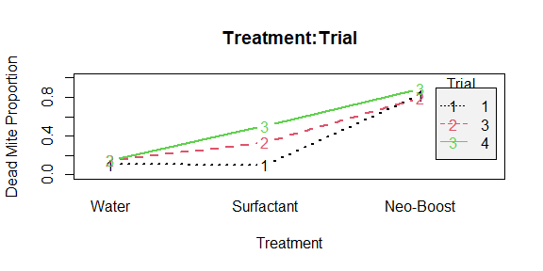

The Trial:Treatment interaction is significant, but the same pattern is observed across Trial with the exception that the detergent had higher proportion of dead mites in 2/3 trials.

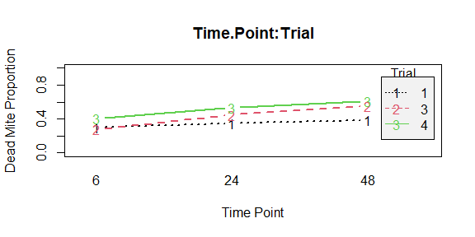

The Trial:Timepoint interaction is significant, but the same pattern is observed across Trial.

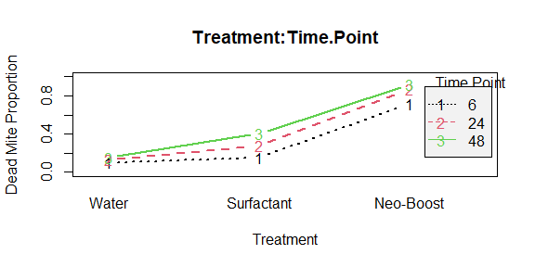

Treatment:Time.Point interaction is significant, pattern of increasing dead mites is reproducible across Time.Point, but the proportion is greater as time proceeds.

# Proportion of adults dead GLMM - Fig. 2c

## Hypothesis testing - Analysis of deviance table

Analysis of deviance table using chi-squared tests due to binomial distribution   
Anova(model.b, type="II", test="Chisq")

Analysis of Deviance Table (Type II Wald chisquare tests)  
  
Response: (Dead.Count/Total.Count)  
 Chisq Df Pr(>Chisq)   
Trial 25.5302 2 2.859e-06 ***  
Treatment 129.2556 2 < 2.2e-16 ***  
Time.Point 196.2164 2 < 2.2e-16 ***  
Trial:Treatment 15.5575 4 0.003674 **   
Trial:Time.Point 4.8325 4 0.304925   
Treatment:Time.Point 13.6829 4 0.008379 **   
---  
Signif. codes: 0 '***' 0.001 '**' 0.01 '*' 0.05 '.' 0.1 ' ' 1

The interaction terms including Trial speak to reproducibility of pattern between Treatments and Time.Points across Trial.

The Trial:Treatment interaction is significant, evidence is fairly strong (low p value), look at interaction plot.

The Trial:Time.Point interaction is not significant. Evidence for reproducibility with respect to Time.Point across Trial.

Main effect of Treatment:Time.Point is significant and of interest. Post-hoc tests to follow after interrogation of interaction plot.

Main effect of Trial is significant, but not of interest (magnitude differences in the response variable between trials is expected).

Main effect of Treatment and Time.Point are significant and of interest.

## Interaction plots

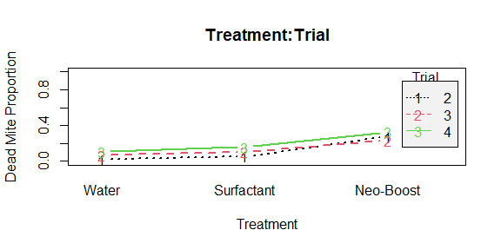

The Trial:Treatment interaction is significant, but the same pattern is observed across Trial.

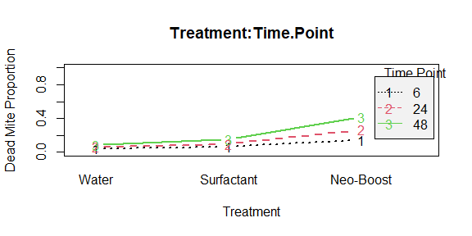

The Treatment:Time.Point interaction is significant, pattern of increasing dead mites is reproducible across Time.Point, but the proportion is greater as time proceeds.

# Proportion of dead ‘Tomato’ mites GLM - Fig. 2d

## Hypothesis testing - Analysis of deviance test

Analysis of deviance table using Wald/ChiSq tests due to binomial distribution  
Anova(model.b, type="II", test="Wald")

Analysis of Deviance Table (Type II tests)  
  
Response: (Dead.Count/Total.Count)  
 Df Chisq Pr(>Chisq)   
Trial 2 8.7273 0.012732 *   
Treatment 2 92.5843 < 2.2e-16 ***  
Trial:Treatment 4 22.0379 0.000197 ***  
---  
Signif. codes: 0 '***' 0.001 '**' 0.01 '*' 0.05 '.' 0.1 ' ' 1

The interaction term speaks to reproducibility of pattern between Treatments across Trial. The interaction is significant with a very low P value (strong evidence for the interaction being real), so we must check interaction plot and see if there is a problem with reproducibility.

Main effect of Trial is significant, but not of interest (magnitude differences in the response variable between trials is expected).

Main effect of Treatment is significant and of interest. Post-hoc tests to follow.

## Interaction plot

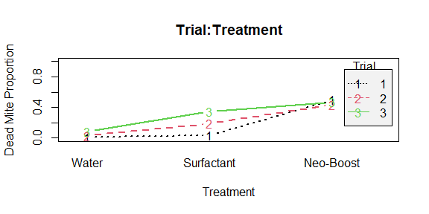

We see a lot of variation between trials in the detergent treatment, but it always falls between water and Neo-Boost. The interaction is valid but does not compromise the interpretation of the main effect of Treatment.

# Egg hatchability positive control (proportion) GLM - Fig. 2e

## Hypothesis testing - Analysis of deviance table

Analysis of deviance table using F tests due to quasibinomial distribution   
Anova(model.qb, type="II", test="F")

Analysis of Deviance Table (Type II tests)  
   
Response: (Hatched.Count/Total.Count)  
Error estimate based on Pearson residuals   
  
 Sum Sq Df F value Pr(>F)   
Treatment 2450.2 1 1774.9217 <2e-16 ***  
Trial 0.6 2 0.2171 0.8056   
Treatment:Trial 0.3 2 0.1085 0.8974   
Residuals 70.4 51   
---  
Signif. codes: 0 '***' 0.001 '**' 0.01 '*' 0.05 '.' 0.1 ' ' 1

The interaction term speaks to reproducibility of pattern between Treatments across Trial. The interaction is not significant. So, the experiment was reproducible.

Main effect of Trial is not significant.

Main effect of Treatment is significant and of interest. Post-hoc tests to follow.

# Proportion of larvae dead positive control GLM - Fig. 2f

## Hypothesis testing - Analysis of deviance table

Analysis of deviance table using Wald tests due to binomial distribution   
Anova(model.b, type="II", test="Wald")

Analysis of Deviance Table (Type II tests)  
   
Response: (Dead.Count/Total.Count)  
 Df Chisq Pr(>Chisq)   
Treatment 1 83.8400 < 2.2e-16 ***  
Trial 2 17.2681 0.0001779 ***  
Treatment:Trial 2 1.8223 0.4020553   
---  
Signif. codes: 0 '***' 0.001 '**' 0.01 '*' 0.05 '.' 0.1 ' ' 1

The interaction term speaks to reproducibility of pattern between Treatments across Trial. The interaction is not significant. So, the experiment was reproducible.

Main effect of Trial is significant, but not of interest (magnitude differences in the response variable between trials is expected).

Main effect of Treatment is significant and of interest. Post-hoc tests to follow.

# Proportion of adults dead positive control GLM - Fig. 2g

## Hypothesis testing - Analysis of deviance table

Analysis of deviance table using Wald tests due to binomial distribution   
Anova(model.b, type="II", test="Wald")

Analysis of Deviance Table (Type II tests)  
   
Response: (Dead.Count/Total.Count)  
 Df Chisq Pr(>Chisq)   
Treatment 1 184.7843 <2e-16 ***  
Trial 2 0.2428 0.8857   
Treatment:Trial 2 3.0681 0.2157   
---  
Signif. codes: 0 '***' 0.001 '**' 0.01 '*' 0.05 '.' 0.1 ' ' 1

The interaction term speaks to reproducibility of pattern between Treatments across Trial. The interaction is not significant. So, the experiment was reproducible.

Main effect of Trial is not significant.

Main effect of Treatment is significant and of interest. Post-hoc tests to follow.

# Proportion of dead larvae, Component testing Experiment 1 GLM - Fig. 3a

## Hypothesis testing - Analysis of deviance table

Analysis of deviance table using F tests due to quasibinomial distribution  
Anova(model.qb, type="II", test="F")

Analysis of Deviance Table (Type II tests)  
   
Response: (Dead.Count/Total.Count)  
Error estimate based on Pearson residuals   
   
 Sum Sq Df F value Pr(>F)   
Trial 103.30 2 28.7796 4.126e-12 ***  
Treatment 731.91 4 101.9559 < 2.2e-16 ***  
Trial:Treatment 21.00 8 1.4623 0.1707   
Residuals 511.49 285   
---  
Signif. codes: 0 '***' 0.001 '**' 0.01 '*' 0.05 '.' 0.1 ' ' 1

The interaction term speaks to reproducibility of pattern between Treatments across Trial. The interaction is not significant. So, the experiment was reproducible.

Main effect of Trial is significant, but not of interest (magnitude differences in the response variable between trials is expected).

Main effect of Treatment is significant and of interest. Post-hoc tests to follow.

# Proportion of dead larvae, Component testing Experiment 2 GLM - Fig. 3b

## Hypothesis testing - Analysis of deviance table

Analysis of deviance table using Wald/ChiSq tests due to binomial distribution  
Anova(model.b, type="II", test="Wald")

Analysis of Deviance Table (Type II tests)  
   
Response: (Dead.Count/Total.Count)  
 Df Chisq Pr(>Chisq)   
Trial 2 9.1625 0.01024 *   
Treatment 3 361.8842 < 2e-16 ***  
Trial:Treatment 6 1.8388 0.93391   
---  
Signif. codes: 0 '***' 0.001 '**' 0.01 '*' 0.05 '.' 0.1 ' ' 1

The interaction term speaks to reproducibility of pattern between Treatments across Trial. The interaction is not significant. So, the experiment was reproducible.

Main effect of Trial is significant, but not of interest (magnitude differences in the response variable between trials is expected).

Main effect of Treatment is significant and of interest. Post-hoc tests to follow.

# Proportion of developmental stages Experiment 1 GLM - Fig. 3c

## Hypothesis testing - Analysis of deviance table

Analysis of deviance table using F tests due to quasibinomial distribution  
Anova(larvae.model.qb, type="II", test = "F")

Analysis of Deviance Table (Type II tests)  
   
Response: (Mite.Count/Alive.Count)  
Error estimate based on Pearson residuals   
   
 Sum Sq Df F value Pr(>F)   
Trial 38.643 2 15.0712 8.081e-07 ***  
Treatment 189.039 4 36.8638 < 2.2e-16 ***  
Trial:Treatment 34.231 8 3.3377 0.001318 **   
Residuals 253.838 198   
---  
Signif. codes: 0 '***' 0.001 '**' 0.01 '*' 0.05 '.' 0.1 ' ' 1

The interaction term speaks to reproducibility of pattern between Treatments across Trial. The interaction is significant with a low P value (evidence for the interaction being real), so we must check interaction plot and see if there is a problem with reproducibility.

Main effect of Trial is significant, but not of interest (magnitude differences in the response variable between trials is expected).

Main effect of Treatment is significant and of interest. Post-hoc tests to follow.

## Interaction plot

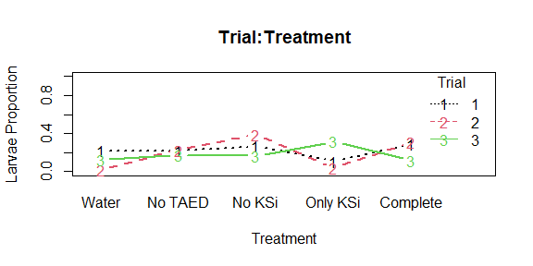

A lot of variability in the larvae stage between trials. Effect of treatment probably real but very time sensitive. I will perform post-hoc tests (they will be representative of the data as a whole).

## Hypothesis testing - Analysis of deviance table: Larvae Molting

Analysis of deviance table with either likelihood ratio, Wald, or F tests  
Anova(larvae.molt.model.qb, type="II", test = "F")

Analysis of Deviance Table (Type II tests)  
   
Response: (Mite.Count/Alive.Count)  
Error estimate based on Pearson residuals   
   
 Sum Sq Df F value Pr(>F)   
Trial 59.918 2 23.2873 8.263e-10 ***  
Treatment 6.973 4 1.3549 0.251048   
Trial:Treatment 27.349 8 2.6573 0.008618 **   
Residuals 254.728 198   
---  
Signif. codes: 0 '***' 0.001 '**' 0.01 '*' 0.05 '.' 0.1 ' ' 1

The interaction term speaks to reproducibility of pattern between Treatments across Trial. The interaction is significant with a low P value (evidence for the interaction being real). As there is no effect of treatment, there is no need to check interaction plot.

Main effect of Trial is significant, but not of interest (magnitude differences in the response variable between trials is expected).

Main effect of Treatment is not significant, so no post-hoc tests performed.

## Hypothesis testing - Analysis of deviance table: Protonymph

Analysis of deviance table using Wald/ChiSq tests due to binomial distribution  
Anova(proto.model.b, type="II", test="Wald")

Analysis of Deviance Table (Type II tests)  
   
Response: (Mite.Count/Alive.Count)  
 Df Chisq Pr(>Chisq)   
Trial 2 13.719 0.00105 **   
Treatment 4 71.978 8.676e-15 ***  
Trial:Treatment 8 18.211 0.01970 *   
---  
Signif. codes: 0 '***' 0.001 '**' 0.01 '*' 0.05 '.' 0.1 ' ' 1

The interaction term speaks to reproducibility of pattern between Treatments across Trial. The interaction is significant with a somewhat low P value (provides some evidence for the interaction being real), so we must check interaction plot and see if there is a problem with reproducibility.

Main effect of Trial is significant, but not of interest (magnitude differences in the response variable between trials is expected).

Main effect of Treatment is significant and of interest. Post-hoc tests to follow.

## Interaction plot

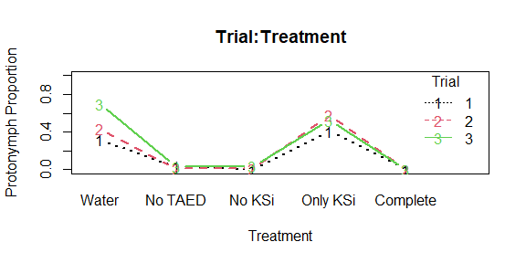

Interaction is significant, but the same pattern is observed between Treatments across Trial.

# Proportion of developmental stages Experiment 2 GLM - Fig. 3d

## Hypothesis testing - Analysis of deviance table: Larvae

Analysis of deviance table using Wald/ChiSq tests due to binomial distribution

**Anova**(larvae.model.b, type="II", test = "Wald")

Analysis of Deviance Table (Type II tests)  
   
Response: (Mite.Count/Alive.Count)  
 Df Chisq Pr(>Chisq)   
Trial 2 1.6796 0.4318   
Treatment 3 101.3166 <2e-16 ***  
Trial:Treatment 6 4.4276 0.6190   
---  
Signif. codes: 0 '***' 0.001 '**' 0.01 '*' 0.05 '.' 0.1 ' ' 1

The interaction term speaks to reproducibility of pattern between Treatments across Trial. The interaction is not significant. So, the experiment was reproducible.

Main effect of Trial is not significant.

Main effect of Treatment is significant and of interest. Post-hoc tests to follow.

## 

## Hypothesis testing - Analysis of deviance table: Larvae Molting

Analysis of deviance table using Wald/ChiSq tests due to binomial distribution  
Anova(larvae.molt.model.b, type="II", test = "Wald")

Analysis of Deviance Table (Type II tests)  
   
Response: (Mite.Count/Alive.Count)  
 Df Chisq Pr(>Chisq)   
Trial 2 0.2362 0.8886088   
Treatment 3 19.0211 0.0002707 ***  
Trial:Treatment 6 4.8360 0.5650104   
---  
Signif. codes: 0 '***' 0.001 '**' 0.01 '*' 0.05 '.' 0.1 ' ' 1

The interaction term speaks to reproducibility of pattern between Treatments across Trial. The interaction is not significant. So, the experiment was reproducible.

Main effect of Trial is not significant.

Main effect of Treatment is significant and of interest. Post-hoc tests to follow.

## Hypothesis testing - Analysis of deviance table: Protonymph

Analysis of deviance table with either likelihood ratio, Wald, or F tests  
Anova(proto.model.b, type="II", test = "Wald")

Analysis of Deviance Table (Type II tests)  
   
Response: (Mite.Count/Alive.Count)  
 Df Chisq Pr(>Chisq)   
Trial 2 2.3010 0.3165   
Treatment 3 150.3233 <2e-16 ***  
Trial:Treatment 6 2.5689 0.8607   
---  
Signif. codes: 0 '***' 0.001 '**' 0.01 '*' 0.05 '.' 0.1 ' ' 1

The interaction term speaks to reproducibility of pattern between Treatments across Trial. The interaction is not significant. So, the experiment was reproducible.

Main effect of Trial is not significant.

Main effect of Treatment is significant and of interest. Post-hoc tests to follow.

# Proportion of dead adults - GLM - Fig. 3e

## Hypothesis testing - Analysis of deviance table

Analysis of deviance table using F tests due to quasibinomial distribution   
Anova(model.qb, type="II", test="F")

Analysis of Deviance Table (Type II tests)  
   
Response: (Dead.Count/Total.Count)  
Error estimate based on Pearson residuals   
   
 Sum Sq Df F value Pr(>F)   
Trial 3.985 2 1.6196 0.2002   
Treatment 99.583 3 26.9803 5.695e-15 ***  
Trial:Treatment 5.599 6 0.7584 0.6033   
Residuals 280.513 228   
---  
Signif. codes: 0 '***' 0.001 '**' 0.01 '*' 0.05 '.' 0.1 ' ' 1

The interaction term speaks to reproducibility of the pattern between Treatments across Trial and is not significant. Therefore, it was a reproducible experiment.

Main effect of Trial is not significant.

Main effect of Treatment is significant and of interest. Strong evidence against the null hypothesis. Post-hoc tests to follow.

# Proportion of deterred adults - GLM - Fig. 3f

## Hypothesis testing - Analysis of deviance table

Analysis of deviance table using F tests due to quasibinomial distribution  
Anova(model.qb, type="II", test="F")

Analysis of Deviance Table (Type II tests)  
   
Response: (Deterred.Count/Total.Count)  
Error estimate based on Pearson residuals   
   
 Sum Sq Df F value Pr(>F)   
Trial 8.171 2 3.1289 0.04565 *   
Treatment 66.395 3 16.9503 5.665e-10 ***  
Trial:Treatment 17.176 6 2.1925 0.04464 *   
Residuals 297.694 228   
---  
Signif. codes: 0 '***' 0.001 '**' 0.01 '*' 0.05 '.' 0.1 ' ' 1

The interaction term speaks to reproducibility of the pattern between Treatments across Trial and is significant. There is only weak evidence for this interaction as the p value just crossed the significance level. Interaction plot needs to be checked for reproducibility across trials.

Main effect of Trial is significant, but not of interest (magnitude differences in the response variable between trials can be expected).

Main effect of Treatment is significant and of interest. Strong evidence against the null hypothesis. Post-hoc tests to follow.

## Interaction plot

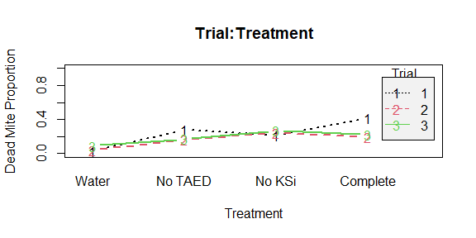

Trial 1 has some variability among non-control treatments ‘No TAED’ and ‘Complete’, but no huge deviations in reproducibility across trials.

# Proportion of dead mites, Residual exposure GLM - Fig. 4a

## Hypothesis testing - Analysis of deviance table

Analysis of deviance table using F tests due to quasibinomial distribution   
Anova(model.qb, type="II", test="F")

Analysis of Deviance Table (Type II tests)  
   
Response: (Dead.Count/Total.Count)  
Error estimate based on Pearson residuals   
  
 Sum Sq Df F value Pr(>F)   
Trial 0.29 2 0.1389 0.8704   
Treatment 580.49 3 184.4523 <2e-16 ***  
Trial:Treatment 6.41 6 1.0178 0.4144   
Residuals 239.18 228   
---  
Signif. codes: 0 '***' 0.001 '**' 0.01 '*' 0.05 '.' 0.1 ' ' 1

The interaction term speaks to reproducibility of the pattern between Treatments across Trial and is not significant. Therefore, it was a reproducible experiment.

Main effect of Trial is not significant.

Main effect of Treatment is significant and of interest. Strong evidence against the null hypothesis. Post-hoc tests to follow.

# Proportion of developmental stages, Residual Exposure GLM - Fig. 4b

## Hypothesis testing - Analysis of deviance table: Larvae

Analysis of deviance table using Wald/ChiSq tests due to binomial distribution  
Anova(larvae.model.b, type="II", test = "Wald")

Analysis of Deviance Table (Type II tests)  
   
Response: (Mite.Count/Alive.Count)  
 Df Chisq Pr(>Chisq)   
Trial 2 45.89 1.084e-10 ***  
Treatment 3 148.81 < 2.2e-16 ***  
Trial:Treatment 6 2.43 0.8762   
---  
Signif. codes: 0 '***' 0.001 '**' 0.01 '*' 0.05 '.' 0.1 ' ' 1

The interaction term speaks to reproducibility of the pattern between Treatments across Trial and is not significant. Therefore, it was a reproducible experiment.

Main effect of Trial is significant, but not of interest (magnitude differences in the response variable between trials can be expected).

Main effect of Treatment is significant and of interest. Strong evidence against the null hypothesis. Post-hoc tests to follow.

## Hypothesis testing - Analysis of deviance table: Larvae molting

Analysis of deviance table using Wald/ChiSq tests due to binomial distribution   
Anova(larvae.molt.model.b, type="II", test = "Wald")

Analysis of Deviance Table (Type II tests)  
   
Response: (Mite.Count/Alive.Count)  
 Df Chisq Pr(>Chisq)   
Trial 2 2.8970 0.2349   
Treatment 3 38.5498 2.162e-08 ***  
Trial:Treatment 6 5.9801 0.4254   
---  
Signif. codes: 0 '***' 0.001 '**' 0.01 '*' 0.05 '.' 0.1 ' ' 1

The interaction term speaks to reproducibility of the pattern between Treatments across Trial and is not significant. Therefore, it was a reproducible experiment.

Main effect of Trial is not significant.

Main effect of Treatment is significant and of interest. Strong evidence against the null hypothesis. Post-hoc tests to follow.

## Hypothesis testing - Analysis of deviance table: Protonymph

Analysis of deviance table using Wald/ChiSq tests due to binomial distribution  
Anova(proto.model.b, type="II", test = "Wald")

Analysis of Deviance Table (Type II tests)  
   
Response: (Mite.Count/Alive.Count)  
 Df Chisq Pr(>Chisq)   
Trial 2 32.0740 1.084e-07 ***  
Treatment 3 65.6887 3.573e-14 ***  
Trial:Treatment 6 2.8847 0.8232   
 ---  
Signif. codes: 0 '***' 0.001 '**' 0.01 '*' 0.05 '.' 0.1 ' ' 1

The interaction term speaks to reproducibility of the pattern between Treatments across Trial and is not significant. Therefore, it was a reproducible experiment.

Main effect of Trial is significant, but not of interest (magnitude differences in the response variable between trials can be expected).

Main effect of Treatment is significant and of interest. Strong evidence against the null hypothesis. Post-hoc tests to follow.

# Proportion of dead mites, Contact Exposure GLM - Fig. 4c

## Hypothesis testing - Analysis of deviance table

Analysis of deviance table using Wald/ChiSq tests due to binomial distribution   
Anova(model.b, type="II", test="Wald")

Analysis of Deviance Table (Type II tests)  
   
Response: Response  
 Df Chisq Pr(>Chisq)   
Treatment 3 123.32 < 2.2e-16 ***  
 ---  
Signif. codes: 0 '***' 0.001 '**' 0.01 '*' 0.05 '.' 0.1 ' ' 1

Main effect of Treatment is significant and of interest. Post-hoc tests to follow.

# Fecundity, tomato priming - Linear model - Fig. 5c

## Hypothesis testing - Analysis of variance (ANOVA) table

Anova(model.lm, type="II")

Anova Table (Type II tests)  
   
Response: Egg.Count/Total.Count  
 Sum Sq Df F value Pr(>F)   
Trial 587.45 2 12.5937 4.954e-05 ***  
Treatment 215.49 2 4.6196 0.01523 *   
Trial:Treatment 47.85 4 0.5129 0.72652   
Residuals 1002.90 43   
---  
Signif. codes: 0 '***' 0.001 '**' 0.01 '*' 0.05 '.' 0.1 ' ' 1

The interaction term speaks to reproducibility of the pattern between Treatments across Trial and is not significant. Therefore, it was a reproducible experiment.

Main effect of Trial is significant, but not of interest (magnitude differences in the response variable between trials can be expected).

Main effect of Treatment is significant and of interest. Evidence against the null hypothesis, but not very strong. Post-hoc tests to follow.

# Session Info

## R version 3.6.1 (2019-07-05)  
## Platform: x86_64-w64-mingw32/x64 (64-bit)  
## Running under: Windows 10 x64 (build 19041)  
##   
## Matrix products: default  
##   
## locale:  
## [1] LC_COLLATE=English_Canada.1252 LC_CTYPE=English_Canada.1252   
## [3] LC_MONETARY=English_Canada.1252 LC_NUMERIC=C   
## [5] LC_TIME=English_Canada.1252   
##   
## attached base packages:  
## [1] stats graphics grDevices utils datasets methods base   
##   
## other attached packages:  
## [1] ggsci_2.9 ggeffects_0.14.3 broom_0.5.6 forcats_0.5.0   
## [5] stringr_1.4.0 purrr_0.3.4 readr_1.3.1 tidyr_1.0.2   
## [9] tibble_3.0.1 tidyverse_1.3.0 multcomp_1.4-13 TH.data_1.0-10   
## [13] MASS_7.3-51.4 survival_3.1-12 mvtnorm_1.1-0 emmeans_1.4.6   
## [17] car_3.0-7 carData_3.0-3 lme4_1.1-23 Matrix_1.2-17   
## [21] ggpubr_0.3.0 rcompanion_2.3.25 dplyr_0.8.5 ggplot2_3.3.0   
##   
## loaded via a namespace (and not attached):  
## [1] minqa_1.2.4 colorspace_1.4-1 ggsignif_0.6.0 ellipsis_0.3.0   
## [5] modeltools_0.2-23 rio_0.5.16 sjlabelled_1.1.4 estimability_1.3   
## [9] fs_1.4.1 rstudioapi_0.11 farver_2.0.3 fansi_0.4.1   
## [13] lubridate_1.7.8 coin_1.3-1 xml2_1.3.2 codetools_0.2-16   
## [17] splines_3.6.1 libcoin_1.0-5 knitr_1.28 jsonlite_1.6.1   
## [21] nloptr_1.2.2.1 dbplyr_1.4.3 compiler_3.6.1 httr_1.4.1   
## [25] backports_1.1.6 assertthat_0.2.1 cli_2.0.2 htmltools_0.4.0   
## [29] tools_3.6.1 coda_0.19-3 gtable_0.3.0 glue_1.4.0   
## [33] Rcpp_1.0.4.6 cellranger_1.1.0 vctrs_0.2.4 nlme_3.1-140   
## [37] lmtest_0.9-37 insight_0.8.3 xfun_0.13 openxlsx_4.1.4   
## [41] rvest_0.3.5 lifecycle_0.2.0 statmod_1.4.34 rstatix_0.5.0   
## [45] zoo_1.8-8 scales_1.1.0 hms_0.5.3 parallel_3.6.1   
## [49] sandwich_2.5-1 expm_0.999-4 yaml_2.2.1 curl_4.3   
## [53] EMT_1.1 stringi_1.4.6 nortest_1.0-4 boot_1.3-22   
## [57] zip_2.0.4 rlang_0.4.5 pkgconfig_2.0.3 matrixStats_0.56.0  
## [61] evaluate_0.14 lattice_0.20-38 labeling_0.3 tidyselect_1.0.0   
## [65] plyr_1.8.6 magrittr_1.5 R6_2.4.1 DescTools_0.99.34   
## [69] generics_0.0.2 multcompView_0.1-8 DBI_1.1.0 mgcv_1.8-28   
## [73] pillar_1.4.4 haven_2.2.0 foreign_0.8-71 withr_2.2.0   
## [77] abind_1.4-5 modelr_0.1.7 crayon_1.3.4 utf8_1.1.4   
## [81] rmarkdown_2.1 grid_3.6.1 readxl_1.3.1 data.table_1.12.8   
## [85] reprex_0.3.0 digest_0.6.25 xtable_1.8-4 stats4_3.6.1   
## [89] munsell_0.5.0