Wood anatomy of Douglas-fir in eastern Arizona and its relationship with Pacific Basin climate

Balanzategui, D.^{1,2,3}, Nordhauß, H.¹, Heinrich, I.^{1,2,3}, Biondi, F.⁴, Miley, N.⁴, Hurley, A. G.¹, E. Ziaco^{1,5*}

¹ GFZ German Research Centre for Geosciences, Telegrafenberg, 14473 Potsdam, Germany
² Institute of Geography, Humboldt-University, Unter den Linden 6, 10099 Berlin, Germany
³ DAI German Archaeological Institute, Department of Natural Sciences, Im Dol 2-6, 14195 Berlin, Germany
⁴ DendroLab, Department of Natural Resources & Environmental Science, University of Nevada, Reno, NV 89557, USA
⁵ Department of Ecology and Genetics, Plant Ecology and Evolution, University of Uppsala, 752 36 Uppsala, Sweden

SUPPLEMENTARY MATERIALS

Figure S1
Figure S2
Figure S3
Figure S4

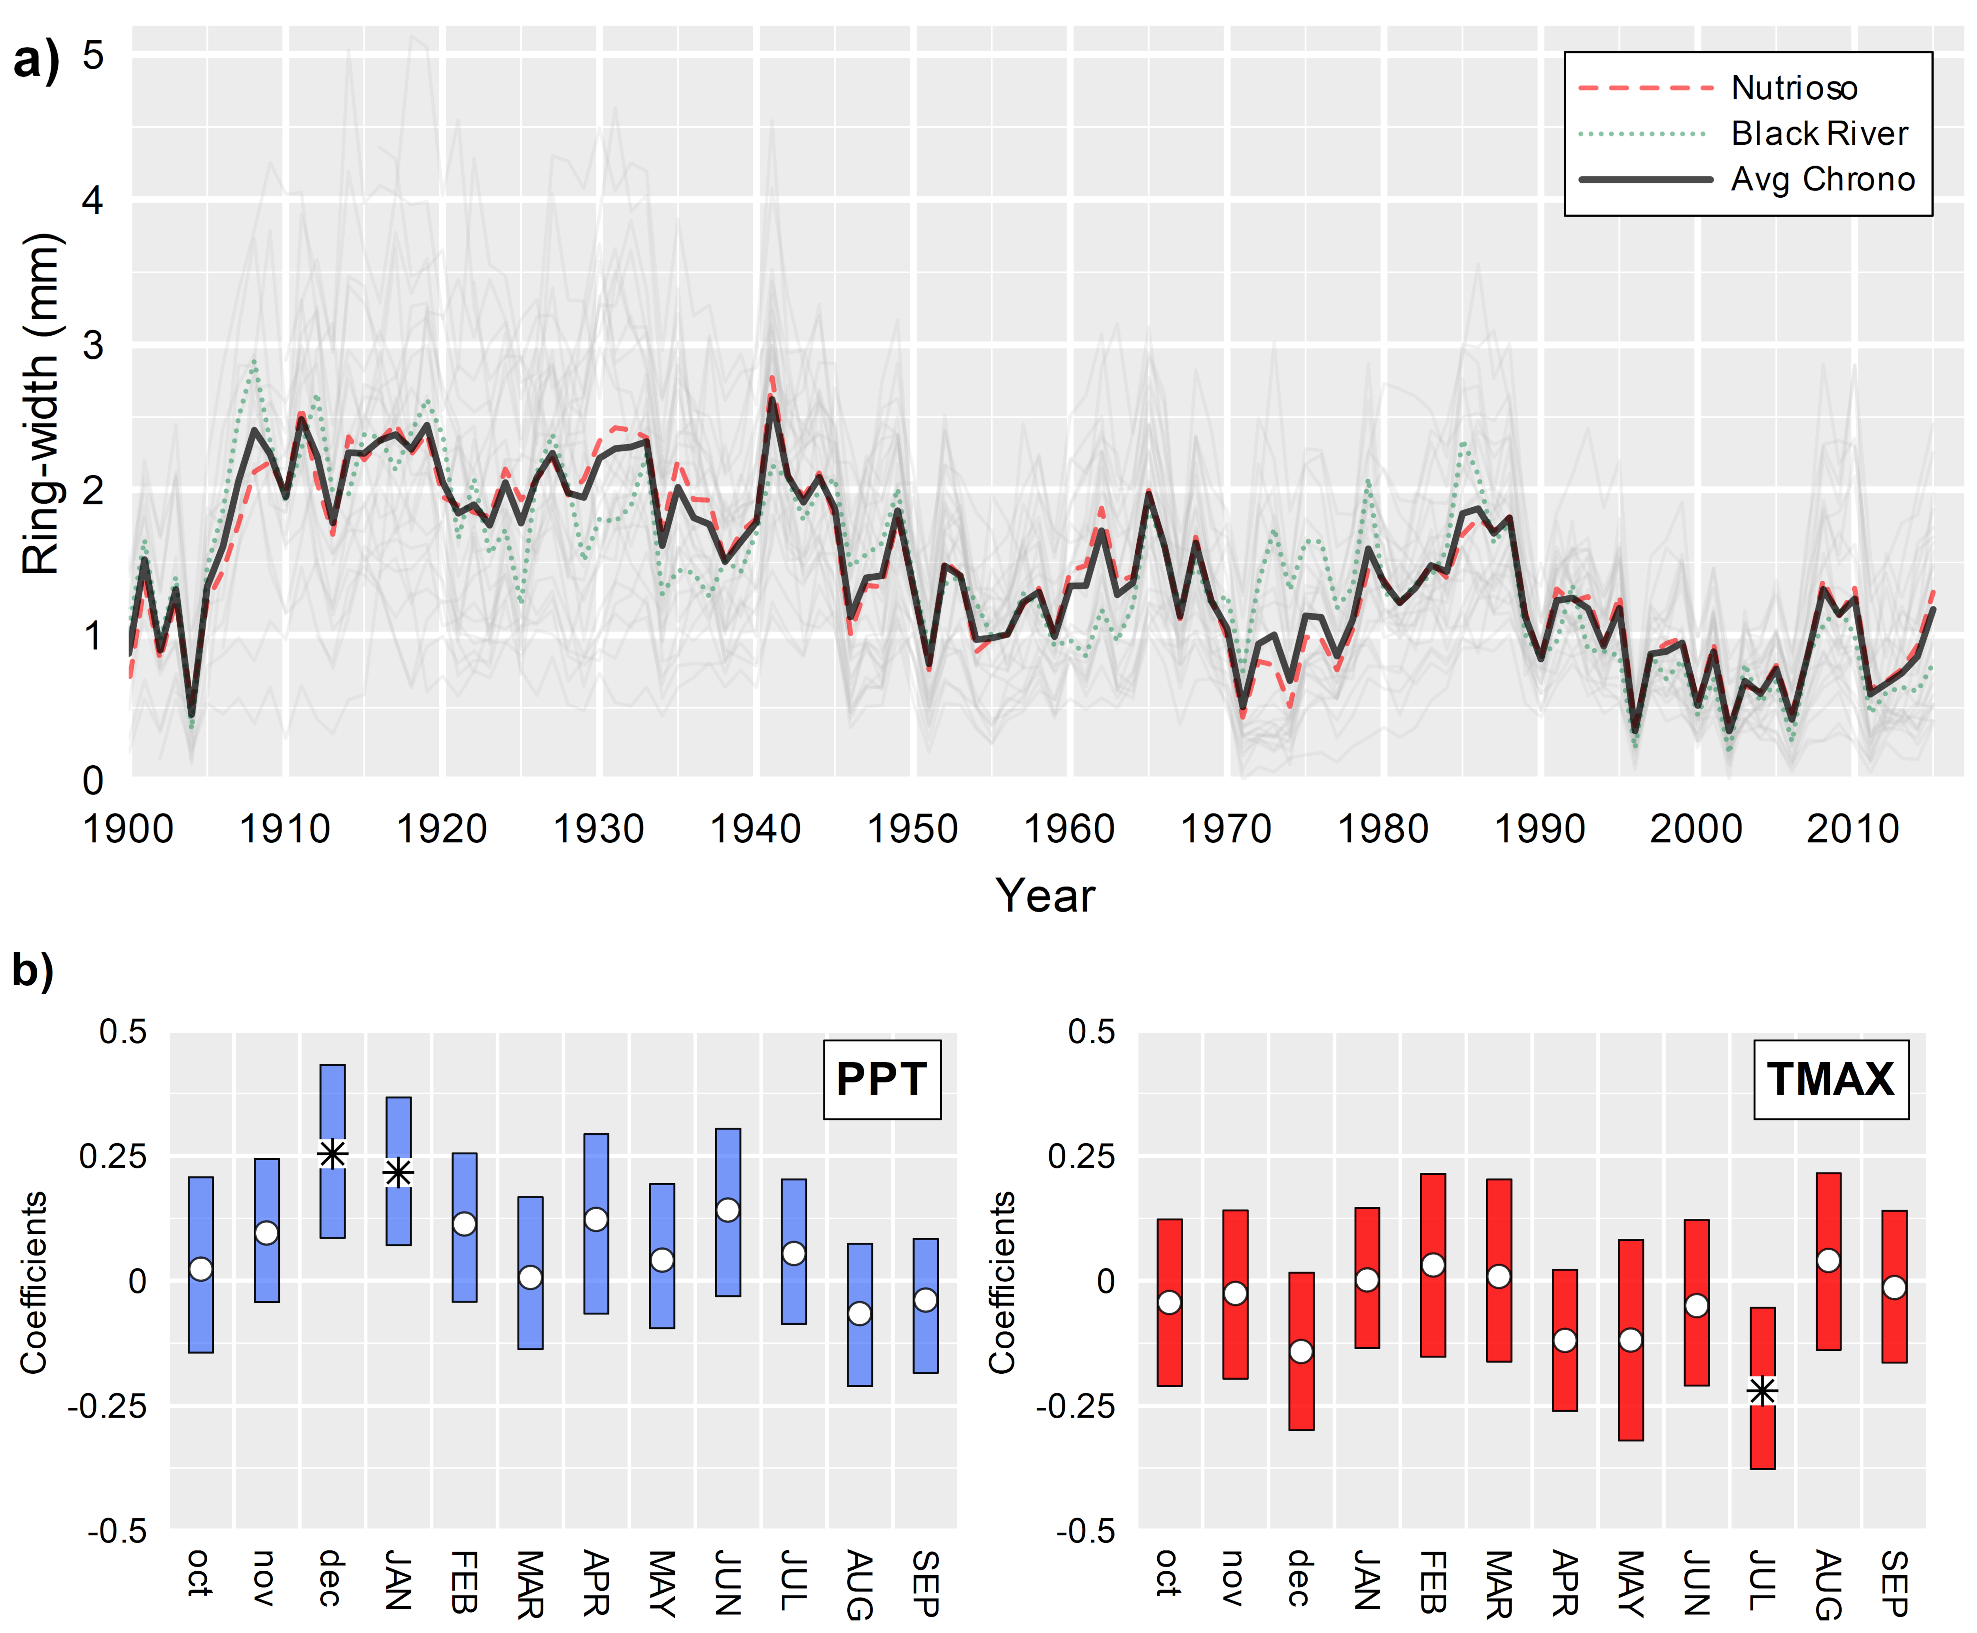

Figure S1 a) Ring-width chronologies for the sites of Nutrioso (red dashed line), Black River (green dotted line), and average of both sites (black bold line); gray lines represent individual ring-width series. b) response function coefficients between residual chronology of Pseudotsuga menziesii, monthly precipitation and maximum temperature for the period 1950-2015, calculated for the “water year” (i.e. previous October to current September). Vertical bars represent 95% bootstrapped (n=1000) confidence interval. Significant coefficients are marked with an asterisk. Monthly climatic data were obtained from the PRISM 4-km dataset at the grid point 33.90° N 109.19°W.

Figure S2 CLIMTREG analysis output of the dendroclimatic correlations between lumen diameter (Sector I) and daily temperature (top) and precipitation (bottom) for the period 1982-2015. Colors indicate strength and direction of correlations, while horizontal bars indicate the temporal extent of significant climatic windows (p<0.05).

Figure S3 CLIMTREG analysis output of the dendroclimatic correlations between lumen diameter (Sectors I-V) and daily temperature (top) and precipitation (bottom) for the period 1982-2015. Colors indicate strength and direction of correlations, while horizontal bars indicate the temporal extent of significant climatic windows (p<0.05).

Figure S4 (a) Normalized time-series of earlywood lumen diameter (Sectors I and I-V) plotted against previous October-current January Pacific Decadal Oscillation (PDO) for the period 1966 to 2015 (bold lines are 5-year cubic smoothing splines). The sign of SOI has been inverted for easier interpretation. (b) Cross wavelet transform of lumen diameter (Sectors I and I-V) and PDO index. White contours represent 95% significance level. The relative phase relationship is shown as arrows (in-phase pointing right, anti-phase pointing left, and PDO leading lumen diameter by 90° pointing down). Results falling outside the cone of influence (white shaded area) might be distorted by edge-effect.

