**Barley nepenthesin-like aspartic protease HvNEP-1 degrades *Fusarium* phytase, impairs toxin production and suppresses the fungal growth**

Zelalem Eshetu Bekalu1, Giuseppe Dionisio1, Claus Krogh Madsen1, Thomas Etzerodt1, Inge S. Fomsgaard1 and Henrik Brinch-Pedersen1

1 Department of Agroecology, Research Center Flakkebjerg, Aarhus University, DK-4200 Slagelse, Denmark

**Supplementary information**

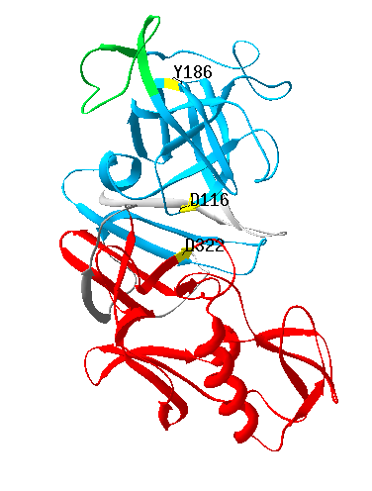 

**Figure 1:** The predicted tertiary structure of HvNEP-1. Structure prediction and annotation was performed using the Swiss-Model (<https://www.swissmodel.expasy.org/>) and Swiss PDB viewer (<https://spdbv.vital-it.ch/>), respectively. The Taxi_N and Taxi_C domains from the profile-HMM scan of the HvNEP-1 sequence. Both domains are shown corresponding to the primary structure (under). Likewise, active site residues (D116, Y186 and D322), the flap Tyr residue (Y186) and the NAP-I are marked with the same color or text.

|  |  |  |  |  |
| --- | --- | --- | --- | --- |
| **Table 1** Primers used in PCR, Cloning and qPCR | | | | |
| **Gene name** | **Usage** | **Primer name** | **Primer sequence (5’-3’)** | **References** |
| HvNEP-1 | PCR | P1 | Fw: GCACATCAATGGCTATGGCGATCATGAACAC/ Rv: GTTCAATCCACACCGGCGGTGTCCTGAG | This study |
| HvNEP-1 | Cloning | P2 | Fw: GAAGGGGTATCTCTCGAGAAAAGAGCTGATGCGGACACCCCAAAAGTC  Rv: TGATGATGATGGTCGACTTAATGATGATGATGATGATGTGGATCCACACCGGCGGTGTCCTGAG | This study |
| AOX1 | Sequencing | P3 | Fw: GACTGGTTCCAATTGACAAGC / Rv: GCAAATGGCATTCTGACATCC | 1 |
| FgPHY1/  FcPHY1 | Sequencing | P4 | Fw: ATGATAATCAGCACCATCGCG/ Rv: TCATACAAAACATCGATCCCAGTGTCC | This study |
| FgPHY1/  FcPHY1 | Cloning | P5 | Fw: GAAGAAGGGGTATCTCTCGAGAAAAGAGAGGCTGAAGCTGAAGTCTGGGTTCACAATTACACTTTGACTTC  Rv: ATGAGTTTTTGTTCTAGATTAATGATGATGATGATGATGTGGTACAAAACATCGATCCCAGTGTCC | This study |
| TRI4 | qPCR | Tri4 | Fw: TATTGTTGGCTACCCCAAGG/ Rv: TGTCAGATGCGCCTTACAAA | 2 |
| TRI5 | qPCR | Tri5 | Fw: TGAAAAGGTCAAGGATCAGGA/ Rv: CCTGCTCAAAGAACTTGCAGA | 2 |
| TRI6 | qPCR | Tri6 | Fw: TTACATGGAGGCCGAATCTC/ Rv: AGACGCAACTCGATCAAAGAG | 2 |
| TRI12 | qPCR | Tri12 | Fw: ATTCGGTACATGGGCT/ Rv: GCAGTGCTGTTCGTCA | 2 |
| GADPH | qPCR | Gpd | Fw: CTCCCTCAACGACAACTTCG / Rv: GGAGTAACCCCACTCGTTGTC | 2 |

**References**

(1) Xuan, Y. J.; Zhou, X. S.; Zhang, W. W.; Zhang, X.; Song, Z. W.; Zhang, Y. X. An Upstream Activation Sequence Controls the Expression of AOX1 Gene in Pichia Pastoris. *FEMS Yeast Res.* **2009**, *9* (8), 1271–1282. https://doi.org/10.1111/j.1567-1364.2009.00571.x.

(2) Boutigny, A. L.; Barreau, C.; Atanasova-Penichon, V.; Verdal-Bonnin, M. N.; Pinson-Gadais, L.; Richard-Forget, F. Ferulic Acid, an Efficient Inhibitor of Type B Trichothecene Biosynthesis and Tri Gene Expression in Fusarium Liquid Cultures, **2009**. https://doi.org/10.1016/j.mycres.2009.02.010.