Supplementary Material

Controllable Synthesis of 2D Non-layered Cr2S3 Nanosheets and their Electrocatalytic Activity Toward Oxygen Evolution Reaction

Tofik Ahmed Shifa *1, Raffaello Mazzaro 2, Vittorio Morandi 2, Alberto Vomiero *1,3

1Division of Materials Science, Department of Engineering Sciences and Mathematics, Luleå University of Technology, 97187 Luleå, Sweden

2CNR-IMM Bologna Section, 40129, Bologna, Italy

3Department of Molecular Sciences and Nanosystems, Ca’ Foscari University of Venice, 30172 Venezia, Italy

**\* Correspondence:**Corresponding Authors  
[alberto.vomiero@ltu.se](mailto:alberto.vomiero@ltu.se)

[tofik.ahmed.shifa@ltu.se](mailto:tofik.ahmed.shifa@ltu.se)

Keywords: 2D materials, non-Layered materials, metal sulfides, chemical vapor deposition, oxygen evolution reaction

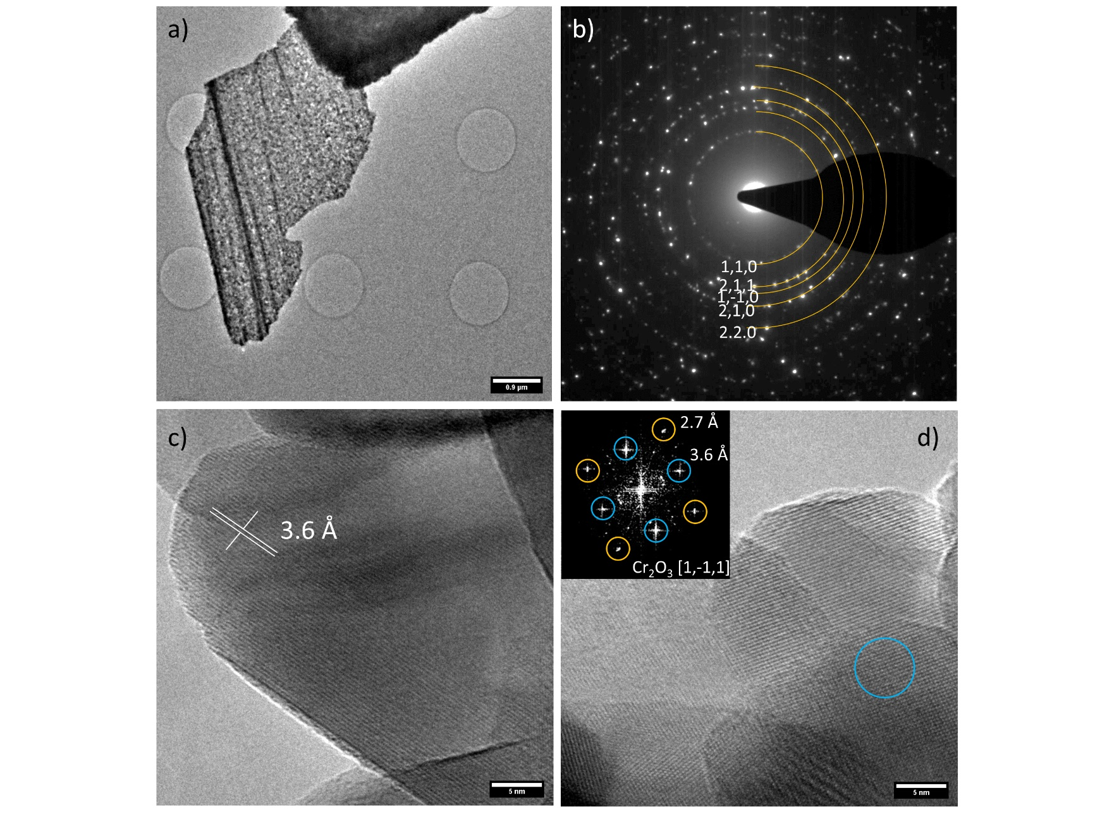

**FIGURE S1:**  a) low magnification HR-TEM micrograph and SAED image of the same structure, displaying a polycrystalline pattern assigned to hexagonal Cr2O3 precursor. c) and d) high magnification micrographs displaying the nanoscale structure and the presence of multiple Cr2O3 crystal domains.

**FIGURE S2:** XRD pattern of Cr2O3/CF precursor.

**FIGURE S3:** HRTEM image (a) and the corresponding SAED pattern (b) of Cr2S3



**FIGURE S4:** The OER performance normalized byelectrochemical activated surface area (ECSA). ECSA was determined by the equation of ECSA = Cdl/Cs×S, where Cs is the capacitance of an atomically smooth planar surface (0.04 mF cm-2 in alkaline media) (McCrory et al., 2013), and S is the electrode area.

**FIGURE S5:** EIS fitting for Cr2S3 (a) and Cr2O3(b)

**Table S1. The comparison of the OER performances in 1M KOH**

|  |  |  |  |  |  |
| --- | --- | --- | --- | --- | --- |
| **S/No** | **Catalyst** | **Overpotential (current density)** | **Tafel slope ( mV/dec)** | **stability** | **Reference** |
|  | FeP/Ni2P | 154 mV (10 mA/cm2) | 22.7 | 24hr | (Yu et al., 2018) |
|  | Fe(PO3)2/Ni2P | 177 mV (10 mA/cm2) | 51.9 | 20hr | (Zhou et al., 2017) |
|  | Fe-doped Ni2P | 255 mV (500 mA/cm2) | 29.1 | 16hr | (Cai et al., 2018) |
|  | Fe-Co-P hollow sphere | 252 mV (10 mA/cm2) | 33 | 24hr | (Liu et al., 2017) |
|  | Ni0.6Co1.4P | 300 mV (10 mA/cm2) | 80 | 10hr | (Qiu et al., 2018) |
|  | NixFe1-xSe2 | 195 mV (10 mA/cm2) | 28 | 24hr | (Xu et al., 2016) |
|  | Al doped Ni5P4 | 180 mV (10 mA/cm2) | 27 | 200hr | (Xu et al., 2018) |
|  | CoMnP | 330 mV (10 mA/cm2) | 61 | 15 hr | (Li et al., 2016a) |
|  | Co doped Nickel phosphide | 360 mV (10 mA/cm2) | 65.7 | 24h | (Li et al., 2016b) |
|  | Fe doped CoP nano array | 310 mV (100 mA/cm2) | 67 | 40hr | (Tang et al., 2017) |
|  | NiCoP/C | 330mV (10 mA/cm2) | 96 | 10 hr | (He et al., 2017) |
|  | NiMoP2 | 330mV (100 mA/cm2) | 90.6 | 24 hr | (Wang et al., 2017) |
|  | Al doped CoP nanoarray | 330mV (10 mA/cm2) | 43 | 40hr | (Zhang et al., 2017) |
|  | Sn doped Ni5P4 | 170mV (10 mA/cm2)  190 (30 mA/cm2) and | 36 | 36 hr | (Ahmed Shifa et al., 2021) |
|  | (NiCo-9AC-AD)* | 350mV (100 mA/cm2)  143mV (10 mA/cm2) | 51.3 | 30hr | (Ye et al., 2019) |
|  | NiFe-LDHs | 370 mV (30 mA/cm2) | 33.4 | 8hr | (Gao and Yan, 2018) |
|  | CrMnFeCoNi)Sx | 295 mV (100 mA/cm2) | 66 | 10hr | (Cui et al., 2021) |
|  | **Cr2S3** | **230mV (10mA/cm2)** | **120** | **10hr** | **This work** |

* Co/Ni-based mixed metal−organic nanosheet array

**References:**

Ahmed Shifa, T., Yusupov, K., Solomon, G., Gradone, A., Mazzaro, R., Cattaruzza, E., et al. (2021). In Situ-Generated Oxide in Sn-Doped Nickel Phosphide Enables Ultrafast Oxygen Evolution. *ACS Catal.* 11, 4520–4529. doi:10.1021/acscatal.1c00476.

Cai, L., Qiu, B., Lin, Z., Wang, Y., Ma, S., Wang, M., et al. (2018). Active site engineering of Fe- and Ni-sites for highly efficient electrochemical overall water splitting. *J. Mater. Chem. A* 6, 21445–21451. doi:10.1039/C8TA08217K.

Cui, M., Yang, C., Li, B., Dong, Q., Wu, M., Hwang, S., et al. (2021). High-Entropy Metal Sulfide Nanoparticles Promise High-Performance Oxygen Evolution Reaction. *Adv. Energy Mater.* 11, 2002887. doi:https://doi.org/10.1002/aenm.202002887.

Gao, R., and Yan, D. (2018). Fast formation of single-unit-cell-thick and defect-rich layered double hydroxide nanosheets with highly enhanced oxygen evolution reaction for water splitting. *Nano Res.* 11, 1883–1894. doi:10.1007/s12274-017-1806-x.

He, P., Yu, X.-Y., and Lou, X. W. (David) (2017). Carbon-Incorporated Nickel–Cobalt Mixed Metal Phosphide Nanoboxes with Enhanced Electrocatalytic Activity for Oxygen Evolution. *Angew. Chemie Int. Ed.* 56, 3897–3900. doi:10.1002/anie.201612635.

Li, D., Baydoun, H., Verani, C. N., and Brock, S. L. (2016a). Efficient Water Oxidation Using CoMnP Nanoparticles. *J. Am. Chem. Soc.* 138, 4006.

Li, J., Yan, M., Zhou, X., Huang, Z.-Q., Xia, Z., Chang, C.-R., et al. (2016b). Mechanistic Insights on Ternary Ni2–xCoxP for Hydrogen Evolution and Their Hybrids with Graphene as Highly Efficient and Robust Catalysts for Overall Water Splitting. *Adv. Funct. Mater.* 26, 6785.

Liu, K., Zhang, C., Sun, Y., Zhang, G., Shen, X., Zou, F., et al. (2017). High-Performance Transition Metal Phosphide Alloy Catalyst for Oxygen Evolution Reaction. *ACS Nano* 12, 158–167. doi:10.1021/acsnano.7b04646.

McCrory, C. C. L., Jung, S., Peters, J. C., and Jaramillo, T. F. (2013). Benchmarking Heterogeneous Electrocatalysts for the Oxygen Evolution Reaction. J. Am. Chem. Soc. 135, 16977.

Qiu, B., Cai, L., Wang, Y., Lin, Z., Zuo, Y., Wang, M., et al. (2018). Fabrication of Nickel–Cobalt Bimetal Phosphide Nanocages for Enhanced Oxygen Evolution Catalysis. *Adv. Funct. Mater.* 28, 1706008. doi:10.1002/adfm.201706008.

Tang, C., Zhang, R., Lu, W., He, L., Jiang, X., Asiri, A. M., et al. (2017). Fe-Doped CoP Nanoarray: A Monolithic Multifunctional Catalyst for Highly Efficient Hydrogen Generation. *Adv. Mater.* 29, 1602441. doi:10.1002/adma.201602441.

Wang, X.-D., Chen, H.-Y., Xu, Y.-F., Liao, J.-F., Chen, B.-X., Rao, H.-S., et al. (2017). Self-supported NiMoP2 nanowires on carbon cloth as an efficient and durable electrocatalyst for overall water splitting. *J. Mater. Chem. A* 5, 7191–7199. doi:10.1039/C6TA11188B.

Xu, J., P. S. Sousa, J., E. Mordvinova, N., Diogo Costa, J., Y. Petrovykh, D., Kovnir, K., et al. (2018). Al-Induced In Situ Formation of Highly Active Nanostructured Water-Oxidation Electrocatalyst Based on Ni-Phosphide. *ACS Catal.* 8, 2595–2600. doi:10.1021/acscatal.7b03817.

Xu, X., Song, F., and Hu, X. (2016). A nickel iron diselenide-derived efficient oxygen-evolution catalyst. *Nat. Commun.* 7, 12324. doi:10.1038/ncomms12324.

Ye, W., Yang, Y., Fang, X., Arif, M., Chen, X., and Yan, D. (2019). 2D Cocrystallized Metal–Organic Nanosheet Array as an Efficient and Stable Bifunctional Electrocatalyst for Overall Water Splitting. *ACS Sustain. Chem. Eng.* 7, 18085–18092. doi:10.1021/acssuschemeng.9b05126.

Yu, F., Zhou, H., Huang, Y., Sun, J., Qin, F., Bao, J., et al. (2018). High-performance bifunctional porous non-noble metal phosphide catalyst for overall water splitting. *Nat. Commun.* 9, 2551. doi:10.1038/s41467-018-04746-z.

Zhang, R., Tang, C., Kong, R., Du, G., Asiri, A. M., Chen, L., et al. (2017). Al-Doped CoP nanoarray: a durable water-splitting electrocatalyst with superhigh activity. *Nanoscale* 9, 4793–4800. doi:10.1039/C7NR00740J.

Zhou, H., Yu, F., Sun, J., He, R., Chen, S., Chu, C.-W., et al. (2017). Highly active catalyst derived from a 3D foam of Fe(PO3)2/Ni2P for extremely efficient water oxidation. *Proc. Natl. Acad. Sci. U. S. A.* 114, 5607–5611. doi:10.1073/pnas.1701562114.