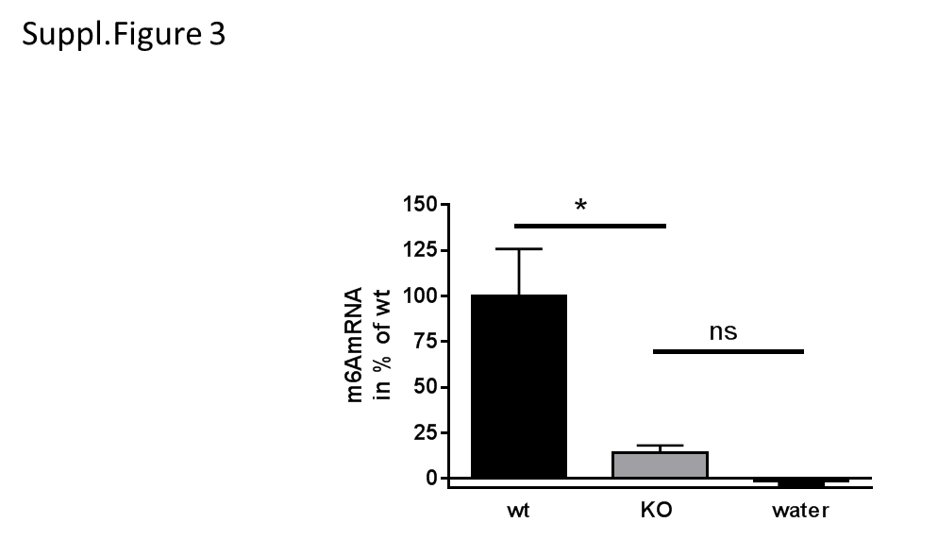

**Supplementary Figure 1: Specificity of m6A mRNA modification measurement**

To evaluate the specificity of the antibody-based assay that was used to quantify m6A modification in murine mRNA, pooled RNA of wild type flies (*D. melanogaster*) and flies with Mettl3 knock-out was used. 200ng of RNA was subjected to the assay in triplicate, water served as absolute negative control. Deletion of the methyltransferase resulted in a significant reduction of the signal (14% of wild type value) that was indifferent to water control.