Supplementary Material

Supplementary Figures

S1-1. ¹H NMR spectrum of streptonaphthalen A (1).
S1-2. ¹³C NMR spectrum of streptonaphthalen A (1).
S1-3. HRESIMS spectrum of streptonaphthalen A (1).
S1-4. ¹H, ¹H-COSY spectrum of streptonaphthalen A (1).
S1-5. HSQC spectrum of streptonaphthalen A (1).
S1-6. HMBC spectrum of streptonaphthalen A (1).

S2-1. ¹H NMR spectrum of streptonaphthalen B (2).
S2-2. ¹³C NMR spectrum of streptonaphthalen B (2).
S2-3. HRESIMS spectrum of streptonaphthalen B (2).
S2-4. ¹H, ¹H-COSY spectrum of streptonaphthalen B (2).
S2-5. HSQC spectrum of streptonaphthalen B (2).
S2-6. HMBC spectrum of streptonaphthalen B (2).

S3-1. ¹H NMR spectrum of pestaloficin F (3).
S3-2. ¹³C NMR spectrum of pestaloficin F (3).
S3-3. HRESIMS spectrum of pestaloficin F (3).
S3-4. ¹H, ¹H-COSY spectrum of pestaloficin F (3).
S3-5. HSQC spectrum of pestaloficin F (3).
S3-6. HMBC spectrum of pestaloficin F (3).
S3-7. NOESY spectrum of pestaloficin F (3).

S4-1. ¹H NMR spectrum of pestaloficin G (4).
S4-2. ¹³C NMR spectrum of pestaloficin G (4).
S4-3. HRESIMS spectrum of pestaloficin G (4).
S4-4. ¹H, ¹H-COSY spectrum of pestaloficin G (4).
S4-5. HSQC spectrum of pestaloficin G (4).
S4-6. HMBC spectrum of pestaloficin G (4).
S4-7. NOESY spectrum of pestaloficin G (4).

S5-1. ¹H NMR spectrum of eudesmanetetraiol A (5).
S5-2. ¹³C NMR spectrum of eudesmanetetraiol A (5).
S5-3. HRESIMS spectrum of eudesmanetetraiol A (5).
S5-4. ¹H, ¹H-COSY spectrum of eudesmanetetraiol A (5).
S5-5. HSQC spectrum of eudesmanetetraiol A (5).
S5-6. HMBC spectrum of eudesmanetetraiol A (5).
S5-7. NOESY spectrum of eudesmanetetraiol A (5).

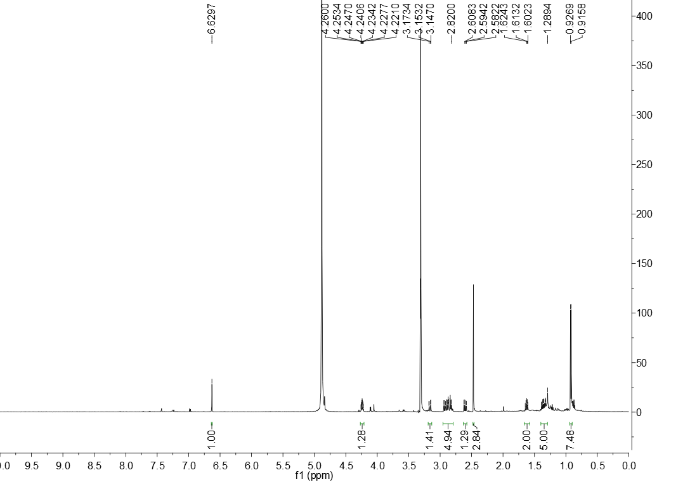S1-1. ¹H NMR spectrum of streptonaphthalen A (1).

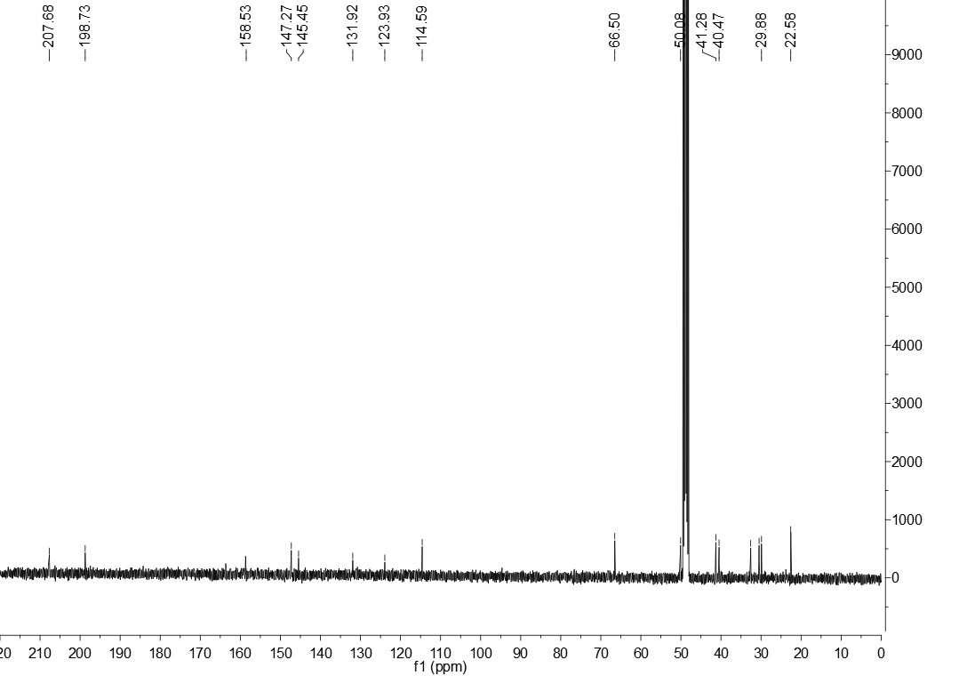
S1-2. ¹³C NMR spectrum of streptonaphthalen A (1).

S1-3. HRESIMS spectrum of streptonaphthalen A (1).

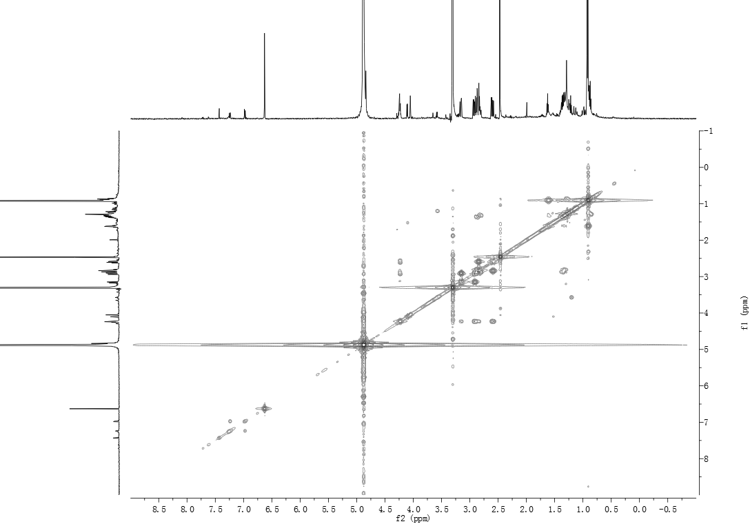
S1-4. ¹H, ¹H-COSY spectrum of streptonaphthalen A (1).

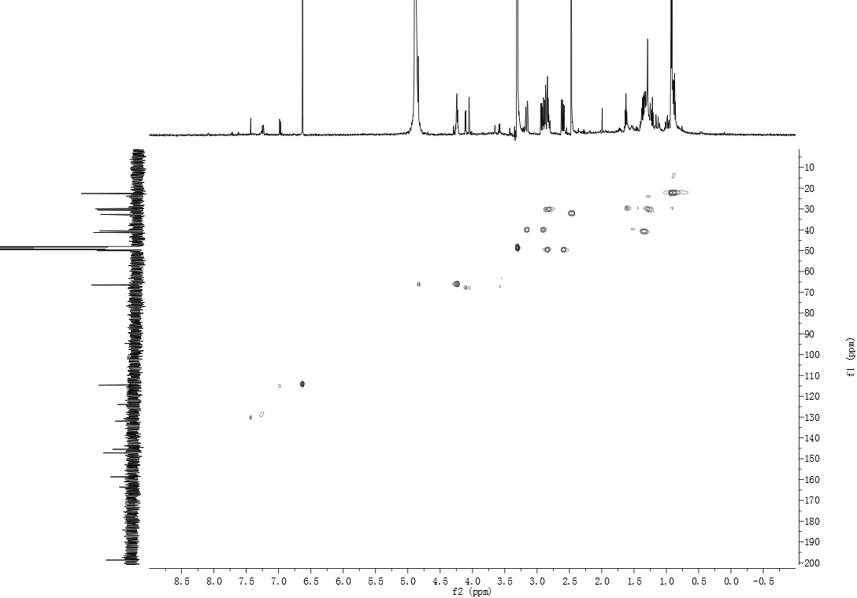S1-5. HSQC spectrum of streptonaphthalen A (1).

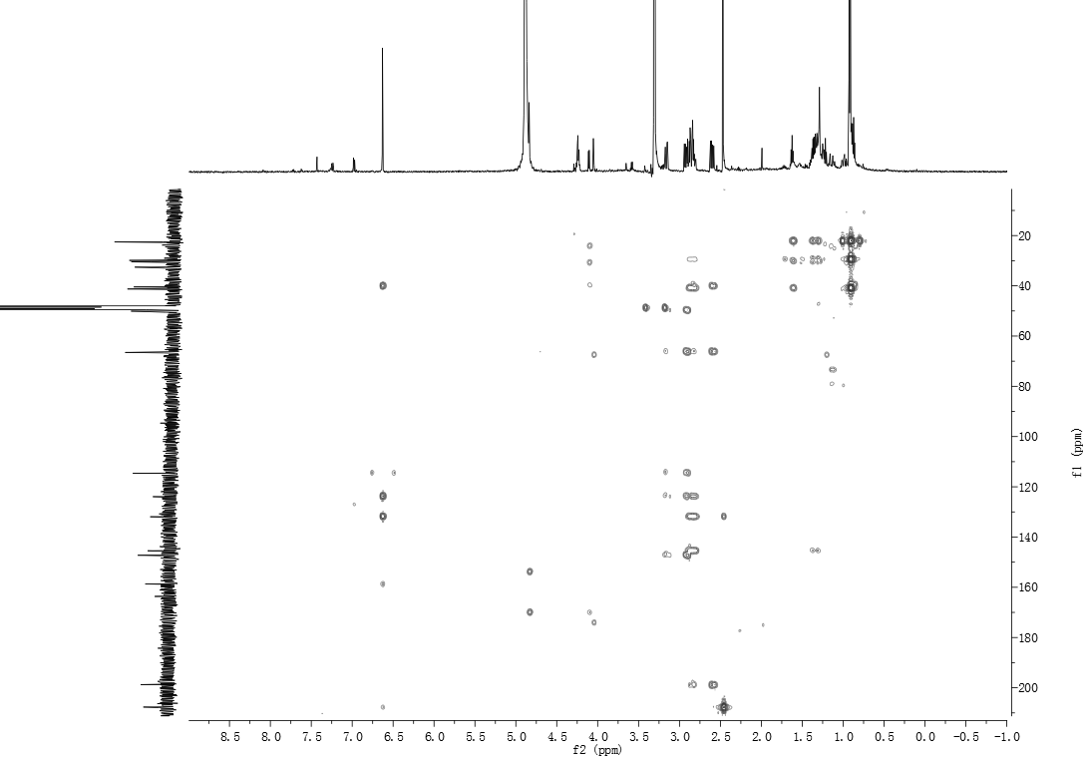
S1-6. HMBC spectrum of streptonaphthalen A (1).

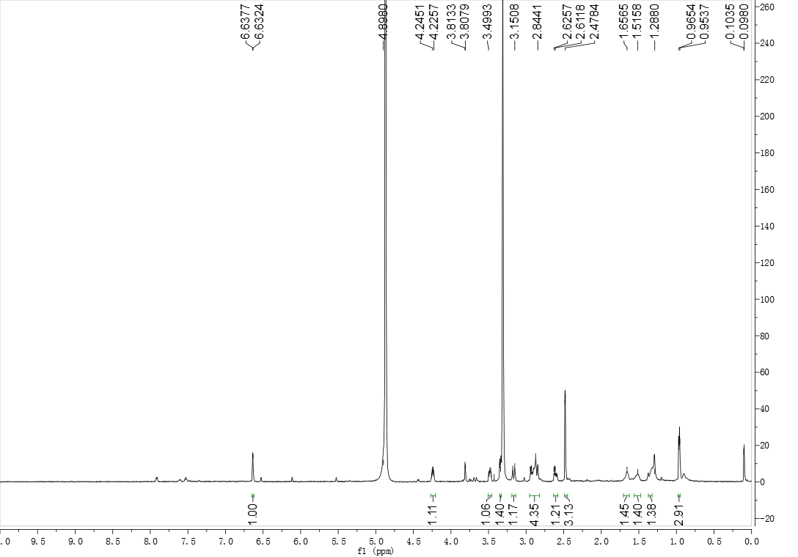
S2-1. ¹H NMR spectrum of streptonaphthalen B (2).

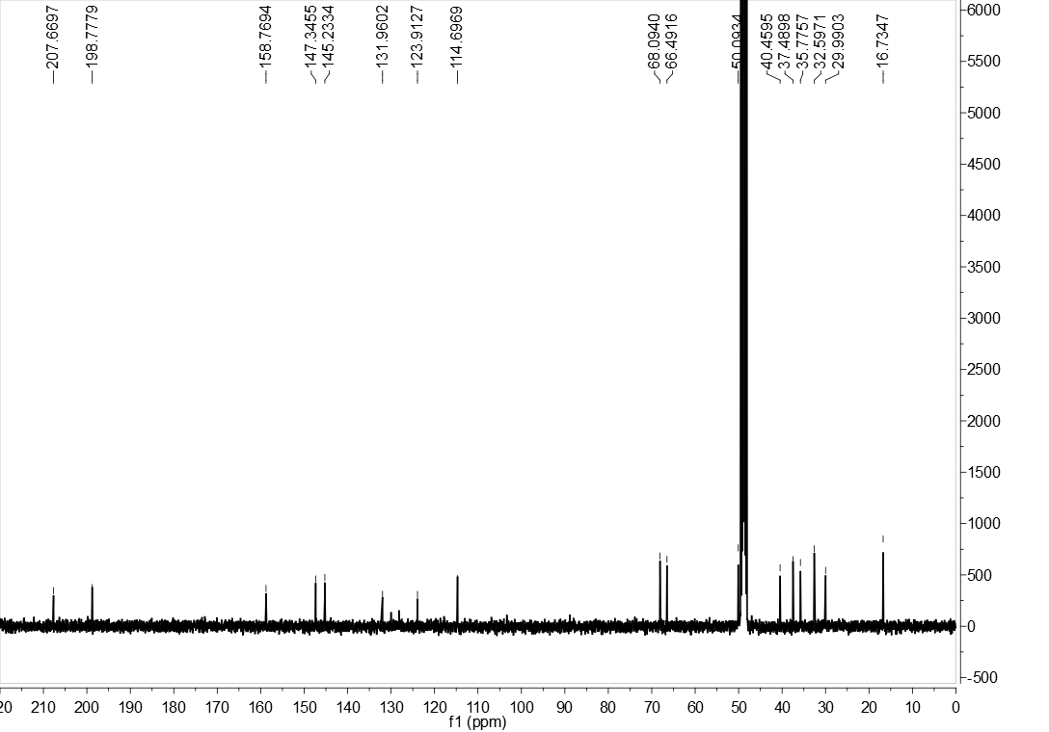
S2-2. ¹³C NMR spectrum of streptonaphthalen B (2).

S2-3. HRESIMS spectrum of streptonaphthalen B (2).

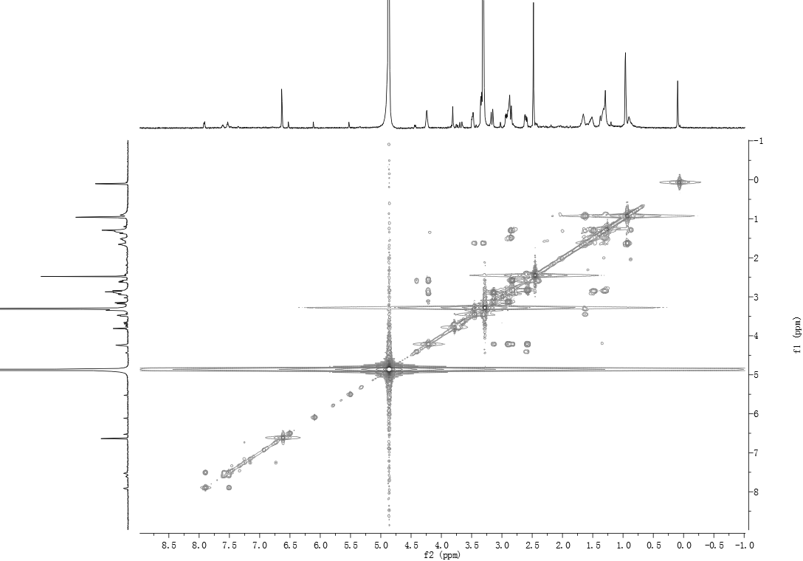
S2-4. ¹H, ¹H-COSY spectrum of streptonaphthalen B (2).

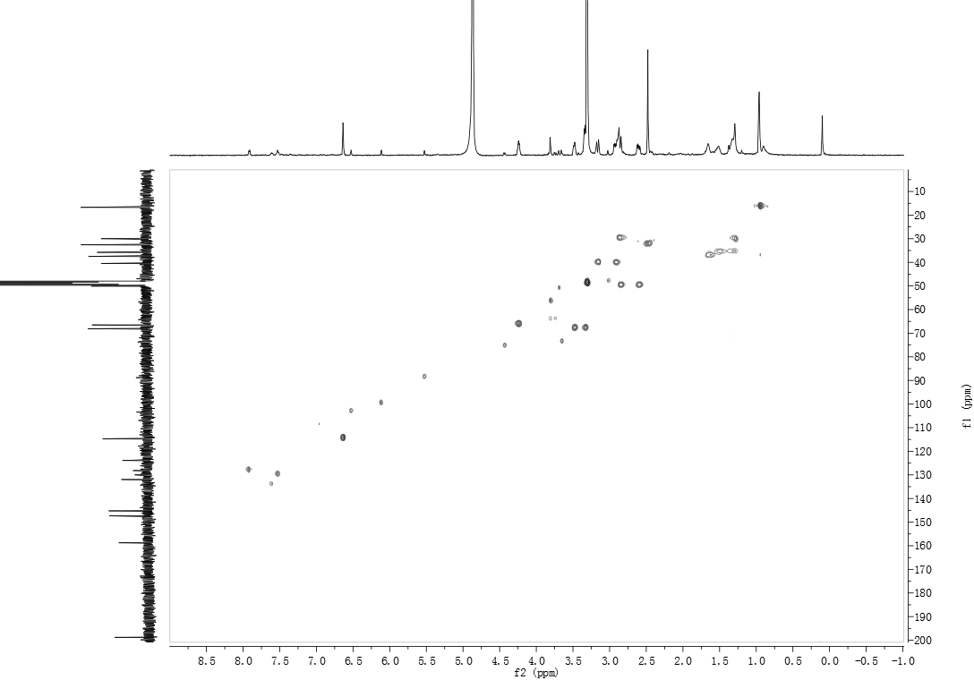S2-5. HSQC spectrum of streptonaphthalen B (2).

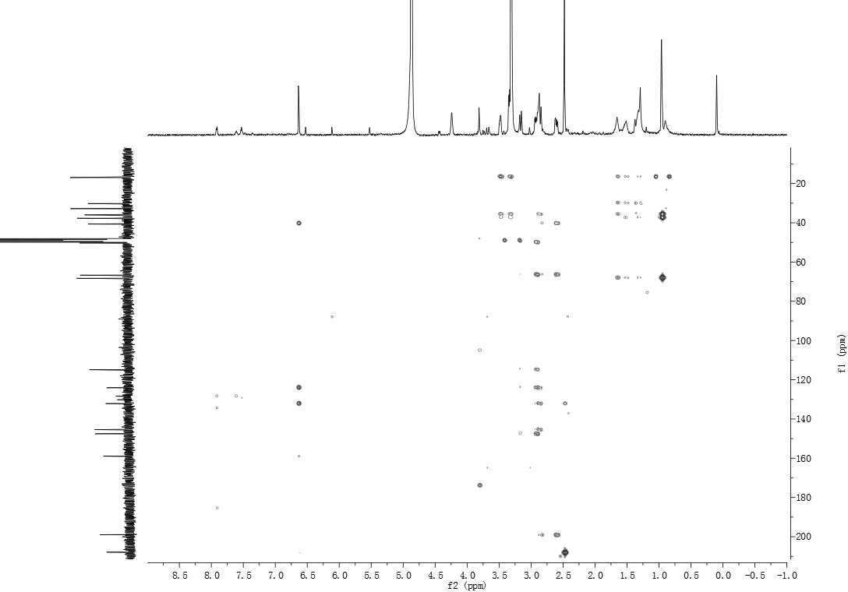
S2-6. HMBC spectrum of streptonaphthalen B (2).

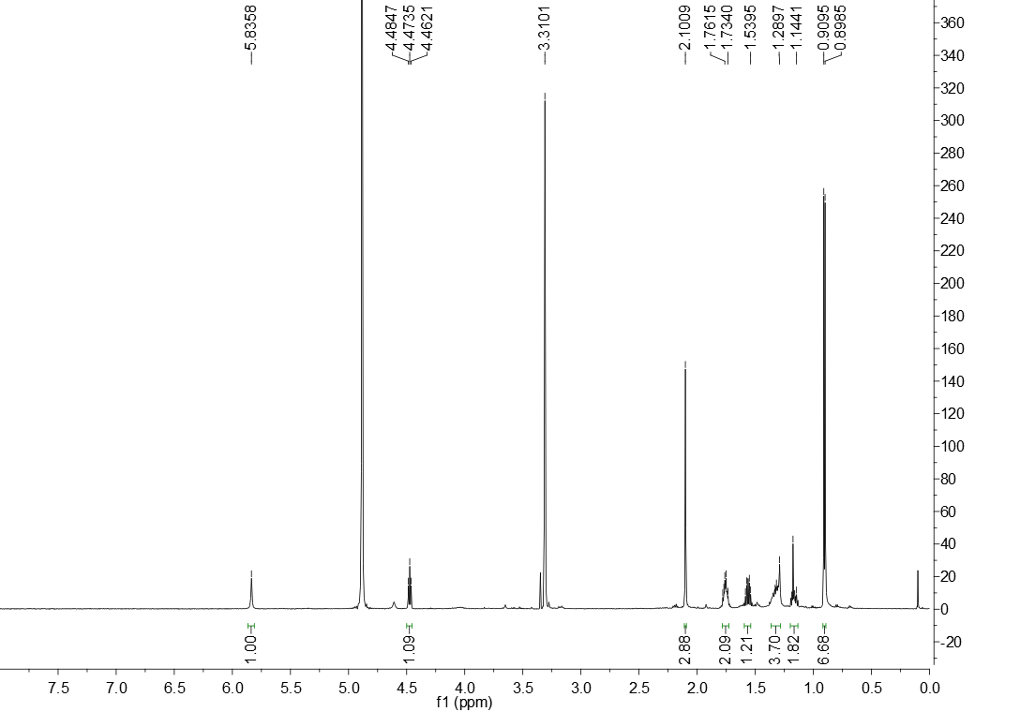S3-1. ¹H NMR spectrum of pestaloficin F (3).

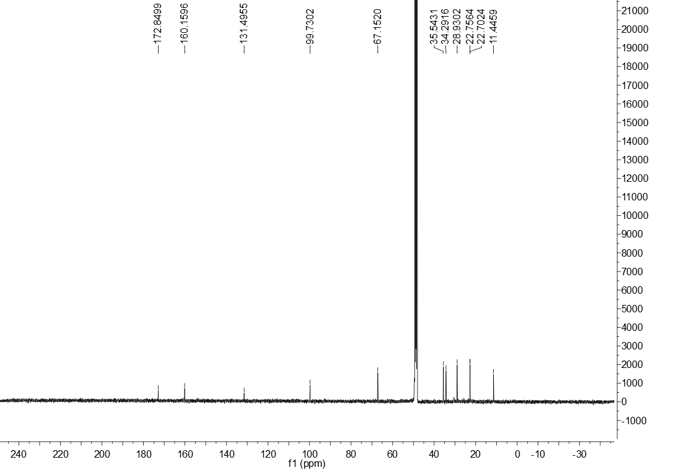
S3-2. ¹³C NMR spectrum of pestaloficin F (3).

S3-3. HRESIMS spectrum of pestaloficin F (3).

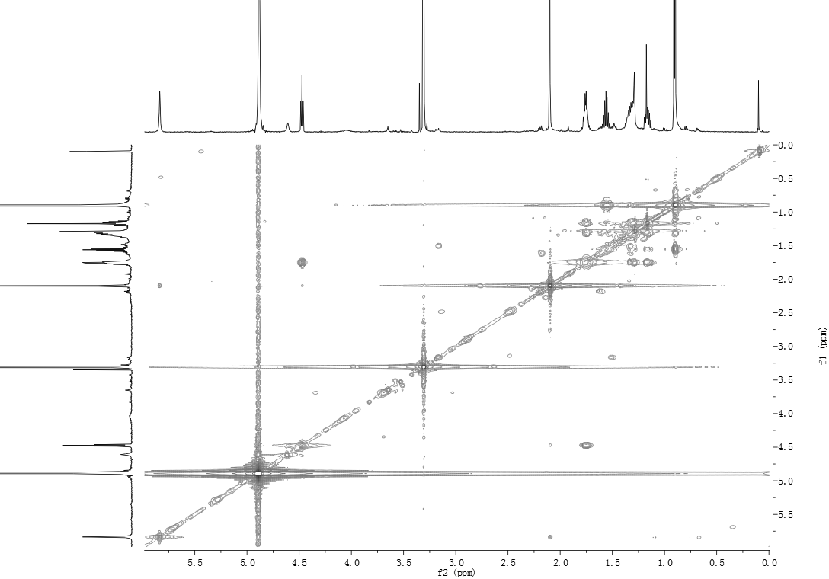
S3-4. ¹H, ¹H-COSY spectrum of pestaloficin F (3).

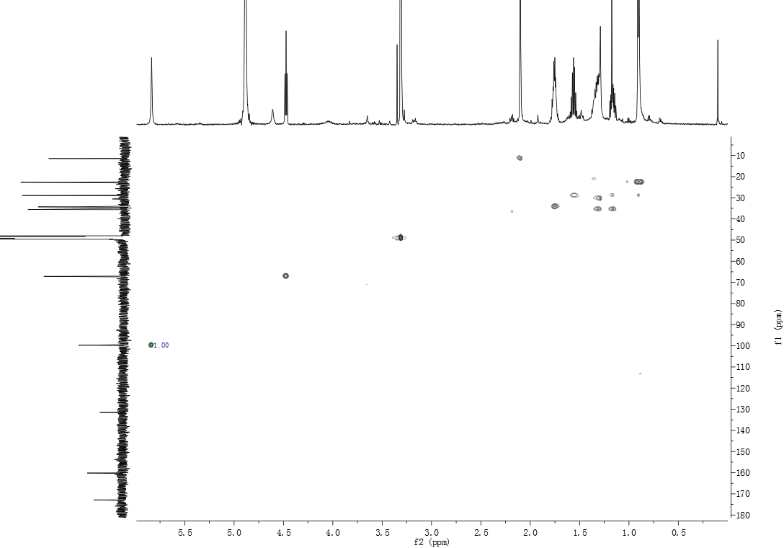
S3-5. HSQC spectrum of pestaloficin F (3).

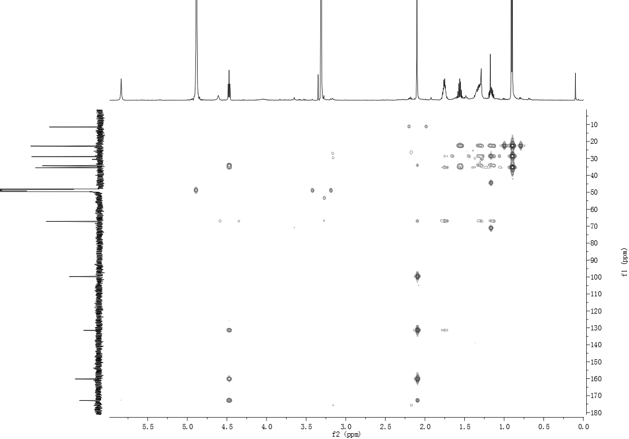
S3-6. HMBC spectrum of pestaloficin F (3).

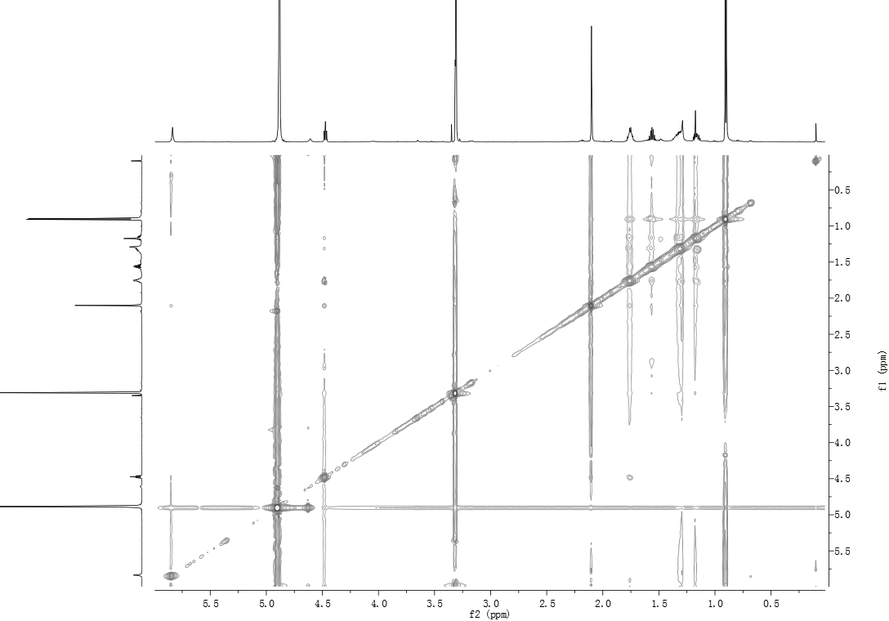
S3-7. NOESY spectrum of pestaloficin F (3).

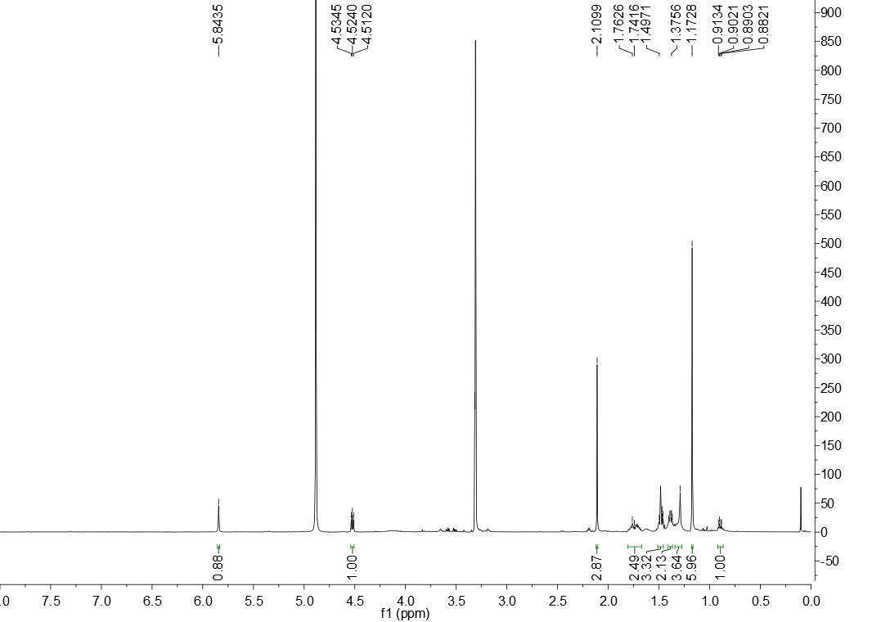
S4-1. ¹H NMR spectrum of pestaloficin G (4).

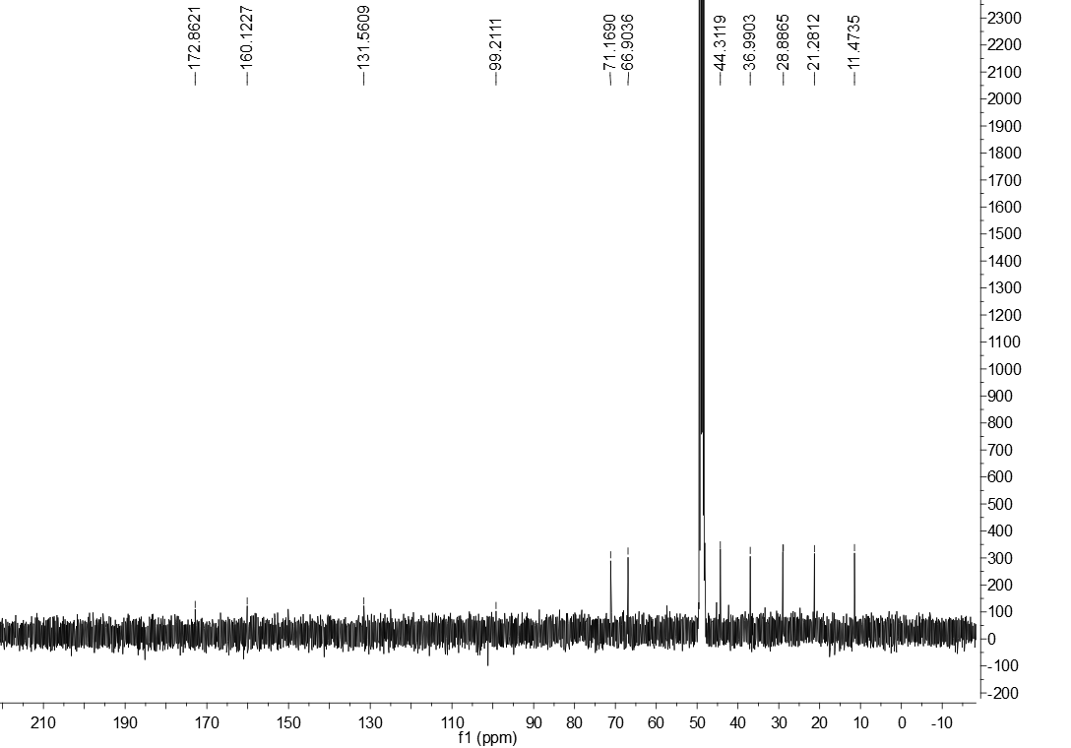
S4-2. ¹³C NMR spectrum of pestaloficin G (4).

S4-3. HRESIMS spectrum of pestaloficin G (4).
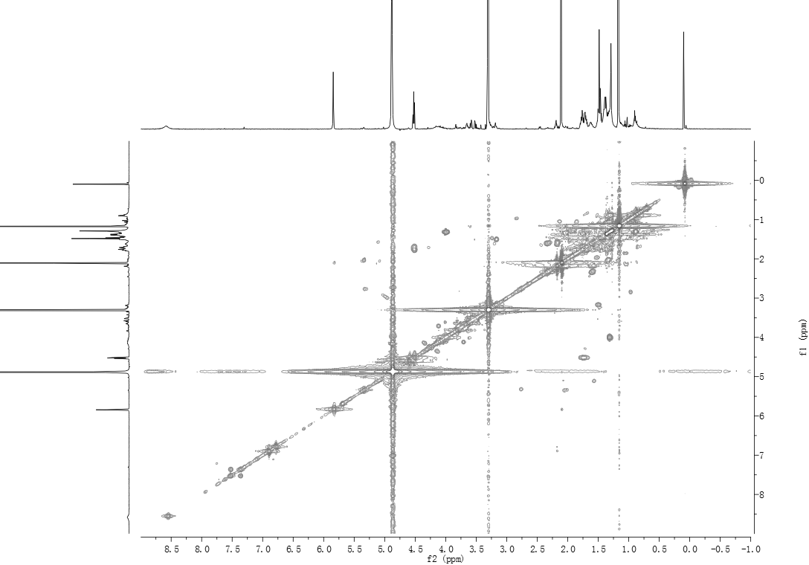
S4-4. ¹H-¹H COSY spectrum of pestaloficin G (4).

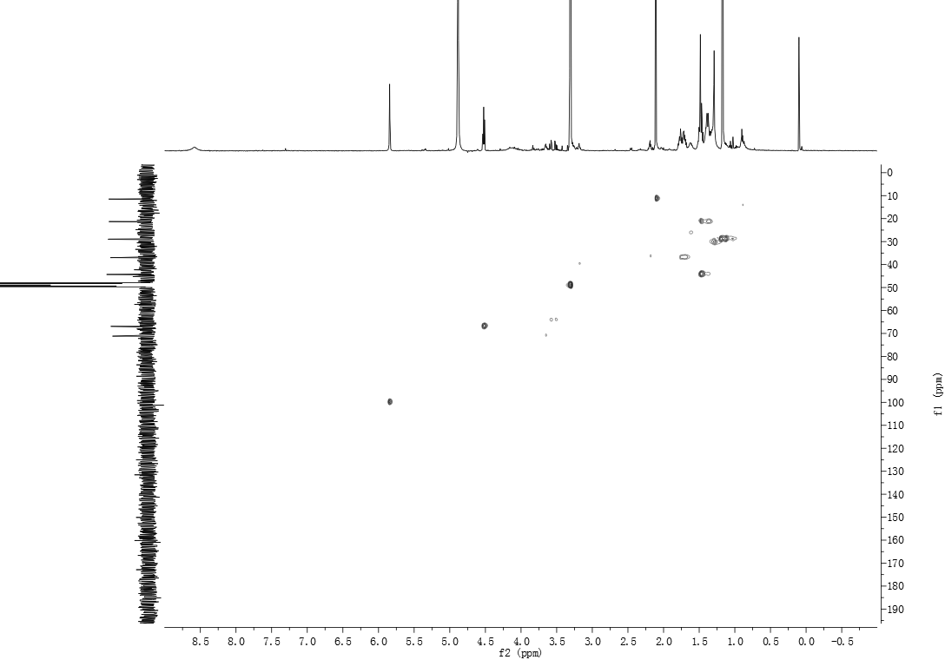
S4-5. HSQC spectrum of pestaloficin G (4).

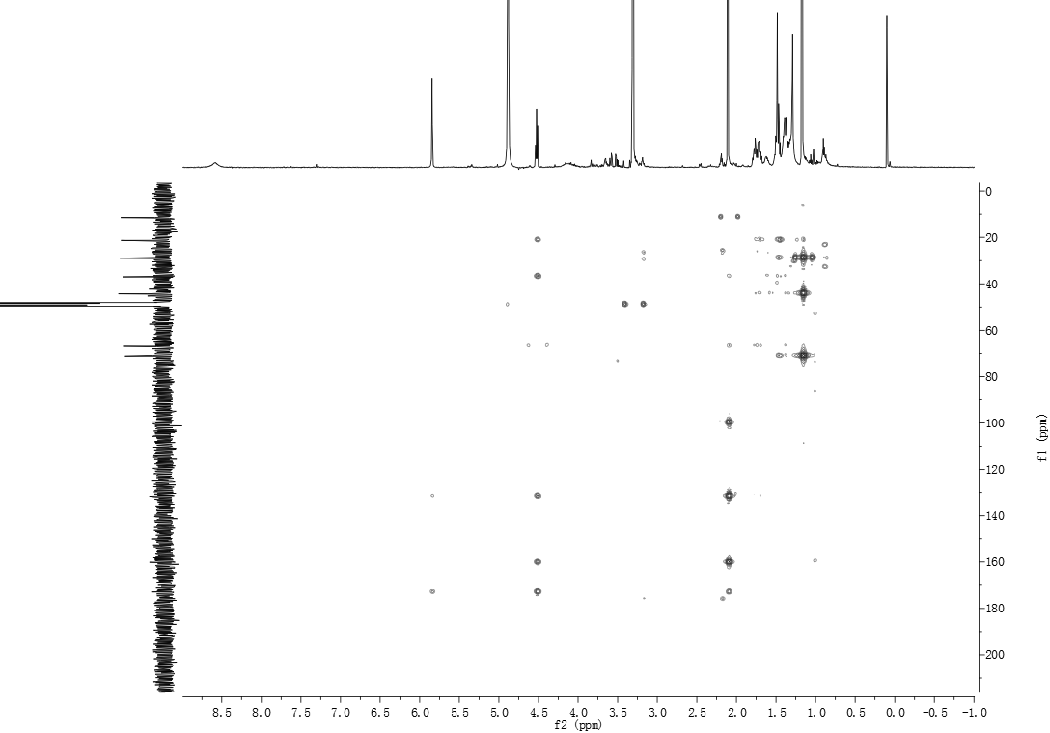
S4-6. HMBC spectrum of pestaloficin G (4).

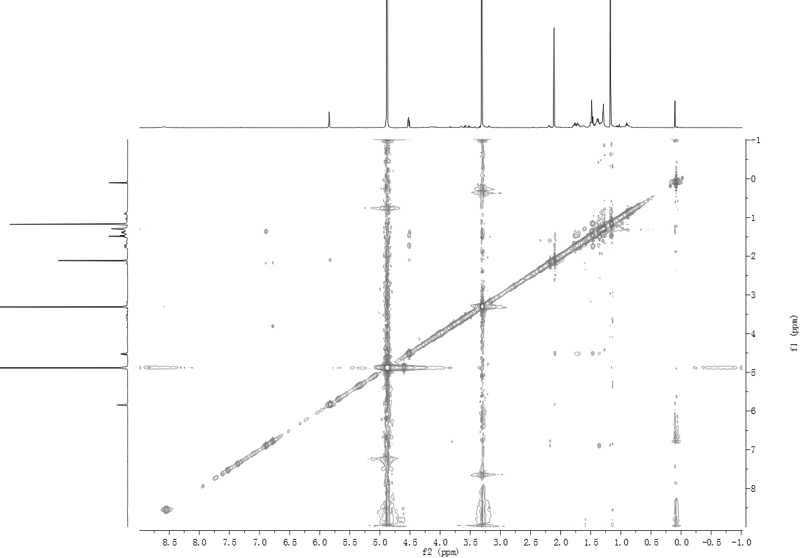
S4-7. NOESY spectrum of pestaloficin G (4).

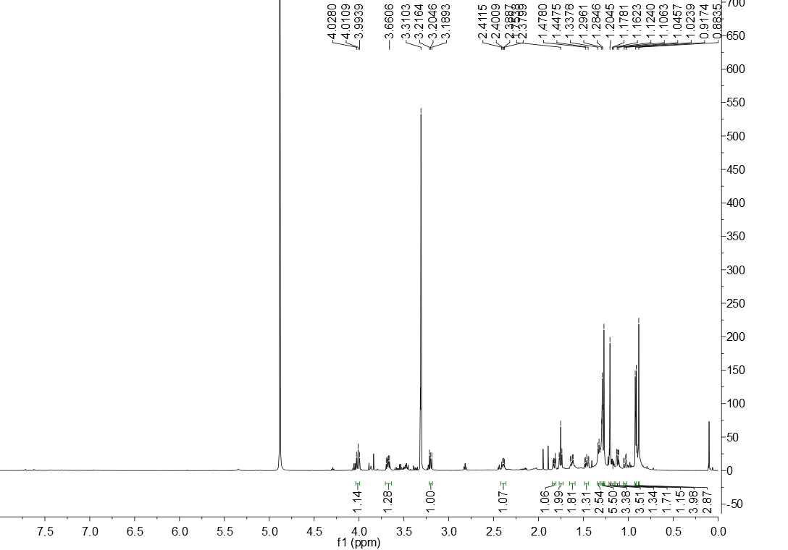
S5-1. ¹H NMR spectrum of eudesmanetetraiol A (5).

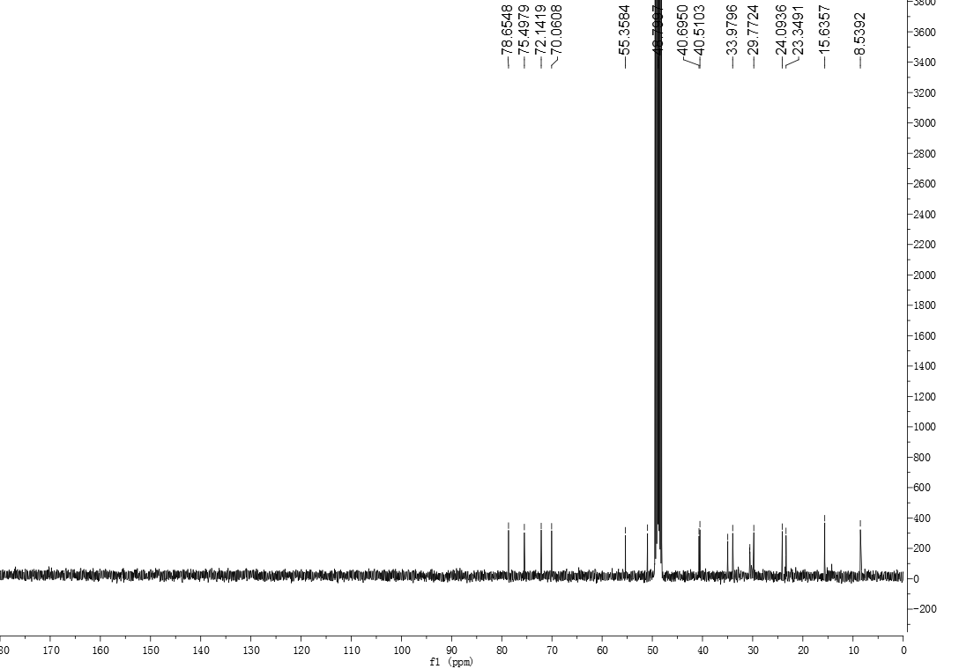
S5-2. ¹³C NMR spectrum of eudesmanetetraiol A (5).

S5-3. HRESIMS spectrum of eudesmanetetraiol A (5).

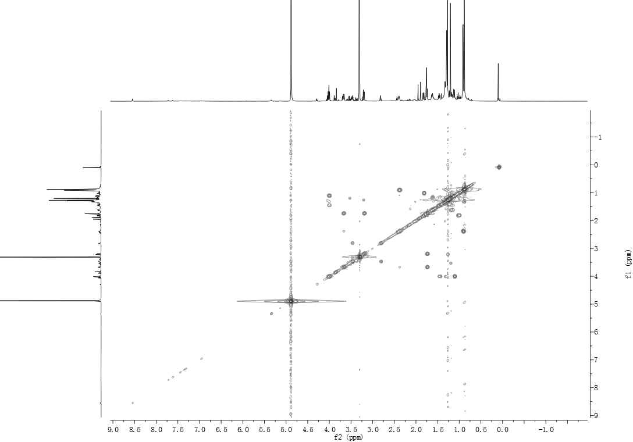
S5-4. ¹H, ¹H-COSY spectrum of eudesmanetetraiol A (5).

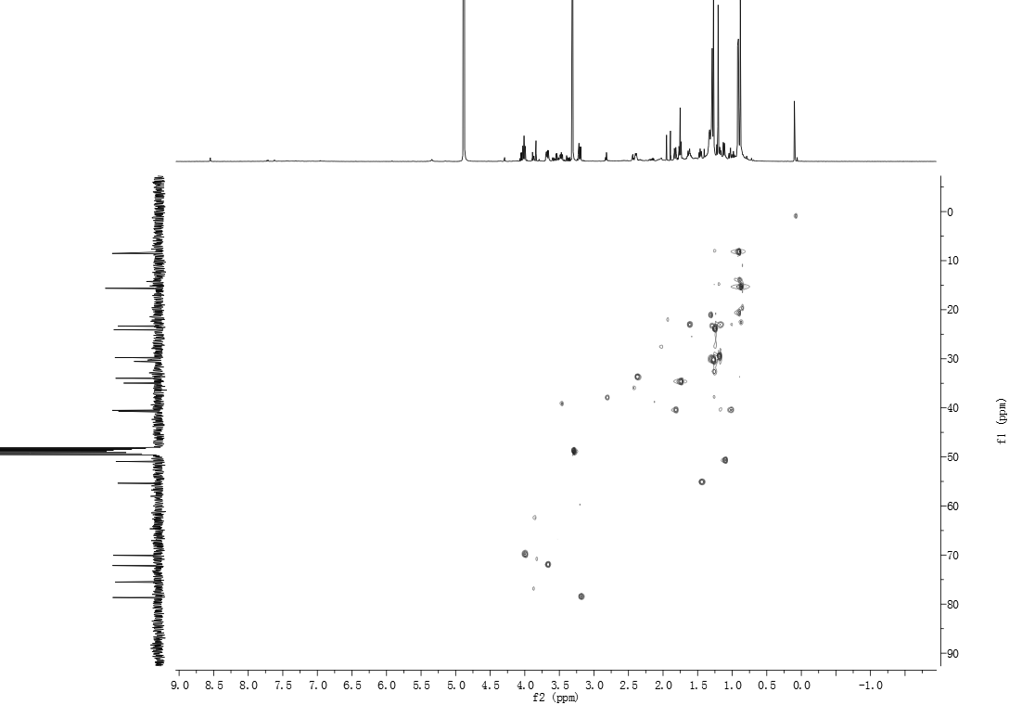
S5-5. HSQC spectrum of eudesmanetetraiol A (5).

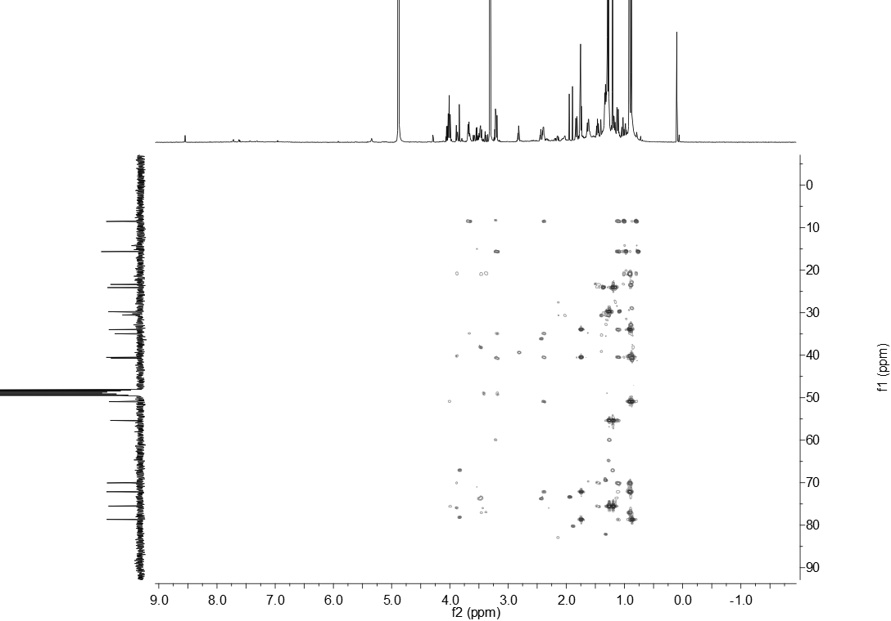
S5-6. HMBC spectrum of eudesmanetetraiol A (5).

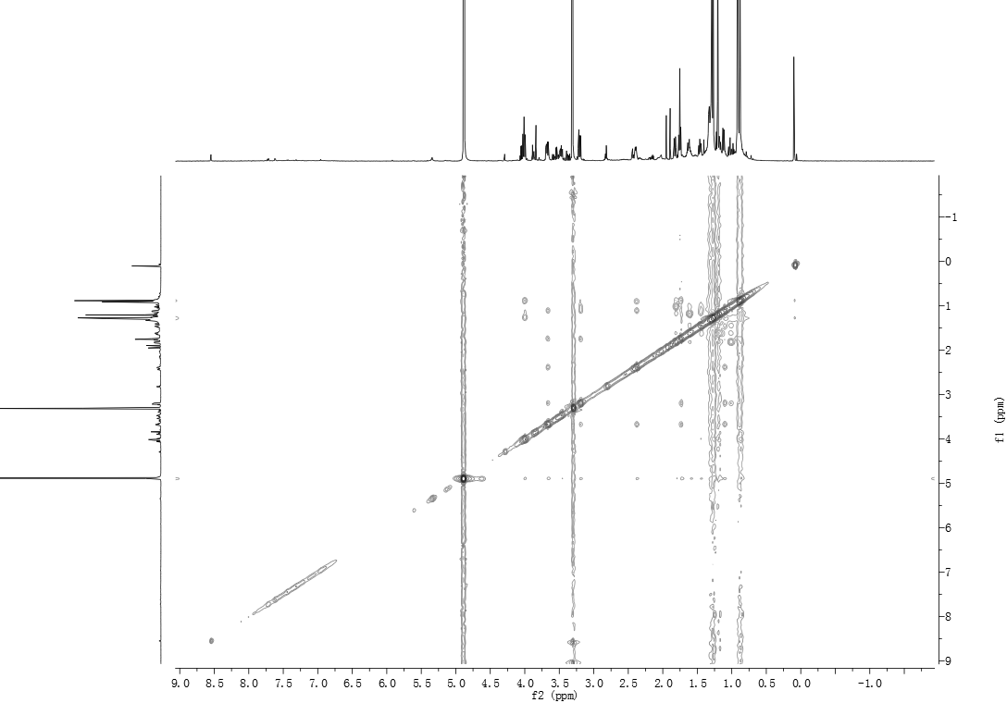
S5-7. NOESY spectrum of eudesmanetetraiol A (5).



