**Supplementary Figures:**

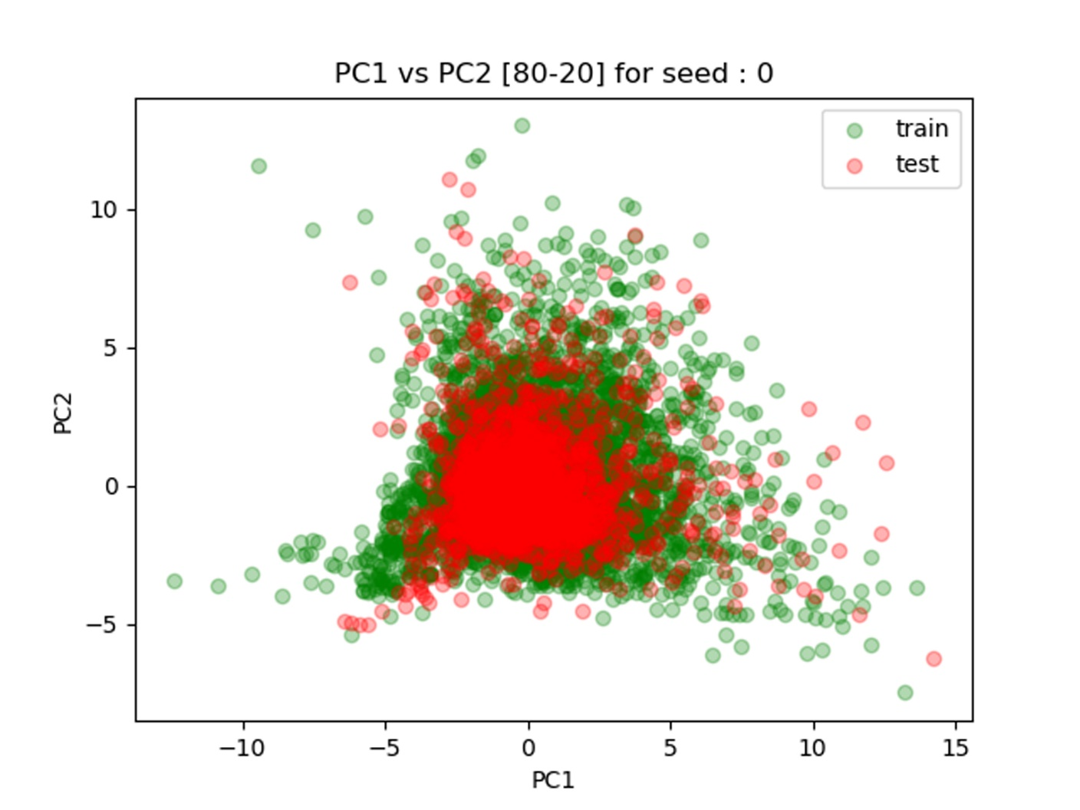

**Supplementary Figure 1.** Principal component analysis (PCA) plot for dipeptide feature set split 1

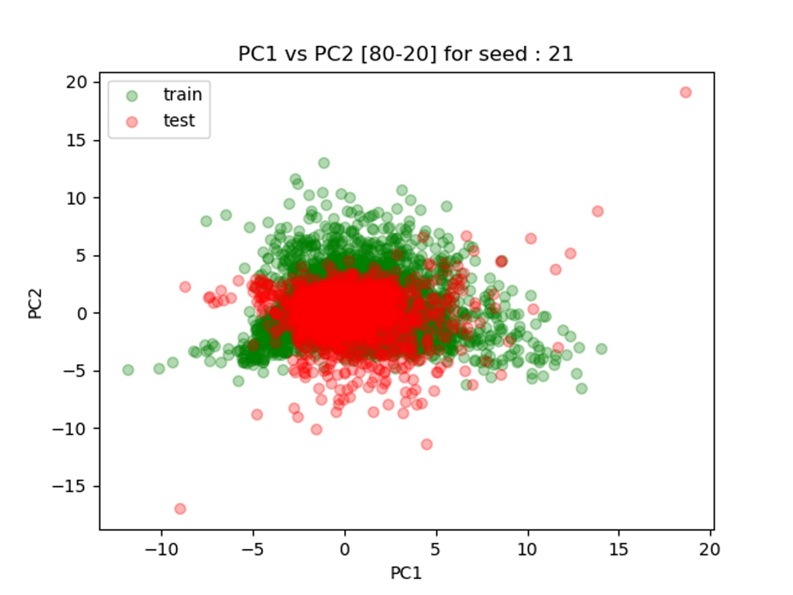

**Supplementary Figure 2.** Principal component analysis (PCA) plot for dipeptide feature set split 2

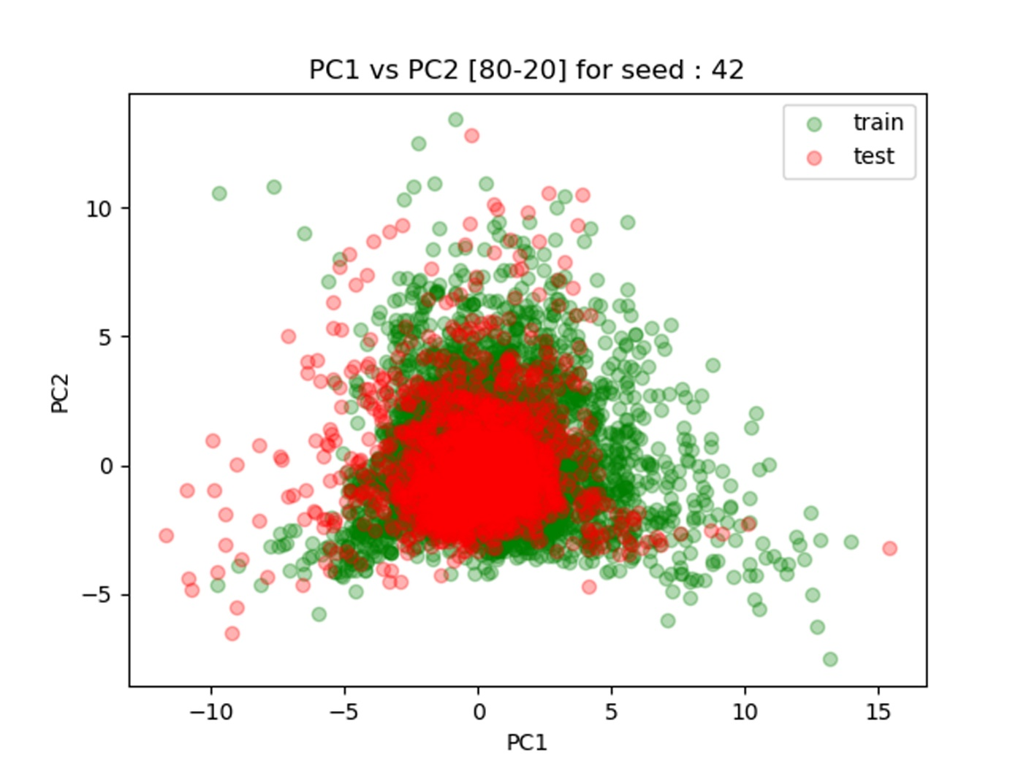

**Supplementary Figure 3.** Principal component analysis (PCA) plot for dipeptide feature set split 3

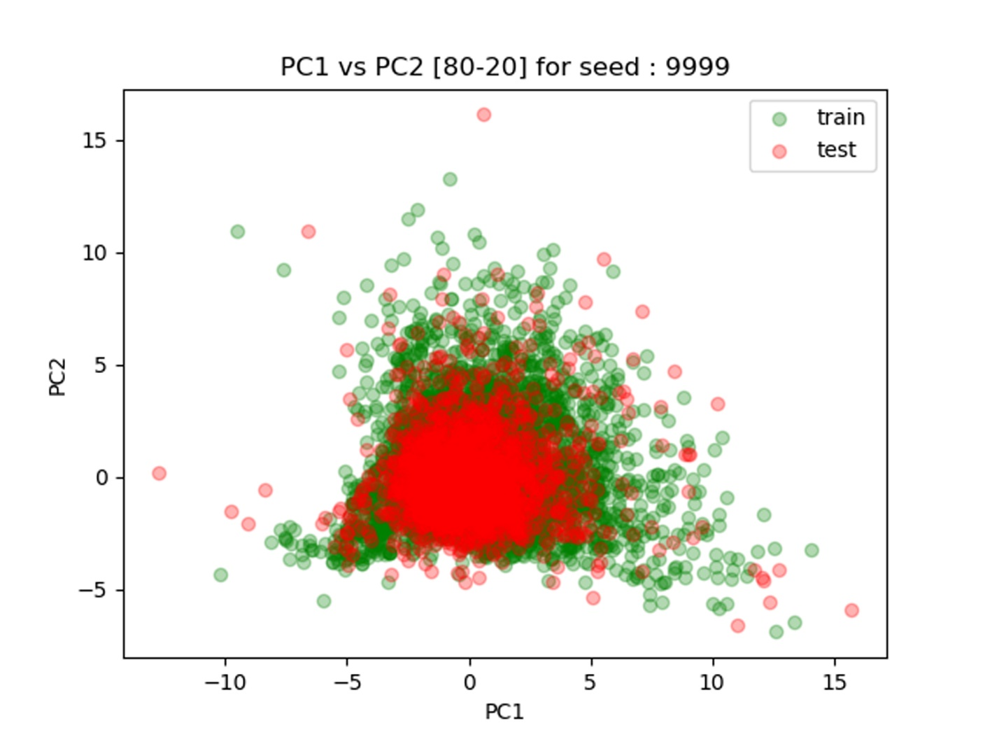

**Supplementary Figure 4.** Principal component analysis (PCA) plot for dipeptide feature set split 4

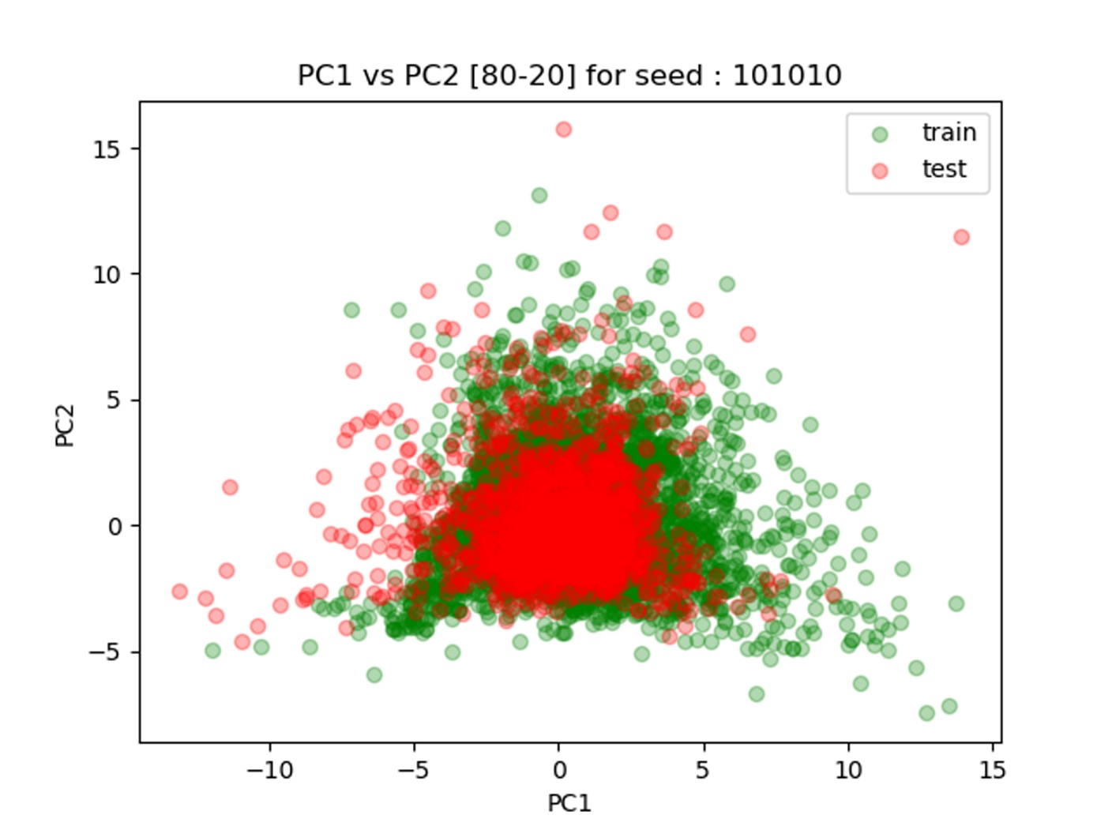

**Supplementary Figure 5.** Principal component analysis (PCA) plot for dipeptide feature set split 5