**Supplementary Information**

Khair Bux,1 Xiayu Shen,2 Muhammad Tariq,1 Junqi Yin,3 Syed Tarique Moin,1 Debsindhu Bhowmik,4 and Shozeb Haider 2,*

1 Third World Center for Science and Technology, H.E.J. Research Institute of Chemistry, International Centre of Chemical and Biological Sciences, University of Karachi, Karachi, 75270 Pakistan

2 UCL School of Pharmacy, London WC1N 1AX, United Kingdom

3 Center for Computational Sciences, Oak Ridge National Laboratory, Oak Ridge, TN 37830, USA

4 Computer Sciences and Engineering Division, Oak Ridge National Laboratory, Oak Ridge, TN 37830, USA

* Corresponding author: Shozeb Haider

Email: [Shozeb.haider@ucl.ac.uk](mailto:Shozeb.haider@ucl.ac.uk)

ORCID: Shozeb Haider: 0000-0003-2650-2925

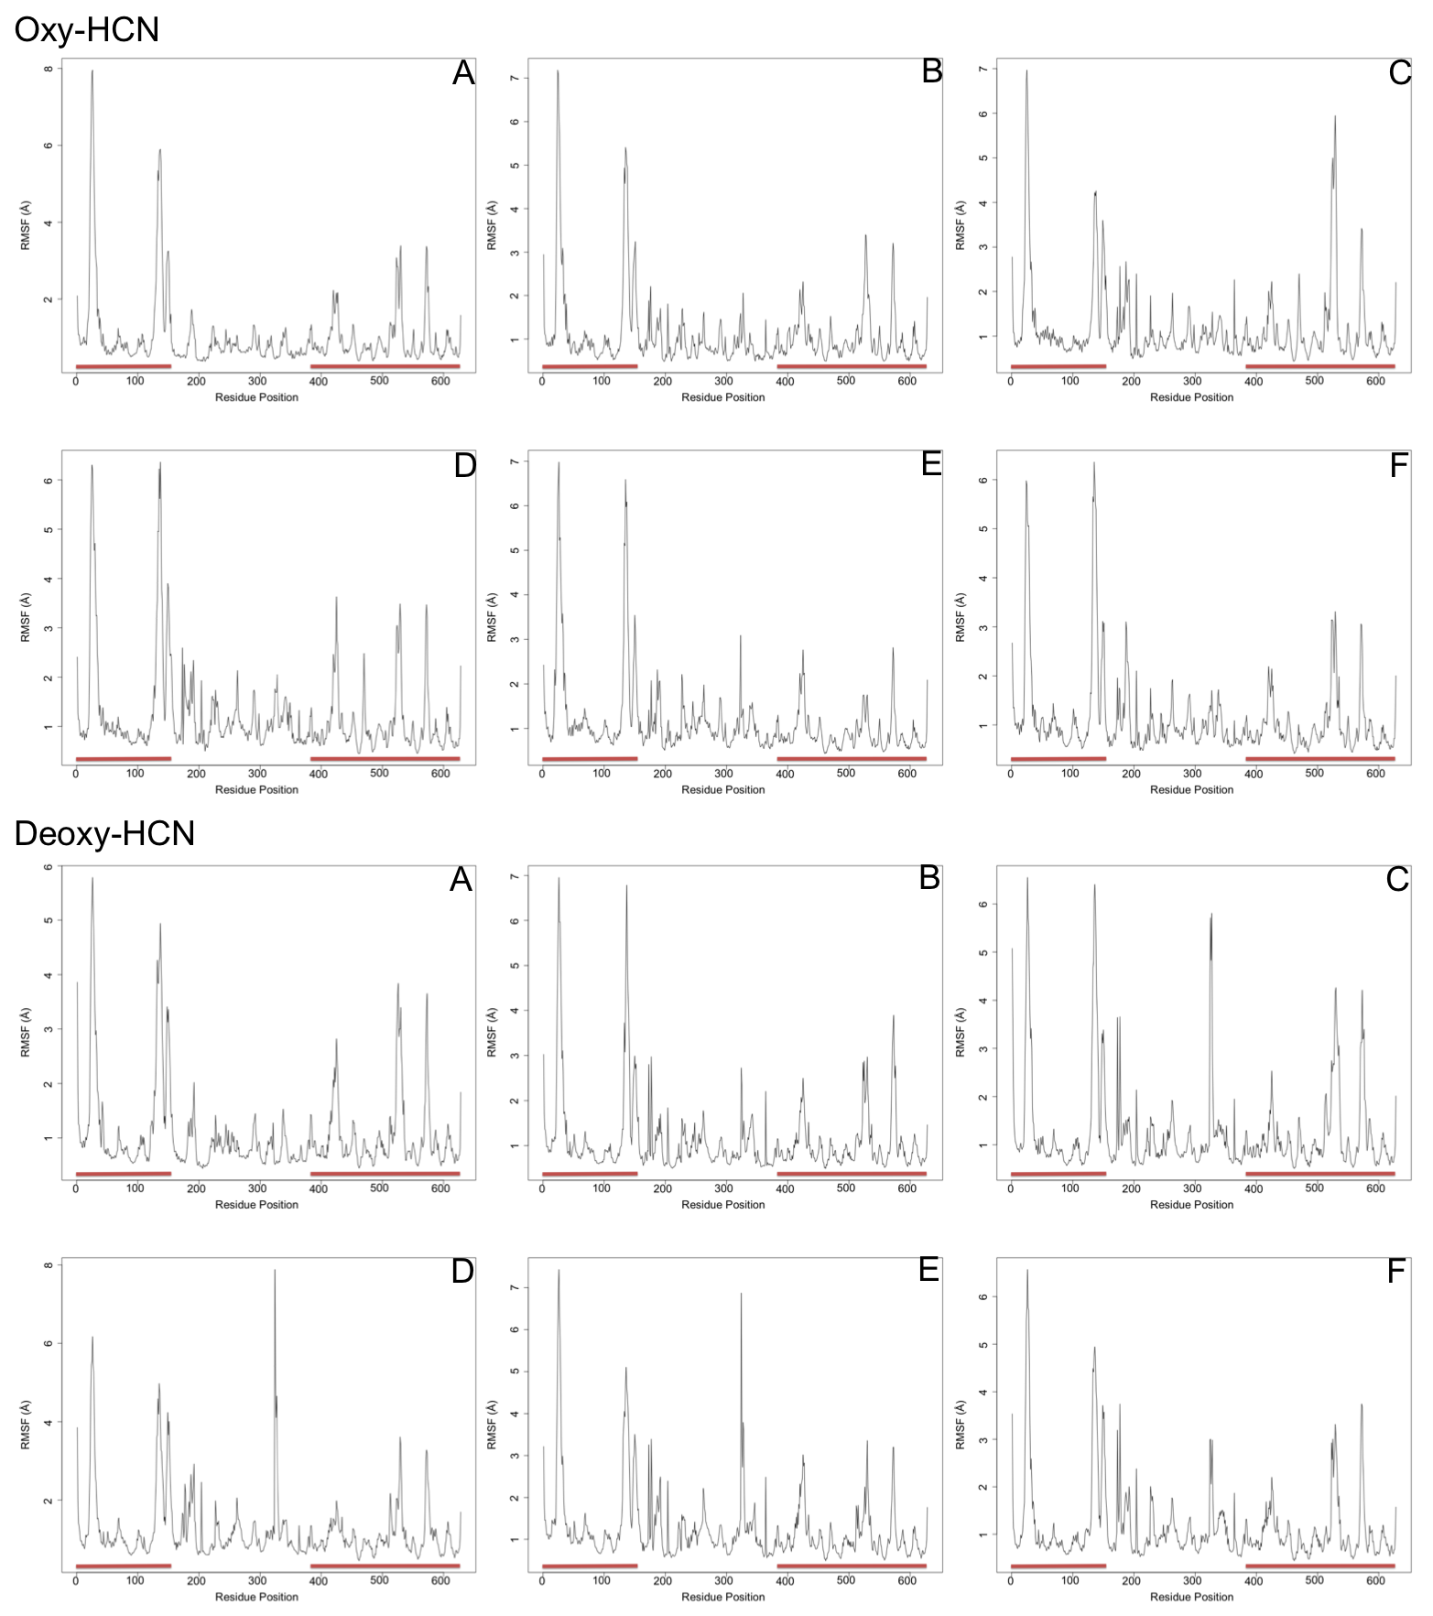

Figure S1: Root mean square fluctuation plots calculate for every subunit from the last 40 ns of the trajectories. The boundaries for domain III and I are indicated by the red line. In Oxy-HCN, domain III and I are largely flexible, where as domain II is stable. This could be because of the presence of oxygen bound in the metal centre in domain II. In Deoxy-HCN, domain II also displays fluctuations (in three subunits) along with domain III and I.