Supplementary Material

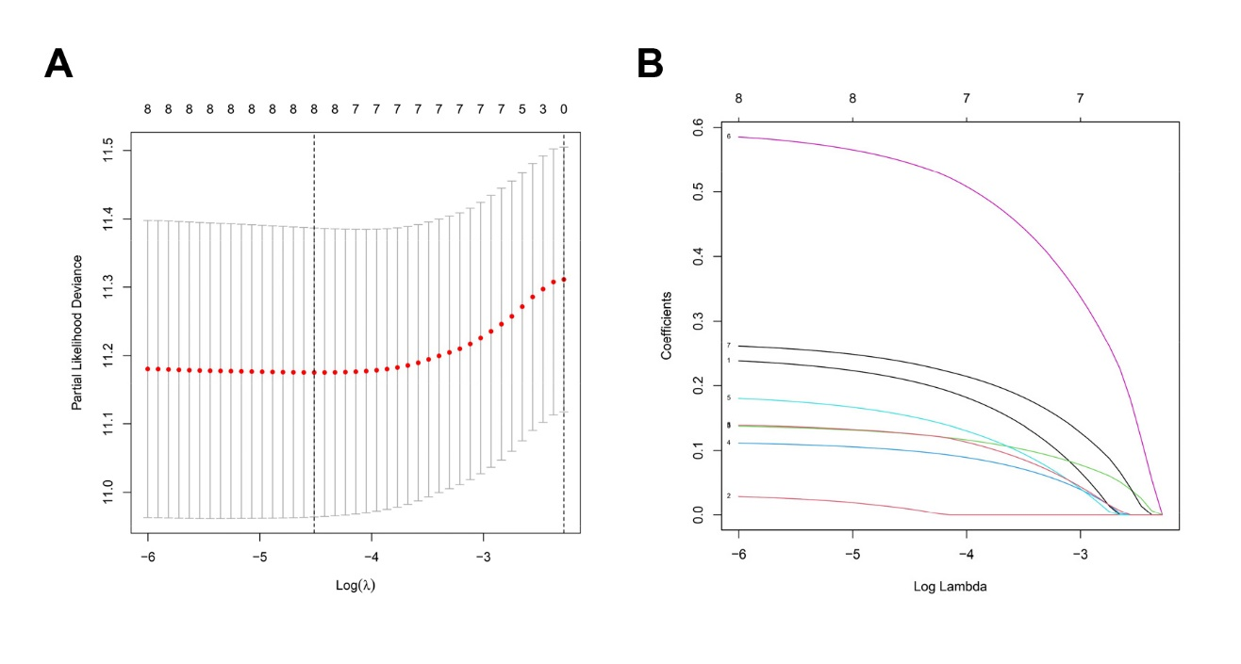

**Supplementary Figure 1.** Lasso regression analysis of ferroptosis-related genes with prognostic potential in the training cohort of BC patients. (**A, B**) Lasso regression analyses of differentially expressed genes using the OS model. The optimal values of the penalty parameter λ were determined by cross validation.

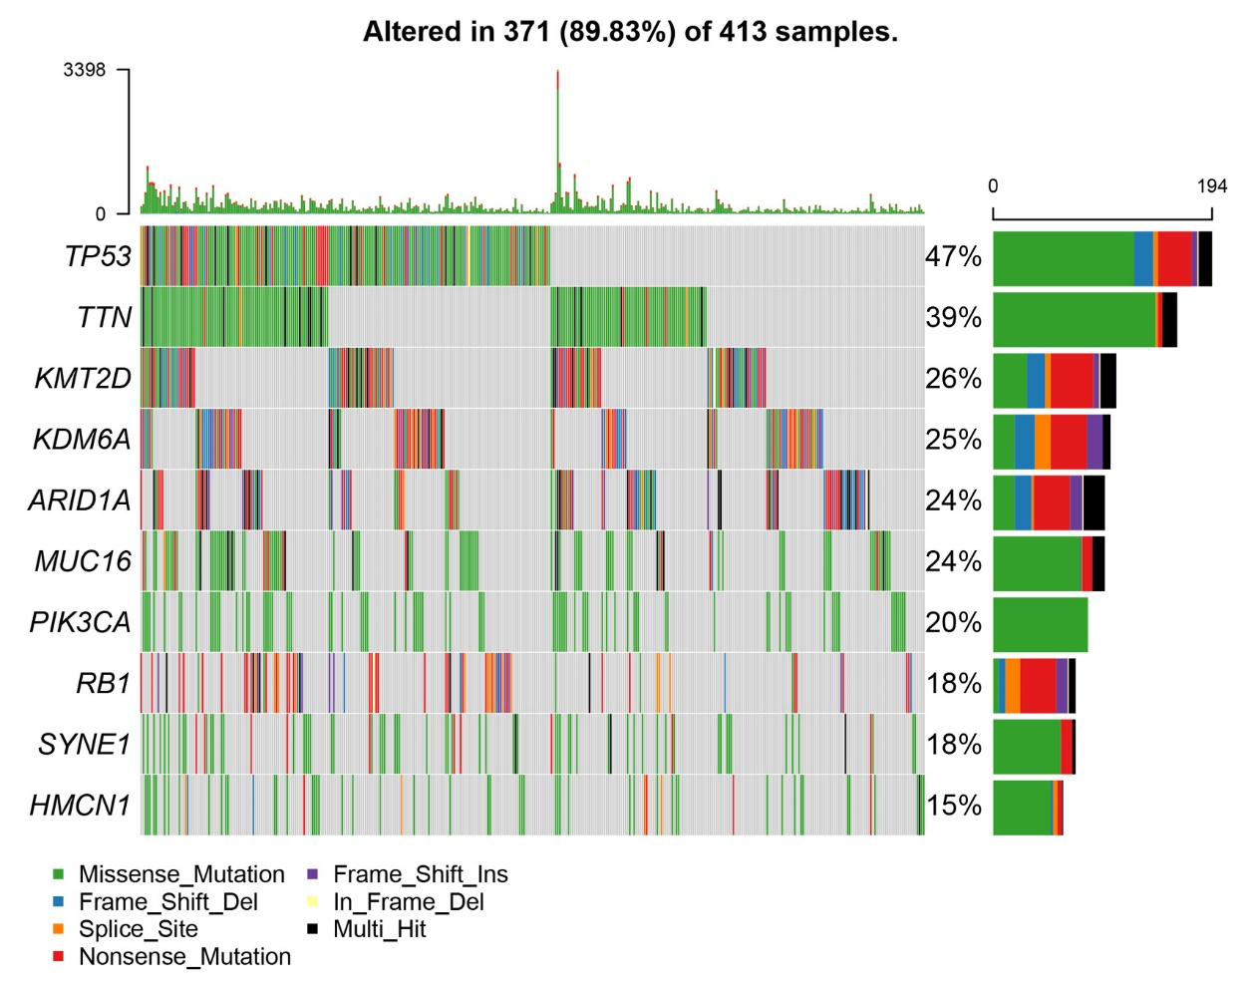

**Supplementary Figure 2.** Landscape of mutation profile in TCGA-BLCA dataset.