

Figure S1: Scatter plot to shown the connection between clinical pathology, clusters and risk scores. A. The risk score was significant related to tumor grade; B. The risk score was significant related to tumor stage; C. The risk score was significant related to tumor T stage; D. The risk score was significant related to clusters (cluster 1 vs. cluster 2 and cluster 2 vs. cluster 3).

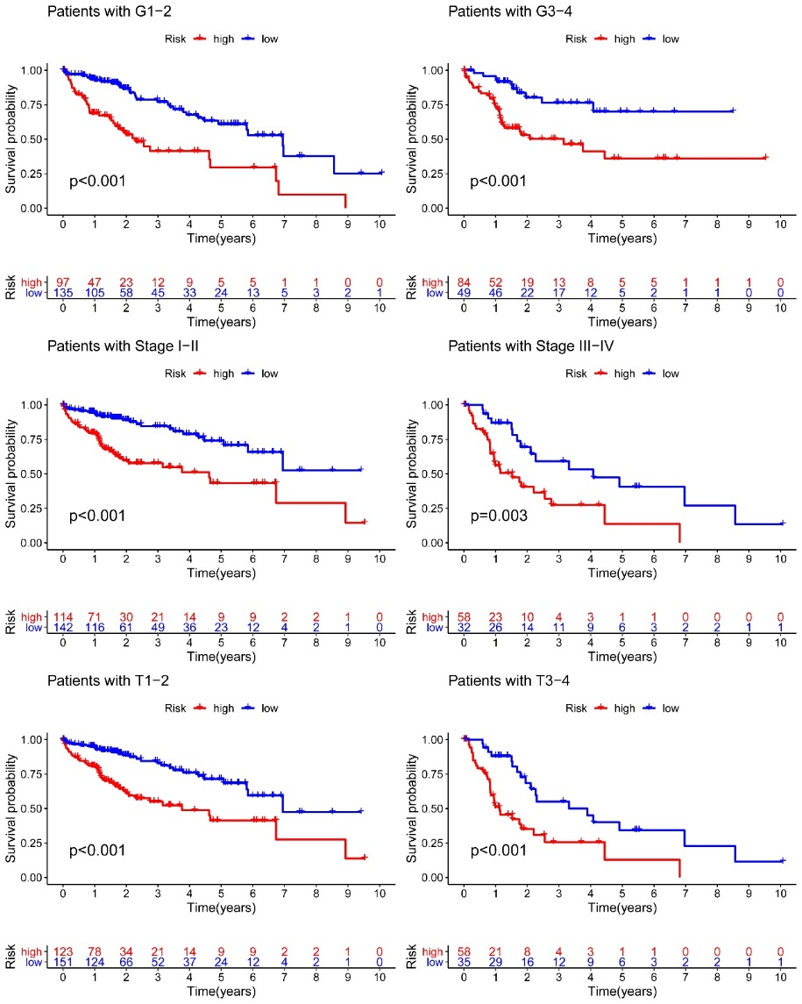

**Figure S2**. The impacts of risk scores on patient overall survival in different clinical subtypes and the results suggested that tumor grade, tumor stage and T stage subtypes significance related to patient’s survival.

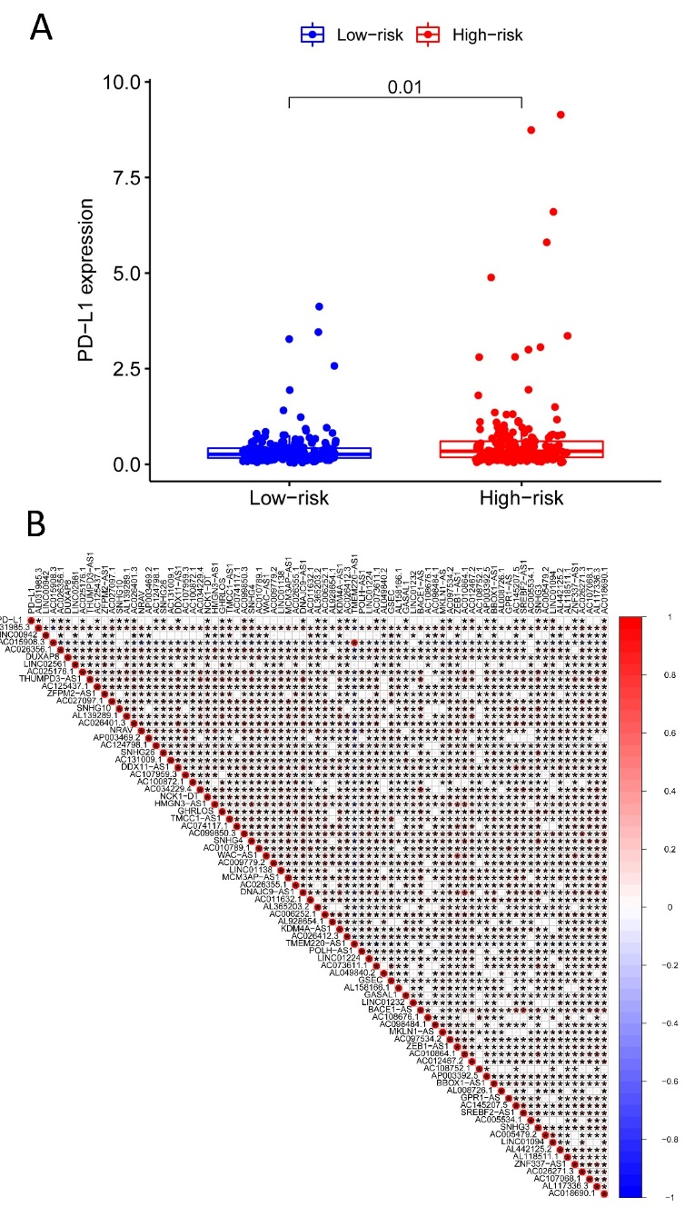

**Figure S3**. The relationship between *PD-L1* and the high and low risk group. A. The high expression of *PD-L1* inhigh risk group;B. The correlation between *PD-L1* and the prognosis-related lncRNAs in TCGA-HCC.

Supplement tables legends:

**Table S1**. The information of 33 pyroptosis-related genes (PRGs).

**Table S2**. The location of CNV alteration of pyroptosis-related genes on chromosomes.

**Table S3**. The univariate Cox analysis identified 336 pyroptosis-related lncRNAs.

**Table S4**. GSVA enrichment analysis investigate the biological function in cluster 1.

**Table S5**. GSVA enrichment analysis investigate the biological function in cluster 3.

**Table S6**. The differently expressed lncRNAs were selected as independent prognosis factors of HCC patients based on the lasso regression.