Supplementary Material

# Supplementary Figures

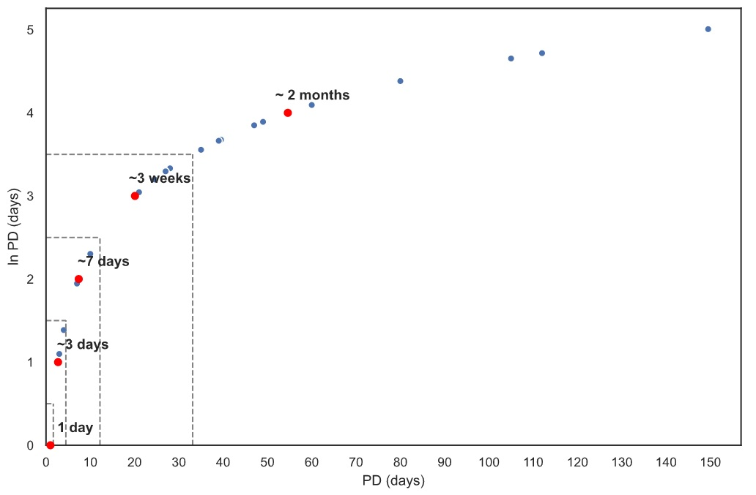

**Figure S1 |** The pelagic propagule duration (PD) of eelgrass associated invertebrates. We binned PD values into 5 levels, and to achieve equal width bins we used values of e0,1,2,3,4 days, which we rounded to 1,3,7,21,60 days on a linear scale. For species that are sessile and do not have a planktonic larval phase, we considered them capable of rafting on seagrass debris, which can remain buoyant for up to three weeks.

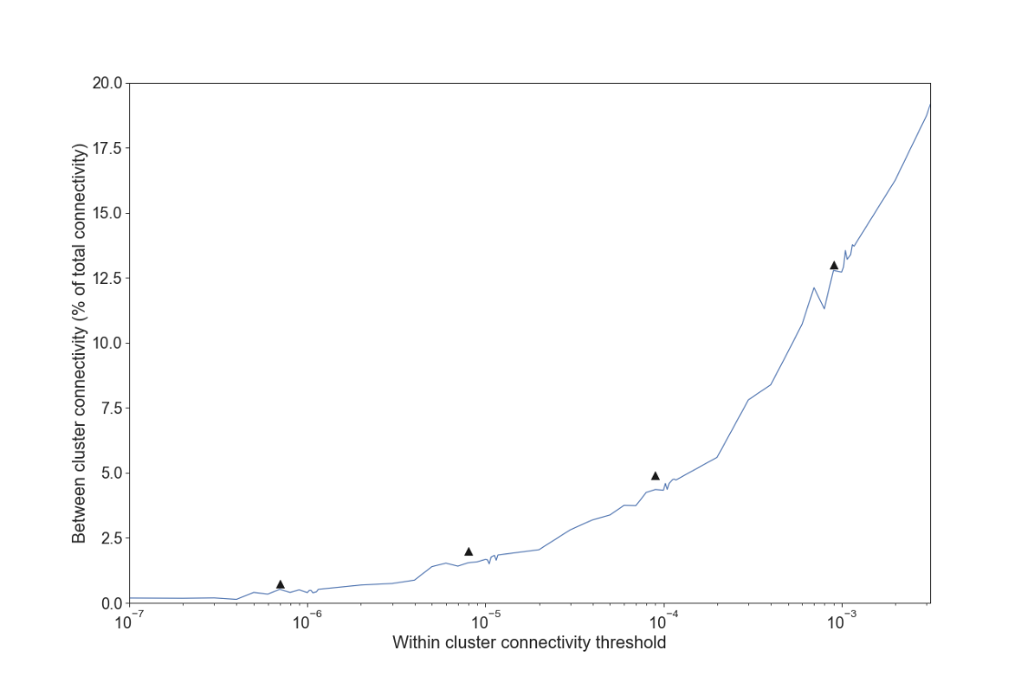

**Figure S2 |** The amount of connectivity existing among clusters vs. the within-connectivity threshold used to detect clusters. Plateaus and inconsistent scaling indicate stable cluster partitions where barriers to dispersal may exist. The x-axis is logarithmic and plateaus at higher values are expected to appear shorter.